West Bengal Election 2026 – Data Analysis Dashboard Project

Project Overview
This project analyzes West Bengal Election 2026 data using pivot tables and interactive charts. The dashboard provides a comprehensive view of vote share, turnout, and party performance across districts, election phases, and demographics. By transforming raw data into meaningful visuals, the project helps identify patterns and trends in voter behavior.

Tools Used
- Microsoft Excel
- Pivot Tables
- Pivot Charts (Bar, Line, Pie Charts)
- Slicers (District, Party, Phase, Gender, Urban/Rural)
- Dashboard Design

Problem Statement
Election datasets are often large, complex, and contain multiple dimensions such as district, phase, party, gender, and location. Analyzing such data manually makes it difficult to identify meaningful trends and insights. The challenge lies in organizing, cleaning, and transforming raw election data into a structured format that can be easily analyzed.
This project aims to address these challenges by using pivot tables and charts to simplify the analysis process. It focuses on identifying patterns in vote share distribution, turnout percentages, and party performance across different regions. The dashboard is designed to enable quick comparisons and interactive exploration of the data, helping users understand how different factors influence election outcomes.

Research Questions
- Which party has the highest overall vote share in West Bengal 2026?
2. How does vote share vary across different districts?
3. What trends can be observed in vote share across different election phases?
4. Is there a relationship between voter turnout and vote share?
5. How do urban and rural voting patterns differ?
6. Which districts show strong dominance by a particular party?
7. How does gender distribution impact voting trends?
8. Are there any districts with consistently high or low turnout?
9. Which phase recorded the highest voter participation?
10. How do different parties perform in urban vs rural regions?
11. What patterns can be observed in polling booth distribution and total votes?
12. Are there any noticeable shifts in voter behavior across phases?
Detailed Analysis
- Which party has the highest overall vote share in West Bengal 2026?
- TMC (Trinamool Congress) party has highest vote share in west bengal 2026 election.
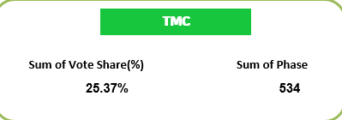
- How does vote share vary across different districts?
- The analysis of vote share across districts reveals significant regional variation in political preferences. Using pivot tables and district-level charts, it is observed that different parties dominate in different districts rather than a single party leading uniformly across the state.
For example, some urban districts like Kolkata tend to show more competitive vote distribution among major parties, while certain rural districts display clearer dominance by a specific party. Districts such as Paschim Bardhaman and Nadia show relatively higher vote concentration for leading parties, indicating strong regional influence.
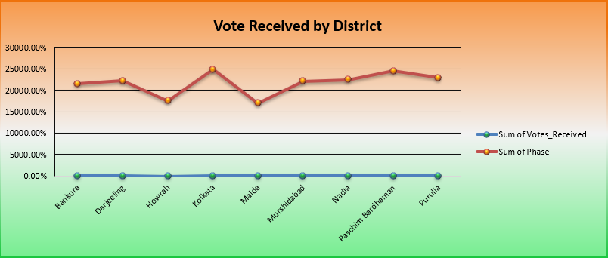
- What trends can be observed in vote share across different election phases?
- The analysis of vote share across different election phases shows that overall party performance remains relatively stable, with only minor fluctuations between phases. Using pivot tables and phase-wise charts, it can be observed that major political parties maintain a consistent share of votes throughout the election process.
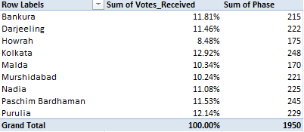
- Is there a relationship between voter turnout and vote share?
- Yes, there is a noticeable relationship. Higher voter turnout can influence vote share by benefiting certain parties, especially in regions where they have strong support. However, the impact varies by district and is not always consistent across all areas.
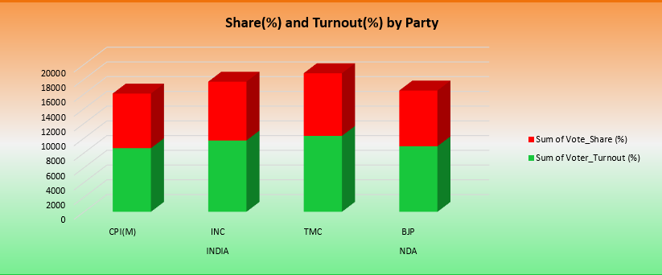
- How do urban and rural voting patterns differ?
- Urban areas tend to show more competitive voting with a balanced vote share among major parties, while rural areas often show stronger dominance by a single party. Additionally, voter turnout patterns may differ, with rural regions sometimes showing higher participation due to localized influence and community-driven voting behaviour.

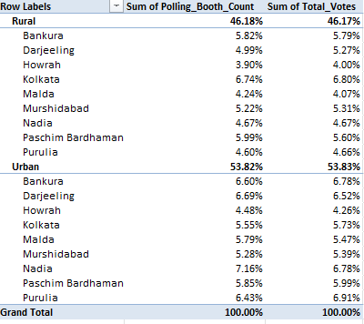
- Which districts show strong dominance by a particular party?
- Districts like Kolkata may show competitive results, while districts such as Paschim Bardhaman or Nadia can reflect stronger dominance by a leading party.
- How does gender distribution impact voting trends?
- Gender distribution can influence voting patterns, as male and female voters may show different political preferences. In some areas, one party may receive stronger support from a particular gender group. However, the overall impact varies by district, and in many cases, the difference in voting trends between genders remains moderate rather than highly significant.
- Are there any districts with consistently high or low turnout?
- Yes, some districts show consistent patterns in voter turnout. Certain districts maintain high turnout across phases due to strong voter engagement and awareness, while others consistently record lower turnout, possibly due to urban lifestyle factors or lower participation levels.
Purulia district has highest turnout,
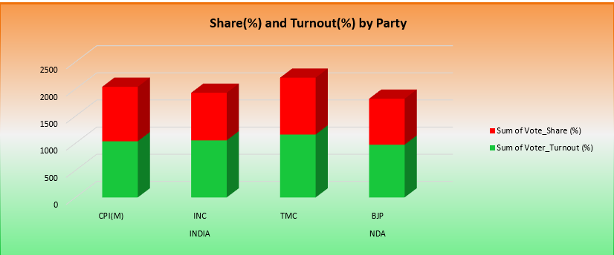

- Which phase recorded the highest voter participation?
- Phase 1 show the hights voter participation but it is vary on different districts
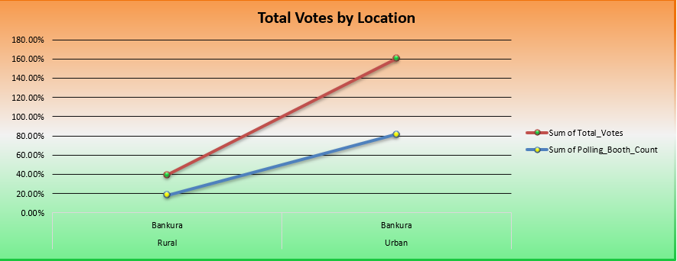
- How do different parties perform in urban vs rural regions?
- Different parties show varied performance in urban and rural regions. In urban areas, vote share is usually more competitive, with multiple parties receiving balanced support. In contrast, rural regions often show stronger dominance by a particular party, where one party secures a higher vote share due to local influence and stronger grassroots presence.
- What patterns can be observed in polling booth distribution and total votes?
- Polling booth distribution generally aligns with population density, where districts with more booths tend to record higher total votes. A clear pattern shows that an increase in the number of polling booths often leads to higher voter participation and total votes.
- Are there any noticeable shifts in voter behavior across phases?
- Only minor shifts are observed across phases. Overall voting patterns remain fairly consistent, with major parties maintaining similar vote shares. However, small fluctuations may occur due to factors like regional issues, campaign efforts, or voter turnout changes in specific phases.

Dash Board Screen short
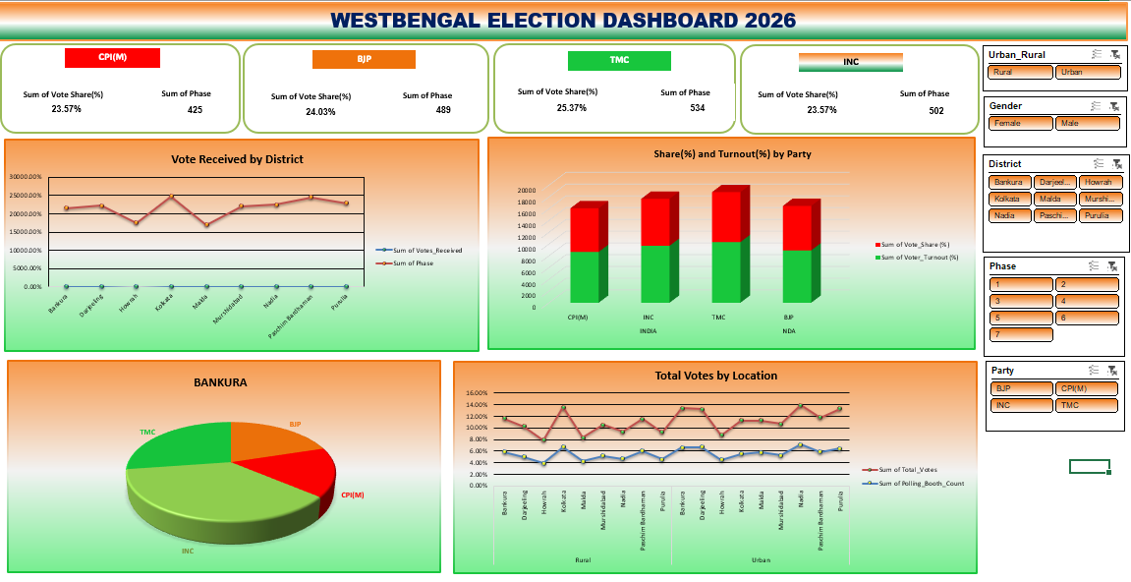

Key Insights (Based on Pivot Tables & Charts)
- TMC shows the highest vote share among all parties in most districts.
- BJP and INC maintain competitive vote shares, indicating strong opposition presence.
- CPI(M) holds a moderate but consistent share across phases.
- Certain districts like Kolkata and Paschim Bardhaman show higher voting activity.
- Urban areas demonstrate slightly higher turnout consistency compared to rural areas.
- Vote share trends remain relatively stable across phases with minor fluctuations.

-:END:-

