Subhadip Kundu
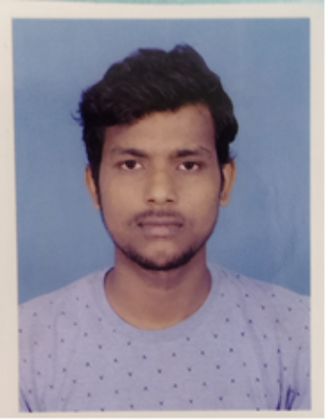

Email: subhadipkundu1000@gmail.com |
Mobile: 8436731710 | linkedin.com/in/subhadip-kundu-b40701220
Village: Gaira, Post: Purandarpur,
District: Bankura, West Bengal
PIN- 722155

CAREER OBJECTIVE

Looking for a position as an engineer in a company that enables state-of-the-art software and hardware components with an innovative, creative association in a working domain that promotes critical thinking, innovation, and proper career development.
ACADEMIC QUALIFICATIONS

Degree | Qualification | Institute | Board / University | Passing Year | Aggregate % / CGPA
Graduation | B.Tech in ECE | Bankura Unnayani Institute of Engineering | Maulana Abul Kalam Azad University of Technology | 2023 | 9.32  CGPA(Till 6th Semester)
Graduation | B.Sc in Chemistry | Panchmura Mahavidyalaya | Bankura University | 2020 | 8.17  CGPA
12th | Higher Secondary Examination | Purandarpur High School (HS) | West Bengal Council of Higher Secondary Education | 2017 | 81.4%
10th | Madhyamik Pariksha | Purandarpur High School (HS) | West Bengal Board of Secondary Education | 2015 | 87.7%

TRAININGS / PROJECTS UNDERTAKEN

Trainings:

- Mobile Repairing Training at Advance Technical Training Institute

2) Full stack Web Devlopment from Internshala

Project:

Name of Institute / Organization: Bankura Unnayani Institute of Engineering
Project Name : IR Remote Control Switch
Technology Used: Concept of digital and analog elrectronics
- Project Description: This circuit can be used for switch ON or OFF the TV, radio, washing machine and any electronic appliances.
- By using the relative relays, we can even switch ON or switch OFF the motor appliances also.

ADDITIONAL QUALIFICATION / CERTIFICATIONS

Certifications:

- Arduino: Electronics circuit, PCB Design & IOT Programming from UDEMY
- Diploma course in INFORMATION TECHNOLOGY APPLICATION of twelve months from Youth Computer Training Centre.

Subjects of Interest:

Web Devlopment

Computer Proficiency:

- Python
- HTML
- CSS
- JAVASCRIPT
- jQuery
- ReactJs
- PHP
- MYSQL

FAMILY DETAILS

Details | Name | Occupation
Father | Mantulal Kundu | Farmar
Mother | Bulu Kundu | Housewife
Siblings | Atanu Kundu | Student

Hobbies

- Repairing electronics Gadgets
- Love to teach SCIENCE To kids

DECLARATION

I hereby declare that the above-mentioned information is correct to the best of my knowledge.

Name-Subhadip Kundu
Date-10/05/2023

