pyGroff

Subhaditya Mukherjee

May 04 ,2021

.

.

.

.

.

.

.

.

.

.

.

.

.

.

.

.

.

.

.

.

.

.

.

.

5. Limitations for now

4

.

.

.

.

.

.

.

.

.

.

.

.

.

.

.

.

.

.

.

.

.

.

.

6. What about code

4

.

.

.

.

.

.

.

.

.

.

.

.

.

.

.

.

.

.

.

.

.

.

.

.

.

.

.

.

.

.

.

.

.

.

.

.

.

.

.

.

.

.

.

.

.

.

.

.

.

.

.

.

4.3. Need a cover page?

4

.

8.2. Some examples

5

.

.

.

.

.

.

.

.

.

.

.

.

.

.

.

8.1. Further syntax specification for easier equations

5

.

.

.

.

.

.

5

.

.

.

.

.

.

.

.

.

.

.

.

.

.

.

.

.

.

.

.

.

.

.

.

.

.

.

.

.

.

.

.

.

.

.

.

.

.

.

.

.

.

.

.

.

7. What about tables

4

.

.

.

.

.

.

.

.

.

.

.

.

.

.

.

.

.

4.2. Advanced

.

.

.

.

8. What about equations .

5

.

.

.

.

.

.

.

.

.

.

.

.

.

.

.

.

.

.

.

.

.

.

.

2.1. Required

2

.

.

.

.

.

.

.

.

.

.

.

.

.

.

.

.

.

.

.

.

.

2.2. Optional

2

.

.

.

.

.

.

.

.

.

.

.

.

.

.

.

.

.

.

.

.

.

.

.

.

.

.

.

.

.

.

.

.

.

.

1. Intro

**Table of Contents**

.

.

.

.

.

.

.

.

.

.

.

.

.

.

.

.

.

.

.

2. Arguments possible

2

.

.

.

.

.

.

.

.

.

4.1. General

3

.

.

.

.

.

.

.

.

.

.

.

.

.

.

.

.

.

.

.

.

.

3

.

.

.

.

.

.

.

.

.

.

.

.

.

.

.

.

.

.

.

.

.

.

.

.

.

.

.

.

.

.

.

.

.

.

.

3. Image .

2

.

.

.

.

.

.

.

.

.

.

.

.

.

.

.

.

.

.

.

.

4. Main syntax .

2

.

.

.

.

-i-

.

.

.

.

.

.

.

.

.

.

.

.

-l : Language string. (Default is python)

**3. Image**

-w : Convert to word (Default False)

8)

-t : Title for cover page

7)

-c : Add cover page (Default true)

6)

-df : Different date format (Default "%B %d, %Y")

5)

-d : Delete intermediates (Default true)

4)

-i : Are there images (Default true)

3)

-t : Add TOC (Default true)

2)

-2-

1)

**2.2. Optional**

-o : output file name. (Dont give path!)

2)

-f : input file path

1)

**2.1. Required**

**2. Arguments possible**

it is also being generated by pyGroff.

markdown syntax. This document is an example as well as a syntax list for easy reference. As you can see,

pyGroff is a tiny wrapper around groff which will let you create professional pdfs and documents in almost

**1. Intro**

*Subhaditya Mukherjee*

**pyGroff, A tiny Syntax guide**

> <text> : move to the right

+ <text> : New page

_ <text> : underline

/ <text> : italics

* <text> : bold

˜ : if you want to use one of the above in a sentence but do not want it to be formatted. Like this document.

- <text> : Lists

## <text> : Heading level 2.. and so on

# <text> : Heading level 1

-3-

< <text> : move to the center (left is default)

@ <author> : Author name

% <title> : Adds a title like the one in this document

**Note that you have to remove the <>**

**4.1. General**

**4. Main syntax**

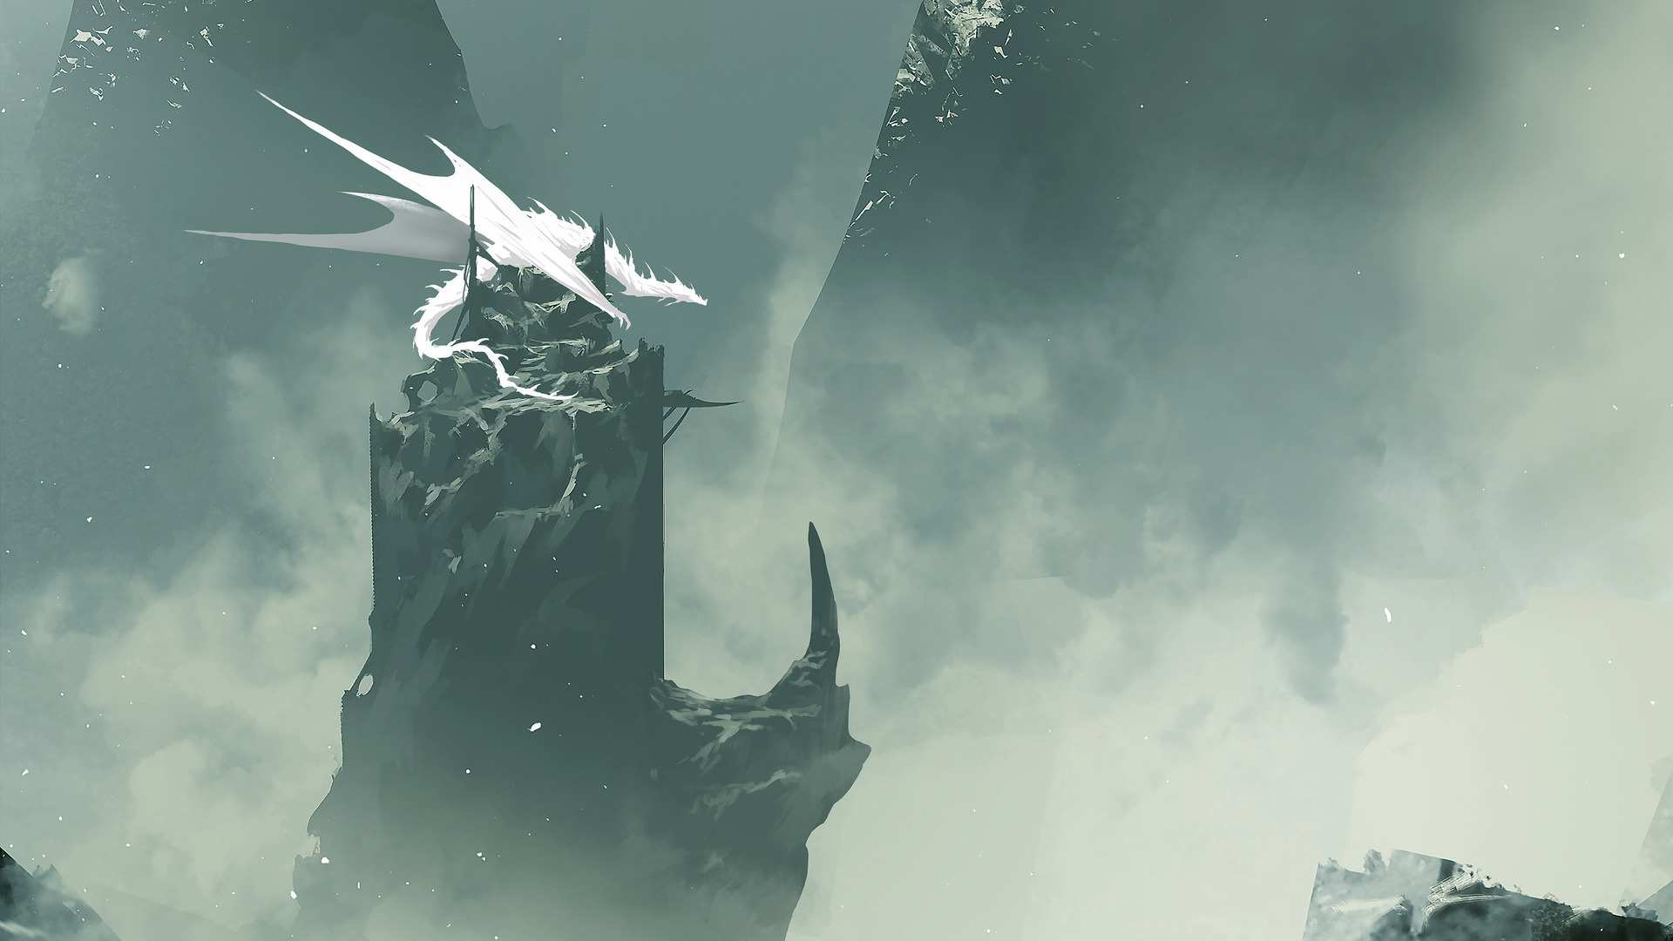

not. File an issue

**5. Limitations for now**

1)

If you have added a title and an author, you must add a body or you will get errors

2)

Formatting can only be applied to the whole row

3)

If you are using < or > , please leave a line gap

4)

If you see any numbering/formatting not working, just leave a line gap. It should mostly work out. If

-d This is optional. But it can be another date format

**6. What about code**

import numpy as np

z = np.random.rand(3,3)

print(z)

Output :

[[0.01639593 0.06791014 0.31183855]

[0.5376254 0.73363774 0.91132527]

[0.55172161 0.49750942 0.33261286]]

**4.3. Need a cover page?**

(Note that this should be in a new line)

ˆ: Superscript

**4.2. Advanced**

| <text> : Table. Format is |[title](1;3;4;5;6,1;3;4;8;9). Separate rows with , and lines with ;

! <image name.jpg> : Make sure it is in the same directory. Or specify the full path. Note that it will be con-

verted to .eps format.

) <code> : Python code, in quotes like : "import numpy as np; z = np.random.rand(3,3);print(z)" . Please

separate lines by ;

= <equation> : One equation per line. For more examples refer below

-4-

**Use the arguments**

1)

-c True

2)

-n "Your name"

3)

-t "Project title"

4)

18)

+

− =

+

=

*b*

5

*a*

3

**8.2. Some examples**

inter : intersection

*x*

union

17)

prod : product symbol

16)

half : 1/2

15)

partial : partial differential symbol

14)

inf : infinity

13)

7

π

θ

*r*

. 8

)

*f* (

=

δ

γ

100

10

int : integral

=

+

* 600

*a*

3

5

γ

3

5*x*

3

**me**

1)

**8.1. Further syntax specification for easier equations**

**8. What about equations**

**1**

**1**

**1**

**1**

**you**

**me**

!= : not equals

**me**

**Who is cool**

**7. What about tables**

7)

12)

sum : sum symbol { write as from {i=1} etc }

11)

grad : grad symbol

10)

del : grad symbol

9)

cdot : circle dot

8)

for any greek letter : just spell it out. Put spaces before and after

-5-

pi

6)

over : divided by

5)

sub : subscript

4)

sup : superscript

3)

>= : greater than or equals (etc etc)

2)

-6-

∞

1

Σ

=

1000*x*

=

*i*

1

Thank you