**Assignmentss**

Q:1:  **Alter Table:**

* **Add a new column linkedin_profile to employees table to store LinkedIn URLs as varchar.**
* **Change the linkedin_profile column data type from VARCHAR to TEXT.**
* **Add unique, not null constraint to linkedin_profile**
* **Drop column linkedin_profile**
* Add a new column linkedin_profile to employees table to store LinkedIn URLs as varchar.

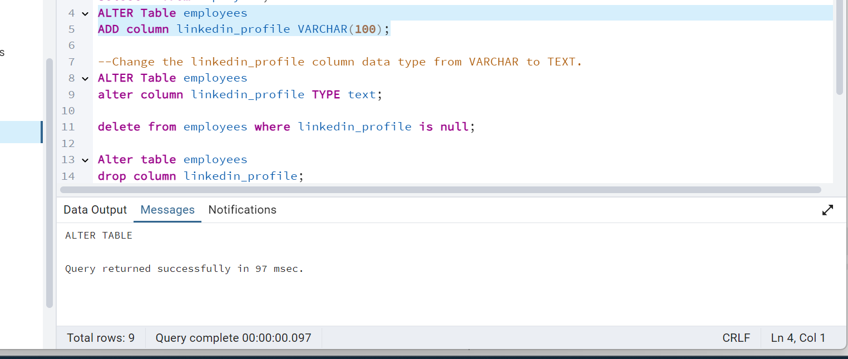

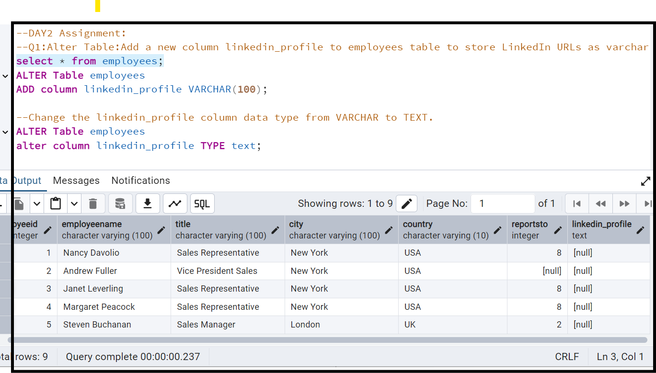

As it contains null values

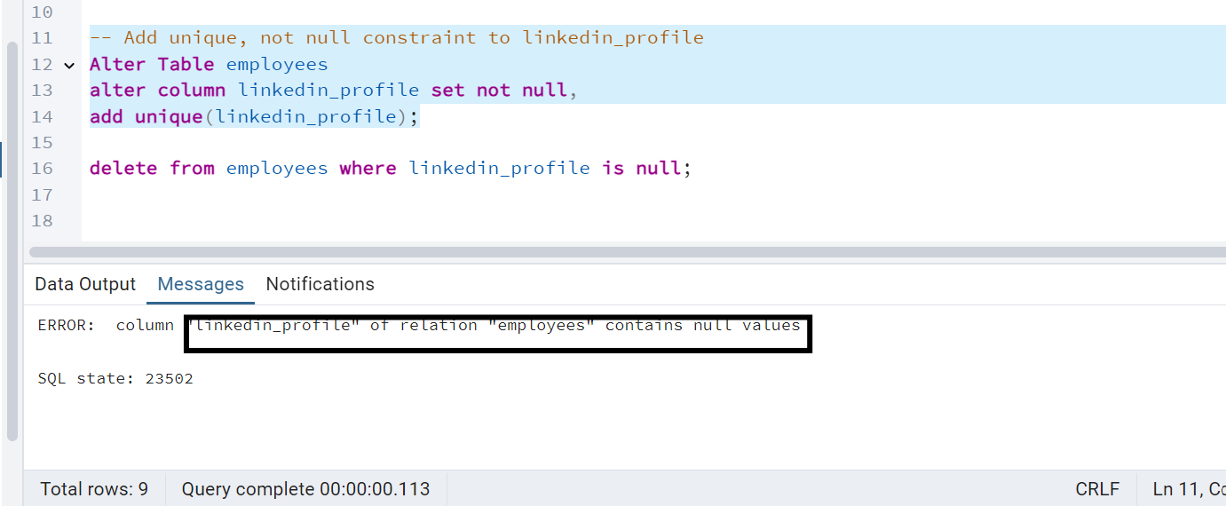

To set not null

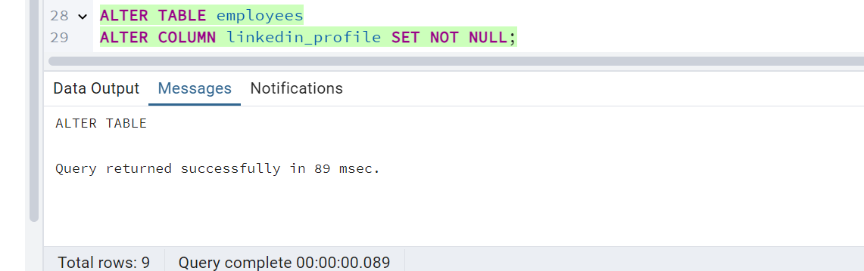

To alter Unique constraint:

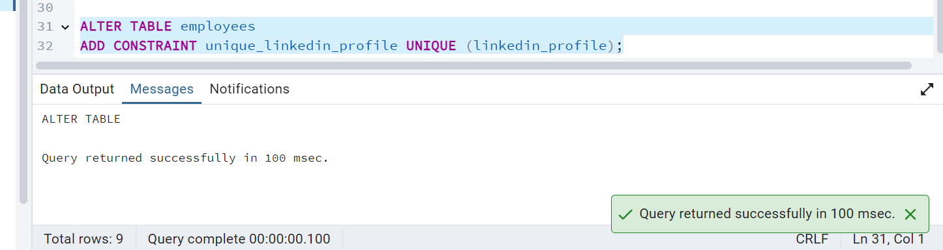

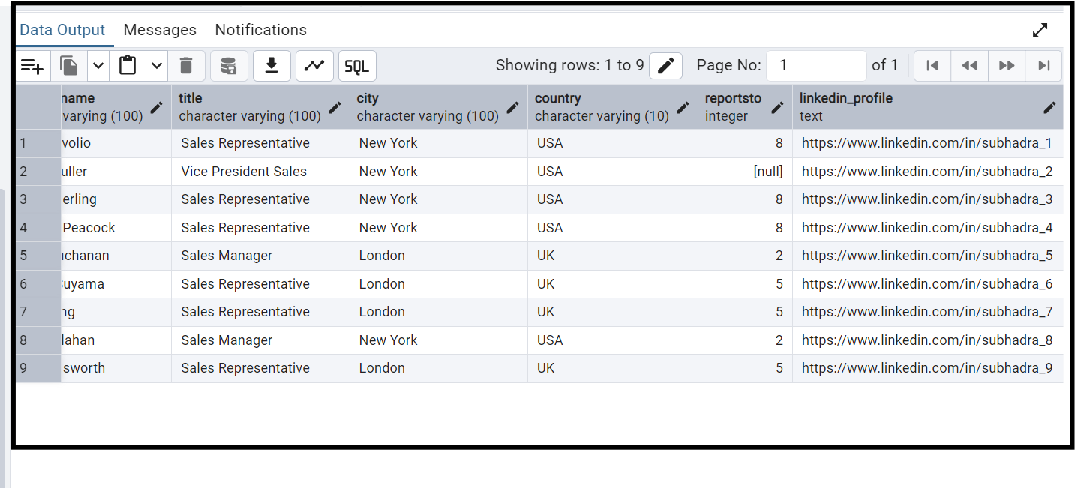

To drop linked-in profile

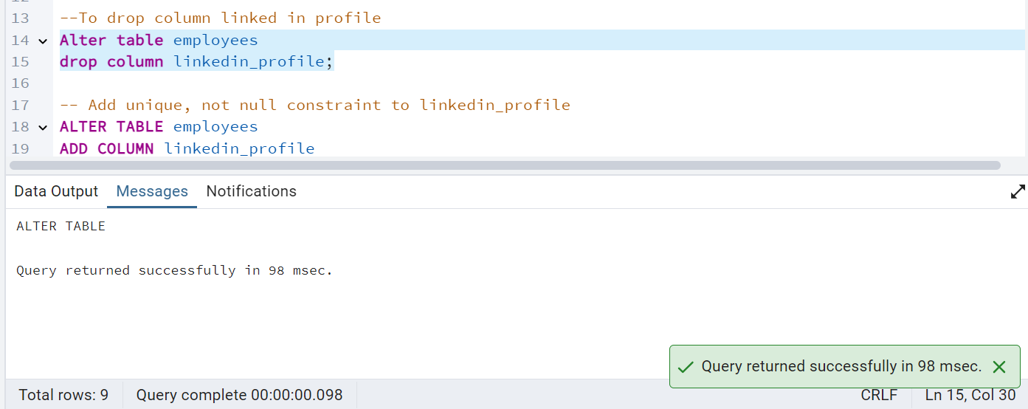

Q2: **Querying (Select)**

* **Retrieve the employee name and title of all employees**
* **Find all unique unit prices of products**
* **List all customers sorted by company name in ascending order**
* **Display product name and unit price, but rename the unit_price column as price_in_usd**
* Retrieve the employee name and title of all employees

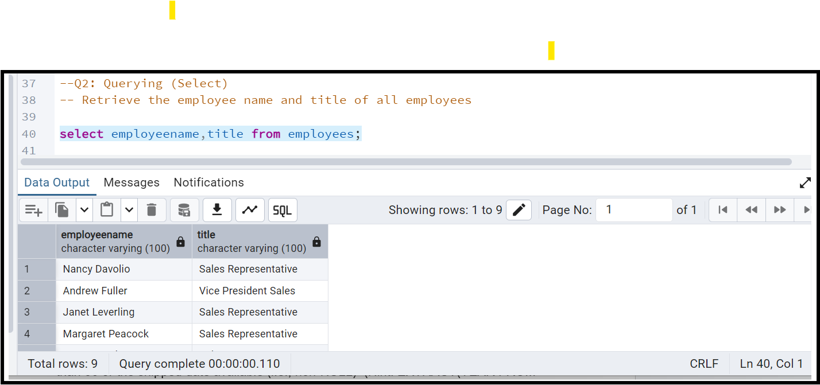

* Find all unique unit prices of products

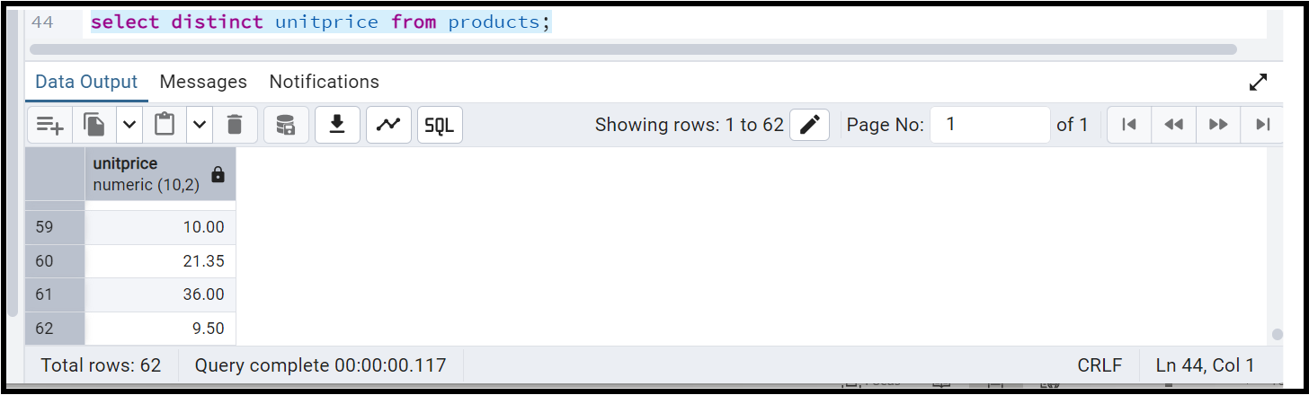

* List all customers sorted by company name in ascending order

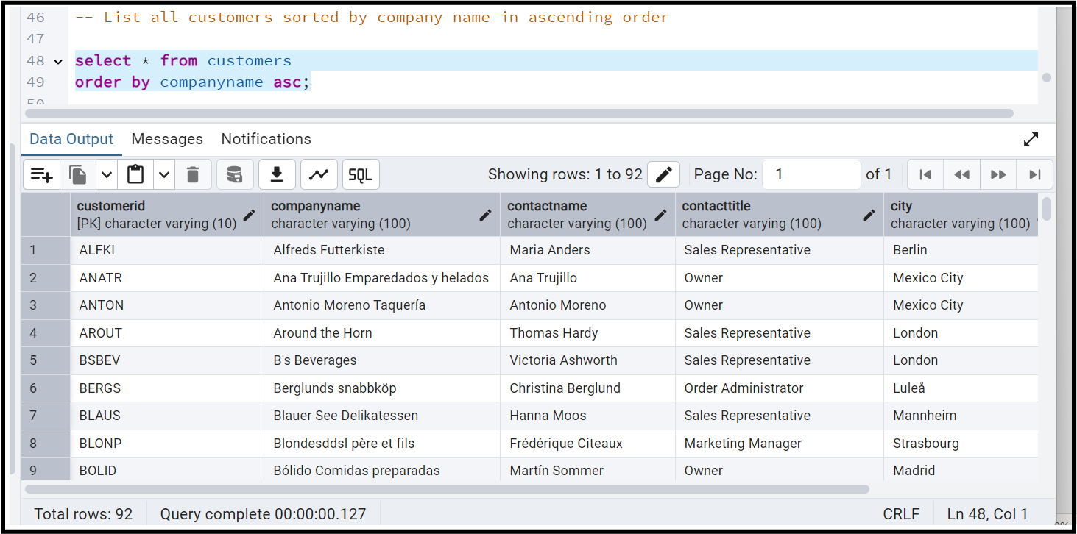

* Display product name and unit price, but rename the unit_price column as price_in_usd

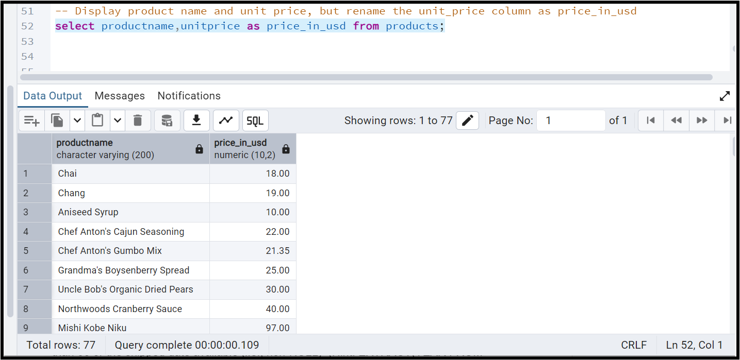

Q.3**:       Filtering**

* **Get all customers from Germany.**
* **Find all customers from France or Spain**
* **Retrieve all orders placed in 2014(based on order_date), and either have freight greater than 50 or the shipped date available (i.e., non-NULL)  (Hint: EXTRACT(YEAR FROM order_date))**
* **Get all customers from Germany.**

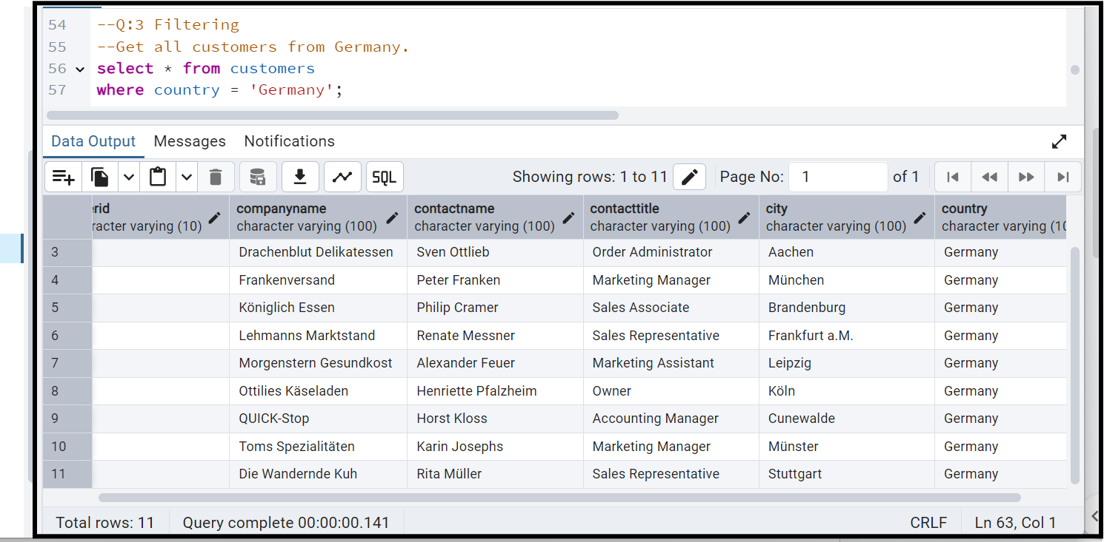

* Find all customers from France or Spain

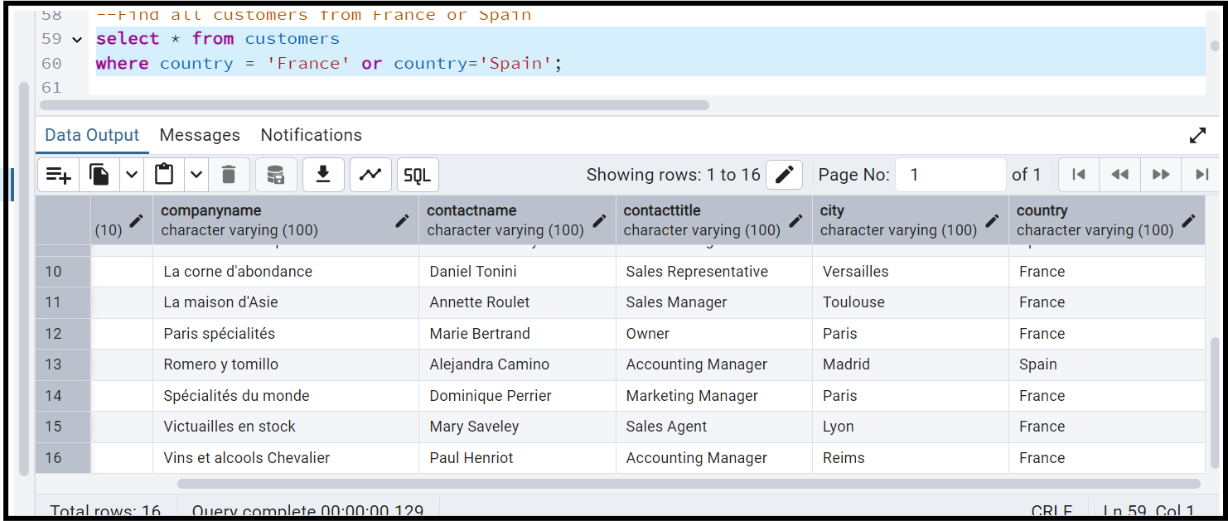

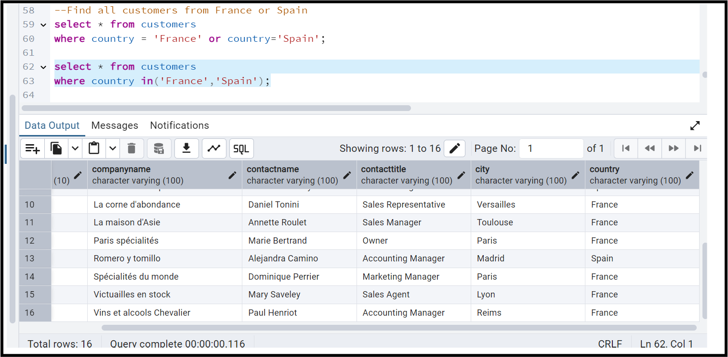

--Retrieve all orders placed in 2014(based on order_date), and either have freight greater than 50 or the shipped date available (i.e., non-NULL) (Hint: EXTRACT(YEAR FROM order_date))

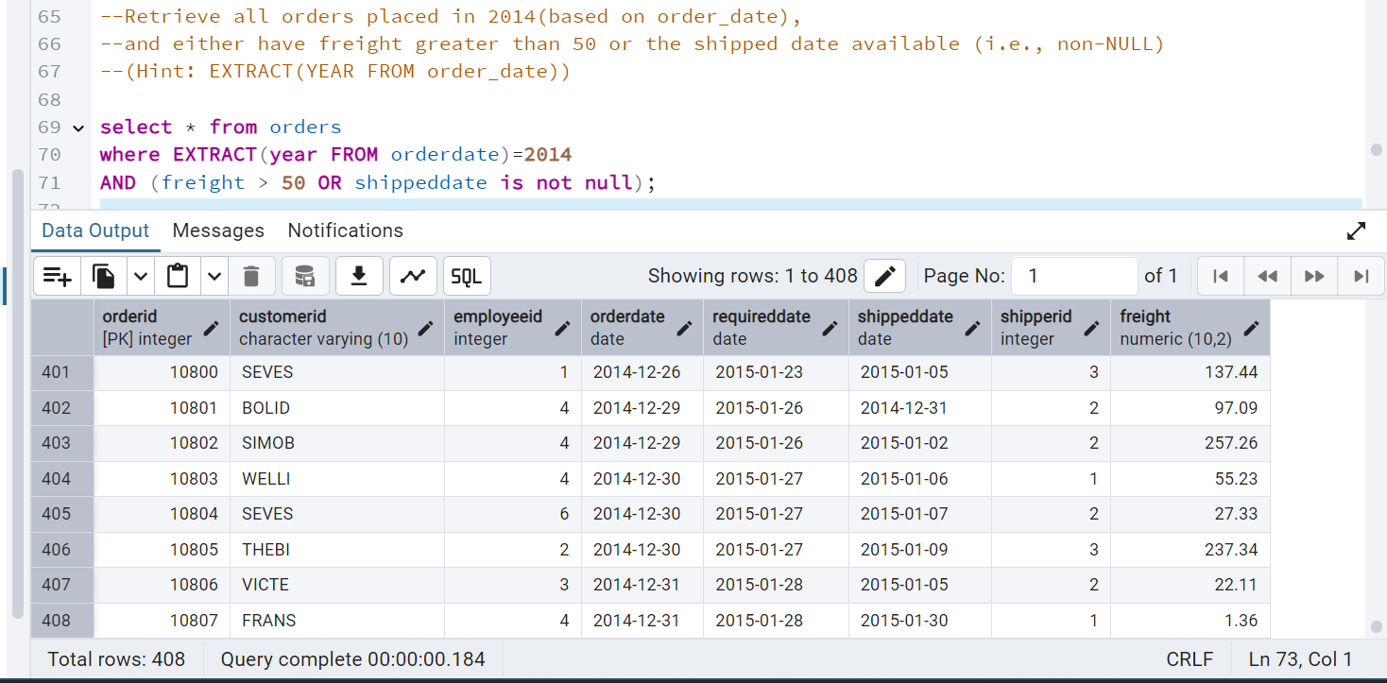

4)      **Filtering**

* **Retrieve the product_id, product_name, and unit_price of products where the unit_price is greater than 15.**
* **List all employees who are located in the USA and have the title "Sales Representative".**
* **Retrieve all products that are not discontinued and priced greater than 30.**

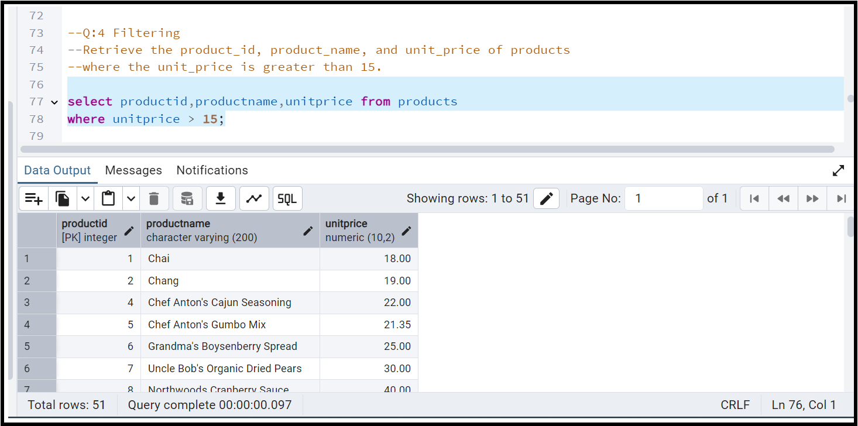

* List all employees who are located in the USA and have the title "Sales Representative".

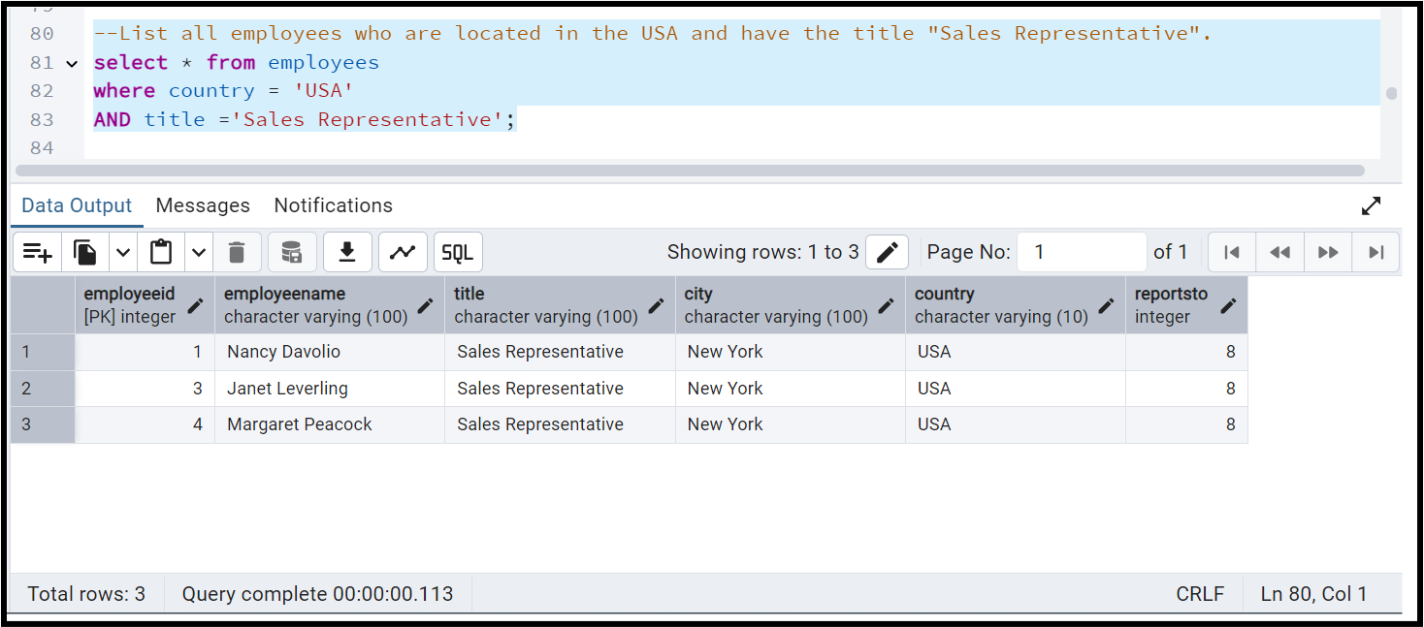

* Retrieve all products that are not discontinued and priced greater than 30.

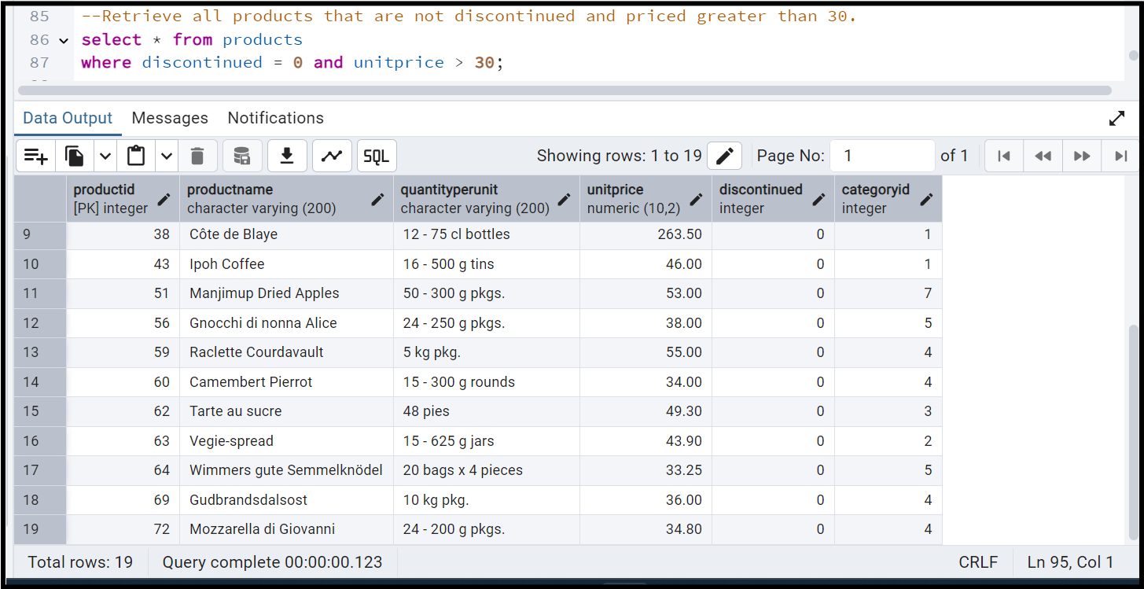

**Q 5)      LIMIT/FETCH**

* **Retrieve the first 10 orders from the orders table.**

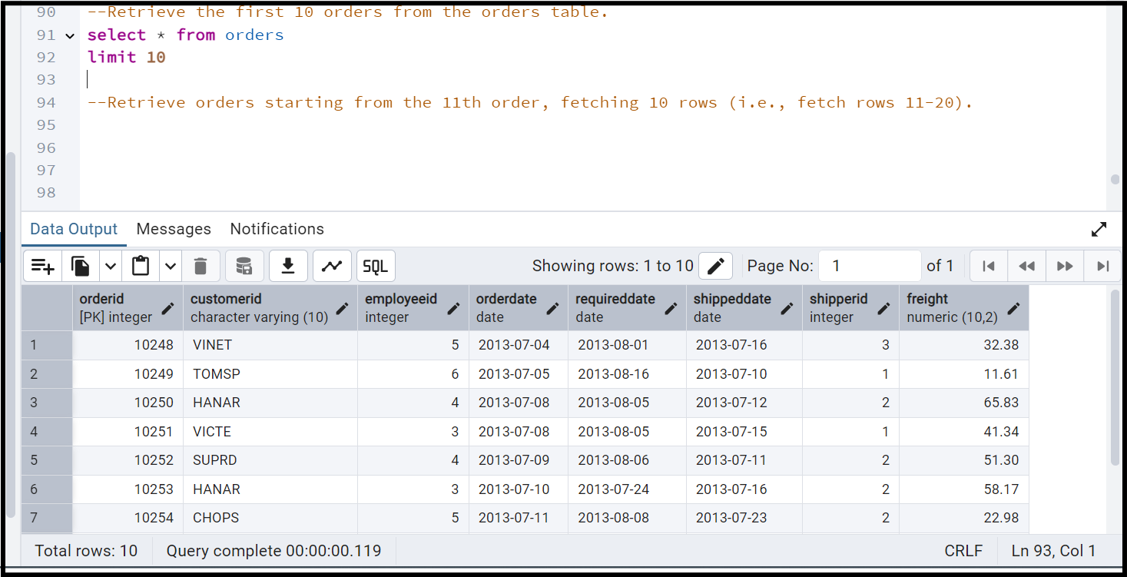

* Retrieve orders starting from the 11th order, fetching 10 rows (i.e., fetch rows 11-20).

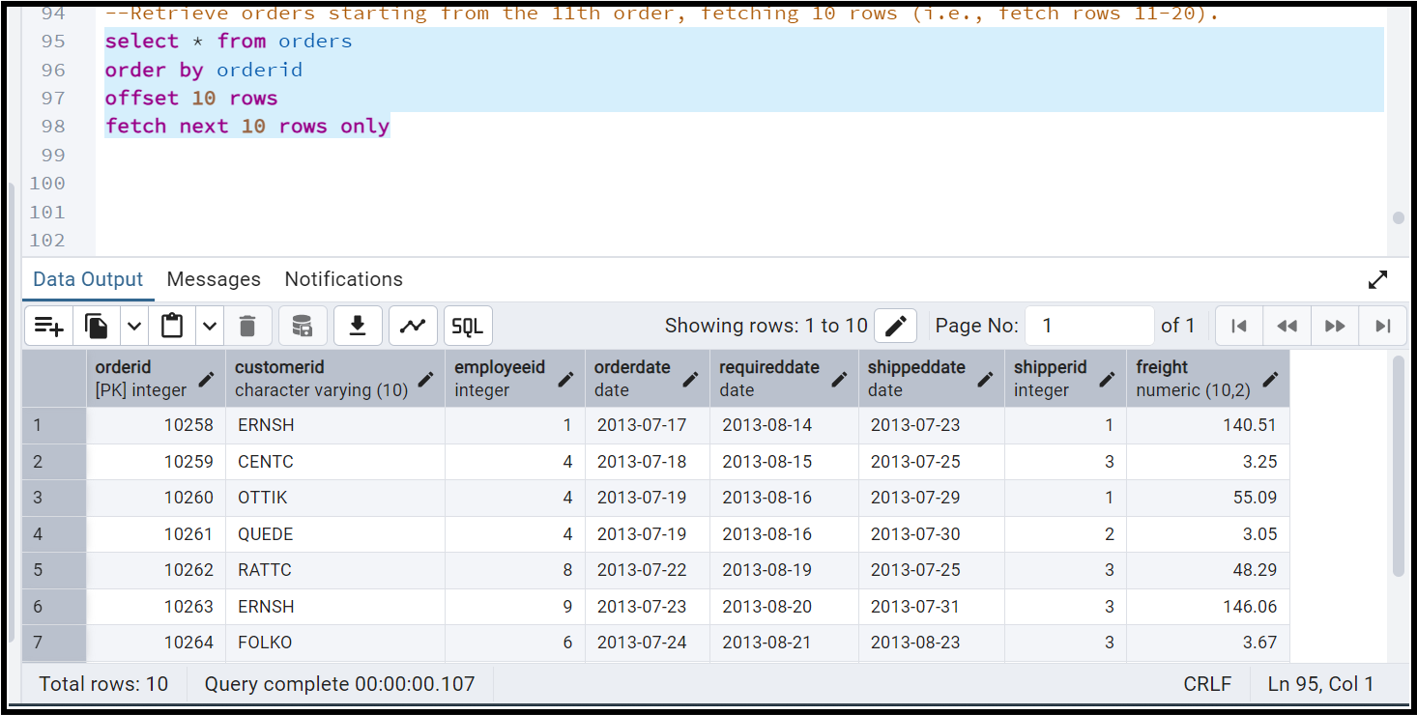

**Q:6  Filtering (IN, BETWEEN)**

* **List all customers who are either Sales Representative, Owner**

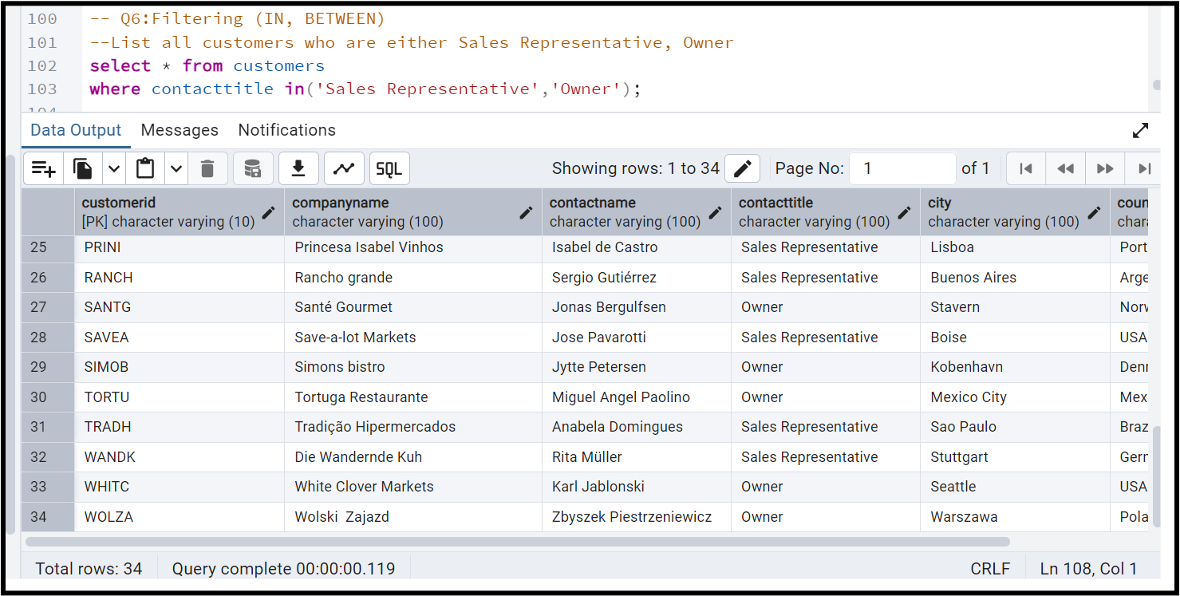

* Retrieve orders placed between January 1, 2013, and December 31, 2013.

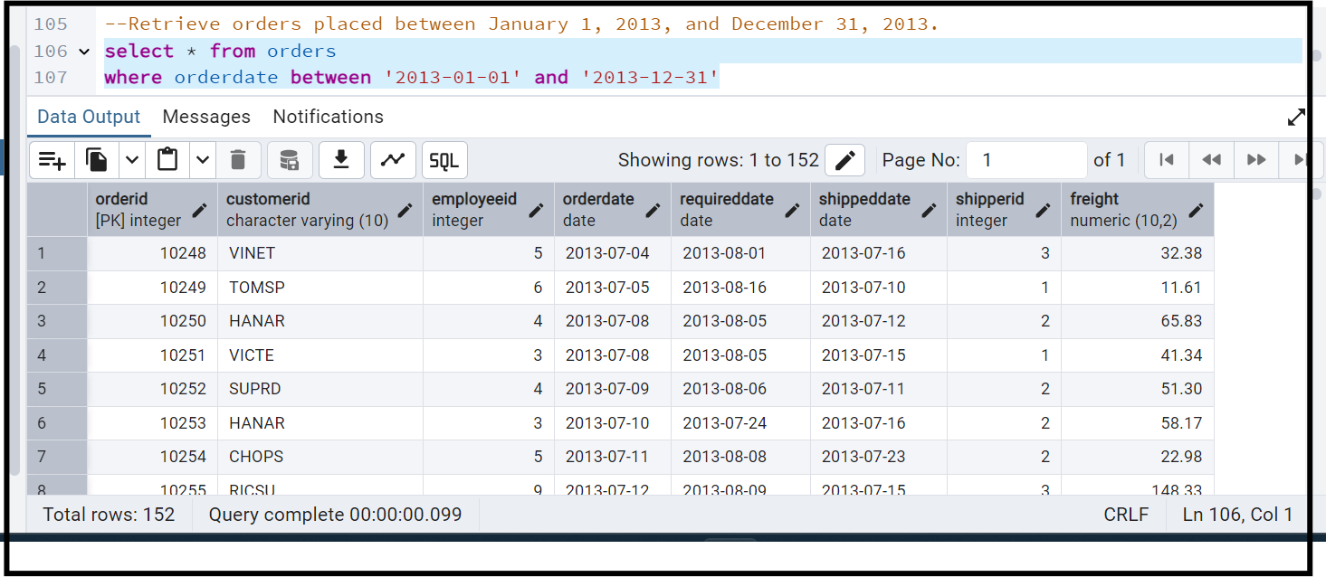

**Q7:    Filtering**

* **List all products whose category_id is not 1, 2, or 3.**

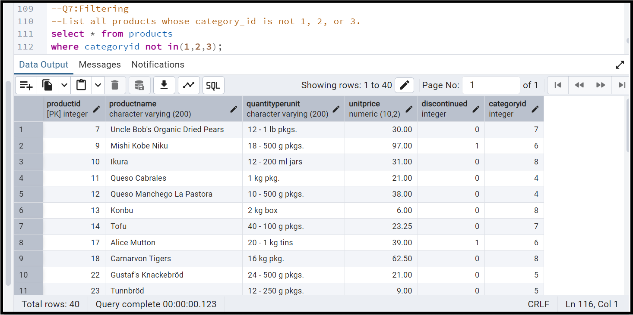

* Find customers whose company name starts with "A".

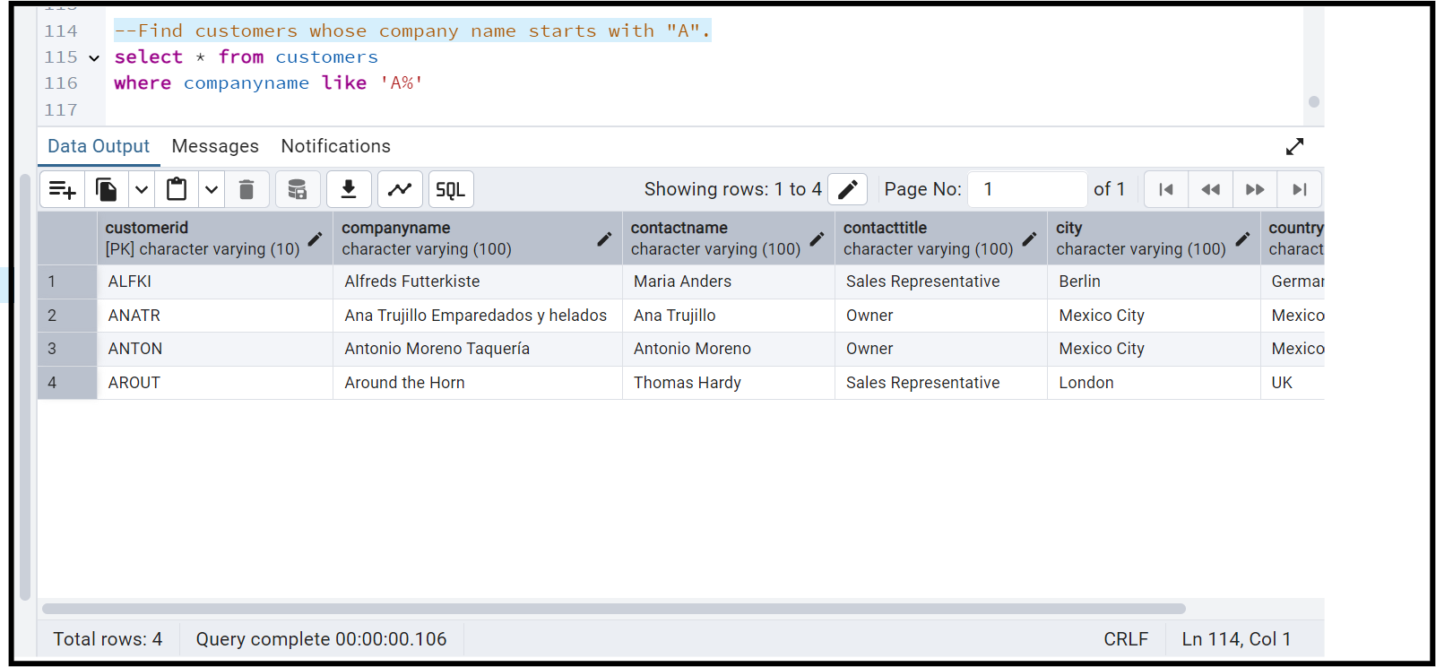

Q**:8)       INSERT into orders table:**

 Task: Add a new order to the orders table with the following details:

Order ID: 11078

Customer ID: ALFKI

Employee ID: 5

Order Date: 2025-04-23

Required Date: 2025-04-30

Shipped Date: 2025-04-25

shipperID:2

Freight: 45.50

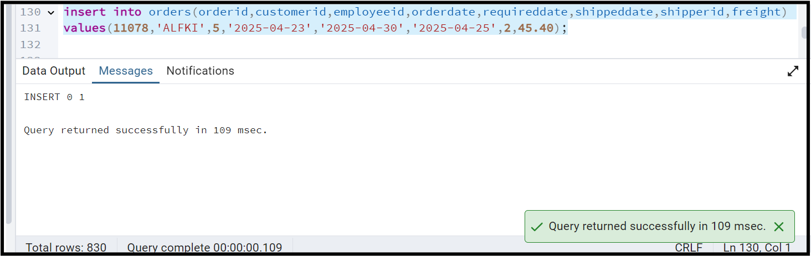

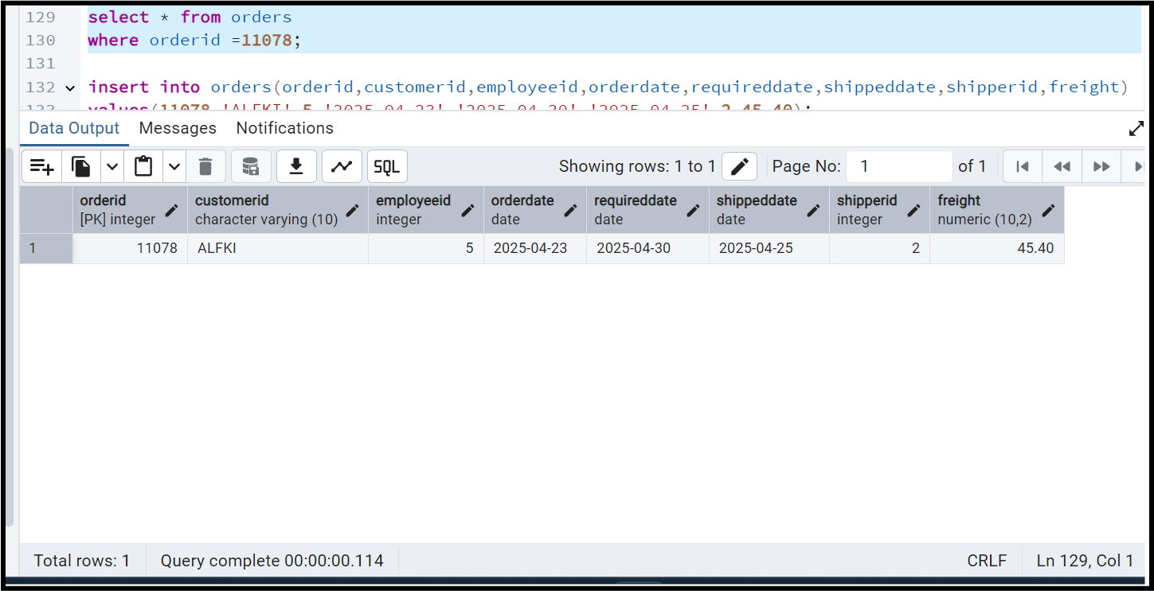

**Q 9: Increase(Update)  the unit price of all products in category_id =2 by 10%.**

**(HINT: unit_price =unit_price * 1.10)**

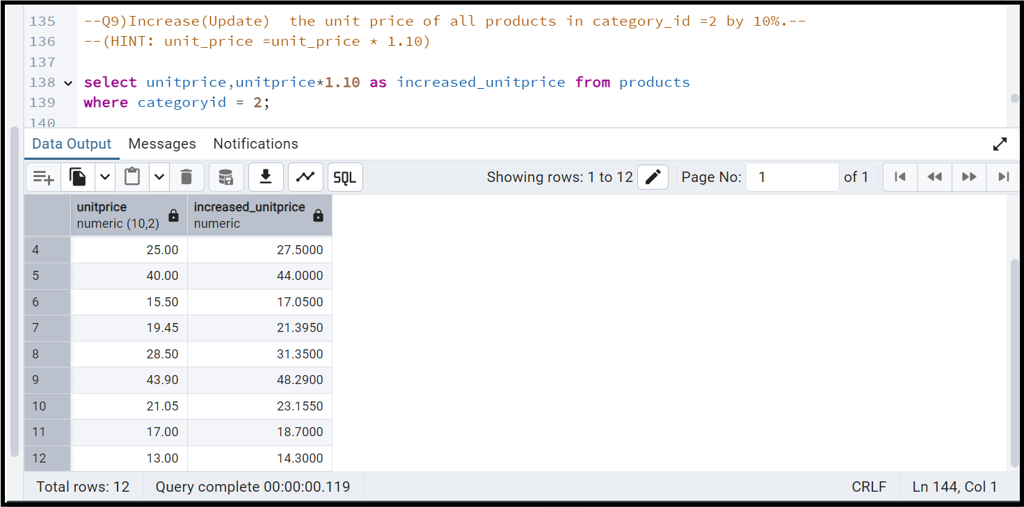

**Q:10) Sample Northwind database:**

Download

1. Download northwind.sql from below link into your local. Sign in to Git first <https://github.com/pthom/northwind_psql>
2. Manually Create the database using pgAdmin:
   1. Right-click on "Databases" → Create → Database
   2. Give name as ‘northwind’ (all small letters)
   3. Click ‘Save’

Import database:

1. Open pgAdmin and connect to your server
2. Select the database  ‘northwind’
3. Right Click-> Query tool.
4. Click the folder icon to open your northwind.sql file
5. Press F5 or click the Execute button.
6. You will see total 14 tables loaded
7. Databases → your database → Schemas → public → Tables

