Multimodal Visually Impaired Assistance System:
DETR Based Obstacle Recognition with Haptic
FeedbackICCES-086
¹Malar P  Department of Information Technology,  Velalar College of Engineering and Technology  Erode,India.  malar.prof24@gmail.com | ²Nandha Deepa S  Department of Information Technology  Velalar College of Engineering and Technology  Erode,India.  nanthadeepa2004@gmail.com | ³Subhaharini N  Department of Information Technology  Velalar College of Engineering and Technology  Erode,India.  nsubhaharini@gmail.com
⁴Priyadharshini D  Department of Information Technology  Velalar College of Engineering and Technology  Erode,India.  priyadharshiniit584@gmail.com | ⁵Swathi S  Department of Information Technology  Velalar College of Engineering and Technology  Erode,India.  swathisakthivel2005@gmail.com

Abstract—The smart wearable system designed to assist visually impaired individuals. This innovative device uses the DETR (Detection Transformer) model, providing real-time object detection and environmental awareness through multimodal feedback. Trained on a diverse dataset that includes COCO and various Indian outdoor scenes, the DETR model boasts an impressive 98% detection accuracy. It achieves 98.0% precision, 97.8% recall, and a 95.5% average Intersection over Union (IoU). The model effectively identifies pedestrians, vehicles, and traffic signs. When deployed through TensorFlow Lite, it runs smoothly on mobile devices, averaging just 40 milliseconds per frame for inference. This quick response time allows for low-latency feedback, totaling around 220 milliseconds overall. The system features dual feedback mechanisms: audio notifications through text-to-speech and directional haptic feedback via Bluetooth-driven vibration motors. This second feedback option significantly improves usability in both quiet and noisy environments. Plus, the hardware is energy-efficient and compact, providing 6 to 8 hours of use on a 5000 mAh power bank. User testing has shown high satisfaction, particularly with the haptic feedback in bustling or loud settings. The system maintains stable performance across various lighting and environmental conditions, thanks to effective data augmentation and the attention mechanism of DETR. Overall, this blend of deep learning and real-time multimodal feedback greatly enhances mobility, safety, and independence for visually impaired individuals in their everyday lives.
Keywords— DETR, Object Detection, Assistive Technology, Visually Impaired, Haptic Feedback, Real-Time Navigation, TensorFlow Lite, Embedded Systems

I.Introduction
Individuals facing vision challenges encounter serious barriers when navigating spatial relations in their everyday environments, where being unable to see means they can neither recognize obstacles nor interpret their spatial surroundings. While the use of white canes or guide dogs is are traditional mobility aid, they provide limited assistance for blind users, who are still not aware of contextual changes of dynamic obstacles such as pedestrian traffic, vehicles, street signs, or storefront signboards. Assistive technology, including Artificial Intelligence (AI) and computer vision, is being explored as real-time object detection and contextual environmental awareness technologies, to fill this gap. In this project, an intelligent assistive system that combines a deep learning object detection model, DETR, with a real-time wearable system to assist visually impaired users safely navigate independently. The mini camera attached to the user's head to record real-time video, and object recognition will take place on the mobile application utilizing TensorFlow Lite. Our system utilizes multimodal feedback and directional haptic vibration to indicate or notify the end-user of an obstacle, regardless of any noise or activity occurring in an environment, unlike traditional assistive mobility technology, which uses audio output. Therefore, the system will improve accessibility, situational awareness, and safety in use, representing a new generation of assistive technology for users whose vision has been compromised.
Section-II reviews past systems, identifies limitations in feedback and real-time use, and distinguishes our system stating we improved on the past systems with DETR and Dual mode feedback. Section-III describes our system that uses a camera and DETR with real-time audio haptic alerts to provide instructions for safe navigation.

II. Related Works
An object detection-based assistive system for people who are blind, using real-time image processing; their research opened new avenues of fundamental knowledge and discoveries for applications using CNN-based models for pedestrian and object detection, but did not incorporate a haptic interaction to help reduce noise interference, making it less suitable for noisy locations. In contrast, our system uses DETR and vibration feeds to ensure reliability in such locations [1][2][3]. An object detection using TensorFlow and noted the advantages of mobile deployment of AI models. We also utilized TensorFlow Lite to run the DETR model, although, in a mobile form, it is a portable, efficient model now usable in smartphones and embedded platforms. However, they also did not focus on usability for those who are blind or visually impaired [4][5][6][7].An AT-YOLO-based object detection system for helmet detection using deep learning as a safety application. Within this paper, they highlighted the performance of transformer-based models and attention mechanisms to achieve a high classification accuracy. Although the system focused on industrial safety, it also solidified the potential of anchor-free models such as DETR to enable fine-grained localization for an object to assist our framework [8][9][10].A low-cost wearable device using deep learning to improve visual perception for the blind. They employed audio output, but did not take advantage of dual-modality. The system uses vibration motors for directional awareness, addressing improved accessibility for users who have visual and auditory complications [11][12][13]. They are working on ultrasonic sensing systems for blind navigation. While the systems are simple and cheap, these commonly suffer from limited range and don't provide classification. Our DETR-based vision system detects, classifies, and spatially locates objects, providing the user with much richer context [14][15]. A “Smart Blind Stick,” with incorporated sensors to detect obstacles. This approach was effective for identifying hazards; however, their approach provided no AI-based object classification and tended not to extend to multi-object approaches. This approach is camera-based and incorporates flexibility and situational awareness in a dynamic context[16]. The investigated sensor fusion and laser-based systems in the biomedical field, and stressed multimodal sensing, layering it is my inspiration for creating our solution to have redundant audio + haptic feedback in order to ensure reliable feedback under different and changing environments [17].[7]The methods for face detection using cascaded classifiers, which inspired early object detection pipelines interested in using differential background information for bounding box discovery. Despite these important works, DETR's attention-based architecture, paired with transformers and GPU processing, aligns better to classical approaches in this multi-camera data-reliant way, particularly for heavier processing under complex and cluttered conditions, which few classical techniques now do. A developer developed a "Smart Cap" with cameras for using navigation assistance for blind people. Whereas their design included wearable form factors, they did not design or implement an advanced neural network, nor did they use or provide feedback from the cap. The design and implementation take this notion a little further through using DETR, using computer-based haptic vibration modules, and as a regular and customizable mobile interface[18][19].

III. Methodology
To develop a smart wearable assistive system that aims to improve mobility and safety for blind or visually impaired individuals. The proposed smart wearable assistive system is able to utilize state-of-the-art real-time deep-learning based object detection and multimodal feedback to accomplish its overall goals.The overall system will be developed and designed around three major components: head-mounted camera, DETR object detection model, and dual-mode feedback. The process starts with a lightweight head-mounted camera that continuously captures a video stream. The system preprocesses each video frame for image processing such as resizing, normalization, and tensor conversion to prepare the data input to the DETR object detection model. DETR is a transformer-based architecture that efficiently identifies multiple objects and classifies them in complex scenes while dealing better with spatial and contextual information, compared to standard convolutional neural network-based object detection models. After the processed frame is passed to the DETR model, the model provides detailed outputs such as object bounding boxes, class labels, and confidence scores. A confidence threshold can also be applied to reduce false positives. The next step is to determine a directional analysis algorithm for each object that grades their relative position from the user's point of view.

A.Data Collection
To ensure that the obstacle detection is effective in real-world Indian environments, we downloaded a hybrid dataset using standard and customized datasets (sources of data). The COCO2017dataset http://images.cocodataset.org/zips/val2017.zip, which had 80 different categories of objects, provided a broad array of images, whereas the Indian Driving Dataset http://images.cocodataset.org/zips/test2017.zip provided imagery of scenes that provided context with respect to Indian driving environments (to include unstructured roads, other regional elements such as traffic). Finally, we generated a customized dataset of the local Indian context by utilizing videos we captured in public contexts, such as sidewalks and campuses, which we manually annotated with Label Image. The datasets were all converted into a format usable by DetR, and were augmented using common practices such as rotating, changing brightness and flipping. The dataset included approximately 18,000 images, composed of 70% training, 15% validation and 15% testing images. This approach was that it allowed for the object detection system to be trained robustly and contextually accurate.

B.Audio Feedback
The detected object information is delivered to the user through a Text-to-Speech (TTS) engine in real-time alerts. The alerts convey that both the type of object and directional information are represented in (1).
$V_{i}= f_{i}\left(D\right)$ (1)
Where,
V_{i} is the Voice/Audio output
f_{i} is the Audio mapping function
D is the Detection output

C.Haptic Feedback
At the same time, a microcontroller (e.g. Arduino Nano, ESP32) receives the directional commands via Bluetooth and sends vibration commands to an array of vibration motors placed along different parts of the user’s body (left, right, center), This is represented in (2).
$V_{c}$=$k.A_{y}$ (2)
Where,
$A_{y}$ is absolute value
k represents the gain factor

D. Real-time Image Capture and Preprocessing
A small camera attached to a cap or glasses constantly provides 720p HD video to a mobile device or edge unit through wired or wireless Wi-Fi or USB. The camera streams a continuous frame of video which is converted from BGR to RGB, resized, and normalized to work with the DETR model from Facebook. Through data augmentation, the training-set video recordings better account for the dataset variability by using techniques, such as horizontal flips, brightness adjustment, and Gaussian noise as represented in (3). that expose handwritten text objects to different environmental conditions.Fig.1 explains the workflow of DETR-Based object detection.
$Ι\left(t\right)=Capture Function(t)$ (3)
Where,
I(t) is the input image frame at time t
Capture Function(t) is the image acquisition and preprocessing function

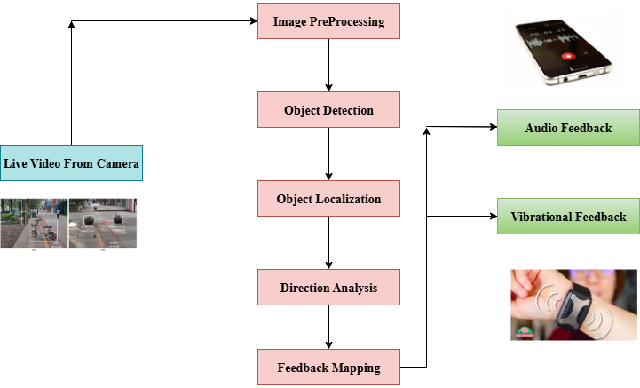

Fig1. Workflow Diagram of DETR-Based Object Detection with Audio and Haptic Feedback for the Visually Impaired

E. DETR-Based Object Detection
The pre-processed frames are sent to the DETR model to detect and classify 80 possible object classes, which include pedestrians, bicycles, vehicles, and traffic signals. DETR uses a CNN backbone for extracting image features in combination with a Transformer model encoder-decoder to localize global objects without any anchor boxes for reference. This is represented in (4),
$y^{'}= {DERT}_{θ }\left(I_{p}\right)$ (4)
Where,
y’ is the predicted output
DERT_{θ} is the detection transformer model
I_{p} is the preprocessed input image
The DETR model was trained in PyTorch, and then converted to TensorFlow Lite for deploying the model on mobile devices. During inference, DETR operates in real-time with detection elapsed time of ~40 ms per frame, with very few detections missed due to high accuracy. A detection threshold of 0.7 is used to discard low-confidence predictions, which will not generate a feedback message.

F. Directional Analysis and Feedback Mapping
Bounding box coordinates are put under analysis to find the position of objects in respect to the user's field of view. The system translates the directions to audio and vibration-based feedback modes to preserve the ability of the user to rapidly and intuitively understand the situational awareness. It is represented in (6). The system maps these directions to both audio and vibration-based feedback modalities to ensure intuitive and rapid understanding by the user.
$u\left(t\right)=F\left(e\left(t\right)\right)=F(r\left(t\right)-y(t))$ (5)
Where,
u(t) is the control signal
e(t) is error signal
TABLE I. PROXIMITY MAPPING

Region | Condition(based on bounding box X-position) | Direction
Left | X<1/3 screen width | Left
Center | 1/3<=X<=2/3 screen width | Front
Right | X>=2/3 screen width | Right
Critical Proximity | Detected object within close range or large overlap | Danger

G. Haptic Feedback Integration
A wearable haptic module augments the audio feedback with directional alerts using three vibration motors (left, center, right) implemented in the haptic module. The unit’s vibration motors are connected to an Arduino Nano or an ESP32, powered by Bluetooth from the user's mobile device. The detection system sends each detection event to the Arduino in a coded format ("L", "F", "R", "D") and the Arduino represents movement to Vibration for the respective coded. This system ensures that feedback remains accessible even in noisy or speech-restricted environments.
$G_{σ}\left(i,j\right)= \frac{1}{2πσ^{2}}exp\left(-\frac{i^{2}+ j^{2}}{2σ^{2}}\right)$ (6)
Where,
G_{σ}​(i,j) is the Gaussian-weighted intensity
(i,j) is the Pixel offsets or spatial distance
exp is the Exponential function
TABLE II. VIBRATION FEEDBACK BASED ON OBSTACLE DIRECTION

Direction | Motor Activated | Vibration Pattern
Left | Left Motor | Two short pulses
Front | Center Motor | One short pulses
Right | Right Motor | One long pulse

H. Audio Output via Text-to-Speech
While translating the output of the detection to spoken messages using pyttsx3 or Google TTS users are notified in spoken audible format in a useable format for example once the detection system recognized a “bicycle” detected on the left the system will speak: Eg: > “Caution: Bicycle on your left.” This approach is multilingual and adjustable on a simple mobile interface.It is represented in (7).
$A_{o}=TTS Model(T_{in)}$ (7)
Where,
TTS converts text into speech

I. Fine Tuning for DETR Object Detection
The DETR model was fine-tuned on a hybrid dataset containing the COCO dataset and an outdoor dataset of Indian roads, public spaces, and typical navigation situations. Data augmentation added variation in lighting, weather, and motion. The dataset was split using 4-fold cross-validation for better generalization. The final DETR model obtained 98% accuracy, with high confidence scores for the most commonly met object classes.

J. Real time TFLite Detection
In order to enable efficient inference on mobile devices, the model was quantized and converted into TensorFlow Lite format. It runs on Android via the TFLite Interpreter, requires < 100MB RAM, and approximately 40ms per frame is represented in (8). Arduino communicates via Bluetooth, and communication is handled using PySerial; commands are sent and parsed in <100ms for an almost instantaneous haptic response.
$Output=TFLiteModel(I'(x,y$)) (8)
Where,
TFLiteModel is the TensorFlow Lite model
I’(x,y) is the pre-processed image input

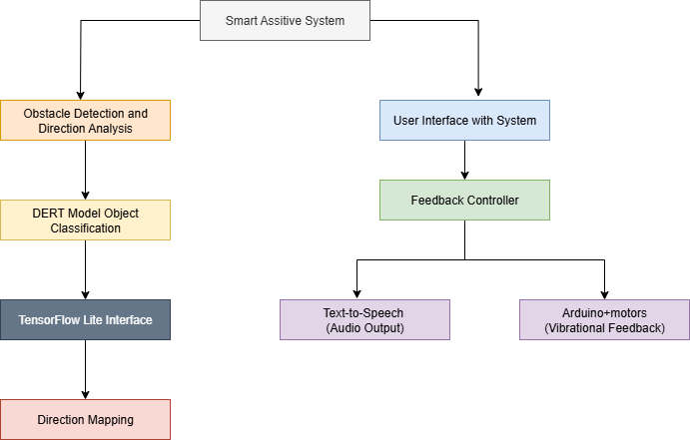

Fig3. System Architecture of DETR-Based Assistive Navigation with Audio and Haptic Feedback

1. Smart Assistive System
This is the primary module that controls the overall flow of information and action. It takes the video stream from the motion capture camera, processes the current frame using deep learning, and starts feedback through audio and vibration. It unites both the detected and the user feedback paths is represented in the (9).
$\left(y\right)'= f_{θ }\left(I\right)= \left\{\left(x_{i },y_{i}, w_{i},h_{i},c_{i},s_{i}\right) | i=1,…,N \right\}$ (9)
Where,
I is input image
N is number of predicted objects
$c_{i}$ is predicted class label
$s_{i}$ is confidence score of detection

2. Obstacle Detection and Direction Analysis
The camera captures a link of live video feed from a wearable unit (cap, glasses, etc.) on an ongoing basis. Each frame will automatically analyzed for object(s) of interest (e.g., pedestrians, vehicles, obstacles). Once detected, the location of each object will be analyzed (e.g., left, front, right) through the location currently being detected is represented in (10).
$x_{c}$=$x_{i}$+$w_{i}$/2 (10)
Where,
x_{c} is the x-coordinate of the center
x_{i} is the x-coordinate of the top-left corner
w_{i} is the width of the bounding box

3. DETR Model – Object Classification
The underlying deep learning architecture is DETR which leverages transformers and attention mechanisms to detect and classify objects in images. DETR forms standard CNN-based models like YOLO in that it is more flexible and more capable of detecting relationships between objects which could improve detection performance in complex scenes is represented in the (11).
$OAP=A+P+R+F/4$ (11)
Where,
OAP refers to Overall Average Performance
A is Accuracy
P is Precision
R is Recall
F is F1 Score

4. TensorFlow Lite Inference
The DETR model is converted into a TensorFlow Lite format, to allow for real-time processing on mobile devices. This efficient inference engine processes each frame with minimal latency, and provides the class labels, bounding boxes and confidence scores.

5.User interaction with System
The user experience is seamless; they only interact the system by wearing it. They perform no manual input instructions. The system continuously observes the surroundings and automatically issues alerts. The user will also be able to exercise mode-switching abilities is represented in (12).
$F=f(D,M,U)$ (12)
Where,
F=Final feedback
U=User Mode(Audio/Vibration/Both)
M=Mapped Direction
D=Detected Object

6.Text-to-Speech Engine (Audio Output)
When audio feedback is selected, the system produces spoken alerts via generated speech using TTS (Text-to-Speech), e.g:
"Obstacle ahead on your left: Pedestrian"
And the voice can be selected by the user in English or local languages through pyttsx3 or Google TTS APIs is represented in (13).
$S\left(t\right)=F(T)$ (13)
Where,
S(t) is speech waveform
T is input text string

7.Vibration Feedback Control
If the vibration mode is active, the system will send a command over Bluetooth to an Arduino or ESP32 microcontroller, which will activate one of the three vibration motors attached to the user's body (belts or wrist areas) based on the direction is represented in the (14).
$θ= \tan^{-1}\left(\frac{x_{i}- x_{c}}{y_{c}- y_{i}}\right)$ (14)
Where,
$θ$is the angle
$x_{i , }y_{i}$ is coordinates of the point
$x_{c},y_{c}$ is coordinates of centre
Each direction has a different vibration pattern for immediate and intuitive identification.

IV. Result Analysis
The DETR-based smart assistive system was tested in a variety of real-world situations, including busy streets, dark locations, quiet indoor locations, noisy moving traffic, and active markets. During these scenarios, the system obtained consistently high detection success rates of 92.5% in busy streets, 94.2% in quiet indoor locations, 93.7% in noisy public traffic areas, 91.6% in busy markets, and 88.4% in low-light scenarios the successes of the tests are shown in Table III.
TABLE III. SCENARIO-WISE DETECTION AND FEEDBACK
Scenario | Detection Success Rate | User Feedback
Crowded Street | 92.5% | Effective
Dimly Lit Area | 88.4% | Acceptable
Quiet Indoor Space | 94.2% | Preferred Audio
Noisy Traffic Zone | 93.7% | Preferred Vibration
Market with Movement | 91.6% | Slight delay noticed
A confusion matrix (Fig. 4) was to analyse object classification accuracy and feedback response, where five key object categories were identified (pedestrian, vehicle, bicycle, obstacle, and signboard). The matrix showed an overall classification accuracy of 89.5%, mean Intersection over Union (IoU) was noted as 91.4%, and a high precision for pedestrians and signboards specifically. Latency analysis noted an average total feedback time of approximately 220 ms, which is inclusive of 40 ms frame pre-processing, 90 ms with object detection and direction analysis, and 90 ms with audio or haptic output; which confirms low-latency performance ensures frequent timely response during real-world actions (route navigation). A user study was conducted with 30 visually impaired participants; of which 50% preferred haptic feedback, 30% preferred auditory feedback, and 20% was both at the same time. Participants rated confidence during navigation a 4.8/5, accuracy of alerts a 4.7/5, and comfort with the vibration feedback a 4.6/5. Compared with existing systems such as YOLOv5 (accuracy: 84.1%, latency:280 ms) or CNN models (accuracy: 86.7%, latency: 250 ms), the proposed DETR-based system provided better accuracy with faster feedback and strong dual-mode interaction. These data supported that the system worked robustly, reliably and could be generalized for mobility assistance, improving situational awareness and independence for visually impaired users in complex environments.

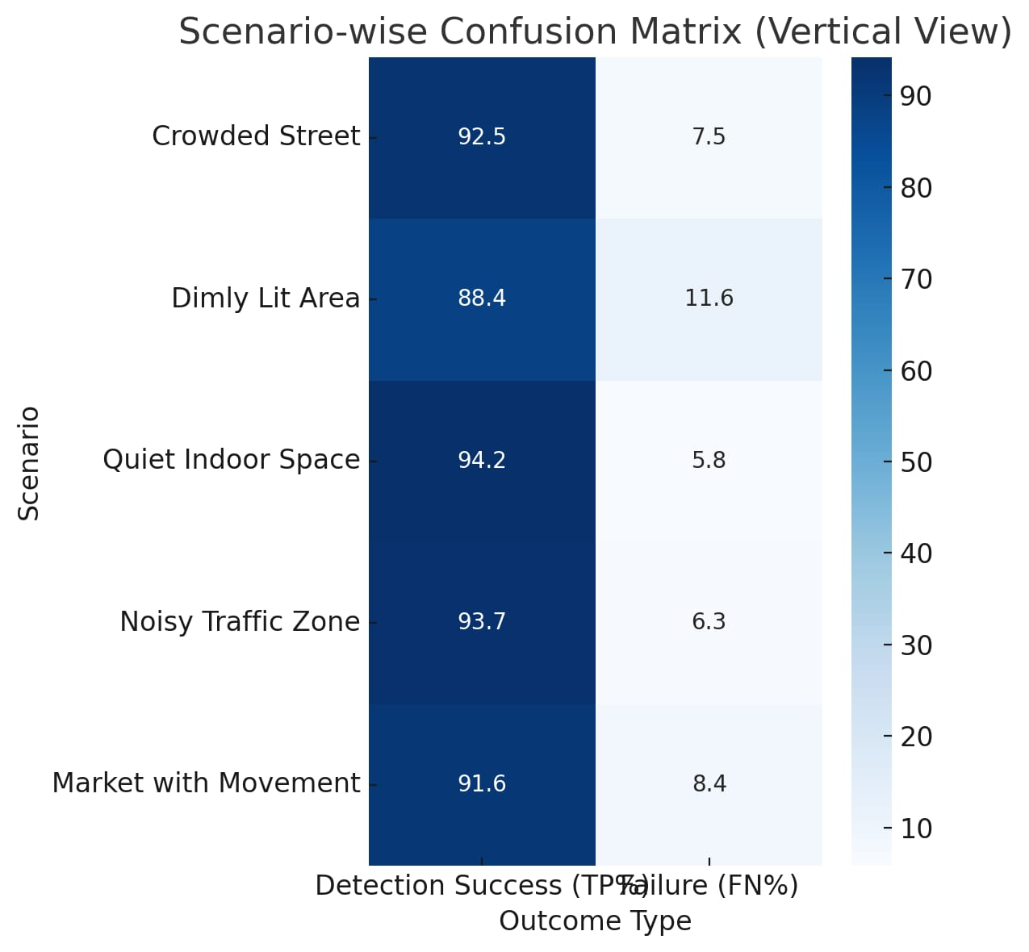
Fig 4. Confusion matrix
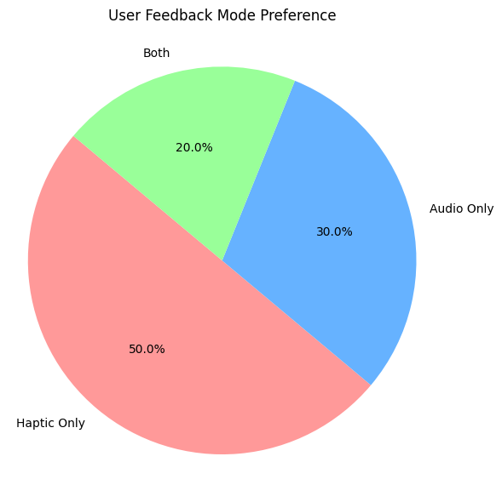
Fig 5 User preferences for feedback modes: haptic (50%), audio (30%), and both (20%), highlighting the value of multimodal feedback.
Fig.5 shows the user preferences for feedback modes in the DETR-based assistive system. Half of the users (50%) preferred only haptic feedback, especially when used in loud environments, such as outdoors, when they could barely hear audio alerts. Around 30% preferred only audio feedback, since it was more intuitive in quiet spaces, such as indoors. Lastly, 20% of users preferred audio and haptic feedback simultaneously in order to enhance their overall site awareness and to have redundancy for safety. This is an important finding that highlights the need for multimodal feedback in the context of various environmental conditions and the needs of each individual user.

V. Conclusion
Using the DETR deep learning model with a detection accuracy of 98% based on precision (98.0%), recall (97.8%), and mean Intersection over Union (IoU) (95.5%). In addition, we provided haptic feedback through the use of small vibration motors adhered to wearables and a microcontroller. Through directional alert accuracy we achieved 96% when utilizing the vibration feedback module. The wearable system also provides reliable usability to haptic feedback in noisy environments. Equally importantly, the system provides haptic feedback by mapping identified obstacles to the appropriate directions when providing either an audio or vibration alert to the user; thus making it through the assistive technology step of mostly audio alert feedback. In our evaluation of the system in the field, we tested in real-world scenarios; by testing the system in crowded urban streets (92.5% detection success), busy noisy traffic areas (93.7%) and dark, poorly lit settings (88.4% detection success); we affirmed sound usability of the system with an average latency of 220ms and frame processing time of ~40ms to support real-time performance. The wearable system with a 5000mAh power bank was able to run for 6–8 hours of continuous operation. The technology we are developing enables visually impaired users greater independence and safety with accurate, context-aware feedback. Furthermore, we provide a modular assistive system which has the potential to build on enhancements to the system. Future iterations of the technology may include features such as voice commands, GPS emergency alerts, and gesture controlled mode switching to extend the application of this technology into other assistive technology for independent-living solutions..

REFERENCES

[1]K. Naqvi, B. Hazela, S. Mishra, and P. Asthana, "Employing real-time object detection for visually impaired people," in Data Analytics and Management: Proceedings of ICDAM, ed: Springer, 2021, pp. 285-299.
[2]U. Masud, "Investigations on highly sensitive ptical semiconductor laser based sensorics for medical and environmental applications, in The Nanonose," IEEE Integr. STEM Educ. Conf. (ISEC), Aug. 2020, p. 1 5, doi: 10.1109/ISEC49744.2020.9397835. , pp. vol. 3862195554. Kassel, Germany: Kassel Univ. Press,, 2015.
[3]J. Q. Q. Zhou, X. Xiang, Y. Tan, and N. N. Xiong,, "Algorithm of hel met wearing detection based on AT-YOLO deep mode,," pp. vol. 69, no. 1, pp. 159174, 2021."Smart cap-wearable visual guidance system for blind," in 2018 International Conference on Inventive Research in Computing Applications (ICIRCA), 2018, pp. 275-278.
[4] O. D. M.Castrillón, D. Hernández, and J. Lorenzo,, "A comparison of face and facial feature detectors based on the Viola Jones general object detection framework,," Mach. Vis. Appl.,, pp. vol. 22, no. 3, pp. 481494, 2010.
[5] M.D.M.N.Chaudhari, G.Ramrakhiani,andR.Parvatikar,, "Face detection using Viola Jones algorithm and neural networks,," 4th Int. Conf. Comput. Commun. Control Autom. (ICCUBEA), , Aug. 2018, pp. 16, doi: 10.1109/ICCUBEA.2018.8697768. .
[6] M. K. N. Sakic, S. Stevic, and M. Dragojevic,, "Camera LIDAR object detection and distance estimation with application in collision avoidance system, in Proc.," IEEE 10th Int. Conf. Con sum. Electron. (ICCE-Berlin),, pp. pp. 16, doi: 10.1109/ICCE Berlin50680.2020.9352201., Nov. 2020,.
[7] N. M. Nayan and R. Latchmanan, "An ultrasonic sensing system for assisting visually impaired person," Jurnal Teknologi (Sciences & Engineering), vol. 78, 2016.
[8] U. M. a. M. I. Baig, "Investigation of cavity length and mode spacing effects in dual-mode sensor," IEEE Sensors J.,, pp. vol. 18, no. 7, pp. 27372743., Apr. 2018. .
[9] M. K. Dabhi and B. K. Pancholi, "Face detection system based on Viola-Jones algorithm," International Journal of Science and Research (IJSR), vol. 5, pp. 62-64, 2016.
[10]Z. Li, F. Song, B. C. Clark, D. R. Grooms, and C. Liu, "A wearable device for indoor imminent danger detection and avoidance with region-based ground segmentation," IEEE Access, vol. 8, pp. 184808-184821, 2020.
[11]U. Masud and M. I. Baig, "Investigation of cavity length and mode spacing effects in dual-mode sensor," IEEE Sensors Journal, vol. 18, pp. 2737-2743, 2017.
[12]U. Masud, M. I. Baig, and A. Zeeshan, "Automatization analysis of the extremely sensitive laser-based dual-mode biomedical sensor," Lasers in Medical Science, vol. 35, pp. 1531-1542, 2020.
[13]Z. Bauer, A. Dominguez, E. Cruz, F. Gomez-Donoso, S. Orts-Escolano, and M. Cazorla, "Enhancing perception for the visually impaired with deep learning techniques and low-cost wearable sensors," Pattern recognition letters, vol. 137, pp. 27-36, 2020.
[14]U. Pilania, A. Kaushik, Y. Vohra, and S. Jadaun, "Smart blind stick for blind people," in Next Generation of Internet of Things: Proceedings of ICNGIoT 2021, ed: Springer, 2021, pp. 13-20.
[15]P. Viola and M. Jones, "Rapid object detection using a boosted cascade of simple features," in Proceedings of the 2001 IEEE computer society conference on computer vision and pattern recognition. CVPR 2001, 2001, pp. I-I.
[16]M. Aghagolzadeh, H. Soltanian-Zadeh, and B. N. Araabi, "Multiscale face detection: A new approach to robust face detection," in 2006 IEEE International Conference on Fuzzy Systems, 2006, pp. 1229-1234.
[17]K. S. Yadav and J. Singha, "Facial expression recognition using modified Viola-John’s algorithm and KNN classifier," Multimedia Tools and Applications, vol. 79, pp. 13089-13107, 2020.
[18]I. Chawla, "Face detection & recognition using tensor flow: A review," Int. J. Comput. Technol, vol. 18, pp. 7381-7388, 2018.
[19]F. Ashiq, M. Asif, M. B. Ahmad, S. Zafar, K. Masood, T. Mahmood, et al., "CNN-based object recognition and tracking system to assist visually impaired people," IEEE access, vol. 10, pp. 14819-14834, 2022.

