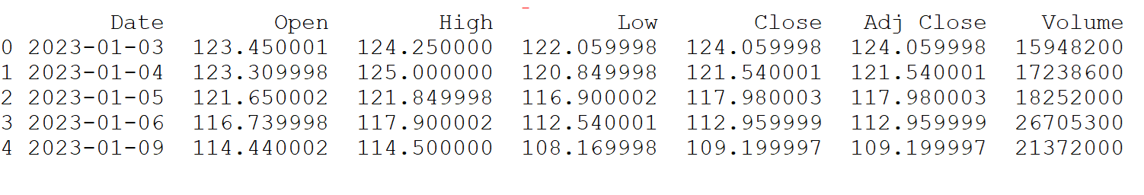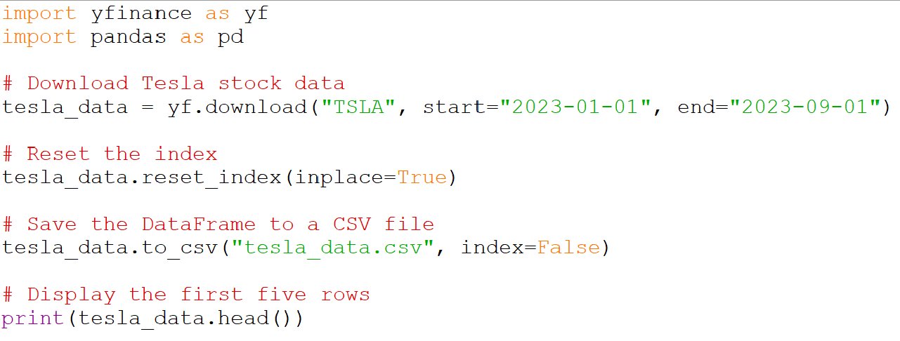

Output

Question 1: Use yfinance to Extract Stock Data