Question 2: Use Webscraping to Extract Tesla Revenue Data

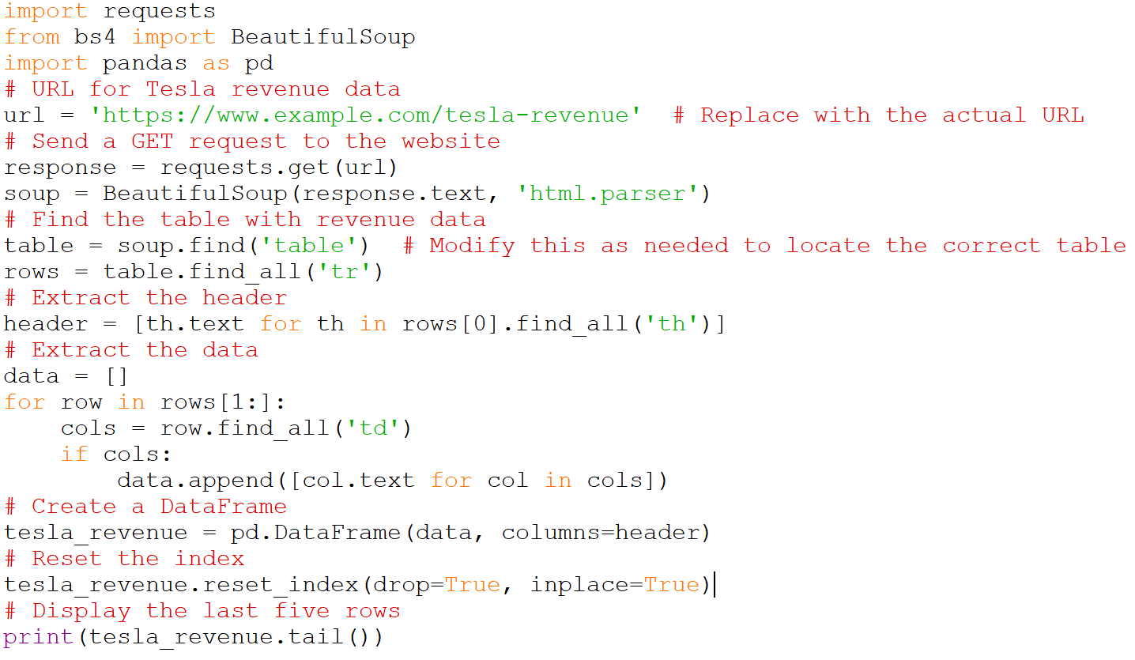

Output

Year Revenue Growth

0 2022 $81.46 Billion 51.0%

1 2021 $53.82 Billion 71.0%

2 2020 $31.53 Billion 28.0%

3 2019 $24.58 Billion 14.0%

4 2018 $21.46 Billion 81.0%