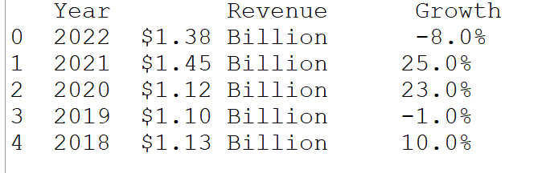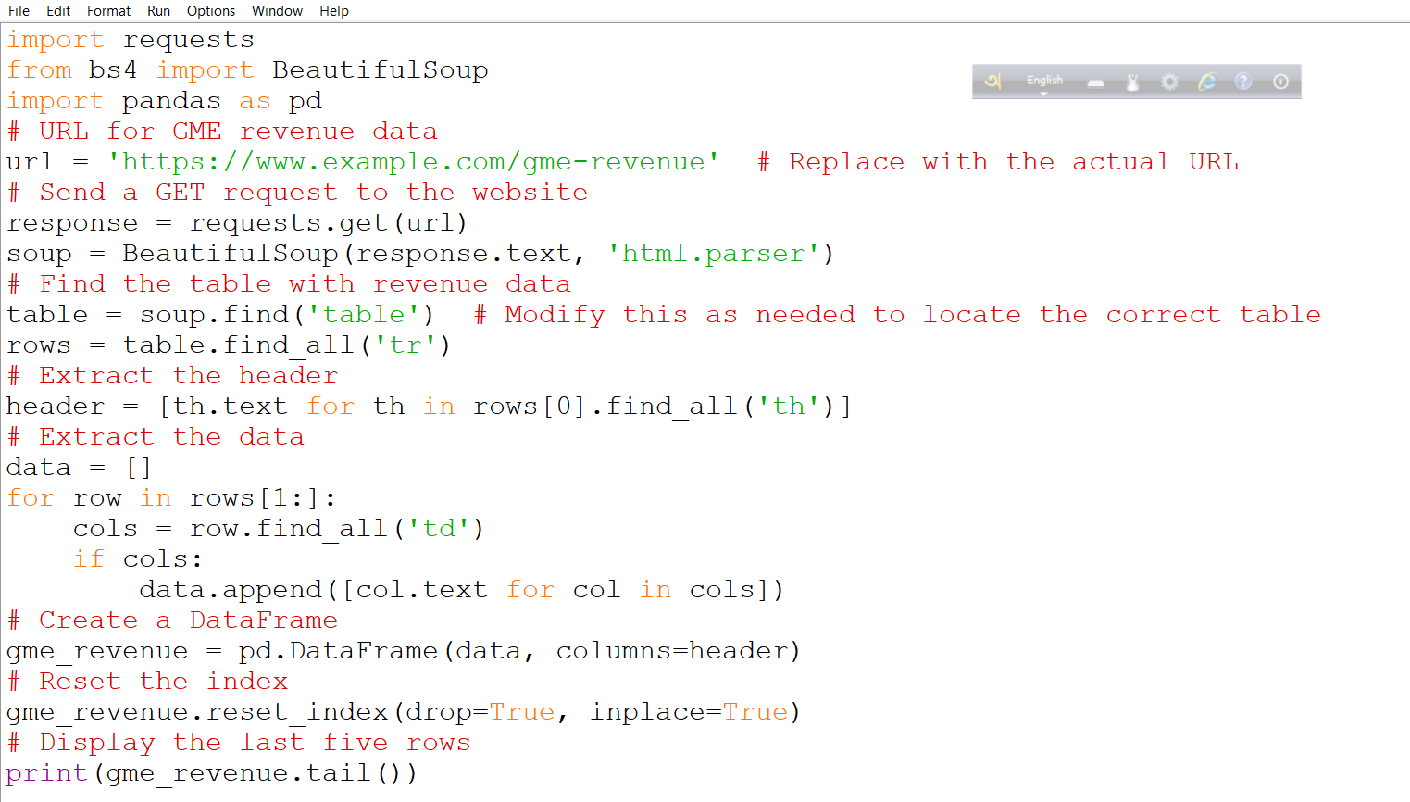

Output

Question 4: Use Webscraping to Extract GME Revenue Data