BCSE407L – Computer Vision
Project Report
SEMANTIC RETRIEVAL AND MULTI-TEMPORAL CHANGE ANALYSIS OF SATELLITE IMAGERY USING A SHARED FOUNDATION-MODEL EMBEDDING SPACE
Submitted by
Reg. No. | Student Name
23BCE0257 | AKANKSHA BHARTI
23BCE0292 | SUBHAJIT MASANTA
23BCE0318 | GONTLA VENKATA SIVA SAI NIKHIL
23BCE2027 | ARJUN PRATAP SINGH

Under the Supervision of
Dr. <Supervisor Name>
<Designation>
School of Computer Science and Engineering
In partial fulfilment of the requirements for the degree of
B.Tech.
in
Computer Science and Engineering
School of Computer Science and Engineering
October 2026

ABSTRACT
Satellites are taking pictures of the Earth every day, so now there is a very huge amount of satellite images stored. But the problem is we can search these images only by date, coordinates or satellite name. We cannot search by what is there inside the picture, so the person should already know where to look. And to find what changed in a place is even more hard, because somebody has to open two images and compare by eye.
So in our project we tried to solve both the problems together. First we cut every image into small tiles. Then each tile we give to a pre-trained CLIP model, and it gives back a list of numbers which is called embedding. All the embeddings we store one time only, in one shared index, and we use it for two works. First is search, where user can type words like "a river" or give one example tile and our system gives the matching tiles. Second is change, where for same place at two dates we compare the two embeddings. We also try to remove the false alarms which come from brightness difference, cloud and shadow. We did not train any model.
We tested on OSCD dataset which is having 24 pairs of Sentinel-2 city images with correct change masks. Our results are mixed and we are writing them as it is. Searching the same place across two dates worked good, the correct tile came first 46% of the time out of 2,139 tiles. Text search was only little better than random. The embedding difference came out weaker than simple pixel difference for finding change. Brightness matching was the most useful step, it reduced false alarms from 24% to 9% of unchanged pixels.

Keywords – Computer Vision, Remote Sensing, Satellite Imagery, Image Retrieval, Change Detection, CLIP, Embeddings, Vector Search.

TABLE OF CONTENTS
Sl.No | Contents | Page No.
 | Abstract | i
1. | INTRODUCTION | 1
 | 1.1 Background | 1
 | 1.2 Motivation | 1
 | 1.3 Scope of the Project | 1
2. | PROJECT DESCRIPTION AND GOALS | 3
 | 2.1 Research Gap | 3
 | 2.2 Objectives | 3
 | 2.3 Problem Statement | 3
 | 2.4 Project Plan | 4
3. | TECHNICAL SPECIFICATION | 5
 | 3.1 Requirements | 5
 | 3.1.1 Functional | 5
 | 3.1.2 Non-Functional | 5
 | 3.2 Feasibility Study | 6
 | 3.2.1 Technical Feasibility | 6
 | 3.2.2 Economic Feasibility | 6
 | 3.2.3 Social Feasibility | 6
 | 3.3 System Specification | 6
 | 3.3.1 Hardware Specification | 6
 | 3.3.2 Software Specification | 7
4. | DESIGN APPROACH AND DETAILS | 8
 | 4.1 System Architecture | 8
 | 4.2 Design | 10
 | 4.2.1 Data Flow Diagram | 10
 | 4.2.2 Use Case Diagram | 10
5. | DATASET DETAILS | 12
 | 5.1 Why We Chose OSCD | 12
 | 5.2 What the Dataset Contains | 12
 | 5.3 The 24 City Pairs | 13
 | 5.4 Metadata We Extract | 14
 | 5.5 Limitations of the Dataset | 15
6. | IMPLEMENTATION | 17
 | 6.1 Setup and Code Structure | 17
 | 6.2 Loading the Data and Extracting Metadata | 17
 | 6.3 Tiling | 18
 | 6.4 Embedding and the Shared Index | 19
 | 6.5 Search | 20
 | 6.6 Change Detection and False Alarm Removal | 20
 | 6.7 Problems We Faced | 21
7. | RESULTS AND ANALYSIS | 22
 | 7.1 Experimental Setup | 22
 | 7.2 Text Search | 22
 | 7.3 Finding the Same Place Across Dates | 23
 | 7.4 Embeddings as a Change Signal | 24
 | 7.5 Pixel-Level Change Maps | 25
 | 7.6 False Alarm Removal | 26
 | 7.7 Summary and Future Work | 28
8. | REFERENCES | 29

1. INTRODUCTION
1.1 Background
Satellites like Sentinel-2 and Landsat take photos of the whole Earth again and again, and most of this data is free to download. Because of this the amount of satellite images today is so much that nobody can check them by hand.
Right now these archives are searched using metadata. Metadata is the extra information saved with the image, like which date it was taken, the coordinates of the area and which satellite took it. This is useful but it has one big limitation, metadata does not tell what the picture is actually showing. We cannot ask the archive to find "a new bridge" or "houses near a river", because the archive does not know what is inside the image.
One more problem is also there. If someone wants to know how a place changed in last two years, they have to find the old image, find the new image, keep them one on other and compare by seeing. This takes lot of time and it works only if the person already knows which place to check.
1.2 Motivation
We took this project because the problem is real and somebody is actually asking for it. It is from Smart India Hackathon 2026, problem statement SIH26227, given by Ministry of Defence (Indian Army, DGIS). So it is not some problem we made up just for marks.
Same idea is useful in many other places also. City planners want to see where new construction is coming. Disaster teams want to see which buildings got damaged after flood or earthquake. Forest department wants to see where trees are cut. Basically all are asking the same question, what is here and what changed.
One more thing motivated us. Most of the new methods for this use deep learning models which have to be trained, and training needs labelled data, good GPU and lot of time. We wanted to check if we can get useful results using only the models which somebody already trained. If it works then the system becomes cheap, fast to setup and anybody can run it, even on a normal laptop.
1.3 Scope of the Project
The official problem statement is asking for six different features. We are four students and we had around ten weeks, so building all six properly was not possible for us. So instead of promising everything and finishing nothing, we decided clearly which parts we will build and which we will leave. We feel it is better to be honest here than to claim more.
The search part and the change detection part we built fully. The false alarm removal part we built partly, and we tell clearly which type of false alarms we handle. Grouping similar places together is a bonus feature, we will try only if time is left.
We did not build the analyst review screen with approve/reject history, and we did not build the offline server version which keeps adding new images without rebuilding whole index. These two are proper engineering work for a company, not for a student project, so we kept them as future work. Also we used only free public datasets. No secret or military data is used anywhere in our project.

2. PROJECT DESCRIPTION AND GOALS
2.1 Research Gap
We looked how the existing systems are doing image search and change detection [1]-[7]. In them we found these gaps, and our proposed project is trying to work on these:
- Two separate systems. Search and change detection are built separately. Each one makes and stores its own features, so memory and computing time both get wasted.
- Training is needed almost always. Most change detection methods need labelled training data of the same area where they will be used. Getting that labelled data is slow and costly.
- They focus on finding change, not on being correct. Many papers tell how much change they found (recall). But in real use the bigger problem is telling a change which is not there. If the system gives wrong alarm too many times, nobody will trust it.
- False alarms are not taken seriously. Season, cloud, shadow and sunlight differences are mostly not handled directly, even though these only cause most of the wrong answers.
2.2 Objectives
In our proposed project we want to do these things:
- To read the satellite image tiles and keep their location and date with them, so that every result we can trace back to where it came from.
- To convert every tile into an embedding using a pre-trained model, without training anything by ourself.
- To store all the embeddings in one single shared index, which both search and change detection will use.
- To let the user search tiles by typing normal words, and also by giving an example image.
- To detect change between two dates by comparing the embeddings of the same tile, and to tell the type of change.
- To remove false alarms coming from cloud, shadow and lighting difference, and to give a confidence value with every change.
- To measure the results properly using Precision@k, mAP, Precision, Recall, F1 and IoU, and compare with simple baseline methods.
2.3 Problem Statement
Satellite image archives can be searched only by metadata like date, location and sensor. They cannot be searched by content of the image, and they cannot directly tell what changed in a place between two dates. The existing solutions take these as two separate problems and make two separate systems, and most of them need labelled training data. On top of this, the simple change detection methods give too many false alarms, because cloud, shadow, season and sunlight make the unchanged places also look different.
So the problem we take in our proposed project is: how can we make a satellite image archive searchable by meaning and by change over time, using one shared set of features, without training any model, and still keeping the false alarms low?
2.4 Project Plan
We planned the work for around ten weeks. The main point of our plan is that four of us do not wait for each other. Each person builds and tests their own part using temporary fake data, and only at the end we join everything. For example the search part can be tested with random numbers in place of real embeddings, because shape of the data is same. Like this nobody is sitting idle waiting for other person to finish.
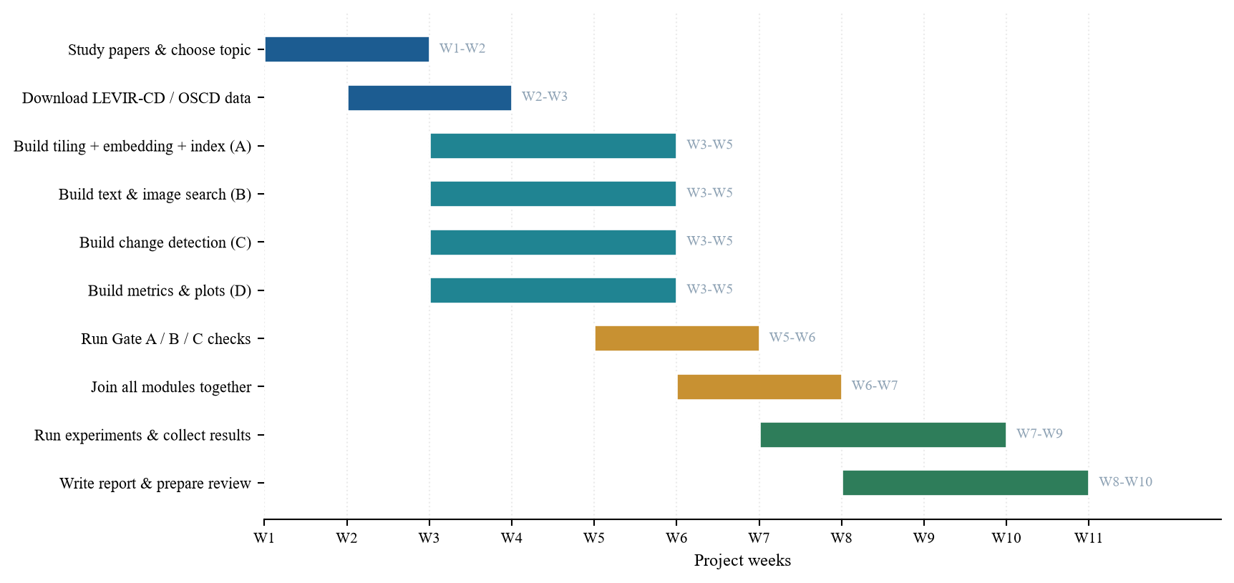
Fig. 1. Gantt chart of the project plan
The yellow bars in the middle are our checking stage. Before going further we run three tests which we call as gates. Gate A checks that search is giving sensible tiles. Gate B checks that our change detection is better than simple image subtraction. Gate C checks that our false alarm removal is really removing false alarms and not deleting the real changes also. If any gate fails, we fix that part first and then continue.

3. TECHNICAL SPECIFICATION
3.1 Requirements
3.1.1 Functional
This is what our proposed system is doing, step by step:
- Image loading and tiling: We read the Sentinel-2 band files (GeoTIFF, 16-bit) and cut every scene into tiles of 64 x 64 px with no overlap.
- Location details: For every tile we store its pixel offset (x, y) inside the scene, the tile size, the acquisition date and the scene name. Position of the scene we store as longitude/latitude bounds [min_lon, min_lat, max_lon, max_lat] which we read from the .geojson file, for example [-48.0498, -15.8596, -48.0016, -15.8164] for aguasclaras.
- Embeddings: Each tile we pass through a frozen CLIP ViT-B/32 model and we get a vector of 512 values, which we scale to length 1.
- One shared index: All vectors we keep in one array and the metadata in a list of same order. Search and change detection both are reading this same index.
- Text search: We encode the typed query with CLIP text encoder and rank all tiles by cosine similarity.
- Image search: We take the vector of a tile which user picked and return its nearest tiles.
- Filters: We can cut down the ranked list by date range, by sensor, and by an area box given as longitude/latitude bounds.
- Change detection: For same tile at two dates we compute the distance between its two vectors and also one pixel change mask.
- Change type: Each changed region we label as construction, clearance, water or vegetation using colour, texture and shape rules.
- False alarm removal: We match the brightness of date 2 to date 1, mask the cloud and shadow, and give a confidence value with every change.
3.1.2 Non-Functional
- Speed: One search over our 4,278 tiles took about 0.32 ms in our run.
- Low cost: We ran the full OSCD experiment on laptop CPU (Intel i5, 16 GB RAM) in about 6 minutes, no paid GPU.
- Repeatable: We fix the random seed and save every number in a results file, so same input gives same output.
- Does not break easily: If FAISS or rasterio is not installed, our code shifts to NumPy search and OpenCV reading and it does not crash.
- Easy to maintain: We split the code in small files, one owner for each, so we do not overwrite each other's work.
- Model details: We note down the name, source and licence of every pre-trained model we use.
- Data safety: We use only free and public datasets. No restricted data.
3.2 Feasibility Study
3.2.1 Technical Feasibility
Our proposed project is technically possible for us. CLIP and RemoteCLIP models are already trained and free to download, so we are not training anything and we do not need a strong computer. The OSCD dataset which we used is free, around 513 MB, and it already has the correct change masks, so we can measure our results in numbers. The two dates of every OSCD city are already aligned pixel to pixel. Aligning two satellite images by ourself is a hard problem, and by taking this dataset we avoid it. OpenCV, NumPy and PyTorch are free and well documented.
3.2.2 Economic Feasibility
Cost of our proposed project is almost zero. Dataset, models and libraries all are free. We ran everything on our own laptop, so we did not rent any GPU or cloud machine. The only real cost is our time and around 3 GB disk space for the dataset and model weights. For a real organisation one more saving is there, since nothing is trained nobody has to label thousands of images.
3.2.3 Social Feasibility
Our proposed system is made to help a human analyst, not to replace. The person still takes the final decision, our system only makes the list of places shorter. This matters because an automatic system which makes mistakes silently can be harmful. That is why with every detected change we give a confidence score and the link back to original image, so analyst can always check it by themself.
We also thought about misuse. Satellite monitoring can affect privacy, so we work only at the scale where buildings and roads are visible, not individual people. All our data is public and openly licensed.
3.3 System Specification
3.3.1 Hardware Specification
Component | Minimum requirement | Why it is needed
Processor | Intel i5 or equivalent (4 cores) | To run tiling and image processing in reasonable speed.
Memory (RAM) | 8 GB (16 GB better) | Big satellite images take lot of memory while tiling.
Storage | 20 GB free space | OSCD is about 1 GB unzipped, model weights about 1.2 GB, plus results.
GPU | Optional | Only makes embedding faster. We ran our experiments on CPU.
Internet | Required once | To download the dataset and the pre-trained model weights.

3.3.2 Software Specification
Software | Version | What we use it for
Operating System | Windows 11 | We developed and ran on this.
Python | 3.10 or above | Main programming language.
PyTorch | 2.0+ | Running the pre-trained model (prediction only).
open_clip_torch | 2.24+ | Loading CLIP and RemoteCLIP models.
FAISS | 1.7+ | Fast search in embeddings (optional, NumPy used if missing).
OpenCV | 4.8+ | Reading images, masks, filtering and morphology.
NumPy | 1.24+ | All number and vector calculations.
rasterio | 1.3+ | Reading GeoTIFF files and their header.
scikit-learn | 1.3+ | Clustering similar places and some metrics.
Matplotlib | 3.7+ | Drawing the result figures and charts.

4. DESIGN APPROACH AND DETAILS
4.1 System Architecture
The design of our proposed system is shown in Fig. 2. The most important idea of the whole project is the orange box in the middle, the shared index. Normally a system which searches images and a system which finds change will each build their own features. In our design we build the features one time only and both sides use the same.
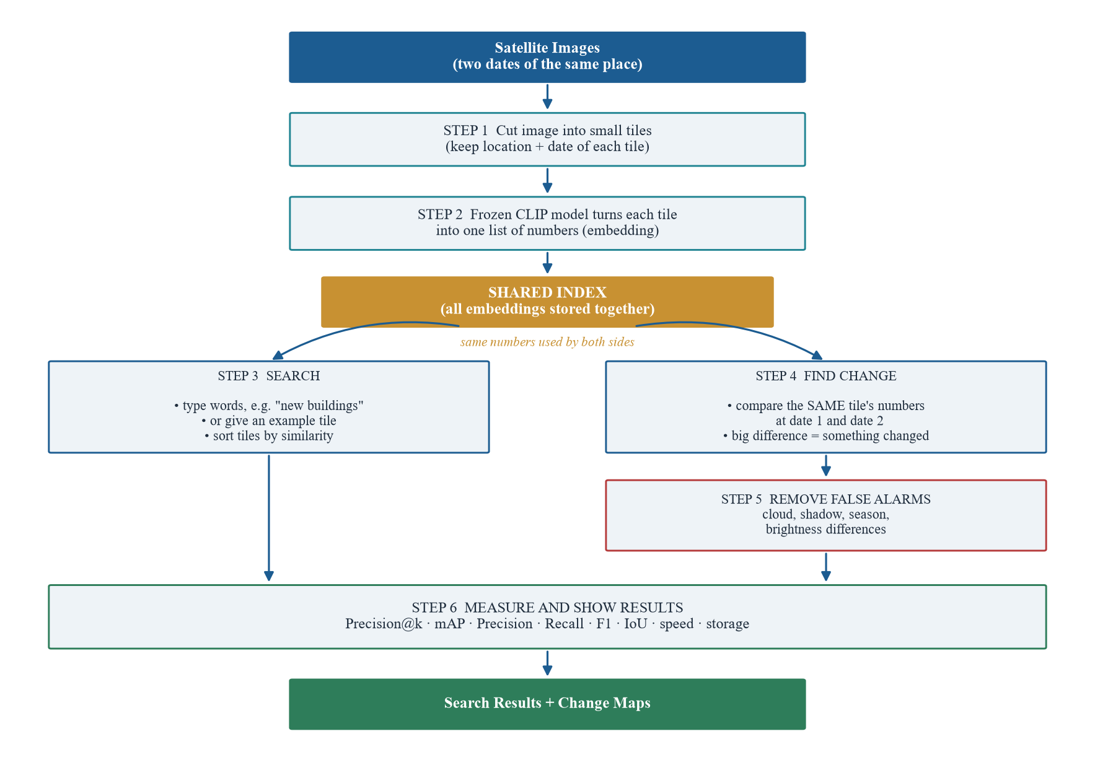
Fig. 2. System architecture
Each step is explained below, with the reason why we did it like that.
- Step 1 – Cut into tiles. One full satellite image is too big to handle at once, and also we want the result to point to a small spot and not the whole scene. So we cut each image into small square tiles. With every tile we keep the coordinates and date, because a result which says "something changed" is of no use if we cannot say where.
- Step 2 – Make embeddings. Each tile goes through a pre-trained CLIP or RemoteCLIP model, which turns the picture into a list of 512 numbers. Tiles which look alike get similar numbers. We freeze the model, means we do not train it at all, we only use it for prediction. We tried RemoteCLIP because normal CLIP was trained on everyday photos and not on satellite views.
- Shared index. All these number lists we store together in one index. This is the heart of our idea. Since the numbers describe how a tile looks, the same numbers can answer "find tiles like this" and also "did this tile change?". Making them once saves memory and time both.
- Step 3 – Search. When user types words, the same CLIP model turns those words into numbers in the same space. Then we compare the query numbers with every tile's numbers and sort the tiles by how close they are. User can also give an example tile in place of words.
- Step 4 – Find change. For one place at two dates, we take the two embeddings of that tile and measure the distance between them. Small distance means nothing much happened, large distance means something changed. After that we compare the pixels to find exactly which part changed, and we label the change as construction, clearance, water or vegetation.
- Step 5 – Remove false alarms. This step is there because two images of same unchanged place can still look very different. A cloud may be in between, sun may be at different angle, or season may have changed the colour of plants. First we match the brightness of both images, then mask out cloud and shadow, and lastly give each change a confidence score. We prefer to report less changes which are correct than many changes which are wrong.
- Step 6 – Measure. At last we measure everything. For search we use Precision@k and mAP, which tell how many of the top results were actually relevant. For change we use Precision, Recall, F1 and IoU, which compare our change map with the correct answer given in the dataset. We also note the speed and storage used.

4.2 Design
4.2.1 Data Flow Diagram
Fig. 3 shows how the data is moving in our system. We used the standard symbols: squares are things outside the system, rounded boxes are the processes inside, and the open box is where data is stored.
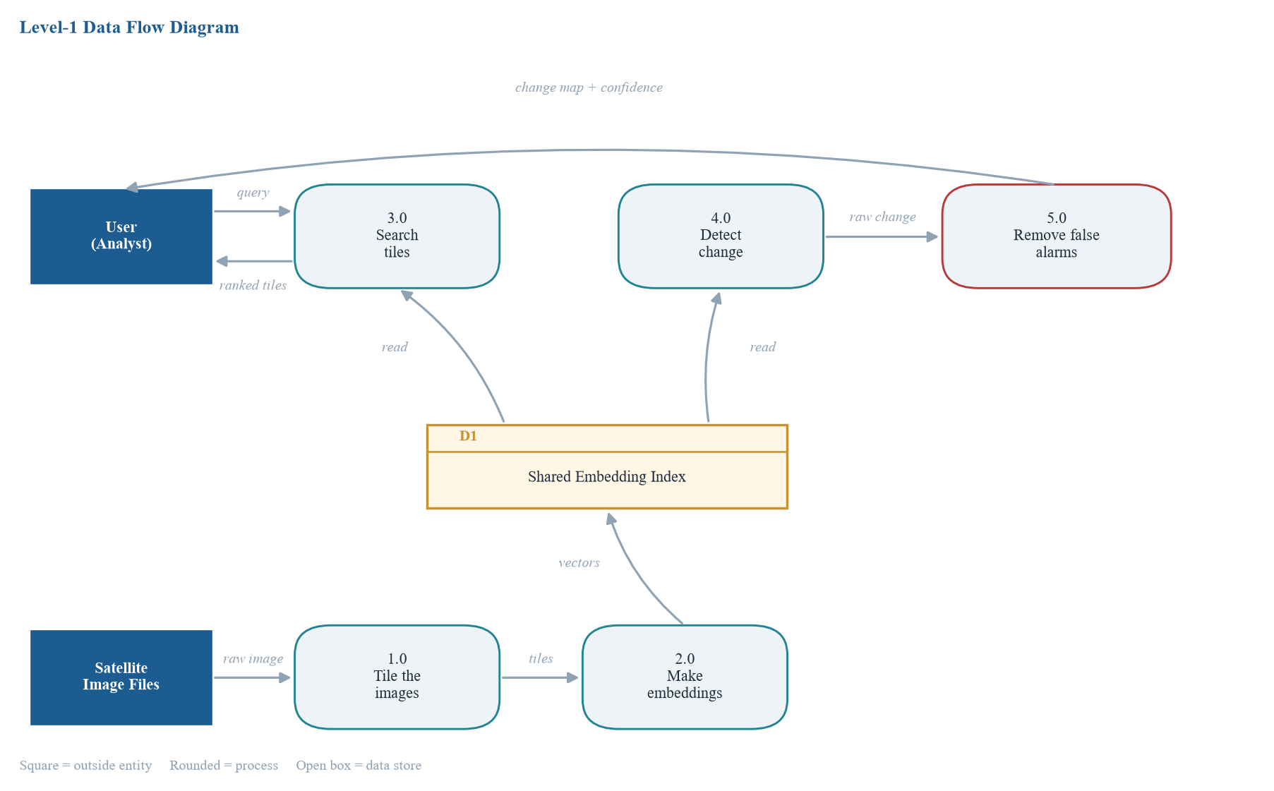
Fig. 3. Level-1 Data Flow Diagram
The bottom row is the preparation path and it runs only once. The satellite image files go into process 1.0 which cuts them into tiles. Those tiles go to process 2.0 which turns them into embeddings and saves in data store D1.
The top row is what happens when somebody actually uses the system. If user types a query, it goes to process 3.0, which reads D1 and sends back a ranked list of tiles. If user wants to compare two dates, process 4.0 reads the same D1 and gives a rough change result, and process 5.0 cleans it before showing to the user.
The thing to notice in this diagram is that D1 has two arrows going out, one to search and one to change detection. That single shared store is the main point of our design.
4.2.2 Use Case Diagram
Fig. 4 shows who uses our proposed system and what they can do with it. We have two types of users. Analyst is the main user who searches and looks at the changes. Data Admin is the person who loads new satellite images and builds the index.
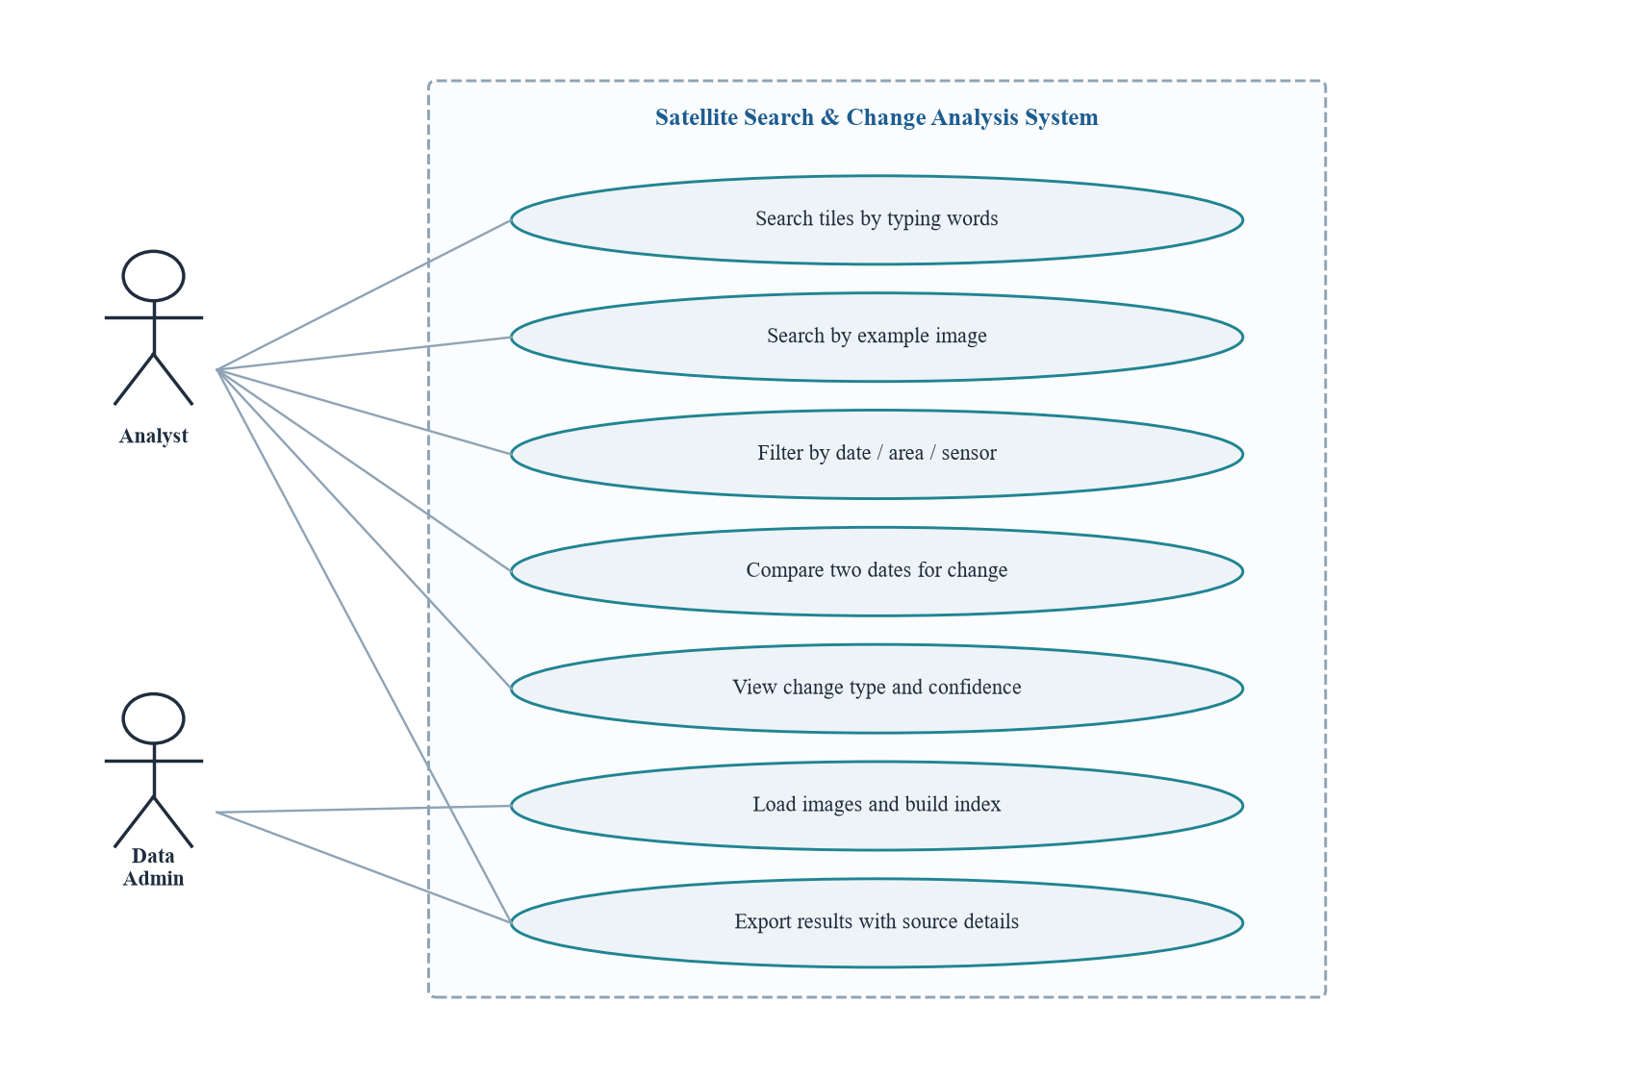
Fig. 4. Use Case Diagram
The Analyst can search by typing words, search by an example image, narrow the results using date, area or sensor filters, compare two dates to see what changed, and see the change type with its confidence value. The Data Admin loads the images and builds the index. Both of them can export results, and every exported result carries the source image name and date with it, so the information can always be checked later.

5. DATASET DETAILS
5.1 Why We Chose OSCD
We needed a dataset which has two images of same place taken at different times, and also the correct answer of what changed, so that we can check our output in numbers. The Onera Satellite Change Detection (OSCD) dataset gives exactly this. We took it for three reasons.
- It is real satellite data. It is real Sentinel-2 data, which is one of the image sources named in the problem statement. So our test is on same kind of data which the real system will see.
- The pairs are already aligned. The two images of every city are already kept one on top of other properly. Aligning two satellite images is itself a hard problem, and this lets us skip it.
- It is small enough for us. Whole dataset is around 513 MB, so we could download it and run on a laptop.
We had planned to use LEVIR-CD dataset also (637 pairs, about 3.8 GB). But we have not run it yet. So every result in this report is from OSCD only, and LEVIR-CD is kept as next step.
5.2 What the Dataset Contains
Property | Value
Number of image pairs | 24 cities (14 for training, 10 for testing, as fixed by the dataset authors)
Satellite and sensor | Sentinel-2, MultiSpectral Instrument (MSI)
Bands per image | 13 (B01 to B12 and B8A), stored as separate GeoTIFF files
Pixel type | 16-bit unsigned integer (uint16)
Ground resolution | 10 m per pixel after resampling (one pixel = 10 m x 10 m)
Years covered | 2015 to 2018; the two dates of a pair are about 1 to 2.5 years apart
Image sizes | From 385 x 241 px (norcia) to 1070 x 1180 px (beirut)
Ground truth | One black and white change mask per city (white = changed)
Type of change labelled | Mostly urban change: new buildings and new roads
Total pixels | 9,595,514
Pixels labelled as changed | 308,267 (3.21%)

Each city folder is having the files shown below. We use the 'rect' folders, because in those the two dates are already aligned with each other.
paris/
imgs_1/ 13 band files, date 1 (original crop)
imgs_2/ 13 band files, date 2 (original crop)
imgs_1_rect/ 13 band files, date 1 (aligned) <- we use this
imgs_2_rect/ 13 band files, date 2 (aligned) <- we use this
pair/ ready-made colour pictures of both dates
dates.txt date_1: 20161130 date_2: 20171107
paris.geojson outline of the area in longitude / latitude

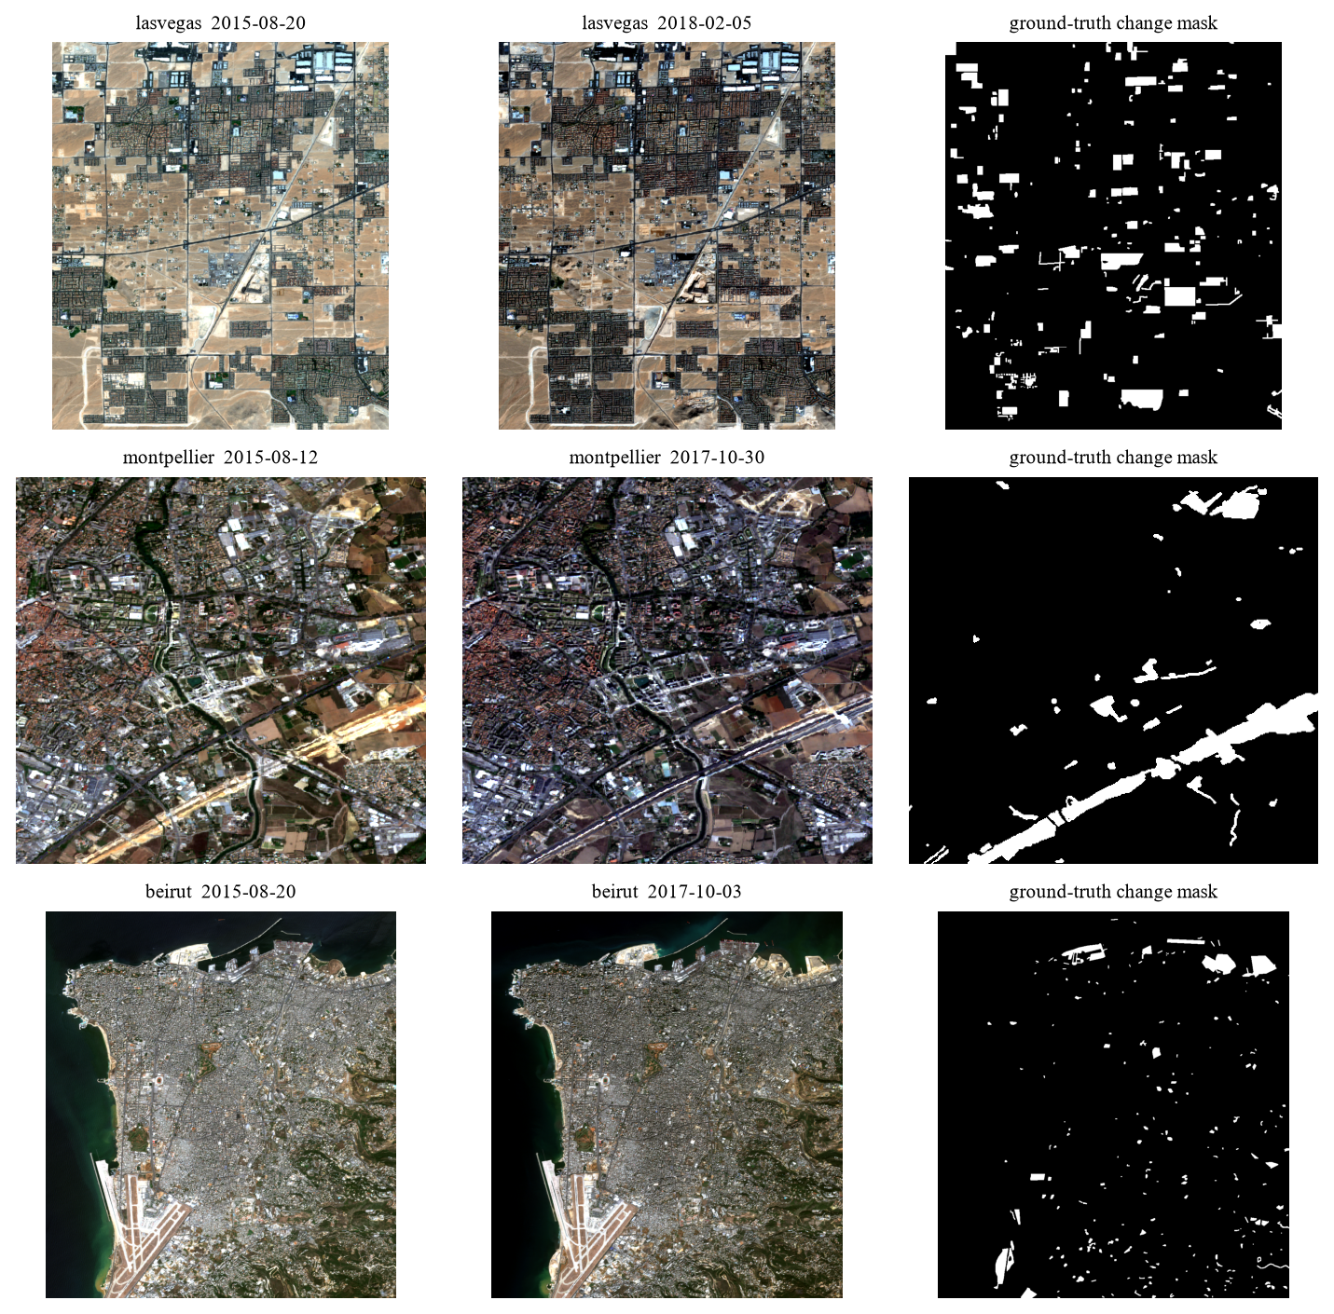
Fig. 5. Three city pairs from OSCD with their ground-truth change masks
5.3 The 24 City Pairs
Below table lists every pair which we used. The last column shows how much of the image is marked as changed. This number is small everywhere, and that becomes important later in our results.
City | Split | Size (px) | Date 1 | Date 2 | Changed %
aguasclaras | train | 525 x 471 | 2015-09-16 | 2017-10-15 | 1.64
bercy | train | 360 x 395 | 2016-11-30 | 2017-08-29 | 0.74
bordeaux | train | 461 x 517 | 2016-05-04 | 2017-10-26 | 1.00
nantes | train | 582 x 522 | 2015-08-21 | 2017-10-14 | 1.14
paris | train | 390 x 408 | 2016-11-30 | 2017-11-07 | 0.29
rennes | train | 563 x 339 | 2015-08-21 | 2017-06-21 | 2.58
saclay_e | train | 688 x 639 | 2016-03-15 | 2017-08-29 | 0.99
abudhabi | train | 785 x 799 | 2016-01-20 | 2018-03-28 | 3.76
cupertino | train | 788 x 1015 | 2015-09-18 | 2018-03-26 | 2.37
pisa | train | 718 x 776 | 2015-07-04 | 2018-02-11 | 1.64
beihai | train | 772 x 902 | 2016-12-09 | 2018-03-09 | 2.49
hongkong | train | 540 x 695 | 2016-09-27 | 2018-03-23 | 3.56
beirut | train | 1070 x 1180 | 2015-08-20 | 2017-10-03 | 2.69
mumbai | train | 557 x 858 | 2015-11-30 | 2018-03-19 | 2.56
brasilia | test | 469 x 433 | 2015-09-16 | 2017-10-17 | 2.58
montpellier | test | 451 x 426 | 2015-08-12 | 2017-10-30 | 6.79
norcia | test | 385 x 241 | 2015-07-11 | 2017-10-18 | 1.32
rio | test | 426 x 353 | 2016-04-24 | 2017-10-11 | 5.69
saclay_w | test | 688 x 639 | 2016-03-15 | 2017-08-29 | 1.14
valencia | test | 476 x 458 | 2016-07-30 | 2017-11-07 | 0.44
dubai | test | 634 x 774 | 2015-12-11 | 2018-03-30 | 9.92
lasvegas | test | 716 x 824 | 2015-08-20 | 2018-02-05 | 7.67
milano | test | 558 x 545 | 2016-12-28 | 2018-01-22 | 0.80
chongqing | test | 544 x 730 | 2017-04-14 | 2018-04-02 | 7.21

5.4 Metadata We Extract
Metadata means the information about an image, not the image itself. We collect it from three places: the dates.txt file, the .geojson file and the GeoTIFF file header. Then we attach it to every tile, so that any search result or change result can be traced back to a city, a date and a position.
Field | Example | Where it comes from | Why we keep it
tile_id | aguasclaras_d1_y0_x0 | we build it | unique name for each tile
city | aguasclaras | folder name | tells us which scene the tile is from
date | 2015-09-16 | dates.txt | needed to compare date 1 with date 2 and to filter by date
date_slot | 1 | which folder (imgs_1 or imgs_2) | pairs the two dates of one place
sensor | Sentinel-2 MSI | dataset documentation | lets a user filter by satellite
gsd_m | 10 | dataset documentation | size of one pixel on the ground in metres
x, y | 0, 0 | tiling step | position of the tile inside the city image
tile_px | 64 | our setting | tile size, so results can be repeated
split | train | dataset authors | keeps train and test cities separate
changed_frac | 0.0002 | ground-truth mask | share of the tile that really changed (only used for scoring)
water / vegetation / builtup | true or false | NDWI and NDVI from bands B03, B04, B08 | automatic labels to score text search
footprint (lon/lat) | [-48.0498, -15.8596, -48.0016, -15.8164] | .geojson file | where the scene is on the Earth

One thing we noticed while reading the files. The aligned GeoTIFF files do not have any coordinate system inside them (the reader gives 'crs: None'). So we cannot get longitude and latitude from the image file itself. We are taking the location from the .geojson file. This means our location is correct for the whole scene, but we do not have exact coordinates for each single tile.
The second last row needs small explanation. OSCD does not tell which tiles are showing water or vegetation, but we need some correct answer to score the text search. So we calculate two standard indices from the bands, NDVI (vegetation) and NDWI (water). A tile is tagged 'water' if at least 30% of it has NDWI above 0.1, 'vegetation' if at least 70% has NDVI above 0.5, and 'builtup' if at least 70% has low NDVI and low NDWI. These tags are made by formula and not by a person, so they are not perfect. We use them only for scoring and never as input to our system.
5.5 Limitations of the Dataset
- Very few changed pixels. Only 3.2% of all pixels are changed. A method which says 'nothing changed' everywhere will be right about 97% of the time, so accuracy is a useless measure here. That is why we report precision, recall, F1 and IoU.
- Low resolution. At 10 m per pixel a house is only one or two pixels wide. Small changes are hard to see even for a person.
- Different seasons. The two dates of a pair are many times in different months, for example August and October. So trees, fields and sunlight look different even where nothing was built.
- Only urban change is labelled. The masks mark only urban change. If a field was ploughed or a lake got smaller it is not marked, so our method can be 'wrong' on something which really did change.
- Small dataset. 24 pairs is a small number, so our scores can move a lot because of one or two cities.

6. IMPLEMENTATION
6.1 Setup and Code Structure
We wrote the project in Python. We split the code in small files so that each of us can work on own part without waiting for others. The table shows what each file is doing.
File | What it does
src/ingest.py | reads images and cuts them into tiles, keeps metadata with each tile
src/embedder.py | loads the pre-trained CLIP model and turns tiles or text into embeddings
src/index_builder.py | stores all embeddings in one shared index and searches it
src/retrieval.py, filters.py | text search, image search, and date / sensor / area filters
src/change_detect.py | change score from embeddings, pixel change map, and the three baseline methods
src/suppress.py | brightness matching, cloud / shadow mask, removing small specks
src/metrics.py, visualizer.py | Precision@k, AP, precision, recall, F1, IoU, and the figures
experiments/run_oscd.py | runs the full experiment on OSCD and saves every number
experiments/extra_analysis.py | the follow-up checks (tile size, change size, Gate C)

To run the project we install the libraries, download OSCD in the data folder, and then run two scripts. First run also downloads the model weights (about 600 MB each for the two CLIP models).
pip install -r requirements.txt
python download_data.py --check # checks the dataset is in place
python experiments/run_oscd.py # main experiment (about 6 minutes)
python experiments/extra_analysis.py # follow-up checks
python experiments/make_figures.py # draws all result figures

Every line printed by these scripts is also saved in results/run_log.txt, and every number is saved in results/results.json. All tables in Chapter 7 are filled from that file, we did not type them by hand.
6.2 Loading the Data and Extracting Metadata
For each city we read four bands for both dates: B02 (blue), B03 (green), B04 (red) and B08 (near infrared). First three make the colour picture which we give to the model. B08 is used only for the NDVI and NDWI tags. The band values are 16-bit numbers, so we rescale them to 0 to 255.
Here one detail is important. We rescale both dates of a city with the same minimum and maximum. If we rescale each date separately, we will hide the brightness difference between the two dates. But that brightness difference is one of the false alarm sources which we want to test, so we keep it.
for i, b in enumerate(("B02", "B03", "B04")):
both = np.concatenate([bands[1][b].ravel(), bands[2][b].ravel()])
lo, hi = np.percentile(both, [2, 98]) # same stretch for both dates
for d in (1, 2):
ch = np.clip((bands[d][b] - lo) / (hi - lo) * 255, 0, 255)

The dates we read from dates.txt and change into normal year-month-day form. The scene outline we read from the .geojson file. The screenshot below is the first part of our program output, it shows all 24 cities getting loaded with their size, dates and changed percentage.
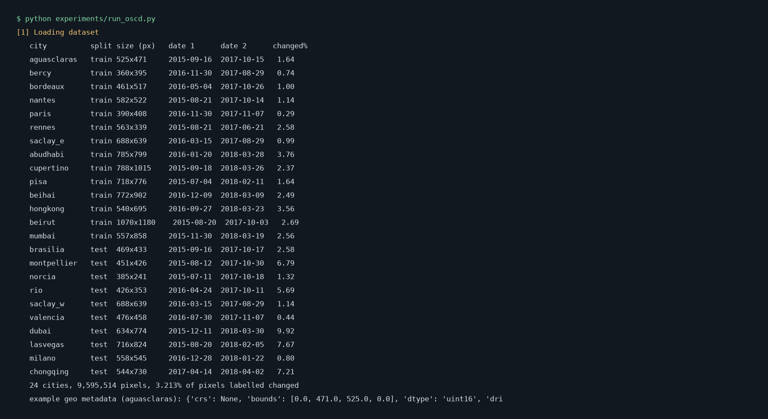
Fig. 6. Program output: loading the 24 OSCD city pairs
6.3 Tiling
One whole city image is too big to describe with one embedding, and we want results which point to a small area. So we cut each image into square tiles of 64 x 64 pixels with no overlap. At 10 m per pixel, one tile covers 640 m x 640 m on the ground. The parts at right and bottom edge which do not fill a whole tile are left out. Like this we got 4,278 tiles, that is 2,139 places at two dates each.
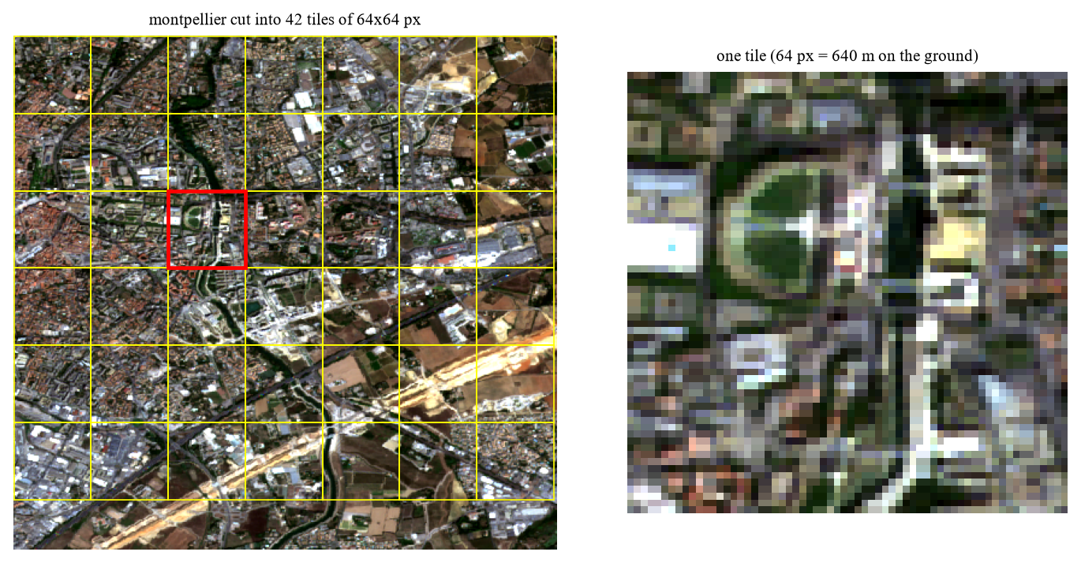
Fig. 7. Left: one city cut into tiles. Right: a single 64 px tile as the model sees it
The right side of the figure is showing a real problem. A 64 px tile is very blurry. The CLIP model expects 224 x 224 px images, so every tile gets enlarged about 3.5 times before going in. We come back to this in results, because we think it is one reason why our text search is weak.
6.4 Embedding and the Shared Index
Every tile we pass through a pre-trained CLIP model and we get back 512 numbers for each tile. This list of numbers is the embedding. We tried two models: RemoteCLIP, which was trained further on satellite and aerial pictures, and the normal OpenCLIP ViT-B/32. We did not train any of them. We put the model in evaluation mode and switch off the gradients.
self.model = model.to(self.device).eval() # frozen, prediction only
for p in self.model.parameters():
p.requires_grad = False
...
with torch.no_grad():
feats = self.model.encode_image(batch)
return feats / np.linalg.norm(feats, axis=1, keepdims=True) # length 1

We make every embedding of length 1. After that the similarity of two tiles is simply the dot product of their embeddings (cosine similarity). All embeddings go in one array, and the metadata goes in a list in the same order. These two together is our shared index. Both search part and change part read from this one index only.
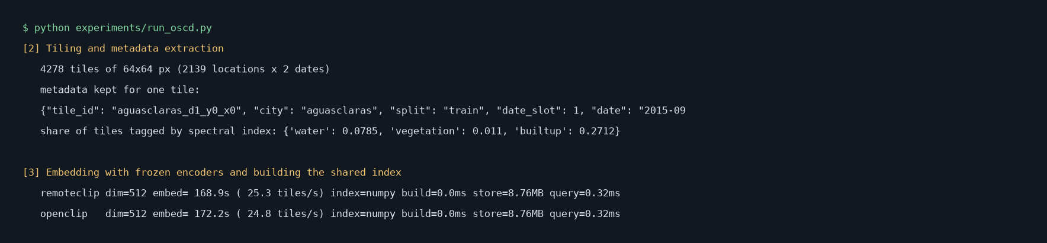
Fig. 8. Program output: tiling, the metadata of one tile, embedding time and index size
On our laptop CPU, embedding all 4,278 tiles took 169 seconds with RemoteCLIP, which is around 25 tiles per second. The index takes 8.76 MB, and one search takes about 0.32 ms. In this run the index used plain NumPy search, because FAISS was not installed on the machine. Our code shifts to NumPy automatically. With only few thousand tiles this is fast enough, but for millions of tiles FAISS will be needed.
6.5 Search
For text search, the typed words go through the text side of the same CLIP model. This gives 512 numbers in the same space as the tiles. Then we take the dot product with every tile and sort from highest to lowest. Image search is same thing, only the query is the embedding of a tile which the user picked.
q = embedder.encode_text("a satellite image of a river, sea or water body")[0]
scores = index.vectors @ q # one similarity score per tile
top = np.argsort(-scores)[:10] # best 10 tiles

We wrote the queries like 'a satellite image of ...' because CLIP was trained on captions which look like sentences, not single words.
6.6 Change Detection and False Alarm Removal
We calculate change in two ways. First one is our main idea: for one place, take its embedding at date 1 and at date 2 from the shared index, and measure how far they are. Second one is normal pixel comparison, which gives the exact shape of the change.
def embedding_change_score(vec_t1, vec_t2):
return 1.0 - np.dot(vec_t1, vec_t2) # 0 = same, bigger = more different

Before comparing the pixels we try to remove false alarms in three steps:
1. Brightness matching. We shift and scale date 2 so that each colour channel has same average and spread as date 1. This removes the differences which come only from sunlight or haze.
2. Cloud and shadow mask. We mark the large, smooth, very bright or very dark areas as unusable and ignore the changes inside them.
3. Removing small specks. We delete very small changed regions, because we expected them to be noise.
t2 = radiometric_normalise(img_t1, img_t2) # step 1
mask = change_mask(img_t1, t2, threshold) # pixel comparison
valid = usable_mask(img_t1, img_t2) # step 2 (on the raw images)
mask = cv2.bitwise_and(mask, valid)
mask = drop_small_regions(mask) # step 3

We compare with three simple baseline methods which need no training: pixel difference with Otsu threshold, Change Vector Analysis (CVA), and SSIM difference. The pixel threshold of our method we chose using only the 14 training cities, and then used it as it is on the 10 test cities.
6.7 Problems We Faced
Some things did not work in the first time. We are listing them because they changed how we built the system.
- Bright roofs were treated as cloud. Our first cloud mask was simply removing every very bright pixel. But new concrete roofs are also very bright, so it was deleting real new buildings. We changed it to remove only the areas which are bright, smooth and large.
- Wrong order of steps. First we made the cloud mask after brightness matching. Brightness matching makes a cloud darker, so the mask stopped finding it. Now we make the mask from the original images.
- Our own test could be fooled. Our first check for false alarm removal was only asking 'are there less false alarms?'. A method which reports nothing at all also passes that check. So we added a second condition, at least 80% of the real change must still be found.
- Folder name clash. The label folders have same city names as the image folders, and our loader was opening the wrong one first. We fixed it by looking for the folder which actually has the image bands.
- Download link problem. One of the official download links for the labels has a broken security certificate. Same file was available from the main server.
The first three problems we found on small test images which we made ourself, before running on real data. As Chapter 7 shows, the real data then showed us more problems which our test images did not.

7. RESULTS AND ANALYSIS
7.1 Experimental Setup
Item | What we used
Computer | Laptop, Intel Core i5-10300H (4 cores), 16 GB RAM, Windows 11
GPU | Not used. We installed the CPU version of PyTorch, so everything ran on the CPU
Software | Python 3.14, PyTorch 2.14, open_clip 3.3, OpenCV 5.0, NumPy 2.5
Models | RemoteCLIP ViT-B/32 and OpenCLIP ViT-B/32 (LAION-2B), both frozen
Data | OSCD, 24 city pairs, 4,278 tiles of 64 x 64 px
Train / test | 14 training cities used only to pick thresholds; 10 test cities used for the reported scores
Total run time | 380 seconds for the main experiment

No model was trained. The only things we 'fitted' are two numbers, the pixel threshold and the embedding threshold. Both we picked on the training cities. So the test scores below are not tuned on the test cities.
7.2 Text Search
We ran three text queries and checked the top results with the automatic tags from Section 5.4. P@10 means how many of the first 10 results were correct. AP (average precision) looks at the whole ranking. The 'random' row is what we get if the tiles are shuffled, so it is the score of a system which knows nothing.
Query | Correct tiles | Random P@10 | Random AP | OpenCLIP P@10 | OpenCLIP AP | RemoteCLIP P@10 | RemoteCLIP AP
water | 336 | 0.05 | 0.080 | 0.10 | 0.104 | 0.10 | 0.105
vegetation | 47 | 0.01 | 0.013 | 0.10 | 0.059 | 0.10 | 0.042
buildings | 1160 | 0.27 | 0.271 | 0.80 | 0.311 | 0.00 | 0.265
Mean AP (mAP) |  |  | 0.121 |  | 0.158 |  | 0.137

The result is weak. The mAP is 0.158 for OpenCLIP and 0.137 for RemoteCLIP, while random gives 0.121. So text search is only little better than guessing. Only the 'buildings' query with OpenCLIP looks good (8 of the first 10 correct), and RemoteCLIP got 0 of 10 on that same query. We were expecting RemoteCLIP to be better because it was trained on overhead images, but on this data it was not.
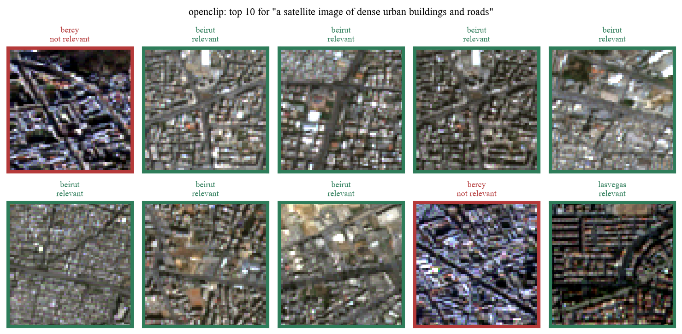
Fig. 9. Top 10 tiles for the 'buildings' query with OpenCLIP (green = correct by our tag)
Seeing the pictures helped us to understand the numbers. We think there are three reasons for the weak result.
- The tiles are too blurry. A 64 px tile at 10 m resolution has very less detail. The models were trained on much sharper pictures.
- Our tags are strict. When we saw the results of the water query, some returned tiles did show water along one edge, but they got marked wrong because our tag needs 30% of the tile to be water. So some part of the low score is coming from our own scoring rule.
- Few correct tiles. Only 47 tiles are tagged as vegetation and 336 as water, out of 4,278. With so few correct tiles, a few mistakes at the top change the score a lot.
We also tried bigger tiles of 128 px. The mAP did not improve (0.147 for OpenCLIP and 0.120 for RemoteCLIP), so tile size alone is not fixing it.
7.3 Finding the Same Place Across Dates
This is the image search test. We take a tile from date 1 and search in all the 2,139 tiles of date 2. The correct answer is the tile of the same place. Here we do not need any tags, because we know exactly which tile is the right one.
Model | Correct tile is first | In the top 5 | In the top 10
Random guess | 0.05% | 0.23% | 0.47%
OpenCLIP | 45.4% | 62.0% | 67.7%
RemoteCLIP | 46.1% | 60.8% | 66.8%

This is our best result. The correct place comes first about 46% of the time, where a random guess will be right about 0.05% of the time. So the embeddings do capture how a place looks, even when the two pictures are one to two years apart and taken in different seasons. With 128 px tiles the top-1 score went up to 76% for OpenCLIP, but there were also less tiles to choose from (495), so that number cannot be compared directly.
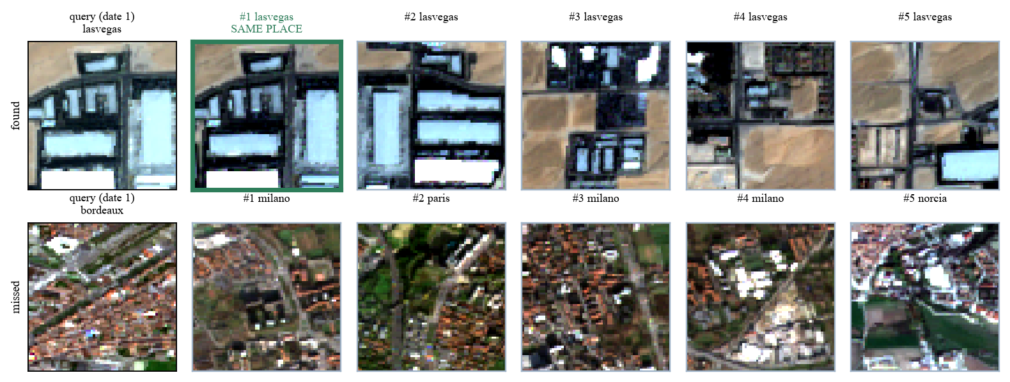
Fig. 10. Image search across dates. Top row: the same place is found first. Bottom row: a miss, where the results are similar-looking towns
The bottom row shows how it fails. For a tile of red-roof houses, the system returns other red-roof towns. They look alike, so this mistake is understandable.
7.4 Embeddings as a Change Signal
This is the test of our main idea: can the distance between the two embeddings of a place tell us that the place changed? We call a tile 'changed' if at least 5% of its pixels are marked in the ground truth. That gives 375 changed tiles out of 2,139. We use AUC to score this. AUC is 0.5 for random guessing and 1.0 for perfect.
Change score for a tile | AUC | AP
pixel difference (raw) | 0.626 | 0.221
pixel difference (normalised) | 0.650 | 0.241
embedding distance (openclip) | 0.599 | 0.219
embedding distance (remoteclip) | 0.535 | 0.170
random guess | 0.500 | 0.175

Our main idea did not work well on this dataset. The embedding distance gets AUC of 0.60 with OpenCLIP and 0.54 with RemoteCLIP. The simple pixel difference gets 0.65. So the embedding is a weaker change signal than just subtracting the pixels, and RemoteCLIP is almost same as guessing.
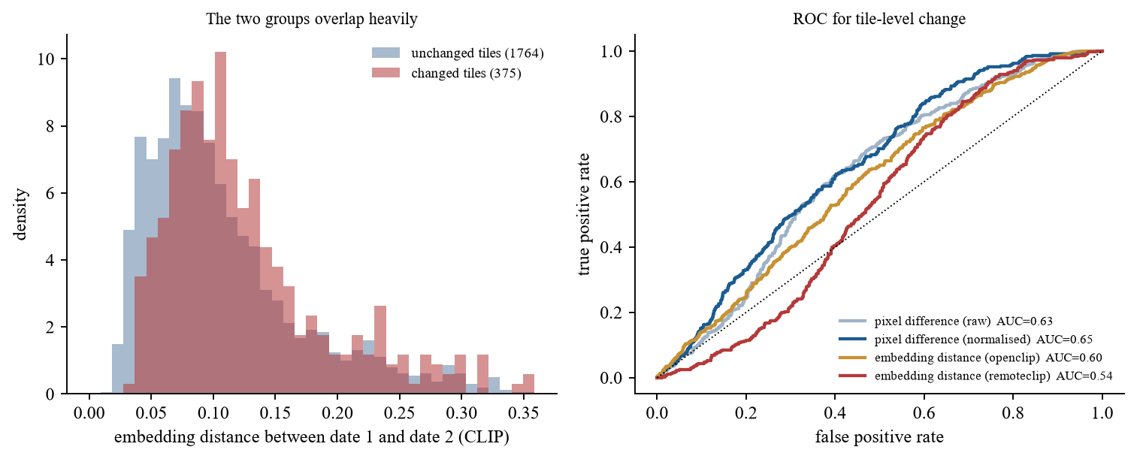
Fig. 11. Left: embedding distance for changed and unchanged tiles. Right: ROC curves of the four change scores
The left plot shows why. The embedding distance of changed tiles and unchanged tiles are overlapping almost completely. Then we checked if the size of the change matters.
It does. When at least half of the tile changed, the OpenCLIP embedding distance reaches AUC of 0.77. But there are only 6 such tiles, so this number is not reliable, and pixel difference is still higher at every size. What we understood is this: an embedding describes the whole tile in 512 numbers. In OSCD most changes are few new buildings which cover a small part of the tile, so the description hardly moves. At the same time the season and light are different between the two dates, and that moves the embedding even when nothing was built. So the small real signal gets hidden by the large unwanted one.
7.5 Pixel-Level Change Maps
Next we compare the full change maps with the ground truth on the 10 test cities. All pixels of the 10 cities are counted together. FPR is the share of unchanged pixels which were wrongly marked as changed.
Method | Precision | Recall | F1 | IoU | FPR %
Pixel difference + Otsu | 0.152 | 0.528 | 0.236 | 0.134 | 16.09
SSIM differencing | 0.100 | 0.909 | 0.181 | 0.099 | 44.44
Change Vector Analysis (CVA) | 0.359 | 0.347 | 0.353 | 0.214 | 3.38
Ours, no false alarm removal | 0.258 | 0.286 | 0.272 | 0.157 | 4.49
Ours, all three removal steps | 0.229 | 0.337 | 0.273 | 0.158 | 6.19
Ours, all steps + embedding check | 0.254 | 0.289 | 0.270 | 0.156 | 4.62
Ours, brightness matching only | 0.278 | 0.332 | 0.302 | 0.178 | 4.69

The best method in this table is not ours. CVA has the highest F1 (0.353) and the highest precision (0.359). Our best version is brightness matching only, with F1 0.302. Our full method with all three removal steps is lower (0.273). Using the embedding to throw away the tiles which it thinks are unchanged also did not help. All scores are low, which is expected for methods which learn nothing from labelled examples.
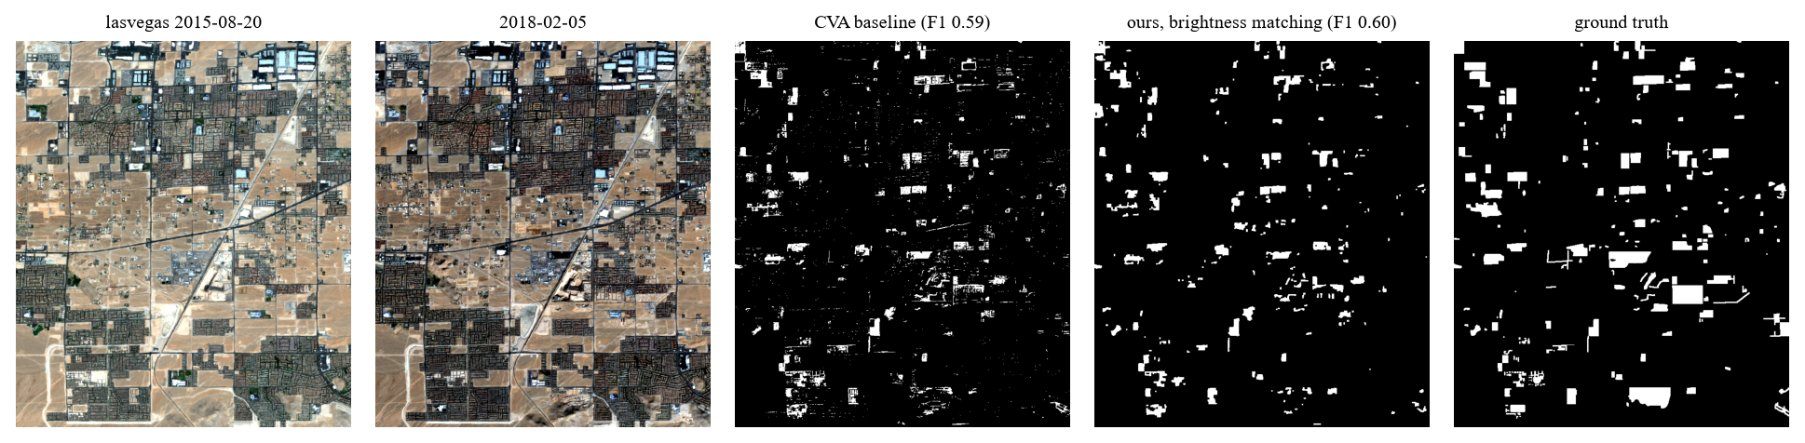
Fig. 12. A good case (lasvegas): large new buildings on plain ground
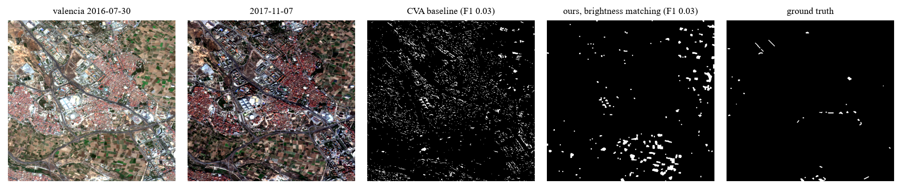
Fig. 13. A bad case (valencia): almost nothing changed, and both methods mark the wrong places
The scores are very different from city to city. Our brightness-only method gets F1 0.60 on lasvegas and 0.57 on montpellier, but only 0.03 on valencia and 0.04 on saclay_w. The good cities have large new buildings on dry plain ground. The bad cities have very little real change (under 1.2% of pixels) and lot of farmland, where fields change colour between the two dates. Those field changes are real differences in the picture, but they are not marked in the ground truth, so they get counted as false alarms.
7.6 False Alarm Removal
Here we look at each removal step separately, all at the same pixel threshold of 40, on the test cities.
Steps used | Precision | Recall | F1 | FPR %
none | 0.114 | 0.575 | 0.190 | 24.38
brightness matching only | 0.242 | 0.518 | 0.330 | 8.82
+ cloud/shadow mask | 0.240 | 0.503 | 0.325 | 8.69
+ remove small specks | 0.229 | 0.337 | 0.273 | 6.19

Brightness matching is clearly the useful step. False alarms fall from 24.38% to 8.82% of unchanged pixels, and recall drops only from 0.575 to 0.518, so about 90% of the real change is kept. F1 goes from 0.190 to 0.330.
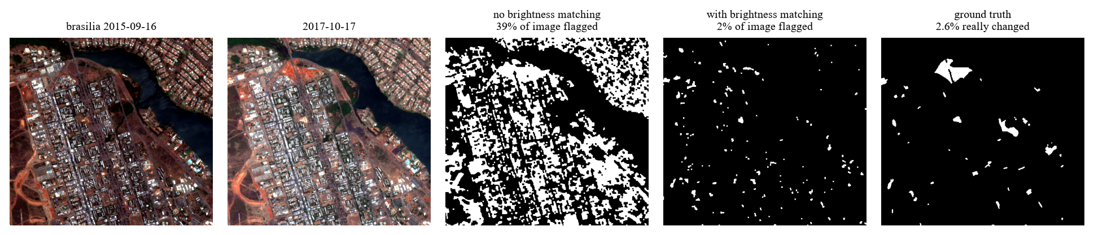
Fig. 14. Effect of brightness matching on brasilia: the flagged area falls from 39% to 2% of the image
The other two steps did not help on OSCD.
- Cloud and shadow mask. It made almost no difference in the scores, and on some cities it removed a large area which had no cloud at all (35% of rio and 22% of brasilia). It took dark water and dark vegetation as shadow. OSCD images have almost no cloud, so here this step could only do harm.
- Removing small specks. This step lowered the recall from 0.503 to 0.337. In OSCD a new building is many times only few pixels, so what we treated as noise was actually real change.
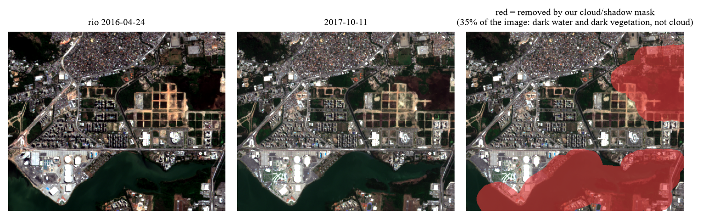
Fig. 15. Our cloud/shadow mask removing dark water and vegetation in rio by mistake
Lastly we ran our Gate C check on the real data, comparing the method with and without the removal steps at the same threshold. The check has two conditions: false alarms must go down, and at least 80% of the real change must still be found.
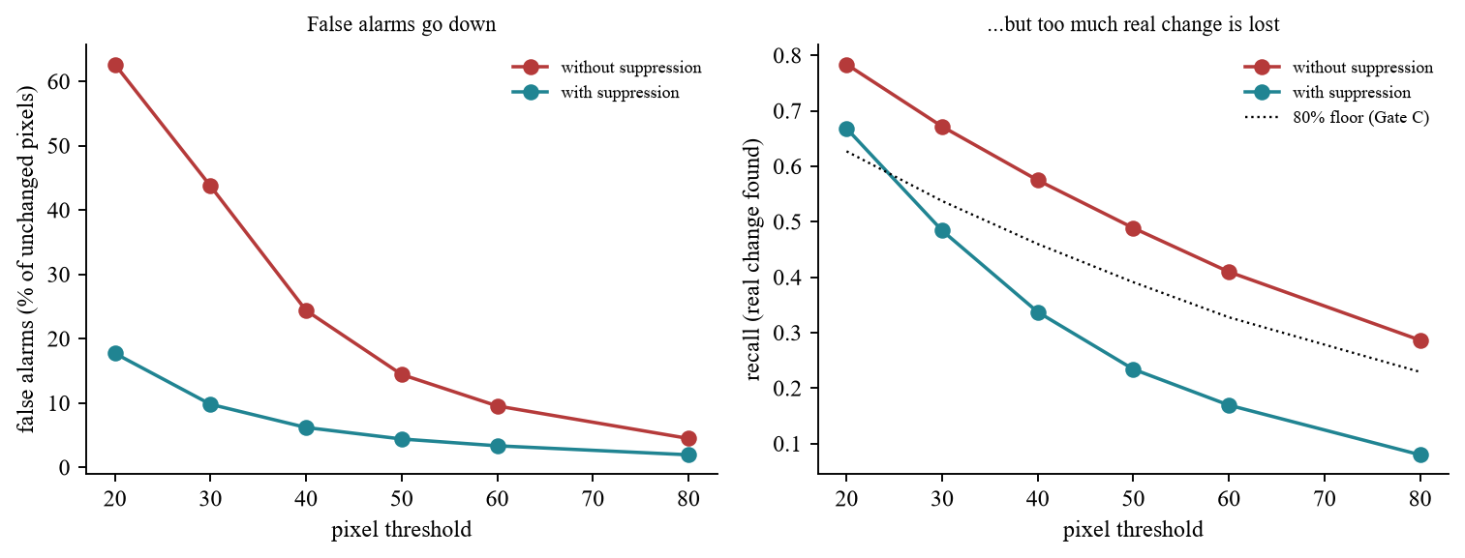
Fig. 16. Gate C on the test cities at each pixel threshold
False alarms go down at every threshold, so the first condition always passes. The second condition passes only at threshold 20 (85% of recall kept). At threshold 40 only 59% is kept, so the gate fails. The reason is the speck removal step explained above. With brightness matching alone, about 90% of recall is kept at threshold 40, which will pass. So our full false alarm removal does not pass our own check on real data, but the brightness matching part of it does.
7.7 Summary and Future Work
This table puts our main findings in one place.
What we tested | Result | Did it work?
Search for the same place across dates | 46% top-1 (random: 0.05%) | Yes
Text search | mAP 0.16 (random: 0.12) | Only slightly
Embedding distance as change signal | AUC 0.60 (pixel difference: 0.65) | No
Brightness matching | false alarms 24.38% to 8.82% | Yes
Cloud mask and speck removal | no gain, or lost real change | No
Our change maps against CVA | F1 0.30 against 0.35 | No, CVA is better
RemoteCLIP against normal CLIP | no clear advantage on this data | No

So the shared index is useful for searching by example image, but on OSCD it is not a good way to detect change. One set of embeddings can do the search work, but for small changes at 10 m resolution we still have to compare the pixels. We feel this is an honest and useful result, even though it is not what we were hoping when we started.
These results have some limits also. They are from one dataset with 24 pairs, our search tags are made by formula, and we tried only two models and two tile sizes. So we cannot say the idea fails everywhere, only that it did not work in this setting.
What we are planning to do next:
- Run the same experiment on LEVIR-CD, which is 0.5 m per pixel. There a building covers many pixels, so the embedding may react more to a new building. This is the most important next step.
- Use patch-level features from the model instead of one embedding for the whole tile, so that a small change is not averaged away.
- Drop the speck removal step for low-resolution data, and replace our cloud mask with the cloud layer that comes with Sentinel-2 products.
- Check a sample of our automatic search tags by hand.
- Use all 13 bands for the pixel comparison. We only used three colour bands, while the infrared bands show vegetation and water much better.

8. REFERENCES
Weblinks:
- LEVIR-CD dataset – https://justchenhao.github.io/LEVIR/
- OSCD (Onera Satellite Change Detection) dataset – https://rcdaudt.github.io/oscd/
- Copernicus Data Space Ecosystem (Sentinel-1/2) – https://dataspace.copernicus.eu/
- USGS EarthExplorer (Landsat Collection 2) – https://earthexplorer.usgs.gov/
- NRSC / ISRO Bhuvan Open Data Archive – https://bhuvan-app3.nrsc.gov.in/data/download/
- Smart India Hackathon 2026, Problem Statement SIH26227 – https://www.sih.gov.in/

