BCSE407L – Computer Vision
Project Report
SEMANTIC RETRIEVAL AND MULTI-TEMPORAL CHANGE ANALYSIS OF SATELLITE IMAGERY USING A SHARED FOUNDATION-MODEL EMBEDDING SPACE
Submitted by
Reg. No. | Student Name
23BCE0257 | AKANKSHA BHARTI
23BCE0292 | SUBHAJIT MASANTA
23BCE0318 | GONTLA VENKATA SIVA SAI NIKHIL
23BCE2027 | ARJUN PRATAP SINGH

Under the Supervision of
Dr. <Supervisor Name>
<Designation>
School of Computer Science and Engineering
In partial fulfilment of the requirements for the degree of
B.Tech.
in
Computer Science and Engineering
School of Computer Science and Engineering
October 2026

ABSTRACT
Satellites are taking pictures of the Earth every day, so now there is a very huge amount of satellite images stored . But the problem is we can search these images only by date, coordinates or satelite name. We cant search by what is there inside the picture, so the person should allready know where to look. and to find what changed in a place is even more hard.
So in our project we tried to solve both the problems together. First we cut every image into small tiles. Then each tile we give to a pre-trained CLIP model, and it gives back a list of numbers wich is called embedding. All the embeddings we store one time only,in one shared index, and we use it for two work. First is search, where user can type words like "a river" or give one example tile and our system gives the matching tiles. second is change, where for same place at two dates we compare the two embeddings. We also try to remove the false alarms which come from brightness diffrence, cloud and shadow. We didnt train any model.
We tested on three datasets: OSCD (24 pairs of Sentinel-2 city images at 10 m), LEVIR-CD (building change at 0.5 m) and EuroSAT (27,000 labelled patches, for search). Search worked: on OSCD the correct tile of the same place came first 46% of the time out of 2,139 tiles,and on EuroSAT 69% of the first 10 text search results were correct. For change, our idea worked on the sharp LEVIR-CD images (AUC 0.92, pixel difference gets 0.70) but it was weak on OSCD (AUC 0.70), where a new building is only few pixels. Brightness matching reduced false alarms from 24% to 9% of unchanged pixles.

Keywords - Computer Vision, Remote Sensing, Satellite Imagery, Image Retrieval, Change Detection, CLIP, Embeddings, Vector Search.

1. INTRODUCTION
1.1 Background
Satellites like Sentinel-2 and Landsat take photos of the whole Earth again and again, and most of this data is free to download. Because of this amount of satelite images today is so much that nobody can check them by hand.
Right now these archives are searched using metadata. Metadata is the extra infomation saved with the image, like wich date it was taken, the coordinates of the area and which satellite took it. This is usefull but it has one big limitation, metadata dont tell what the picture is actualy showing. We cannot ask the archive to find "a new bridge" or "houses near a river", because the archive does not know what is inside the imgae.
One more problem is also their. If someone wants to know how a place changed in last two years, they have to find old image, find the new image, keep them one on other and compare by seeing. This take lot of time and it works only if person already knows which place to check.
1.2 Motivation
We took this project because problem is real and somebody is actually asking for it. It is from Smart India Hackathon 2026, problem statement SIH26227, given by Ministry of Defence (Indian Army, DGIS). So it isnt some problem we made up just for marks.
Same idea is useful in many other places also. City planners want to see where new construction is coming. Disaster teams want to see which buildings got damaged after flood or earthquake. Forest department wants to see where trees are cut. Basically all are asking same question, what is here and what changed.
One more thing motivated us. Most of the new methods for this use deep learning models which have to be trained, and training needs labelled data, good GPU and lot of time. We wanted to check if we can get usefull results using only models which somebody already trained. If it work then system becomes cheap, fast to setup and anybody can run it,even on a normal laptop.
1.3 Scope of the Project
The official problem statement is asking for six diffrent features. We are four students and we had around ten weeks, so building all six properly wasnt posible for us. so instead of promising everything and finishing nothing, we desided clearly wich parts we will build and which we will leave.
The search part and the change detection part we built fully. The false alarm removal part we built partly, and we tell clearly which type of false alarms we handle. Grouping similer places together is a bonus feature, we will try only if time is left.
We didnt build the analyst review screen with approve/reject history, and we didnt build the offline server version which keeps adding new images without rebuilding whole index. These two are proper engineering work for a company, not for a student project, so we kept them as future work. Also we used only free public datasets. no secret or military data is used anywhere in our project.

2. PROJECT DESCRIPTION AND GOALS
2.1 Research Gap
We looked how the existing systems are doing image search and change detection. In them we found these gaps, and our proposed project is trying to work on these:
- Two separate systems. Search and change detection are built seperately. Each one makes and stores its own features, so memory and computing time both get wasted.
- Training is needed almost always. Most change detection methods need labelled training data of the same area where they will be used. Getting that labelled data is slow and costly.
- They focus on finding change, not on being correct. Much papers tell how much change they found (recall). But in real use the bigger problem is telling a change which is not there. If the system give wrong alarm too many times,nobody will trust it.
- False alarms are not taken seriously. Season, cloud, shadow and sunlight diffrences are mostly not handled directly, even though these only cause most of the wrong answers.
2.2 Objectives
In our proposed project we want to do these things:
- To read satelite image tiles and keep thier location and date with them, so that every result we can trace back to where it came from.
- To convert every tile into an embedding using a pre-trained model,without training anything by ourself.
- To store all the embeddings in one single shared index, which both search and chnage detection will use.
- To let the user search tiles by typing normal words, and also by giving an example image.
- To detect change between two dates by comparing the embeddings of the same tile, and to tell the type of change.
- To remove false alarms coming from cloud, shadow and lighting diffrence, and to give a confidence value with every change.
- To measure the results properely using Precision@k, mAP, Precision, Recall, F1 and IoU, and compare with simple baseline methods.
2.3 Problem Statement
Satellite image archives can be searched only by metadata like date, location and sensor. They cannot be searched by content of the image, and they cannot directly tell what changed in a place between two dates. The existing solutions take these as two seperate problems and make two seperate systems, and most of them need labelled training data. On top of this, the simple change detection methods give too many false alarms, because cloud, shadow, season and sunlight make the unchanged places also look different.
So problem we take in our proposed project is: how can we make a satellite image archive searchable by meaning and by change over time, using one shared set of features,without training any model, and still keeping false alarms low?
2.4 Project Plan
We planned the work for around ten weeks. The main point of our plan is that four of us dont wait for each other. Each person builds and tests their own part using temporary fake data, and only at the end we join everything. For example the search part can be tested with random numbers in place of real embeddings, becuase shape of the data is same. Like this nobody is sitting idle waiting for other person to finish.
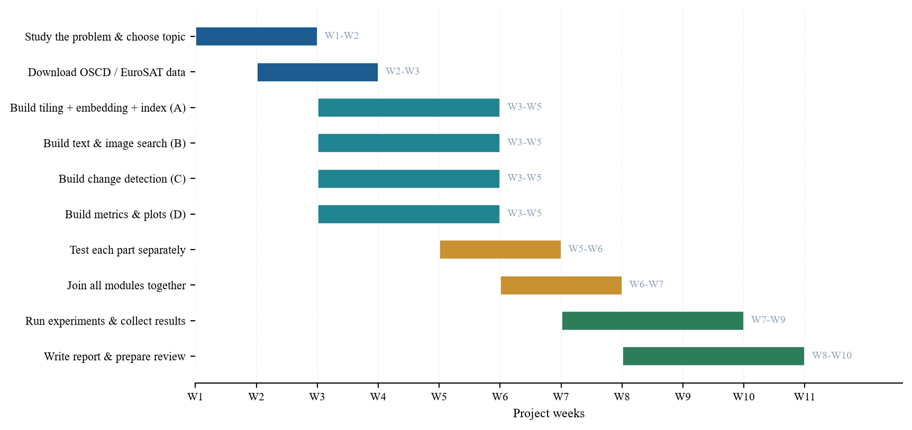
Fig. 1. Gantt chart of the project plan
The yellow bars in the middle are our testing stage. Before joining everything we test each part seperately, and if something isnt working we fix that part first and then continue.

3. DESIGN APPROACH AND DETAILS
3.1 System Architecture
The design of our proposed system is shown in Fig. 2. The most important idea of the whole project is the orange box in middle, the shared index. Normally a system which searches images and a system which finds change will each build their own features. In our design we build the features one time only and both sides use the same.
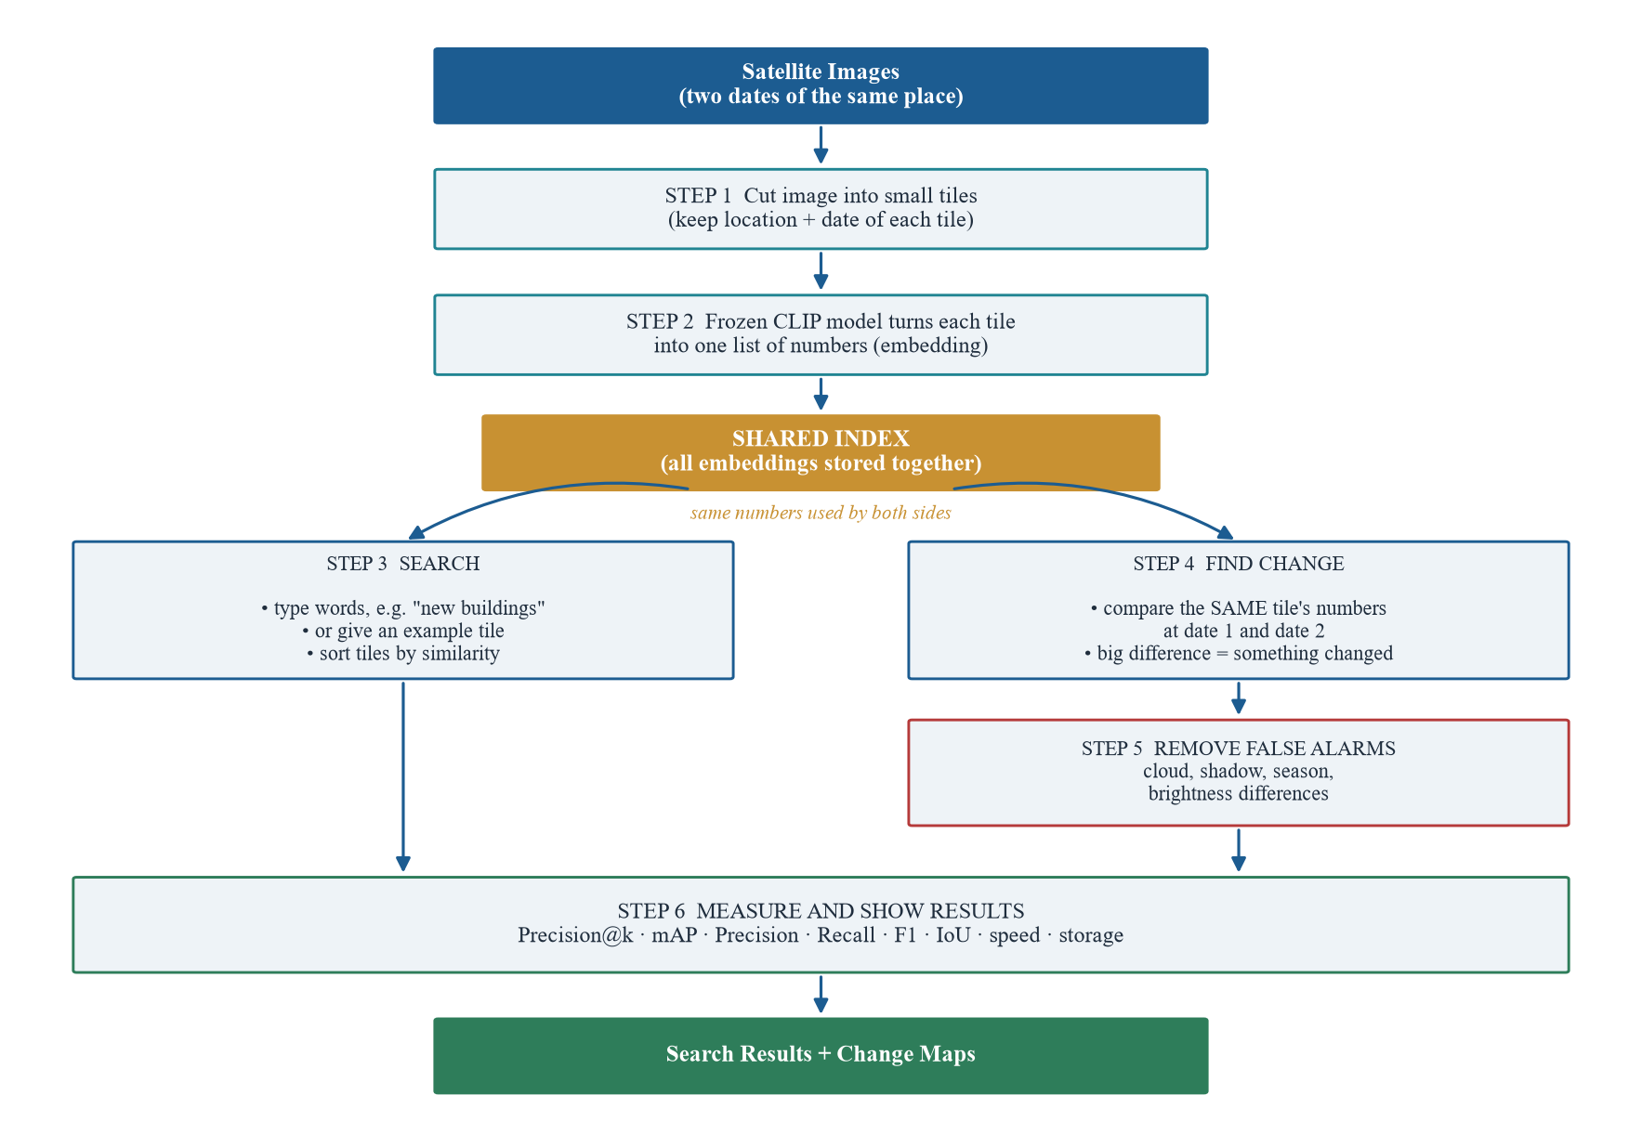
Fig. 2. System architecture
Each step is explained below, with reason why we did it like that.
- Step 1: Cut into tiles. One full satellite image is too big to handle at once, and also we want the result to point to a small spot and not the whole scene. So we cut each image into small square tiles. with every tile we keep coordinates and date, becuase result wich says "something changed" is of no use if we cant say where.
- Step 2: Make embeddings. Each tile goes through pre-trained CLIP or RemoteCLIP model, which turns the picture into a list of 512 numbers. Tiles which look alike get similer numbers. We freeze the model, means we dont train it at all, we only use it for prediction. We tried RemoteCLIP because normal CLIP was trained on everyday photos and not on satellite views.
- Shared index. All these number lists we store together in one index. This is the heart of our idea. Since the numbers describe how tile looks, the same numbers can answer "find tiles like this" and also "did this tile change?". Making them once saves memory and time both.
- Step 3: Search. When user types words, the same CLIP model turns those words into numbers in the same space. Then we compare the query numbers with every tile's numbers and sort the tiles by how close they are. User can also give an example tile in place of words.
- Step 4: Find change. For one place at two dates, we take the two embeddings of that tile and measure the distance beetween them. Small distance mean nothing much happened, large distance means something changed. After that we compare the pixels to find exactly wich part changed, and we label the chnage as construction,clearance, water or vegitation.
- Step 5: Remove false alarms. This step is there becuase two images of same unchanged place can still look very diffrent. A cloud may be in between, sun may be at different angle, or season may have changed the colour of plants. First we match the brightness of both images, then mask out cloud and shadow, and lastly give each change confidence score. We prefer to report less changes which are correct than many changes which are wrong.
- Step 6: Measure. At last we measure everything. For search we use Precision@k and mAP, which tell how many of the top results was actualy relevant. For change we use Precision, Recall, F1 and IoU, which compare our change map with the correct answer given in the dataset. We also note the speed and storage used.

4. DATASET DETAILS
4.1 OSCD Dataset
We needed a dataset which has two images of same place taken at diffrent times, and also the correct answer of what changed, so that we can check our output in numbers. The Onera Satellite Change Detection (OSCD) dataset gives this. It is real Sentinel-2 data, which is one of the image sources named in the problem statement. The two images of every city are allready aligned with each other, and the whole dataset is only around 513 MB so we could run it on laptop.
Property | Value
Number of image pairs | 24 cities (14 for training, 10 for testing)
Satellite and sensor | Sentinel-2, MultiSpectral Instrument (MSI)
Bands per image | 13 (B01 to B12 and B8A), stored as separate GeoTIFF files
Ground resolution | 10 m per pixel
Years covered | 2015 to 2018; two dates of a pair are about 1 to 2.5 years apart
Image sizes | From 385 x 241 px (norcia) to 1070 x 1180 px (beirut)
Ground truth | One black and white change mask per city (white = changed)
Total pixels | 9,595,514
Pixels labelled as changed | 308,267 (3.21%)

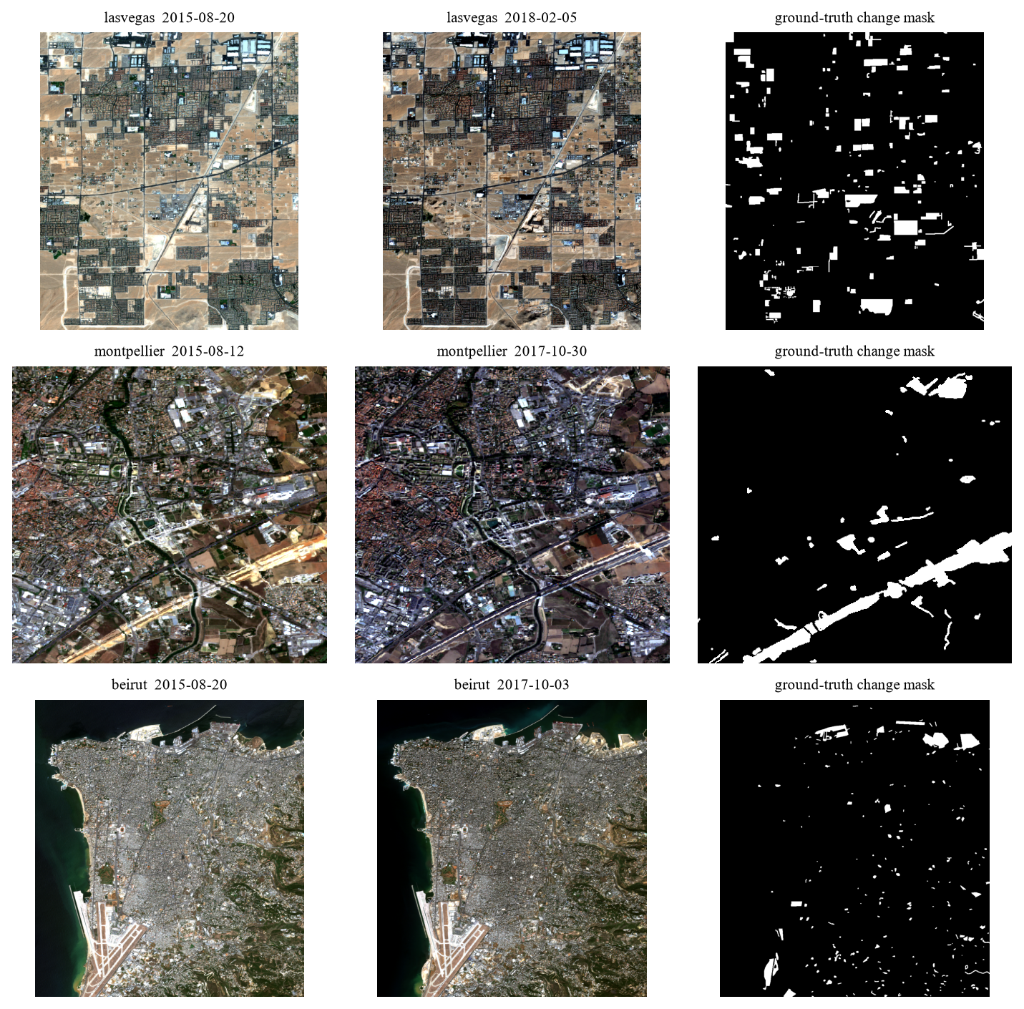
Fig. 3. Three city pairs from OSCD with their ground-truth change masks
4.2 The 24 City Pairs
Below table lists every pair which we used. The last column shows how much of the imgae is marked as changed. This number is small everywhere.
City | Size | Date 1 | Date 2 | Chg % | City | Size | Date 1 | Date 2 | Chg %
aguasclaras | 525 x 471 | 2015-09-16 | 2017-10-15 | 1.64 | beirut | 1070 x 1180 | 2015-08-20 | 2017-10-03 | 2.69
bercy | 360 x 395 | 2016-11-30 | 2017-08-29 | 0.74 | mumbai | 557 x 858 | 2015-11-30 | 2018-03-19 | 2.56
bordeaux | 461 x 517 | 2016-05-04 | 2017-10-26 | 1.00 | brasilia | 469 x 433 | 2015-09-16 | 2017-10-17 | 2.58
nantes | 582 x 522 | 2015-08-21 | 2017-10-14 | 1.14 | montpellier | 451 x 426 | 2015-08-12 | 2017-10-30 | 6.79
paris | 390 x 408 | 2016-11-30 | 2017-11-07 | 0.29 | norcia | 385 x 241 | 2015-07-11 | 2017-10-18 | 1.32
rennes | 563 x 339 | 2015-08-21 | 2017-06-21 | 2.58 | rio | 426 x 353 | 2016-04-24 | 2017-10-11 | 5.69
saclay_e | 688 x 639 | 2016-03-15 | 2017-08-29 | 0.99 | saclay_w | 688 x 639 | 2016-03-15 | 2017-08-29 | 1.14
abudhabi | 785 x 799 | 2016-01-20 | 2018-03-28 | 3.76 | valencia | 476 x 458 | 2016-07-30 | 2017-11-07 | 0.44
cupertino | 788 x 1015 | 2015-09-18 | 2018-03-26 | 2.37 | dubai | 634 x 774 | 2015-12-11 | 2018-03-30 | 9.92
pisa | 718 x 776 | 2015-07-04 | 2018-02-11 | 1.64 | lasvegas | 716 x 824 | 2015-08-20 | 2018-02-05 | 7.67
beihai | 772 x 902 | 2016-12-09 | 2018-03-09 | 2.49 | milano | 558 x 545 | 2016-12-28 | 2018-01-22 | 0.80
hongkong | 540 x 695 | 2016-09-27 | 2018-03-23 | 3.56 | chongqing | 544 x 730 | 2017-04-14 | 2018-04-02 | 7.21

4.3 Metadata We Extract
Metadata mean the information about a image,not the image itself. We collect it from the dates.txt file, the .geojson file and the GeoTIFF header, and attach it to every tile. So any search result or change result can be traced back to a city, a date and a position.
Field | Example | Where it comes from
tile_id | aguasclaras_d1_y0_x0 | we build it
city | aguasclaras | folder name
date | 2015-09-16 | dates.txt
sensor | Sentinel-2 MSI | dataset documentation
gsd_m (pixel size in m) | 10 | dataset documentation
x, y (position in the image) | 0, 0 | tiling step
tile_px | 64 | our setting
changed_frac | 0.0002 | ground-truth mask (only for scoring)
water / vegetation / builtup | true or false | NDWI and NDVI from bands B03, B04, B08
footprint (lon/lat) | [-48.0498, -15.8596, -48.0016, -15.8164] | .geojson file

OSCD does not tell wich tiles are showing water or vegetation, but we need some corect answer to score the text search. So we calcualte NDVI and NDWI from bands and tag a tile as water, vegetation or builtup from that. these tags are made by formula and not by a person, so they are not perfect.
4.4 EuroSAT Dataset
Because the tags above are not perfect, we also tested the search part on EuroSAT. It has 27,000 Sentinel-2 patches of 64 x 64 px, and each patch is labelled by people in to one of 10 land types (river, forest, highway, residential and so on). It is the same satellite and same patch size as our OSCD tiles. EuroSAT has no image pairs, so we use it only for search and not for change.
4.5 LEVIR-CD Dataset
OSCD is 10 m per pixel, so to check our change idea on sharp images we also used LEVIR-CD. It has pairs of 1024 x 1024 px images at 0.5 m per pixel, taken 5 to 14 years apart, with masks of new or removed buildings. We didnt train anything, so we used only the validation part (64 pairs, to pick thresholds) and the test part (128 pairs, for the scores). We cut them into tiles of 256 px.

5. IMPLEMENTATION
5.1 Code Structure
We wrote the project in Python. We split the code in small files so that each of us can work on own part without waiting for others.
File | What it does
src/ingest.py | reads images and cuts them into tiles, keeps metadata with each tile
src/embedder.py | loads the pre-trained CLIP model and turns tiles or text into embeddings
src/index_builder.py | stores all embeddings in one shared index and searches it
src/retrieval.py, filters.py | text search, image search, and date / sensor / area filters
src/change_detect.py | change score from embeddings, pixel change map, baseline methods
src/suppress.py | brightness matching, cloud / shadow mask, removing small specks
src/metrics.py | Precision@k, AP, precision, recall, F1, IoU
experiments/run_oscd.py, run_eurosat.py | run the full experiments and save the numbers

pip install -r requirements.txt
python experiments/run_oscd.py # change detection + search on OSCD
python experiments/run_eurosat.py # search test on EuroSAT

5.2 Loading the Data and Tiling
For each city we read four bands for both dates: B02 (blue), B03 (green), B04 (red) and B08 (near infrared). First three make the colour picture which we give to the model, and B08 is used only for the NDVI and NDWI tags. The band values are 16-bit numbers, so we rescale them to 0 to 255. The dates we read from dates.txt.
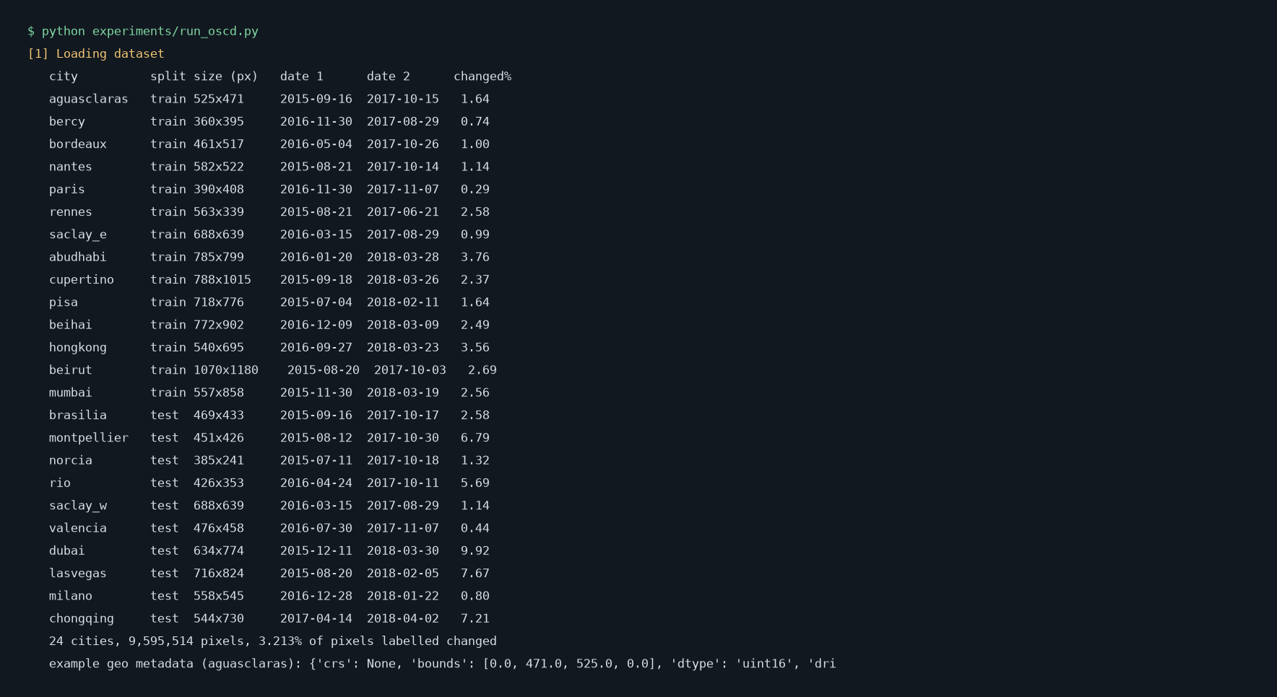
Fig. 4. Program output: loading the 24 OSCD city pairs
One whole city image is to big to describe with one embedding. So we cut each image into square tiles of 64 x 64 pixels with no overlap. At 10 m per pixel one tile covers 640 m x 640 m on the ground. Like this we got 4,278 tiles, that is 2,139 places at two dates each.
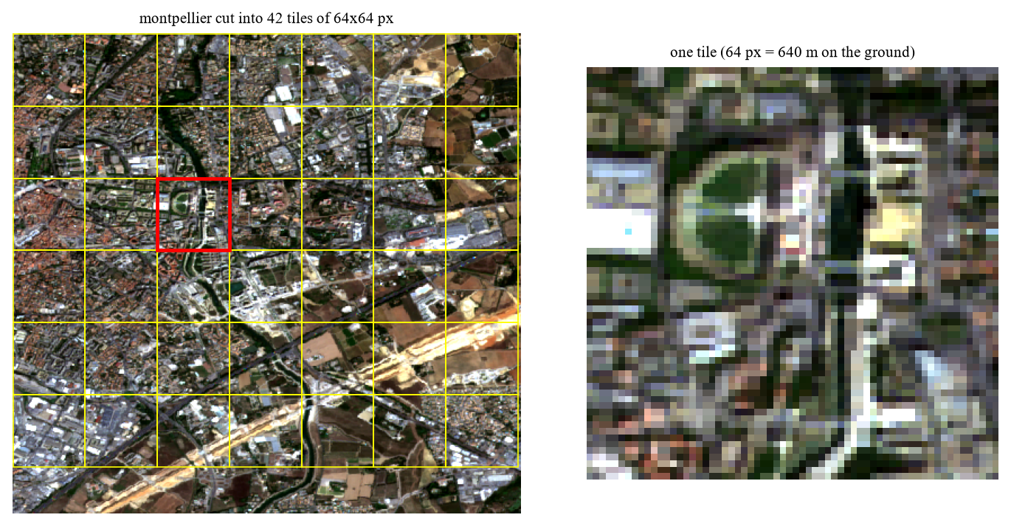
Fig. 5. Left: one city cut into tiles. Right: a single 64 px tile
5.3 Embedding and the Shared Index
Every tile we pass through a pre-trained CLIP model and we get back 512 numbers for each tile. This list of numbers is the embedding. We tried two models, RemoteCLIP and the normal OpenCLIP ViT-B/32. We didnt train any of them. We make every embedding of length 1, so similarity of two tiles is simply the dot product. All embeddings go in one array and the metadata in a list of same order. these two together is our shared index, and both search and change part read from this one index only.
On laptop CPU, embedding all 4,278 tiles took 169 seconds,around 25 tiles per second. The index takes 8.76 MB and one search takes about 0.32 ms. Later we shifted to the laptop GPU (GTX 1650 Ti) and it became about 5 times faster.
5.4 Search
For text search the typed words go thru text side of same CLIP model. This give 512 numbers in the same space as the tiles. Then we take the dot product with every tile and sort from highest to lowest. image search is same thing, only the query is the embedding of a tile which the user picked.
q = embedder.encode_text("a satellite image of a river")[0]
scores = index.vectors @ q # one similarity score per tile
top = np.argsort(-scores)[:10] # best 10 tiles

5.5 Change Detection and False Alarm Removal
We calculate change in two ways. First one is our main idea: for one place, take its embedding at date 1 and at date 2 from the shared index and measure how far they are. Second one is normal pixle comparison, which gives the exact shape of the change. Before comparing the pixels we try to remove false alarms in three steps:
1. Brightness matching. We shift and scale date 2 so that each colour channel have same average and spread as date 1.
2. Cloud and shadow mask. We mark the large, smooth, very bright or very dark areas as unusable.
3. Removing small specks. We delete very small changed regions, because we expected them to be noise.
We compare with three simple methods which need no training: pixel diffrence with Otsu threshhold, Change Vector Analysis (CVA) and SSIM diffrence. The pixel threshhold we chose using the 14 training cities and used it as it is on the 10 test cities.
5.6 Problems We Faced
- Bright roofs were treated as cloud. Our first cloud mask was removing every very bright pixel. But new concrete roofs are allso very bright, so it was deleting real new buildings.
- Wrong order of steps. First we made the cloud mask after brightness matching, and then mask stopped finding the cloud. Now we make it from the original images.
- Small changes got deleted. We were removing all small changed regions thinking its noise. On real data the small regions are many times real change only.

6. RESULTS AND ANALYSIS
6.1 Setup
Item | What we used
Computer | Laptop, Intel Core i5-10300H, 16 GB RAM, GTX 1650 Ti, Windows 11
Software | Python 3.14, PyTorch 2.14, open_clip 3.3, OpenCV 5.0, NumPy 2.5
Models | RemoteCLIP ViT-B/32 and OpenCLIP ViT-B/32, both pre-trained, not trained by us
Data | OSCD: 24 city pairs, 4,278 tiles of 64 x 64 px. EuroSAT: 27,000 patches. LEVIR-CD: 192 pairs

6.2 Text Search
First we tried text search on the OSCD tiles with three queries (water, vegetation, buldings) and checked with our formula tags. The result was weak: mAP was 0.158 for OpenCLIP and 0.137 for RemoteCLIP, and random gives 0.121. Only the buildings query with OpenCLIP was good (8 of first 10 correct). We think the reasons are that our tags are strict and not made by people, and very few tiles are tagged as water or vegetation. We also looked at about 50 tagged tiles by eye, and nearly one third of the buildings tags was wrong (bare sand was tagged as buildings).
So we repeated the text search on EuroSAT, where the labels are made by people. We typed one query for each of the 10 land types. P@10 means how many of the first 10 results was correct, and AP looks at the whole ranking. A random system gets 0.10.
Query (land type) | OpenCLIP P@10 | OpenCLIP AP | RemoteCLIP P@10 | RemoteCLIP AP
AnnualCrop | 0.50 | 0.364 | 0.10 | 0.238
Forest | 1.00 | 0.335 | 0.00 | 0.067
HerbaceousVegetation | 0.00 | 0.207 | 0.00 | 0.128
Highway | 1.00 | 0.720 | 0.40 | 0.205
Industrial | 1.00 | 0.912 | 0.80 | 0.563
Pasture | 0.70 | 0.324 | 0.60 | 0.259
PermanentCrop | 0.70 | 0.422 | 0.90 | 0.310
Residential | 0.90 | 0.574 | 0.30 | 0.495
River | 0.90 | 0.428 | 1.00 | 0.656
SeaLake | 0.20 | 0.076 | 0.40 | 0.125
Mean | 0.69 | 0.436 | 0.45 | 0.305

Here the text search works much better. OpenCLIP gets mAP 0.436 and on average 69% of the first 10 results are corect, where random is 10%. The other model gets mAP 0.305. It is not same for all land types: the best query is Industrial (AP 0.91) and worst is SeaLake (AP 0.08). When we use the text to directly classify each patch, OpenCLIP is correct 48% of the time.
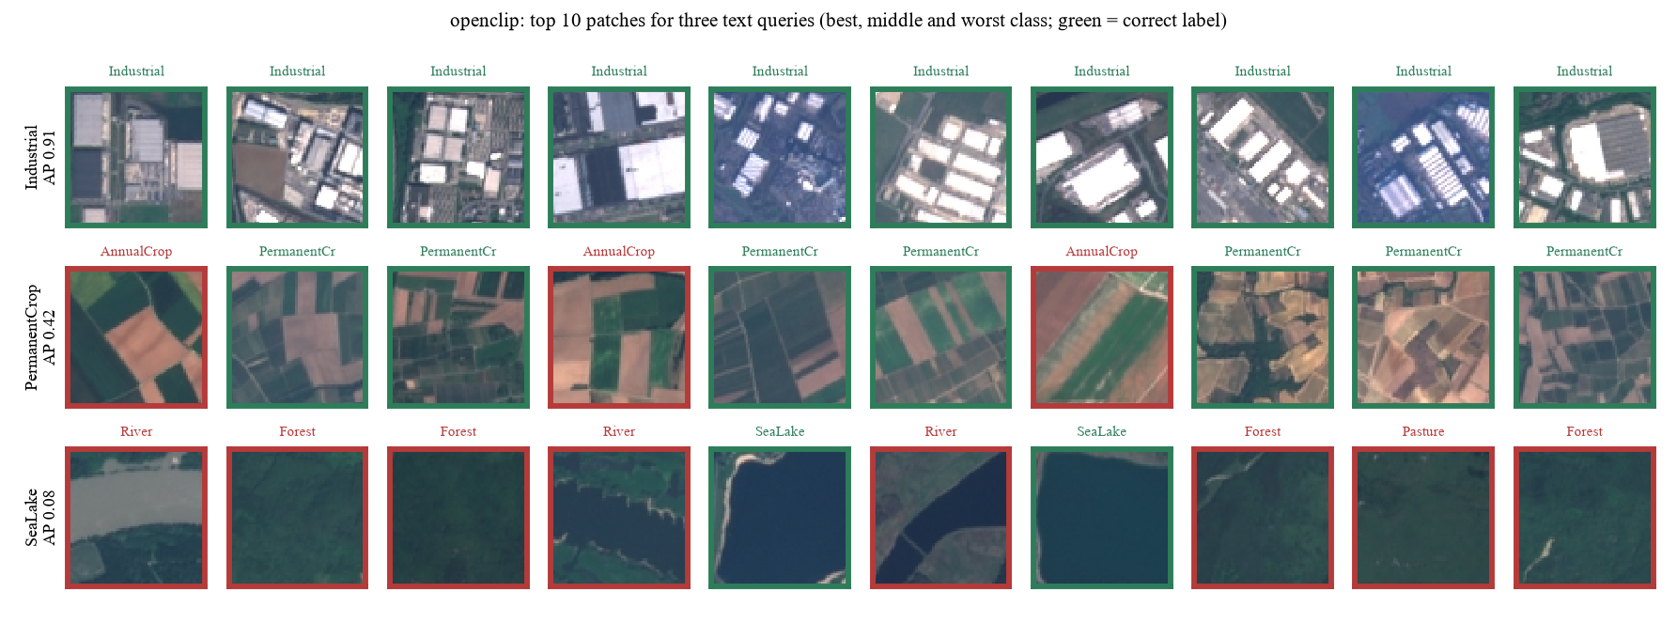
Fig. 6. EuroSAT: top 10 patches from OpenCLIP for the best, a middle and the worst query (green = correct label)
6.3 Image Search
For image search on OSCD we take tile from date 1 and search in all the 2,139 tiles of date 2. The correct answer is the tile of same place.
Model | Correct tile is first | In the top 5
Random guess | 0.05% | 0.23%
OpenCLIP | 45.4% | 62.0%
RemoteCLIP | 46.1% | 60.8%

The corect place comes first about 46% of the time, where a random guess will be right about 0.05% of the time. So embedings do capture how place looks, even when the two pictures are one to two years apart. On EuroSAT also image serach is strong: for 94% of the patches the nearest patch is of the same land type.
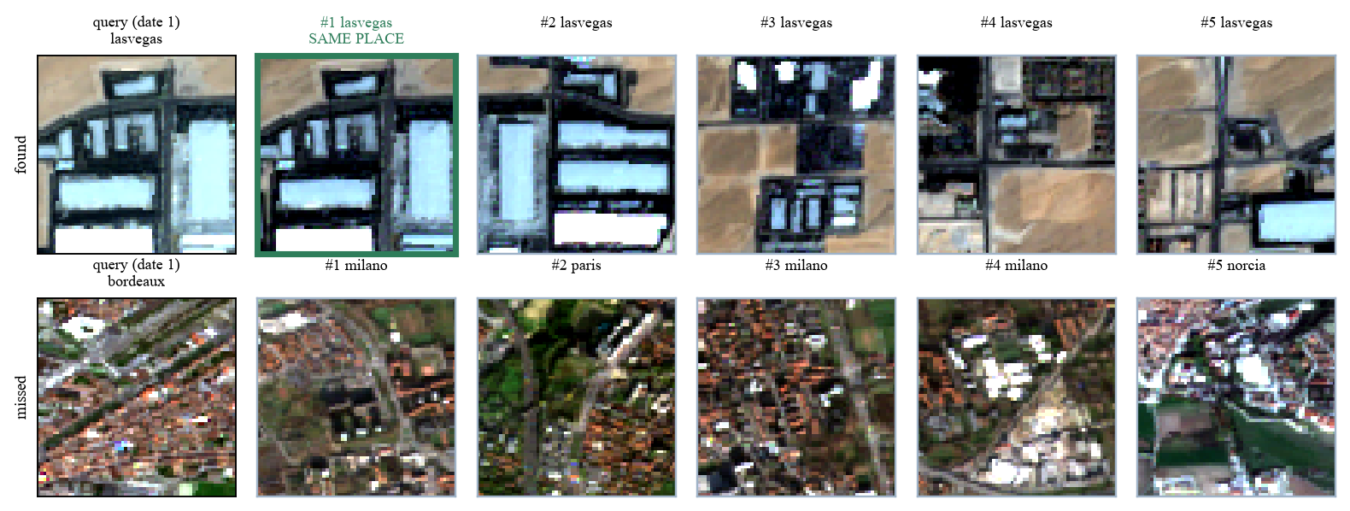
Fig. 7. Image search across dates. Top row: same place found first. Bottom row: a miss
6.4 Embeddings as a Change Signal
This is the test of our main idea: can the embeddings of a place at two dates tell us that the place changed? We call a tile 'changed' if at least 5% of its pixels are marked in the ground truth. AUC is 0.5 for random guessing and 1.0 for perfect. We tried it in two ways. First with one embedding for the whole tile. Second with the patch features, where the model give a small grid of features inside the tile and we compare the grid of date 1 with the grid of date 2 and take the 10% most different patches. We picked the model on the training part and the scores below are on the test part.
Change score for a tile | OSCD (10 m) | LEVIR-CD (0.5 m)
Pixel difference | 0.640 | 0.698
One embedding for the whole tile | 0.564 | 0.823
Patch features (top 10% patches) | 0.696 | 0.924
Random guess | 0.500 | 0.500

On OSCD the whole tile embedding is weak, it is even below the simple pixel difference (0.56 and 0.64). The reason we think is that at 10 m a new bulding is only few pixels, so one embedding of the whole tile hardly moves, but season and light move it. with patch features it goes up to 0.70, which is better than pixel difference but still not high . On LEVIR-CD the picture is different. There the whole tile embedding allready gets 0.82 and the patch features get 0.92, where pixel difference gets only 0.70. So our main idea works when images are sharp, and its weak when one bulding is only 2 or 3 pixels. (OSCD scores are with CLIP ViT-B/32, LEVIR-CD with RemoteCLIP ViT-B/32. Bigger models like CLIP ViT-B/16 and DINOv2 did not do better.)
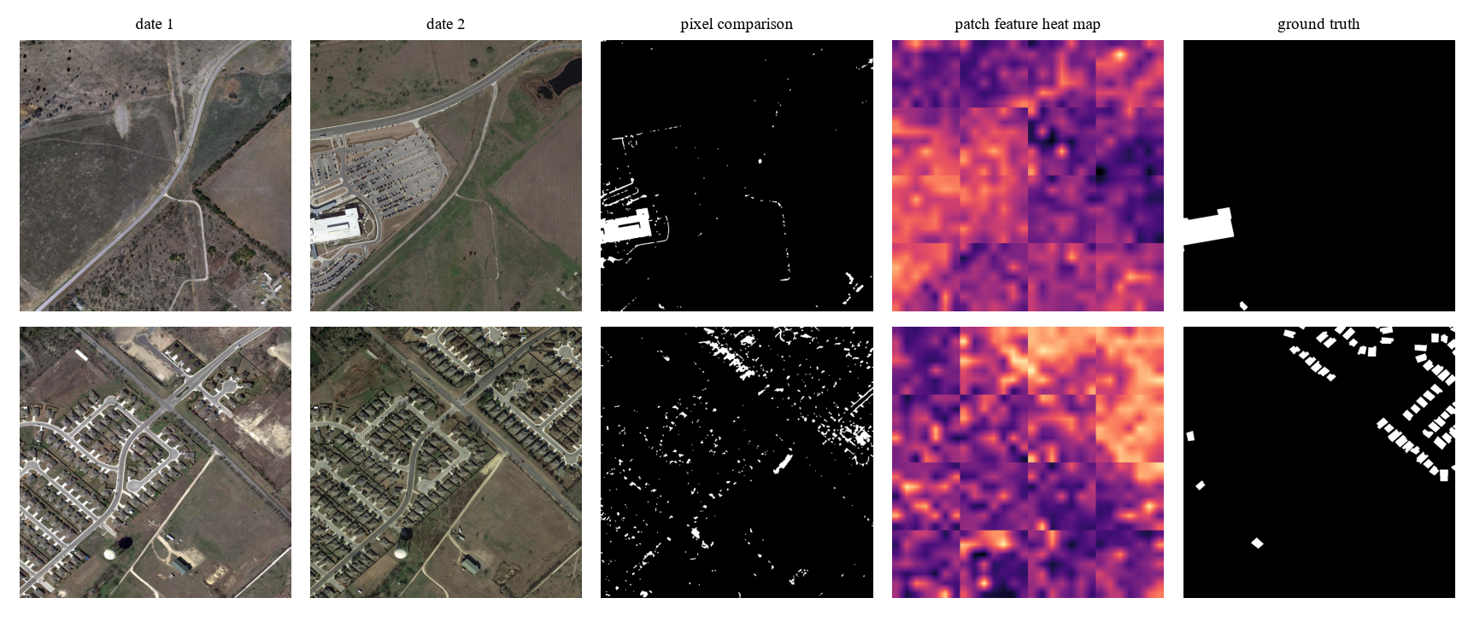
Fig. 8. LEVIR-CD examples: the two dates, pixel comparison, our patch feature heat map and the ground truth
6.5 Change Maps
Next we compare the full change maps with ground truth, pixel by pixel. FPR is the share of unchanged pixels which were wrongly marked as changed. First table is for the 10 OSCD test cities.
Method (OSCD) | Precision | Recall | F1 | IoU | FPR %
Pixel difference + Otsu | 0.152 | 0.528 | 0.236 | 0.134 | 16.09
SSIM differencing | 0.100 | 0.909 | 0.181 | 0.099 | 44.44
Change Vector Analysis (CVA), 3 bands | 0.359 | 0.347 | 0.353 | 0.214 | 3.38
Ours, brightness matching, 3 bands | 0.278 | 0.332 | 0.302 | 0.178 | 4.69
Ours, brightness matching, all 13 bands | 0.460 | 0.267 | 0.338 | 0.203 | 1.71

On OSCD the CVA method still has the highest F1 (0.353). When we use all 13 bands in place of three, our F1 go from 0.302 to 0.338 and our precision becomes highest (0.460), with only 1.71% false alarms. The scores are very different from city to city. We get F1 0.60 on lasvegas,which has large new buldings on plain ground, but only 0.03 on valencia, where allmost nothing changed and the farm fields change colour between the two dates.
Method (LEVIR-CD) | Precision | Recall | F1 | IoU | FPR %
Pixel difference + Otsu | 0.057 | 0.366 | 0.099 | 0.052 | 32.43
Change Vector Analysis (CVA) | 0.079 | 0.078 | 0.078 | 0.041 | 4.85
Ours, brightness matching | 0.134 | 0.202 | 0.161 | 0.088 | 6.98
Ours, patch feature heat map | 0.264 | 0.604 | 0.368 | 0.225 | 9.03

On LEVIR-CD all the pixel comparison methods are bad, because the two dates are many years apart and trees, grass and shadows all look different. Here our patch feature heat map is the best one (F1 0.368, it finds 60% of the changed pixels). But the heat map is coarse, so it marks the area around a new building and not its exact shape, and that is why precision is low. Methods which are trained on LEVIR-CD get much higher scores then this, we did not train anything.
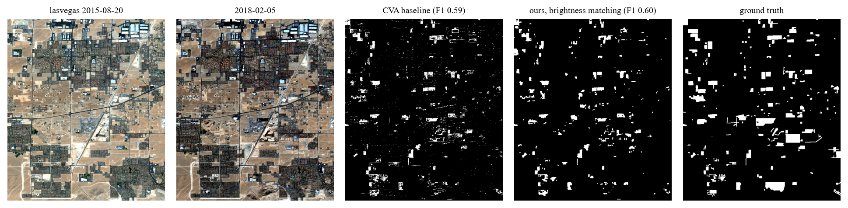
Fig. 9. OSCD, a good case (lasvegas)
6.6 False Alarm Removal
Steps used (OSCD) | Precision | Recall | F1 | FPR %
none | 0.114 | 0.575 | 0.190 | 24.38
brightness matching only | 0.242 | 0.518 | 0.330 | 8.82
+ cloud/shadow mask | 0.240 | 0.503 | 0.325 | 8.69
+ remove small specks | 0.229 | 0.337 | 0.273 | 6.19

Brightness matching is useful step. False alarms fall from 24.38% to 8.82% of unchanged pixels and about 90% of the real change is still found. The other two steps didnt help on OSCD. The cloud mask made allmost no diffrence,and on rio it removed dark water thinking it is shadow. removing small specks lowered the recall to 0.337, becuase in OSCD a new building is many times only few pixels.
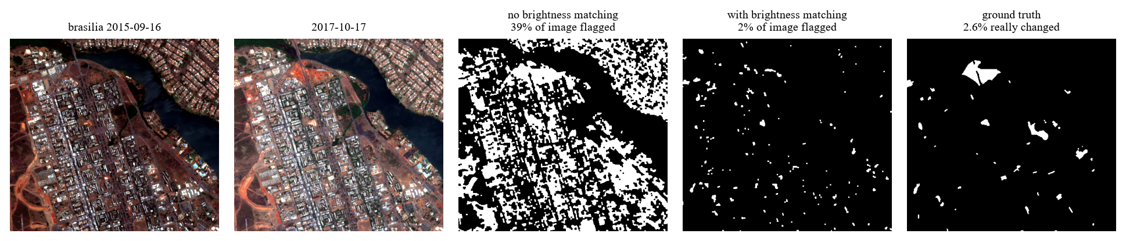
Fig. 10. Brightness matching on brasilia: flagged area falls from 39% to 2% of the image
6.7 Summary and Future Work
What we tested | Result | Did it work?
Image search (same place, OSCD) | 46% top-1 (random 0.05%) | Yes
Text search on EuroSAT | mAP 0.44 (random 0.10) | Yes
Text search on OSCD tiles | mAP 0.16 (random 0.12) | Only little
Change from embeddings, LEVIR-CD (0.5 m) | AUC 0.92 (pixel difference 0.70) | Yes
Change from embeddings, OSCD (10 m) | AUC 0.70 (pixel difference 0.64) | Only little
Brightness matching | false alarms 24.38% to 8.82% | Yes
Exact change maps, pixel by pixel | best F1 0.35 OSCD, 0.37 LEVIR-CD | Weak

So one shared index can do both works. Search works, and the same features can also tell which tile changed when the images are sharp like LEVIR-CD. At 10 m resolution it is weak, there we still need the pixel comparision with brightness matching. Drawing the exact shape of the change is the weak part of our project in both datasets. Next we want to use the patch features at more than one tile size, so that the heat map becomes less coarse.
7. DATASET LINKS
- OSCD (Onera Satellite Change Detection): https://rcdaudt.github.io/oscd/
- EuroSAT: https://github.com/phelber/EuroSAT
- LEVIR-CD: https://justchenhao.github.io/LEVIR/
- Copernicus Sentinel-1 / Sentinel-2: https://dataspace.copernicus.eu/
- USGS Landsat Collection 2: https://earthexplorer.usgs.gov/
- NRSC / ISRO Bhuvan: https://bhuvan-app3.nrsc.gov.in/data/download/
- SIH 2026 problem statement SIH26227: https://www.sih.gov.in/sih2026PS

