Question 1:

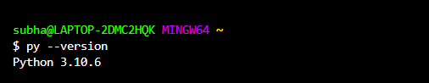

Question 2:

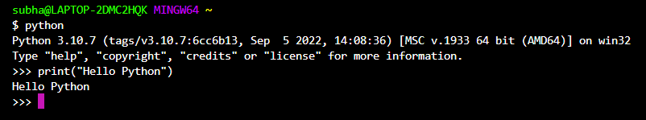

Question 3:

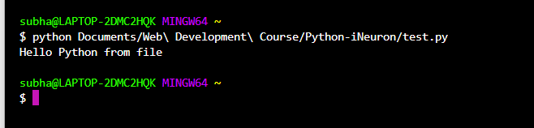

Question 4:

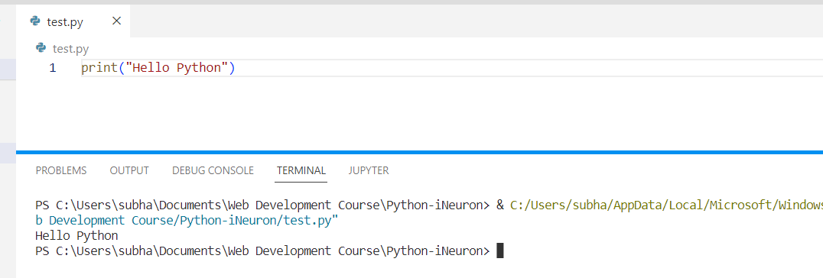

Question 5:

print("Hello \nPython")

Question 6:

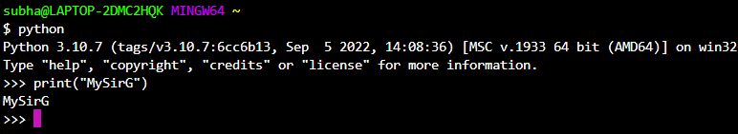

Question 7:

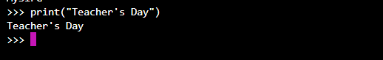

Question 8:

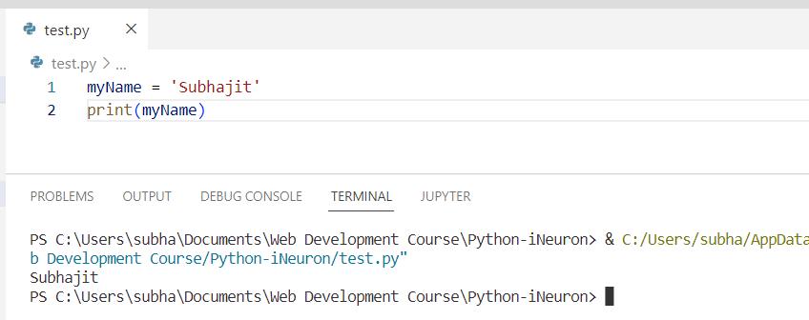

Question 9:

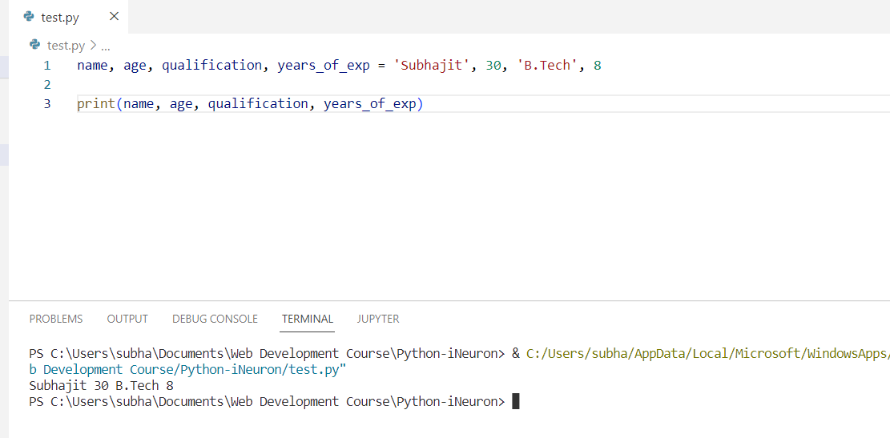

Question 10:

