**Exploring Learning abilities of Traditional  ML Algorithms Across Market Cycles: A  Comparative Study in Indian Context**

# Abstract

A total of six algorithms have been used in the current study, such as multinomial logistic regression (MLR), support vector machine (SVM), decision tree (DT), naive bayes (NB), random forest (RF) and artificial neural network (ANN), to predict of directional movement over 3 and 5 days. Five clusters have been created out of the 6 years using Kmeans on the basis direction of movement and volatility. Three clusters captured three types of movements such upward, downward and sideways (or range bound) movement. Two clusters were created based on volatility. MLR & NB have achieved an accuracy of 100% for both homogeneous and heterogeneous data across 3-day and 5-day ahead prediction. Average accuracy of RF stands at 75.5% and 84%. Average accuracy of DT and ANN hovers around 64%. Ridge , LASSO and Spline were used to predict periodic return. It is observed that spline is the most accurate method to predict 3-day and 5-day ahead return and Williams R has emerged as the most important predictor of periodic return.

# Introduction

Traditional machine learning models refer to probabilistic models such as linear regression, binomial logistic regression, multinomial logistic regression, decision tree, support vector machines, K-nearest neighbour, naive bayes. Studies like Bustos and Pomares-Quimbaya (2020) shows that with passage of time ensemble models and deep learning are gaining much acceptance. Studies like Mokhtari et al. (2021) have clubbed such as extreme gradient boositng (XGB) along with other probabilistic models for comparative study.

The proposed study is being conducted in the backdrop of two reports published by Security Exchange Board of India (SEBI). These two reports underline trading characteristics of Indian stock market. One report show that Indian traders are preferring algorithmic trading and increased preference to use mobile phones for trading (Handbook of Statistics 2023-24). 1. Another study clearly underlines the propensity of retail traders to trade riskier assets such future, options and also their pathetic performance 2. It has been observed that 89% of the individual traders who traded in index options incurred an average loss of Rs.77,000. 89% of the individual traders incurred losses averaging Rs. 110,000 in 2022. For active traders, the average loss was over



15 times of the average profit. Abysmal trading performance coupled with increasing preference towards trade in riskier assets using algorithmic trading, implies that traders need to have clarity with respect to their performance.

## Model Selection Problem

Poor trading performance of retail investors clearly underlines their inability in three aspects of trading -

* inability to predict direction of market movement
* inability to predict the extent of movement or periodic return
* and most importantly which model to select for forecasting

It is normal for a retail trader to be in dilemma on selection of recommendation system whether to follow the recommendations of trading rules based on technical indicators Ergun et al. (2023), the recommendations of ML algorithms Nabipour et al. (2020).

In case, a retail trader chooses to follow the recommendations of ML algorithms, consequently questions arises on selection of algorithm and also its fitness with respect to the market situation encountered by him. The comparative studies of performance of ML models are empirical in nature and do not offer explanations for the superior performance of the proposed model compared to other base models.

There are two types of comparative studies which a person come across. First, where upfront the performance of ML algorithms have been compared and in the second case ML models have been used as base cases to prove the superiority of a proposed model Kia et al. (2018). Given the emperical nature of comparative studies, they vary extensibly with respect to application of ML models. In terms of choice of prediction horizon, **?** has a horizon of 1 year and Khan et al. (2023) has a horizon of 1 day as well as 15 minutes.Bustos and Pomares-Quimbaya (2020) shows that the the predominant choice of inputs for ML models is the historical market information (open, high, low, close, and volume) along with technical indicators. But studies such as (Campisi et al., 2024) have mostly used volatility indices for prediction of direction of S&P 500. Similarly, wide range of options are available to train the models e.g. (Khan et al., 2023) has split the dataset into 70.67% : 29.33%, whereas as Ismail et al. (2020) used 50% for training and 50% for testing, whereas the popular data split rations are 80:20, 70:30 etc Giudici et al. (2023).

The significant part is there is no universal superior ML model. Ayala et al. (2021) has shown that for certain datasets, simple method like linear regression has outperformed sophisticated algorithms such as artificial neural network (ANN), random forest (RF) and support vector machine (SVM). the study of Mokhtari et al. (2021) has shown that SVM and LR has out performed ANN, which considered to be superior method to account for non-linearities and shocks of stock market. The study of Khan et al. (2023) underlines that with change prediction horizon the performance of the ML models changed, whereas the dataset remained the same for both prediction horizon.

Further, most of the studies while presenting the performance of ML models under consideration hardly factor in market conditions. This implies that the best performing model will retain their performance for all market conditions or datasets.

## Research Objective

Stock market operates in cycles i.e. accumulation and distribution. Market cycles often lead to trend reversals (i.e. change of direction), which can be explained with the help of investor sentiment (Checkley et al., 2017). (Oppenheimer, 2020) has observed that during despair and optimism volatility increases, while during the hope and growth phases volatility decreases.

[]

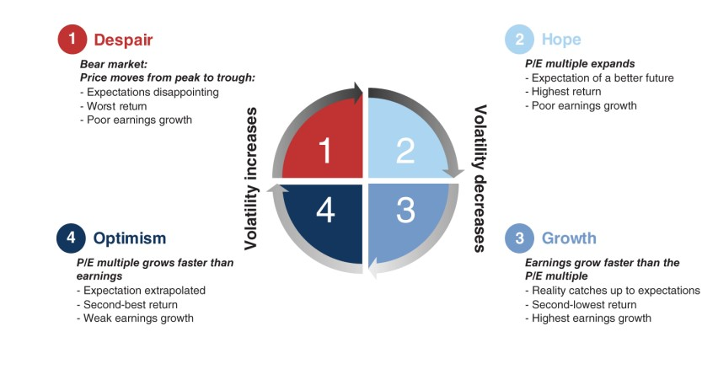

[]

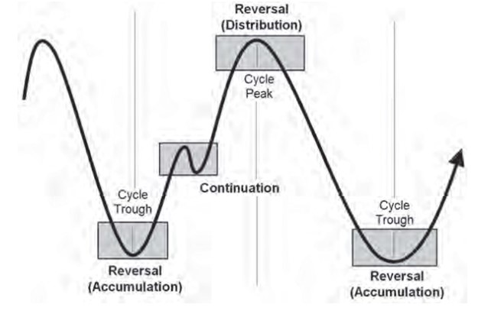

Figure 1: left panel - Market Sentiment , right panel Market Cycle

In an Indian context, a retail investor can obtain information about volatility, trend, or momentum from VIX and other technical indicators to form an idea of the current market condition. This information is either available or can be easily estimated. Thus, a retail investor would like to know, how the traditional ML algorithms perform for various market conditions. In this context , the research objectives of the study are as follows -

* to examine the performance of traditional ML algorithms (multinomial logistic regression (MLR), support vector machine (SVM), decision tree (DT), random forest (RF), naive bayes (NB) and artificial neural network (ANN)) in the context prediction of direction (3-days and 5-days ahead).
* to compare the performances of the aforementioned algorithms under different market conditions (with respect to direction and volatility)
* to compare of the performance of traditional algorithms (such as multivariate adaptive regression (spline), regularized regression (ridge and LASSO) for prediction of periodic return (3-day & 5-day ahead return)
* to identify the predictors of periodic returns for entire study period and also for different market condition and also to underline the changes if any.

# Literature Review

In this section, performance of the traditional ML models will be presented as obtained in the past studies. In cases where a model has been applied to different markets , average accuracy has been estimated for comparison purpose.

Ayyildiz and Iskenderoglu (2024) used DT, RF, KNN, NB , LR, SVM and ANN to predict the direction of seven markets. It is observed that the average accuracy of ANN stand at 83.43%, which is highest. This is followed by LR with an accuracy of 82.56% and SVM with an accuracy of 79.43%. It is also observed that out of the seven markets , in three markets accuracy of logistic regression is higher than that of ANN.

Campisi et al. (2024) compared performance of lieanera regression, linear discriminant analysis, LR, RF, XGM, Bagging to predict direction of S&P 500 after 30 days. They also used linear regression ,ridge , LASSO to estimate return over 30 days. Khan et al. (2023) used DT, LR, KNN , NB, RF, SVM, ADA boost, XGB, ANN to predict the direction of movement Tesla stock. The highest accuracy is achieved by LR , followed by XGB, ANN and RF. But the prediction horizon was reduced to 15 minutes, highest accuracy is achieved by RF , followed by ADA and XGB and ANN. Oukhouya and El Himdi (2023) used to SVR, XGB, LSTM, MLP to predict daily prices of MSI 20 index. The study showed that both MLP and SVR achieved an accuracy of 98.9%, followed by XGB and LSTM. Mcwera and Mba (2023) deployed SVM , KNN , DT and SVM to repdict the next day’s direction of five stocks of South African Banks. Accuracies differ widely across the datsets. The accuracy range of SVM is 62.49% to 99.49%. The same for KNN is 47.79 to 85.03% . For DT , the accuracy range stands at 51.74% to 53.62%. The same for majority voting is 81.67% to 93.39%, which makes it the most accurate model.

Mokhtari et al. (2021) used LR, Gaussian Naive Bayes, Bernouli Naive Bayes, DT, RF, SVM, XGB and ANN for forecasting the the daily stock price of Apple. SVM achieved the highest accuracy of 75.5%, followed by RF and LR , both having an accuracy of 72.7%. Ayala et al. (2021) compared the performance of linear regression (LR), support vector regression (SVR), random forest (RF) and artificial neural netowrk (ANN) with respect to generation of trading rules for three indices IBEX35, DAX and DJI. In terms of RMSE, linear regression outperformed others for IBEX and DAX, where as ANN produced least result for DJI. Dimingo et al. (2021) deployed SVM , DT , KNN and LDA (linear discriminant analysis) to predict next day market direction for S&P500, FTSE100, Bovespa and ALSI. Highest accuracy has been acheived by RF with 99.9% followed by KNN with 98.33% and SVM with 97.37%.

Nabipour et al. (2020) deployed DT, RF , AdaBoost, XGB, SVC, NB, KNN, LR, ANN , LSTM , RNN to predict next day market direction for four sectoral index (i.e. diversified financials, metals, minerals and petroleum of Tehran Stock Exchange). The accuracy of LSTM is highest at 85.95% followed by that of RNN at 84.45%. Roy et al. (2020) studied performance of ANN (DNN), RF, GBM NB, ADA, logis boosting and sequential minimal optimization (SMO) to predict where KOSPI index can generate more than 25% return over a year. Highest accuracy was for logit boosting , followed by NB and SMO. Ismail et al. (2020) used LR, ANN , SVM RF with persistent homology to predict the next day’s direction of two indices such as KLSE Industry and KLSE technologies. The study shows that when the ML methods are used with persistent homology technique the accuracy performance increases, but remains in the range of

63.65% to 65.74%.

# Research Methodology

The varied performance results of the traditional machine learning for different markets and prediction horizons as observed in past studies does not help a retail trader to have a clarity in terms of the performance. Information with respect to performance of ML models under various market conditions helps a trader to select an appropriate model. Since , technical indicators provide some information about the market condition in terms of it volatility , trend , momentum - it would be useful to know how various models perform under each condition. As stated earlier, two types of predictions have tested - first prediction of direction and prediction of periodic return.

## Approach

To explore the performance of the models against various market conditions, first the aforementioned models have been deployed on the entire dataset, which is heterogeneous in nature, to predict direction and return. Subsequently, these models also have been deployed for all the five clusters have been created on the basis of Chaikin’s AD (Chaikin’s Accumulation & Distribution and volume ) and VIX (Volatility index and volume). So these clusters can be considered as homogeneous with respect to either movement or volatility.

Performance of the models will be estimated by accuracies of prediction in case prediction of direction and RMSE (root mean square error) is used to examine the performance on periodic return. Performance of the models with unpartitioned data as well as for each cluster provide the clarity to the investors about the performance of the models.

## Data

To examine the performance of the aforementioned models pertaining to prediction of direction and periodic return, historical information of Nifty 50 along with VIX have been collected for the period 01/03/2019 to 28/03/2025. The data has been collected from National Stock Exchange (NSE) [1]. This time period covers various geopolitical shocks encompassing covid pandemic, Russia - Ukrain war, conflict in Israel - Gaza, geoplotical unrest in middle east, imposition of tariff by USA. Figure 3 shows , spectacular recovery of the economy between 2020 to 2022 and then another upward trend from 2023 to 2024. Volatility spiked in 2020 once lockdown was imposed for covid. Post 2021, volatility calmed down considerably , but remained still remained high till mid of 2022. But there were sporadic jump of VIX can be seen be seen from 2024.

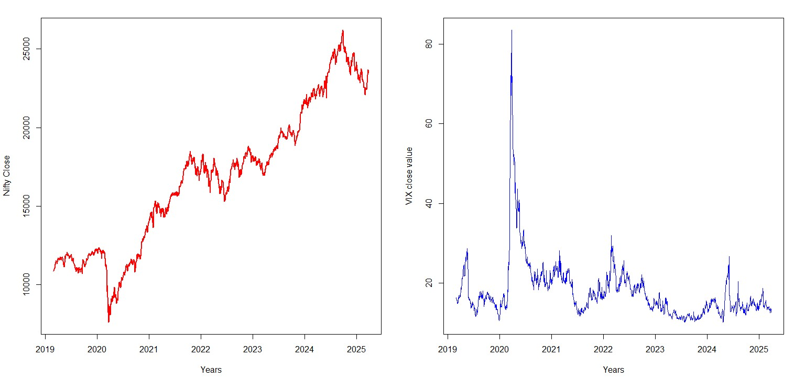

Figure 2: Movement of Nifty 50 and VIX -1st March, 2019 - 31st March 2025

### Estimation of Technical indicators

Colby (2003) in his book has proposed 14 to 26 days for estimation of various technical indicators.

Given the prediction horizon of 3 and 5 days, the estimation period is reduced to 7 days only. In line with the study of Alsubaie et al. (2019), technical indicators such as AD (William’s Accumulation & Distribution), ADX (Average Directional Index), ADXR (Average Directional Index Rating), ATR (Average True Range), Aroon’s Oscillator, Chaikin Oscillator ,NATR (Normalized Average Directional Index), Bollinger Band (UP & Low), OVB (On Balance Volume), TRIX (Triple Exponential Moving Average), William’s R and VIX. To estimate ADXR and NATR following formulae have been used - *NATR* = *NiftyCloseATRi i* ∗ 100 and,

(where *ATRi* denotes ATR of i-th day, *ADXi* denotes ADX on i-th day).

Rest of the technical indicators have been estimated using established formulae, with 7 days of estimation period. Estimates of all the technical indicators along with VIX have been standardized before using them as inputs to the aforementioned models.

### Prediction Horizon

In the proposed study, the prediction horizon is limited to 3 and 5 days, which is applicable for both, prediction of direction and periodic return.

### Dependent Variables

Periodic return (for 3 and 5 days) has been estimated as follows -

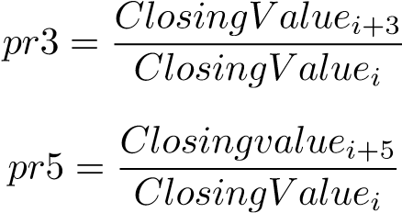

In terms of estimation of direction of market movement, three types of movement have been considered - upward , downward and sideways (i.e. range bound). The movements have been operationalized with the help of upper and lower limits of periodic returns, which have been estimated as follows -

* upper limit = average periodic return (3 day or 5 day) + 0.25 * standard deviation of periodic return (3 day or 5 day)
* lower limit = average periodic return (3 day or 5 day) - 0.25* standard deviation of periodic return (3 day or 5 day)

The directions of market movement have been coded in the following manner -

* if, periodic return *>*= upper limit , then it implies upward movement coded as 1.
* if, periodic return *<* lower limit , then it implies downward movement coded as -1.
* if, lower limit *<*= periodic return *<* upper limit , then it implies range-bound movement coded as 0.

## Methods

In line with the research objectives, following two sets of methods have been selected • for prediction of direction - multinomial logistic regression (MLR), support vector machine (SVM), Decision Tree (DT) , Naive Bayes (NB), Random Forest (RF) , artificial neural network (ANN)

• for prediction of periodic return - , regularised regression (ridge and adaptive regression model (LASSO and Spline).

The models pertaining to prediction of direction have been trained with 10-fold cross-validation, except for NB. Further, to improve performance, parameters of RF and ANN have been tuned. To find optimal parameters for RF, following grid has been used - no of features = (0.05,0.15,0.25, 0.333 , 0.4), node size = (1, 3, 5, 10), sample fraction = (0.5,0.63,0.80).

For ANN, hyperparamters were tuned to improve performance and following were the results - no of layers = 4, no. of units = 128, activation function (hidden layers) = tanh, activation function (output layers) = softmax

In case of prediction of periodic return, to find better parameters following grid has been designed for Spline - degree = (1:3) (i.e. linear to cubic relations among predictors have been considered), no of variable combinations = (2:100) - the number of various combinations of predictors is limited to 100 and only most important 10 predictors were displayed.

Since, many of the technical indicators used in the study captures the momentum of the market, there is a significant possible of presence of multicolinearity. Ridge and LASSO handles such multicolinearity in an effective way , which offers a rational for their selection. On the other hand , spline is efficient in factoring in non-linearity as well as interactions among variables.

## Creation of Clusters

Homogeneity of data has been ensured by creating clusters from the original dataset in terms of direction of market condition i.e. accumulation, distribution and holding phases as well as volatility. Three clsuters have been created on the basis of Chaikin’s Accumulation and Distribution (i.e. Chaikin’s AD) indicator and volume. And two clusters have been created on the basis of volatility (i.e. VIX index) and volume. The five clusters have been created using K-means algorithm. The cluster data can be considered homogeneous data compared to the entire or unpartitioned dataset.

# Data Analysis

## Composition of Data

**Description of Entire Dataset** It is observed that for the unpartitioned dataset, the average periodic return for 1-day , 3 days and 5 days stand at 0.058%, 0.1149% and 0.2287% respectively. The standard deviations of aforementioned periodic return are 0.0115, 0.159 and 0.0224 respectively. In case of 3-day ahead movement, Upward, side-wise and downward movement constitute 25.53%, 48.88% and 25.59% of the entire dataset respectively. The same for the 5-day ahead movement are 27.02%, 48.02% and 24.78% respectively. These provides a sense of the size of the clusters.

**Profile of the Clusters:** The clusters on upward , downward and side-wise movements constitute 15.82% , 54.04% and 30.14% of the entire data. This shows that the cluster of side-wise movement is the biggest cluster followed by the cluster on downward movement. The cluster with low volatility constitute 75.04% of the entire data and the same for high volatility cluster is 23.96% respectively. Figure 3 underlines characteristics of each cluster with respect Chaikin’s AD, closing value of VIX and volume -

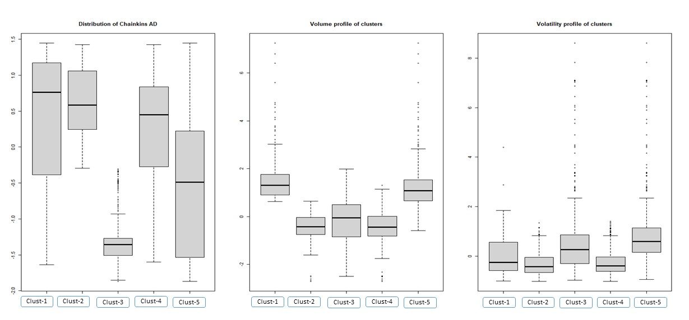

Figure 3: Cluster Profile

|  |  |  |  |
| --- | --- | --- | --- |
| Cluster | AD | VIX | Vol |
| Cluster-1 | 0.43 | 1.57 | -0.0048 |
| Cluster-2 | 0.61 | -0.4 | -0.324 |
| Cluster-3 | -1.315 | -0.11 | 0.59 |
| Cluster-4 | 0.17 | -0.40 | -0.29 |
| Cluster-5 | -0.52 | 1.25 | 0.91 |

Table 1: Cluster Profile - Average of AD , VIX and Volume

Figure 2 and figure 1 show that cluster-1 is the accumulation period, cluster-2 is captures the range bound movement (or holding period) and cluster-3 marks the distribution period. Figure2 also shows that volume remained during accumulation phase (i.e. cluster-1) and high volatile phase (i.e. cluster-5). Also, during distribution phase (i.e. cluster-3) volatility remained high, but less that cluster-5 (i.e. high volatile phase).

## Analysis of Unpartitioned Dataset

### Prediction of direction of movement

Table 2 summarizes the performance of the traditional algorithms. It shows that the accuracies of 3-day and 5-day ahead movement for the test data. MLR has outperformed the rest of the methods. It is followed by SVM and RF. Further, accuracies of the models increased for 5-day ahead prediction, except for SVM. NB shows the most significant improvement for 5-day ahead prediction.

|  |  |  |  |  |
| --- | --- | --- | --- | --- |
|  | 3-day prediction |  | 5 day Prediction |  |
| Algorithm | Accuracy | CI (95%) | Accuracy | CI (95%) |
| MLR | 1.00 | 0.98-1.0 | 1.00 | 0.98 - 1.00 |
| SVM | 0.75 | 0.69 - 0.79 | 0.73 | 0.69 - 0.79 |
| DT | 0.63 | 0.57 - 0.68 | 0.66 | 0.60-0.71 |
| RF | 0.74 | 0.69 - 0.79 | 0.77 | 0.72 - 0.82 |
| NB | 0.64 | 0.57 - 0.62 | 0.99 | 0.97 - 1.00 |
| ANN | 0.61 | - | 0.68 | - |

Table 2: Comparative Performance of the ML Algorithms - Unpartitioned Data

### Prediction of periodic return

Table 3 summarizes the performance in terms of RMSE of Ridge , LASSO, Spline algorithms.

|  |  |  |  |  |
| --- | --- | --- | --- | --- |
|  | 3-day return |  | 5-day return |  |
| Methods | Train | Test | Train | Test |
| Ridge | 0.0125 | 0.0116 | 0.0150 | 0.0272 |
| LASSO | 0.0126 | 0.0110 | 0.0153 | 0.0264 |
| Spline | 0.0081 | 0.009 | 0.0114 | 0.0142 |

Table 3: Prediction of Periodic Return - Unpartitioned Data (RMSE)

Table 3 shows that both for 3-day and 5-day ahead return spline has least error. The RMSE of ridge and LASSO. Table 4 underlines the five most important factors governing the above periodic returns -

|  |  |  |
| --- | --- | --- |
| Methods | 3-day return | 5-day return |
| Ridge | wr, rsi, vix, adx, natr | wr, osc., trix, rsi, adx |
| LASSO | wr | wr, trix |
| Spline | wr, osc., bb-dn, vix | wr, adx, trix, natr, bb-dn |

Table 4: Factors Governing Periodic Returns - Unpartitioned Data

The common factors that govern the periodic return over 3-days are WR (William’s R) and VIX. The common factors that govern 5-day periodic return are WR , ADX and TRIX.

## Analysis of Clustered Data

### Prediction of Direction

Table 5 and Table 6 captures the performances of the machine learning algorithms for the partitioned data. The accuracies obtained for the only the test data have been presented in the table.

|  |  |  |  |  |  |
| --- | --- | --- | --- | --- | --- |
| Algorithm | Cluster-1 | Cluster-2 | Cluster-3 | Cluster-4 | Cluster-5 |
| MLR | 1.0 | 1.0 | 1.0 | 1.0 | 1.0 |
| CI(95%) | 0.92-1.0 | 0.98-1.0 | 0.99-1.0 | 0.98-1.0 | 0.94-1.0 |
| SVM | 0.70 | 0.67 | 0.60 | 0.70 | 0.66 |
| CI(95%) | 0.55-0.83 | 0.49-0.70 | 0.5-0.70 | 0.64-0.76 | 0.54-0.77 |
| DT | 0.68 | 0.65 | 0.63 | 0.66 | 0.55 |
| CI(95%) | 0.53-0.80 | 0.57-0.72 | 0.52-0.73 | 0.60-0.73 | 0.43-0.67 |
| RF | 1.0 | 1.0 | 0.91 | 0.95 | 0.98 |
| CI(95%) | 0.98-1.0 | 0.99-1.0 | 0.88-0.95 | 0.94-0.97 | 0.97-1.0 |
| NB | 1.0 | 1.0 | 1.0 | 1.0 | 1.0 |
| CI(95%) | 0.98-1.0 | 0.94-1.0 | 0.96-1.0 | 0.98-1 | 0.94-1.0 |
| ANN | 64.25 | 59.93 | 57.19 | 65.22 | 65.63 |

Table 5: Prediction of direction (3-day ahead) - Performance of ML algorithms across market

cycles

Table 5 underlines the remarkable improvement of performance of RF and NB algorithms compared to unpartitoned data, where as MLP retains the top spot. Accuracy MLR, NB and RF remained above 95% across market cycles. On the other hand, average accuracy for SVM, DT and ANN stands at 66%, 63.4%, 62% respectively.

|  |  |  |  |  |  |
| --- | --- | --- | --- | --- | --- |
| Algorithm | Cluster-1 | Cluster-2 | Cluster-3 | Cluster-4 | Cluster-5 |
| MLR | 1.0 | 1.0 | 1.0 | 1.0 | 1.0 |
| CI(95%) | 0.98-1.0 | 0.99=1.0 | 0.95-1.0 | 0.98-1.0 | 0.95-1 |
| SVM | 0.72 | 0.70 | 0.69 | 0.73 | 0.79 |
| CI(95%) | 0.72-0.84 | 0.63-0.78 | 0.58-0.78 | 0.66-0.78 | 0.68-0.88 |
| DT | 0.62 | 0.63 | 0.70 | 0.65 | 0.60 |
| CI(95%) | 0.46-0.75 | 0.55-0.70 | 0.59-0.79 | 0.59-0.71 | 0.48-0.72 |
| RF | 0.72 | 0.78 | 0.66 | 0.73 | 0.69 |
| CI(95%) | 0.57-0.84 | 0.72-0.84 | 0.55-0.76 | 0.67-0.79 | 0.57-0.80 |
| NB | 1.0 | 1.0 | 1.0 | 1.0 | 1.0 |
| CI(95%) | 0.89-1.0 | 0.98-1.0 | 0.95-1.0 | 0.98-1.0 | 0.94-1.0 |
| ANN | 61.70 | 68.93 | 66.96 | 74.37 | 67.32 |

Table 6: Prediction of direction (5-day ahead) - Performance of ML algorithms across market

cycles

In case 5-day ahead prediction of direction , MLR and NB have been the most accurate methods across all clusters. But the performance of RF has declined. The average accuracy of RF, SVM , DT and ANN stands at 71.6%, 72%, 64% and 67.85% respectively.

### Prediction of Periodic Return

Table 7 summarizes the performance of the ridge , LASSO and Spline in term predicting periodic return across different market cycles. It also shows the three most important predictors of periodic return of 3 and 5 days. Except for 3-day ahead periodic return for cluster-5 i.e. the most volatile clusters, for the rest of the clusters spline has outperformed ridge and LASSO.

|  |  |  |  |  |  |  |
| --- | --- | --- | --- | --- | --- | --- |
| Cluster - 1 | 3-day return |  | 5-day return |  | 3-day return | 5-day return |
| Methods | Train | Test | Train | Test | Imp. Pred | Imp. Pred. |
| Ridge | 0.012 | 0.015 | 0.0150 | 0.023 | wr, vix, natr | wr, osc.,rsi |
| LASSO | 0.0123 | 0.0145 | 0.014 | 0.023 | wr | wr, vix, bb-dn |
| Spline | 0.012 | 0.014 | 0.009 | 0.012 | null | wr, vix, bb-up |
| Cluster - 2 | 3-day return |  | 5-day return |  | 3day return | 5-day return |
| Methods | Train | Test | Train | Test | Imp. Pred | Imp. Pred. |
| Ridge | 0.008 | 0.008 | 0.009 | 0.017 | wr, vix, trix | wr, osc., obv |
| LASSO | 0.007 | 0.007 | 0.009 | 0.027 | wr, trix, osc. | natr, wr, atr |
| Spline | 0.006 | 0.006 | 0.008 | 0.008 | wr, trix, natr | wr, atr, adx |
| Cluster - 3 | 3-day return |  | 5-day return |  | 3-day return | 5-day return |
| Methods | Train | Test | Train | Test | Imp. Pred | Imp. Pred. |
| Ridge | 0.017 | 0.019 | 0.023 | 0.026 | wr, bb-up, ad | wr, bb-up, osc |
| LASSO | 0.015 | 0.018 | 0.021 | 0.032 | bb-up, ad, wr | wr, bb-up, adx |
| Spline | 0.009 | 0.015 | 0.011 | 0.017 | wr, osc., atr | wr, adx, atr |
| Cluster - 4 | 3-day return |  | 5-day return |  | 3-day return | 5-day return |
| Methods | Train | Test | Train | Test | Imp. Pred | Imp. Pred. |
| Ridge | 0.008 | 0.008 | 0.001 | 0.016 | wr, trix, vix | wr, osc., rsi |
| LASSO | 0.007 | 0.008 | 0.001 | 0.017 | wr, trix, osc | wr |
| Spline | 0.006 | 0.007 | 0.008 | 0.008 | wr, osc, natr | wr, natr, bb-up |
| Cluster - 5 | 3-day return |  | 5-day return |  | 3-day return | 5-day return |
| Methods | Train | Test | Train | Test | Imp. Pred | Imp. Pred. |
| Ridge | 0.019 | 0.015 | 0.022 | 0.048 | wr, rsi, adxr | wr, osc. rsi |
| LASSO | 0.020 | 0.015 | 0.022 | 0.051 | wr, adxr | wr, adx, trix |
| Spline | 0.012 | 0.017 | 0.013 | 0.018 | vix, bb-up, trix | wr, rsi, adx |

Table 7: RMSE of Periodic Return of Ridge, LASSO and Spline - Clustered Data

## Comparison of the Proposed & Past Studies

Table 8 allows us to compare the performance results of the proposed study with some previous studies in which the results of traditional ML algorithms have been compared. Previous studies reported an accuracy of 67.76% to 90.60% for LR. The same for NB is 62.60% to 81.04%. The current study shows that accuracy of MLR and NB are 100% accurate for both unpartitioned and partitioned data. This result is in line with the results obtained by Dimingo et al. (2021) for DT, RF and KNN for FTSE 100, S& P 500. The accuracy range for RF stands at 51% to 92.3%. The present study shows that for unpartitioned data the average accuracy of RF is 75.5% and the same for partitioned data is 84%. In case 3-day ahead prediction for some clusters RF did achieve an accuracy of 100%. The range of accuracy reported by past studies is 51% to 92.30%. The range of accuracy of SVM from the past studies is 75.5% to 90.8%. In the current study shows an average accuracy of 74% for the heterogeneous data. But overall, for all the clusters and all prediction horizons its average accuracy stands at 69.6%. The average accuracy of DT for unpartitioned data stands at 64.5% and that of partitioned dat stands at 63.7%. Past studies report an accuracy range of 54.61% to 88.10%. For ANN, the range of accuracy reported from past studies is 80.1% to 89.93%. The average accuracy of ANN in the present study for heterogeneous study stands at 64.5% and the same for homogeneous data is 64.75%. The observations of the proposed study is in line with Mokhtari et al. (2021) where LR and RF out performed ANN and SVM. In one day ahead predict of Khan et al. (2023), LR outperformed ANN and XGB. Further, the performance of DT, SVM , RF and ANN of Nabipour et al. (2020) is closer to results obtained in the proposed study.

|  |  |  |  |  |  |  |  |  |  |
| --- | --- | --- | --- | --- | --- | --- | --- | --- | --- |
| Study | LR | SVM / SVC /  SVR | DT | NB | RF | KNN | ANN/  DNN | RNN/  LSTM | XGB/  GBM |
| Mcwera and  Mba (2023) | x | 79.30 | 54.61 | x | 51 | 47.73 | x | x | x |
| Ayyildiz and  Iskenderoglu  (2024) | 82.56 | 79.43 | 56.53 | 62.60 | 59 | 50.26 | 83.43 | x | x |
| Yun et al.  (2021) | x | 85.46 | 90.78 | x | 92.42 | 80.24 | x | x | 73.91 |
| Mokhtari et al. (2021) | 72.7 | 75.5 | 62 | 63.4-  64.4 | 72.7 | x | x | x | 70.9 |
| Campisi et al. (2024) | 67.76 | x | x | x | 82.39 | x | x | x | 71.13 |
| Roy et al.  (2020) | x | x | x | 91 | 82 | x 78 |  |  | 81 |
| Khan et al.  (2023) | 85.51  -  90.60 | 82.68 -  88.59 | 83.01  -  88.10 | 73.49  -  81.04 | 84.45  -  91.27 | 79.15  -  80.53 | 84.45 -  89.93 | x | 84.8 -  90.93 |
| Nti et al.  (2020) | x | 90.8 | 75.3 | x | 92.3 | x | 80.1 | x | x |

Table 8: Summary of Accuracies of Different ML Models of Select Past Studies

(LR - logistic regression ; SVM - support vector machine ; SVC - support vector classifier; SVR - support vector regression ; DT - decision tree ; NB - naive bayes ; RF - random forest ; KNN - K-nearest neighbour; ANN - artificial neural netowrk ; DNN - deep neural network ; RNN - recurrent neural network; LSTM - long short term memory ; XGB - extreme gradient boosting ; GBM = gradient boosting machine)

# Conclusion

* Prediction of Direction
  + Unpartitioned data : In case of 3-day ahead prediction of MLR, SVM , RF are the most of accurate method. In case of 5-day prediction MLR, NB and RF are the most accurate models.
  + Partitioned Data : Partitioned data: Table 5 and table 6 shows that NLR and NB are the most accurate methods for both 3-day ahead and 5-day ahead prediction of movement.

∗ Table 5 shows that , among SVM, DT and ANN , SVM is more accurate in accumulation stage and volatile phase and DT is more accurate in the distribution stage.

∗ Table 6 shows that among SVM, RF, DT and ANN , in the accumulation stage performance SVM and RF are same. The accuracy of SVM and DT are very similar. The prediction accuracy in the volatile phase, SVM has the highest accuracy.

* Prediction of Periodic return
  + Unpartitioned data : Table 3 shows tthat Spline is the most accurate method for both 3-day ahead and 5-day ahead prediction of periodic return. William’s R is the most important predictor of periodic return.
  + Partitioned Data: Table 7 shows spline the most accurate model for prediction of periodic return across all market cycles , except cluster-5.

∗ wr and vix are the most important two predictors during accumulation phase (i.e. cluster-1). For the distribution phase (i.e. cluster-3), the periodic return is governed by wr, bb-up, ad and adx. The important predictors of volatile phase i.e.cluster-5 are, wr,adxr, rsi, trix.

The ML models based on probabilistic learning, such as MLR and NB, has outperfomed other ML methods for both heterogeneous and homogeneous datasets. Their accuracies have been 100% for both homogeneuous and heterogenous data and also for both prediction horizons. Significant improvement in performance of SVM can be noted for partitioned data (or homogeneous data) compared to unpartitioned data. The average accuracy of DT is 63. 4% for homogeneous compared to 64% accuracy for heterogeneous data.

Hence, for prediction of direction MLR and NB are the methods of choice. For prediction of periodic return Spline is the most efficient method. William’s R (wr) is the crucial variable for prediction of return across all clusters. During accumulation phahse, apart from wr, bb-up and vix plays an important role. During the distribution phases atr, oscillator and natr plays an important role. The periodic return of the most volatile phase (i.e. cluste) is governed by vix, bb-up, trix , rsi and adx. Though the present study uncovered some dimensions of performance of various ML models, but there is some scope of improvement in terms of estimation of technical indicators for various market cycles.

# References

Alsubaie, Y., El Hindi, K., and Alsalman, H. (2019). Cost-sensitive prediction of stock price direction: Selection of technical indicators. *IEEE Access*, 7:146876–146892.

Ayala, J., Garc´ıa-Torres, M., Noguera, J. L. V., G´omez-Vela, F., and Divina, F. (2021). Technical analysis strategy optimization using a machine learning approach in stock market indices. *Knowledge-Based Systems*, 225:107119.

Ayyildiz, N. and Iskenderoglu, O. (2024). How effective is machine learning in stock market predictions? *Heliyon*, 10(2).

Bustos, O. and Pomares-Quimbaya, A. (2020). Stock market movement forecast: A systematic review. *Expert Systems with Applications*, 156:113464.

Campisi, G., Muzzioli, S., and De Baets, B. (2024). A comparison of machine learning methods for predicting the direction of the us stock market on the basis of volatility indices. *International Journal of Forecasting*, 40(3):869–880.

Checkley, M., Hig´on, D. A., and Alles, H. (2017). The hasty wisdom of the mob: How market sentiment predicts stock market behavior. *Expert Systems with applications*, 77:256–263.

Colby, R. W. (2003). *The Encyclopedia of Technical Market Indicators*. McGraw-Hill.

Dimingo, R., MWAMBA, J. W. M., and Bonga-Bonga, L. (2021). Prediction of stock market direction: Application of machine learning models. *International Economics/Economia Internazionale*, 74(4).

Ergun, L., Molchanov, A., and Stork, P. (2023). Technical trading rules, loss avoidance, and the business cycle. *Pacific-Basin Finance Journal*, 82:102172.

Giudici, P., Gramegna, A., and Raffinetti, E. (2023). Machine learning classification model comparison. *Socio-Economic Planning Sciences*, 87:101560.

Ismail, M. S., Noorani, M. S. M., Ismail, M., Razak, F. A., and Alias, M. A. (2020). Predicting next day direction of stock price movement using machine learning methods with persistent homology: Evidence from kuala lumpur stock exchange. *Applied Soft Computing*, 93:106422.

Khan, A. H., Shah, A., Ali, A., Shahid, R., Zahid, Z. U., Sharif, M. U., Jan, T., and Zafar, M. H. (2023). A performance comparison of machine learning models for stock market prediction with novel investment strategy. *Plos one*, 18(9):e0286362.

Kia, A. N., Haratizadeh, S., and Shouraki, S. B. (2018). A hybrid supervised semi-supervised graph-based model to predict one-day ahead movement of global stock markets and commodity prices. *Expert Systems with Applications*, 105:159–173.

Mcwera, A. and Mba, J. C. (2023). Predicting stock market direction in south african banking sector using ensemble machine learning techniques. *Data science in finance and economics*, 3(4):401–426.

Mokhtari, S., Yen, K. K., and Liu, J. (2021). Effectiveness of artificial intelligence in stock market prediction based on machine learning. *arXiv preprint arXiv:2107.01031*.

Nabipour, M., Nayyeri, P., Jabani, H., Shahab, S., and Mosavi, A. (2020). Predicting stock market trends using machine learning and deep learning algorithms via continuous and binary data; a comparative analysis. *Ieee Access*, 8:150199–150212.

Nti, I. K., Adekoya, A. F., and Weyori, B. A. (2020). Efficient stock-market prediction using ensemble support vector machine. *Open Computer Science*, 10(1):153–163.

Oppenheimer, P. C. (2020). *The Long Good Buy: Analysing Cycles in Markets*. John Wiley & Sons.

Oukhouya, H. and El Himdi, K. (2023). Comparing machine learning methods—svr, xgboost, lstm, and mlp—for forecasting the moroccan stock market. In *Computer Sciences & Mathematics Forum*, volume 7, page 39. MDPI.

Roy, S. S., Chopra, R., Lee, K. C., Spampinato, C., and Mohammadi-ivatlood, B. (2020). Random forest, gradient boosted machines and deep neural network for stock price forecasting: a comparative analysis on south korean companies. *International Journal of Ad Hoc and Ubiquitous Computing*, 33(1):62–71.

Yun, K. K., Yoon, S. W., and Won, D. (2021). Prediction of stock price direction using a hybrid ga-xgboost algorithm with a three-stage feature engineering process. *Expert Systems with Applications*, 186:115716.

1. https : //www.nseindia.com/reports − indices − historical − index − data