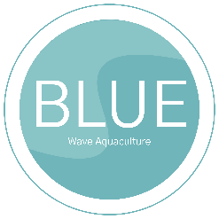

**Blue Wave Aquaculture**

Bluewaveaquaculture.com

**Market Report**

Prepared by

**Tony Edwards**

1. **Introduction**

This report offers a detailed analysis of Blue Wave Aquaculture's current market position and growth prospects within the aquaculture industry. As the world continues to experience an increase in seafood consumption and growing concerns about sustainability, understanding the dynamics of the aquaculture market is vital for informed decision-making and strategic planning.

1. **Background**

The global aquaculture industry is valued at $10 billion, and it is expected to exhibit steady growth with a projected Compound Annual Growth Rate (CAGR) of 5% over the next five years. Factors contributing to this growth include the rising global demand for seafood, the depletion of wild fisheries, and a greater emphasis on sustainable and eco-friendly practices.

1. **Scope**

This report covers a wide range of sections from market size and segmentation to trends, competitive analysis, and recommendations for future growth. By exploring these areas, Blue Wave Aquaculture aims to position itself strategically and capitalize on emerging opportunities within the aquaculture sector.

1. **Market Overview**
2. **Market Size and Growth**

The global aquaculture market, currently valued at $10 billion, is expected to grow at a CAGR of 5% over the next five years. This growth can be attributed to the increasing demand for seafood products, driven by factors such as population growth, changing dietary preferences, and awareness of the health benefits associated with seafood consumption.

1. **Market Segmentation**

The aquaculture market is highly diverse and segmented based on species, culture systems, and geographical regions. Species-specific aquaculture dominates the market, accounting for $6 billion, while culture systems, including ponds, tanks, and cages, contribute to a $4 billion market segment. Geographically, Asia leads the industry, with a significant share due to its extensive aquaculture practices.

The following table presents a detailed segmentation of the aquaculture market:

|  |  |  |
| --- | --- | --- |
| **Market Segmentation** | **Value** | **Growth Rate** |
| Species-specific | $6,000,000,000 | 4.5% |
| Culture systems | $4,000,000,000 | 6.2% |

The table breaks down the market into its primary segments, highlighting the significant share held by species-specific aquaculture, which is valued at $6 billion and grows at a rate of 4.5%. Culture systems, at $4 billion, show a higher growth rate of 6.2%.

1. **Trends and Drivers**
2. **Sustainability Emphasis**

One prominent trend in the aquaculture industry is the growing emphasis on sustainability. Consumers are increasingly demanding eco-friendly seafood products. This trend reflects a desire for transparent and traceable supply chains, ensuring that aquaculture operations have a minimal environmental impact.

1. **Technological Advancements**

The industry is also experiencing rapid technological advancements. Automation, data-driven systems, and advanced monitoring techniques are improving operational efficiency, reducing waste, and optimizing yield. By staying at the forefront of these innovations, aquaculture businesses can remain competitive and sustainable.

1. **Competitive Landscape**
2. **Major Players**

The competitive landscape of the aquaculture market includes several major players. Notable competitors alongside are Aqua Prime Ecosystems, Marine Coastline Farm, and Vantage View Aquaculture. These organizations have established a strong presence within the industry, making competition robust and diverse.

1. **Market Concentration**

The aquaculture market exhibits a moderate level of concentration, with the top players, including Blue Wave Aquaculture, holding approximately 30% of the market share. The remaining 70% of the market is shared among various smaller operators and potential new entrants.

The following table presents a detailed competitive landscape in the aquaculture market:

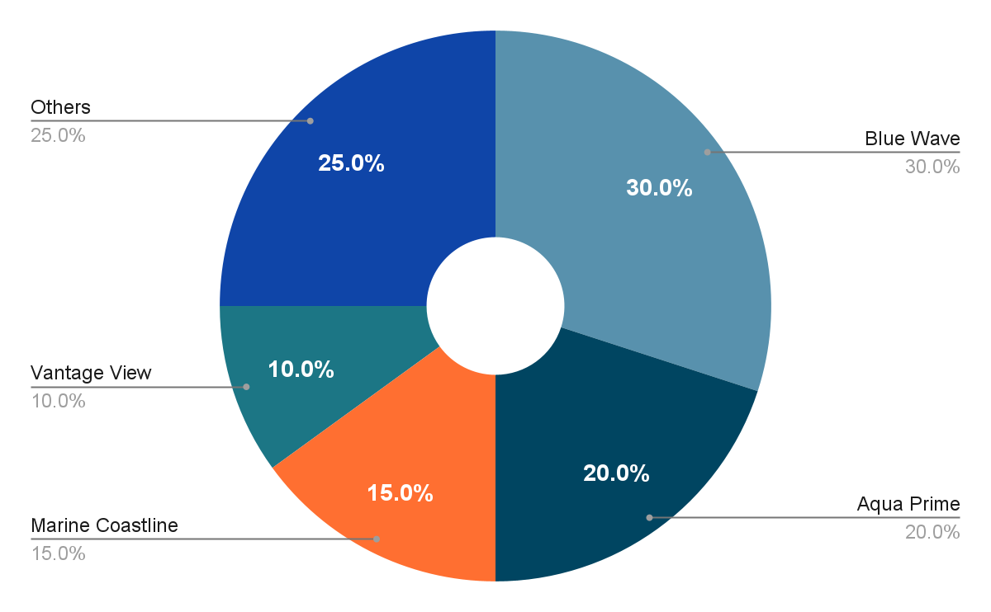

The table provides an insightful view of the competitive landscape, highlighting Blue Wave Aquaculture as a major player with a 30% market share. Additionally, it underscores other significant competitors like Aqua Prime Ecosystems (20%), Marine Coastline Farm (15%), and Vantage View Aquaculture (10%). The remaining 25% represents smaller players and potential new entrants.

1. **Market Segmentation**
2. **Species-Specific Markets**

Blue Wave Aquaculture currently operates primarily in the fish and shrimp segments of the market. The focus on these species has allowed the company to establish itself as a leader in these segments, with a reputation for high-quality products and sustainable practices. Nevertheless, there is a promising opportunity to diversify into other species, such as mollusks, to further broaden the product portfolio and mitigate potential risks associated with species-specific markets.

1. **Regional Markets**

The organization's main presence is in the state of Colorado, where it has successfully catered to the local and regional demand for aquaculture products. The organization's next strategic move is to expand into the neighboring state of Wyoming, a region experiencing a surge in seafood consumption. A careful expansion strategy that takes into account local preferences, regulatory environments, and distribution channels will be essential to capitalize on the growing demand in this new region.

1. **Market Dynamics**
2. **Price Fluctuations**

The aquaculture market has witnessed price fluctuations, especially in the fish and shrimp segments. These fluctuations are often linked to factors such as disease outbreaks affecting supply, adverse weather conditions impacting production, and global economic shifts influencing consumer demand. Monitoring and mitigating these price fluctuations are vital for maintaining stable revenue streams and profitability.

1. **Distribution Channels**

Blue Wave Aquaculture has established effective distribution channels, including direct sales to restaurants, retailers, and wholesalers. Partnerships with local restaurants and retail chains have enabled the company to reach a broader consumer base. Maintaining and strengthening these distribution channels is crucial for market presence and growth.

1. **Regulatory Environment**
2. **Environmental Regulations**

Compliance with environmental regulations is a core aspect of Blue Wave Aquaculture's commitment to sustainability. Effective waste management, water quality maintenance, and adherence to environmental standards are essential to minimize the company's environmental impact. Regular assessments of operations for environmental compliance are recommended to ensure continued sustainable practices.

1. **Safety Standards**

Meeting stringent food safety and quality standards is imperative for maintaining consumer trust and regulatory compliance. Regular audits, testing, and monitoring of products for contaminants or quality issues should be integral to the company's operations. Any deviations from these standards should be addressed promptly and effectively to uphold product quality.

1. **Recommendations**

Cognizant of the dynamic aquaculture landscape and the unique position of Blue Wave Aquaculture, this section presents a set of strategic recommendations aimed at fostering growth, sustainability, and market leadership for our business:

1. **Diversify Product Range**

To reduce risk and increase market reach, Blue Wave Aquaculture should explore opportunities to diversify its product range. This may include expanding into mollusk farming or other species that align with market demands and company capabilities.

1. **Expand into the state of Wyoming**

Initiating the process of expansion into the state of Wyoming presents a valuable opportunity to tap into a region with a growing demand for aquaculture products. Conduct market research and establish local partnerships to ensure a successful expansion.

1. **Invest in Technology**

Staying at the forefront of technological advancements in aquaculture, such as automation and data-driven systems, will improve operational efficiency, reduce waste, and optimize production yield.

1. **Strengthen Sustainability Initiatives**

Enhancing sustainability efforts, including transparent supply chains and environmentally friendly practices, will meet consumer demands for eco-friendly seafood products. These initiatives can also contribute to brand differentiation and customer loyalty.

1. **Monitor Price Trends**

Blue Wave Aquaculture should establish effective mechanisms to monitor market price trends, assess risk factors, and implement risk management strategies. This will help the company adapt to price fluctuations and maintain consistent profitability.

1. **Outlook**

Blue Wave Aquaculture is well-positioned to leverage the opportunities presented by the growing aquaculture market. The company's strengths, including sustainable practices and dedication to innovation, provide a solid foundation for future growth. The expansion into new species markets and regions is an exciting prospect that aligns with the company's commitment to quality and sustainability.

**CHOOSE & DOWNLOAD MORE** [**REPORT TEMPLATE**](https://www.template.net/editable/reports/word) **©** [**TEMPLATE.**NET](https://www.template.net/)