WEEK 3 TASK
Advanced Data Analysis and Visualization in Logistics
Logistics Data Science Internship | Subhajit Sangram
B.Tech Data Science | Narula Institute of Technology, Kolkata

1. Dataset and Analytical Objective
The analysis uses the supplied 5,000-record synthetic logistics dataset. The objective is to explore delivery performance, shipment workload, transportation cost, inventory conditions and customer experience. The analysis is designed to demonstrate how EDA converts raw logistics data into operational questions and measurable insights.

2. Data Preparation
The dataset contains order date, geography, category, transport mode, shipment volume, weight, distance, weather, processing time, delivery time, promised delivery time, freight cost, transport cost, inventory level, stockout flag and customer rating. The analysis checks data types, missing values, descriptive statistics and correlations before visualization.

3. Central Tendency and Distribution
The average delivery time in the supplied dataset is 3.51 days, while the median is 3.46 days. The distribution is useful because a mean alone may hide a long tail of slow shipments. A histogram makes the concentration and spread visible.
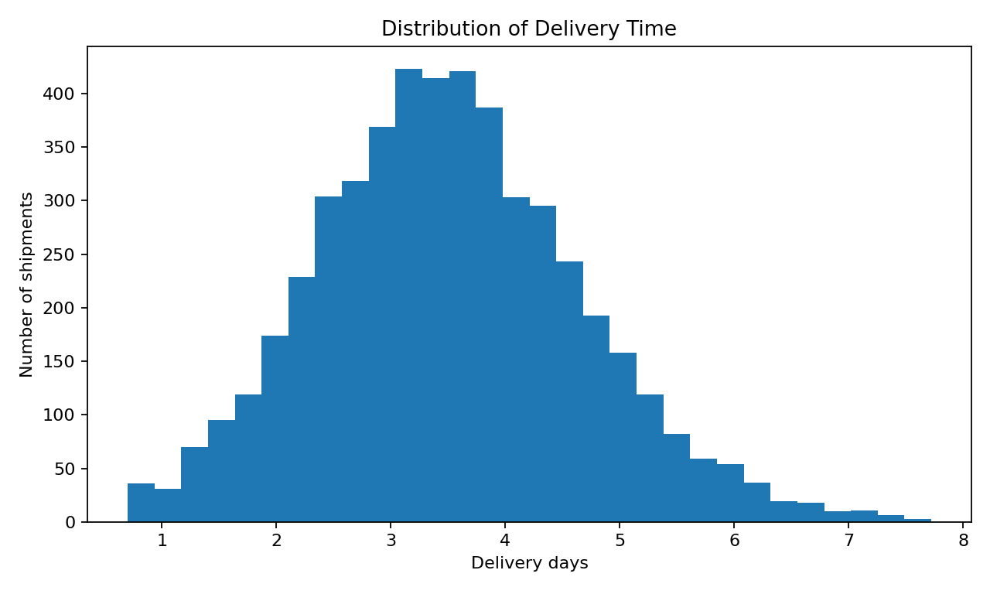
Figure 1. Distribution of delivery time.

4. Regional Performance
In this simulated dataset, Gujarat has the highest observed late-delivery rate among the states in the sample. The ranking is descriptive for this synthetic dataset and should not be interpreted as a real-world comparison of Indian logistics performance.
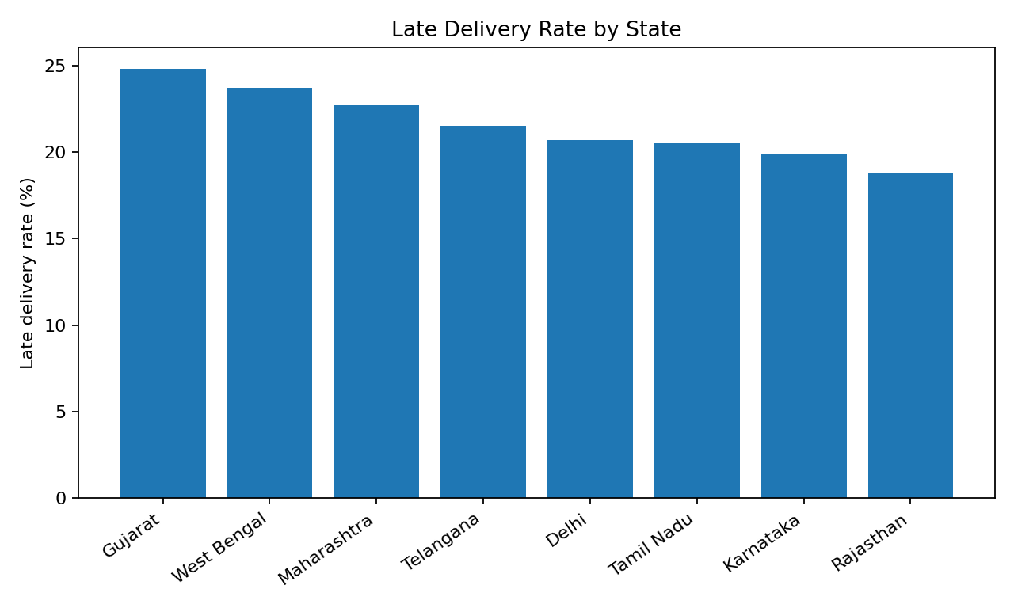
Figure 2. Late delivery rate by state.

5. Transportation Cost Drivers
The Pearson correlation between distance and transport cost is 0.78 in the supplied dataset. The scatter plot is appropriate because it shows both the direction of association and the variability around the relationship.
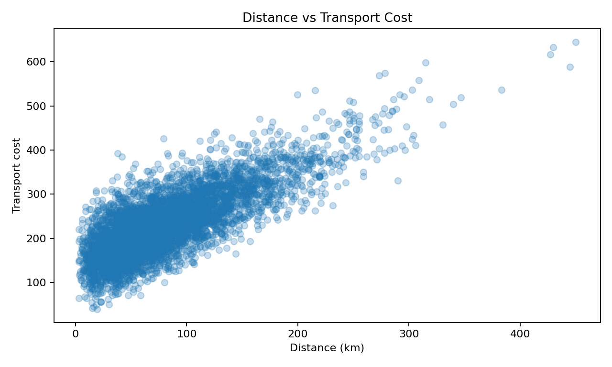
Figure 3. Distance versus transport cost.

6. Product Category Analysis
A bar chart is used to compare average delivery time across discrete product categories. This can help an operations team investigate whether product characteristics, handling requirements or shipment composition are associated with longer delivery times.
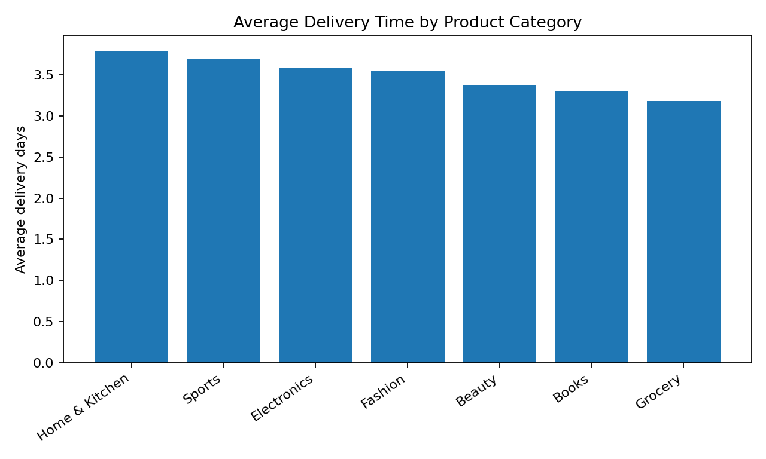
Figure 4. Average delivery time by category.

7. Correlation Analysis
The correlation matrix provides a compact view of linear relationships among numeric logistics variables. Correlation is useful for hypothesis generation, but it does not establish causation.
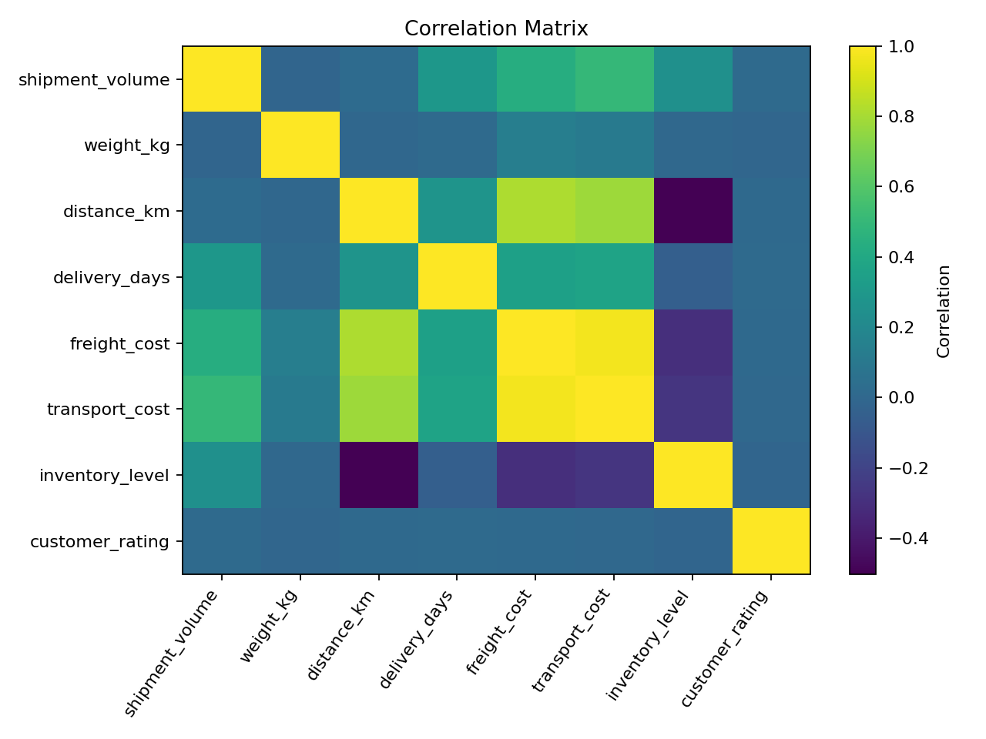
Figure 5. Numeric correlation matrix.

8. Python Visualization Code
import matplotlib.pyplot as plt
plt.hist(df["delivery_days"], bins=30)
plt.xlabel("Delivery days")
plt.ylabel("Number of shipments")
plt.title("Distribution of Delivery Time")
plt.show()
state_rate = df.groupby("state")["late_flag"].mean() * 100
state_rate.sort_values(ascending=False).plot(kind="bar")
plt.ylabel("Late delivery rate (%)")
plt.show()

9. Analytical Insights and Recommendations
- Use regional KPI monitoring to identify locations where late delivery is concentrated.
- Investigate distance and transport cost together when planning delivery capacity.
- Compare category-level delivery time to identify products requiring special handling or fulfillment rules.
- Use correlation analysis as a starting point for modeling, not as proof of causation.
- Combine delivery KPIs with inventory information to identify areas where service and stock availability may interact.

