BreathSafe Uses continuous monitoring to monitor location’s AQI level. Update interval is set to 3 hours.

Steps to use:

1. Install and open the application
2. Allow Permission

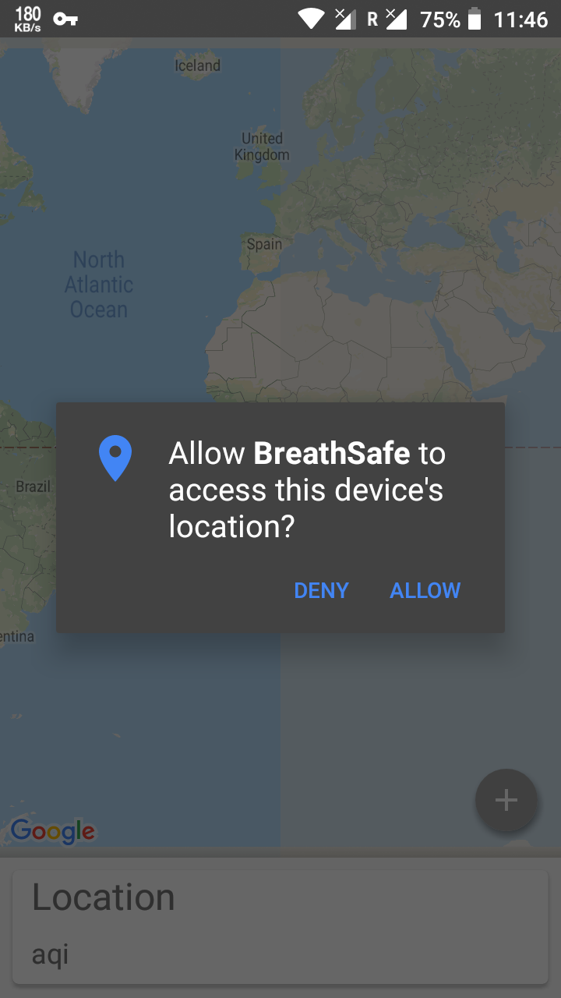

1. Wait for the location to be detected. After it is found, the screen flies to your location.

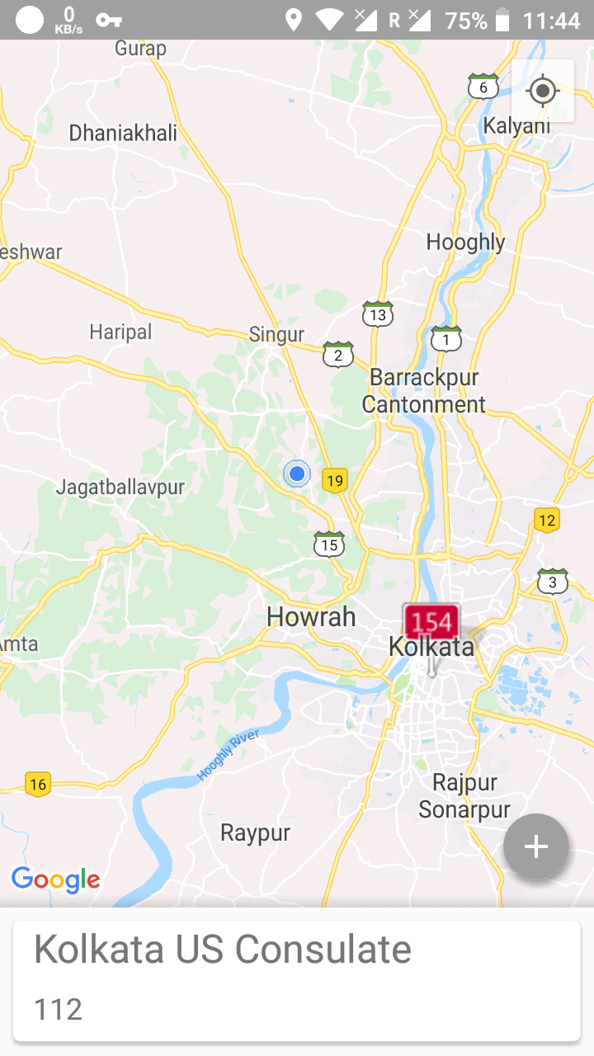

1. This will automatically start the monitoring service.
2. Now you can close the application and the notification service will stay.
3. After every 3 hours, your location will be auto detected and notification will be auto updated.
4. The notification service stays till