Oracle VPD Implementation
Contents
1.VPD Configuration in Database 2
2.VPD Implementation Steps 2
2.1 Create VPD Admin User 2
2.2 Load GSAM tables 2
2.3 Create Profiles 2
2.4 Create Lookup tables 3
2.5 Create VPD Function 4
2.6 Add Policy 5
2.7 Create Test users 7
2.8 Test VPD policies 7
3.Rollback Steps 8
3.1 Drop Policy 8
4.Miscellaneous Steps 9
4.1 Disable Policy 9
4.2 Enable Policy 9
4.3 Adding New Tables 9
4.4 Adding New Users 10
4.5 Service Account Password Maintenance 10
4.6 GSAM as a Service DB Access 11
4.7 Bypass Security Policies 12

Virtual Private Database (VPD) is a database security feature introduced in Oracle database that started in Oracle 8i and used to enable fine grained access at row and column level among shared/common objects with users having different roles and responsibilities at Application level or at Organization level. Security policies are attached directly to tables, views, and synonyms and hence there is no way for users to bypass the security settings.
VPD consists of
- A VPD Policy function – this returns the predicate to be applied at run time.
- A VPD Policy – Name of the VPD Policy.
When a user accesses a table (or view or synonym) which is protected by a VPD policy (function):
- The Oracle server invokes the policy function.
- The policy function returns a predicate based on session attributes or database contents.
- The server dynamically rewrites the submitted query by appending the returned predicate to the WHERE clause.
- The modified SQL query is executed.
DBMS_RLS PL/SQL package enables you to create VPD policies which is available with Oracle's Enterprise Edition. Users who have been granted the EXECUTE privilege on the DBMS_RLS PL/SQL package can create Oracle Virtual Private Database policies.

1.VPD Configuration in Database
No additional software has to be installed on the database. User should have executed privilege on DBMS_RLS PL/SQL package

2.VPD Implementation Steps
VPD implementation steps can be performed when the database is online and has no impact on the applications.

2.1 Create VPD Admin User

Create the VPD admin user, which will be used for the VPD function and policy maintenance.
VPD admin username should be as VPD_ADMIN (Please don’t change the username)
Update the VPD_ADMIN user password in orapass file.
Login into the database as a SYSDBA privileged user
Run the below script to create a user and grant the permission to the user.
create user vpd_admin identified by *****;
grant connect,resource,dba to vpd_admin;
grant select_catalog_role to vpd_admin;
grant select on dba_users to vpd_admin;
grant select any table to vpd_admin;
grant update any table to vpd_admin;
grant execute on DBMS_RLS to vpd_admin;
grant create procedure to vpd_admin;
grant create trigger to vpd_admin;
alter user vpd_admin profile <>;

2.2 Load GSAM tables

Please follow the document GSAM Data load to load the GSAM profiled column tables into vpd_admin.gsam_profiled_columns table.

2.3 Create Profiles

Create OFFSHORE profiles OFFSHORE_APP_USER_PROFILE,OFFSHORE_DBA_PROFILE and OFFSHORE_SYSACCOUNT_PROFILE which will be assigned to offshore users .
Login into the database as a SYSDBA privileged user
Run the below sample script to create profiles and assign the profile to the OFFSHORE users.
CREATE PROFILE <PROFILE_NAME> LIMIT
SESSIONS_PER_USER DEFAULT
CPU_PER_SESSION DEFAULT
CPU_PER_CALL DEFAULT
CONNECT_TIME DEFAULT
IDLE_TIME 15
LOGICAL_READS_PER_SESSION DEFAULT
LOGICAL_READS_PER_CALL DEFAULT
COMPOSITE_LIMIT DEFAULT
PRIVATE_SGA DEFAULT
FAILED_LOGIN_ATTEMPTS 3
INACTIVE_ACCOUNT_TIME 35
PASSWORD_LIFE_TIME 60
PASSWORD_REUSE_TIME 365
PASSWORD_REUSE_MAX 10
PASSWORD_LOCK_TIME UNLIMITED
PASSWORD_GRACE_TIME 5
PASSWORD_VERIFY_FUNCTION ORA12C_STIG_VERIFY_FUNCTION;

Check the Profiles using the below SQL.
select distinct profile from dba_profiles where profile like 'OFFSHORE%';

2.4 Create Lookup tables

Lookup tables will be used to load the GSAM data . The table name should be named as LOOKUP_<identifier_type>
Login into the database as a VPD_ADMIN user and use the below script to generate the create Lookup table and create index scripts.
Create Lookup Tables
SELECT ' create table VPD_ADMIN.LOOKUP_' || identifier_type || ' (
identifier varchar2 (20) not null ) tablespace users;'
FROM (SELECT DISTINCT identifier_type
FROM vpd_admin.gsam_profiled_columns
WHERE gsam_to_apply='Y'
AND NOT EXISTS
(SELECT 1
FROM dba_objects
WHERE owner='VPD_ADMIN' and SUBSTR (object_Name,
INSTR (object_Name, '_') + 1) =
identifier_type));

select owner,object_name,object_type from dba_objects where owner='VPD_ADMIN' and object_name like 'LOOKUP_%';
Create Index on Lookup Tables
select 'alter table VPD_ADMIN.LOOKUP_' || identifier_type ||
' add constraint LKP_' || identifier_type || '_PK' ||
' primary key (' || 'identifier' || ')' ||
' using index tablespace users;'
FROM (SELECT DISTINCT identifier_type
FROM vpd_admin.gsam_profiled_columns
WHERE gsam_to_apply = 'Y'
AND NOT EXISTS
(SELECT 1
FROM dba_objects
WHERE owner='VPD_ADMIN' and object_type='INDEX' and OBJECT_NAME=UPPER('LKP_'||identifier_type||'_PK')));

select owner,object_name,object_type from dba_objects where owner='VPD_ADMIN' and object_type='INDEX';

2.5 Create VPD Function

A VPD policies use a function to generate the dynamic WHERE clause, and a policy to attach the function to objects that need to be protect

Login into the database as an VPD_ADMIN privileged user
Run the below script to create a VPD function.
CREATE OR REPLACE FUNCTION VPD_ADMIN.VPD_FUNCTION_COMMON (
p_schema VARCHAR2,
p_object VARCHAR2)
RETURN VARCHAR2
AS
l_user VARCHAR2 (20);
l_profile VARCHAR2 (20);
l_profile_cnt NUMBER (10);
l_predicate VARCHAR2 (1024);
l_lookup_table VARCHAR2 (1024);
V_lookup_count NUMBER (10);
lookup_sql VARCHAR2 (1024);
BEGIN
--SELECT USER INTO l_user FROM DUAL;
l_predicate := NULL;

SELECT COUNT (1)
INTO l_profile_cnt
FROM dba_users
WHERE username = USER
AND profile IN
('OFFSHORE_APP_USER_PROFILE',
'OFFSHORE_DBA_PROFILE',
'OFFSHORE_SYSACCOUNT_PROFILE');

IF l_profile_cnt > 0
THEN
SELECT 'VPD_ADMIN.LOOKUP_' || IDENTIFIER_TYPE || ''
INTO l_lookup_table
FROM vpd_admin.gsam_profiled_columns
WHERE db_schema = p_schema AND db_table = p_object;

lookup_sql :=
'select count(1) from ' || l_lookup_table || ' where rownum= 1';

EXECUTE IMMEDIATE lookup_sql
INTO V_lookup_count;

IF V_lookup_count = 0
THEN
l_predicate := '1=2';
ELSE
SELECT 'not exists (select 1 from vpd_admin.LOOKUP_'
|| IDENTIFIER_TYPE
|| ' where identifier='
|| LOOKUP_COLUMN
|| ')'
INTO l_predicate
FROM vpd_admin.gsam_profiled_columns
WHERE db_schema = p_schema AND db_table = p_object;

END IF;

END IF;

IF DBMS_SNAPSHOT.i_am_a_refresh
THEN
l_predicate := NULL;
END IF;

RETURN l_predicate;
END;
/

Check the function using the below SQL.
select owner,object_name,object_type,status from dba_objects where object_name='VPD_FUNCTION_COMMON';

2.6 Add Policy

Oracle Virtual Private Database (VPD) policy to control database access at the row and column level.
Login into the database as an VPD_ADMIN privileged user
Run the below script to add a policy on a table.
The Below SQL will generate the dynamic sql’s to add the policy for list of tables based below conditions.
Tables present in vpd_admin.gsam_profiled_columns table
Tables where VPD policy was not yet applied
Tables whose lookup table are available

set lines 500 trims on pages 0 feedback off
SELECT distinct 'exec DBMS_RLS.ADD_POLICY('||' - '||chr(10)||
' object_schema => '''||db_schema||''','||' - '||chr(10)||
' object_name => '''||db_table||''','||' - '||chr(10)||
' policy_name => ''P_'||db_schema|| '_'||b.object_id || ''','||' - '||chr(10)||
' function_schema => ''VPD_ADMIN'','||' - '||chr(10)||
' policy_function => ''VPD_FUNCTION_COMMON'','||' - '||chr(10)||
' policy_type => DBMS_RLS.CONTEXT_SENSITIVE,'||' - '||chr(10)||
' update_check => FALSE '||' - '||chr(10)||
');'
FROM (SELECT DISTINCT db_schema, db_table
FROM vpd_admin.gsam_profiled_columns
WHERE gsam_to_apply= 'Y' and lookup_column is not null
AND EXISTS
(SELECT 1
FROM dba_objects
WHERE SUBSTR (object_Name,
INSTR (object_Name, '_') + 1) =
identifier_type)
AND NOT EXISTS
(SELECT 1
FROM dba_policies
WHERE function = 'VPD_FUNCTION_COMMON'
AND object_name = db_table
AND object_owner = db_schema)) a,
dba_objects b
WHERE a.db_schema = b.owner
AND a.db_table = b.object_name
AND b.status='VALID'
AND b.object_type in ('TABLE','VIEW','MATERIALIZED VIEW')
and 1 in
(with status_view as
(
select 'VALID' status,decode(count(1),1,1,0) cnt from dba_objects where object_name='VPD_FUNCTION_COMMON' and status='VALID' and owner='VPD_ADMIN'
union all
select 'INVALID',decode(count(1),1,2,0) from dba_objects where object_name='VPD_FUNCTION_COMMON' and status='INVALID' and owner='VPD_ADMIN'
union all
select 'EXISTS',decode(count(1),0,3,0) from dba_objects where object_name='VPD_FUNCTION_COMMON' and owner='VPD_ADMIN'
)
select sum(cnt) from status_view
);

Check the Policies on tables using the below SQL.
select * from dba_policies WHERE pf_owner='VPD_ADMIN' and function = 'VPD_FUNCTION_COMMON';

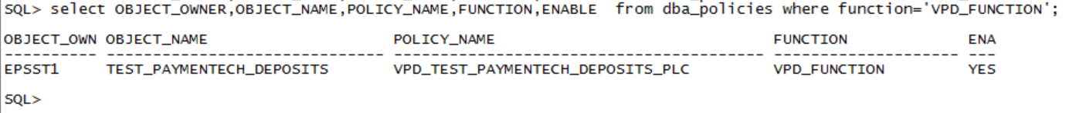
Note : If tables are missing from dynamic SQL . Please make sure tables present from Step 2.4 and Step 2.5

Note : If Datavault is enable in the database. We have to grant realm to VPD_ADMIN
To check VAULT is enabled status.
select value from v$option where parameter='Oracle Database Vault';
To grant realm access
select 'exec DBMS_MACADM.ADD_AUTH_TO_REALM ( -
realm_name => ''' || NAME || ''', -
grantee => ''VPD_ADMIN'', -
auth_options => DBMS_MACUTL.G_REALM_AUTH_OWNER);' from DBA_DV_REALM;

To revoke realm access

select 'exec DBMS_MACADM.DELETE_AUTH_FROM_REALM ( -
realm_name => ''' || NAME || ''', -
grantee => ''VPD_ADMIN'');' from DBA_DV_REALM;

2.7 Create Test users
Create a test user which will be used for testing the VPD policies.

Login into the database as a SYSDBA privileged user
Run the below scripts to create and grant privileges

create user onshore identified by **** profile default;
grant connect to onshore;

grant select privileges on policy applied tables to Onshore

SELECT ' grant select on '
|| object_owner
|| '.'
|| object_name
|| ' to onshore;'
FROM dba_policies
WHERE pf_owner='VPD_ADMIN' and function = 'VPD_FUNCTION_COMMON';

create user offshore identified by **** profile “OFFSHORE_***_PROFILE”;
grant connect to offshore;
grant select on table to offshore;

grant select privileges on policy applied tables to offshore

SELECT ' grant select on '
|| object_owner
|| '.'
|| object_name
|| ' to offshore;'
FROM dba_policies
WHERE pf_owner='VPD_ADMIN' and function = 'VPD_FUNCTION_COMMON';

Check the users using the below SQL
select username,profile from dba_users where username like '%SHORE';

2.8 Test VPD policies

Login into the database as a Onshore user whose profile not OFFSHORE
When the user selects the data. User will get full data (both GSAM and Non GSAM)

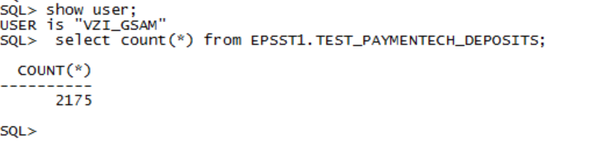
Login into the database as a offshore user whose profile is OFFSHORE
When the user selects the data. User will get only Non GSAM data

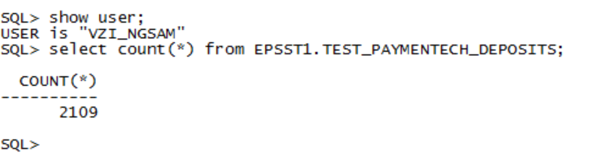

Note: Users whose profile is OFFSHORE will be able to see only Non GSAM data.

Check the user profile using below SQL.

select username,profile from dba_users;

3.Rollback Steps

3.1 Drop Policy
Login into the database as an VPD_ADMIN privileged user
Run the below script to drop policy on a table.

SELECT 'exec DBMS_RLS.DROP_POLICY(object_schema => '''
|| object_owner
|| ''',object_name => '''
|| object_name
|| ''',policy_name => '''
|| policy_name
|| ''');'
FROM dba_policies
WHERE pf_owner='VPD_ADMIN' and function = 'VPD_FUNCTION_COMMON';

Check the status of the policies using below SQL
select * from dba_policies WHERE pf_owner='VPD_ADMIN' and function = 'VPD_FUNCTION_COMMON';;

4.Miscellaneous Steps

4.1 Disable Policy

Login into the database as an VPD_ADMIN privileged user
Run the below script to drop policy on a table.

SELECT 'exec DBMS_RLS.ENABLE_POLICY(object_schema => '''
|| object_owner

|| ''', object_name => '''
|| object_name
|| ''', policy_name => '''
|| policy_name
|| ''', enable => FALSE);'
FROM dba_policies
WHERE pf_owner='VPD_ADMIN' and function = 'VPD_FUNCTION_COMMON';;

select * from dba_policies WHERE pf_owner='VPD_ADMIN' and function = 'VPD_FUNCTION_COMMON';;

4.2 Enable Policy

Login into the database as an VPD_ADMIN privileged user
Run the below script to drop policy on a table.

SELECT 'exec DBMS_RLS.ENABLE_POLICY(object_schema => '''
|| object_owner
|| ''', object_name => '''
|| object_name
|| ''', policy_name => '''
|| policy_name
|| ''', enable => TRUE);'
FROM dba_policies
WHERE pf_owner='VPD_ADMIN' and function = 'VPD_FUNCTION_COMMON';

4.3 Adding New Tables

When application team requires to add any new table/column in the database
App Team has to provide the below details along with table creation/alter script.
The template contains
- Table has GSAM Data YES/NO
- Schema Name
- Table Name
- GSAM Column Name
- GSAM Identifier Type
If the table contains GSAM data ,based on the above details we have to add a record into the VPD_ADMIN.GSAM_PROFILED_COLUMNS table
insert into vpd_admin.gsam_profiled_columns (db_schema,db_table,gsam_to_apply,lookup_column,identifier_type) values (schema_name,table_name,'Y',column_name,identifier_type);
Run add policy script to apply the policy on the new table.
exec DBMS_RLS.ADD_POLICY (
object_schema => schema_name
,object_name => table_name
,policy_name => policy_name
,function_schema => 'VPD_ADMIN'
,policy_function => 'VPD_FUNCTION_COMMON'
,update_check => FALSE);

4.4 Adding New Users

An AYS ticket is required to create an account/user on the database.
A Role/Privileges is assigned to a user based on the account type and Profiles are assigned to the requested user based on the user role when an account on the database is created.
OFFSHORE_APP_USER_PROFILE -- Offshore Application/dev users
OFFSHORE_DBA_PROFILE --- Offshore DBA users.
OFFSHORE_SYSACCOUNT_PROFILE ---- Application service/functional account required for the app to access only Non-GSAM Data.

4.5 Service Account Password Maintenance

The service account VPD_ADMIN password will be configured in cyber security tool. User has to fetch the password from cyberark and it will be audited who and when the password is fetched from cyberark
User has to raise an ADOM request to access the Cyberark and this request has to be approved by Jeyvel Pratap Chengavarayan

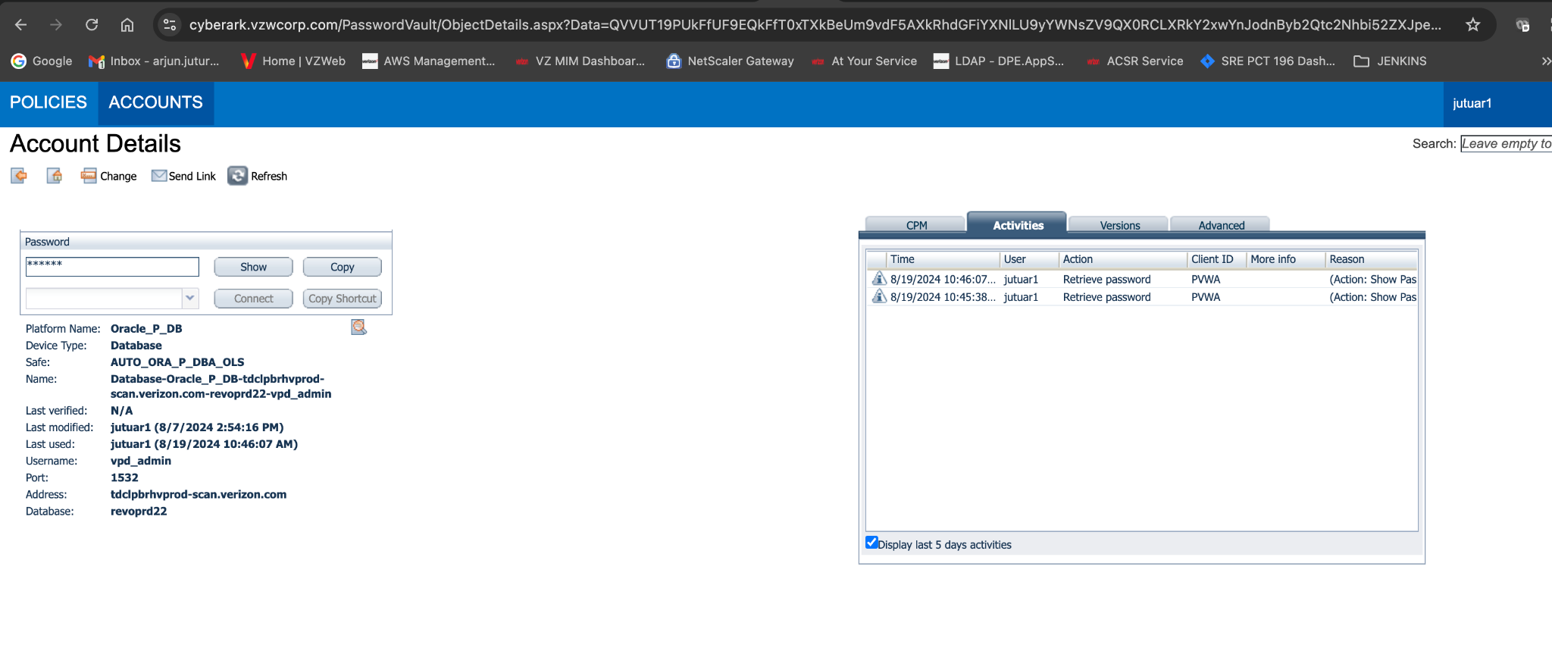
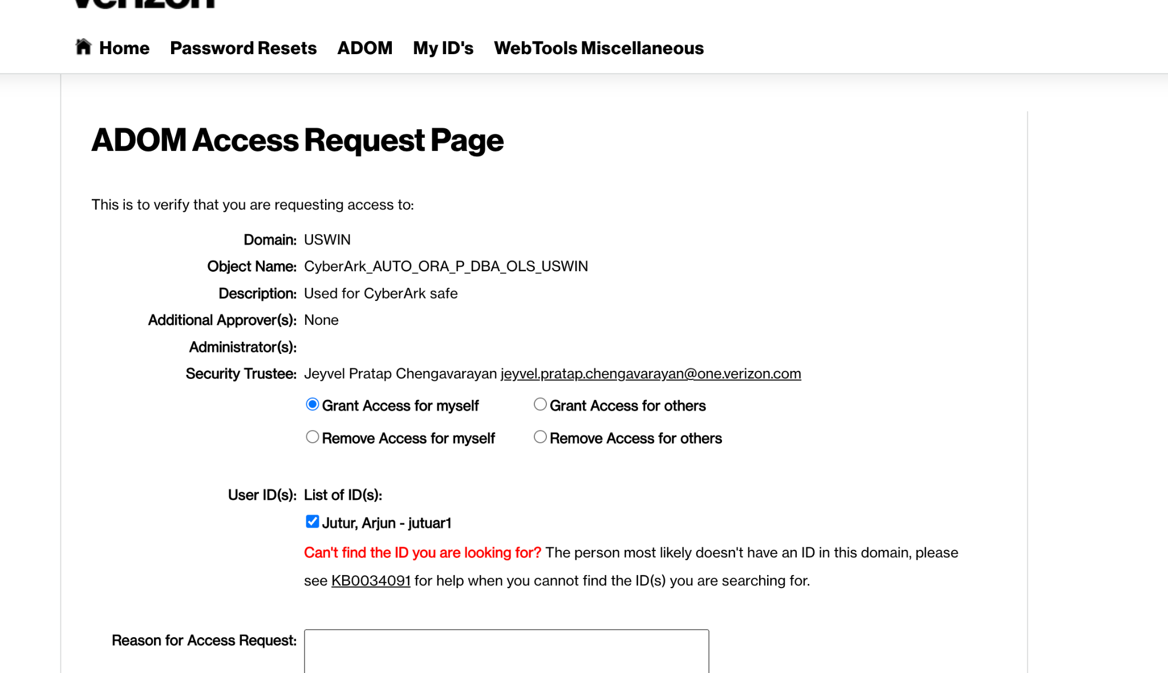

4.6 GSAM as a Service DB Access

- A Functional/Service account was created on GSAM as a Service Database.
  - Username: gsam_outbound
- Functional Account have access only to the Views created for the identifier types required for all the application databases.
- Username and Password will be vaulted in the Cyberark with no AUTO rotation of password and access will be given only to ONSHORE DBA team through ADOM Request.
- A DB Link is created on all the databases using a functional account to populate the data in the Lookup tables.
- Credentials to Functional Account is required only once, when a DB link is created on the database.
- Once a DB link is created on the database no one can access the password for the functional account through the database. Definition for the DB Link in the database looks like below.
CREATE DATABASE LINK GSAMPRD
CONNECT TO GSAM_OUTBOUND
IDENTIFIED BY <password>
USING '(DESCRIPTION = (ADDRESS = (PROTOCOL = TCP)(HOST = uiittpd56scan.verizon.com)(PORT = 1521)) (CONNECT_DATA = (SERVER = DEDICATED) (SERVICE_NAME = gsamprd)))';

4.7 Bypass Security Policies

To Bypass the security policies for an user, provide the below grant to the user.

GRANT EXEMPT ACCESS POLICY to <USER>;

The EXEMPT ACCESS POLICY privilege does not affect the enforcement of object
privileges such as SELECT, INSERT, UPDATE, and DELETE.
These privileges are enforced even if a user has been granted the EXEMPT ACCESS
POLICY privilege

To revoke the EXEMPT access

REVOKE EXEMPT ACCESS POLICY FROM <USER>;

Points to be consider:

- VPD policies are working based on DBA profiles. User’s profiles should be monitored carefully.
- All new profiles created in the database should be whitelisted in the VPD function based on the access privilege.
- DBLink :- Users will be able to access the data based on the DBlink privilege.
- Make sure the database doesn't have any public DB links.

Test Case : -
https://docs.google.com/document/d/11-L0RfqqK_EYdTLfYbOPoxlQOgVsPrpn/edit
https://docs.google.com/spreadsheets/d/121Rwsc6jZdhdFwiJA7yUMTJEbCjTw7zv/edit#gid=1508369160

Pros & Cons:

Pros & Cons | OLS | VPD
Install Software | Yes | No
Database Restart | Yes | No
New user creation | Yes | Yes
New Profile creation | No | Yes
Additional column to table | Yes | No
Batch Jobs | Yes | No
GSAM Reference data lookup | Yes | Yes
License - Additional cost | Yes | No

4.8 Lookup Data:

Lookup table data needs to be loaded using the files which can be requested from below Follow the instructions Which would require to create AYS and ticket as needed. .

https://gsam.verizon.com/

