**Name: Subhalaxmi Das**

**Roll No: 08**

**TY-IT**

**Experiment No. 3**

**Aim:** Implement following using Typescript:

a. Access Modifiers example using TypeScript

b. Building a Simple Website with TypeScript

**Software Requirement:** Windows, Visual Studio Code IDE, web browser.

**Code:**

**Exp3a:**

class Student {

public studCode: number;

studName: string;

private year: string;

public display(){

console.log(`${this.year} in public function and year is private var`);

}

}

let stud = new Student();

stud.studCode = 08;

stud.studName = "SUbhalaxmi Das";

console.log(stud.studCode+ " "+stud.studName);

console.log(stud.display());

**Exp3b:**

**App.tsx**

import React, { FC, ChangeEvent, useState } from "react";

import "./App.css";

import TodoTask from "./Components/TodoTask";

import { ITask } from "./Interfaces";

const App: FC = () => {

const [task, setTask] = useState<string>("");

const [deadline, setDeadline] = useState<number>(0);

const [todoList, setTodoList] = useState<ITask[]>([]);

const handleChange = (event: ChangeEvent<HTMLInputElement>): void => {

if (event.target.name === "task") {

setTask(event.target.value);

} else {

setDeadline(Number(event.target.value));

}

};

const addTask = (): void => {

const newTask = { taskName: task, deadline: deadline };

setTodoList([...todoList, newTask]);

setTask("");

setDeadline(0);

};

const completeTask = (taskNameToDelete: string): void => {

setTodoList(

todoList.filter((task) => {

return task.taskName != taskNameToDelete;

})

);

};

return (

<div className="App">

<div className="header">

<div className="inputContainer">

<input

type="text"

placeholder="Task"

name="task"

value={task}

onChange={handleChange}

/>

<input

type="number"

placeholder="Deadline (in Days)"

name="deadline"

value={deadline}

onChange={handleChange}

/>

</div>

<button onClick={addTask}>Add Task</button>

</div>

<div className="todoList">

{todoList.map((task: ITask, key: number) => {

return <TodoTask key={key} task={task} completeTask={completeTask} />;

})}

</div>

</div>

);

};

export default App;

**TodoTask.tsx:**

import React from "react";

import { ITask } from "../Interfaces";

interface Props {

task: ITask;

completeTask(taskNameToDelete: string): void;

}

const TodoTask = ({ task, completeTask }: Props) => {

return (

<div className="task">

<div className="content">

<span>{task.taskName}</span>

<span>{task.deadline}</span>

</div>

<button

onClick={() => {

completeTask(task.taskName);

}}

>

Delete

</button>

</div>

);

};

export default TodoTask;

**Performance:**

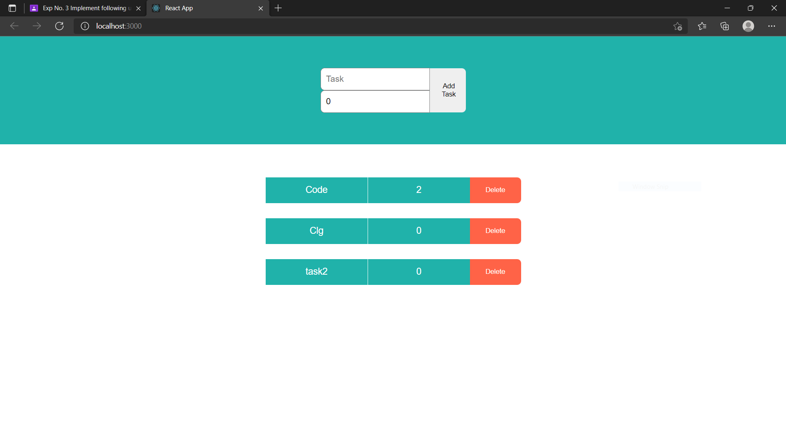

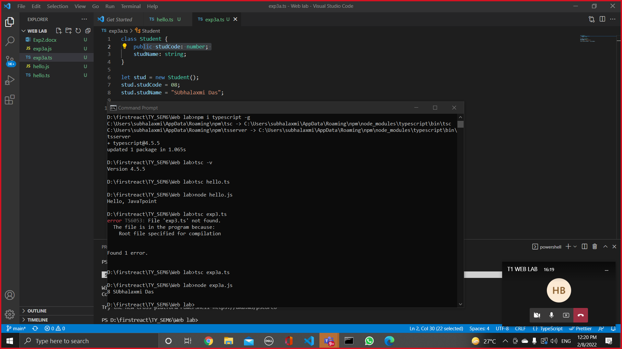

**Snap taken at the time of practical:**



**Conclusion:**

In this experiment, we are able to understand and implement the access modifier such as public, private and protected. We are also able to implement basic web page using typescript.