**Name:** Subhalaxmi Das

**Roll No:** 08

**TY-IT**

**Web lab**

**EXPERIMENT NO. 4**

**AIM:** To create a simple HTML web page Project using Angular - Framework and apply ng-controller, ng-model and expressions.

**Software Requirement:** Angular, VScode, browser.

**Performance:**

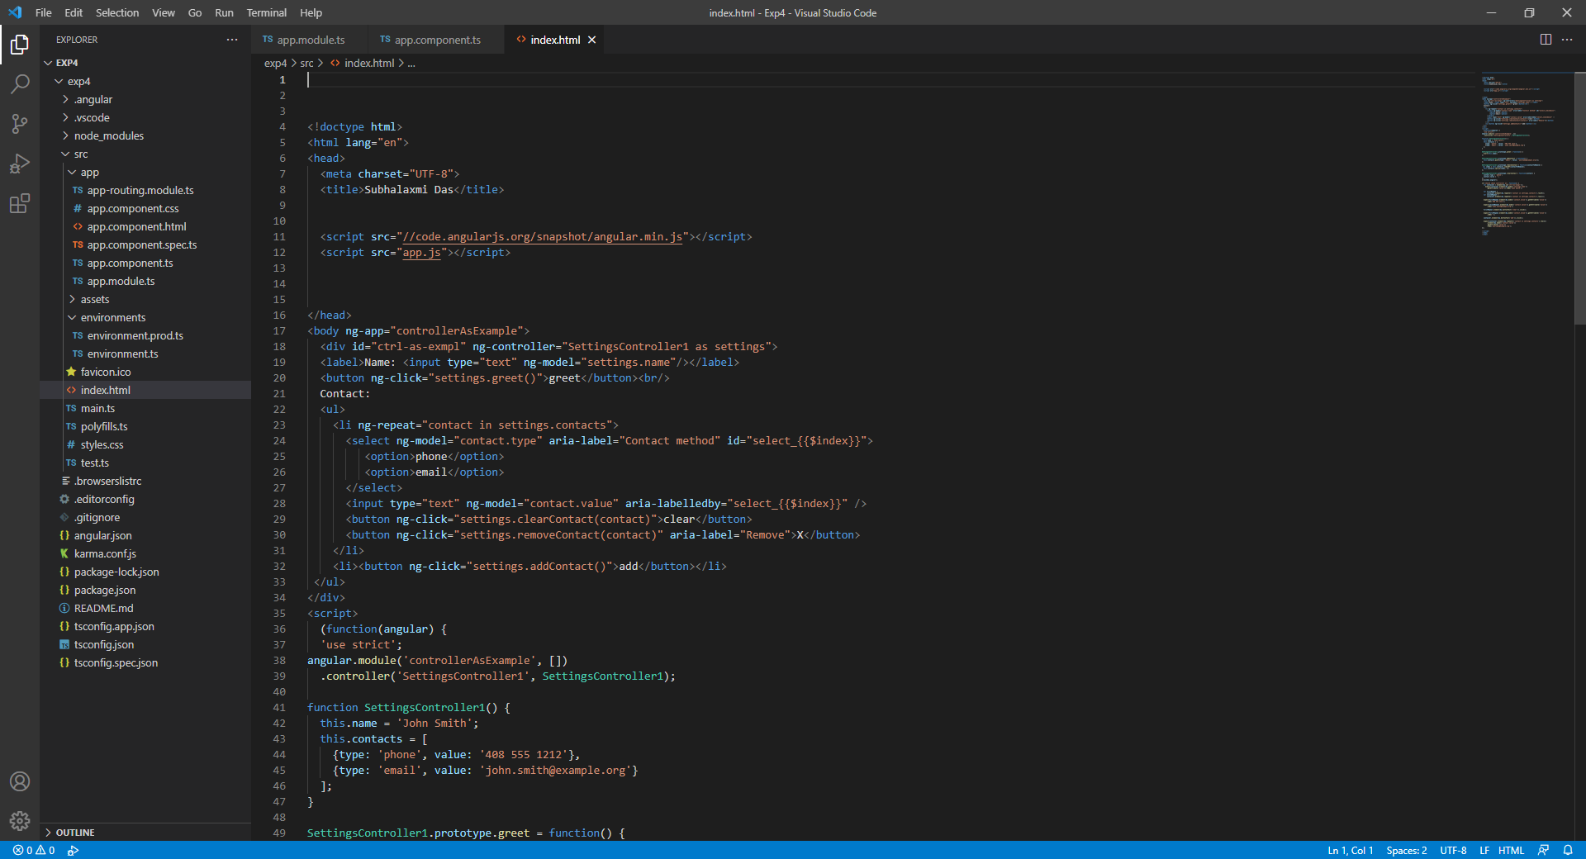

**Code:**

In index.html

<!doctype html>

<html lang="en">

<head>

  <meta charset="UTF-8">

  <title>Subhalaxmi Das</title>

  <script src="//[code.angularjs.org/snapshot/angular.min.js](http://code.angularjs.org/snapshot/angular.min.js)"></script>

  <script src="app.js"></script>

</head>

<body ng-app="controllerAsExample">

  <div id="ctrl-as-exmpl" ng-controller="SettingsController1 as settings">

  <label>Name: <input type="text" ng-model="[settings.name](http://settings.name/)"/></label>

  <button ng-click="settings.greet()">greet</button><br/>

  Contact:

  <ul>

    <li ng-repeat="contact in settings.contacts">

      <select ng-model="contact.type" aria-label="Contact method" id="select_{{$index}}">

         <option>phone</option>

         <option>email</option>

      </select>

      <input type="text" ng-model="contact.value" aria-labelledby="select_{{$index}}" />

      <button ng-click="settings.clearContact(contact)">clear</button>

      <button ng-click="settings.removeContact(contact)" aria-label="Remove">X</button>

    </li>

    <li><button ng-click="settings.addContact()">add</button></li>

 </ul>

</div>

<script>

  (function(angular) {

  'use strict';

angular.module('controllerAsExample', [])

  .controller('SettingsController1', SettingsController1);

function SettingsController1() {

  this.name = 'John Smith';

  this.contacts = [

    {type: 'phone', value: '408 555 1212'},

    {type: 'email', value: '[john.smith@example.org](mailto:john.smith@example.org)'}

  ];

}

SettingsController1.prototype.greet = function() {

  alert(this.name);

};

SettingsController1.prototype.addContact = function() {

  this.contacts.push({type: 'email', value: '[yourname@example.org](mailto:yourname@example.org)'});

};

SettingsController1.prototype.removeContact = function(contactToRemove) {

 var index = this.contacts.indexOf(contactToRemove);

  this.contacts.splice(index, 1);

};

SettingsController1.prototype.clearContact = function(contact) {

  contact.type = 'phone';

  contact.value = '';

};

})(window.angular);

it('should check controller as', function() {

  var container = element(by.id('ctrl-as-exmpl'));

    expect(container.element(by.model('[settings.name](http://settings.name/)'))

      .getAttribute('value')).toBe('John Smith');

  var firstRepeat =

      container.element(by.repeater('contact in settings.contacts').row(0));

  var secondRepeat =

      container.element(by.repeater('contact in settings.contacts').row(1));

  expect(firstRepeat.element(by.model('contact.value')).getAttribute('value'))

      .toBe('408 555 1212');

  expect(secondRepeat.element(by.model('contact.value')).getAttribute('value'))

      .toBe('[john.smith@example.org](mailto:john.smith@example.org)');

  firstRepeat.element(by.buttonText('clear')).click();

  expect(firstRepeat.element(by.model('contact.value')).getAttribute('value'))

      .toBe('');

  container.element(by.buttonText('add')).click();

  expect(container.element(by.repeater('contact in settings.contacts').row(2))

      .element(by.model('contact.value'))

      .getAttribute('value'))

      .toBe('[yourname@example.org](mailto:yourname@example.org)');

});

</script>

</body>

</html>

**OUTPUT:**

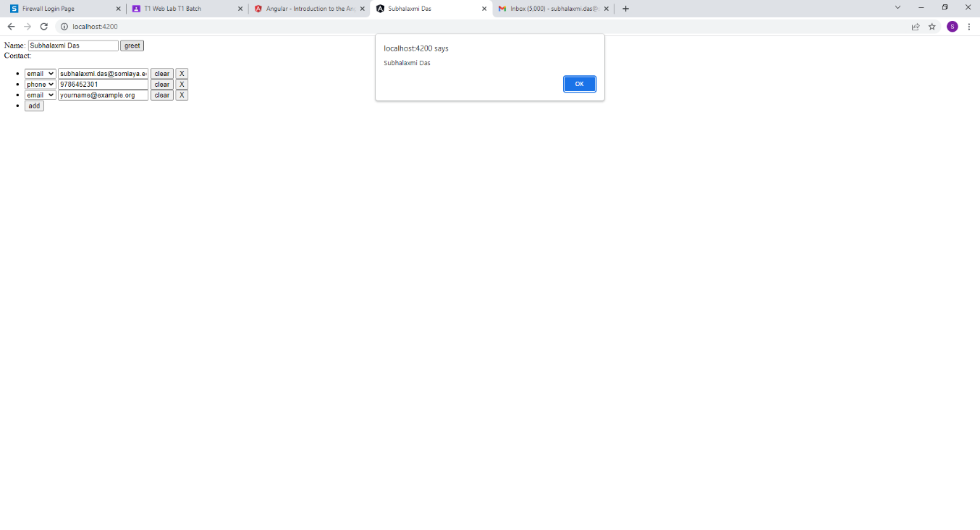

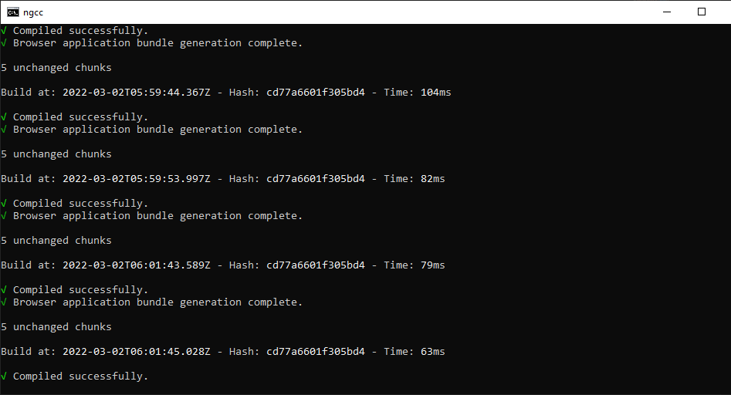

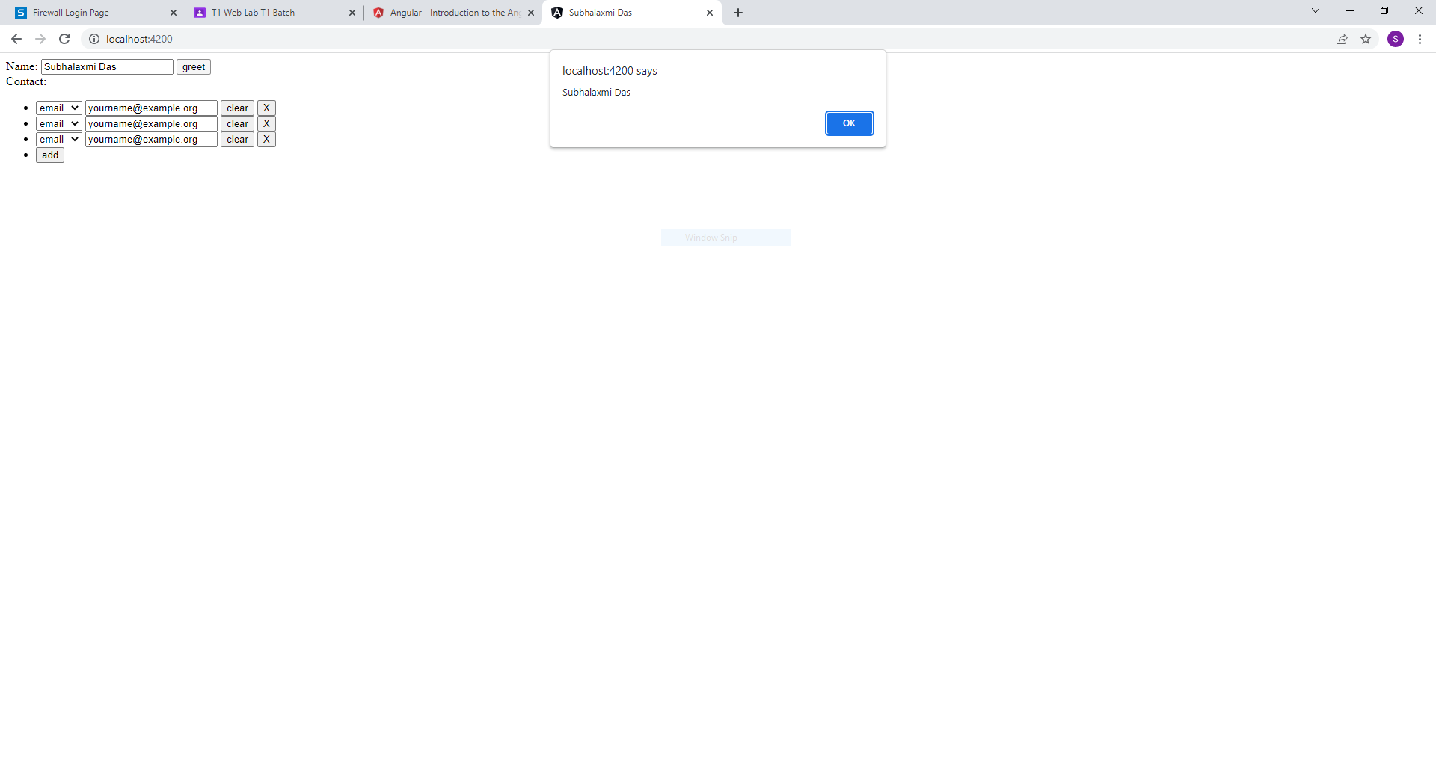

**Conclusion:** In this experiment, we learned to create simple web page project using Angular framework using ng-controller, ng-model and expressions. Ng-controller is used to control based on condition applied using expressions.