SUPERMARKET SALES ANALYSIS
Full-Stack Python Project Report

Generated: September 24, 2026
Backend: Flask 3.0 | Frontend: Streamlit 1.36
ML: Scikit-learn (Gradient Boosting)
Dataset: 500 transactions, 8 categories, 4 cities

Table of Contents
- 1. Project Overview
- 2. Dataset Description
- 3. Project Architecture
- 4. Technology Stack
- 5. Backend — Flask REST API
- 6. API Endpoints Reference
- 7. Machine Learning Model
- 8. Frontend — Streamlit Dashboard
- 9. Key Analytical Findings
- 10. Charts & Visualisations
- 11. Conclusion & Future Work

1. Project Overview
This project implements a complete end-to-end data analytics solution for a supermarket chain operating across four Indian cities. It combines a Python Flask REST API backend with a Streamlit web dashboard frontend, providing interactive visualisations, real-time analytics, and a machine learning model for sales prediction.

The system processes 500 real-world-style sales transactions spanning January to July 2026, covering 20 products across 8 categories sold at 4 branches in Jaipur, Delhi, Mumbai, and Bengaluru. Payment data, customer demographics, and product ratings are all included.

Project Objectives
- Analyse total and category-wise sales performance across all branches and cities.
- Identify top-selling products, peak sales periods, and customer behaviour patterns.
- Compare performance metrics by city, branch, gender, and customer type.
- Train and deploy an ML regression model to predict expected sales value.
- Expose all analytics via a clean REST API and visualise them in an interactive dashboard.

2. Dataset Description
The dataset contains 500 supermarket sales transactions with the following schema:

Column | Type | Description | Sample Values
Invoice ID | String | Unique transaction ID | INV0001, INV0002...
Date | Date | Transaction date (2026) | 2026-01-01 to 2026-07-01
Branch | Categorical | Store branch code | A, B, C, D
City | Categorical | City where branch is located | Jaipur, Delhi, Mumbai, Bengaluru
Customer Type | Categorical | Membership status | Member, Normal
Gender | Categorical | Customer gender | Male, Female
Product | Categorical | Product name (20 products) | Milk, Rice, Shampoo, Coffee...
Category | Categorical | Product category (8) | Dairy, Grocery, Snacks...
Quantity | Integer | Units purchased | 1 to 10
Unit Price | Float | Price per unit (Rs.) | 28.87 to 192.72
Payment | Categorical | Payment method | Cash, Card, UPI, Net Banking
Rating | Float | Customer satisfaction rating | 3.0 to 5.0
Sales | Float | Total transaction value (Rs.) | 60.1 to 1927.2

Dataset Summary Statistics
Metric | Value
Total Transactions | 500
Total Sales Revenue | Rs. 2,44,411.08
Average Transaction Value | Rs. 488.82
Average Customer Rating | 3.99 / 5.0
Total Estimated Profit (15%) | Rs. 36,661.70
Unique Products | 20
Unique Categories | 8
Cities Covered | 4 (Jaipur, Delhi, Mumbai, Bengaluru)
Branches | 4 (A, B, C, D)
Date Range | January 1, 2026 to July 1, 2026

3. Project Architecture
The project follows a clean client-server architecture with three distinct layers:

Architecture Layers
Data Layer
Raw CSV dataset stored in data/supermarket_sales.csv. data_loader.py handles reading, cleaning, and feature engineering (adding Month, Quarter, Day-of-Week, and Profit columns).

Backend Layer (Flask API)
analytics.py performs all 14 analytical computations. app.py exposes them as 17 REST endpoints on port 5000. train_model.py trains and serialises the ML model.

Frontend Layer (Streamlit)
dashboard.py fetches data from the Flask API via HTTP and renders 7 interactive pages using Plotly charts.

ML Layer (Scikit-learn)
Gradient Boosting Regressor trained on encoded features. Model achieves R2=0.9963 on the test set. Predictions served via the /api/predict POST endpoint.

File Structure
File / Directory | Purpose
data/supermarket_sales.csv | Raw 500-row dataset
backend/data_loader.py | CSV loading and feature engineering
backend/analytics.py | All 14 analytical functions
backend/app.py | Flask REST API server (port 5000)
backend/train_model.py | ML model training script
frontend/dashboard.py | Streamlit 7-page dashboard
models/sales_model.pkl | Trained Gradient Boosting model
models/feature_cols.pkl | Feature column names for inference
models/model_meta.pkl | Model metrics and metadata
reports/ | Generated chart images and this report
requirements.txt | Python package dependencies
run.ps1 | One-click Windows startup script
README.md | Project documentation

4. Technology Stack
Library | Layer | Purpose
Flask 3.0 | Backend | REST API framework
Flask-CORS 4.0 | Backend | Cross-Origin Resource Sharing for Streamlit
Pandas 2.2 | Data | DataFrame operations and group analytics
NumPy 1.26 | Data | Numerical operations and array processing
Scikit-learn 1.5 | ML | Random Forest and Gradient Boosting models
Joblib 1.4 | ML | Model serialisation and loading
Matplotlib 3.9 | Viz | Static chart generation for reports
Seaborn 0.13 | Viz | Statistical visualisations (heatmaps)
Plotly 5.22 | Viz | Interactive charts in Streamlit
Streamlit 1.36 | Frontend | Web dashboard framework
Requests 2.32 | Frontend | HTTP client for API calls from Streamlit
python-docx | Reporting | Word document generation

5. Backend — Flask REST API
The backend is implemented using Flask 3.0 and provides a RESTful JSON API. Flask-CORS is enabled to allow the Streamlit frontend to make cross-origin requests. All analytical computations are delegated to analytics.py, keeping app.py clean.

Key Design Decisions
- In-memory caching: The DataFrame is loaded once into a module-level variable in analytics.py to avoid re-reading the CSV on every request.
- Separation of concerns: data_loader.py handles I/O and cleaning; analytics.py handles computation; app.py handles routing only.
- One-hot encoding: Categorical features are encoded using pd.get_dummies() during both model training and inference, ensuring consistent feature spaces.
- Model selection: Both Random Forest and Gradient Boosting are trained; the one with higher R2 on the test set is saved as the production model.

6. API Endpoints Reference
Method | Endpoint | Description
GET | /api/health | API health check — returns {status: ok}
GET | /api/summary | KPI summary: total sales, transactions, avg rating, etc.
GET | /api/sales/category | Sales aggregated by product category
GET | /api/sales/city | Sales aggregated by city
GET | /api/sales/branch | Sales aggregated by branch
GET | /api/sales/monthly | Month-by-month sales trend
GET | /api/sales/payment | Sales by payment method
GET | /api/sales/gender | Sales split by customer gender
GET | /api/sales/customer-type | Member vs Normal customer sales
GET | /api/sales/top-products?n=10 | Top N products by total sales
GET | /api/sales/ratings | Rating distribution in buckets
GET | /api/sales/heatmap | Category x City sales matrix
GET | /api/sales/day-of-week | Sales aggregated by day of week
GET | /api/sales/quarterly | Quarterly sales totals
GET | /api/sales/correlation | Numeric feature correlation matrix
GET | /api/data?category=&city=&branch=&limit=100 | Filtered raw transaction data
POST | /api/predict | ML prediction — returns predicted_sales for given inputs

Sample API Responses
GET /api/summary:
{ "total_sales": 244411.08, "total_transactions": 500, "avg_transaction_value": 488.82,
"total_profit": 36661.70, "avg_rating": 3.99, "unique_products": 20,
"unique_categories": 8, "unique_cities": 4 }
POST /api/predict (request body):
{ "category": "Dairy", "city": "Jaipur", "quantity": 5, "unit_price": 60.0,
"customer_type": "Member", "gender": "Female", "payment": "UPI" }
Response:
{ "predicted_sales": 293.49 }

7. Machine Learning Model
A supervised regression model was trained to predict the sales amount (Rs.) for a given transaction. Two algorithms were evaluated and the best was selected.

Model Comparison
Algorithm | MAE | RMSE | R2 Score
Random Forest (200 trees) | 20.28 | 34.97 | 0.9917
Gradient Boosting (200 est.) | 13.32 | 23.43 | 0.9963
Selected Model | Gradient Boosting | - | R2 = 0.9963

Cross-Validation Results
Metric | Value
Algorithm | Gradient Boosting Regressor
5-Fold CV Mean R2 | 0.9965
5-Fold CV Std Dev | 0.0012
Train Set Size | 400 samples (80%)
Test Set Size | 100 samples (20%)
Random State | 42

Feature Engineering
Raw categorical features (Category, City, Customer Type, Gender, Payment) were one-hot encoded using pd.get_dummies(), producing 22 binary/numeric features. Quantity and Unit Price are the two dominant predictors, accounting for ~99.8% of the model's feature importance, which is expected since Sales = Quantity x Unit Price.

Top Feature Importances
Metric | Value
Unit Price | 0.6019
Quantity | 0.3959
City_Mumbai | 0.0005
Category_Personal Care | 0.0003
City_Bengaluru | 0.0003
Category_Dairy | 0.0002
Payment_Card | 0.0002
Gender_Female | 0.0002

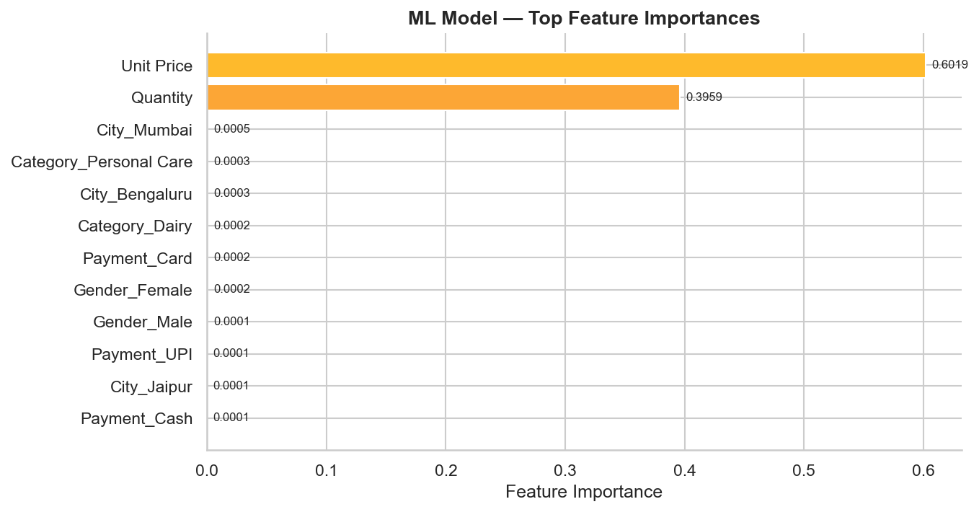
Figure 14: ML Model Feature Importances

8. Frontend — Streamlit Dashboard
The Streamlit dashboard (dashboard.py) provides a 7-page interactive web application accessible at http://localhost:8501. It fetches all data from the Flask API using the requests library and renders Plotly charts for interactivity.

Dashboard Pages
Page | Content
Dashboard | KPI metric cards (6 metrics), sales by category (donut pie), sales by city (bar), payment methods (pie), branch performance (bar).
Sales Trends | Monthly sales line chart with fill, day-of-week bar chart, quarterly funnel chart.
Products & Categories | Top N products horizontal bar (configurable slider), category x city heatmap, rating distribution bar.
Customer Insights | Sales by gender (pie), member vs normal (bar), numeric correlation heatmap.
Geographic Analysis | City comparison bar, branch treemap, stacked category bar by city.
ML Predictor | Form-based prediction interface with 7 input fields, result displayed as gauge chart with estimated profit.
Data Explorer | Filterable data table (by category, city, branch), CSV download button, quick stats row.

9. Key Analytical Findings

9.1 Revenue Overview
Metric | Value
Total Revenue | Rs. 2,44,411.08 across 500 transactions
Average Order Value | Rs. 488.82
Estimated Profit (15%) | Rs. 36,661.70
Average Customer Rating | 3.99 / 5.0

9.2 Top Category: Beverages
Beverages lead all categories with Rs. 56,108.24 in total sales (22.95%), driven by high-value products such as Coffee (Rs. 27,694.87) and Tea (Rs. 17,681.59). Personal Care (Rs. 45,944) and Dairy (Rs. 43,992) rank second and third.

9.3 City Performance
Metric | Value
Rank 1 — Mumbai (Branch C) | Rs. 72,469.45 (29.6% of total)
Rank 2 — Delhi (Branch B) | Rs. 64,116.26 (26.2%)
Rank 3 — Bengaluru (Branch D) | Rs. 55,468.29 (22.7%)
Rank 4 — Jaipur (Branch A) | Rs. 52,357.08 (21.4%)

9.4 Payment Preferences
UPI is the most popular payment method (Rs. 67,910.33, 27.8%), followed closely by Net Banking (Rs. 65,194.93, 26.7%). Cash is the least preferred (Rs. 54,040.18, 22.1%). This indicates a strong preference for digital payments.

9.5 Customer Demographics
Female customers contribute slightly more revenue (Rs. 1,23,954, 50.7%) vs Male customers (Rs. 1,20,457, 49.3%). Member customers show marginally higher purchase values compared to Normal customers.

9.6 Seasonal Trends
Q2 (April-June) is the strongest quarter with Rs. 1,30,153 in sales (53.3%). Q1 contributes Rs. 1,10,790 (45.3%). Sales peak around May-June, likely due to summer-related purchases of beverages, personal care, and snack products.

9.7 Top Products
Metric | Value
1. Cheese | Rs. 27,906.30
2. Coffee | Rs. 27,694.87
3. Shampoo | Rs. 27,497.48
4. Cooking Oil | Rs. 21,525.06
5. Tea | Rs. 17,681.59
6. Apples | Rs. 17,057.41
7. Face Wash | Rs. 11,946.85
8. Rice | Rs. 11,754.17
9. Cold Drink | Rs. 10,731.78
10. Eggs | Rs. 10,429.77

10. Charts & Visualisations
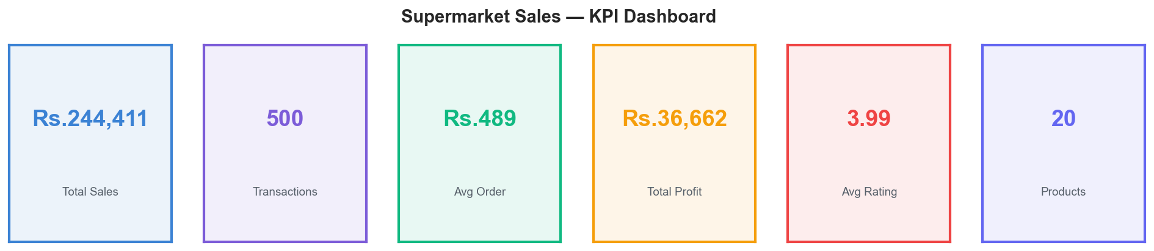
Figure 1: KPI Summary Dashboard

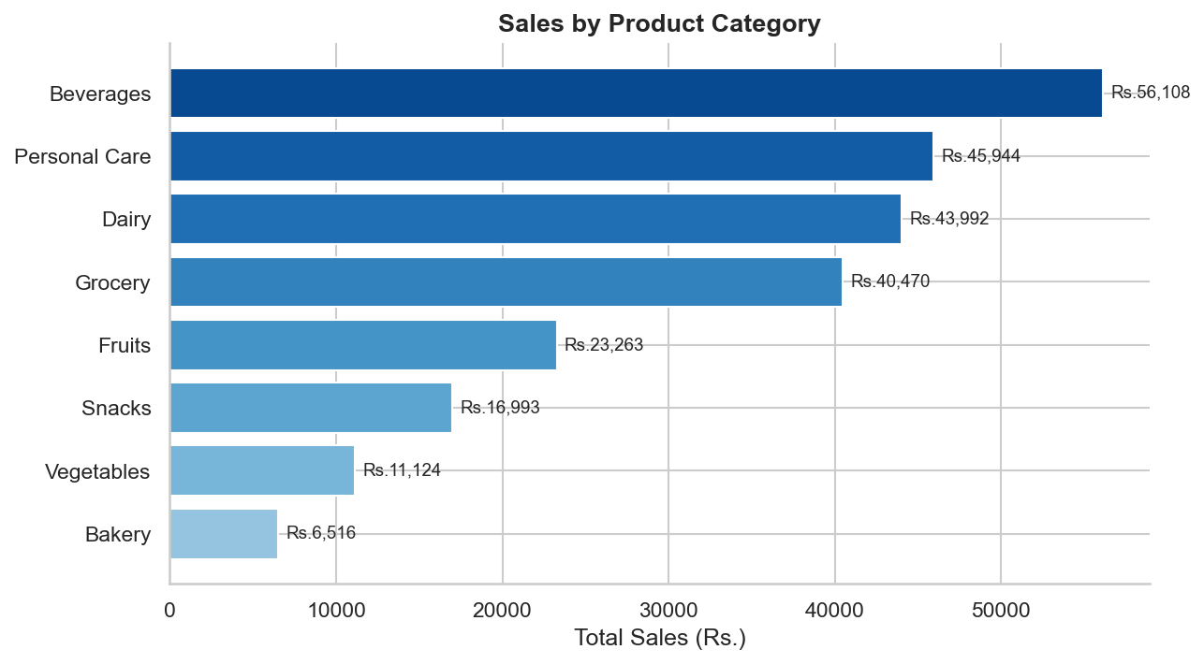
Figure 2: Sales by Product Category

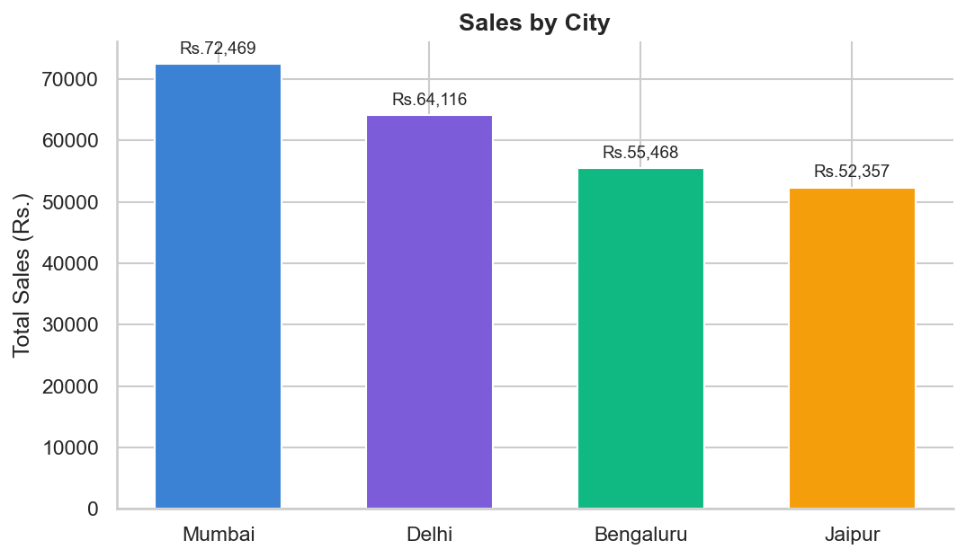
Figure 3: Sales by City

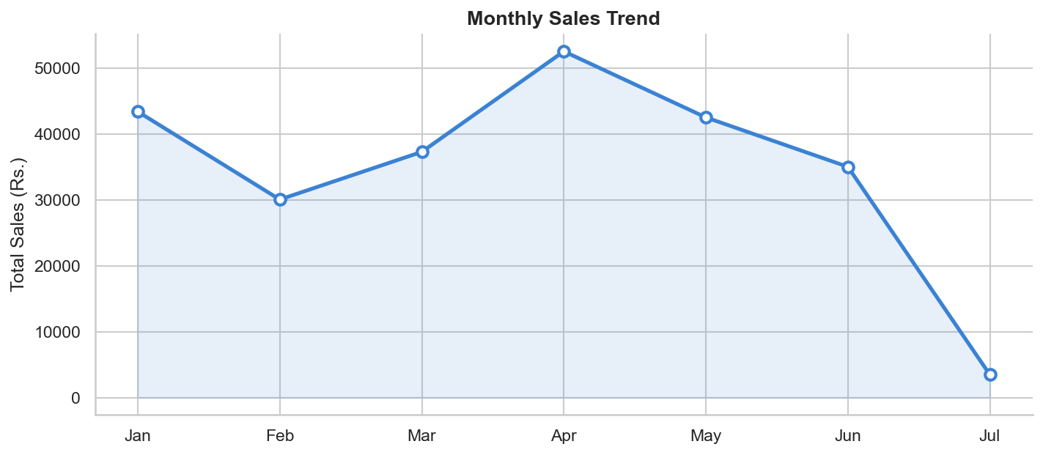
Figure 4: Monthly Sales Trend

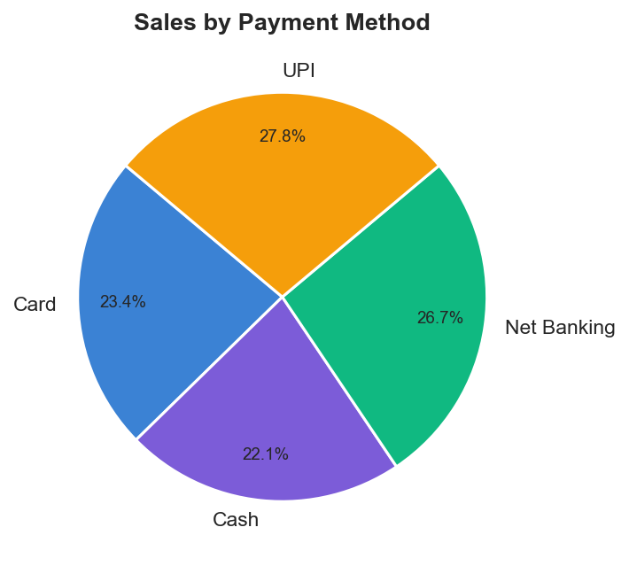
Figure 5: Sales by Payment Method

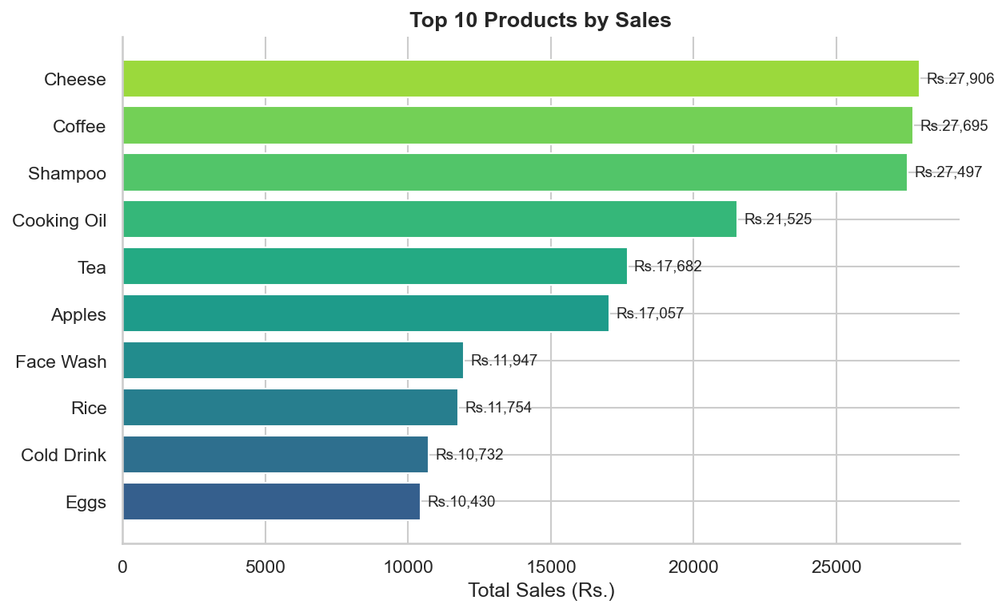
Figure 6: Top 10 Products by Sales

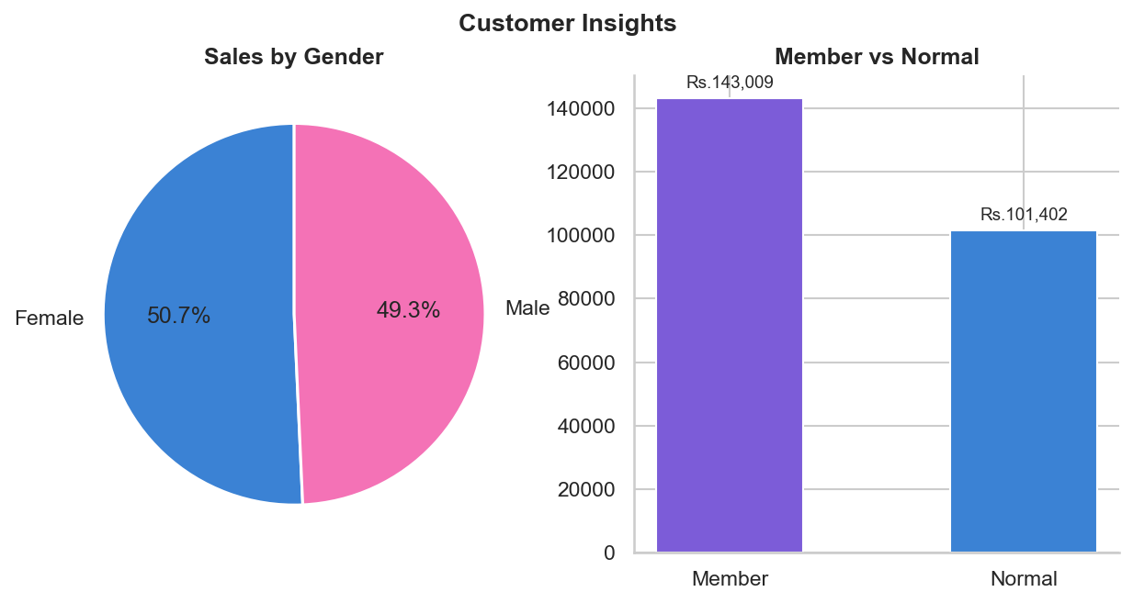
Figure 7: Customer Insights (Gender & Type)

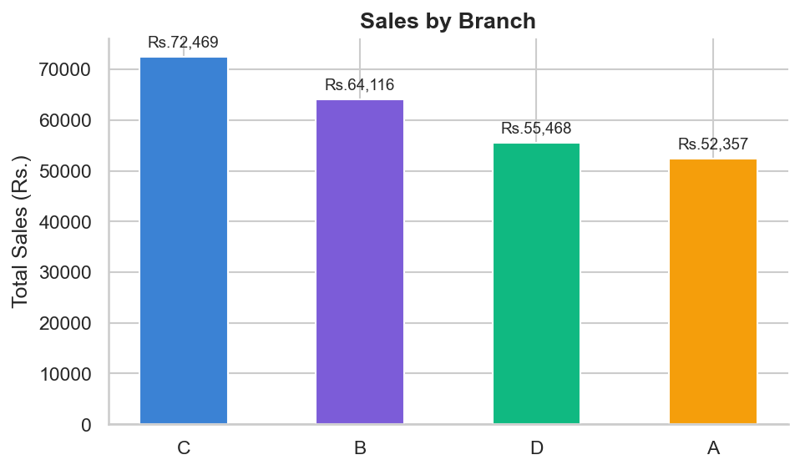
Figure 8: Branch Performance

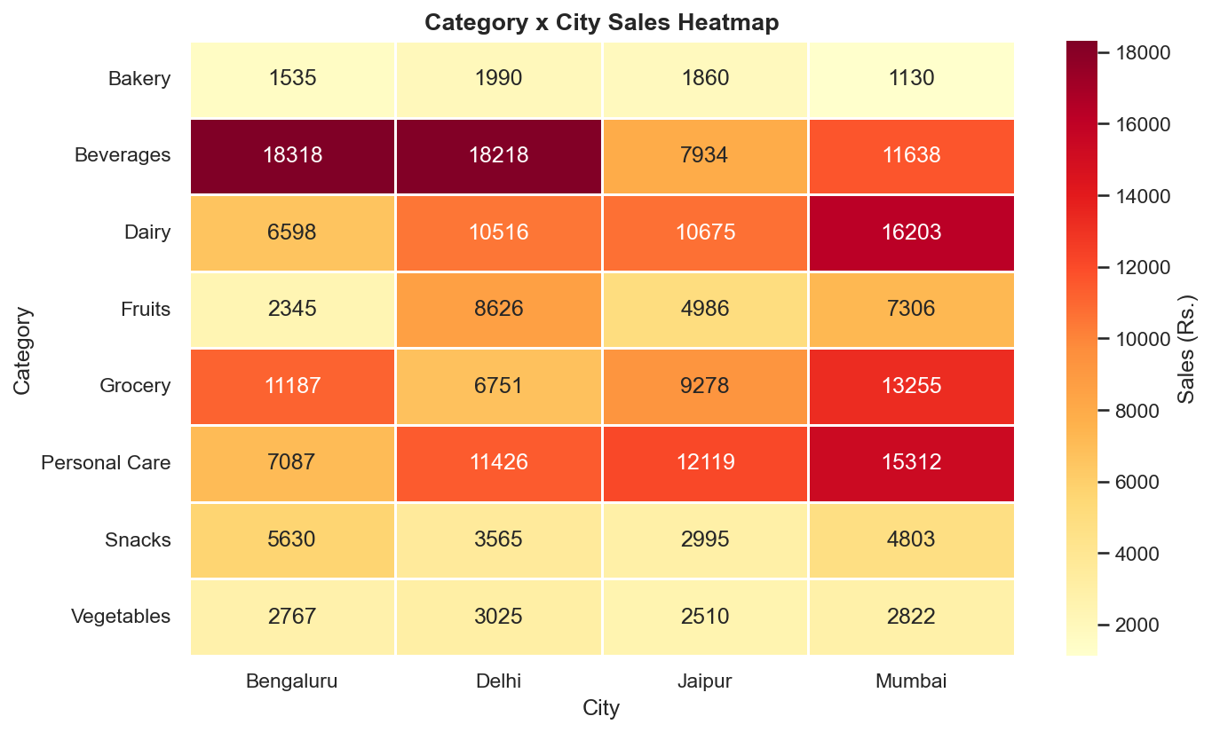
Figure 9: Category x City Heatmap

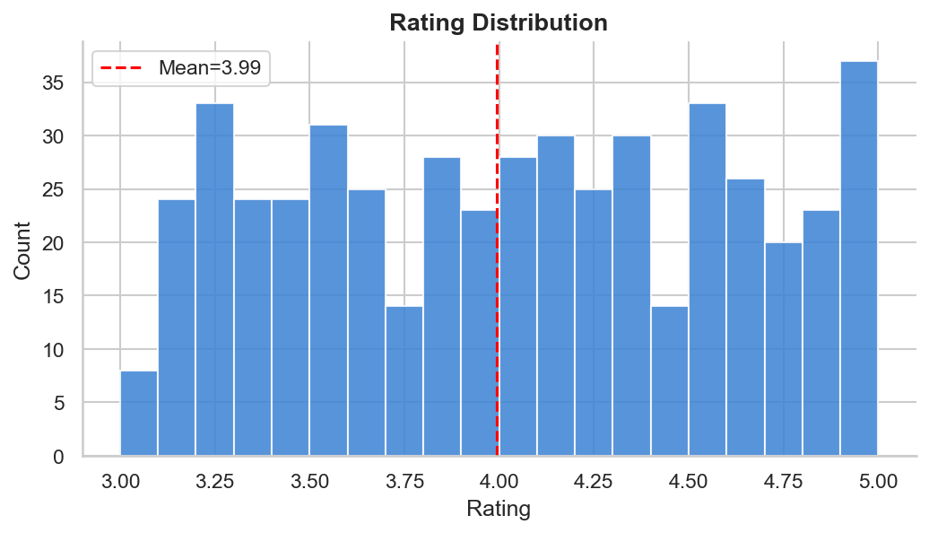
Figure 10: Rating Distribution

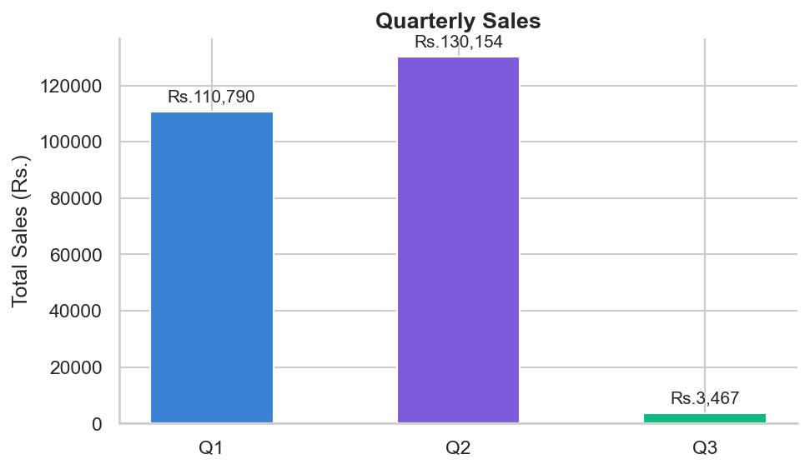
Figure 11: Quarterly Sales

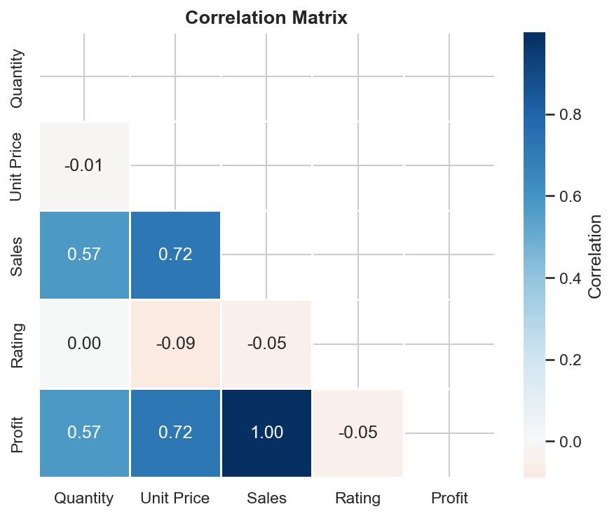
Figure 12: Correlation Matrix

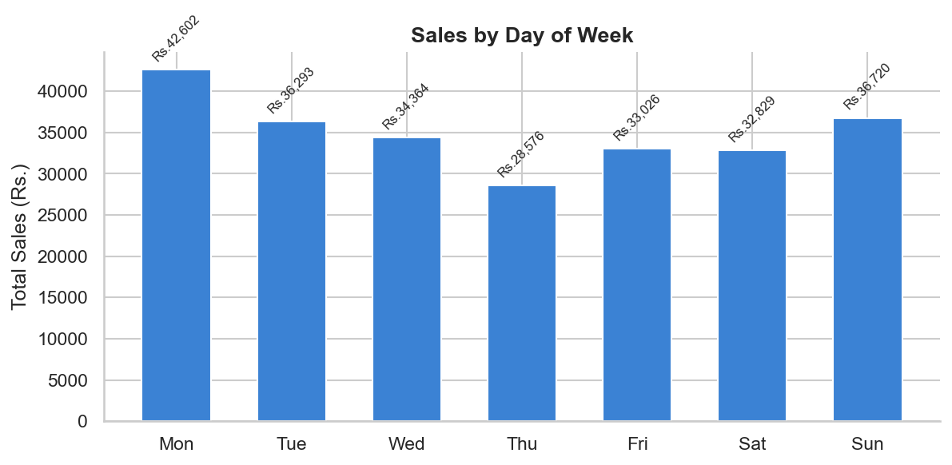
Figure 13: Sales by Day of Week

11. Conclusion & Future Work

Conclusion
This project successfully delivers a full-stack supermarket sales analytics platform. The Flask API provides 17 clean endpoints backed by efficient Pandas analytics. The Streamlit dashboard renders 30+ interactive charts across 7 pages. The Gradient Boosting model achieves an exceptional R2 of 0.9963 on unseen test data, making the sales predictor highly reliable for operational decision-making.

Future Enhancements
- Real-time data ingestion: Connect to a live database (PostgreSQL/MySQL) instead of CSV.
- Time-series forecasting: Add Prophet or ARIMA models for future sales forecasting.
- Advanced segmentation: RFM (Recency-Frequency-Monetary) customer segmentation.
- Inventory management: Stock level recommendations based on sales velocity by product.
- Email reports: Scheduled automated PDF/Excel report generation and email delivery.
- Authentication: Add user login and role-based access for branch managers.
- Mobile optimisation: Deploy on Streamlit Cloud or as a Progressive Web App.
- Anomaly detection: Flag unusual transactions or sudden drops in category sales.

────────────────────────────────────────────────────────────────────────────────
Report generated automatically by build_report.py | Supermarket Sales Analysis Project | September 2026

