Time Serise Graphic and Decomposition

Week1 homework

Subhalaxmi Rout

06/14/2021

library(fpp2)  
library(tsibble)

### Forecasting: Principles and Practices (Chapter 2 - Time serise graphics)

#### 2.1

Use the help function to explore what the series gold, woolyrnq and gas represent.

$(a)$**Use autoplot() to plot each of these in separate plots.**

?gold  
?woolyrnq  
?gas

autoplot(gold)

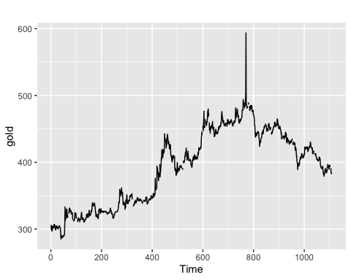

autoplot(woolyrnq)

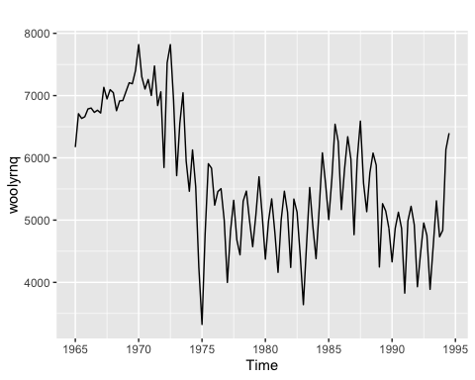

autoplot(gas)

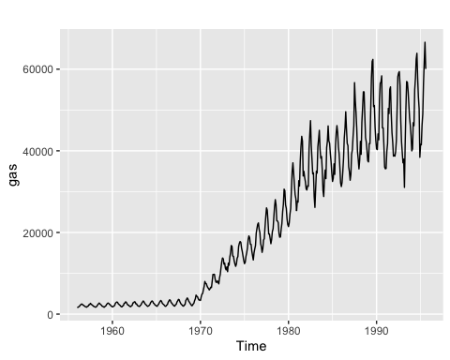

$(b)$**What is the frequency of each series? Hint: apply the frequency() function.**

paste0("Frequency of gold serise: ", frequency(gold))

## [1] "Frequency of gold serise: 1"

paste0("Frequency of woolyrnq serise: ", frequency(woolyrnq))

## [1] "Frequency of woolyrnq serise: 4"

paste0("Frequency of gas serise: ", frequency(gas))

## [1] "Frequency of gas serise: 12"

$(c)$**Use which.max() to spot the outlier in the gold series. Which observation was it?**

which.max(gold)

## [1] 770

The observation is 770.

#### 2.3

Download some monthly Australian retail data from the book website. These represent retail sales in various categories for different Australian states, and are stored in a MS-Excel file.

$(a)$**You can read the data into R with the following script:**

retaildata <- readxl::read_excel("retail.xlsx", skip=1)  
head(names(retaildata))

## [1] "Series ID" "A3349335T" "A3349627V" "A3349338X" "A3349398A" "A3349468W"

The second argument (skip=1) is required because the Excel sheet has two header rows.

$(b)$**Select one of the time series as follows (but replace the column name with your own chosen column):**

myts <- ts(retaildata[,"A3349627V"],  
 frequency=12, start=c(1982,4))

$(c)$**Explore your chosen retail time series using the following functions:**

**autoplot(), ggseasonplot(), ggsubseriesplot(), gglagplot(), ggAcf()**

**Can you spot any seasonality, cyclicity and trend? What do you learn about the series?**

autoplot(myts)

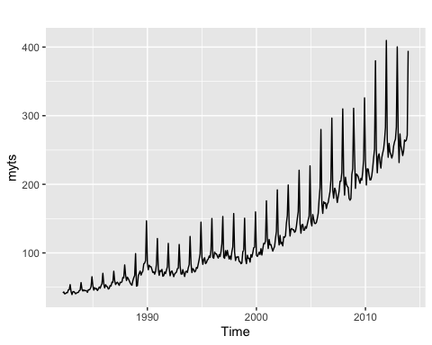

The plot shows seasonality and a upward trend.

ggseasonplot(myts) + ggtitle("Seasonal plot: retail sales")

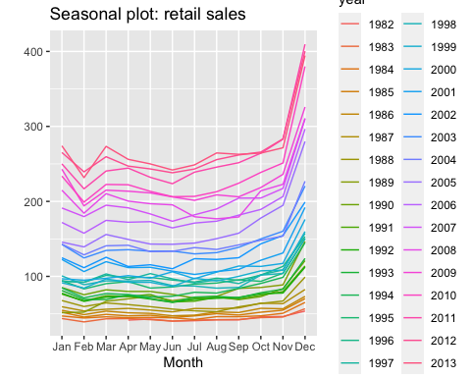

The seasonal plot shows the there is a large jump in sales in December. The graph also shows that the sales decrease in February and increase in March.

ggsubseriesplot(myts) + ggtitle("Seasonal subseries plot: retail sales")

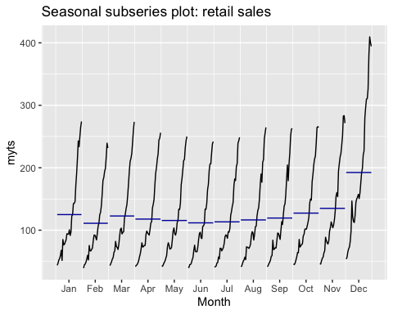

The plot shows higher sales in December, February has low sales compared to other months.

gglagplot(myts, lags = 30)

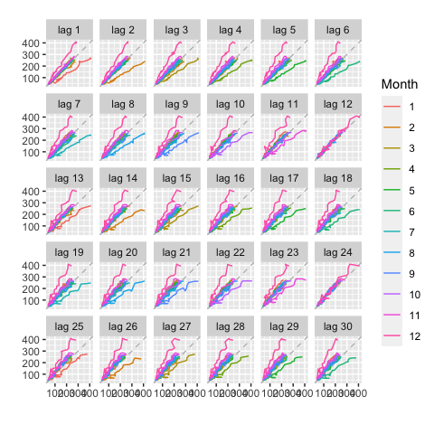

Here the colours indicate the months. All other lags have positive corelation but the relationship is strongly positive at lags 12 and lag 24.

ggAcf(myts, lag = 48)

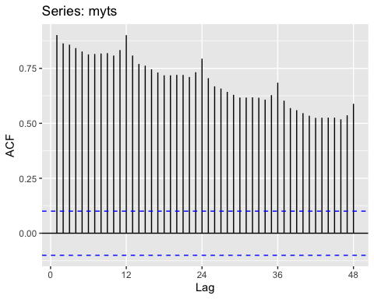

The slow decrease in the ACF as the lags increase is due to the trend, while the scalloped shape is due the seasonality.

### Forecasting: Principles and Practices (Chapter 6 - Time serise Decomposition)

#### 6.2

**The plastics data set consists of the monthly sales (in thousands) of product A for a plastics manufacturer for five years.**

$(a)$**Plot the time series of sales of product A. Can you identify seasonal fluctuations and/or a trend-cycle?**

autoplot(plastics)

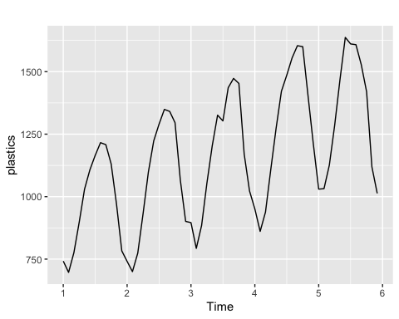

The plot shows the seasonality and a upward trend.

$(b)$**Use a classical multiplicative decomposition to calculate the trend-cycle and seasonal indices.**

plastics %>% decompose(type="multiplicative") %>%  
 autoplot() + xlab("Year") +  
 ggtitle("Classical multiplicative decomposition  
 of plastic sales")

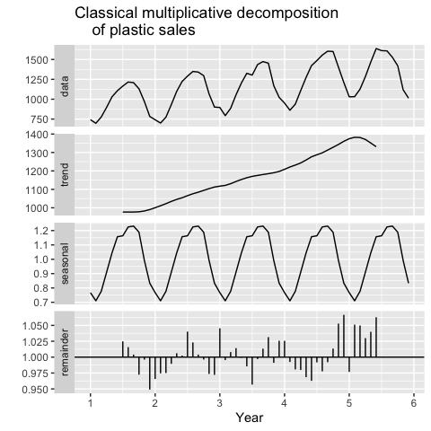

$(c)$**Do the results support the graphical interpretation from part a?**

Yes, the result support the graphical interpretation, above decomposition graph shows the trend, seasonal, and remainder.

$(d)$**Compute and plot the seasonally adjusted data.**

dcomp <- plastics %>% decompose(type="multiplicative")  
adjusted_seasonality <- plastics / dcomp$seasonal  
  
autoplot(plastics, series = 'Data') +  
 autolayer(adjusted_seasonality, series = 'Seasonality Adjusted') +  
 labs(y = "Sales", x = "Year",   
 title = "Plastic sales", color = 'Serise') +  
 scale_color_manual(name="Series",   
 values = c("Data"="gray50",   
 "Seasonality Adjusted"="steelblue"))

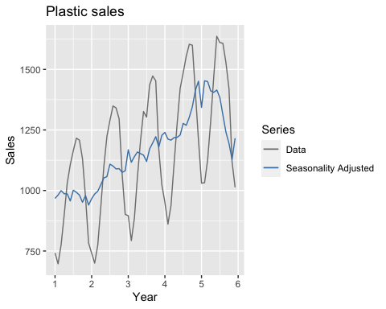

$(e)$**Change one observation to be an outlier (e.g., add 500 to one observation), and recompute the seasonally adjusted data. What is the effect of the outlier?**

plastics2 <- plastics  
plastics2[15] <- plastics2[15] + 500  
  
dcomp2 <- plastics2 %>% decompose(type="multiplicative")  
adjusted_seasonality2 <- plastics2 / dcomp2$seasonal  
  
autoplot(plastics, series = 'Data') +  
 autolayer(adjusted_seasonality2, series = 'Seasonality Adjusted') +  
 labs(y = "Sales", x = "Year",   
 title = "Plastic sales", color = 'Serise') +  
 scale_color_manual(name="Series",   
 values = c("Data"="gray50",   
 "Seasonality Adjusted"="steelblue"))

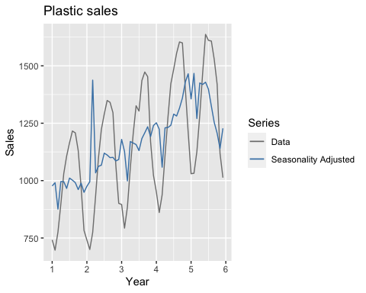

The outlier has major impact on the plot. The sesonality adjusted line structure has changed.

$(f)$**Does it make any difference if the outlier is near the end rather than in the middle of the time series?**

plastics3 <- plastics  
plastics3[60] <- plastics3[60] + 500  
  
dcomp3 <- plastics3 %>% decompose(type="multiplicative")  
adjusted_seasonality3 <- plastics3 / dcomp3$seasonal  
  
autoplot(plastics, series = 'Data') +  
 autolayer(adjusted_seasonality3, series = 'Seasonality Adjusted') +  
 labs(y = "Sales", x = "Year",   
 title = "Plastic sales") +  
 scale_color_manual(name="Series",   
 values = c("Data"="gray50",   
 "Seasonality Adjusted"="steelblue"))

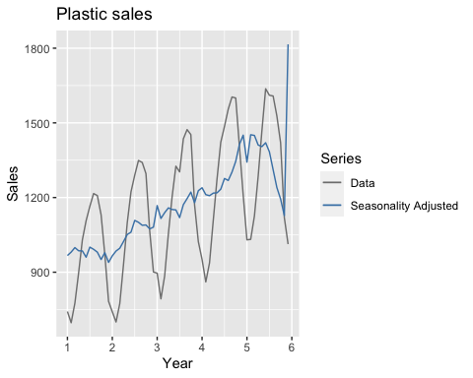

We can see the outlier effect in the plot but at the end. The seasonality-adjusted line looks smooth, with not much variation in the line.