**Exercise 1: Implementing the Singleton Pattern**

using System;

namespace SingletonPatternExample

{

public class Logger

{

private static Logger _instance;

private static readonly object _lock = new object();

private Logger()

{

Console.WriteLine("Logger instance created.");

}

public static Logger GetInstance()

{

if (_instance == null)

{

lock (_lock)

{

if (_instance == null)

{

_instance = new Logger();

}

}

}

return _instance;

}

public void Log(string message)

{

Console.WriteLine($"Log: {message}");

}

}

class Program

{

static void Main(string[] args)

{

Logger logger1 = Logger.GetInstance();

logger1.Log("First log message.");

Logger logger2 = Logger.GetInstance();

logger2.Log("Second log message.");

Console.WriteLine($"Are logger1 and logger2 the same instance? {logger1 == logger2}");

Console.ReadKey();

}

}

}

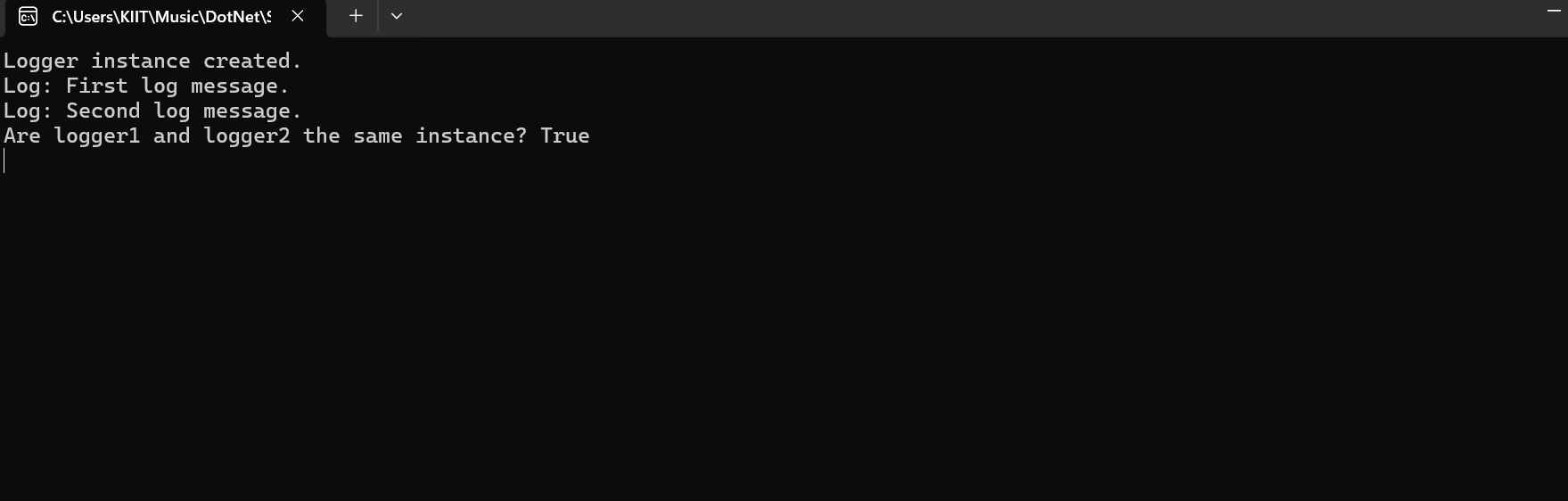

**Exercise 2: Implementing the Factory Method Pattern**

using System;

namespace FactoryMethodPatternExample

{

public interface IDocument

{

void Open();

void Close();

}

public class WordDocument : IDocument

{

public void Open()

{

Console.WriteLine("Opening Word Document.");

}

public void Close()

{

Console.WriteLine("Closing Word Document.");

}

}

public class PdfDocument : IDocument

{

public void Open()

{

Console.WriteLine("Opening pdf Document.");

}

public void Close()

{

Console.WriteLine("Closing pdf Document.");

}

}

public class ExcelDocument : IDocument

{

public void Open()

{

Console.WriteLine("Opening Excel Document.");

}

public void Close()

{

Console.WriteLine("Closing Excel Document.");

}

}

public abstract class DocumentFactory

{

public abstract IDocument CreateDocument();

}

public class WordDocumentFactory : DocumentFactory

{

public override IDocument CreateDocument()

{

return new WordDocument();

}

}

public class PdfDocumentFactory : DocumentFactory

{

public override IDocument CreateDocument()

{

return new PdfDocument();

}

}

public class ExcelDocumentFactory : DocumentFactory

{

public override IDocument CreateDocument()

{

return new ExcelDocument();

}

}

class Program

{

static void Main(string[] args)

{

DocumentFactory wordFactory = new WordDocumentFactory();

DocumentFactory pdfFactory = new PdfDocumentFactory();

DocumentFactory excelFactory = new ExcelDocumentFactory();

IDocument wordDocument = wordFactory.CreateDocument();

IDocument pdfDocument = pdfFactory.CreateDocument();

IDocument excelDocument = excelFactory.CreateDocument();

wordDocument.Open();

wordDocument.Close();

pdfDocument.Open();

pdfDocument.Close();

excelDocument.Open();

excelDocument.Close();

Console.ReadKey();

}

}

}

