**Exercise 1: Ranking and Window Functions**

-- Ensure you are using the correct database

USE exercise1;

-- Using ROW_NUMBER() to get top 3 products per category

WITH RankedProducts AS (

SELECT

ProductID,

ProductName,

Category,

Price,

ROW_NUMBER() OVER (PARTITION BY Category ORDER BY Price DESC) AS RowNum

FROM

Products

)

SELECT

ProductID,

ProductName,

Category,

Price,

RowNum

FROM

RankedProducts

WHERE

RowNum <= 3;

-- Using RANK() to get top 3 products per category

WITH RankedProducts AS (

SELECT

ProductID,

ProductName,

Category,

Price,

RANK() OVER (PARTITION BY Category ORDER BY Price DESC) AS RankNum

FROM

Products

)

SELECT

ProductID,

ProductName,

Category,

Price,

RankNum

FROM

RankedProducts

WHERE

RankNum <= 3;

-- Using DENSE_RANK() to get top 3 products per category

WITH RankedProducts AS (

SELECT

ProductID,

ProductName,

Category,

Price,

DENSE_RANK() OVER (PARTITION BY Category ORDER BY Price DESC) AS DenseRankNum

FROM

Products

)

SELECT

ProductID,

ProductName,

Category,

Price,

DenseRankNum

FROM

RankedProducts

WHERE

DenseRankNum <= 3;

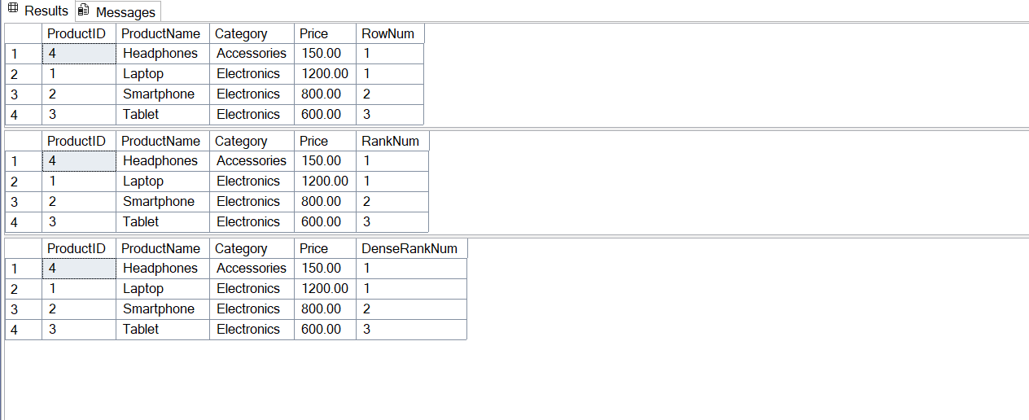

**Exercise 1: Create a Stored Procedure**

USE EmployeeManagement;

GO

CREATE PROCEDURE sp_GetEmployeesByDepartment

@DepartmentID INT

AS

BEGIN

SELECT

EmployeeID,

FirstName,

LastName,

DepartmentID,

Salary,

JoinDate

FROM

Employees

WHERE

DepartmentID = @DepartmentID;

END;

GO

EXEC sp_GetEmployeesByDepartment @DepartmentID = 3;

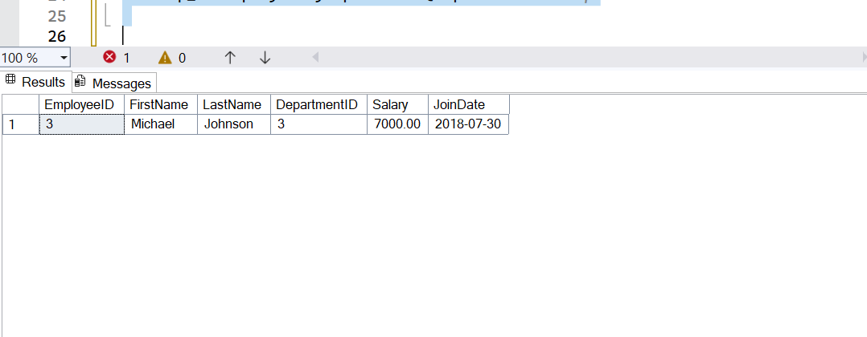

3.

USE EmployeeManagement;

GO

CREATE PROCEDURE sp_InsertEmployee

@FirstName VARCHAR(50),

@LastName VARCHAR(50),

@DepartmentID INT,

@Salary DECIMAL(10,2),

@JoinDate DATE

AS

BEGIN

INSERT INTO Employees (FirstName, LastName, DepartmentID, Salary, JoinDate)

VALUES (@FirstName, @LastName, @DepartmentID, @Salary, @JoinDate);

END;

GO

EXEC sp_InsertEmployee

@FirstName = 'Alex',

@LastName = 'Wilson',

@DepartmentID = 2,

@Salary = 6200.00,

@JoinDate = '2022-08-10';

**Exercise 5: Return Data from a Stored Procedure**

USE EmployeeManagement;

GO

CREATE PROCEDURE sp_GetEmployeeCountByDepartment

@DepartmentID INT

AS

BEGIN

SELECT

COUNT(*) AS TotalEmployees

FROM

Employees

WHERE

DepartmentID = @DepartmentID;

END;

GO

EXEC sp_GetEmployeeCountByDepartment @DepartmentID = 2;

