Handson :-1

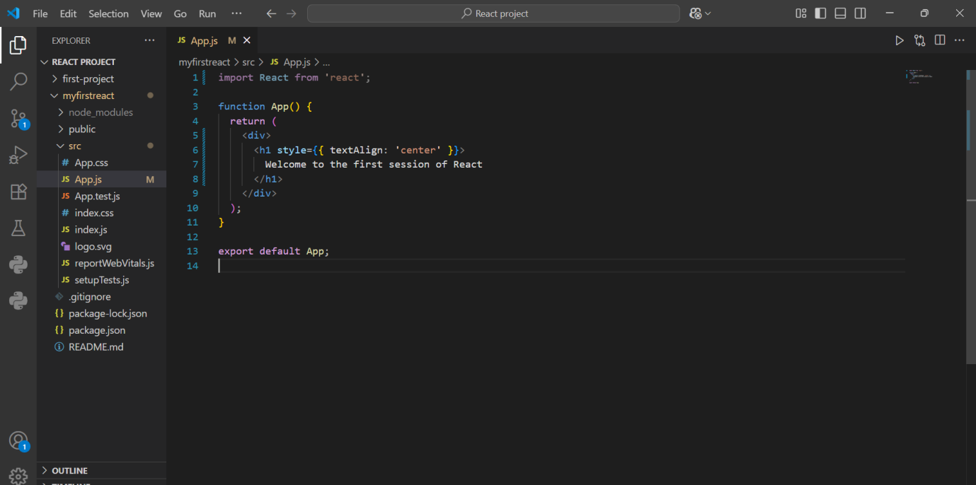

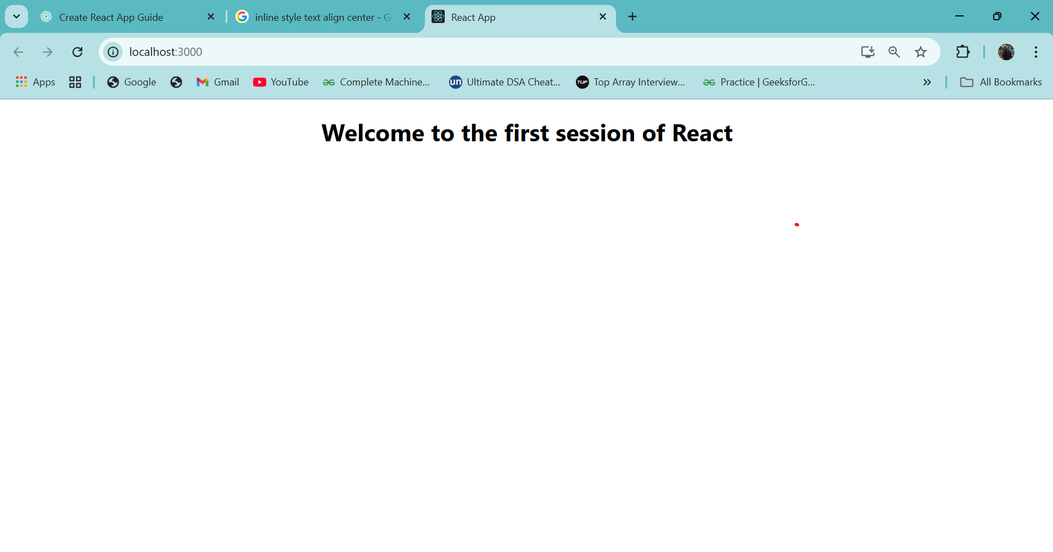

Handson 2:-

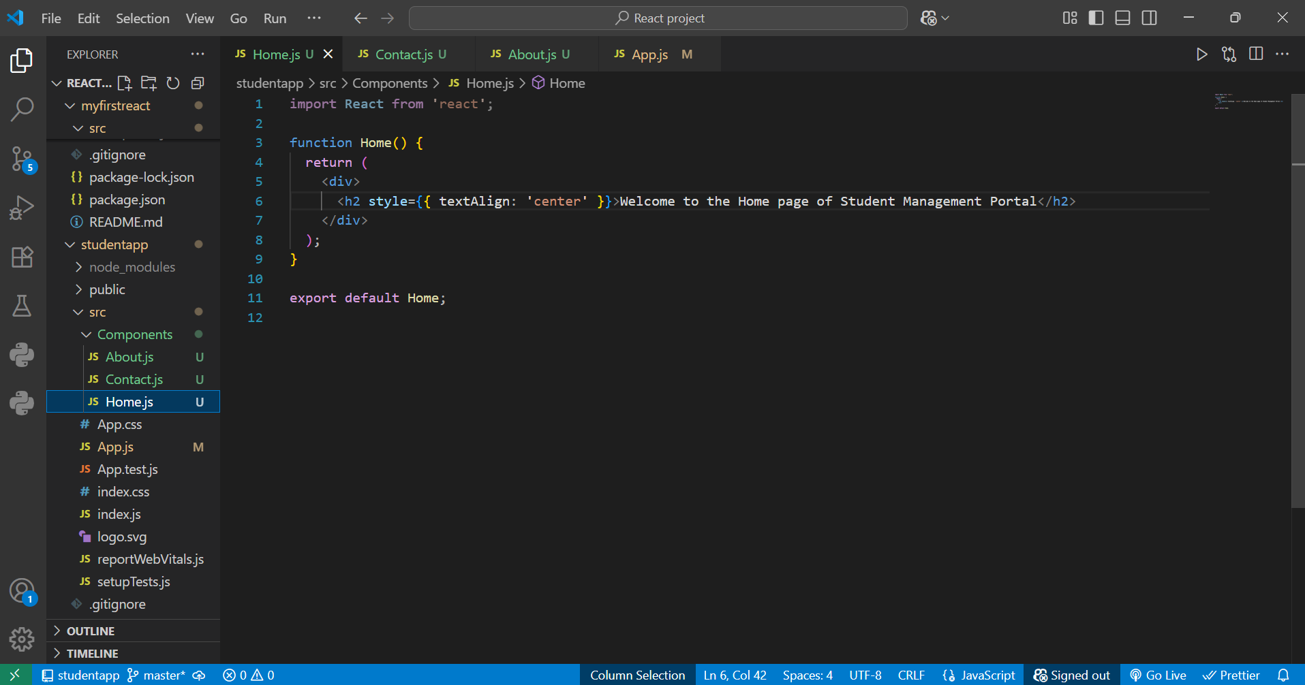

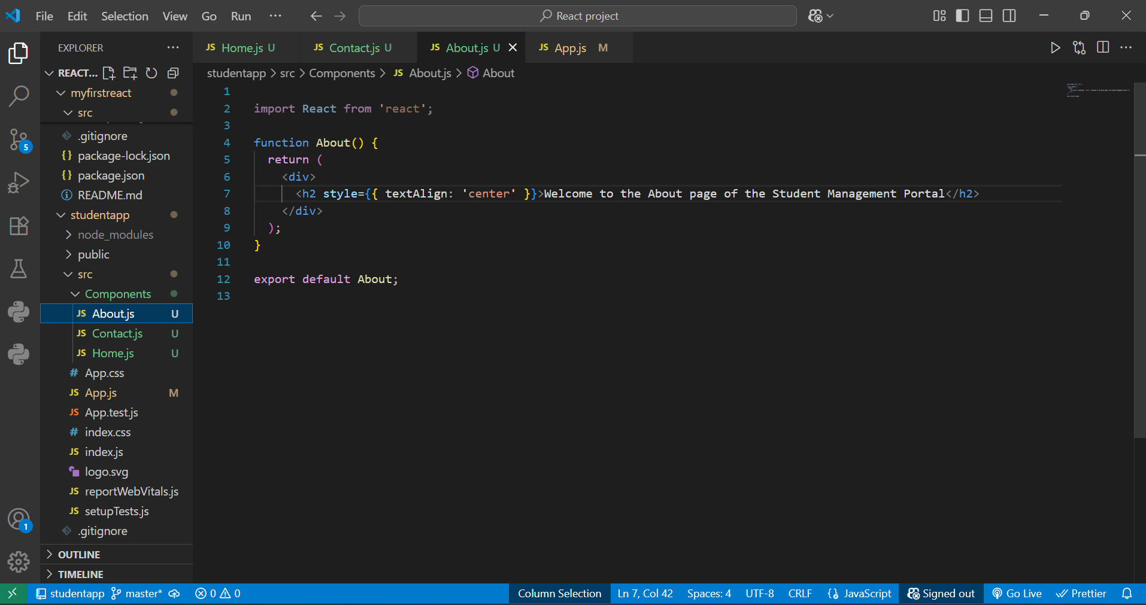

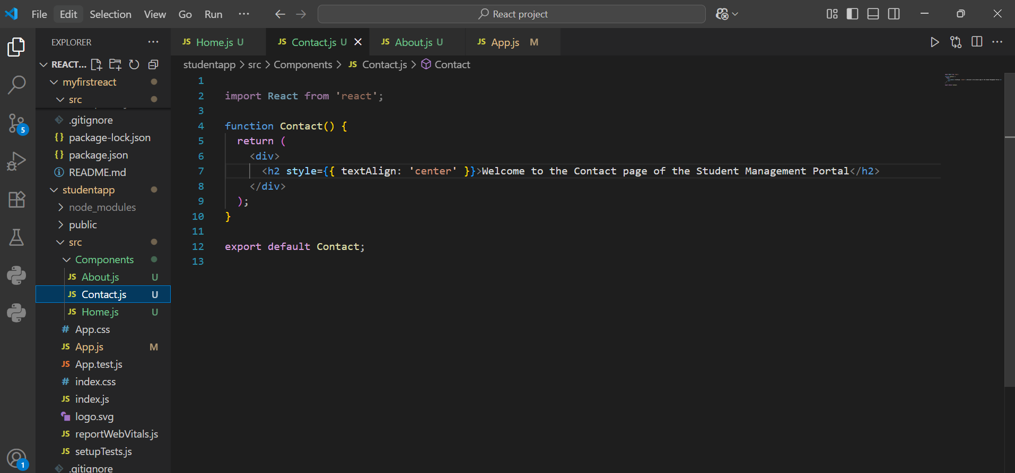

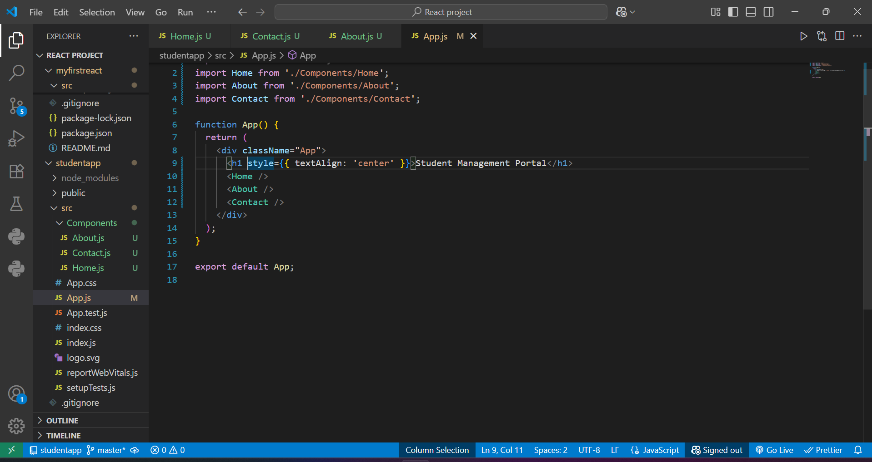

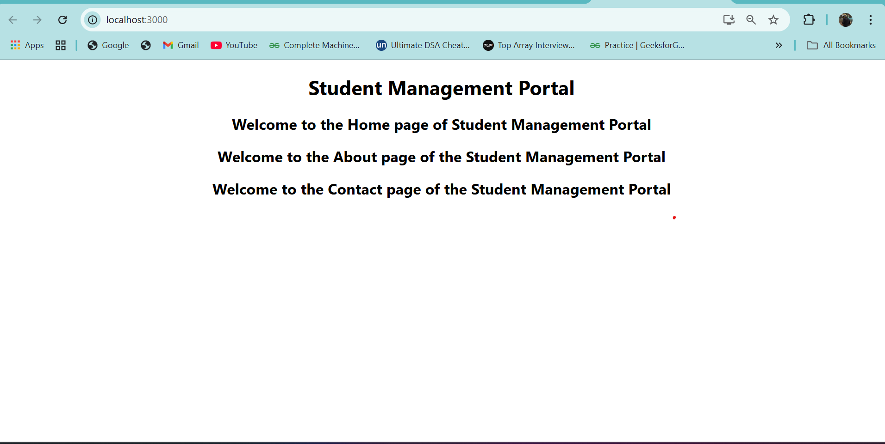

Question 3:-

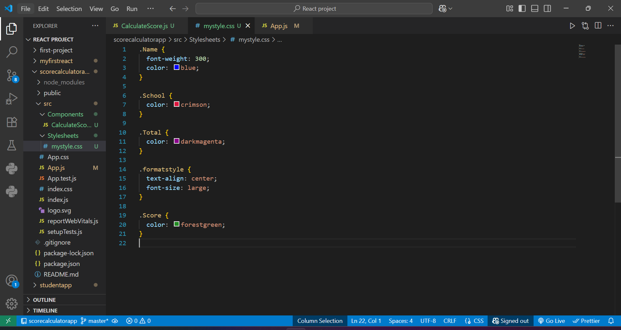

calculateScore.js

import '../Stylesheets/mystyle.css';

const percentToDecimal = (decimal) => {

  return (decimal \* 100).toFixed(2) + '%';

};

const calcScore = (total, goal) => {

  return percentToDecimal(total / goal);

};

export const CalculateScore = ({ Name, School, total, goal }) => (

  <div className="formatstyle">

    <h1><font color="Brown">Student Details:</font></h1>

    <div className="Name">

      <b><span> Name: </span></b>

      <span>{Name}</span>

    </div>

    <div className="School">

      <b><span> School: </span></b>

      <span>{School}</span>

    </div>

    <div className="Total">

      <b><span> Total: </span></b>

      <span>{total}</span>

      <span> Marks</span>

    </div>

    <div className="Score">

      <b>Score: </b>

      <span>{calcScore(total, goal)}</span>

    </div>

  </div>

);

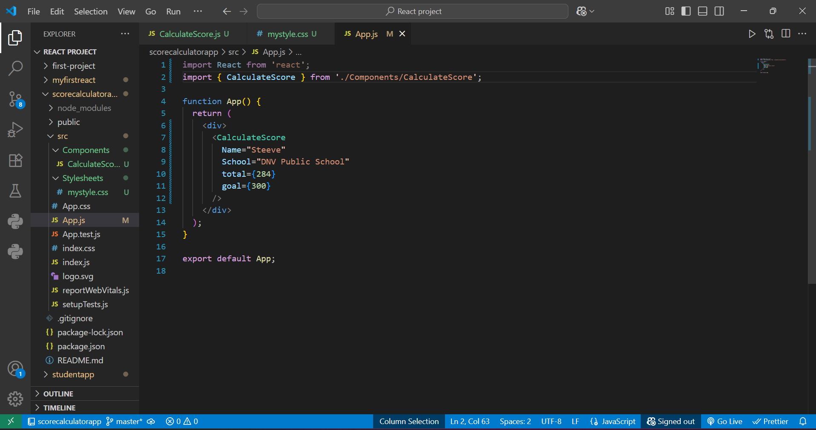

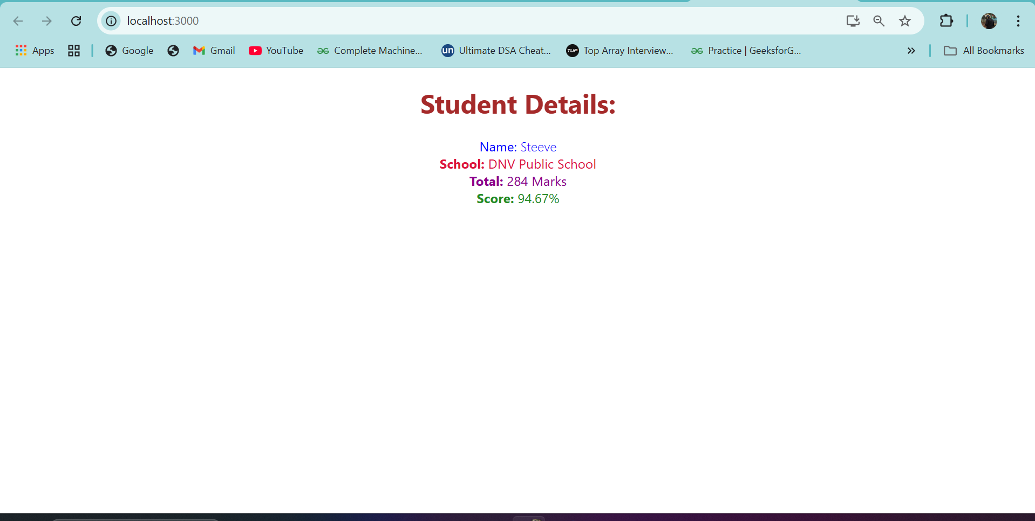

Question-4

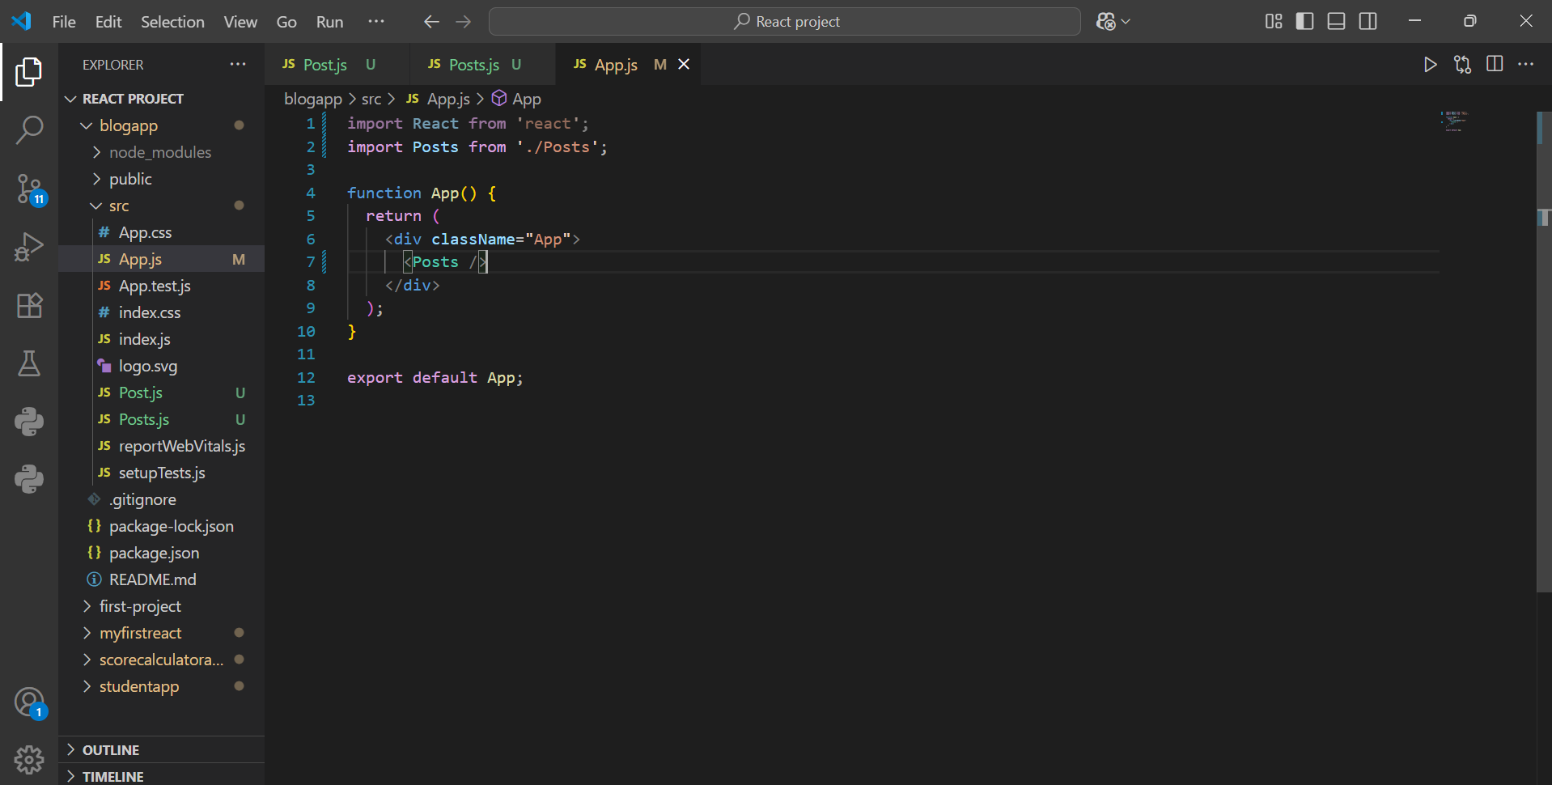

Posts.js

import React, { Component } from 'react';

class Posts extends Component {

  constructor(props) {

    super(props);

    this.state = {

      posts: [],

      hasError: false,

    };

  }

  loadPosts() {

    fetch('https://jsonplaceholder.typicode.com/posts')

      .then((response) => response.json())

      .then((data) => {

        this.setState({ posts: data });

      })

      .catch((error) => {

        console.error("Error fetching posts:", error);

        this.setState({ hasError: true });

      });

  }

  componentDidMount() {

    this.loadPosts();

  }

  componentDidCatch(error, info) {

    alert('Something went wrong while displaying posts!');

    console.log("Error caught in componentDidCatch:", error, info);

  }

  render() {

    if (this.state.hasError) {

      return <h2>Error loading posts.</h2>;

    }

    return (

      <div style={{ padding: '20px' }}>

        <h1>Blog Posts</h1>

        {this.state.posts.map(post => (

          <div key={post.id} style={{ borderBottom: '1px solid #ccc', marginBottom: '15px' }}>

            <h3>{post.title}</h3>

            <p>{post.body}</p>

          </div>

        ))}

      </div>

    );

  }

}

export default Posts;

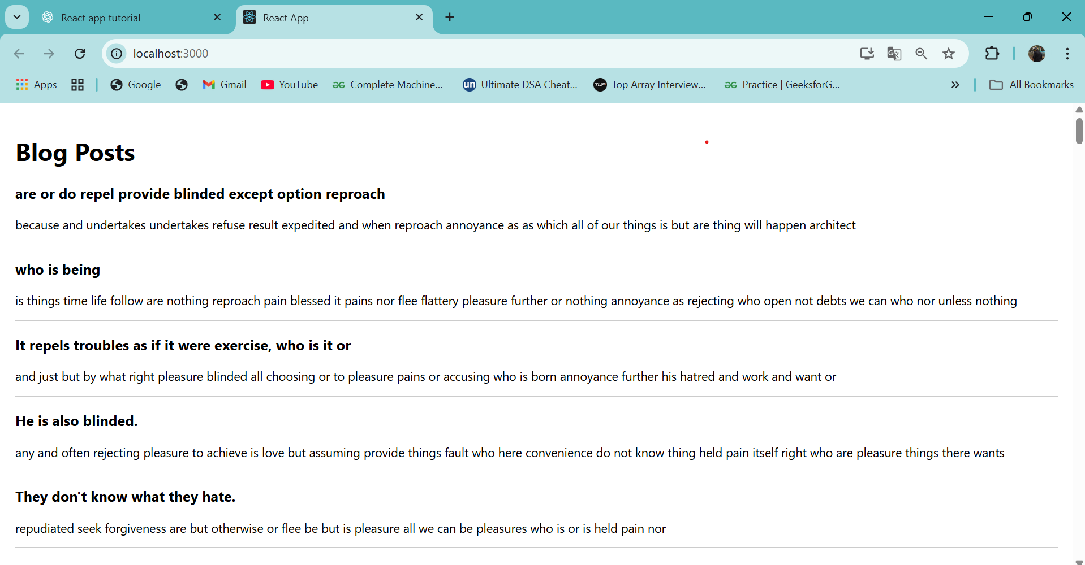

Question 5:-

