HandsOn :9

//IndianPlayer.jsx

import React from 'react';

const IndianPlayers = () => {
const T20players = ['Virat', 'Rohit', 'Hardik', 'Pant'];
const RanjiTrophy = ['Jaiswal', 'Shaw', 'Sarfaraz', 'Iyer'];

const allPlayers = [...T20players, ...RanjiTrophy];

const oddTeam = allPlayers.filter((_, i) => i % 2 === 0);
const evenTeam = allPlayers.filter((_, i) => i % 2 !== 0);

return (
<div>
<h2>All Indian Players</h2>
<p>Merged Players: {allPlayers.join(', ')}</p>

<h3>Odd Team</h3>
<ul>
{oddTeam.map((player, index) => <li key={index}>{player}</li>)}
</ul>

<h3>Even Team</h3>
<ul>
{evenTeam.map((player, index) => <li key={index}>{player}</li>)}
</ul>
</div>
);
};

export default IndianPlayers;

//List of plaayers.jsx
import React from 'react';

const ListofPlayers = () => {
const players = [
{ name: 'Virat', score: 95 },
{ name: 'Rohit', score: 80 },
{ name: 'Rahul', score: 45 },
{ name: 'Jadeja', score: 70 },
{ name: 'Bumrah', score: 65 },
{ name: 'Shami', score: 88 },
{ name: 'Gill', score: 92 },
{ name: 'Pant', score: 56 },
{ name: 'Hardik', score: 76 },
{ name: 'Surya', score: 69 },
{ name: 'Kuldeep', score: 85 }
];

const below70 = players.filter(player => player.score < 70);

return (
<div>
<h2>All Players</h2>
<ul>
{players.map((player, index) => (
<li key={index}>{player.name} - {player.score}</li>
))}
</ul>

<h3>Players with Score below 70</h3>
<ul>
{below70.map((player, index) => (
<li key={index}>{player.name} - {player.score}</li>
))}
</ul>
</div>
);
};

export default ListofPlayers;

For Flag=True;
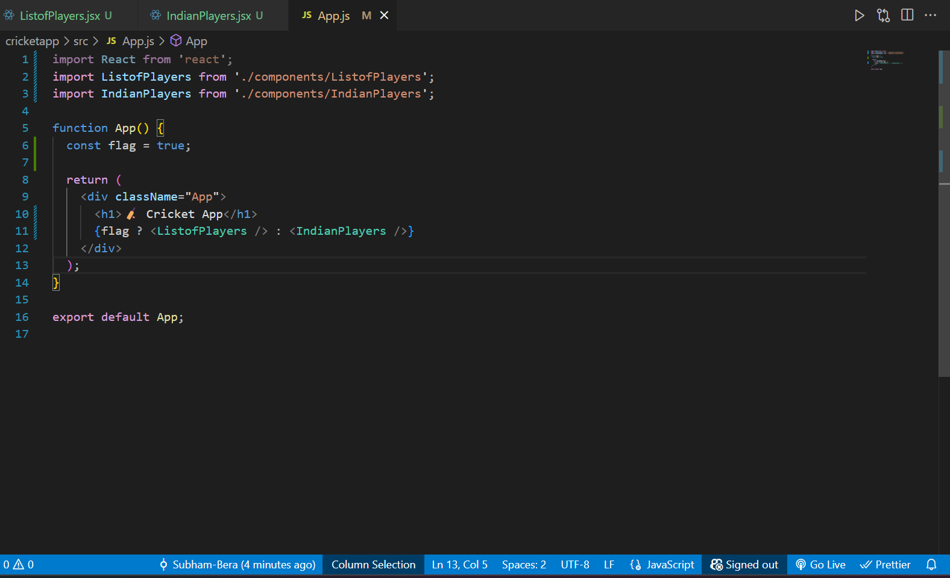
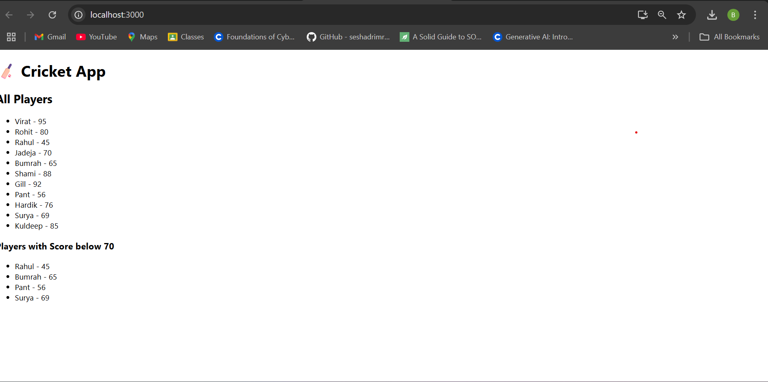
For flag=False;
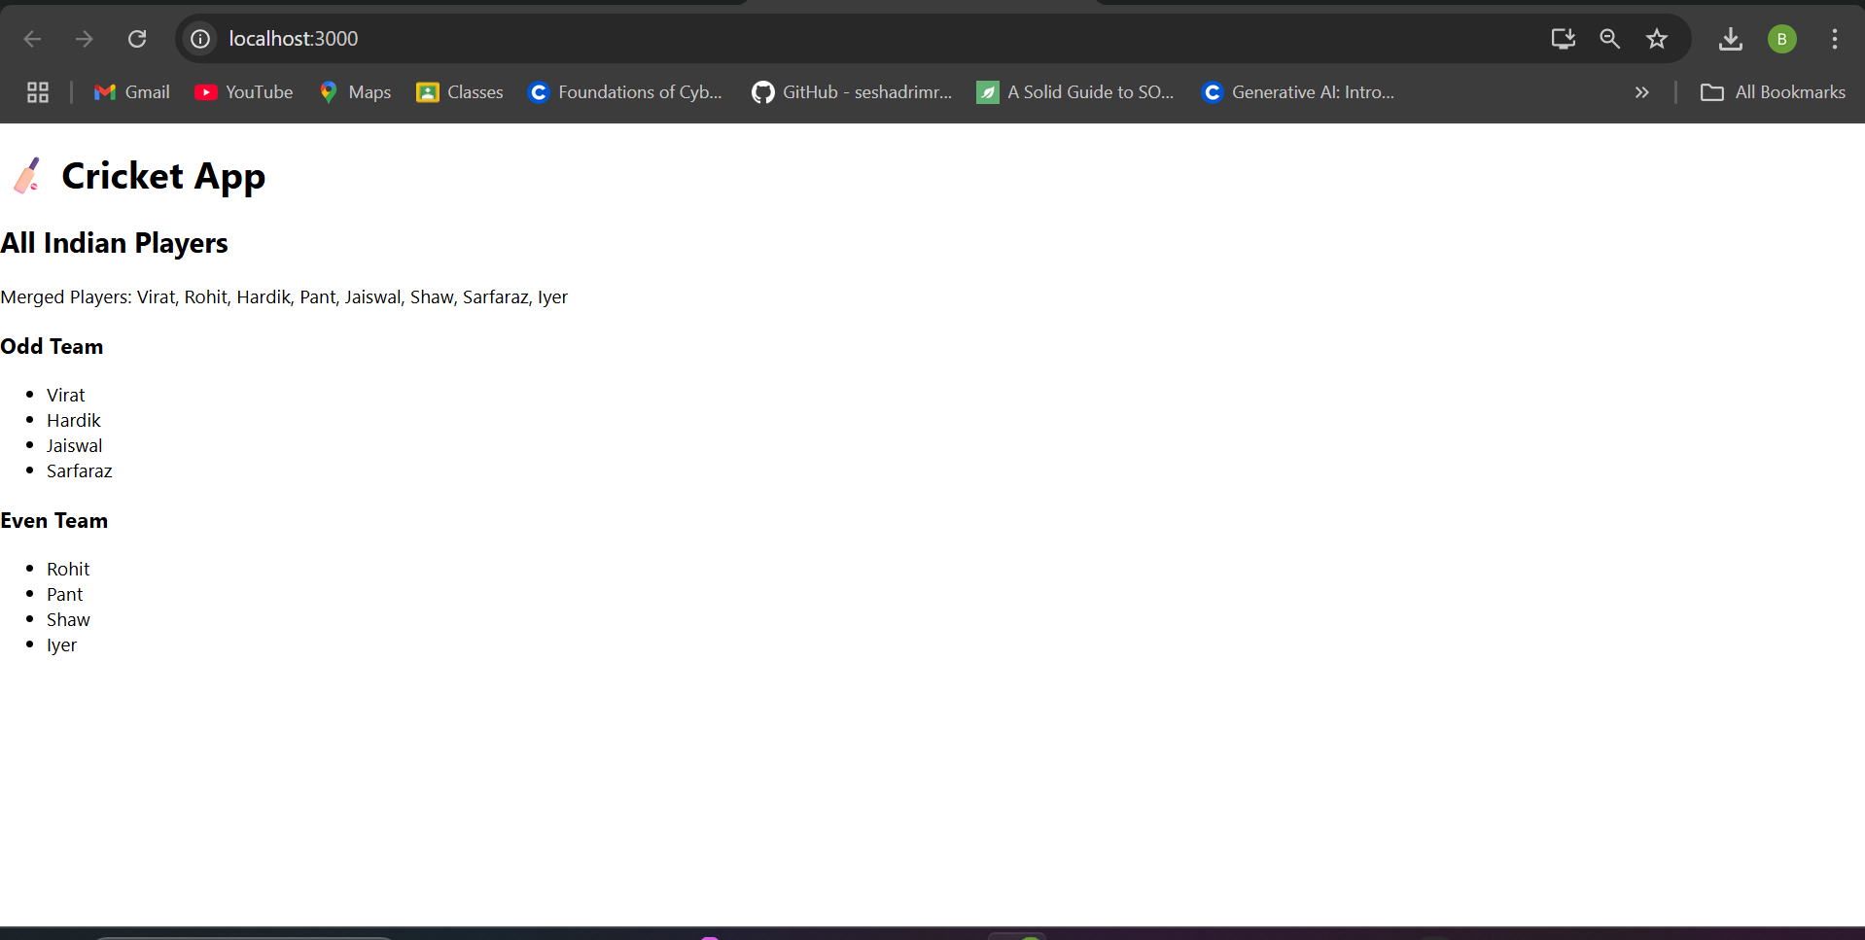

HandsOn 10:-

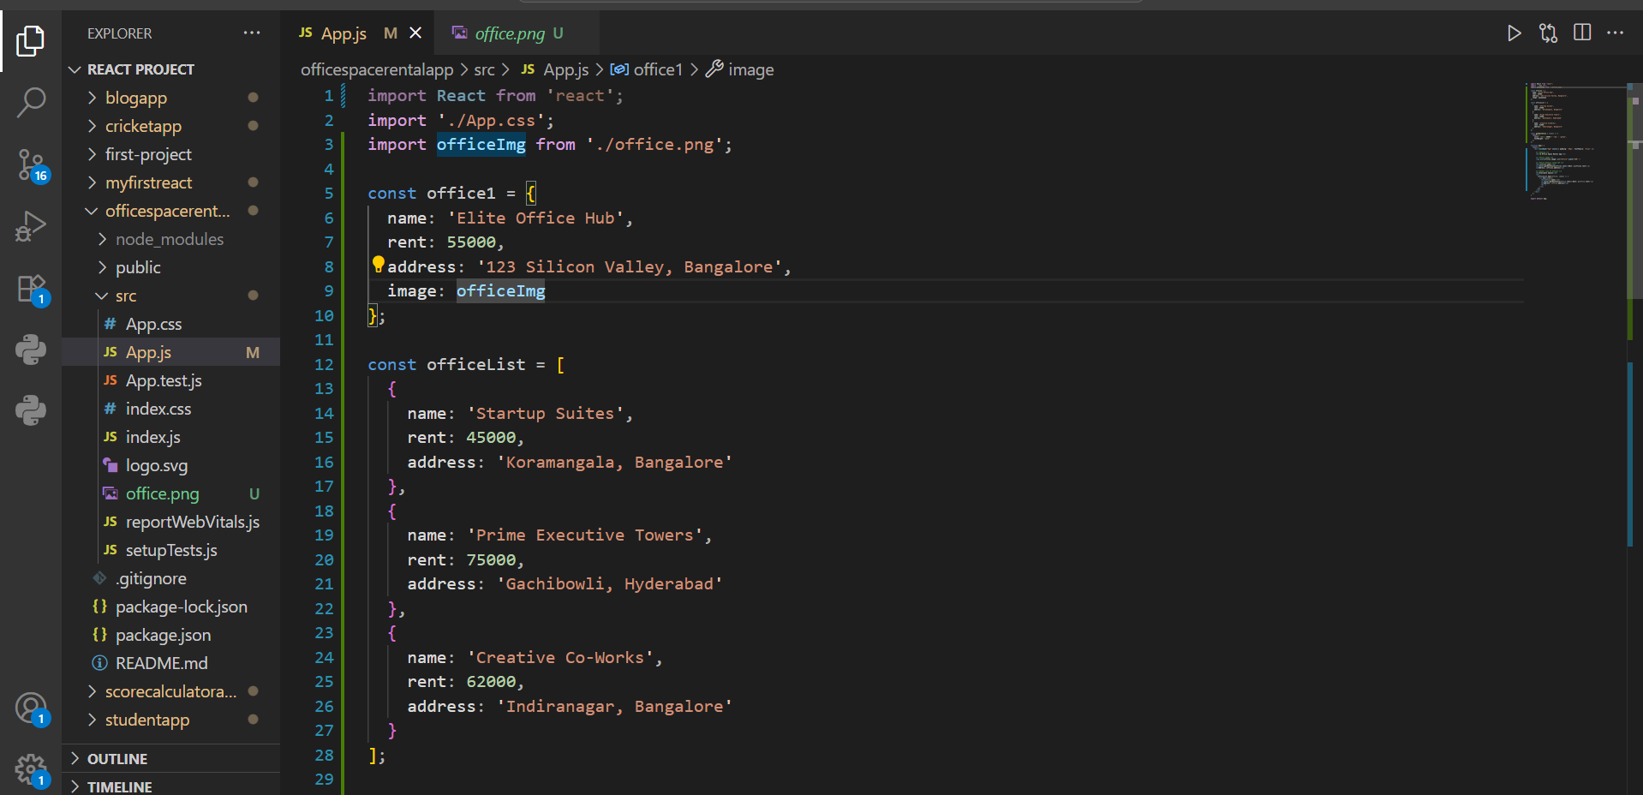

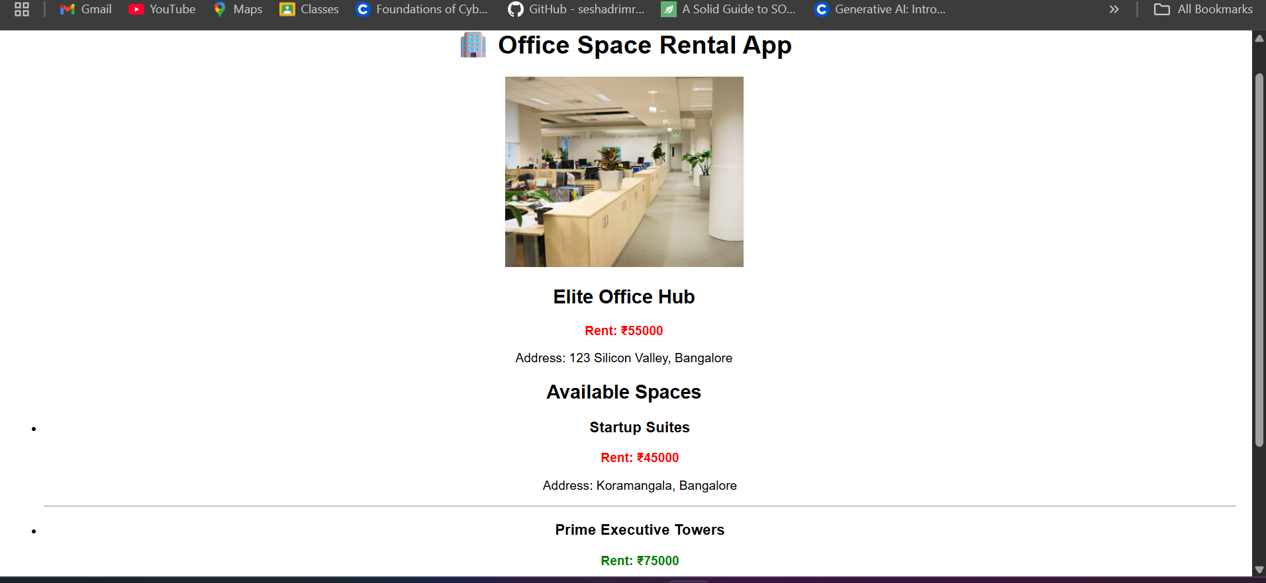

HandsOn :- 11

APP.JS

import React, { Component } from 'react';
import CurrencyConvertor from './CurrencyConvertor';

class App extends Component {
constructor(props) {
super(props);
this.state = {
count: 0,
message: ''
};
}

increment = () => {
this.setState({ count: this.state.count + 1 }, () => {
this.sayHello();
});
};

decrement = () => {
this.setState({ count: this.state.count - 1 });
};

sayHello = () => {
this.setState({ message: 'Hello! This is a static message.' });
};

sayWelcome = (msg) => {
alert(`Welcome message: ${msg}`);
};

handleClick = (event) => {
alert('I was clicked');
console.log(event);
};

render() {
return (
<div style={{ padding: '20px', fontFamily: 'Arial' }}>
<h1>🎯 React Event Handling Lab</h1>

<h2>Counter: {this.state.count}</h2>
<button onClick={this.increment}>Increment</button>{' '}
<button onClick={this.decrement}>Decrement</button>

<p>{this.state.message}</p>

<hr />

<button onClick={() => this.sayWelcome('Welcome to React!')}>
Say Welcome
</button>

<hr />

<button onClick={this.handleClick}>OnPress Event</button>

<hr />

<CurrencyConvertor />
</div>
);
}
}
export default App;

CurrencyConverter.jsx

import React, { Component } from 'react';

class CurrencyConvertor extends Component {
constructor(props) {
super(props);
this.state = {
rupees: '',
euro: ''
};
}

handleChange = (e) => {
this.setState({ rupees: e.target.value });
};

handleSubmit = () => {
const euroValue = (parseFloat(this.state.rupees) / 89).toFixed(2); // example rate
this.setState({ euro: euroValue });
};

render() {
return (
<div>
<h2>💱 Currency Convertor</h2>
<label>Enter amount in INR: </label>
<input
type="number"
value={this.state.rupees}
onChange={this.handleChange}
/>
<button onClick={this.handleSubmit}>Convert</button>

{this.state.euro && (
<p>💶 Value in Euros: €{this.state.euro}</p>
)}
</div>
);
}
}

export default CurrencyConvertor;

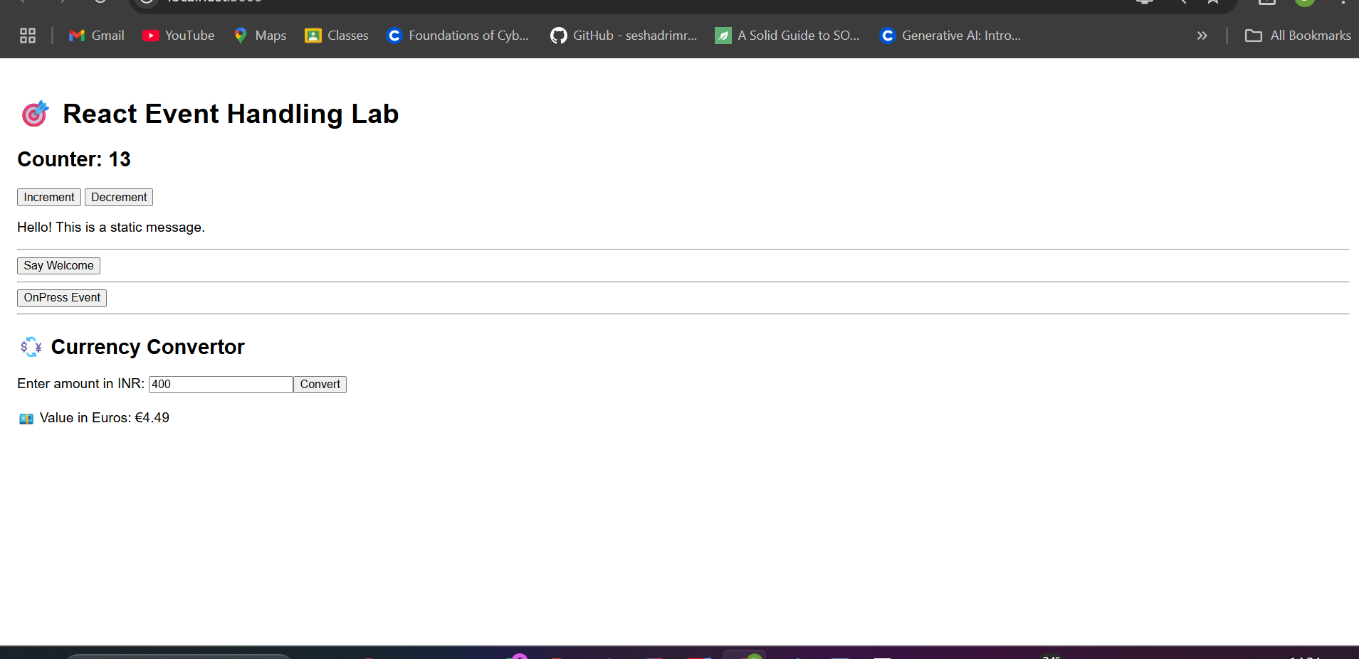

HANDS ON 12:-
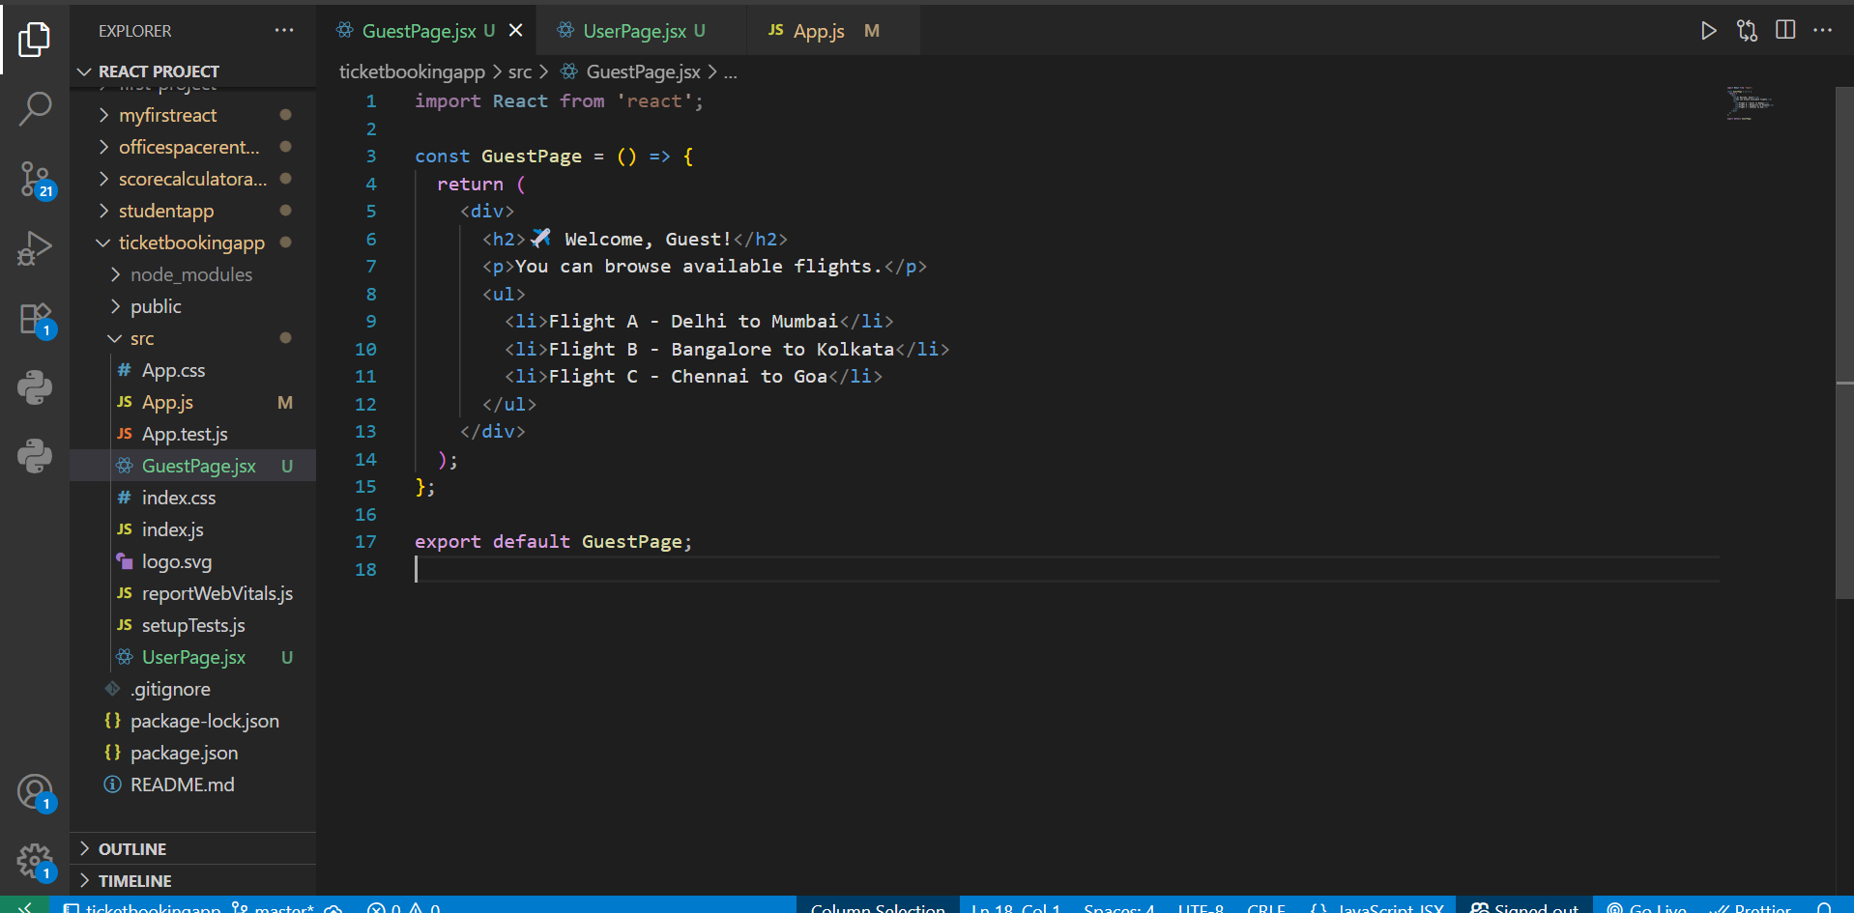
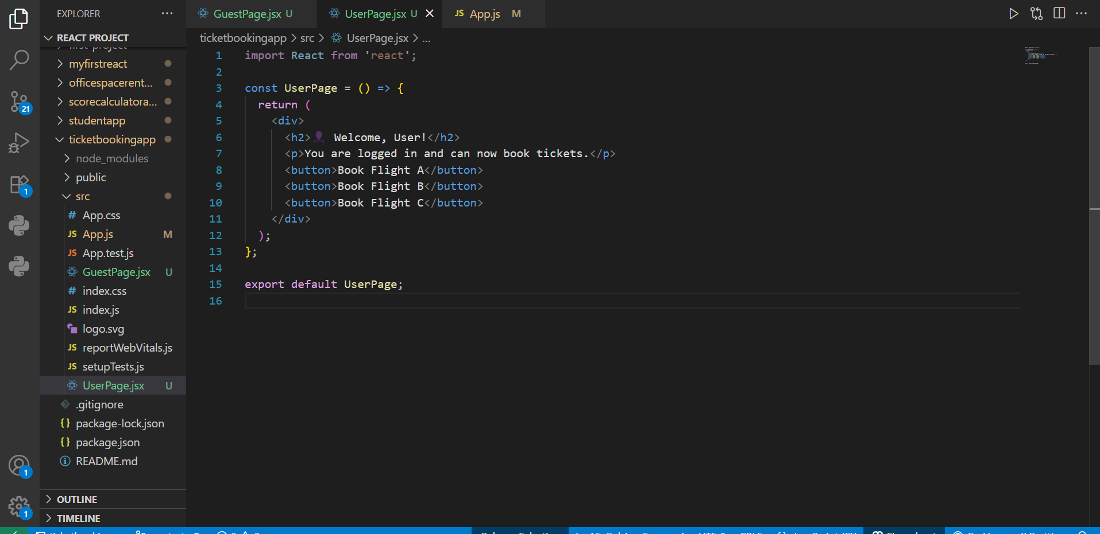
App.js

import React, { useState } from 'react';
import GuestPage from './GuestPage';
import UserPage from './UserPage';

function App() {
const [isLoggedIn, setIsLoggedIn] = useState(false);

const handleLogin = () => setIsLoggedIn(true);
const handleLogout = () => setIsLoggedIn(false);

let displayPage;

if (isLoggedIn) {
displayPage = <UserPage />;
} else {
displayPage = <GuestPage />;
}

return (
<div className="App" style={{ padding: '20px', fontFamily: 'Arial' }}>
<h1>🛫 Ticket Booking App</h1>

{!isLoggedIn ? (
<button onClick={handleLogin}>Login</button>
) : (
<button onClick={handleLogout}>Logout</button>
)}

<hr />

{displayPage}
</div>
);
}

export default App;

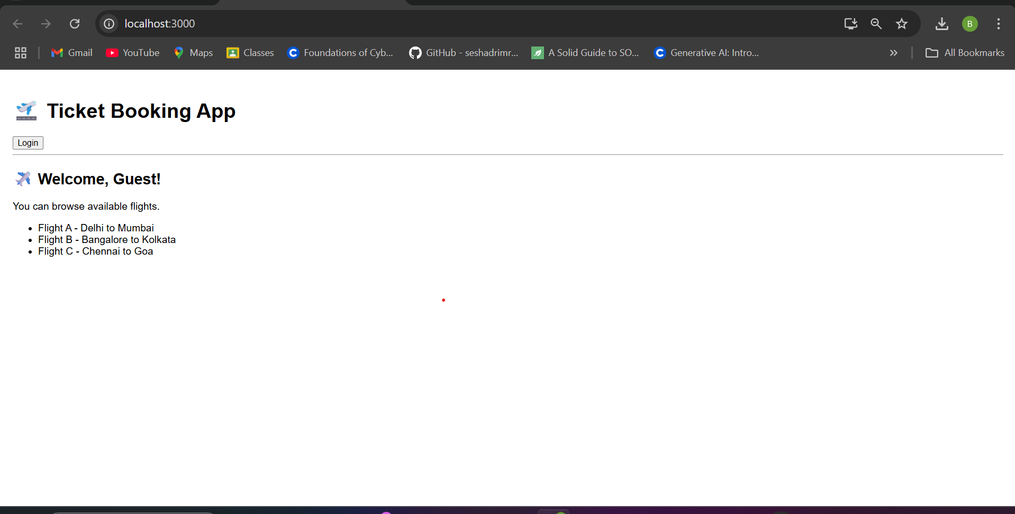
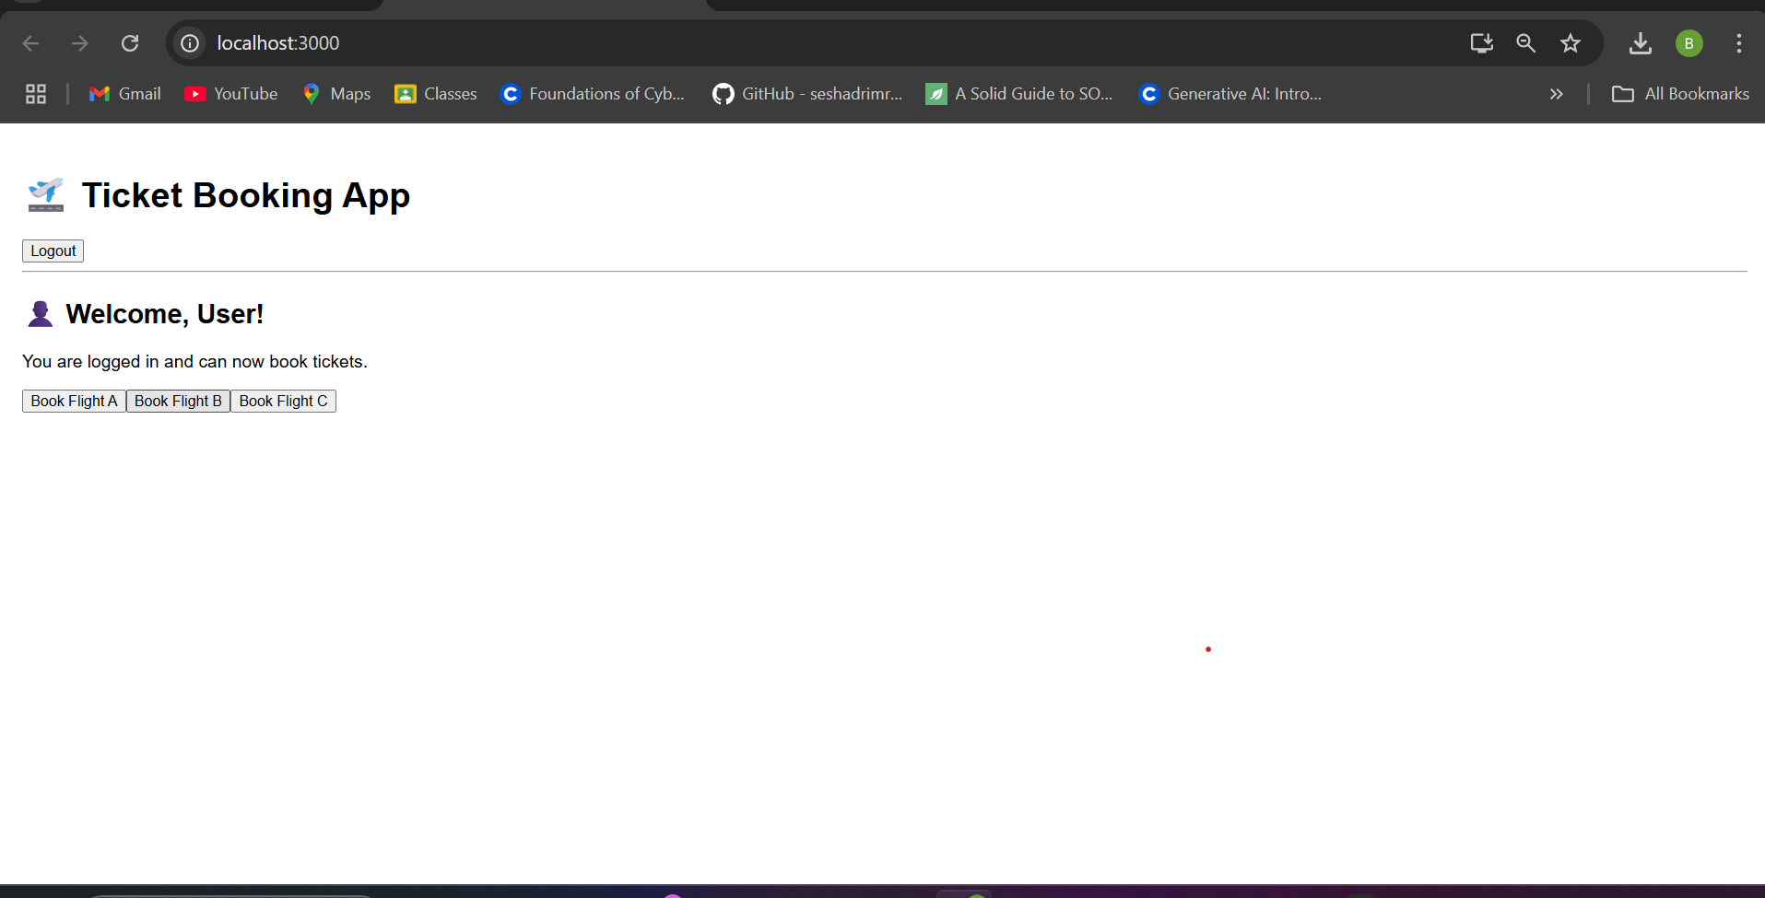

HANDS ON 13:-
