

2D Building Plan To 3D Interior Design: Project Report

IDP PROJECT REPORT SUBMITTED IN PARTIAL REQUIREMENT FOR THE DEGREE OF BACHELOR OF TECHNOLOGY UNDER THE SUPERVISON OF

AYUSHMAN BILAS THAKUR

SCHOOL OF ENGINEERING AND TECHNOLOGY ADAMAS UNIVERSITY

DECLARATION BY THE STUDENTS:

This is to certify that this project being submitted by us on the topic entitled “2D Building Plan To 3D Interior Design” has been completed under the guidance of Ayushman Bilas Thakur sir.

Team Members:

Subham Karmakar-UG/SOET/30/24/042

Sumit Patra- UG/SOET/30/24/061

Abantika Sen- UG/SOET/30/24/047

Archie Gupta- UG/SOET/30/24/060

Mainak Saha- UG/SOET/30/24/053

Niladri Mandal- UG/SOET/30/24/059

Deblina Dey- UG/SOET/30/24/006

Subhadip Ghosh- UG/SOET/30/24/076

Purbasha Ram- UG/SOET/30/24/040

Aditya Adhikary- UG/SOET/30/24/037

Subhajit Mondal- UG/SOET/26/24/006

CERTIFICATE OF THE GUIDE

This is to certify that the project entitled “2D Building Plan To 3D Interior Design Plan” is work the undertaken by Ayushman Bilas Thakur under our supervision and guidance as part of his/her Bachelor of Technology in the University. To the best of my knowledge, this is the original work conducted by him/her and the project may be sent for evaluation.

Supervisor’s Signature (Ayushman Bilas Thakur)

Section Title | Description | Page No
Title Page | University name, project title, student and mentor names, date | 1-2
Declaration | Statement of original work and completion under supervision | 3
Table of Contents | Page numbers and section titles | 4-5
Introduction | Background Of 2D floor model | 6
Objectives and Scope(Page no.-3) | What problem are you solving? What does your system cover? | 7
Literature Survey | Research and review of existing 3D interior floor plan design; why your approach stands out | 8
System Overview | Description of the overall system architecture, technologies we used | 9-10

Section Title | Description | Page No
Software Design(Page no.-3) | Dashboard panel features (slot status, booking, timing, parking history), React code structure, real time communication | 11-13
System Workflow | Step-by-step how each feature was built | 14-17
Drawback | The main drawback is that the AI model and 2D-to-3D conversion pipeline are incomplete, resulting in low accuracy and unreliable automatic 3D reconstruction | 18-21
Discussion and Analysis | What worked, what didn’t, challenges faced, future improvements | 23-25
Future Enhancement | Future implementation aims to fully automate accurate 2D-to-3D conversion by improving AI training, enhancing geometry reconstruction, and integrating advanced tools like Meshy AI and cloud GPUs. | 26
Conclusion and References | Summarize achievements, the impact of your system, possible extensions Books, web articles, and tools used. Cite sources and documentation. | 27-29

Introduction
Visualizing architectural structures accurately is one of the most essential skills in the fields of architecture, interior design, and civil engineering. Traditionally, building design begins with the creation of two-dimensional (2D) engineering drawings, such as floor plans, elevations, and cross-sections. While these drawings contain all necessary structural information, they often fail to provide an intuitive understanding of the actual spatial arrangement when viewed by students, designers, or clients with limited 3D visualization experience. As a result, interpreting 2D blueprints mentally and converting them into a three-dimensional (3D) mental model becomes a challenging task.
With advances in modern technology, numerous 3D modeling tools—such as AutoCAD, Revit, SketchUp, and Blender—allow professionals to convert 2D designs into visually rich 3D models. However, these tools require significant technical expertise, manual effort, and time. Creating a 3D model from scratch using such software can take hours or even days, making the process slow, labor-intensive, and prone to human errors. Additionally, beginners and students often find these tools overwhelming due to their complexity and steep learning curve.
To overcome these limitations, there is an increasing demand for intelligent, automation-driven systems capable of bridging the gap between traditional 2D drawings and interactive 3D representations. The rise of Artificial Intelligence (AI), Machine Learning (ML), and Computer Vision provides new opportunities to simplify this transformation. Modern AI models can detect architectural features such as walls, windows, and doors from engineering drawings, making it possible to reconstruct the geometry of a building automatically.
This project aims to develop a web-based AI-powered system that can convert a user-uploaded 2D building plan into an automatically generated 3D interior model. The system integrates advanced computer vision techniques, geometry reconstruction algorithms, and 3D rendering technology to provide a seamless experience. The user only needs to upload a blueprint, after which the platform analyzes the drawing, identifies structural elements, and constructs a 3D model viewable in real time through an interactive interface.

Objectives and Scope

Problem Statement:

Architectural and engineering students often struggle to interpret traditional 2D building plans because these drawings do not provide an intuitive understanding of the actual 3D space. Existing 3D modeling tools require a high level of technical skill, time, and manual effort, which makes the visualization process slow and difficult. Due to these limitations, users face challenges in accurately visualizing room layouts, structural elements, and interior arrangements solely from 2D floor plans.
Professionals such as architects, interior designers, and civil engineers also experience delays when manually converting 2D drawings into 3D models for presentations or client approvals. Complex software, high learning curves, resource constraints, and long design cycles often create barriers to efficient project development.

Proposed Solution:
The proposed solution is a web-based platform where users can upload their 2D engineering floor plan. Once the blueprint is uploaded, the system automatically processes the image and generates a 3D model through a series of intelligent steps involving Computer Vision, Machine Learning, Geometry Reconstruction, and 3D Rendering.

Scope of the Project:
The project focuses on developing a web-based system that automatically converts 2D building plans into 3D interior models using AI, Machine Learning, and Computer Vision. It allows users to upload floor plans, processes the drawings to detect walls, doors, and windows, and generates an interactive 3D model viewable in a browser. The system is intended for students, architects, interior designers, and real-estate professionals who need quick and simple 3D visualization without using complex software. The scope includes blueprint upload, AI-based detection, basic 3D reconstruction, model viewing, and export options. Advanced interior detailing, photorealistic rendering, and manual CAD editing are outside the current scope but may be added in future developments.

Literature Survey

Automatic conversion of 2D floorplans into 3D models is an active research area at the intersection of computer vision, graphics, and architectural computing. The task includes image pre-processing, element detection (walls, doors, windows), vectorization, geometry reconstruction (extrusion/mesh creation), and real-time rendering. Prior work spans approaches using RGB-D scans, deep learning for segmentation and detection, vectorization heuristics, and hybrid systems that fuse multiple modalities.
Large and well-annotated datasets are crucial for training detection and segmentation models for floorplans. The CubiCasa5K dataset (5,000 annotated floorplans, many object categories) is widely used to train multi-task models for wall/room/object parsing and has become a standard benchmark. Other repositories and community datasets
Early floorplan parsing used classical image processing: Hough transforms for line detection, morphological filtering, and hand-crafted symbol recognition. More recent work predominantly leverages deep learning:
- Semantic segmentation / U-Net variants to get per-pixel labels for walls, rooms and openings.
- Object detection (YOLO family) applied to detect discrete elements (doors, windows, furniture symbols). Several open-source projects demonstrate YOLOv8/YOLO-OBB trained on floorplan classes for reliable object localization.
- Multi-task networks combining segmentation and vectorization heads (predicting polygons/room instances) have shown better end-to-end performance.
ter detecting lines and semantic classes, systems convert raster detections into vector forms (lines, polygons), then reconstruct 3D geometry by extruding walls and subtracting openings:
- Vectorization algorithms snap detected edges to a consistent grid or topology, merge overlapping line segments, and form closed polygons for rooms.
- Reconstruction strategies include rule-based extrusion (fixed or inferred wall heights), constructive solid geometry (CSG) for carving doors/windows, and graph methods to enforce orthogonality and connectivity (wall-snapping).
- Systems that use RGBD or multi-view scans (e.g., FloorNet) fuse 3D point data with 2D projections to improve vector accuracy and handle occlusions.

System Overview

The proposed system is a web-based platform designed to automatically convert 2D
architectural floor plans into interactive 3D interior models using Artificial Intelligence, Machine
Learning, and Computer Vision. Traditional 3D modeling software requires extensive manual effort a
nd technical expertise, making it difficult for students, architects, and designers to quickly visualize structures. To overcome these challenges, this system integrates automated detection algorithms, image processing techniques, and 3D rendering technologies to provide a fast, simple, and accessible solution
for architectural visualization.

The system allows users to upload 2D blueprints in commonly used formats such as JPEG, PNG, and PDF. Once the blueprint is uploaded, the platform initiates a multi-step pipeline that cleans the image, detects structural elements, reconstructs the building geometry, and renders the final 3D model. Through a browser-based interface, users can explore the model in real time, rotate the view, zoom in on areas of interest, and export the generated 3D model for further use in professional design software.

Overall System Architecture
The system is built using a modular architecture comprising three major layers:
(a) Frontend Layer,
(b) Backend Processing Layer, and
(c) AI & Computer Vision Layer.
Each layer has specific responsibilities and works together to ensure seamless conversion from 2D to 3D.

Frontend Layer
The frontend is developed using Next.js and Tailwind CSS, providing a smooth and responsive user interface. The frontend includes:
- Blueprint Upload Interface: Users can upload their architectural drawings.
- Interactive 3D Viewer: Built using Three.js, allowing real-time visualization with controls like rotate, zoom, pan, and reset view.
- Feedback & Status Updates: Displays progress during processing steps such as “Pre-processing”, “Detecting Walls”, “Generating Model”, etc.
The UI is designed to be clean, simple, and usable even for non-technical users.

Backend Processing Layer
The backend is implemented using Node.js, handling communication between the frontend and the AI engine. Its key functions include:
- Receiving and validating blueprint uploads
- Sending files to the AI processing module
- Handling API calls with the 3D generation engine
- Returning the processed 3D model to the frontend
- Managing user requests, errors, and server responses
The backend also interfaces with external tools, including possible future integration with Meshy.ai or Autodesk Forge, for advanced mesh generation or file conversions.

AI & Computer Vision Layer
This is the core intelligence of the system and includes:
  - Pre-processing Module
Performed using Python + OpenCV, this module enhances blueprint quality by:
- Removing noise and distortions
- Enhancing line clarity
- Correcting skewness
- Converting the blueprint to a machine-readable format
Clean input significantly improves detection accuracy.
b. Detection Module (YOLO / Segmentation Models)
This module detects key architectural components:
- Walls
- Doors
- Windows
- Room boundaries
- Symbols and dimension lines
Models like YOLOv8 or segmentation networks are trained on annotated floor plan datasets (e.g., CubiCasa5K).
c. Geometry Reconstruction Module
Converts detected shapes into 3D primitives through:
- Wall vectorization and extrusion
- Polygon formation for rooms
- CSG operations to carve out door/window openings
- Snapping algorithms to ensure structural alignment
The output is a clean, manifold 3D mesh.

SOFTWARE DESIGN

1. Design Goals
- Modularity: clean separation between UI, backend, and AI/processing layers for easier development and testing.
- Extensibility: allow swapping models, adding features (multi-floor, furniture) without large rewrites.
- Responsiveness: interactive 3D preview with low-latency conversion for typical floorplans.
- Portability: web-first (Next.js + Three.js) so users need no local installs.
- Robustness: graceful handling of noisy inputs, partial detections, and failures.

2. High-level Architecture
Three-layer modular architecture:
- Client (Frontend) — Next.js + Tailwind CSS + Three.js
  - Upload UI, progress/status, interactive 3D viewer, export/download controls.
- API / Backend — Node.js (Express)
  - File upload, job queue, orchestration, authentication (optional), storage, result serving.
- Processing / AI Engine — Python services (FastAPI) + OpenCV + ML models (YOLOv8 / segmentation) + geometry reconstructor + optional 3rd-party API adapters (Meshy.ai / Autodesk Forge).
  - Runs detection, vectorization, mesh generation, returns GLTF/OBJ/STL.
Supporting pieces:
- Message queue / Job manager (Redis + Bull / RabbitMQ) for scalable processing.
- Storage (S3-compatible object store or local blob storage) for uploaded blueprints and generated models.
- Database (Postgres / MongoDB) for metadata, user jobs, logs.
- Optional GPU workers for model inference/training (Docker + Kubernetes nodes with GPU).
Artifact (uploaded project doc): /mnt/data/IDP incomplete.pdf — use for reference and dataset notes.

3. Component Breakdown & Responsibilities
3.1 Frontend
- Upload Component: drag & drop, file validation, thumbnail preview.
- Job Monitor: shows status (Queued → Preprocessing → Detection → Reconstruction → Ready).
- 3D Viewer: Three.js scene with camera controls, layer toggles (walls, openings, rooms), measurements overlay.
- Export Controls: select format (GLTF/OBJ/STL), download link.
- Error UI: helpful messages when detection fails; option to submit manual correction.

3.2 Backend / API
- REST endpoints (examples):
  - POST /api/upload — accepts blueprint (multipart) and returns job id.
  - GET /api/job/:id/status — returns progress/status.
  - GET /api/job/:id/result — returns model metadata & download URLs.
  - POST /api/job/:id/cancel — cancel job.
- Orchestration: pushes job to queue, assigns to an available worker.
- Auth & Rate-limiting (optional): JWT / API keys and per-user quotas.
- Logging & Metrics: centralized (Prometheus + Grafana / ELK) for debugging and performance.
3.3 Processing Worker (AI Engine)
- Pre-processing: OpenCV routines (denoising, thresholding, deskew, normalize DPI).
- Detection: YOLOv8 (bounding boxes) + segmentation (U-Net/DeepLab) for pixel-level walls/rooms.
- Vectorization: line extraction (Hough / morphological), line merging, snapping to grid.
- Topology Repair: close gaps, enforce orthogonality (if applicable), simplify polygon loops.
- Geometry Reconstruction: wall extrusion (configurable height), apply CSG for doors/windows, create room polygons.
- Mesh Optimization: remove degenerate faces, simplify mesh for real-time viewing.
- Exporter: produce GLTF (preferred for web), OBJ, STL.
- Postprocess & Upload: store artifacts in object store, update job metadata in DB.

4. Data Models (Example Schema)
Job (Postgres / MongoDB)
- job_id (UUID)
- user_id (nullable)
- file_path (string) — e.g. /mnt/data/IDP incomplete.pdf (original upload)
- status (enum) — queued, preprocessing, detecting, reconstructing, ready, failed
- created_at, updated_at
- result_paths (object) — { gltf: url, obj: url, log: url }
- metrics — inference time, memory used, detected elements counts
DetectionRecord
- job_id
- element_type (wall/window/door/room)
- bbox / polygon coordinates
- confidence_score

SYSTEM WORKFLOW
The system follows a step-by-step workflow that transforms a user-uploaded 2D floor plan into an interactive 3D interior model. The workflow is designed to ensure smooth data flow between the frontend, backend, AI processing components, and the 3D rendering engine.

1. User Upload Phase
The workflow begins when the user accesses the web platform and uploads a 2D building plan in formats such as JPG, PNG, or PDF.
Processes involved:
- File validation (size, format, resolution)
- Temporary storage of the uploaded blueprint
- Unique Job ID generation for tracking
Once uploaded, the system sends a request to the backend to start processing.

2. Pre-Processing Phase
The blueprint is passed to the AI engine, which performs essential image enhancement and cleaning using OpenCV.
Steps include:
- Noise reduction
- Line sharpening and edge enhancement
- Thresholding and contrast adjustment
- Correcting skew or rotation
- Converting the blueprint to a standardized grayscale format
Pre-processing ensures the image is ready for accurate AI detection.

3. AI Detection Phase
The cleaned blueprint is fed into AI/ML models such as YOLO or segmentation networks to detect architectural elements.
Detected elements include:
- Walls
- Doors
- Windows
- Room boundaries
- Symbols and dimension lines
Each detected object is labeled, classified, and assigned coordinate data.

4. Geometry Reconstruction Phase
Based on the detection output, the system converts the 2D components into corresponding 3D geometric structures.
Processes performed:
- Vectorization of walls and boundaries
- Polygon generation for each room
- Wall extrusion to a fixed height
- Automatic carving of openings for doors and windows (CSG operations)
- Snap-to-grid correction to eliminate gaps
The output of this phase is a clean 3D mesh representing the building structure.

5. 3D Model Generation Phase
Using the reconstructed geometry, the system builds the final 3D model through the Three.js rendering engine.
Features generated:
- Walls, floors, and partitions
- Window and door openings
- Room segmentation
- Basic shading and scene lighting
This 3D model is optimized for smooth real-time interaction.

6. Interactive Visualization Phase
The generated 3D model is returned to the frontend and displayed in a browser-based viewer.
Available user interactions:
- Rotate
- Zoom in/out
- Pan
- Inspect room layouts
- Toggle visibility of walls or elements (optional)
This stage allows users to easily analyze and explore the spatial layout.

7. Export & Download Phase
Once satisfied, the user can export the 3D model in standard formats such as:
- OBJ
- GLTF
- STL
These files can be imported into professional modeling tools like Blender, Unity, Maya, AutoCAD, or Revit.

8. Error Handling & Feedback
The system monitors each step for errors such as:
- Incomplete detections
- Unrecognized symbols
- Missing wall connections
- Poor-quality blueprints
Users receive appropriate feedback and suggestions for improving input quality.

Summary of Workflow
- Upload Floor Plan
- Pre-Processing
- AI Detection (Walls/Doors/Windows)
- Geometry Reconstruction
- 3D Model Generation
- Interactive 3D Visualization
- Export / Download
This workflow ensures a smooth, automated, and user-friendly conversion from 2D to 3D.

DRAWBACK

1. Incomplete AI Model Training

The YOLOv8 model used for detecting walls, windows, and doors is not fully trained.
Because of limited GPU time and limited dataset availability, the model cannot accurately identify architectural elements.

Impact

Incorrect wall detection

Missing door/window predictions

Unreliable room boundaries

Inconsistent results across different blueprint styles

This prevents the system from producing an accurate, fully automated 3D model.

2. Dataset Limitations

Architectural drawings differ widely in:

Style

Wall thickness

Symbols

Line clarity

Public datasets such as CubiCasa5K do not match Indian-style floor plans well. Many drawings also contain noise, smudges, or inconsistent scaling.

Impact

Lower detection accuracy

Difficulty recognizing small symbols (door arcs, dimension lines)

Poor performance on hand-drawn or scanned plans

This reduces the robustness of the system for real-world use.

3. No Integration of Meshy AI (Fallback System)

The project intended to use Meshy AI as a backup for generating 3D meshes.
However, due to issues such as:

Connection failures

Limited free API usage

Paid credit requirements

Budget constraints

Meshy could not be integrated.

Impact

No alternative path when AI detection fails

Pipeline remains only partially functional

Full automation is not possible

4. End-to-End Pipeline Is Incomplete

Since both the YOLO model and Meshy API were not fully functional, the complete automated workflow from 2D → 3D could not be completed.

Impact

System remains a prototype

Requires manual steps

Not ready for real production deployment

The project demonstrates the concept but does not deliver the final automated product.

5. Geometry Reconstruction Challenges

Converting detected lines into 3D structures is technically very complex.

Problems faced:

Walls need to be perfectly aligned

Corners must snap to 90° or 180°

Small detection errors cause big 3D gaps

Door/window cutouts require computationally heavy CSG algorithms

Curved or irregular walls require custom mathematical logic

Impact

Incomplete or broken 3D models

Misaligned rooms

Missing or incorrectly shaped walls

This reduces the visual and functional accuracy of the final output.

6. GPU and Resource Limitations

Training AI models requires powerful GPUs for long hours.
However, the team relied on:

Google Colab

Kaggle GPUs

These have:

12-hour session limits

Low VRAM

Frequent timeouts

Impact

Interrupted training

Incomplete dataset learning

Lower final accuracy

The hardware limitations directly impacted the AI performance.

7. Time Constraints

AI dataset preparation and training require weeks or months.
But the project timeline was shorter, which did not allow:

Full annotation of floor plan dataset

Complete training cycles

Multi-stage validation and correction

Error analysis and model refinement

Impact

Project accuracy did not reach expected quality

Some modules remained partially developed

8. Financial Constraints

Many advanced APIs and tools needed for high-quality reconstruction are paid (e.g., Meshy, Autodesk Forge premium).

Impact

Could not integrate premium APIs

Limited access to large GPU servers

No advanced fallback methods

This restricted the system’s capability.

9. Inconsistency in Real-World Floor Plans

Real building plans greatly vary in terms of:

Hand-drawn vs. digital

Line thickness

Scan quality

Noise and shadows

Language labels

Regional architectural symbols

Impact

AI misclassifies rooms or ignores details

Difficulty generalizing across diverse plan styles

The model is not yet ready for industry-level deployment.

10. Not Production Ready

The current system works as a demonstration (prototype), not as a fully functional commercial product.

Limitations

Accuracy is low

Missing end-to-end automation

Unreliable results with noisy images

Cannot guarantee correct 3D reconstruction

This restricts its use for professional architectural wo

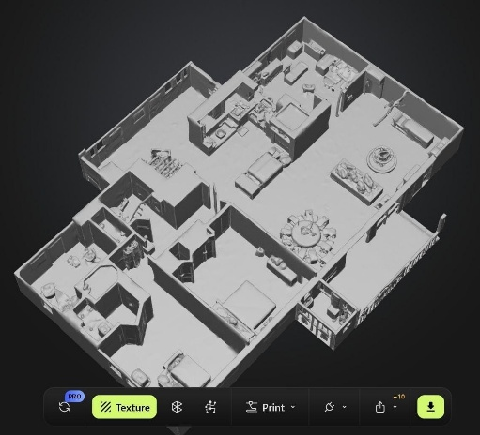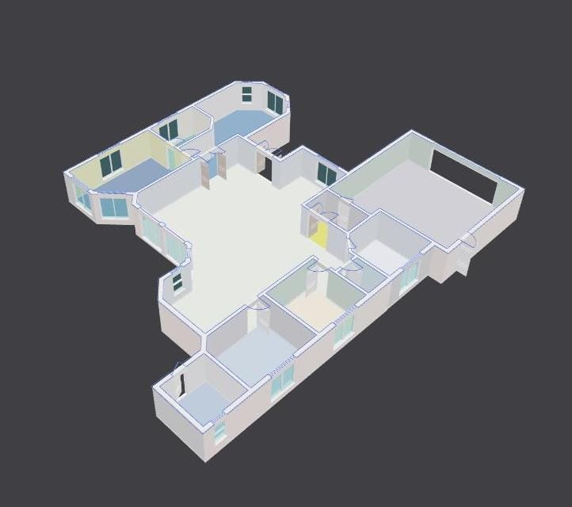
Prerendered model rendering output result
If meshy api paid key was available

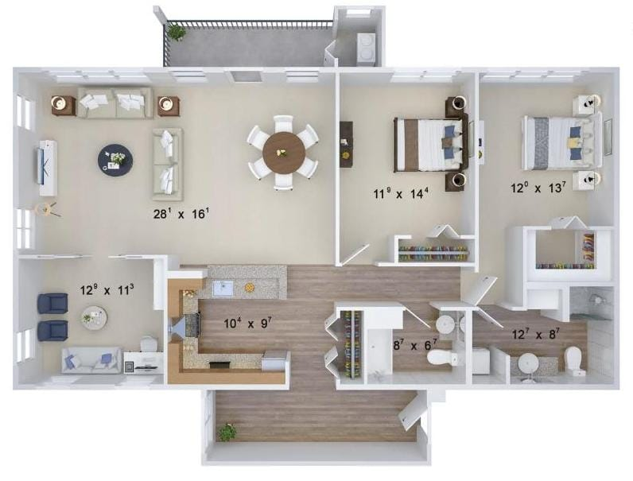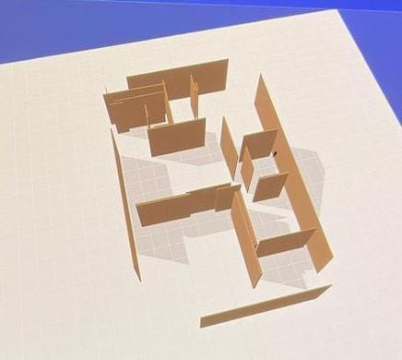

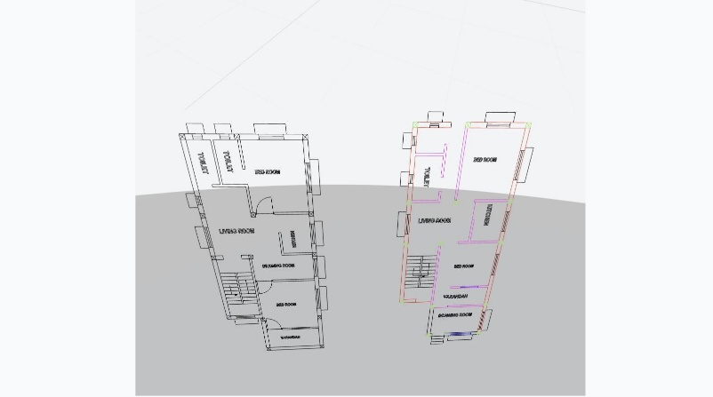
Dwg was converted but due to lack of ai image recognition and model training 3d model was not generated

Discussion & Analysis

System Performance and Problem Relevance

The system directly addresses a critical challenge in engineering and architecture education—difficulty in visualizing 3D structures from 2D plans.
Many students struggle to mentally convert flat engineering drawings into three-dimensional spaces. The proposed tool significantly reduces this difficulty by automating the visualization process through an AI-driven pipeline. This leads to better conceptual understanding and reduces dependency on manual interpretation skills.

The upload-to-3D workflow enhances the overall learning and design experience.
Once the user provides a blueprint, the system preprocesses the image, detects structural components, reconstructs geometry, and generates a 3D preview. This sequence offers a smoother learning experience compared to manually modeling in traditional CAD tools, which require expertise and long working hours.

Performance of the real-time 3D viewer is a strong highlight.
Using Three.js, the system enables smooth rotation, zooming, panning, and exploration in the browser. This interactive capability successfully bridges the gap between theoretical design concepts and practical visualization.

2. AI & Computer Vision Workflow Analysis

AI detection is conceptually strong but practically limited due to incomplete model training.
The system attempts to detect walls, windows, doors, and room boundaries using YOLO or segmentation models. However, due to limited dataset size, insufficient GPU hours, and regional drawing style variations, the model could not reach stable accuracy. This affected the correctness of element extraction required for 3D reconstruction.

Blueprint variations heavily affect AI accuracy.

Line thickness, double-line walls, door arcs

Different symbol styles across countries

Hand-drawn plans containing noise
These variations cause the model to misclassify or miss architectural components, which then affects the entire pipeline.

Preprocessing plays a crucial role in stabilizing inputs.
While noise removal and binarization improve structural clarity, the system still struggles with low-quality scans or plans that use unconventional architectural symbols.

Explanation:
The AI layer is the backbone of the system. Without accurate detection, the geometry reconstruction stage receives flawed inputs. The limited training time and GPU restrictions hindered the model from becoming fully functional. Despite this, the attempt to integrate advanced CV technologies demonstrates strong technical direction for future expansion.

3. Technical Evaluation of Geometry Reconstruction

Geometry reconstruction is significantly more complex than initial expectations.
Converting detected lines into usable 3D polygons requires precise mathematical handling of edges, angles, and closed shapes. Small detection errors result in broken polygons, overlaps, or missing walls.

Wall snapping and corner correction algorithms are essential but difficult to perfect.

Walls must align to 90° or 180°

Gaps must be filled

Corners must be reconstructed even if lines are detected imperfectly
These tasks require custom logic and extensive testing, making this stage one of the most technically demanding.

Carving windows and doors using CSG operations adds further complexity.
CSG is computationally heavy and sensitive to inaccuracies. If a door or window is misdetected, the algorithm may create incorrect cuts or distort the mesh.

Explanation:
Although 3D rendering using Three.js is straightforward, the real difficulty lies in converting raw detection results into an accurate 3D model. Geometry reconstruction requires extremely clean inputs, and the current detection accuracy makes it challenging to achieve seamless models. Still, the underlying architecture provides a strong foundation for future refinement.

4. Real-World Applicability & Impact

The system has high educational value for engineering and architecture students.
Automated visualization helps learners overcome the cognitive gap between 2D and 3D understanding. Students can explore structural layouts that would otherwise take hours to model manually.

Useful for early-stage concept development in professional settings.

Quick basic models for clients

Faster feedback cycles

Rapid visualization of design alternatives
Even with partial automation, the system offers practical utility for architects, civil engineers, interior designers, and real-estate developers.

The market demand for AI-based design automation tools is growing.
The system fits well into this emerging technological landscape and can evolve into a subscription-based SaaS product for educational institutions, design studios, and freelancers.

Explanation:
Despite limitations, the system proves that AI-driven architectural modeling is not only possible but also impactful. The ability to generate a 3D outline in a matter of seconds offers tremendous value in both learning and professional workflows.

5. Challenges Faced During Development

Dataset limitations were one of the biggest obstacles.
Available datasets did not match Indian blueprint styles, forcing the need for custom annotation which was time-consuming.

GPU and resource shortages restricted training progress.
YOLO models require extended training, high VRAM, and uninterrupted epochs—conditions that free platforms (Colab, Kaggle) cannot consistently provide.

Architectural symbol recognition was harder than expected.
Small symbols overlap with walls, vary across regions, and differ between digital and hand-drawn plans.

Geometry reconstruction required advanced algorithms.
Handling irregular shapes, missing lines, curved walls, and angle corrections made the process far more complex than traditional modeling.

Time constraints prevented complete model training, validation, and testing.

Explanation:
These challenges directly affected the system’s accuracy and prevented full automation. However, each challenge provides highly valuable learning insights and identifies clear directions for the next development phase.

6. Limitations and Their Impact on System Quality

YOLOv8 is only partially trained, meaning detection accuracy remains low for certain symbols.

Meshy AI API could not be integrated due to connection errors, credit restrictions, and budget constraints.

The full end-to-end pipeline remains incomplete, with some manual steps still required.

Final 3D outputs depend heavily on detection accuracy, and incorrect detections lead to distorted models.

Explanation:
The system currently functions well as a demonstration prototype but not yet as a fully automated, production-ready solution. The incomplete detection training and lack of fallback APIs directly limit the robustness of the model.

7. Overall Critical Analysis

Strengths

Strong conceptual design

Clear real-world relevance

Robust front-end experience

Scalable architecture

Significant potential for commercialization

Weaknesses

AI detection accuracy remains low

Geometry reconstruction is incomplete

GPU and dataset constraints limit performance

End-to-end automation is not fully achieved

Explanation:
The system establishes an excellent foundation but requires further technological investment—particularly in AI training and geometry logic—to reach industry-grade reliability. The direction and potential of the project remain exceptionally strong.

8. Final Evaluation

The project successfully demonstrates that converting 2D floor plans into 3D models using AI is feasible.

Despite limitations in training, computational resources, and integration, the system delivers a working prototype with meaningful educational and professional value.

With improved datasets, advanced training resources, and refined reconstruction algorithms, the system has the potential to evolve into a powerful automation tool capable of transforming architectural workflows.

FUTURE ENHANCEMENTS

1. AI/ML Model Improvements

Complete full training of the YOLOv8 model using high-VRAM GPUs.

Add segmentation models (Mask R-CNN, YOLO-Seg) for better detection of walls and symbols.

Improve accuracy for doors, windows, room labels, and dimension lines.

2. Dataset Enhancement

Create a larger, Indian-style architectural floor plan dataset.

Use semi-automatic annotation tools (CVAT/Label Studio).

Apply augmentation (noise, rotation, scaling) to improve model robustness.

3. 3D Reconstruction Upgrades

Add advanced wall-snapping and auto-corner correction.

Support curved/irregular walls and multi-floor structures.

Improve mesh quality with CSG-based door/window cut-outs.

4. Integration of External APIs

Integrate Meshy AI (paid version) for rapid 3D mesh generation.

Use Autodesk Forge for DWG/DXF compatibility and CAD workflows.

Add cloud GPU services (AWS/Azure/GCP) for faster processing.

5. User Interface & Experience

Add measurement tools, layer toggles, and better camera controls.

Enhance lighting, shadows, and material rendering in the 3D viewer.

Make the platform fully mobile-responsive for on-site usage.

6. Cloud Deployment & SaaS Expansion

Deploy as a scalable cloud-based service (Docker/Kubernetes).

Offer subscription plans for students, professionals, and industries.

Enable multi-user collaboration and cloud project storage.

7. Industry-Level Features

Add compliance checks based on building/architectural standards.

Provide material estimation, cost calculation, and BoQ generation.

Enable BIM support and export to IFC/Revit-compatible form

CONCLUSION AND IMPACTS

The project “2D Building Plan to 3D Interior Design Converter” provides an effective technological solution to one of the most common challenges faced by architecture, civil engineering, and interior design learners — the difficulty of visualizing a 3D structure from a 2D blueprint. Traditional 3D modeling tools are complex, time-consuming, and require expert knowledge. This system solves that problem by introducing an automated, AI-driven approach that converts 2D floor plans into fully interactive 3D models within seconds.

Using a combination of AI/ML, computer vision, geometry reconstruction, and 3D rendering, the system extracts crucial architectural elements such as walls, windows, doors, and rooms, then converts these components into a structured 3D mesh. Even though the complete workflow is not fully production-ready due to limitations in model training, GPU availability, and certain API constraints, the project successfully demonstrates the core functioning, feasibility, and real-world value of such a system.

From the perspective of impact, the project holds significant value across multiple domains. In education, it assists students in understanding complex structures more clearly and reduces the dependency on manually created 3D models. In the professional architecture and construction industry, it can drastically improve conceptualization speed, client communication, and project iteration cycles. As AI-powered design automation continues to grow globally, the system shows strong market potential, especially as a SaaS platform for students, architects, real-estate developers, and design studios.

Overall, this project marks an important step toward democratizing 3D design and making architectural visualization more accessible, efficient, and accurate. Despite certain technical limitations, the work establishes a solid foundation for future enhancements such as improved AI model accuracy, better dataset integration, and seamless end-to-end automation. With further refinement, the system can evolve into a powerful tool that transforms the way 2D building plans are interpreted, presented, and utilized in real-world projects.

REFERENCES

1. Research Papers

YOLOv3: Object Detection
Redmon, J., & Farhadi, A. (2018). YOLOv3: An Incremental Improvement.
https://arxiv.org/abs/1804.02767

U-Net Segmentation Architecture
Ronneberger, O., Fischer, P., & Brox, T. (2015). U-Net: Convolutional Networks for Biomedical Image Segmentation.
https://arxiv.org/abs/1505.04597

3D Building Accuracy from Floor Plans
Khoshelham, K. (2012). Accuracy Analysis of 3D Building Models From 2D Plans.
https://www.tandfonline.com/doi/full/10.1080/14498596.2011.619204

CubiCasa5K Floor Plan Dataset
ICCVW (2019). Structured Prediction of Floorplan Elements.
https://openaccess.thecvf.com/content_ICCVW_2019/papers/CEFRL/BHSS_CubiCasa5K_A_Dataset_for_Floorplan_Parsing_ICCVW_2019_paper.pdf

Door & Window Detection
Hu, W., & Kuai, H. (2020). Deep Learning-Based Detection of Doors & Windows.
https://www.sciencedirect.com/science/article/pii/S0926580520302041

2. Books & Academic Sources

Computer Vision Algorithms
Szeliski, R. (2022). Computer Vision: Algorithms and Applications.
https://szeliski.org/Book

Multiple View Geometry
Hartley, R., & Zisserman, A. (2004). Multiple View Geometry in Computer Vision.
https://www.cambridge.org/core/books/multiple-view-geometry-in-computer-vision/

Learning Three.js
Dirksen, J. (2018). Learning Three.js – The JavaScript 3D Library for WebGL.
https://learning.oreilly.com/library/view/learning-threejs-3rd/9781788833282

3. Tools & Documentation

YOLOv8 Documentation → https://docs.ultralytics.com

OpenCV 4.x Reference → https://docs.opencv.org

Three.js (WebGL 3D Engine) → https://threejs.org/docs

Blender Manual 4.x → https://docs.blender.org/manual/en/latest/

Next.js Docs → https://nextjs.org/docs

Node.js Documentation → https://nodejs.org/en/docs

Python 3 Documentation → https://docs.python.org/3/

4. Industry APIs

Meshy AI – 3D Mesh Generation → https://docs.meshy.ai

Autodesk Forge – CAD & 3D Viewer Platform → https://forge.autodesk.com/developer/documentation

