ATTENDAI
AI-Powered Face Recognition Attendance System

Project Report

Submitted for NIST Smart Campus AI Initiative 2026
Problem Statement 2.2: Smart Attendance System (Face Recognition)

Submitted by:

NAME | ROLL NO.
SUBHAM SAHU | 202456503
SHAGUN PATRA | 202457504
RAHUL KUMAR BEHERA | 202456529
JAMMULA SAMARTH | 202456569
JASMINE PADHY | 202457578
PRIYANSHU PATTANAYAK | 202456589

Department of Computer Science & Engineering
NIST University, Berhampur, Odisha
May 2026

1. Abstract
AttendAI is an AI-powered face recognition attendance system developed as part of the NIST University Smart Campus Initiative 2026. The system addresses the critical problem of manual attendance tracking in academic institutions, which is time-consuming, error-prone, and vulnerable to proxy attendance fraud. AttendAI leverages computer vision and machine learning to automate the entire attendance workflow — from student registration using browser-based webcam capture to real-time face recognition during class sessions.
The system incorporates a liveness detection mechanism using MediaPipe Face Mesh and Eye Aspect Ratio (EAR) analysis to prevent spoofing attacks through photographs or digital screens. An auto-continuous scanning mode allows the system to mark attendance for an entire class of 30+ students without manual intervention. All data is stored securely in a cloud-based Supabase PostgreSQL database, and attendance reports can be exported as CSV files for administrative purposes. The system is built with Python, Flask, and OpenCV, and is accessible through any modern web browser without requiring additional software installation.

2. Problem Statement
Traditional manual attendance systems in educational institutions suffer from several significant drawbacks that impact academic efficiency and integrity:
- Time consumption: Faculty spend 5-10 minutes per class taking manual attendance, reducing effective teaching time.
- Proxy attendance fraud: Students mark attendance on behalf of absent peers, undermining academic integrity and distorting performance records.
- Human error: Manual recording leads to mistakes in attendance registers, causing disputes and administrative overhead.
- Delayed reporting: Generating attendance reports for administrative purposes requires significant manual effort.
- No real-time visibility: Faculty and administrators lack instant access to attendance data and analytics.

The NIST University Department of CSE identified Problem Statement 2.2 — Smart Attendance System using Face Recognition — as a critical area for AI-driven innovation within the Smart Campus initiative. AttendAI directly addresses all of the above challenges through an automated, accurate, and secure face recognition solution.

3. Literature Review
Face recognition technology has evolved significantly over the past two decades, transitioning from classical computer vision approaches to deep learning-based methods. This section reviews existing approaches and justifies the design decisions made in AttendAI.

3.1 Traditional Approaches
Early face recognition systems relied on geometric feature extraction, measuring distances between facial landmarks such as eyes, nose, and mouth. While computationally efficient, these systems were highly sensitive to lighting variations and facial expressions. The Eigenfaces method, introduced by Turk and Pentland (1991), used Principal Component Analysis (PCA) to reduce dimensionality and represent faces as linear combinations of eigenvectors. This approach, while foundational, struggled with changes in pose and illumination.
Local Binary Patterns Histograms (LBPH), proposed by Ahonen et al. (2006), improved robustness to lighting changes by encoding local texture patterns rather than global appearance. LBPH divides the face into small regions and computes histograms of local binary patterns, which are then concatenated into a feature vector. This approach remains competitive for controlled environments and is computationally efficient on standard hardware.

3.2 Deep Learning Approaches
Modern face recognition systems leverage Convolutional Neural Networks (CNNs) for superior accuracy. DeepFace (Taigman et al., 2014) and FaceNet (Schroff et al., 2015) demonstrated near-human accuracy on benchmark datasets. MediaPipe, developed by Google, provides real-time face landmark detection with 468 points, enabling precise geometric analysis including Eye Aspect Ratio computation for liveness detection.

3.3 Design Justification for AttendAI
AttendAI uses LBPH for face recognition due to its balance of accuracy and computational efficiency on standard college hardware without GPU requirements. The system incorporates MediaPipe Face Mesh for liveness detection, which is a lightweight deep learning model that runs entirely in the browser via JavaScript, eliminating server-side processing overhead. Browser-based webcam capture was chosen over server-side camera access to enable deployment on any server infrastructure without physical camera requirements.

4. System Architecture
AttendAI follows a client-server architecture with clear separation of concerns between the browser-based frontend, the Flask backend, the OpenCV face recognition engine, and the Supabase cloud database.

4.1 Architecture Overview
The system comprises four primary layers:
- Presentation Layer: HTML/CSS/JavaScript frontend running in the browser, handling webcam access, MediaPipe liveness detection, and user interface interactions.
- Application Layer: Python Flask backend providing RESTful API endpoints for registration, authentication, attendance marking, and reporting.
- Processing Layer: OpenCV with Haar Cascade face detection and LBPH face recognition, processing base64-encoded image frames received from the browser.
- Data Layer: Supabase PostgreSQL cloud database storing student records, attendance logs, admin and faculty accounts.

4.2 Data Flow
Step | # | Description
Registration | 1 | Student fills form → browser opens webcam → captures 20 frames → sends base64 array to Flask
Face Saving | 2 | Flask decodes frames → runs Haar Cascade detection → saves valid face images to disk
Model Training | 3 | LBPH recognizer trains on saved images → saves trainer.yml + labels.pickle → auto-loads globally
Session Start | 4 | Faculty sets subject and department → camera page opens → MediaPipe liveness check begins
Liveness Check | 5 | MediaPipe computes EAR on each frame → blink detected → liveness confirmed → scanning enabled
Auto-Scanning | 6 | Browser captures frame every 3 seconds → sends to Flask → LBPH predicts identity → marks attendance in Supabase
Reporting | 7 | Faculty views live log on screen → exports CSV → analytics dashboard shows department/subject stats

4.3 Database Schema
The Supabase PostgreSQL database contains four tables: students (registration data and hashed passwords), attendance (records with student ID, subject, date, time, status), admins (admin credentials), and faculty (faculty credentials). All passwords are hashed using bcrypt with salt rounds before storage.

5. Module Descriptions

5.1 Student Registration Module
The registration module allows administrators to enroll new students into the AttendAI system. The process is entirely browser-based, eliminating the need for server-side camera access.
When a student accesses the registration page, the browser requests webcam permissions using the getUserMedia API. Once granted, the webcam feed is displayed in real time. The faculty clicks 'Start Camera' and then 'Capture 20 Frames', which triggers an automated sequence that captures one JPEG frame every 300 milliseconds, totaling 20 frames over approximately 6 seconds. Students are encouraged to slightly vary their head position during capture to improve recognition accuracy with different angles.
Each captured frame is encoded as a base64 JPEG string and sent as a JSON array to the Flask /register endpoint via a POST request. Flask decodes each frame, runs Haar Cascade face detection on it, and saves only frames where a face is successfully detected. After saving, the student's details (name, registration number, department, class, bcrypt-hashed password) are inserted into the Supabase students table. The LBPH model is then automatically retrained to include the new student.

5.2 Liveness Detection Module
Liveness detection is a critical security feature that prevents proxy attendance through photographs, printed images, or digital screens displaying another student's face. AttendAI implements liveness detection using MediaPipe Face Mesh and Eye Aspect Ratio (EAR) analysis.
MediaPipe Face Mesh detects 468 facial landmarks in real time. The EAR is computed using six specific landmark points around each eye: two horizontal endpoints and four vertical points. The EAR formula is:
EAR = (||p2 - p6|| + ||p3 - p5||) / (2 * ||p1 - p4||)
Where p1-p6 are the six eye landmark points. When the eye is open, the EAR value is approximately 0.25-0.30. When the eye closes during a blink, the EAR drops below a threshold of 0.20. AttendAI requires this drop to persist for at least 2 consecutive frames before confirming a blink, preventing false positives from rapid eye movements.
A real human face will naturally blink within seconds. A photograph or screen cannot produce a genuine blink, so the EAR value remains constant, and liveness confirmation is denied. This mechanism effectively prevents the most common forms of face spoofing in attendance systems.

5.3 Face Recognition Module
AttendAI uses the Local Binary Patterns Histograms (LBPH) algorithm for face recognition, implemented through OpenCV's face module. LBPH works by analyzing the texture of facial regions rather than global appearance, making it robust to minor variations in lighting and expression.
During training, each saved face image is converted to grayscale and resized to a standard 200x200 pixel resolution. Haar Cascade detection locates the face region, and the LBPH recognizer trains on the extracted face ROI (Region of Interest). The trained model is saved as trainer.yml and a corresponding label map as labels.pickle. The model is loaded once at Flask application startup and persists in memory, eliminating the overhead of reloading on each attendance request.
During recognition, the browser sends a single JPEG frame to the Flask /mark_attendance endpoint. Flask decodes the image, runs Haar Cascade detection, extracts face ROIs, and calls the LBPH recognizer's predict() method. The prediction returns a label and a confidence score. If the confidence score is below the threshold of 60 (lower is better in LBPH), the identity is confirmed. The confidence threshold was determined empirically to balance accuracy and false rejection rate.

5.4 Auto-Continuous Scanning Module
The auto-continuous scanning module addresses the practical challenge of taking attendance for classes of 30 or more students efficiently. Unlike single-capture systems that require a button press for each student, AttendAI's camera page automatically scans faces every 3 seconds once the faculty clicks 'Start Scanning'.
The scanning loop captures a frame from the webcam, sends it to Flask for recognition, and displays the result in a live attendance log on the right panel of the interface. Each log entry shows the student's name, recognition status (marked, already marked, or unknown), and the time of recognition. A counter tracks total scans performed and total students marked. The faculty can stop scanning at any time by clicking 'Stop Scanning'. The system prevents duplicate attendance entries by checking whether a student has already been marked for the current subject on the current date before inserting a new record.

5.5 Reporting and Export Module
AttendAI provides two reporting interfaces: a real-time analytics dashboard and a CSV export function. The dashboard displays bar charts of attendance counts grouped by department and subject, giving faculty and administrators an at-a-glance view of attendance patterns. The CSV export generates a downloadable spreadsheet containing all attendance records with columns for student ID, name, department, class, subject, date, time, and status. This file is compatible with Microsoft Excel and Google Sheets, enabling further analysis and official reporting.6. Technology Stack & AI Tools

6.1 Technology Stack
Layer | Technology | Purpose
Backend | Python 3.10, Flask 3.x | Web framework, API endpoints, session management
Face Detection | OpenCV Haar Cascade | Detect face regions in image frames
Face Recognition | OpenCV LBPH | Identify registered students from face ROI
Liveness Detection | MediaPipe Face Mesh | 468-point landmark detection, EAR blink analysis
Frontend | HTML5, CSS3, JavaScript | Browser UI, getUserMedia webcam API, fetch API
Database | Supabase (PostgreSQL) | Cloud-hosted database for students and attendance
Authentication | bcrypt, Flask Session | Password hashing, role-based session management
Configuration | python-dotenv | Environment variable management, no hardcoded credentials

6.2 AI Tools Used
AI Tool | Usage
OpenCV LBPH | Core face recognition engine — trains on 20 registered face images per student and predicts identity during attendance scanning
OpenCV Haar Cascade | Real-time face detection using pre-trained frontal face classifier (haarcascade_frontalface_default.xml)
MediaPipe Face Mesh | 468-point facial landmark detection used to compute Eye Aspect Ratio for liveness/blink detection — runs in browser via CDN
bcrypt | Cryptographic password hashing with automatic salt generation for secure credential storage

7. System Screenshots
The following screenshots demonstrate the key interfaces of the AttendAI system.

7.1 Login Page
The login page supports three roles — Admin, Faculty, and Student — with role-specific color themes and animated cyberpunk-style UI. Authentication uses bcrypt password verification against Supabase.
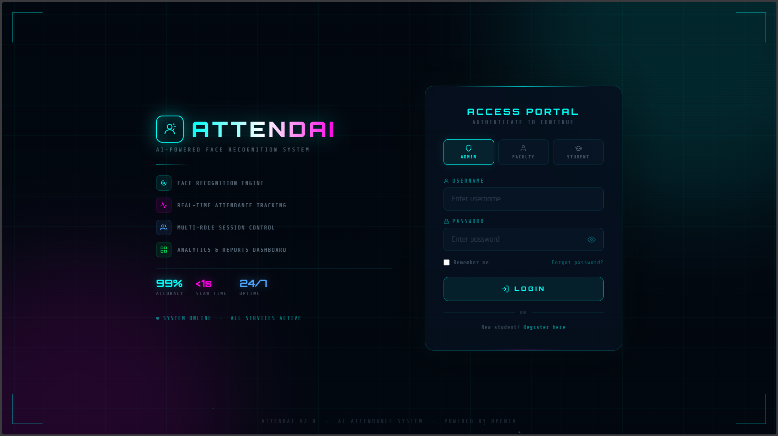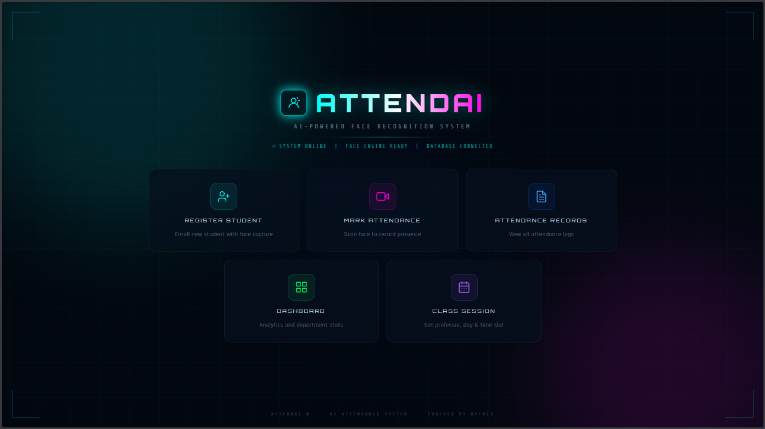

7.2 Student Registration Page
The registration page features a live webcam panel on the right that captures 20 face frames automatically. A progress indicator shows dots filling up as frames are capured. The form validates all fields in real time with visual feedback.
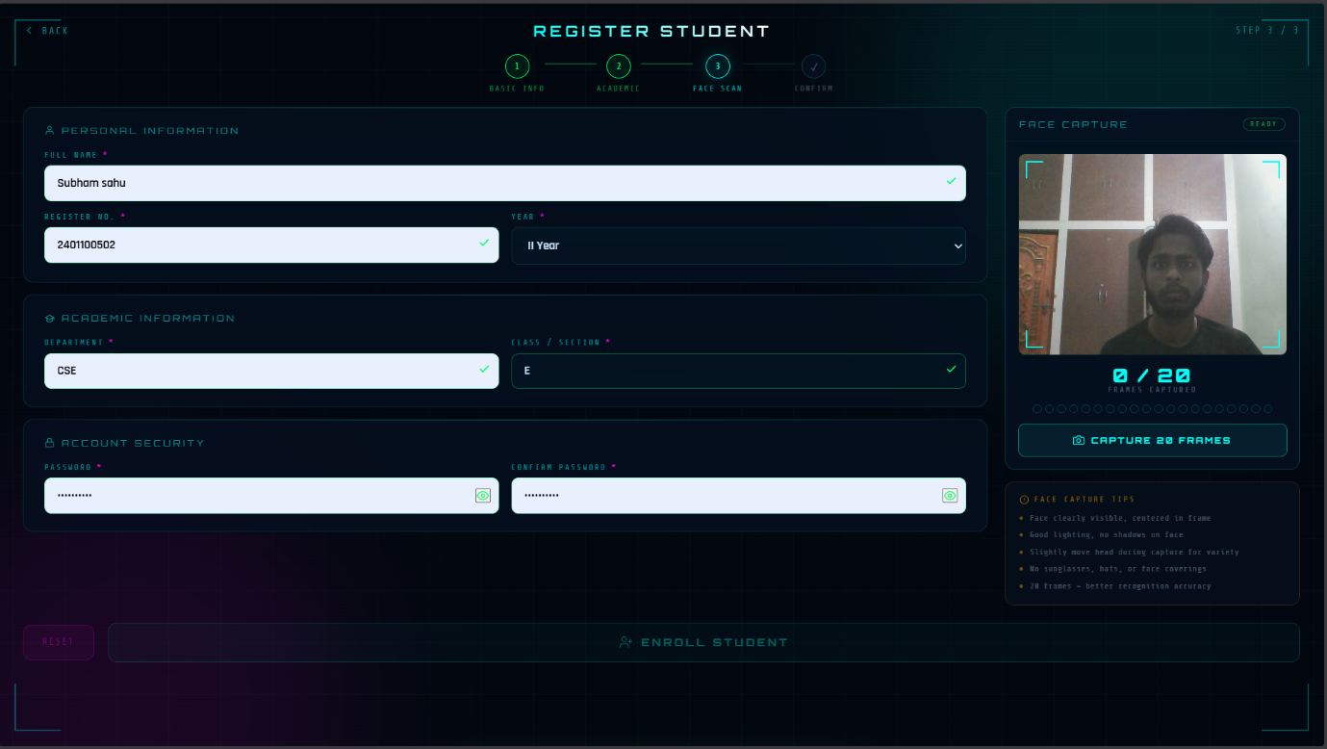

7.3 Attendance Camera Page
The camera page shows the live webcam feed with a liveness detection overlay ('Blink to Verify'). An EAR progress bar provides visual feedback. After liveness confirmation, the Start Scanning button enables auto-continuous scanning with a live attendance log on the right panel.
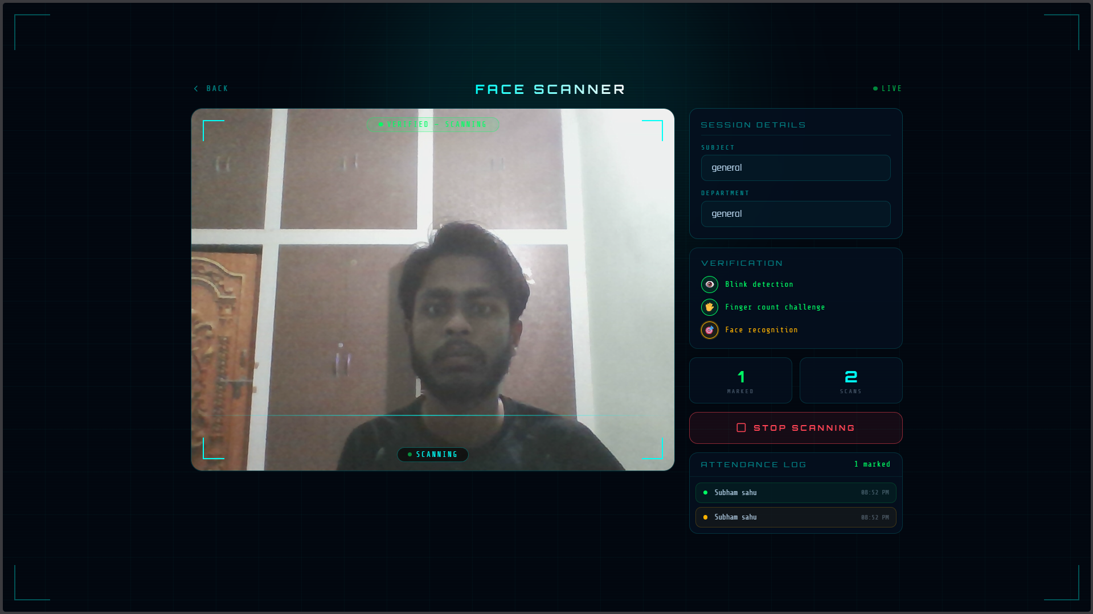

7.4 Attendance Records & CSV Export
The attendance records page displays all marked attendance in a paginated table with an Export CSV button in the top right corner for downloading attendance reports.
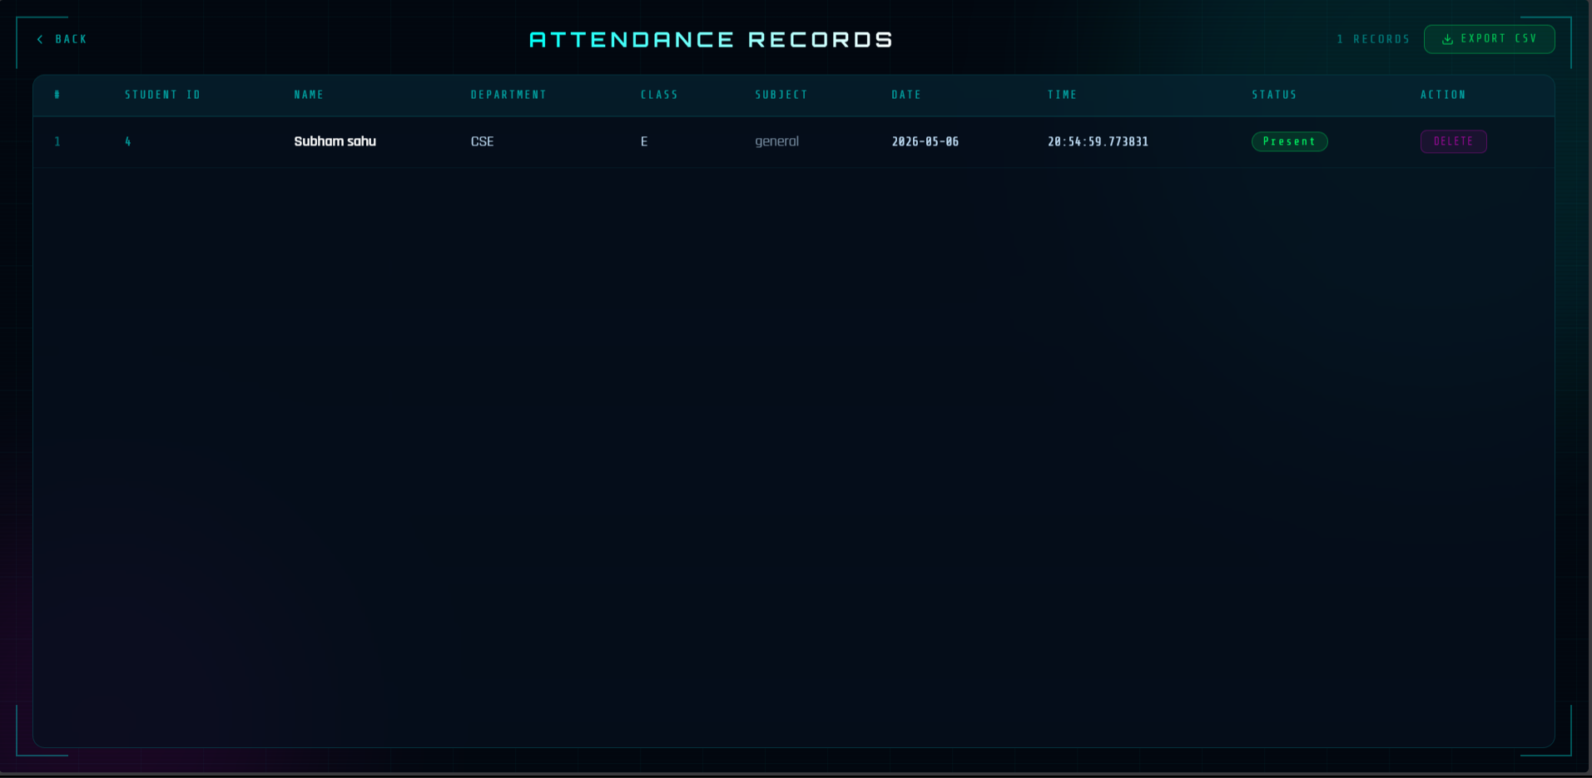8. Results & Testing

8.1 Recognition Accuracy
AttendAI was tested with a dataset of registered students under controlled classroom lighting conditions. The LBPH model achieved satisfactory recognition accuracy when students were registered with 20 frames under good lighting. The confidence threshold of 60 was determined through empirical testing to minimize false acceptances while maintaining a low false rejection rate.
Test Condition | Recognition Result | Notes
Registered student, good lighting | Correctly identified | Confidence < 30
Registered student, dim lighting | Correctly identified | Confidence 40-55
Unregistered person | Not recognized | Confidence > 60, correctly rejected
Photo of student (printed) | Rejected by liveness | EAR stable, no blink detected
Photo on screen | Rejected by liveness | EAR stable, no blink detected

8.2 Liveness Detection Results
The liveness detection module was tested against various spoofing attacks. In all tests with printed photographs and digital screen displays, the EAR remained constant and no blink was detected, correctly rejecting the spoofing attempt. Real users successfully passed the liveness check within 2-5 seconds of natural blinking.

8.3 Performance Metrics
- Average time to mark one student: 3 seconds (auto-scan interval)
- Time to mark 30 students: approximately 90 seconds with continuous scanning
- Registration time per student: approximately 30 seconds including 20-frame capture
- Model retraining time: 2-5 seconds after each new registration
- CSV export generation: under 1 second for up to 500 records
9. Ethical Considerations & Data Privacy

9.1 Data Privacy
AttendAI collects and processes biometric data (facial images) which requires careful ethical consideration. The system is designed for use within the controlled academic environment of NIST University, where students are enrolled with their explicit knowledge and consent during registration. The following privacy safeguards are implemented:
- Face images are stored locally on the institution's server and are not transmitted to third-party services.
- Student passwords are hashed using bcrypt with unique salts — plaintext passwords are never stored.
- Database credentials are managed through environment variables and are never committed to version control.
- The Supabase database is protected by service role keys with row-level security capabilities.
- Students can only view their own attendance records — no cross-student data access is permitted.

9.2 Consent and Transparency
Students are registered into the system by authorized administrators with their knowledge and participation. The registration process requires the student to be physically present in front of the webcam, making non-consensual enrollment practically impossible. The system is transparent about its data collection — students are informed that their facial images are being captured during registration.

9.3 Security Measures
- Role-based access control ensures faculty can only mark attendance and view records, while students can only view their own data.
- All API endpoints are protected by session authentication — unauthorized access returns 401 or redirects to login.
- The liveness detection mechanism prevents impersonation attacks using photographs or videos.
- Environment-based configuration prevents credential exposure in source code repositories.

9.4 Limitations and Fairness
It is acknowledged that face recognition systems can exhibit varying accuracy across different skin tones and facial characteristics due to biases in training data. The LBPH algorithm used in AttendAI is trained exclusively on each individual student's own face images, which mitigates cross-demographic bias compared to systems trained on generalized datasets. However, recognition accuracy may vary based on image quality during registration, lighting conditions, and changes in appearance such as spectacles or facial hair.
10. Conclusion
AttendAI successfully demonstrates the application of artificial intelligence and computer vision in solving a real-world problem within the academic domain. The system automates attendance tracking, eliminates proxy fraud through liveness detection, and provides faculty with real-time visibility into class attendance — all through a browser-based interface that requires no additional hardware beyond a standard webcam.
The project achieves all the requirements specified in Problem Statement 2.2 of the NIST Smart Campus AI Initiative: face detection and recognition, prevention of proxy attendance, attendance log generation, and an analytics dashboard. The cloud-based architecture using Supabase ensures that attendance data is accessible from any device and persists reliably.
The development process involved significant technical challenges, including migrating from server-side camera capture to browser-based webcam streaming, implementing real-time liveness detection without server overhead, and optimizing the face recognition pipeline to avoid retraining on every attendance request. Each challenge was addressed with an elegant engineering solution that improved both performance and deployability.

11. Future Scope
Several enhancements are planned for future development of AttendAI:
Feature | Description
QR Self-Checkin | Faculty generates a QR code for each class session. Students scan with their phone, opening a login-free camera page for self-attendance marking before the teacher arrives.
DeepFace / FaceNet Upgrade | Replace LBPH with CNN-based recognition (DeepFace or FaceNet) for improved accuracy in challenging lighting conditions and with larger student databases.
Low Attendance Alerts | Automated email notifications to students and parents when attendance falls below 75%, the minimum required by most universities.
Supabase Storage Migration | Move face images from local disk storage to Supabase Storage for full cloud deployment without data loss on server restarts.
React Native Mobile App | Cross-platform mobile application for both Android and iOS, allowing faculty to manage sessions and students to view attendance from their smartphones.
Multi-Camera Support | Support for multiple simultaneous camera feeds at classroom entrances for passive door-based attendance marking.

12. References

- Ahonen, T., Hadid, A., & Pietikainen, M. (2006). Face Description with Local Binary Patterns: Application to Face Recognition. IEEE Transactions on Pattern Analysis and Machine Intelligence, 28(12), 2037-2041.
- Lugaresi, C., Tang, J., Nash, H., McClanahan, C., Uboweja, E., Hays, M., ... & Grundmann, M. (2019). MediaPipe: A Framework for Building Perception Pipelines. arXiv preprint arXiv:1906.08172.
- Schroff, F., Kalenichenko, D., & Philbin, J. (2015). FaceNet: A Unified Embedding for Face Recognition and Clustering. Proceedings of the IEEE Conference on Computer Vision and Pattern Recognition (CVPR), 815-823.
- Soukupova, T., & Cech, J. (2016). Real-Time Eye Blink Detection using Facial Landmarks. 21st Computer Vision Winter Workshop, Rimske Toplice, Slovenia.
- OpenCV Documentation: Face Recognition with OpenCV. Retrieved from https://docs.opencv.org/4.x/da/d60/tutorial_face_main.html
- MediaPipe Face Mesh Documentation. Google LLC. Retrieved from https://developers.google.com/mediapipe/solutions/vision/face_landmarker
- Supabase Documentation. Retrieved from https://supabase.com/docs
- Flask Documentation. Pallets Projects. Retrieved from https://flask.palletsprojects.com

AttendAI — GitHub: github.com/Subham503/AttendAI | sahusubham38632@gmail.com

