**NAME-Subham Rauta**

Create a VPC, e.g., VPC1, and create three subnets within it: one that is half the size

and two that are quarter-sized. The larger subnet should be public, while the other two

should be private.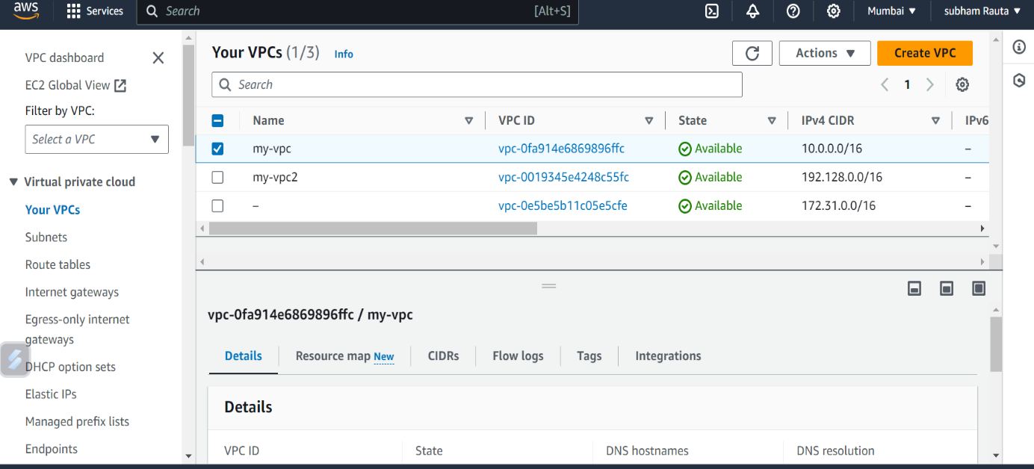

vpc1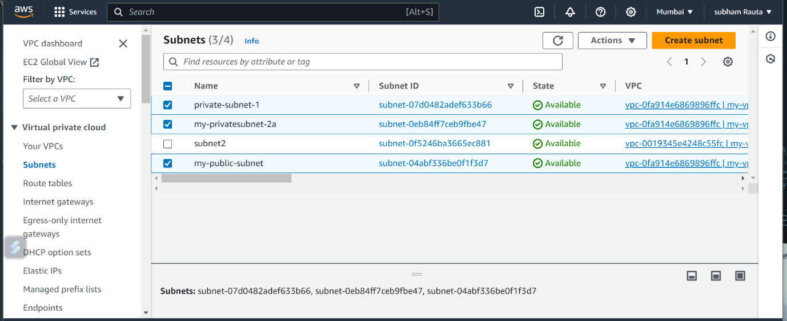

2private subnet and 1 public subnet under vpc1

2. 2. Establish a NAT gateway connection for subnet 2 and subnet 3 in VPC1.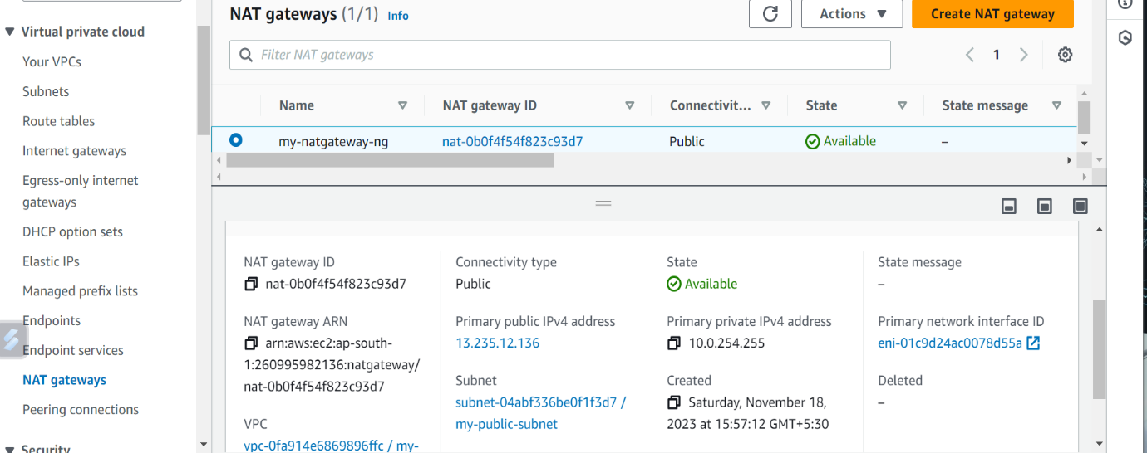

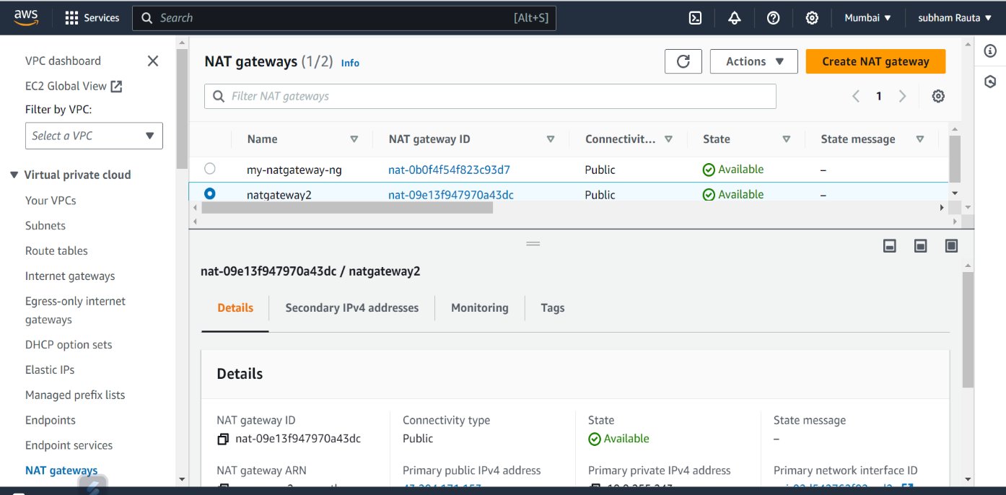

NAT gateway connection for subnet2 and subnet3

3. VPC2, and set up one subnet within it without internet

connectivity. Connect to the Windows server running in the VPC2 subnet using a Peering connection from Subnet 2 of VPC1.

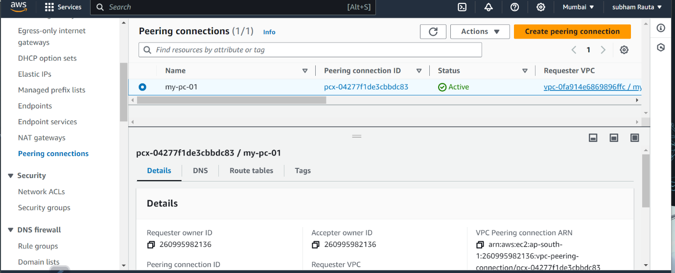

**B. Network Security:**

**Launch two instances: one with Windows and the other with Amazon Linux .**

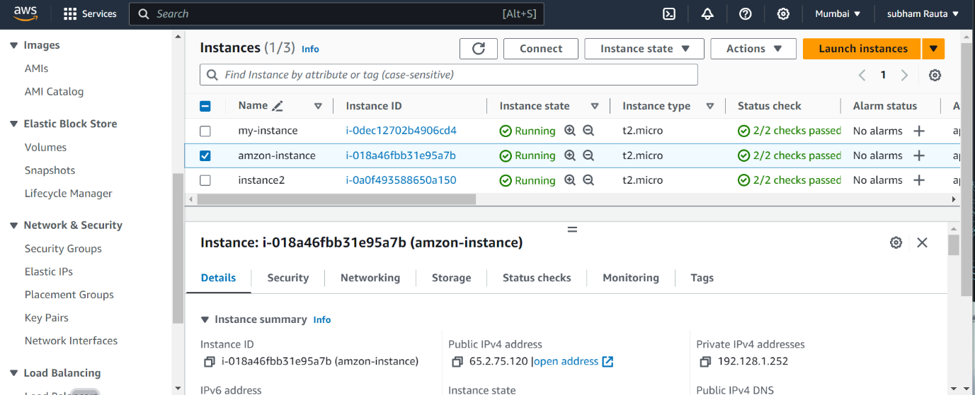

**Instance create with linux**

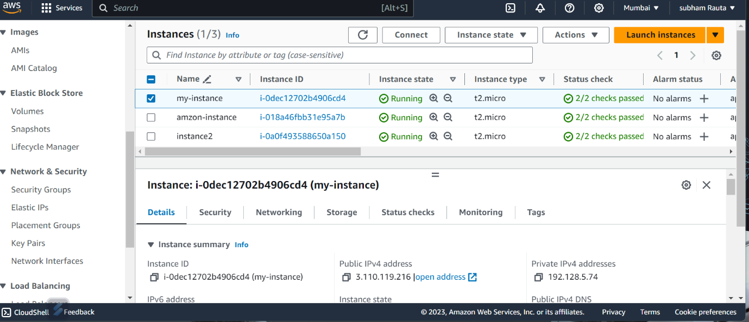

**Instance create with windows..**

**LOAD BALANCER .**

**Create a Classic Load Balancer (CLB) and attach it to an Auto Scaling Group (ASG).**

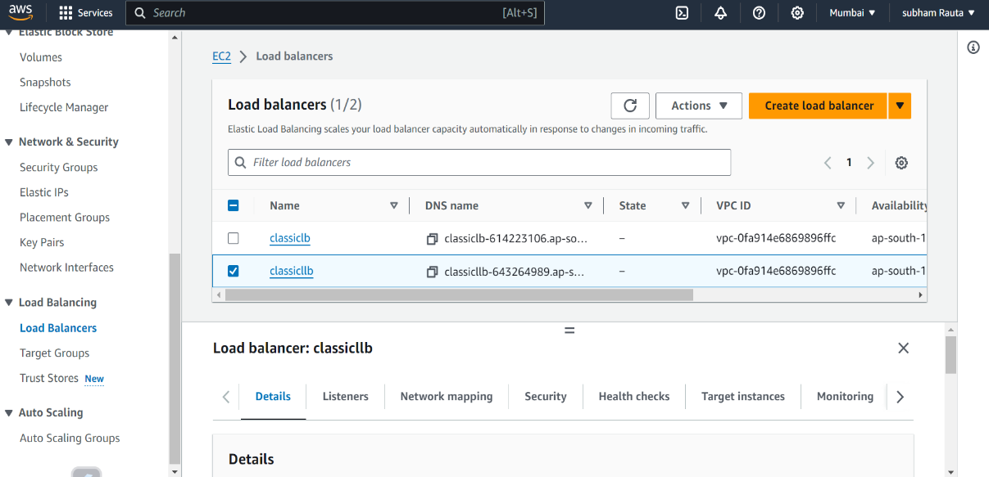

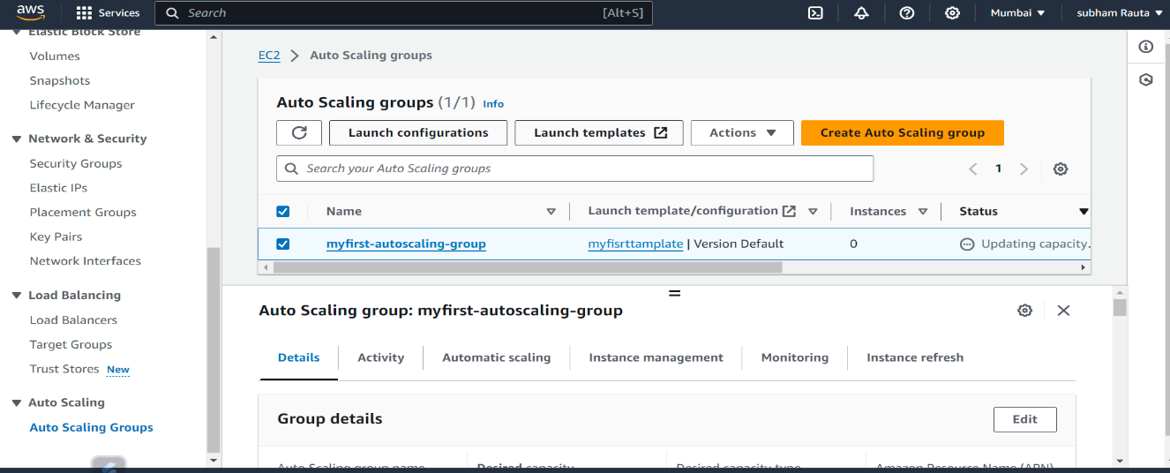

**CLASSIC LOAD BALANCER ATTACH INTO AN AUTOSCLING GROUP**