Here is a complete, pre-written report you can copy directly into Microsoft Word or Google Docs. Simply paste your screenshots into the indicated placeholders.

Docker Containerization Assignment Report
Student Name: Subham Panda
Topic: Containerizing a Full-Stack Application (Node.js/Express + Python/Flask) using Docker & Docker Compose
GitHub Repository: [https://github.com/Subham706/Docker_Subha](https://github.com/Subham706/Docker_Subha)
Docker Hub Frontend Image: [https://hub.docker.com/r/subham706/express-frontend](https://hub.docker.com/r/subham706/express-frontend)
Docker Hub Backend Image: [https://hub.docker.com/r/subham706/flask-backend](https://hub.docker.com/r/subham706/flask-backend)

1. Project Overview & Architecture
The objective of this assignment is to containerize a decoupled full-stack application and orchestrate its multi-container environment:
- Frontend Service: Built with Node.js and Express using EJS view templating. It exposes a web form on port 3000 to collect user input (Name, Email, Message) and forwards the submission to the backend over internal Docker DNS (http://backend:5000/api/submit).
- Backend Service: Built with Python and Flask. It listens on port 5000, receives data from the frontend, processes the payload, and returns a JSON confirmation response.
- Networking & Orchestration: Managed using docker-compose.yml under a shared bridge network (app-network). The frontend service is configured with depends_on: - backend to ensure proper startup order.

2. Directory Structure
Plaintext
Docker_Subha/
├── backend/
│ ├── app.py
│ ├── requirements.txt
│ ├── .dockerignore
│ └── Dockerfile
├── frontend/
│ ├── package.json
│ ├── server.js
│ ├── views/
│ │ ├── index.ejs
│ │ └── result.ejs
│ ├── .dockerignore
│ └── Dockerfile
├── docker-compose.yml
├── .gitignore
└── Assignment_Documentation.docx

3. Implementation Details & Commands

Dockerfile Configurations
- Backend (backend/Dockerfile): Uses python:3.11-slim, installs dependencies via pip install --no-cache-dir -r requirements.txt, exposes port 5000, and executes python app.py.
- Frontend (frontend/Dockerfile): Uses node:18-alpine, executes npm install --omit=dev, exposes port 3000, and runs npm start.

Docker Compose Orchestration (docker-compose.yml)
The Compose configuration defines two services (backend and frontend), sets container names, assigns port forwarding (5000:5000 and 3000:3000), sets the backend URL environment variable for the frontend, and links both services within a custom bridge network (app-network).

4. Execution Logs & Screenshots

Task 1: Building and Starting Services with Docker Compose
- Command: docker compose up --build
- Explanation: Downloads the base images, builds container layers using the Dockerfiles, links the custom network, creates the containers, and starts both Express and Flask application processes.

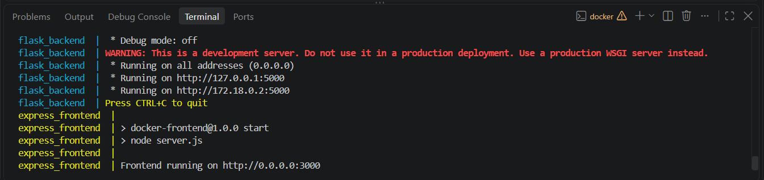
(Screenshot of VS Code terminal showing the successful build and active logs for both flask_backend and express_frontend)

Task 2: Verifying Running Containers
- Command: docker ps
- Explanation: Lists active containers, verifying container IDs, names (flask_backend, express_frontend), statuses (Up), and port bindings (0.0.0.0:3000->3000/tcp, 0.0.0.0:5000->5000/tcp).
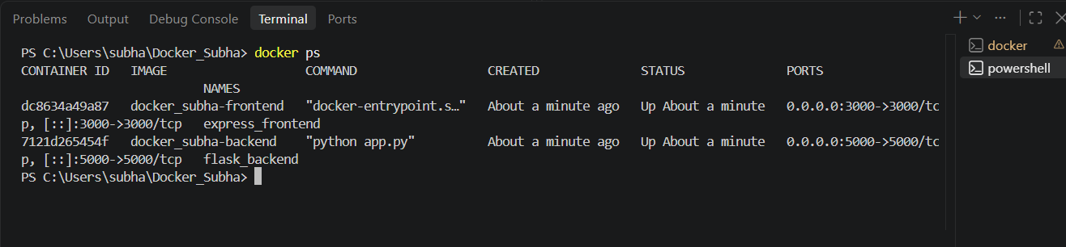(Screenshot of terminal running docker ps showing both containers running)

Task 3: Frontend Web Form Interface
- Access Point: http://localhost:3000
- Explanation: Express renders index.ejs, presenting the input form to the client to collect user data before submission.
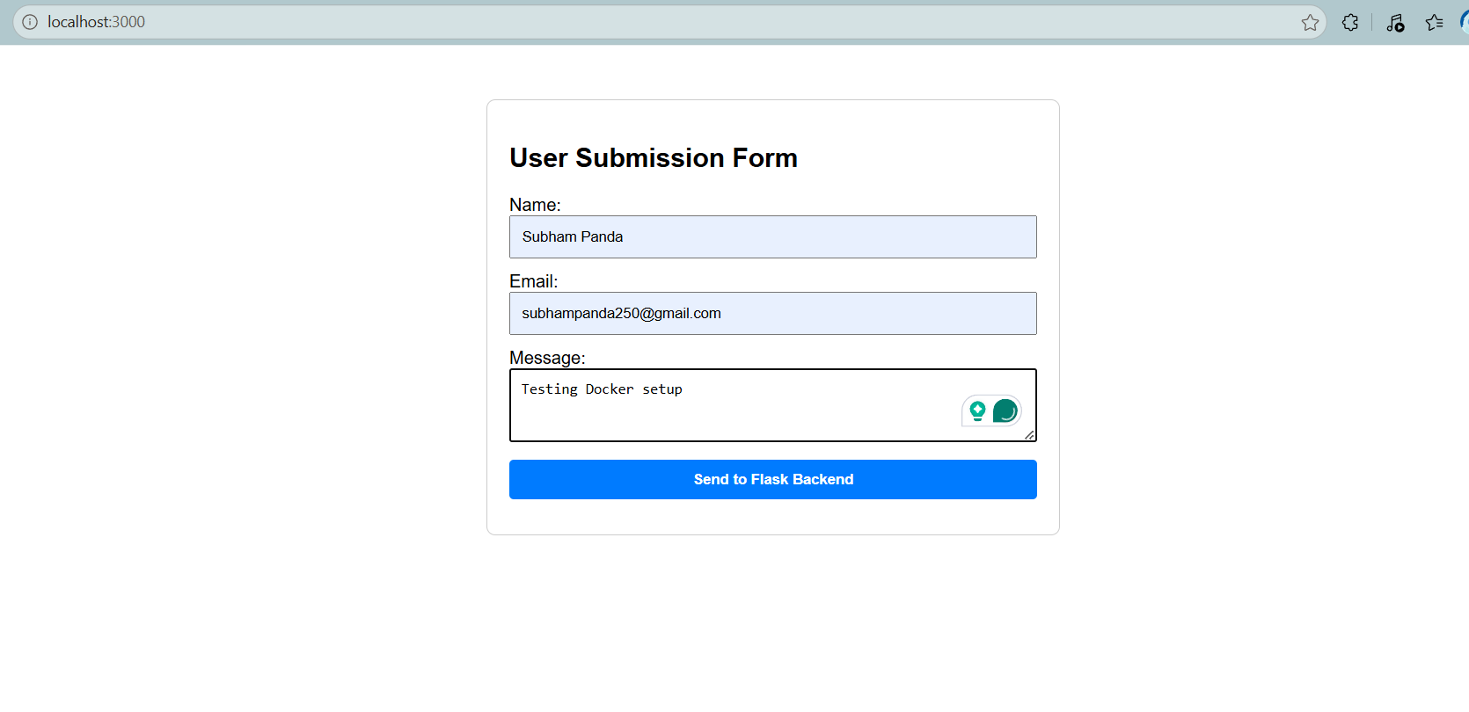
(Screenshot of browser at http://localhost:3000 with the form filled in)

Task 4: Backend Processing & Response
- Route: POST /submit -> http://backend:5000/api/submit
- Explanation: The Express server posts data to the Flask container, which processes the input and returns a structured JSON payload rendered on result.ejs.
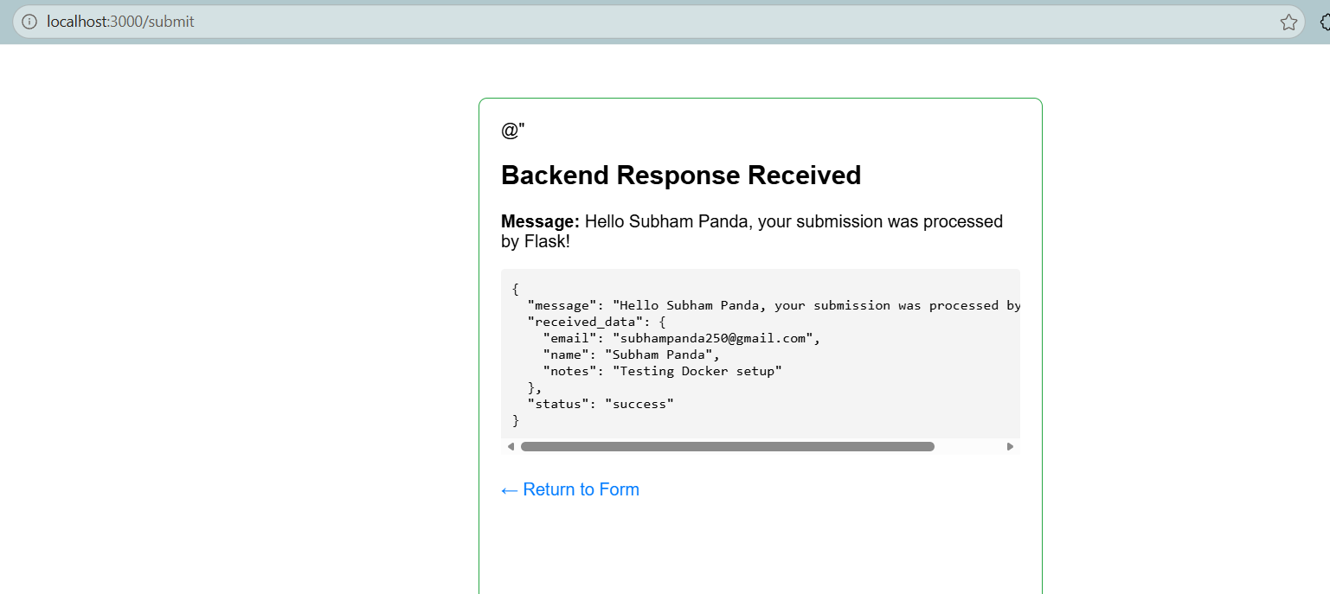(Screenshot of browser showing the Flask JSON response)

Task 5: Tagging and Pushing Docker Images to Docker Hub
- Commands:
- PowerShell
docker login
docker tag docker_subha-backend:latest subham706/flask-backend:v1
docker tag docker_subha-frontend:latest subham706/express-frontend:v1
docker push subham706/flask-backend:v1
docker push subham706/express-frontend:v1
- Explanation: Tags local application images with the Docker Hub registry namespace (subham706) and uploads the image layers to the public registry.
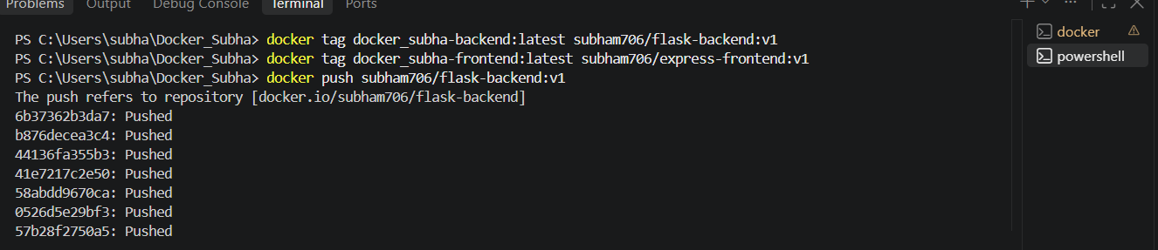
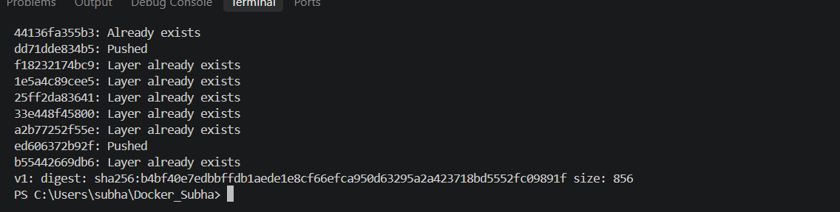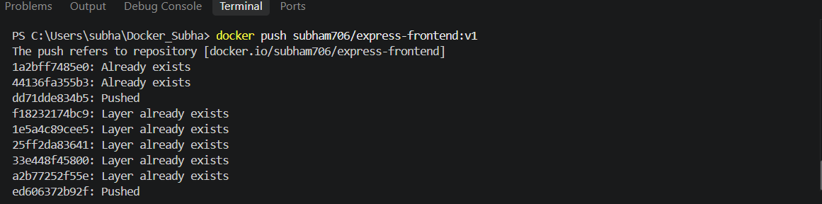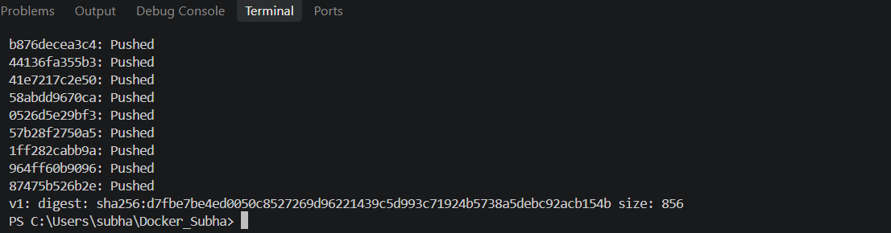
(Screenshot of terminal showing completed docker push outputs with image digests)

Task 6: Docker Hub Repository Verification
- Dashboard: [https://hub.docker.com/repositories](https://hub.docker.com/repositories)
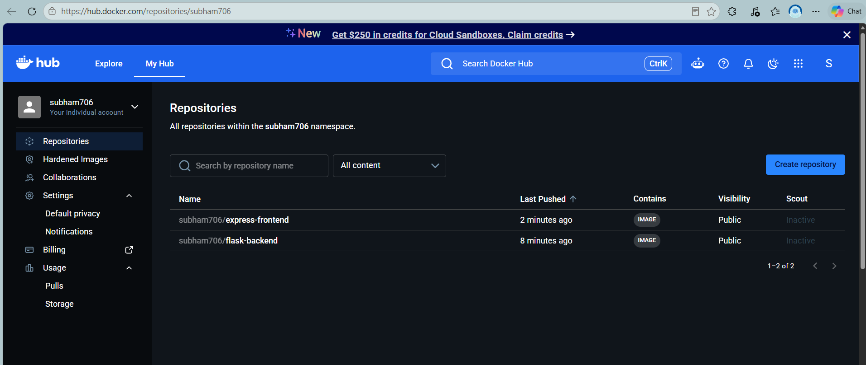
- Explanation: Confirms that both repositories (subham706/flask-backend and subham706/express-frontend) are stored and accessible in Docker Hub.

(Screenshot of Docker Hub web page showing both repositories listed under profile subham706)

Task 7: Version Control & GitHub Repository
- Commands:
- PowerShell
git init
git add .
git commit -m "Containerized full stack app with Express and Flask using Docker Compose"
git branch -M main
git remote add origin https://github.com/Subham706/Docker_Subha.git
git push -u origin main

- Explanation: Pushes the application source code, Dockerfiles, compose configuration, and .gitignore to GitHub.
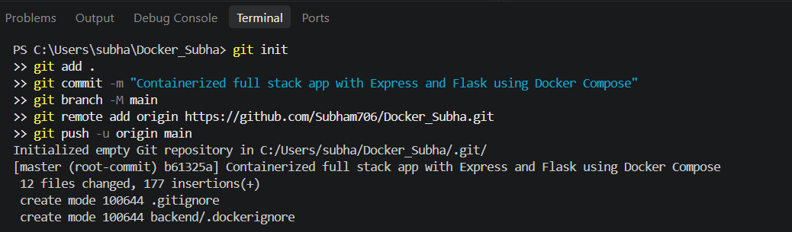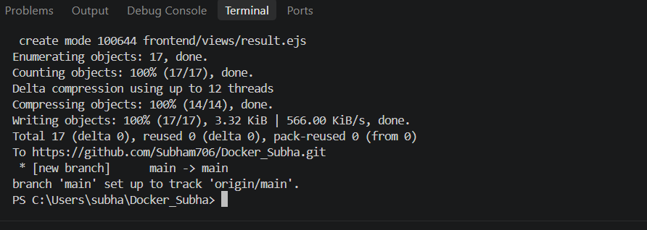
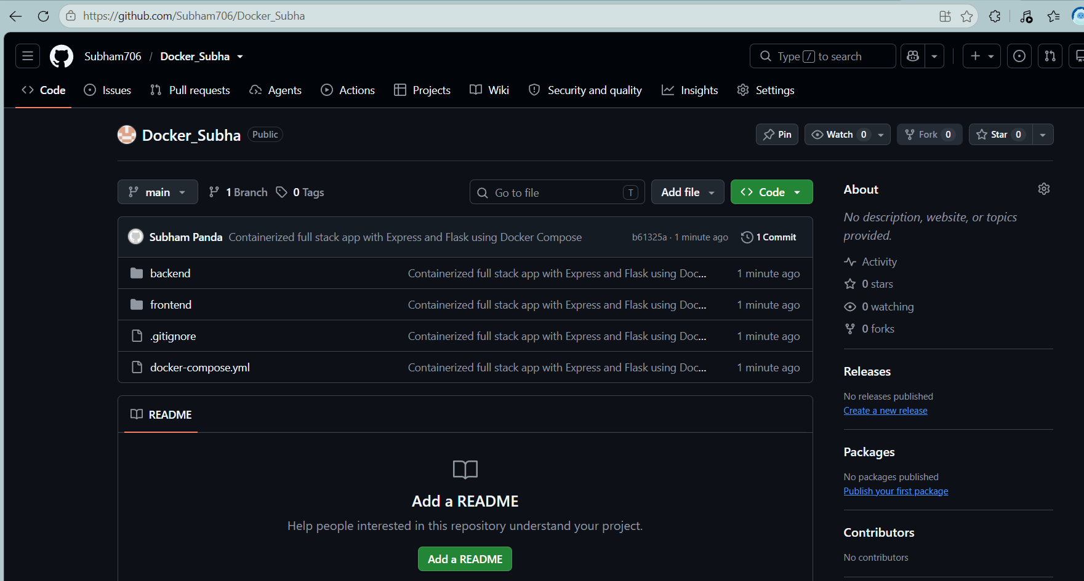(Screenshot of GitHub repository web page Subham706/Docker_Subha)

5. Teardown Procedure
- Command: docker compose down
- Explanation: Stops the running application containers, detaches attached volumes, and tears down the bridge network cleanly.

