**Student Name:** Subham Jaguri

**Student Id:** 11806002

**Email Address:** [techlious1@gmail.com](mailto:techlious1@gmail.com)

**GitHub Link:**

**Submitted to: Ms. Amandeep Kaur**

* **DESCRIPTION**

The problem is based on the concept of ***CPU SCHEDULING*.**

**Definition of CPU Scheduling**

1. It is the process by which CPU decides which process needs to be executed at which time. The main aim of CPU scheduling is to make system efficient. Only one process can be executed one time.
2. In some cases, processes of less priority (*depends on the algorithm*) may have to be on hold due to unavailability of resources like I/O.

**Types of CPU Scheduling**

There are two types of CPU scheduling

1. **Non-Preemptive Scheduling**
   1. In this type of scheduling, there is complete execution of the process by CPU.
   2. There is no interrupt in between the execution of one process
2. **Preemptive Scheduling**
   1. In this type of scheduling processes having higher priority are executed first
   2. Process may be interrupted in between while execution due to arrival of some process having higher priority

**Important terminologies related to concept**

1. **Turn Around Time**
   1. It is the time taken by CPU from the arrival of a process to the completion of it
   2. **Mathematically,**

***Turn Around Time = Completion time – Arrival time***

1. **Waiting Time**
   1. It is the sum of all the time units while the process waits because some other processes are executing.
   2. **Mathematically,**

***Waiting Time = Turn Around Time – Burst time***

* **ALGORITHM and COMPLEXITY ANALYSIS**

**There are total 6 algorithms which are used in CPU scheduling**

* + - 1. First Come First Serve (FCFS) Scheduling
      2. Shortest-Job-First (SJF) Scheduling
      3. Priority Scheduling
      4. Round Robin (RR) Scheduling
      5. Multilevel Queue Scheduling
      6. Multilevel Feedback Queue Scheduling

In this problem we will use Shortest Job First algorithm.

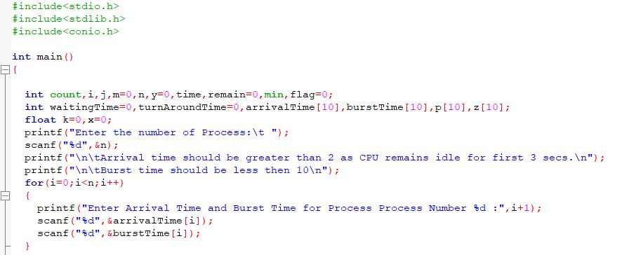

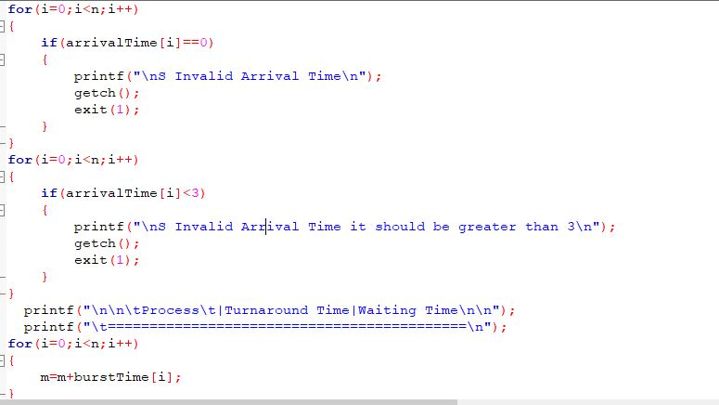

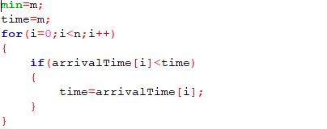

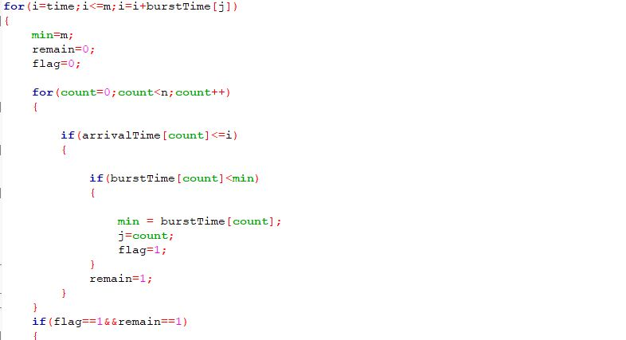

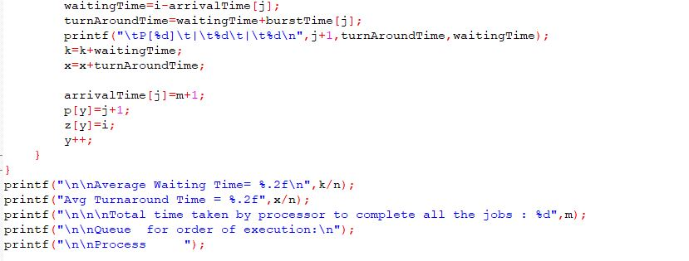

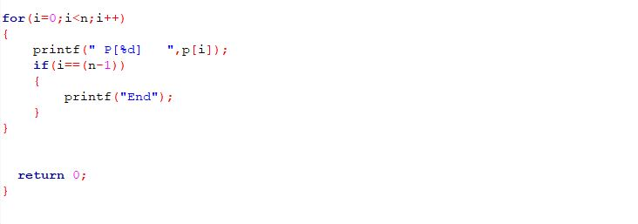

**#COMPLEXITY ANALYSIS**

Complexity of loop 1 = O(n)

Similarly, complexities of loop 2, loop 3 and loop 4 are also O(n).

And the complexity of Loop 5 (Main loop) is O(m*n)

So, the overall complexity = O(m*n)

* **Boundary Conditions and Constraints**

1. **The arrival time must be greater than 2**

**Because CPU remains idle for 3 sec**

1. **Burst time must be less than 10 sec**

**Because it is given in the question that CPU must not allocate more than 10-time units**

1. **When burst time of two processes are same then arrival time is considered .**

**Lesser arrival time process will be executed first**

**Constraint Code snippet** 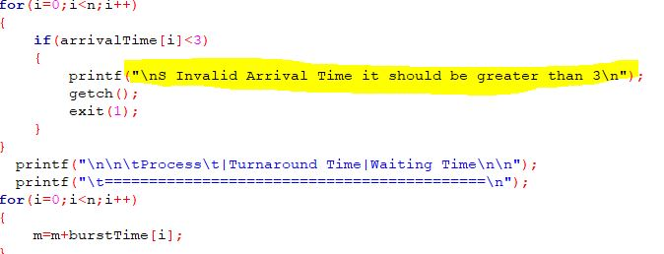

* **Boundary conditions Output Validation**

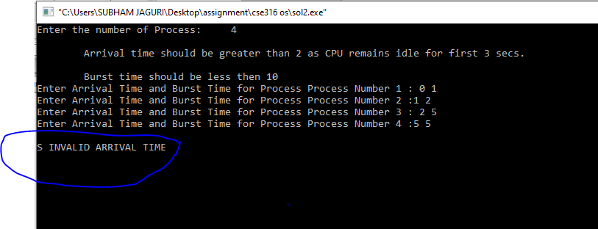

**It arises because arrival time is entered less than 3**

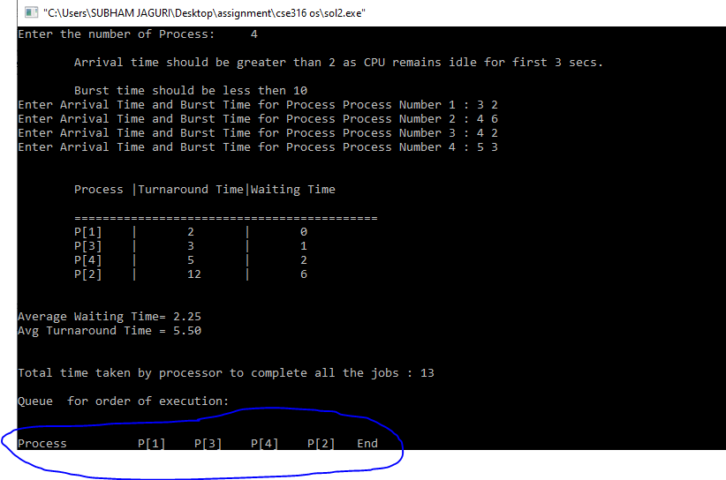

**Both P[1] and P[3] have same burst time but P[1] executed first because it has less arrival time**

* **TEST CASES**

1. **Test Case 1**

**Input 1.**

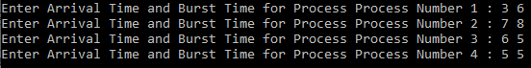

**Output 1.**

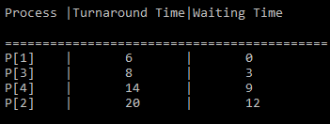



**Input 2.**

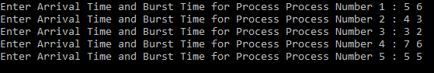

**Output 2.**

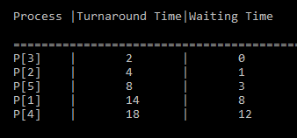



* **Source Code GitHub Link**

<https://github.com/SubhamJaguri/CSE-316-OS-ASSIGNMENT>

* **Yes, I have pushed code revisions to GitHub in above repository**

**Thank you**

**\*\*\***