Résumé

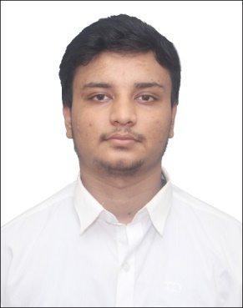

**Name :** Subham Kumar Rout

**Contact Number :**+91 8961553278

**Email** **:** subham.kumar.rout.fiem.ece15[@teamfuture.in](mailto:preetam@teamfuture.in)

subhamrout707@gmail.com

**Career Objective:**

To pursue a challenging career and be a part of progressive Organization that gives a scope to enhance my knowledge and utilizing my skill towards the growth of the Organization.

.

**Academic Qualification:**

**Graduation: B-Tech in ECE**

|  |  |  |  |  |  |  |  |
| --- | --- | --- | --- | --- | --- | --- | --- |
| **Sem** | **7** | **6** | **5** | **4** | **3** | **2** | **1** |
| **SGPA** | 8.2 | 8.2 | 8.42 | 8.42 | 7.66 | 7.66 | 7.74 |
| **Average** | 8.01 | | | | | | |

**Secondary & Higher Secondary**

|  |  |  |  |  |  |
| --- | --- | --- | --- | --- | --- |
| **Examination** | Board | **Year of Passing** | **Marks** | | |
| **Obtained** | **Out of (Total)** | **%** |
| **12th std** | ISC | 2015 | 466 | 600 | 77.6 |
| **10th Std** | ICSE | 2013 | 487 | 600 | 81.1 |

**AMCAT Scores**

|  |  |  |  |  |  |
| --- | --- | --- | --- | --- | --- |
| **Subject** | **Computer Programming** | **English Comprehension** | **Quantitative Ability (Advanced)** | **Logical Ability** | **Electronics and Semiconductor Engineering** |
| **National**  **Percentile** | 59 | 80 | 48 | 85 | 85 |
| **College**  **Percentile** | 47.6 | 76 | 50.8 | 96.3 | 83.2 |

**Projects & Internships:**

|  |  |  |  |
| --- | --- | --- | --- |
| **SL. NO.** | **Company** | **Project Title** | **Duration** |
|
| **1** | PRASAR BHARATI | TELEVISION ENGINEERING | 1 WEEK |

**Technical Proficiency & Certifications :**

* C
* Data Structure
* Java
* Html

**Achievements (Academic & Social)**

* Won many Quiz competition. “LIMCA QUIZ”,HORLICKS QUIZ”.
* Stood 2nd in robotics competition-“YANTRA”
* Paper presentation on “Evolution of light bulbs”
* Pitched and marketized product.
* Participated in many debate competition
* Work as a Campus ambassador for PARIDHI-MSIT fest
* Also was a part of “HELP AGE INDIA” for two years.

**Interests & Extra Curricular :**

Event Management, Quizzing, playing cricket and Table tennis.

**Language Known :-**

English, Hindi, Bengali.

**Personal Details:**

|  |  |
| --- | --- |
| Permanent Address | **:** 91/1/12 Dhramatalla road Belur Howrah near Belur station road |
| Date of Birth | **:** 31-03-1996 |
| Passport No | **: APPLIED** |
| ADHAR Card | **: 754086543987** |
| PAN Number | **: CGYPR7804R** |

**Declaration:**

I hereby declare that the information given above is true and correct.

**DATE: 30/08/2018 SIGNATURE: **