

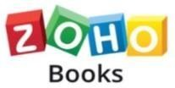

|  |  |
| --- | --- |
| COURSE NAME: | FINANCE & ACCOUNTING WITH ZOHO BOOKS |
| PROJECT TITLE: | PREPARATION AND MAINTENANCE OF ZOHO BOOKS OF KEERTHI SWEETS |
| PROJECT SUBMITTED TO: | SMART INTERNZ |
| YEAR: | 2023-2024 |
| DEPARTMENT: | COMMERCE (CA) |
| SEMESTER: | V |
| TEAM ID: | NM2023TMIDO9443 |
| MEMBERS OF THE GROUP: | Register No. Student Name  1321152042 R.SRI HARINI  1321152043 M.SRI NITHI  1321152044 M.SUBALAKSHMI  1321152045 K.SUGANTHI |
| GUIDED BY: | Ms. M. Jemima Suganthi, M.Com., M.Phil., Assistant Professor.  Ms. M. JeyaBharathi, M.Com., M.Phil., Assistant Professor. |
| SPOC NAME: | Ms. K. Elizabeth, M.Sc., M.Phil., B.Ed., Assistant Professor |

**INDEX**

|  |  |
| --- | --- |
| **Particulars** | **Pg. No.** |
| Introduction | 3 |
| Problem Definition & Design Thinking | 5 |
| Result | 6 |
| Advantages & Disadvantages | 11 |
| Applications | 15 |
| Conclusion | 15 |
| Future Scope | 16 |

**PREPARATION AND MAINTENANCE OF ZOHO BOOKS FOR KEERTHI SWEETS**

1. **INTRODUCTION**

Zoho Books is an accounting solution that is designed to help small businesses manage their finances. This solution includes dashboards and a wide variety of reports. Business users can automate tasks and set up custom workflows.

# OVERVIEW

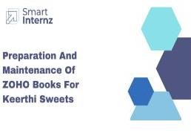

## Zoho books:

Zoho Books is cloud-based smart accounting software which takes care of all our accounting needs. To fully understand how Zoho Books works, go through modules below in the given order.

## Accessing zoho books:

To access Zoho Books, we have to sign up for the free 14-day trial period during which we can test the product for free. The free trial version of Zoho Books contains all the features in the Premium plan of Zoho Books. If we are already a registered user, then we can directly log in to Zoho Books.

## Project Description

Keerthi sweets manufacturer and trader of sweets relies on zoho books to manage their inventory handle purchase orders and generate invoices for their

customers they can track stock levels manage supplier payments and generate financial reports zoho books helps them streamline their wholesale operations and optimize inventory management.

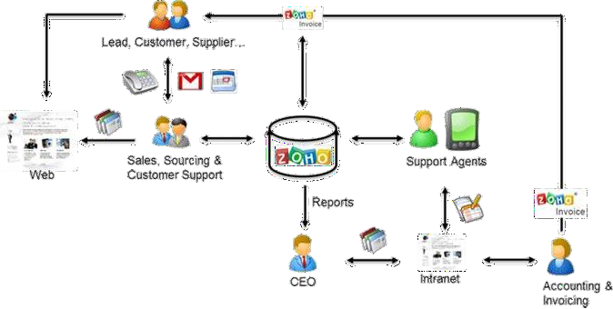

# PURPOSE

Keerthi sweets is a renewed manufacturer and trader of delectable sweets catering to both wholesale and retail customers with a rich heritage spanning several decades, Keerthi sweets has earned a reputation for its commitment to quality authenticity and customer satisfaction specializing in a wide variety of traditional and innovative sweets they combine traditional recipes with modern techniques to create flavors that tantalize taste buds.

Keerthi sweets is a private limited company also register under GST in Tamil Nādu Keerthi sweets is a manufacture and trader of various sweets in wholesale and retail it has a wide range of customers all over the state and it procures raw material from various suppliers in the state it operates in a gross profit margin.

# PROBLEM DEFINITION & DESIGN THINKING

* 1. **EMPATHY MAP**

In Keerthi Sweets, an empathy map is a simple visual that captures knowledge about the behaviors, attitudes, needs, strengths, struggles, emotional states, and other key attributes of a particular Customers or group of Customers.

# EMPATHY MAP:

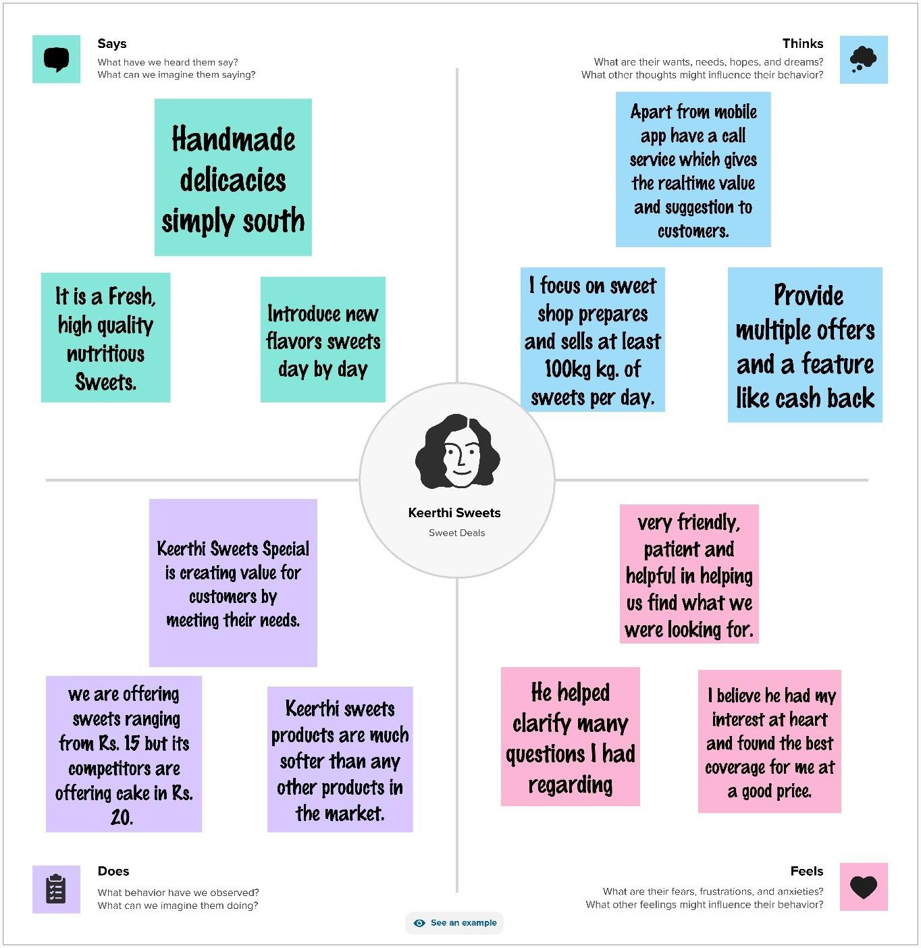

.

# IDEATION AND BRAINSTORMING MAP:

Brainstorming is a large- or small-group discussion that encourages students to generate a wide range of perspectives or potential next steps or solutions regarding a specific topic.

**BRAINSTRORMING**:

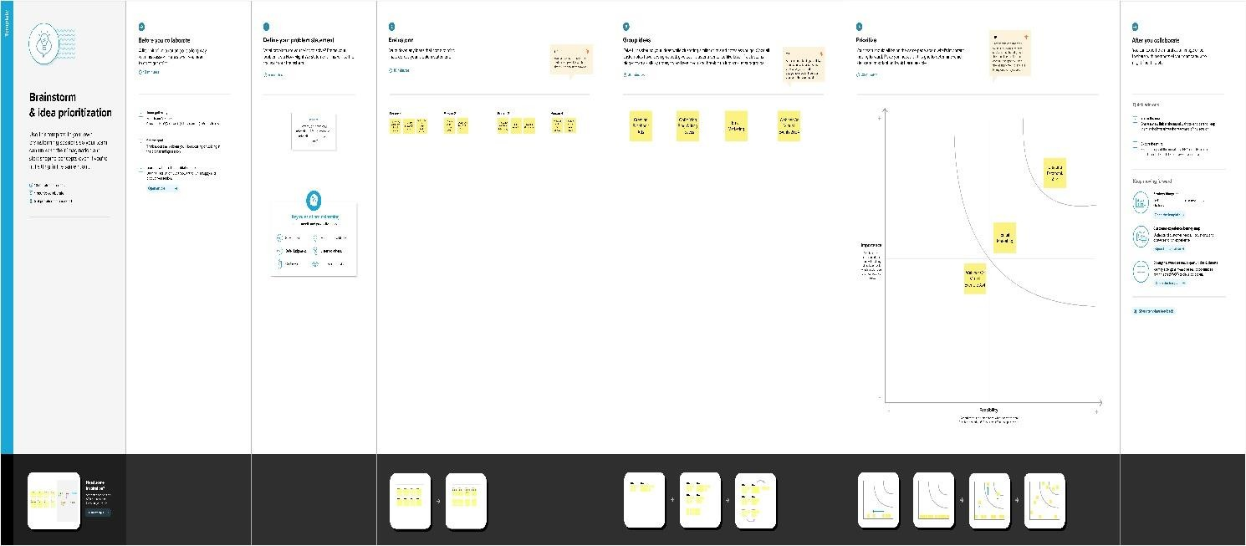

# RESULT

Final findings (output)of the project with screenshots.

* PROFIT AND LOSS ACCOUNT
* BALANCE SHEET
* CASH FLOW STATEMENT
* MOVEMENT OF EQUITY

# PROFIT & LOSS

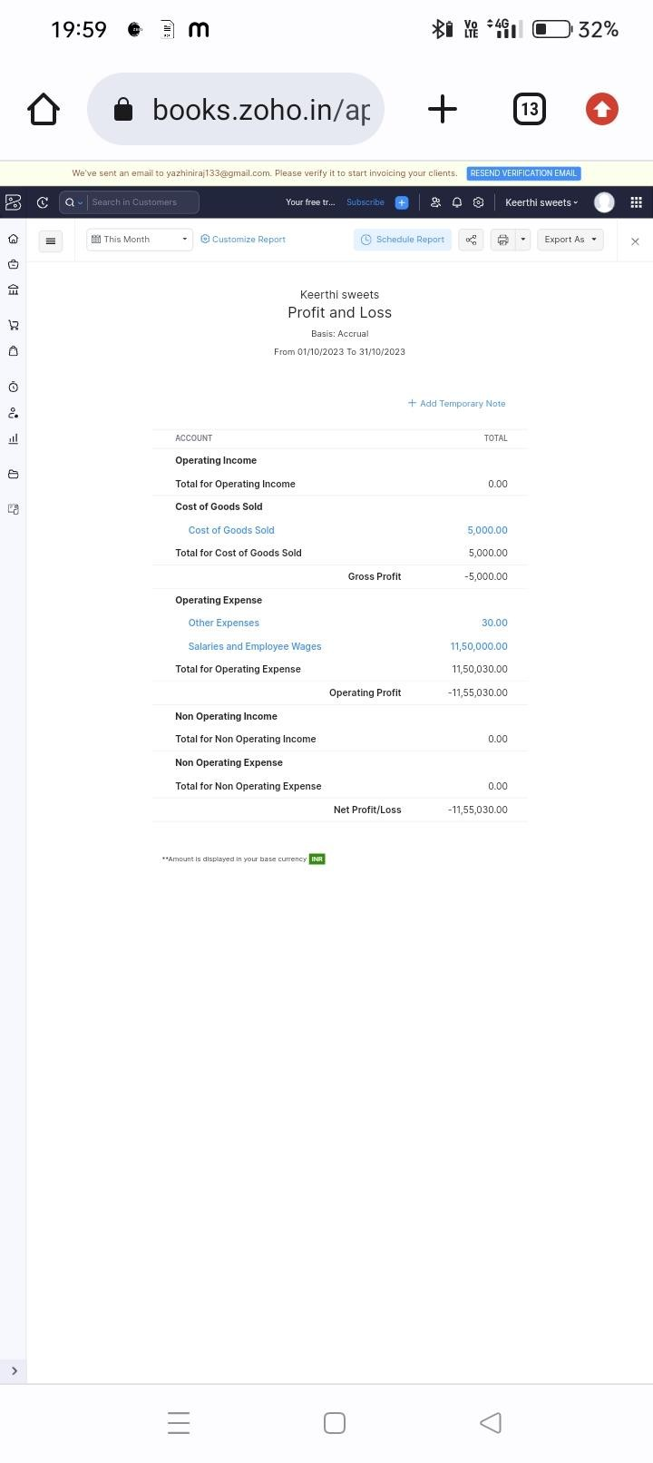

**BALANCE SHEET**

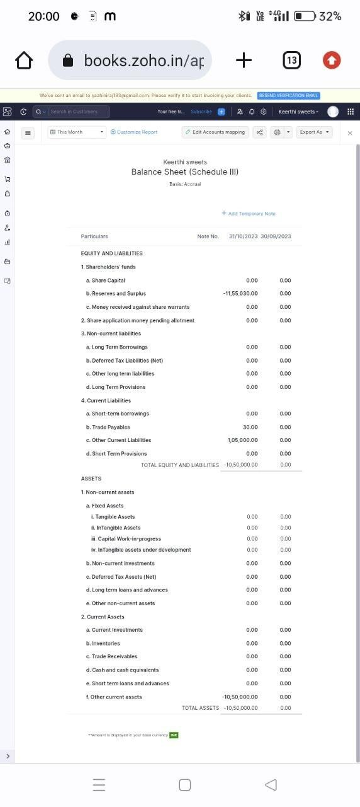

* CASH FLOW STATEMENT

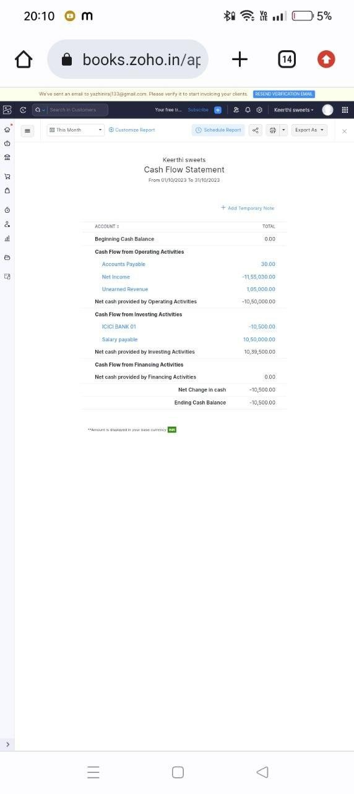

* 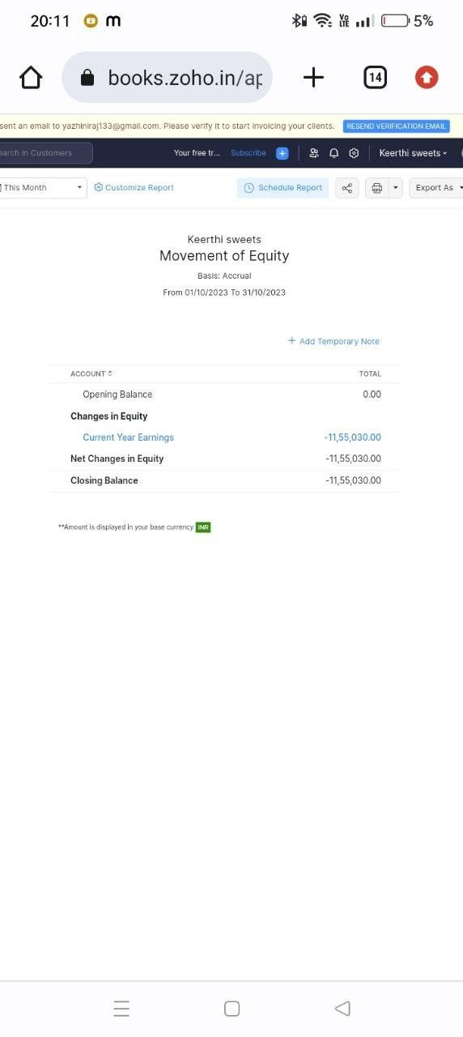MOVEMENT OF EQUITY

10

# ADVANTAGE AND DISADVANTAGES

* 1. **ADVANTAGES**

Invoicing and billing are essential business functions and the primary source of cash flowing into our business. However, managing invoices manually is time-consuming and error-prone. Zoho Books addresses these issues effectively and offers great features that make our invoicing easier. Zoho Books allows us to automate our payment reminders and track due dates and expected payment dates. So, it can send them to our customers automatically.

Zoho books gives more benefit to the Keerthi sweets for creating customer, vendors, purchase order, sales order, bill. In addition, we can handle all kinds of currencies and connect our accounting application with Zoho Books to support multiple currencies. Zoho Books is built to add our local tax regulations and make working with taxes easier.

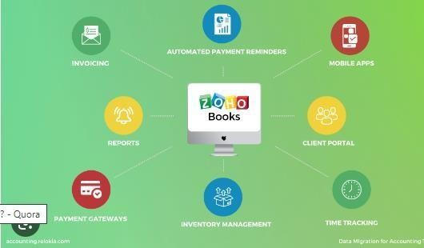

## Customization

This addresses a company’s ability to configure the software to fit its specific use case and workflow.

**API for custom integration:** An API (application programming interface) provides a standard programming interface for connecting third-party systems to the software for data creation, access, updating and/or deletion.

## Security

This component helps a company minimize the security risks by controlling access to the software and its data, and encouraging best practices among users.

**Single sign-on capability:** The software system supports a centralized authentication mechanism allowing the user to access multiple systems with a single, centrally managed password.

**Role-based user permissions:** Permissions to perform actions or access or modify data are assigned to roles, which are then assigned to users, reducing complexity of administration.

## Reporting & Analytics

Users can report on and analyze usage, performance, ROI, and/or other metrics of success.

**Dash Board:** Users can create, customize and share dashboards, which provide an overview of the most important metrics.

**Standard Report:** The software offers pre-built reports with metrics standard to the category.

**Custom Reports:** Users can create custom reports.

## General Ledger and Configurable Accounting

Financial management solution, including capabilities for general ledger and configurable accounting

**Accounts Payable:** This includes the automation and tracking of payment to vendors and suppliers, with features such as payment scheduling, check printing,

open purchase order alerts, document management, direct ACH bill payment, and vendor records.

**Accounts Reveivable:** This includes the management and automation of invoices and collections, with features like statements, invoices, receipts, payment reminders, customer records, auto billing, and refund checks.

**Cash Management:** The software provides a complete picture of a company’s cash flows, streamlines payment processing, and includes cash forecasting.

**Bank Reconciliation:** The software connects to a company’s financial institutions in order to reconcile accounting records with checking, savings and credit card accounts. Often month and year closing capabilities are included.

**Expense Management:** The software can log and track business expenses and reimbursements, including travel-related expenses, with the ability to tie them to particular projects.

**Time Tracking:** The software can track billable and non-billable employee time by project.

**Multi Currency Support:** The software supports transactions across multiple currencies.

**Regulations Compliance:**The software helps users adhere to typical accounting standards and regulations such as IFRS, GASB, or GAAP.

**Self Service Portal:** The software provides online portals for certain stakeholders to find information relevant to them, such as employees, vendors and customers.

## Inventory Management

The ability to track and manage the flow of goods or materials into and out of an inventory.

**Inventory Tracking:** The software syncs orders and stock to maintain a real-time picture of inventory and supports multiple methods such as LIFO and FIFO.

**Automatic reordering:** The software can be set up to automatically reorder a good when it falls below a certain threshold.

## Order Management

The ability to process orders, and track them from quote to cash.

**Pricing:** Users can set up complex and unique pricing requirements.

**Order Entry:** Users can enter an order once, and the data flows to all the necessary units such as fulfillment and billing.

**Credit Card Processing:** The software facilitates credit card processing.

Cost of Goods sold: The software calculates the direct costs attributable to a finished product, such as materials and labor, and includes roll-up pricing.

# DISADVANTAGES

Monthly transaction cap one significant Zoho Books limitation is the cap on monthly transactions. Users are limited to 5,000 transactions monthly, even on the highest-tier plan.

Zoho supports only three users on its Standard plan and up to 10 users on its Premium plan; after that, we must pay an extra monthly fee for each additional user.

In some cases, integration with other applications and tools can be limited, which can make it challenging to work with other business solutions.

1. **APPLICATIONS**

Zoho Books is one-stop platform for managing our accounting tasks and organizing our transactions. It's a single secure location to keep up with our company's bills and invoices, reconcile our bank statements, control our spending, oversee projects, and eliminate GST compliance worries.

The zoho books can be used in the area of education fields and also many industries can use zoho books for various purposes

# CONCLUSION

Zoho books help them streamline their financial operations and enhance the customer service

By now, we must have understood how Zoho Books is a powerful and versatile online accounting software that can help businesses of all sizes manage their finances and streamline their accounting processes.

Whether we are looking for free accounting software or a more advanced paid plan, Zoho Books is worth considering for our business!

Zoho Books is an online accounting application that takes care of the accounting needs of our business. We can record, audit and analyze all financial transactions easily.



# FUTURE SCOPE

Zoho development is going to focus on cloud services. Furthermore, expectations are that cloud would form 70% of Zoho's business and 30% would be from on-premise offerings. However, Zoho is going to continue its global expansion plans.

Zoho plans to embrace transnational localism, adapting its products and services to meet the specific needs of local markets while maintaining a global outlook.