**MLOPS**

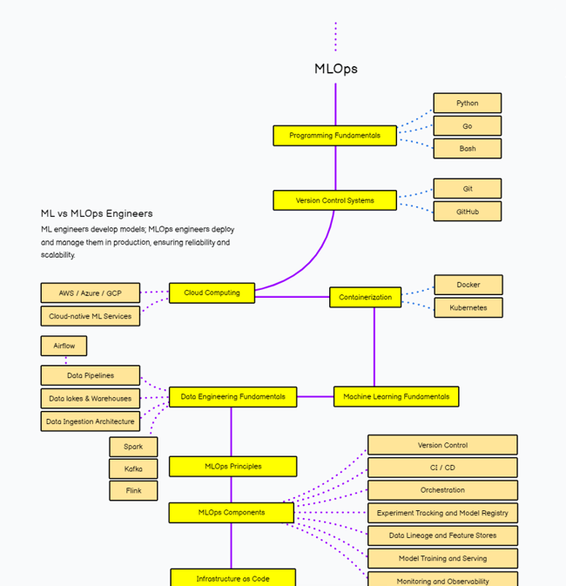

1. **PROGRAMMING LANGUAGE:**

In MLOps (Machine Learning Operations), the choice of programming language is crucial for various stages of the machine learning lifecycle, including data collection, model development, deployment, and monitoring

Python: Widely used for its extensive libraries and ease of use, suitable for various stages of the machine learning lifecycle.

R: Specialized for statistical analysis and data visualization, often used in academic and research settings.

Rust: Known for its performance and safety, ideal for building performance-critical components of ML systems.

1. **VERSION CONTROL SYSTEM:**

In MLOps, a version control system (VCS) like Git, often hosted on platforms like GitHub, plays a crucial role in managing machine learning projects.

Purpose: Tracks changes to code, data, and configurations, enabling collaboration, reproducibility, and tracking of model versions.

Git: A distributed version control system widely used in MLOps.

GitHub: A platform for hosting Git repositories, facilitating collaboration, code review, and project management.

Key Functions:

Versioning: Tracks changes to code, data, and configurations, enabling developers to revert to previous versions if needed.

Collaboration: Facilitates teamwork by allowing multiple developers to work on the same project concurrently, merging changes seamlessly.

Reproducibility: Ensures that experiments and model training are reproducible by capturing the exact state of the codebase at each point in time.

1. **CLOUD COMPUTING:**

**Cloud Computing in MLOps:** Cloud computing in MLOps refers to leveraging scalable, on-demand resources from platforms like AWS or Azure to streamline the development, deployment, and management of machine learning models.

AWS (Amazon Web Services): A leading cloud computing platform offering a wide range of services for MLOps, including storage, compute, machine learning, and deployment tools.

Azure: Microsoft's cloud computing platform providing a suite of services for MLOps, including data storage, AI, machine learning, and deployment solutions.

1. **CONTAINERIZATION:**

Containerization, facilitated by tools like Docker and Kubernetes, enables packaging and deploying machine learning models and their dependencies into portable and isolated environments, ensuring consistent performance across different computing environments, and facilitating scalable deployment and management.

1. **MACHINE LEARNING FUNDAMENTALS:**

In MLOps, ML fundamentals refer to the core concepts and principles underlying machine learning processes. This includes understanding algorithms for data analysis and prediction, feature engineering to extract relevant information from raw data, model training to learn patterns and relationships from labelled examples, model evaluation to assess performance and generalization ability, and model deployment to make predictions on new data. It also involves continuous monitoring and iteration to maintain model accuracy and relevance over time, ensuring effective integration of machine learning into operational workflows.

1. **MLOPS PRINCIPLES:**

MLOps, or Machine Learning Operations, is a set of principles and practices aimed at streamlining the development, deployment, and maintenance of machine learning models at scale. It emphasizes collaboration and automation across the entire ML lifecycle, from data collection and preprocessing to model training, deployment, and monitoring. Key principles include version control for code and data, continuous integration, and deployment (CI/CD) pipelines, reproducibility, monitoring, and governance. MLOps enables teams to iterate quickly, maintain model quality, and ensure reliability and scalability in production environments.

1. **MLOPS COMPONENT:**

In MLOps, the components typically include:

1. **Model Development:** This involves creating, training, and validating machine learning models using frameworks like TensorFlow or PyTorch.
2. **Version Control:** Tracking changes to code, data, and models using version control systems like Git, ensuring reproducibility and collaboration.
3. **Continuous Integration/Continuous Deployment (CI/CD):** Automating the process of building, testing, and deploying models into production environments, enabling rapid iteration and deployment.
4. **Model Monitoring:** Monitoring model performance and data quality in real-time, detecting anomalies and drift to maintain model accuracy and reliability over time.
5. **Feedback Loop:** Incorporating feedback from deployed models to iteratively improve performance, retraining models with new data and insights to adapt to changing conditions.

**MLOPS TOOLS**

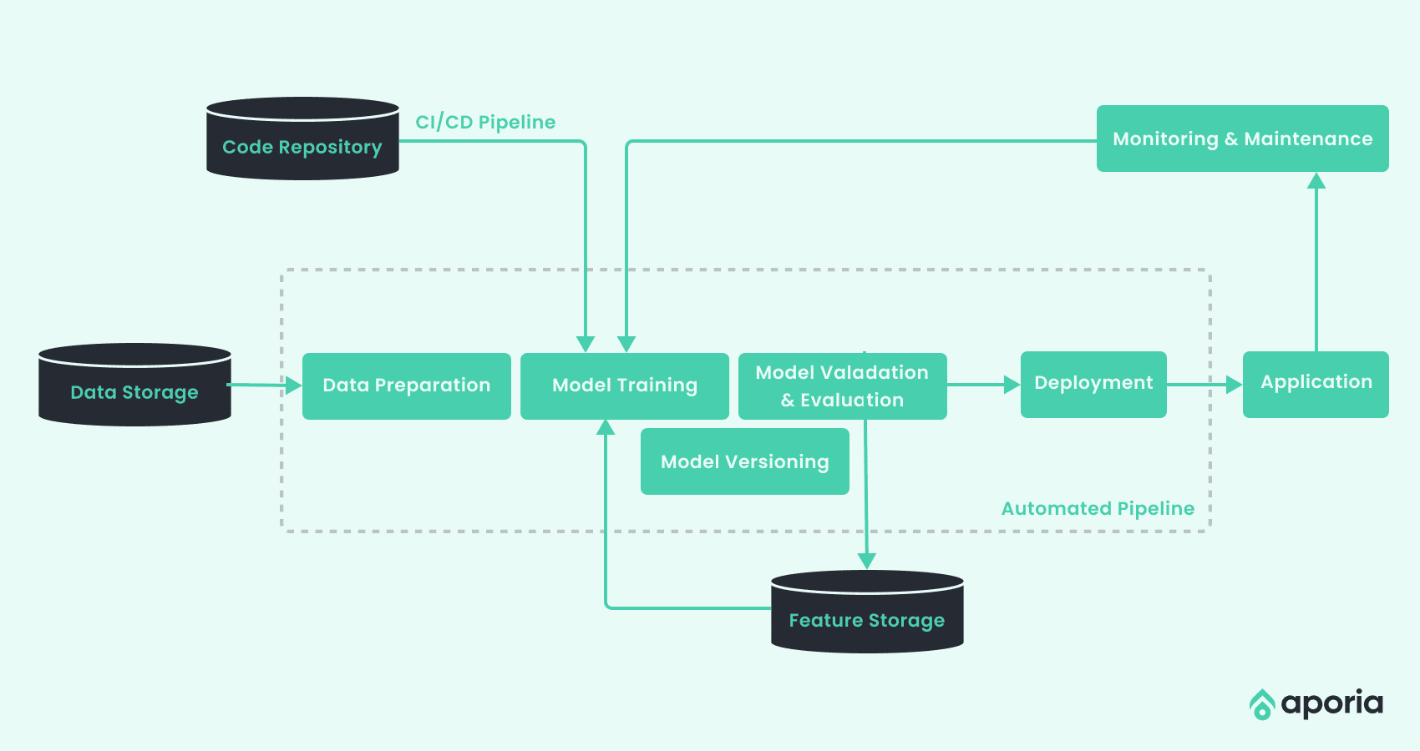

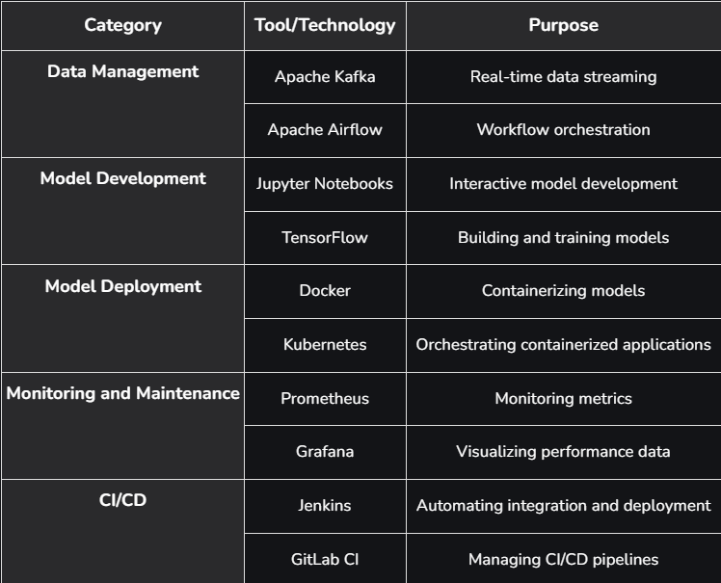

1. **DATA COLLECTION:**

For MLOps, data collection involves collecting data from a variety of sources, including databases, APIs, sensors, and user interactions. This data is then pre-processed and converted into a format suitable for training machine learning models. Effective data collection ensures high-quality, relevant, and diverse data, which is critical to building realistic and robust machine learning models. Tools such as Apache Kafka and Apache NiFi are often used to automate and streamline this process, enabling continuous and scalable data collection.

1. **APACHE KAFKA**: Widely used for building real time data pipelines & streaming applications. It provides features like full tolerance and reliability & scalability.

**Source: Open Source**

|  |  |
| --- | --- |
| **ADVANTAGES** | **DISADVANTAGES** |
| Can handle large volume of data. | Challenging for the users who are not familiar with distributed system. |
| Ensures data reliability through replication. | Requires maintenance & monitoring. |
| Scales horizontally to accommodate growing data needs. |

1. **APACHE NIFI**: Distribution system that supports powerful & scalable directed graphs of data routing, transformation & mediation logic.

**Source: Open Source**

|  |  |
| --- | --- |
| **ADVANTAGES** | **DISADVANTAGES** |
| User friendly interface. Easy to create & manage data pipelines. | NIFI can be resource intensive when large volume of data is presented. |
| Supports plugins for integration with various data sources. | Limited scalability. |
| NIFI tracks the lineage of data, as it moves through the system. |

1. **GOOGLE CLOUD DATAFLOW**: System used in storing of data in data collection method.

**Source: Not an Open Source**

1. **MODEL DEVELOPMENT:**

In MLOPS, model development involves the process of building, training, and testing machine learning models. This includes selecting appropriate algorithms, preparing, and processing data, training the model on this data, tuning hyperparameters, validating model performance The goal is to build models that predict accurate results based on new data on, forming the basis for assembling machine learning solutions.

**MODEL TRAINING:**

Model training in MLOps involves the process of feeding training data to a machine learning algorithm so that it can identify patterns and relationships in the data. This step is part of an ongoing pipeline in which models are trained, tested, and iterated to improve performance. MLOps ensure that these processes are automated, reproducible, and scalable, integrating best practices from DevOps to effectively manage code, data, and instances.

1. **TENSOR FLOW**: Developed by google. Provides a comprehensive ecosystem for building, training & developing machine learning models.

**Source: Open Source**

|  |  |
| --- | --- |
| **ADVANTAGES** | **DISADVANTAGES** |
| Large community, extensive documentation, support for various platform & devices. | Can be complex and challenging for beginners to learn and understand. |
| Supports a range of models and algorithm, from simple to deep learning models. | Tensor flow requires some more boilerplate code. |
| Integrates well with end-to-end machine Learning workflows. |

1. **PyTorch**: Machine Learning library developed by Facebook’s AI. It is known for dynamic computational graph & ease of use.

**Source: Open Source**

|  |  |
| --- | --- |
| **ADVANTAGES** | **DISADVANTAGES** |
| Easier to debug & modify models on the fly. | Less Mature compared to TensorFlow. |
| More intuitive & easier to learn, especially python & NumPy. | Limited mobile support. |
| Strong community & increasing number of tutorials. |

1. **Scikit-Learn**: Simple and efficient tool for data mining & data analysis, built on NumPy, SciPy & Matplotlib.

**Source: Open Source**

|  |  |
| --- | --- |
| **ADVANTAGES** | **DISADVANTAGES** |
| Easy to use for Beginners. | Limited Deep learning support. |
| Offers wide range of algorithm for classification, regression, clustering. | Scalability: Not able to handle large volume of data |
| Integrates well with python libraries like Pandas and NumPy. |

1. **CONTINUOUS INTEGRATION/ COTINUOUS DEPLOYMENT (CI/CD)**

In MLOps, CI/CD (Continuous Integration/Continuous Deployment) is a way to deliver changes, model testing, and deployment together to production are working releases in production environments, enabling fast and reliable updates This ensures that they are provided machine learning models are consistently effective and implemented with minimal intervention, increasing performance, and reducing error.

1. **Jenkins**: Automatic server that supports building, deploying & automating any projects.

**Source: Open Source**

|  |  |
| --- | --- |
| **ADVANTAGES** | **DISADVANTAGES** |
| Vast libraries to support various task and integration. | Can be complex to set up for beginners. |
| Large user base & community support with extensive support. | Requires regular maintenance and updates. |
| Can be customized for any CI/CD workflow |

1. **Gitlab CI/CD**: Part of Gitlab, a web-based Dev-ops lifecycle tools that provides a git repository manager providing wiki, CI/CD pipeline feature.

**Source: Open Source**

|  |  |
| --- | --- |
| **ADVANTAGES** | **DISADVANTAGES** |
| Provides a seamless experience from code repository management system. | Can be resource intensive, especially for larger projects. |
| Automatically sets up CI/CD pipelines, saving time & effort. | Complexity of setting up. |
| Strong vision control integration. |

1. **MODEL DEPLOYMENT**

In MLOps, model development refers to the process of creating machine learning models by experimenting with various algorithms and techniques, tuning hyperparameters, and validating models on different datasets. This phase involves using tools and frameworks to code, train, and optimize models to achieve the best possible performance on given tasks. The goal is to develop models that can be effectively deployed to solve real-world problems.

1. **Kubeflow**: Runs Machine Learning workflows on Kubernetes supporting end to end ML lifecycle management.

**Source: Open Source**

|  |  |
| --- | --- |
| **ADVANTAGES** | **DISADVANTAGES** |
| Leverages Kubernetes for scaling, deployment making it highly scalable & resilient. | Can be complex to set up for beginners. |
| End to end solution: support the ML lifecycle from training to deployment & monitoring. | Kubeflow can be resource intensive, leading to higher operational cost. |
| Supports multiple ML framework, including TensorFlow, PyTorch. |

1. **TensorFlow**: Flexible, high performance serving system for machine learning, designed for production engineer.

**Source: Open Source**

|  |  |
| --- | --- |
| **ADVANTAGES** | **DISADVANTAGES** |
| Seamless integration with TensorFlow models, offering efficient deployment. | Primarily designed for TensorFlow models. |
| Supports high throughput & low latency, making it suitable for large scale development. | Complexity of setting up. |

1. **Torch Serve**: Framework for Pytorch developed by AWS & Facebook.

**Source: Open Source**

|  |  |
| --- | --- |
| **ADVANTAGES** | **DISADVANTAGES** |
| Optimized for PyTorch. | Designed specifically for PyTorch model. |
| Supports high performance inference & batch processing. | Relatively newer compared to TensorFlow serving lack some advance features. |
| Extensibility: Supports custom handlers for various model types. |

1. **MONITORING & MAINTAINENANCE**

Monitoring in MLOps involves continuously monitoring the performance of production machine learning models to detect issues such as data drift, model degradation, or anomalies Update models for corrections, retrain new data, and ensure continuity well. This ensures that models remain valid and reliable over time, adapting to changes in data and business needs.

1. **Prometheus**: Monitoring & Alerting toolkit designed for reliability & scalability.

**Source: Open Source**

|  |  |
| --- | --- |
| **ADVANTAGES** | **DISADVANTAGES** |
| Powerful query language for extracting & analysing metrics | Can be complex to set up for beginners. |
| Wide range of integration with various system and services. | Limited built in visualization. |
| Handles large amount of data efficiently. |  |

1. **Grafana**: Used for monitoring & observability, providing interactive visualization of metrics.

**Source: Open Source**

|  |  |
| --- | --- |
| **ADVANTAGES** | **DISADVANTAGES** |
| Visualization: Excellent capabilities for creating & sharing dashboards. | Can be complex to set up for beginners. |
| Integration: Works well with data sources. | Often used in conjunction with Prometheus making it complex. |
| Highly customizable & extensible with plugins. |

1. **ML Flow**: Managing the end-to-end machine learning lifecycle, including monitoring & maintenance.

**Source: Open Source**

|  |  |
| --- | --- |
| **ADVANTAGES** | **DISADVANTAGES** |
| Logs & tracks experiments, providing insight into model performance. | Can be complex to set up for beginners. |
| Support various ML framework & cloud platform. | Limited Monitoring: Primarily focussed on model life cycle management, with less emphasis on real time monitoring. |
| Centralized repository for managing models. |