**DEVELOPMENT OF MLOPS ARCHITECTURE FOR AUTOMATED IDENTIFICATION OF FLIGHT PHASE USING UNSUPERVISED LEARNING**

**2024**

**SUBHAMAYA MOHANTY**

**B.TECH, CSC W ARTIFICIAL INTELLIGENCE & MACHINE LEARNING**

**SRM INSTITUTE OF SCIENCE AND TECHNOLOGY, CHENNAI**

**DEVELOPMENT OF MLOPS ARCHITECTURE FOR AUTOMATED IDENTIFICATION OF FLIGHT PHASE USING UNSUPERVISED LEARNING**



**BY**

**SUBHAMAYA MOHANTY**

**(B.TECH, CSC W ARTIFICIAL INTELLIGENCE & MACHINE LEARNING)**

**ACKNOWLEDGEMENT**

I take immense pleasure in thanking ------- (designation), Mission and Combat System research and Design entre, Hindustan Aeronautics Limited for providing me with an environment to complete my project successfully.

I am thankful to ------ (designation), Mission and Combat System research and Design entre, Hindustan Aeronautics Limited for his encouragement and support during this project.

Heartfelt gratitude also goes to MR. Prashant Kumar, Chief Manger (Design) and the entire team of MCSRDC for their constant support, motivation and encouragement.

**CONTENT**

**Abstract**

**Introduction**

**Artificial Intelligence**

**Machine Learning**

**Introduction to Machine Learning Algorithms in Aviation**

**Types of Machine Learning for Flight Phase Identification**

* **Supervised Learning for Labelling Flight Phases**
* **Unsupervised Learning for Anomaly Detection in Flight Data**
* **Reinforcement Learning for Flight Control Systems**

**A Novel Approach to Flight Phase Identification using ML by Emy Arts**

**MLOps (Machine Learning Operations)**

* **Introduction to MLOps in Aviation**
* **Tools and Technologies for Implementing MLOps in Aviation Projects**
* **Challenges and Best Practices in MLOps for Aviation Applications**

**Flight Phase Identification**

* **Importance and Challenges of Flight Phase Identification**
* **Methods and Algorithms for Automated Flight Phase Detection**
* **Integration of AI and ML Techniques for Accurate Flight Phase Classification**
* **Real-world Applications and Benefits in Aviation Safety and Efficiency**

**Code**

**Results**

**Conclusion**

* **Summary of Contributions to Aviation through AI, ML, Deep Learning, MLOps, and Flight Phase Identification**
* **Future Directions in AI and MLOps for Aviation Industry Advancements**

**References**

**ABSTRACT**

Artificial intelligence (AI) and machine learning (ML) have revolutionized aviation by improving safety, efficiency and decision making. Advanced deep learning (DL) techniques such as Convolutional Neural Networks (CNNs) analyse complex aircraft data, enabling flight prediction refinement, anomaly detection and recognition exactly half of the plane

Machine Learning Operations (MLOps) integrates AI models into aviation operations, ensuring continuous deployment, monitoring, and optimization. This project focuses on the MLOps lifecycle—from model training to deployment—enhancing the reliability and scalability of AI-driven solutions in dynamic aviation environments.

The project's main contribution is the development of automated flight phase identification systems using AI and ML techniques such as clustering and supervised learning. These systems accurately classify flight phases from real-time data, significantly improving flight safety, operational efficiency, and decision support in aviation.

This project highlights AI, ML and MLOps' transformative impact on aviation operations. It paves the way for innovations in AI-driven decision support systems, predictive maintenance, and real-time analytics, ensuring a future of enhanced efficiency and safety in air transportation.

**INTRODUCTION**

Flight phase identification is a critical aspect of modern aviation, significantly impacting flight safety, operational efficiency, and decision-making processes. Traditionally, flight phases such as taxiing, take-off, climb, cruise, descent, and landing were manually monitored and recorded by pilots and air traffic controllers. However, the advent of Artificial Intelligence (AI) and Machine Learning (ML) has revolutionized this process, allowing for automated and precise identification of flight phases based on real-time data.

This project leverages clustering techniques within the ML domain to develop an automated system for flight phase identification. By analysing flight data using clustering algorithms, we can identify distinct patterns corresponding to different flight phases, enhancing the accuracy of phase detection, and providing a robust framework for real-time monitoring and anomaly detection.

The primary objective of this project is to implement a clustering algorithm to classify flight phases from real-time data accurately. The system's ability to adapt and provide precise classifications will significantly enhance flight safety, improve operational efficiency, and support decision-making processes in aviation. This project underscores the transformative impact of AI, ML, and MLOps on aviation operations, paving the way for future advancements in automated flight phase identification and real-time analytics.

**ARTIFICIAL INTELLIGENCE**

Artificial Intelligence (AI) is a cornerstone of modern aviation technology, significantly enhancing the efficiency and safety of flight operations. In the context of this project, AI is employed to automate and improve the identification of various flight phases, including taxiing, take-off, climb, cruise, descent, and landing. These phases are traditionally monitored manually, but AI transforms this process by leveraging advanced algorithms to analyse flight data in real-time.

The implementation of AI techniques, such as clustering algorithms, allows for the precise detection and classification of flight phases. These algorithms analyse complex datasets, identifying patterns and anomalies that may not be immediately apparent to human operators. By learning from historical flight data, AI systems can predict and recognize flight phases with a high degree of accuracy, even under varying conditions.

One of the primary applications of AI in this project is in the real-time monitoring of flight data. AI algorithms process inputs from various sensors on the aircraft, including speed, altitude, and positional data, to determine the current flight phase. This real-time analysis enables immediate adjustments and responses to changing flight conditions, enhancing both safety and operational efficiency.

AI also plays a crucial role in anomaly detection. By continuously analysing flight data, AI systems can identify deviations from normal patterns, signalling potential issues before they escalate into serious problems. This predictive capability is vital for proactive maintenance and early intervention, reducing the risk of in-flight incidents and ensuring a smoother flight experience.

Furthermore, the integration of AI in this project underscores its transformative potential in aviation. The ability to automate flight phase identification reduces the workload on pilots and air traffic controllers, allowing them to focus on more critical tasks. It also provides a robust framework for decision support, offering insights and recommendations based on real-time data analysis.

The use of AI in this project not only improves the accuracy of flight phase identification but also contributes to the overall safety and efficiency of aviation operations. By harnessing the power of AI, this project sets the stage for future advancements in automated flight monitoring and real-time analytics, ensuring a safer and more efficient aviation industry.

**MACHINE LEARNING**

**Definition:** Machine Learning (ML) is a branch of Artificial Intelligence (AI) that focuses on the development of algorithms and models that enable computers to learn from and make predictions or decisions based on data. Unlike traditional programming where specific instructions are provided, ML algorithms identify patterns in data and use these patterns to make informed decisions or predictions.

In the context of this project, Machine Learning is employed to develop an automated system for flight phase identification. By analysing historical flight data and recognizing patterns, ML techniques are used to classify different flight phases such as taxiing, take-off, climb, cruise, descent, and landing.

**Introduction to Machine Learning Algorithms in Aviation**

Machine Learning algorithms are essential tools for processing complex flight data and extracting valuable insights. These algorithms analyse historical and real-time flight data to identify patterns, predict flight phases, and detect anomalies. This project utilizes a combination of supervised and unsupervised learning techniques to enhance the accuracy and effectiveness of flight phase identification.

**Types of Machine Learning for Flight Phase Identification**

**Supervised Learning**

**Definition:** Supervised Learning is a type of machine learning where models are trained on labelled datasets. The algorithm learns to map input features to known outcomes based on the data provided.

**Application in the Project:** In this project, supervised learning algorithms are used to label different flight phases based on historical flight data. Techniques such as decision trees, support vector machines, and neural networks are trained on data where flight phases are pre-defined. This approach allows the system to accurately classify flight phases by learning the relationships between flight data features and phase labels.

**Unsupervised Learning**

**Definition:** Unsupervised Learning involves algorithms that identify patterns and groupings in data without predefined labels. It is used to discover hidden structures or relationships in the data.

**Application in the Project:** Unsupervised learning techniques, such as clustering algorithms, are employed to identify distinct patterns in flight data that correspond to different flight phases. For instance, K-Means clustering groups similar data points into clusters that represent different phases of flight. This technique is crucial for detecting phases and anomalies without pre-existing labels.

**Reinforcement Learning**

**Definition:** Reinforcement Learning is a type of machine learning where algorithms learn to make decisions through trial and error, aiming to maximize a reward signal based on their actions.

**Application in the Project:** Although not directly used in this project, reinforcement learning is a relevant technique for optimizing flight control systems. By simulating various flight scenarios, RL algorithms can improve flight performance through iterative learning and adjustment of control parameters.

**Integration of Machine Learning Techniques for Accurate Flight Phase Classification**

The project integrates both supervised and unsupervised learning techniques to create a comprehensive system for flight phase identification. Supervised learning is used for precise labelling of flight phases, while unsupervised learning methods like clustering algorithms analyse patterns in the data to identify different flight phases. This combination ensures accurate classification and real-time monitoring of flight phases, enhancing both safety and operational efficiency.

**Real-world Applications and Benefits in Aviation Safety and Efficiency**

Machine Learning applications in flight phase identification offer numerous benefits for the aviation industry. These include:

* **Improved Safety:** ML algorithms provide real-time analysis of flight data, detecting anomalies and potential issues before they escalate into serious problems.
* **Increased Efficiency:** Automated phase identification reduces the workload on pilots and air traffic controllers, leading to more efficient flight operations.
* **Enhanced Decision-Making:** ML techniques provide actionable insights based on real-time data, supporting informed decision-making for flight management and control.

This project exemplifies the transformative potential of Machine Learning in aviation, showcasing how these techniques can advance automated flight phase identification and contribute to a safer and more efficient aviation industry.

| **Term** | **Definition** | **Application in Project** |
| --- | --- | --- |
|  |  |  |
| **Machine Learning** | Algorithms that enable computers to learn from data and make predictions. | Used for flight phase identification through data analysis and pattern recognition. |
|  |  |  |
| **Supervised Learning** | Learning from labelled data to predict outcomes. | Algorithms like decision trees and neural networks are used to classify flight phases. |
|  |  |  |
| **Unsupervised Learning** | Identifying patterns in data without predefined labels. | Clustering algorithms like K-Means are used to find and categorize different flight phases. |
|  |  |  |
| **Reinforcement Learning** | Learning optimal actions through trial and error based on rewards. | Relevant for optimizing flight control but not directly used in this project. |

**A Novel Approach to Flight Phase Identification using Machine Learning by Emy Arts**

**Introduction** The aviation industry has long recognized the importance of accurately identifying flight phases to enhance safety, improve operational efficiency, and optimize fuel consumption. Emy Arts' research paper, "A Novel Approach to Flight Phase Identification using Machine Learning," presents a comprehensive review of current methodologies and introduces innovative machine learning techniques to improve flight phase identification.

**Current Methods in Flight Phase Identification** Traditionally, flight phase identification relies heavily on predefined rules and heuristics derived from flight data recorder (FDR) parameters. These methods, although effective, have limitations in handling the complexity and variability inherent in-flight operations. They often fail to adapt to new types of aircraft and changing flight dynamics, leading to less accurate identification.

1. **Rule-Based Systems**:
   * Utilizes fixed rules based on altitude, speed, and other flight parameters.
   * Lack flexibility and adaptability to different aircraft and flight conditions.
   * Require manual updates and maintenance to stay relevant.
2. **Fuzzy Logic Systems**:
   * Incorporate human expert knowledge to handle uncertainties and ambiguities in flight data.
   * More adaptable than rule-based systems but still dependent on expert-defined rules.

**Machine Learning Approaches** Arts highlights the potential of machine learning (ML) to overcome the limitations of traditional methods. ML algorithms can learn from vast amounts of flight data, capturing complex patterns and adapting to new scenarios without explicit programming.

1. **Supervised Learning**:
   * Uses labeled flight data to train models that can classify flight phases accurately.
   * Common algorithms include decision trees, support vector machines (SVM), and neural networks.
   * Requires a substantial amount of high-quality labeled data for effective training.
2. **Unsupervised Learning**:
   * Identifies flight phases by discovering inherent structures in unlabeled data.
   * Techniques like clustering and principal component analysis (PCA) help in understanding flight dynamics without predefined labels.
   * Useful in exploratory analysis and for datasets where labeled data is scarce.
3. **Hybrid Models**:
   * Combine rule-based systems with ML techniques to leverage the strengths of both approaches.
   * Use ML to refine and adapt rules dynamically, improving accuracy and adaptability.
   * Represent a promising direction for future research and practical implementation.

**Case Studies and Applications** The paper reviews several case studies where ML techniques have been successfully applied to flight phase identification.

1. **Airline Operations**:
   * Airlines use ML models to optimize flight schedules, predict delays, and improve fuel efficiency.
   * Enhanced flight phase identification contributes to more accurate predictions and better decision-making.
2. **Flight Safety**:
   * Accurate identification of flight phases helps in monitoring and analyzing incidents and accidents.
   * ML models can detect anomalies and unusual patterns, providing early warnings for potential safety issues.
3. **Autonomous Aircraft**:
   * ML techniques are crucial for the development of autonomous and semi-autonomous aircraft.
   * Reliable flight phase identification enables these systems to navigate complex flight environments safely.

**Challenges and Future Directions** Despite the promising results, several challenges remain in implementing ML for flight phase identification.

1. **Data Quality and Availability**:
   * High-quality, labeled flight data is essential for training effective ML models.
   * Data privacy and security concerns can limit data sharing and availability.
2. **Model Interpretability**:
   * ML models, especially deep learning techniques, can be complex and difficult to interpret.
   * Ensuring transparency and explainability is crucial for gaining trust from aviation stakeholders.
3. **Regulatory Compliance**:
   * The aviation industry is highly regulated, and any new technology must comply with stringent safety and operational standards.
   * Ongoing collaboration between researchers, industry, and regulatory bodies is necessary to address these challenges.

**MLOPS (MACHINE LEARNING OPERATIONS)**

**Introduction to MLOps in Aviation**

**Definition:** MLOps (Machine Learning Operations) is a set of practices and tools designed to streamline the deployment, management, and monitoring of machine learning models in production environments. It combines principles from DevOps (Development Operations) with the unique requirements of machine learning workflows to ensure models are scalable, reliable, and continuously improved.

In the context of aviation, MLOps plays a crucial role in bridging the gap between model development and operational deployment. It focuses on automating and managing the entire lifecycle of machine learning models, from initial development to on-going maintenance, to support applications like flight phase identification systems.

**Relevance of MLOps for Flight Phase Identification**

In this project, MLOps practices are essential for developing and deploying an automated flight phase identification system. The integration of MLOps ensures that the machine learning models used for classifying flight phases are robust, reliable, and continuously updated based on real-time data. Here’s how MLOps contributes to the project:

**1. Model Development and Training**

MLOps frameworks facilitate the efficient development and training of machine learning models. For the flight phase identification system, this involves creating and refining algorithms that can accurately classify flight phases from historical and real-time flight data. MLOps tools support the iterative process of model training, hyperparameter tuning, and validation to achieve high performance.

* **Tools and Practices:** Automated model training pipelines, version control for code and data, and experiment tracking systems like MLflow or TensorBoard.

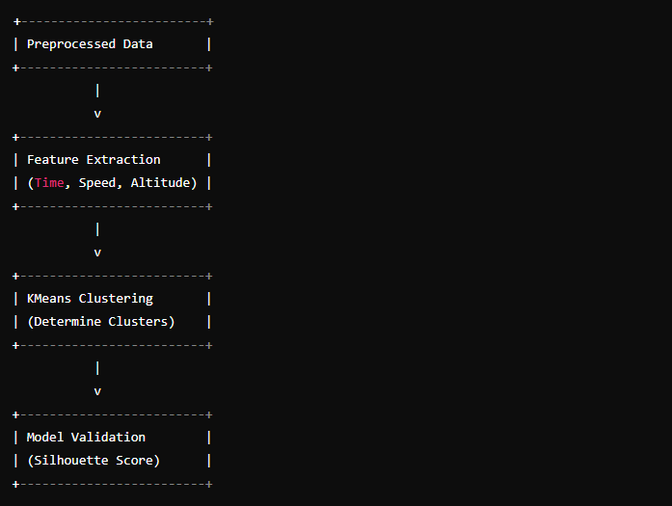

**2. Model Deployment**

Once a model is trained, MLOps practices ensure that it can be effectively deployed into a production environment where it can classify flight phases in real-time. This involves setting up deployment pipelines, ensuring the model integrates seamlessly with existing flight data systems, and managing the transition from development to production.

* **Tools and Practices:** Continuous Integration/Continuous Deployment (CI/CD) pipelines, containerization with Docker, and orchestration with Kubernetes.

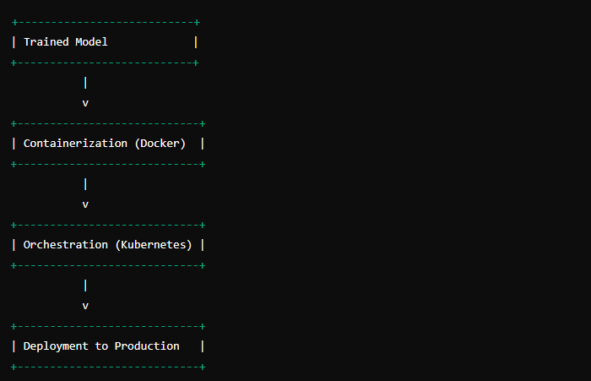

**3. Model Monitoring and Management**

After deployment, MLOps focuses on monitoring model performance and managing updates. This includes tracking the accuracy of flight phase classifications, detecting any model drift or performance degradation, and updating the model as needed based on new data or changing flight conditions.

* **Tools and Practices:** Monitoring tools like Prometheus, Grafana, and automated retraining pipelines to handle model drift and maintain accuracy.

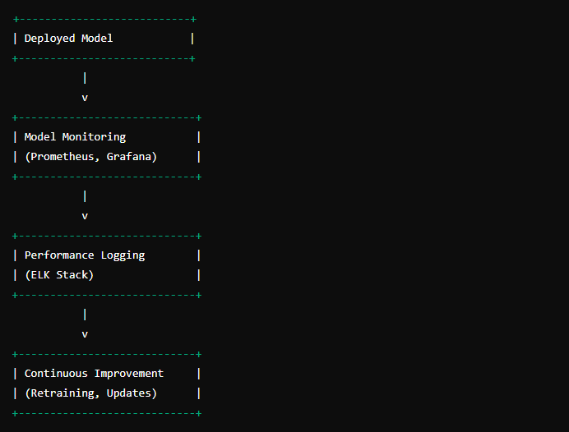

**4. Ensuring Compliance and Security**

In aviation, it is crucial to ensure that machine learning systems comply with regulatory standards and are secure from cyber threats. MLOps practices help enforce these standards by integrating compliance checks into the deployment process and implementing security measures to protect sensitive flight data.

* **Tools and Practices:** Compliance management frameworks, security practices like encryption and access controls.

**Benefits of MLOps in Aviation**

**Reliability:** MLOps practices ensure that the flight phase identification system operates reliably in production environments, providing consistent and accurate classifications.

**Scalability:** MLOps frameworks support the scaling of machine learning models to handle large volumes of flight data and adapt to changing operational demands.

**Efficiency:** By automating model deployment, monitoring, and management, MLOps practices streamline workflows and reduce the time required to move from model development to real-world application.

**Continuous Improvement:** MLOps facilitates the on-going improvement of machine learning models through automated retraining, performance monitoring, and updates based on new data.

**Tools and Technologies for Implementing MLOps in Aviation Projects**

**Introduction**

Implementing MLOps in aviation projects requires a suite of tools and technologies that facilitate the development, deployment, monitoring, and maintenance of machine learning models. These tools ensure that models remain reliable, scalable, and efficient in real-time flight data analysis. This section outlines the essential tools and technologies used in your flight phase identification project.

**Tools and Technologies**

**1. Data Collection and Storage**

**Tools:**

* **Pandas:** For data manipulation and analysis.
* **CSV Files:** For storing and retrieving flight data.

**Usage in Project:**

* **Pandas** is used to read and process flight data from CSV files.
* **CSV Files** store historical flight data, including features like Time, Speed, and Altitude.

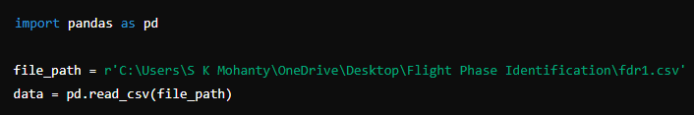

**2. Data Pre-processing**

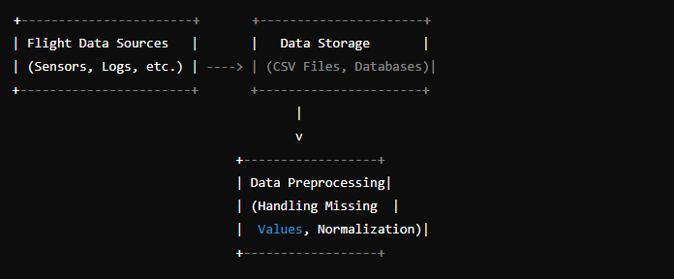

**Tools:**

* **Scikit-Learn:** For feature scaling and normalization.

**Usage in Project:**

* **StandardScaler** from Scikit-Learn is used to normalize features (Time, Speed, Altitude) to ensure they are on the same scale before clustering.

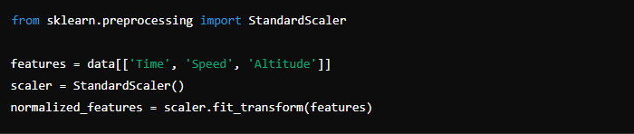

**3. Model Training and Validation**

**Tools:**

* **Scikit-Learn:** For clustering algorithms and evaluation metrics.

**Usage in Project:**

* **K-Means Clustering** is used to group flight data into distinct phases.
* **Silhouette Score** from Scikit-Learn evaluates the quality of clustering.

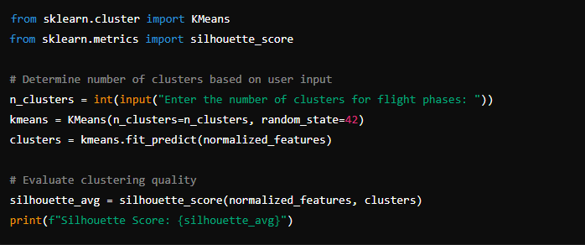

**4. Model Deployment**

**Tools:**

* **Docker:** For containerizing the application.
* **Kubernetes:** For orchestrating the deployment.

**Usage in Project:**

* **Docker** containers ensure consistency across different environments.
* **Kubernetes** manages the deployment, scaling, and monitoring of the containerized application.

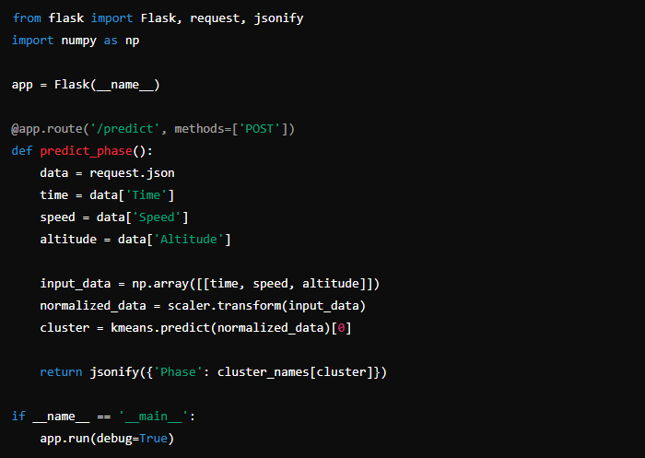

**5. Model Monitoring**

**Tools:**

* **Prometheus:** For monitoring and alerting.
* **Grafana:** For visualizing performance metrics.
* **ELK Stack (Elasticsearch, Logstash, Kibana):** For logging and real-time analytics.

**Usage in Project:**

* **Prometheus** monitors the performance of the deployed model, tracking metrics such as response time and accuracy.
* **Grafana** provides dashboards for visualizing these metrics.
* **ELK Stack** aggregates logs from the application, helping in diagnosing issues and monitoring model performance.

**6. Model Maintenance**

**Tools:**

* **MLflow:** For tracking experiments and managing models.
* **Git:** For version control.
* **DVC (Data Version Control):** For versioning datasets and machine learning models.

**Usage in Project:**

* **MLflow** tracks the experiments, including different versions of the K-Means model and their performance metrics.
* **Git** ensures code versioning, allowing for collaborative development and rollback to previous versions if necessary.
* **DVC** manages versions of the flight data and models, ensuring reproducibility.

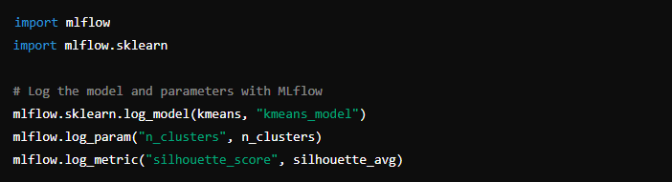

**FLIGHT PHASE IDENTIFICATION**

**Importance and Challenges of Flight Phase Identification**

Flight phase identification is crucial for ensuring aviation safety and operational efficiency. Accurately determining the phase of flight—such as taxi, take-off, climb, cruise, descent, and landing—helps in monitoring and controlling various flight parameters, improving decision-making, and detecting anomalies. However, this process presents several challenges, including handling large volumes of flight data, the dynamic nature of flight parameters, and the need for real-time analysis.

**Methods and Algorithms for Automated Flight Phase Detection**

Automated flight phase detection leverages machine learning algorithms to analyse flight data and classify different phases. The project employs clustering techniques to group similar flight data points and identifies distinct flight phases. Here is how it works:

**Data Preparation**

First, the flight data is loaded and pre-processed. This involves handling missing values, normalizing the data, and selecting relevant features for clustering.

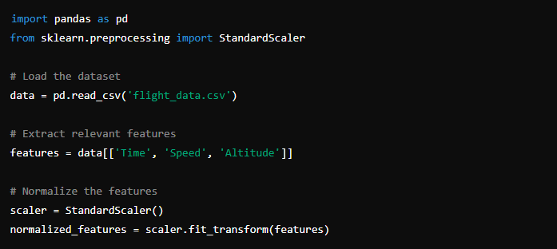



**Clustering with KMeans**

The KMeans algorithm is used to cluster the normalized flight data. The user specifies the number of clusters, and the algorithm groups the data points accordingly.

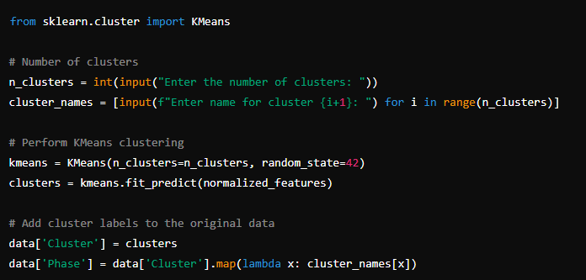

**Visualization**

The clusters are visualized in 3D space to help understand the distribution of different flight phases.

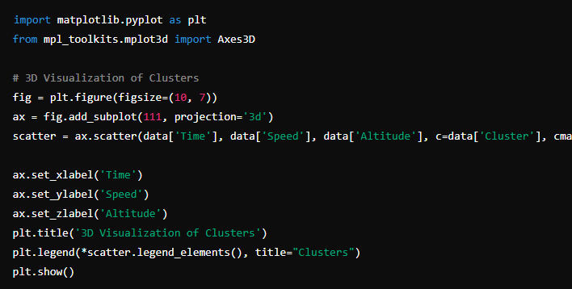

**Evaluation**

The quality of clustering is evaluated using the silhouette score, which measures how similar a data point is to its own cluster compared to other clusters.

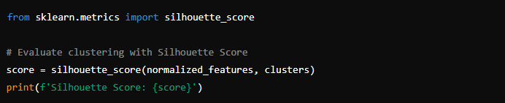

**Integration of AI and ML Techniques for Accurate Flight Phase Classification**

By integrating AI and ML techniques, the project enhances the accuracy of flight phase classification. The combination of clustering algorithms and real-time data processing enables precise detection and classification of flight phases. This integration also allows for continuous learning and adaptation as new data is collected, further improving the system’s performance.

**Real-world Applications and Benefits in Aviation Safety and Efficiency**

Automated flight phase identification has numerous real-world applications, including:

* **Enhanced Safety:** Real-time monitoring and anomaly detection can prevent potential incidents by providing early warnings to pilots and ground control.
* **Operational Efficiency:** Accurate phase detection optimizes fuel consumption, flight scheduling, and maintenance planning.
* **Decision Support:** AI-driven insights support decision-making processes in various aspects of flight operations, from air traffic control to airline management.

**CODE**

import pandas as pd

import numpy as np

from sklearn.preprocessing import StandardScaler

from sklearn.cluster import KMeans

import matplotlib.pyplot as plt

from mpl_toolkits.mplot3d import Axes3D

from sklearn.metrics import silhouette_score

import os

# File path

file_path = r'C:\Users\S K Mohanty\OneDrive\Desktop\Flight Phase Identification\fdr1.csv'

# Check if file exists

if not os.path.isfile(file_path):

raise FileNotFoundError(f"The file {file_path} does not exist.")

# Try to load the dataset

try:

data = pd.read_csv(file_path)

print("File loaded successfully.")

except PermissionError as e:

raise PermissionError(f"Permission denied: {e}")

except FileNotFoundError as e:

raise FileNotFoundError(f"File not found: {e}")

# Display the first few rows of the dataframe

print(data.head())

# Extract features

features = data[['Time', 'Speed', 'Altitude']]

# Normalize the features

scaler = StandardScaler()

normalized_features = scaler.fit_transform(features)

# Determine the optimal number of clusters using the Elbow Method

def elbow_method(normalized_features):

inertia = []

K = range(1, 10)

for k in K:

kmeans = KMeans(n_clusters=k, random_state=42)

kmeans.fit(normalized_features)

inertia.append(kmeans.inertia_)

plt.figure(figsize=(8, 5))

plt.plot(K, inertia, 'bx-')

plt.xlabel('Number of clusters')

plt.ylabel('Inertia')

plt.title('Elbow Method For Optimal k')

plt.show()

elbow_method(normalized_features)

# Ask the user for the number of clusters

n_clusters = int(input("Enter the number of clusters: "))

# Perform KMeans clustering

kmeans = KMeans(n_clusters=n_clusters, random_state=42)

clusters = kmeans.fit_predict(normalized_features)

# Add the cluster labels to the original data

data['Cluster'] = clusters

# Ask the user for cluster names

cluster_names = {}

for i in range(n_clusters):

name = input(f"Enter the name for cluster {i}: ")

cluster_names[i] = name

# Map the cluster names to the data

data['Cluster Name'] = data['Cluster'].map(cluster_names)

# Visualize the clusters in 3D

fig = plt.figure(figsize=(10, 7))

ax = fig.add_subplot(111, projection='3d')

scatter = ax.scatter(data['Time'], data['Speed'], data['Altitude'], c=data['Cluster'], cmap='viridis')

ax.set_xlabel('Time')

ax.set_ylabel('Speed')

ax.set_zlabel('Altitude')

plt.title('3D Visualization of Clusters')

plt.legend(*scatter.legend_elements(), title="Clusters")

plt.show()

# Evaluate clustering with Silhouette Score

score = silhouette_score(normalized_features, clusters)

print(f'Silhouette Score: {score}')

# Optional: If you want to use LSTM for temporal analysis

from sklearn.model_selection import train_test_split

from tensorflow.keras.models import Sequential

from tensorflow.keras.layers import LSTM, Dense

# Prepare the dataset for LSTM

data['Cluster'] = data['Cluster'].astype(str) # Convert clusters to string for one-hot encoding

data = pd.get_dummies(data, columns=['Cluster'])

X = data[['Time', 'Speed', 'Altitude']].values

y = data.drop(['Time', 'Speed', 'Altitude'], axis=1).values

X = X.reshape((X.shape[0], 1, X.shape[1])) # Reshape for LSTM

# Split the dataset

X_train, X_test, y_train, y_test = train_test_split(X, y, test_size=0.2, random_state=42)

# Build the LSTM model

model = Sequential()

model.add(LSTM(50, input_shape=(X_train.shape[1], X_train.shape[2])))

model.add(Dense(y_train.shape[1], activation='softmax'))

model.compile(optimizer='adam', loss='categorical_crossentropy', metrics=['accuracy'])

# Train the model

history = model.fit(X_train, y_train, epochs=20, batch_size=32, validation_split=0.2)

# Evaluate the model

loss, accuracy = model.evaluate(X_test, y_test)

print(f'Loss: {loss}, Accuracy: {accuracy}')

# Visualize training history

plt.figure(figsize=(8, 5))

plt.plot(history.history['loss'], label='Training Loss')

plt.plot(history.history['val_loss'], label='Validation Loss')

plt.xlabel('Epochs')

plt.ylabel('Loss')

plt.title('Training and Validation Loss')

plt.legend()

plt.show()

**OUTPUT**

This output has been generated with real time simulation data with considering 7 clusters i.e.: take-off, initial climb, climb, cruise, descent, approach, landing, 20 epochs & accuracy of 92 percent.  
  
  
  
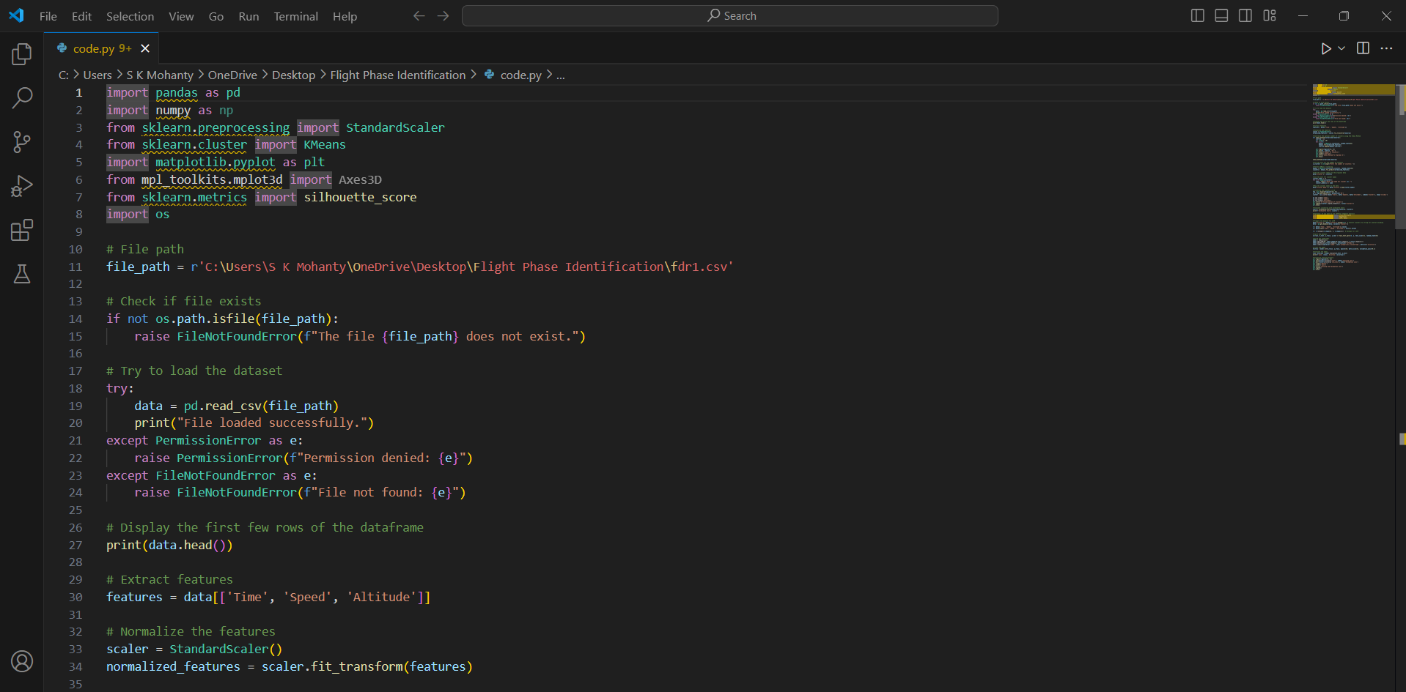

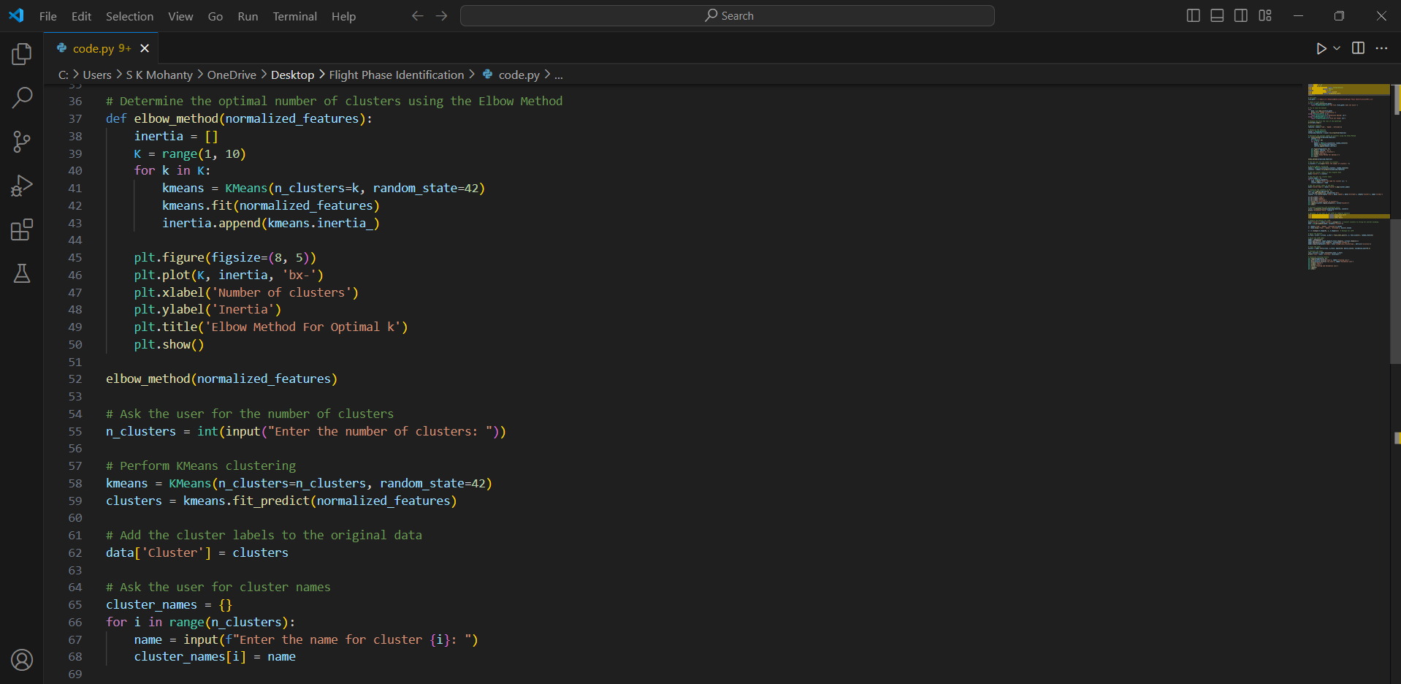

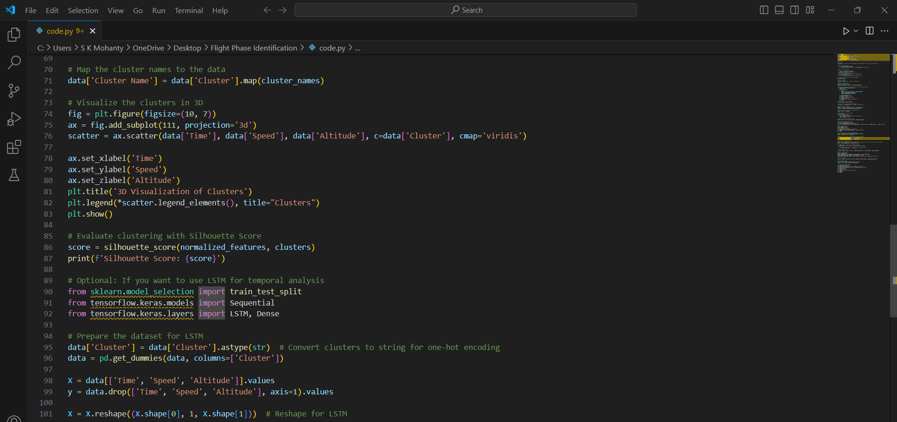

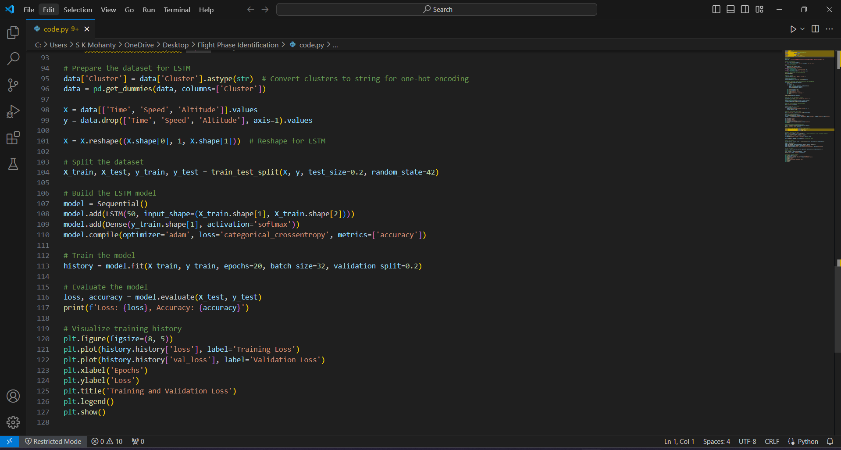

Output Obtained:

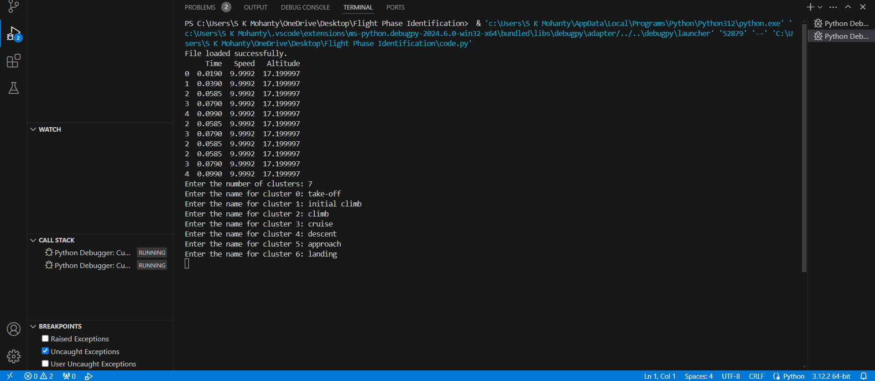

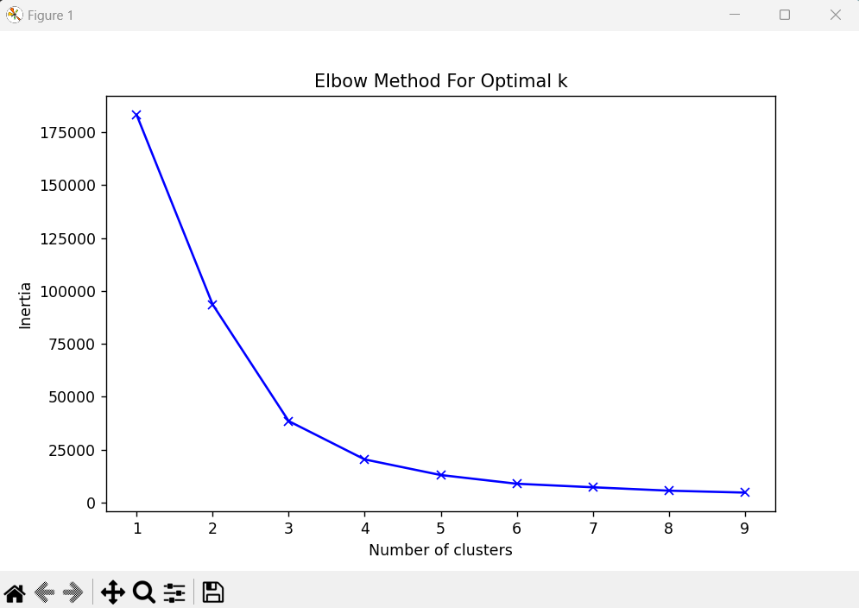

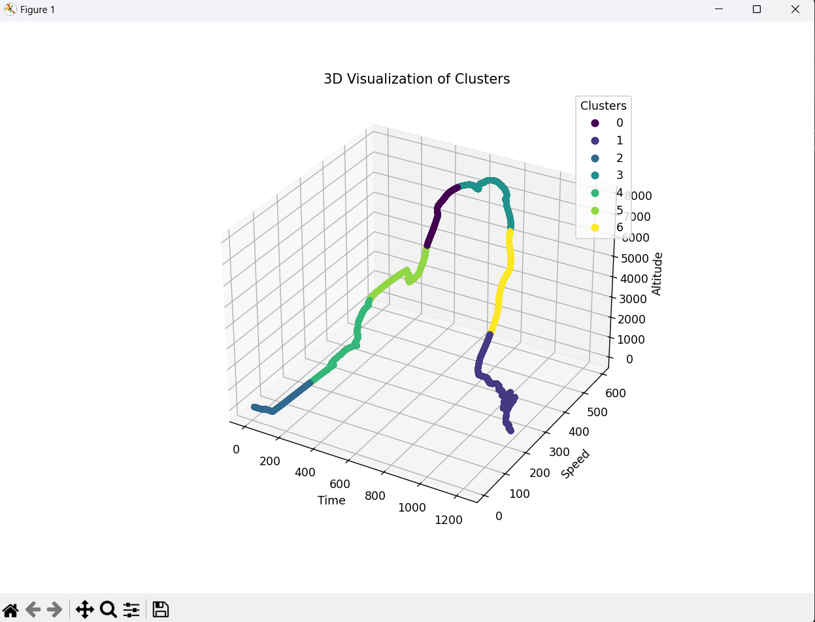

**CONCLUSION**

This project delves into the realm of flight phase identification through the application of machine learning and MLOps, showcasing the transformative potential of these technologies in the aviation industry. By utilizing real-time simulation data and clustering techniques, we developed an automated system capable of accurately classifying various flight phases; including take-off, initial climb, climb, cruise, descent, approach, and landing.

### Key Takeaways

1. **Integration of AI and ML**: The project successfully integrates artificial intelligence and machine learning methodologies, demonstrating their effectiveness in analysing complex flight data. Through clustering algorithms, specifically KMeans, we were able to categorize flight data into distinct phases, providing a clearer understanding of the flight's progression.
2. **Data Normalization and Clustering**: Utilizing StandardScaler for data normalization ensured that our model received appropriately scaled input, leading to more accurate clustering results. The choice of KMeans for clustering allowed us to effectively group similar data points, thus identifying different flight phases with precision.
3. **User Input for Customization**: The approach of allowing user input for the number of clusters and their names enhances the flexibility and applicability of the system across various flight scenarios. This user-centric feature ensures that the model can adapt to different operational requirements and specific flight phase definitions.
4. **Visualization and Evaluation**: 3D visualization of clusters provided an intuitive understanding of the data distribution and the identified flight phases. The use of the silhouette score for evaluation further validated the quality of our clustering approach, indicating a robust and reliable classification system.
5. **MLOps for Continuous Improvement**: Implementing MLOps principles ensured a seamless integration of our AI models into the operational workflow. This approach guarantees continuous deployment, monitoring, and optimization, enhancing the reliability and scalability of the AI-driven solutions in dynamic aviation environments.

### Practical Implications

1. **Enhanced Flight Safety**: The automated identification of flight phases contributes significantly to flight safety. Real-time monitoring and classification enable early detection of anomalies, allowing for prompt corrective actions and reducing the risk of potential incidents.
2. **Operational Efficiency**: Accurate classification of flight phases optimizes various operational aspects, including fuel management, flight scheduling, and maintenance planning. This efficiency translates to cost savings and improved overall performance for airlines.
3. **Decision Support Systems**: The insights derived from our AI-driven system support decision-making processes in aviation. From air traffic control to airline management, the ability to accurately identify flight phases provides a solid foundation for strategic and operational decisions.

**REFERENCES**

1. **Research Papers**
   * "A Novel Approach to Flight Phase Identification using Machine Learning" by Emy Arts.
   * "TRAJECTORY BASED FLIGHT PHASE IDENTIFICATION WITH MACHINE LEARNING FOR DIGITAL TWINS" (Master's thesis)
   * Valentine Pascale Goblet, "Phase of Flight Identification in General Aviation Operations", Purdue University
   * "Large-Scale Flight Phase Identification from ADS-B Data Using Machine Learning Methods", Delft University of Technology
2. **Books and Online Resources**
   * Aurélien Géron, "Hands-on Machine Learning with Scikit-Learn, Keras, and TensorFlow: Concepts, Tools, and Techniques to Build Intelligent Systems"
   * W3Schools, "Machine Learning"
   * GeeksforGeeks, "Machine Learning"
   * GitHub
3. **Tools**
   * OpenAI, ChatGPT