**Supplementary Material 2** SEM-EDS Data for Indian KPB sites

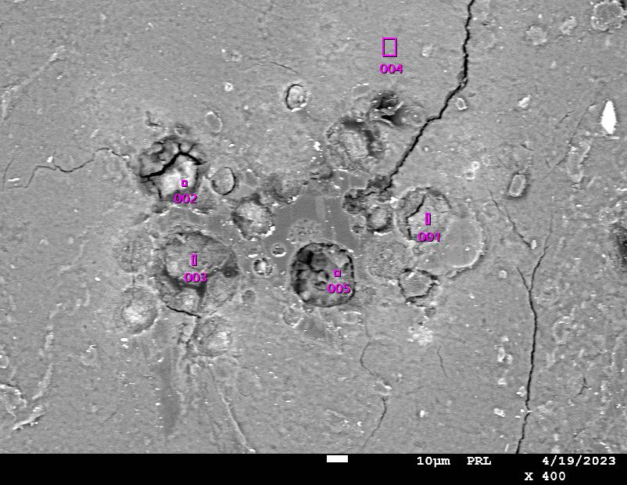**SGA-1**

|  |  |  |  |  |  |  |
| --- | --- | --- | --- | --- | --- | --- |
| Formula | mass% | mol% | Cation | Sigma | K ratio | Line |
| O |  |  |  |  |  |  |
| Al2O3 | 47.11 | 36.35 | 8.46 | 0.06 | 2.171165 | K |
| SiO2 | 25.69 | 33.64 | 3.91 | 0.06 | 0.986653 | K |
| K2O | 0.43 | 0.36 | 0.08 | 0.01 | 0.038755 | K |
| CaO | 1.08 | 1.51 | 0.18 | 0.02 | 0.091427 | K |
| FeO | 25.7 | 28.14 | 3.27 | 0.05 | 2.061164 | K |
| Total | 100 | 100 | 15.9 |  |  |  |

|  |  |  |  |  |  |  |
| --- | --- | --- | --- | --- | --- | --- |
| Formula | mass% | mol% | Cation | Sigma | K ratio | Line |
| C | 0.68 | 3.71 | 0 | 0 | 0.001164 | K |
| O |  |  |  |  |  |  |
| Al2O3 | 10 | 6.43 | 1.94 | 0.05 | 0.143305 | K |
| SiO2 | 45.8 | 49.95 | 7.54 | 0.11 | 0.650299 | K |
| K2O | 0.34 | 0.24 | 0.07 | 0.02 | 0.010406 | K |
| CaO | 1.1 | 1.28 | 0.19 | 0.03 | 0.031365 | K |
| FeO | 42.08 | 38.39 | 5.79 | 0.13 | 1.13604 | K |
| Total | 100 | 100 | 15.53 |  |  |  |

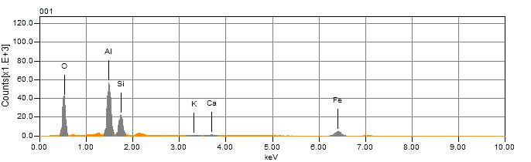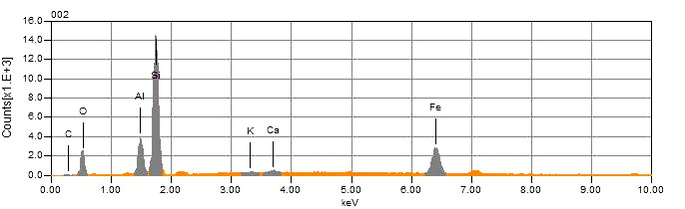

**ALMANDINE**

**CHLORITOID**

|  |  |  |
| --- | --- | --- |
| Element | Weight % | Atomic % |
| C K | 2.60 | 5.83 |
| N K | 1.00 | 1.92 |
| O K | 35.53 | 59.85 |
| MgK | 0.89 | 0.98 |
| TiK | 30.96 | 17.42 |
| FeK | 28.54 | 13.77 |
| CoK | 0.49 | 0.23 |

|  |  |  |
| --- | --- | --- |
| Element | Weight % | Atomic % |
| C K | 3.21 | 5.29 |
| O K | 50.75 | 62.81 |
| SiK | 44.88 | 31.65 |
| NbL | 1.16 | 0.25 |

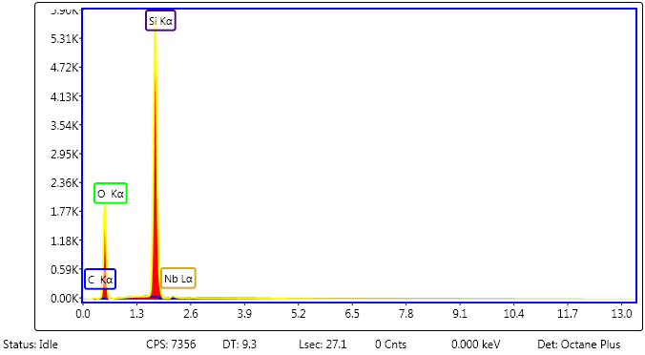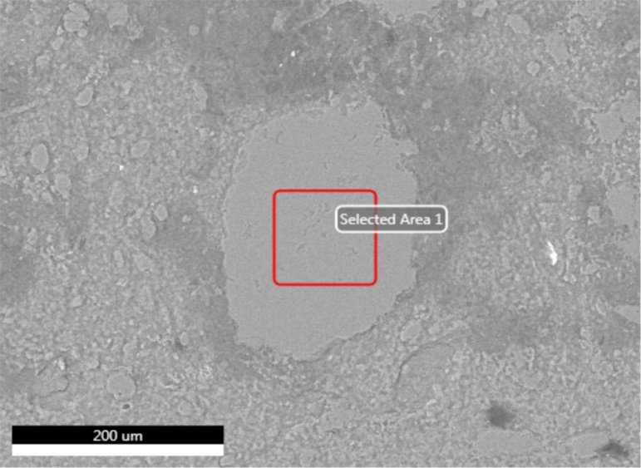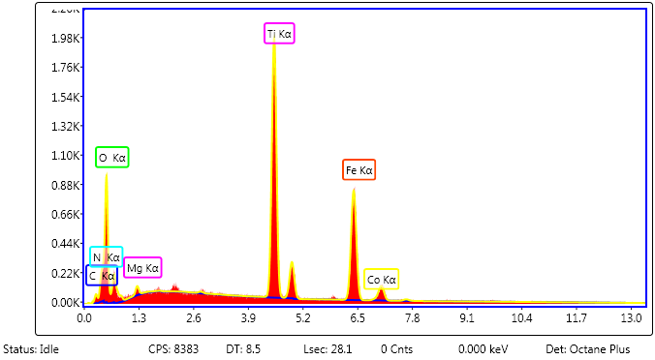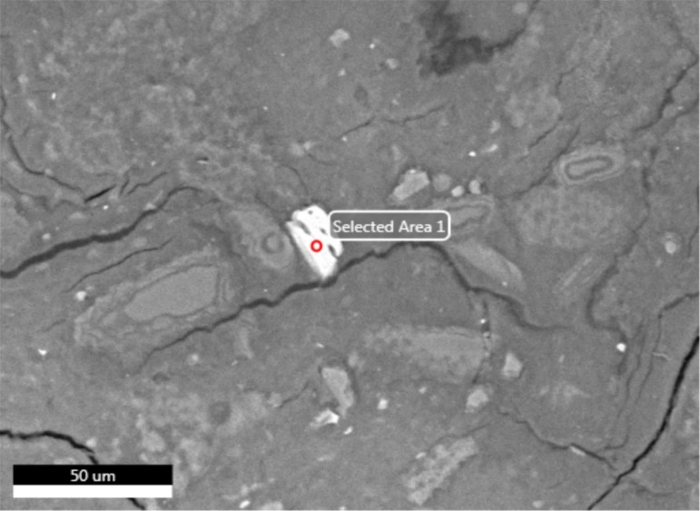

**QUARTZ**

**ILMENITE**

|  |  |  |
| --- | --- | --- |
| lement | Weight % | Atomic % |
| N K | 2.78 | 5.07 |
| O K | 41 | 65.48 |
| NbL | 1.71 | 0.47 |
| TiK | 53.19 | 28.37 |
| FeK | 1.33 | 0.61 |

|  |  |  |
| --- | --- | --- |
| Element | Weight % | Atomic % |
| Si O2 | 37.75 | 55.43 |
| Zr O2 | 62.25 | 44.57 |

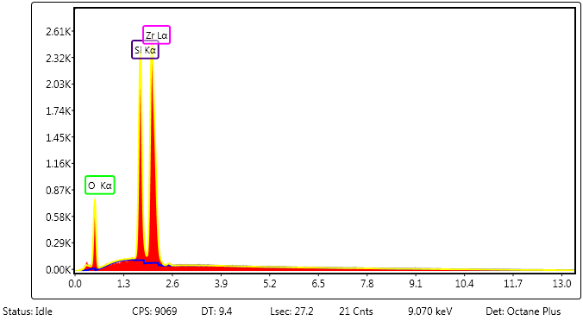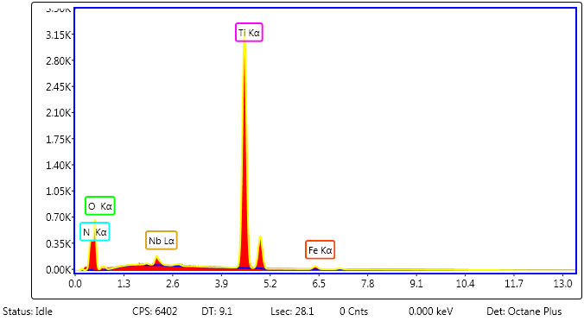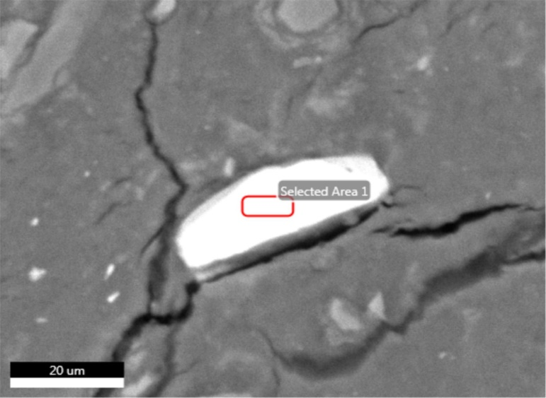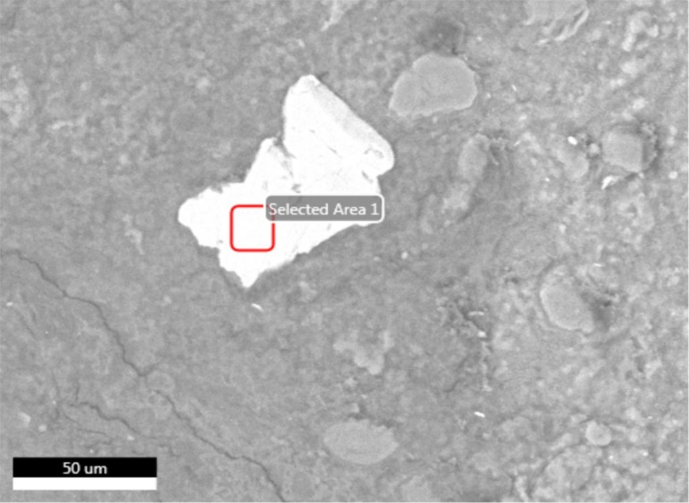**SGA-9**

**ZIRCON**

**RUTILE**

**ILMENITE**

|  |  |  |
| --- | --- | --- |
| Element | Weight % | Atomic % |
| C K | 7.80 | 17.70 |
| O K | 28.19 | 48.04 |
| MgK | 0.98 | 1.10 |
| TiK | 29.35 | 16.71 |
| MnK | 1.27 | 0.63 |
| FeK | 32.06 | 15.65 |
| CoK | 0.36 | 0.17 |

|  |  |  |
| --- | --- | --- |
| Element | Weight % | Atomic % |
| O K | 46.23 | 61.01 |
| MgK | 0.85 | 0.74 |
| AlK | 0.83 | 0.65 |
| SiK | 48.81 | 36.70 |
| FeK | 1.05 | 0.40 |
| NbL | 2.22 | 0.50 |

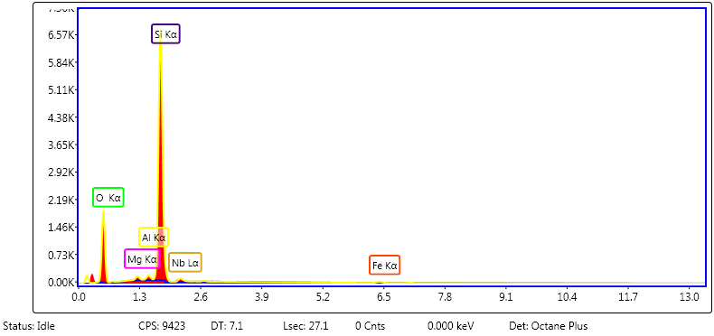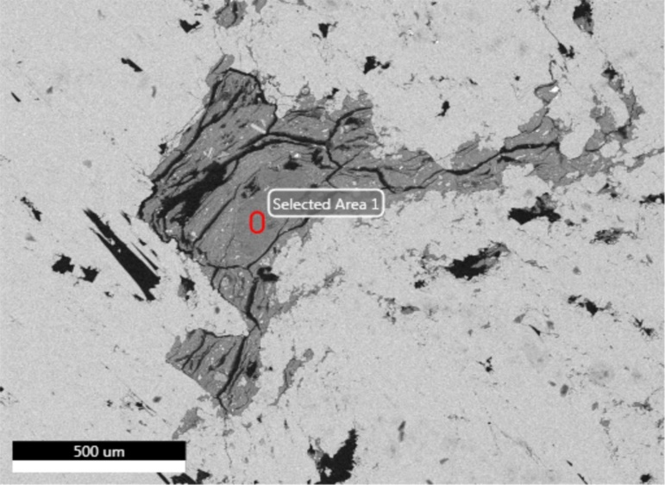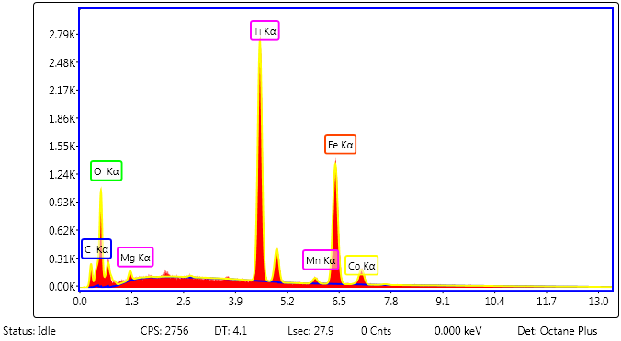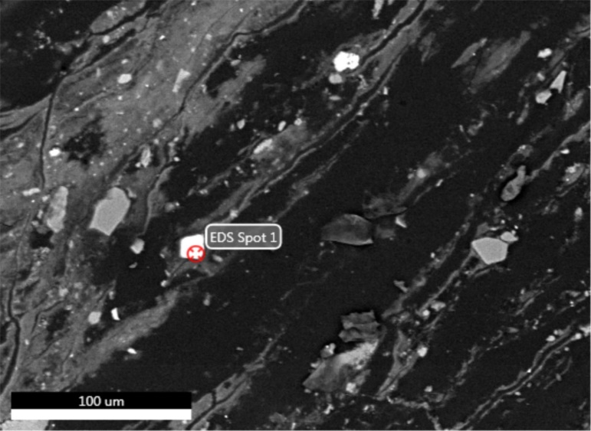

**QUARTZ**

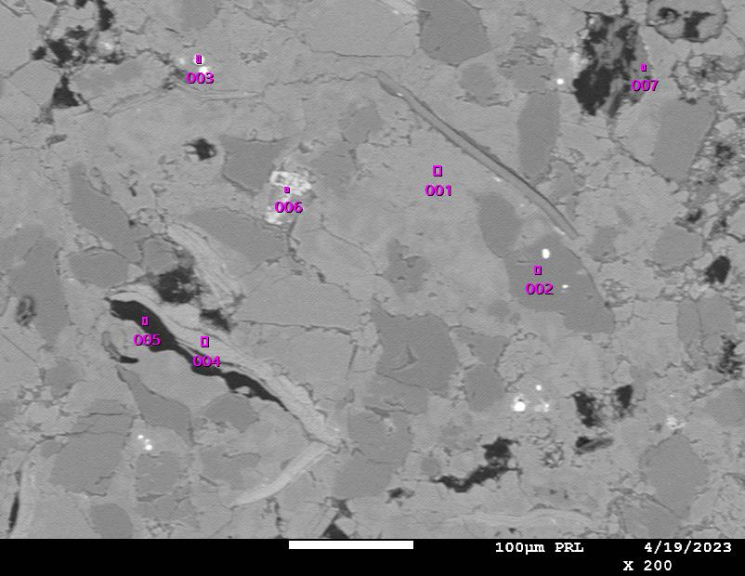**SGA-3**

|  |  |  |  |  |  |  |
| --- | --- | --- | --- | --- | --- | --- |
| Formula | mass% | mol% | Cation | Sigma | K ratio | Line |
| O |  |  |  |  |  |  |
| Na2O | 12.38 | 13.1 | 3.16 | 0.02 | 1.036091 | K |
| Al2O3 | 19.76 | 12.72 | 3.07 | 0.03 | 1.251015 | K |
| SiO2 | 67.29 | 73.5 | 8.87 | 0.07 | 3.860196 | K |
| CaO | 0.58 | 0.68 | 0.08 | 0.01 | 0.062598 | K |
| Total | 100 | 100 | 15.18 |  |  |  |

|  |  |  |  |  |  |  |
| --- | --- | --- | --- | --- | --- | --- |
| Formula | mass% | mol% | Cation | Sigma | K ratio | Line |
| O |  |  |  |  |  |  |
| Al2O3 | 38.54 | 27.33 | 5.95 | 0.05 | 2.047476 | K |
| SiO2 | 54.74 | 65.89 | 7.17 | 0.07 | 2.40573 | K |
| K2O | 0.64 | 0.49 | 0.11 | 0.01 | 0.060382 | K |
| CaO | 0.61 | 0.79 | 0.09 | 0.01 | 0.053522 | K |
| FeO | 5.46 | 5.5 | 0.6 | 0.03 | 0.455585 | K |
| Total | 100 | 100 | 13.91 |  |  |  |

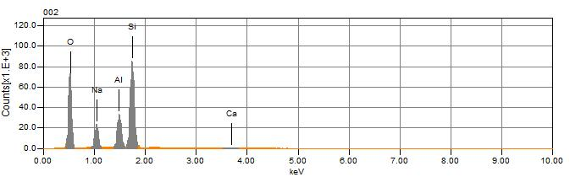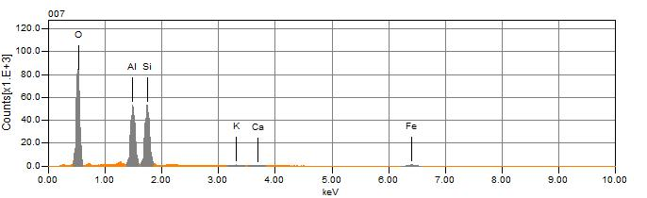

**KAOLINITE**

**ALBITE**

|  |  |  |  |  |  |  |
| --- | --- | --- | --- | --- | --- | --- |
| Formula | mass% | mol% | Cation | Sigma | K ratio | Line |
| C | 1.91 | 13.17 | 0 | 0.01 | 0.009192 | K |
| O |  |  |  |  |  |  |
| SiO2 | 29.59 | 40.79 | 5.64 | 0.05 | 2.060631 | K |
| ZrO2 | 68.5 | 46.04 | 6.36 | 0.09 | 5.719969 | L |
| Total | 100 | 100 | 12 |  |  |  |

|  |  |  |  |  |  |  |
| --- | --- | --- | --- | --- | --- | --- |
| Formula | mass% | mol% | Cation | Sigma | K ratio | Line |
| C | 2.2 | 8.49 | 0 | 0 | 0.020198 | K |
| O |  |  |  |  |  |  |
| F | 18.2 | 44.43 | 0 | 0.08 | 0.530347 | K |
| Na2O | 0.27 | 0.2 | 0.1 | 0.01 | 0.019566 | K |
| P2O5 | 37.4 | 12.22 | 6.11 | 0.04 | 2.314721 | K |
| CaO | 41.93 | 34.67 | 8.67 | 0.04 | 5.124326 | K |
| Total | 100 | 100 | 14.88 |  |  |  |

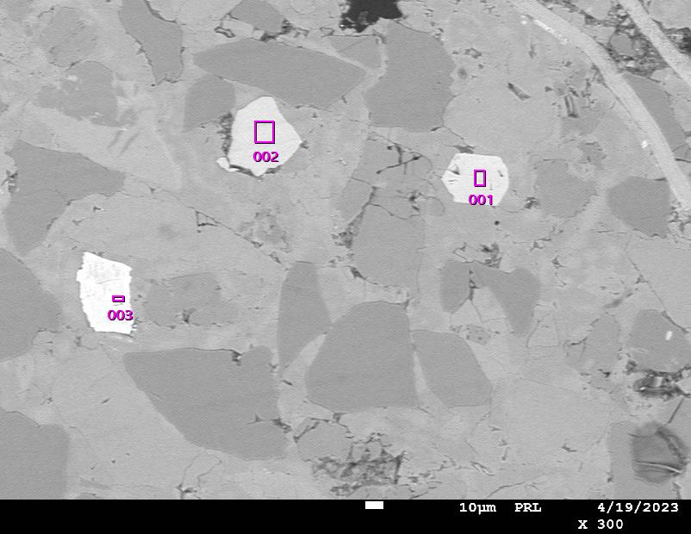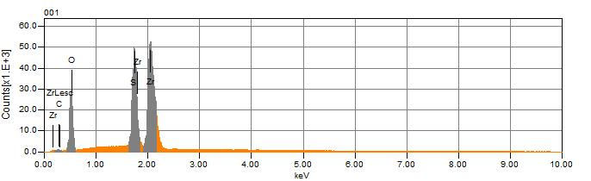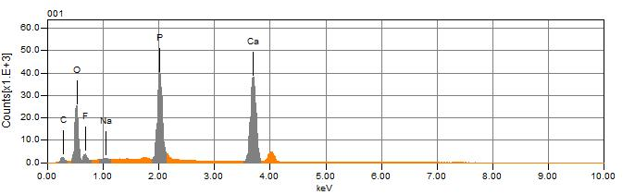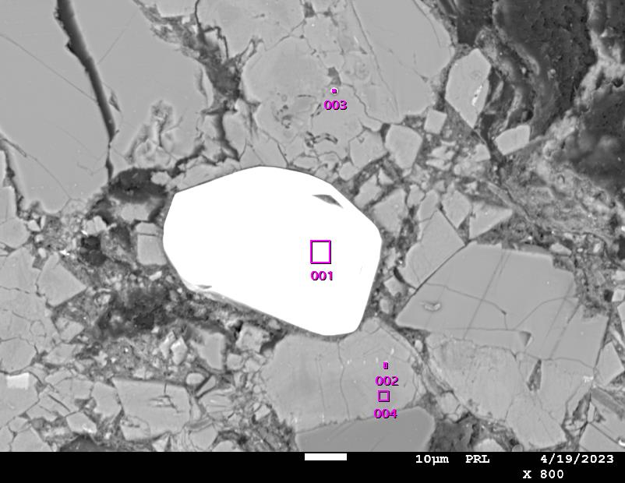

**ZIRCON**

**SPODIOSITE**

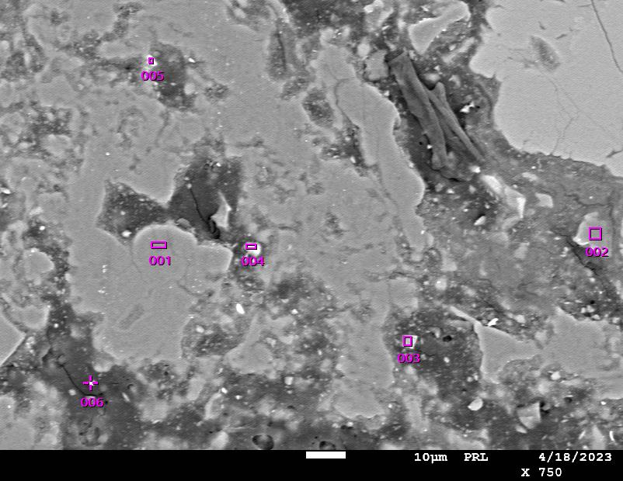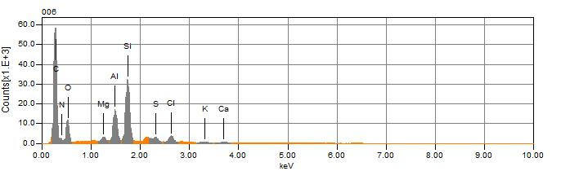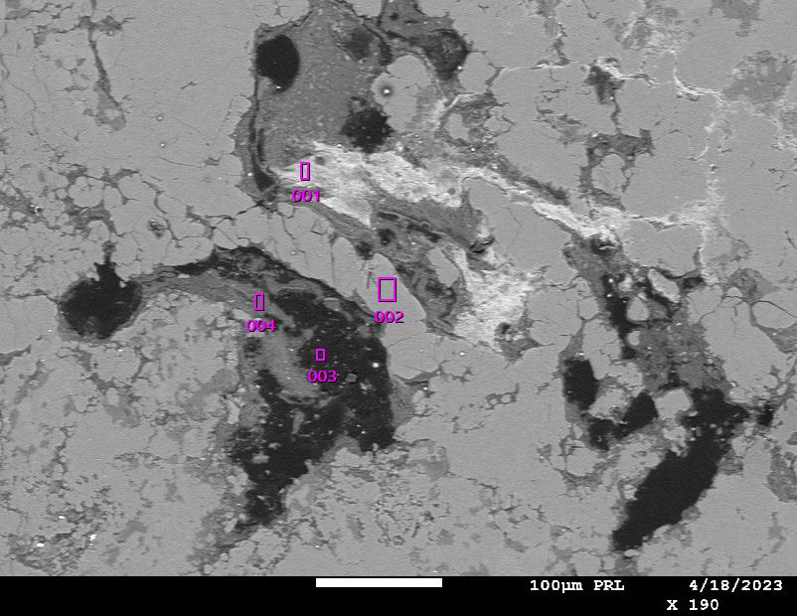

**SGA-17**

**ALMANDINE**

|  |  |  |  |  |  |  |
| --- | --- | --- | --- | --- | --- | --- |
| Formula | mass% | mol% | Cation | Sigma | K ratio | Line |
| C | 23.38 | 63.81 | 0 | 0.01 | 0.179215 | K |
| O |  |  |  |  |  |  |
| Al2O3 | 12.1 | 3.89 | 3.31 | 0.03 | 0.63707 | K |
| SiO2 | 24.47 | 13.35 | 5.68 | 0.05 | 1.258083 | K |
| Cl | 0.95 | 0.88 | 0 | 0.01 | 0.120004 | K |
| CaO | 1.81 | 1.06 | 0.45 | 0.02 | 0.187596 | K |
| FeO | 37.29 | 17.02 | 7.24 | 0.06 | 3.594987 | K |
| Total | 100 | 100 | 16.67 |  |  |  |

|  |  |  |  |  |  |  |
| --- | --- | --- | --- | --- | --- | --- |
| Formula | mass% | mol% | Cation | Sigma | K ratio | Line |
| C | 6.37 | 27.01 | 0 | 0.01 | 0.040562 | K |
| O |  |  |  |  |  |  |
| Na2O | 0.57 | 0.47 | 0.22 | 0.02 | 0.027168 | K |
| MgO | 4.98 | 6.29 | 1.44 | 0.02 | 0.206565 | K |
| Al2O3 | 6.41 | 3.2 | 1.47 | 0.03 | 0.277417 | K |
| SiO2 | 29.8 | 25.25 | 5.79 | 0.06 | 1.308738 | K |
| K2O | 0.57 | 0.31 | 0.14 | 0.01 | 0.05518 | K |
| CaO | 3.45 | 3.13 | 0.72 | 0.02 | 0.308831 | K |
| MnO | 47.86 | 34.35 | 7.88 | 0.07 | 3.895063 | K |
| Total | 100 | 100 | 17.65 |  |  |  |

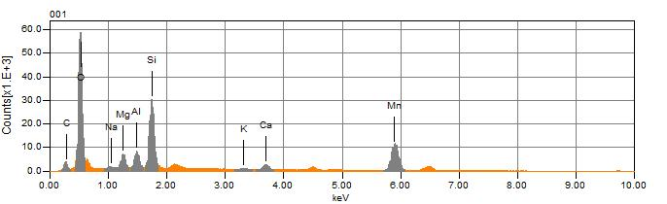**SMU-LT**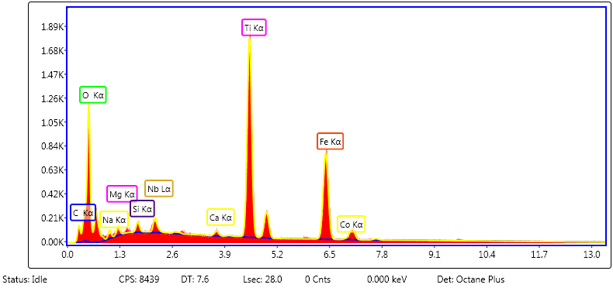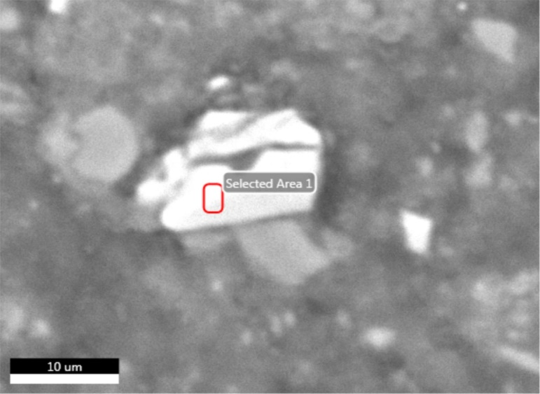

**TEPHROITE**

**PSEUDORUTILE**

|  |  |  |
| --- | --- | --- |
| Element | Weight % | Atomic % |
| C K | 2.6 | 5.83 |
| N K | 1 | 1.92 |
| O K | 35.53 | 59.85 |
| MgK | 0.89 | 0.98 |
| TiK | 30.96 | 17.42 |
| FeK | 28.54 | 13.77 |
| CoK | 0.49 | 0.23 |

|  |  |  |
| --- | --- | --- |
| Element | Weight % | Atomic % |
| Si O2 | 37.20 | 54.85 |
| Zr O2 | 62.80 | 45.15 |

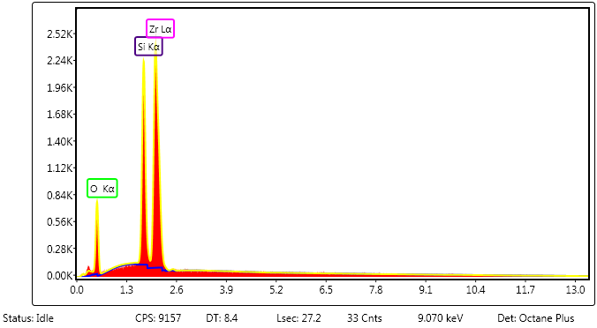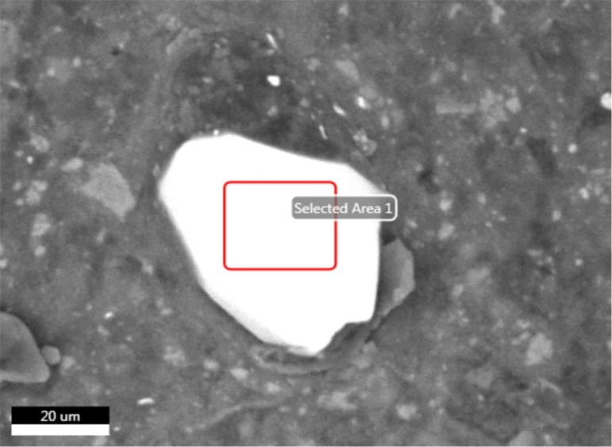

**ZIRCON**