**SOLAR POWER BANK**

**BASIC ELECTRICAL ENGINEERING LAB PROJECT**

**GROUP IV**

**SECTION: K**

**FIRST YEAR**

**FIRST SEMESTER**

Name : Subham Kumar

Enrollment No. : 12022002013007

Roll No. : 46

**Members:**

Subham Kumar (46)

Dipanjan Nath (48)

Sanchari Chatterjee (49)

Ahana Mukherjee (50)

Debarati Nandi (51)

Prottus Manna (52)

Raj Bhowmik (53)

Aryan Banerjee (54)

Archisman Jha (55)

Rayan Paul (56)

Priyanshu Pathak (57)

Pinaki Dutta (58)

Swetasree Chattoraj (59)

Ayan Jana (60)

Avigyan Kulari (61)

Sumit Paul (63)

Sayan Chakraborty (64)

Moupiya Bose (65)

Unmisa Das (66)

Satish Kumar (67)

Akash Pandey (68)

Priyanjan Paul (69)

Souvonik Basu (70)

Priyam Mukhopadhayay (71)

Sonali Saha (72)

Ayush Kumar (73), Prabhat Kumar (74)

**ACKNOWLEDGEMENT**

We would like to thank STR sir, our Professor-in-charge and our HOD, PKD sir for their support and guidance in completing our Basic Electrical Engineering(BEE) Project. It was one of the best learning experience. It enhanced our understanding of Electrical components, soldering (the wires on the board), and about the uses of solar panels as a means to generate and store electrical energy.

It was a team effort in making this project a reality, so I would like to thank each and every member of this group for their inputs and hard work.

**INTRODUCTION**

A Solar Power Bank is a type of electrical energy storing device which can recharge the batteries within it using solar energy. The 4 3V solar panels convert solar energy into electrical energy which is then converted into 5V DC and recharges the 3 18650 Li-ion batteries through a 18650 battery charger module which has a protection circuit built in it.

This power bank works on the principle of conversion of Solar energy into electrical energy using solar panels.

**MATERIALS REQUIRED**

* Li-ion Batteries (x3)

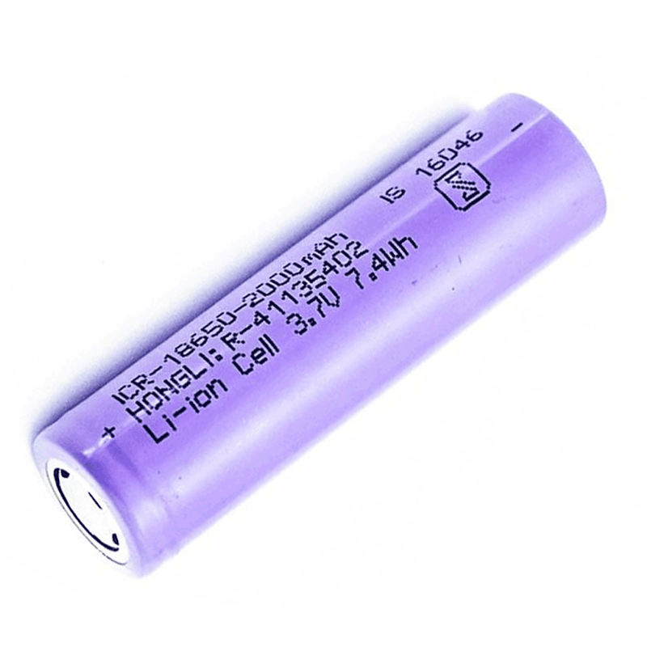

* 3V Solar Panels (x4)

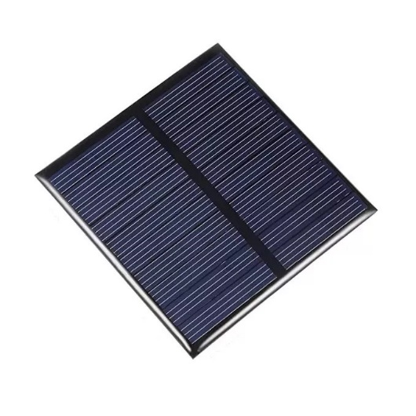

* DC-DC Boost Module (0.9V~5V) to 5V

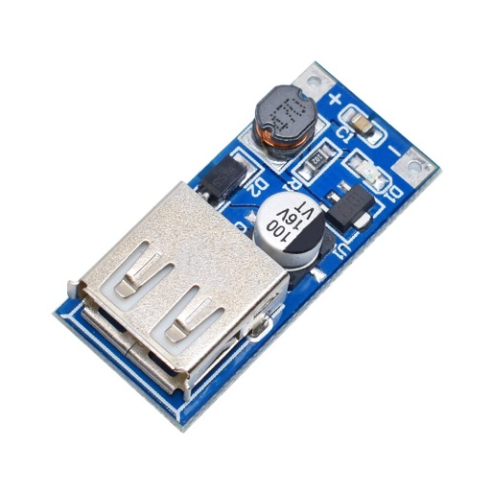

* Connecting Wires

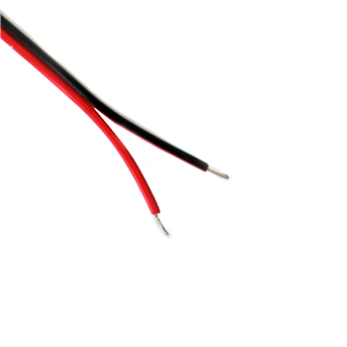

* 18650 Battery Charging Module

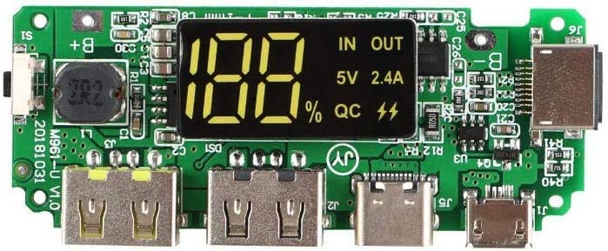

* 3x 18650 Battery holder

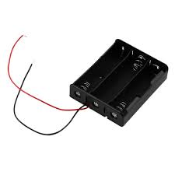

**PROCEDURE**

* This project works on the principle of conversion of Solar Energy into Electrical Energy using solar panels. The solar panels when kept under sun generate electricity which can be stored in batteries after converting the electrical energy to DC.
* This project has two parts I & II.
* We connect the positive end of the battery case to the positive terminal of 18650 Battery charging Module and the negative end of the battery case to the negative terminal of the charging module. This concludes the making of Part I.
* We connect the 4 solar panels in a parallel arrangement. Then we connect the positive end of the arrangement to positive terminal of 5V DC-DC boost module and connect the negative end of the arrangement to the negative terminal of the module. This concludes the making of Part II.
* Now on a sunny day we take our Part II and keep it anywhere under the sun so that the solar panels receive sunlight without any obstruction. We connect a USB cable to the 5V DC-DC boost module and connect it with 18650 charging module through the Type-B part of the USB cable.
* The batteries will be charged in some time. Then we connect any electronic device with the 18650 charging module using a USB cable and charge that device. The Power Bank ideally holds 6000mAH electrical energy.

**CIRCUIT DIAGRAM**

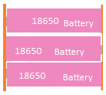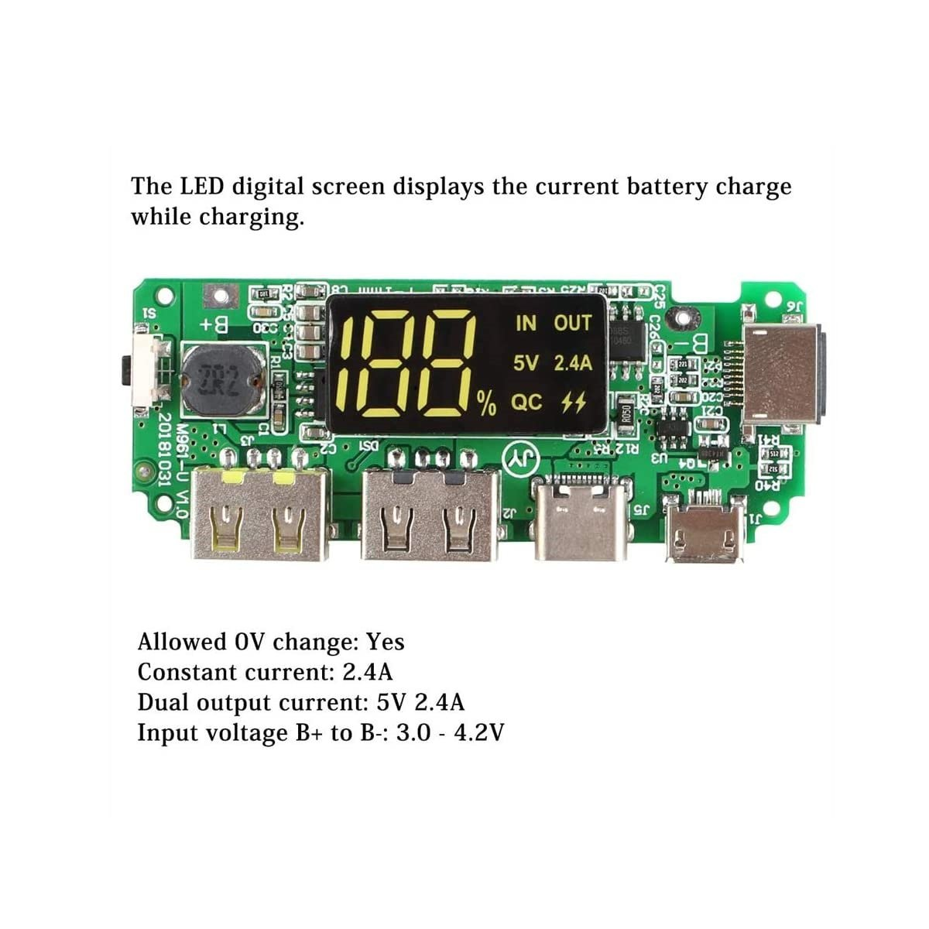



**Part-I**

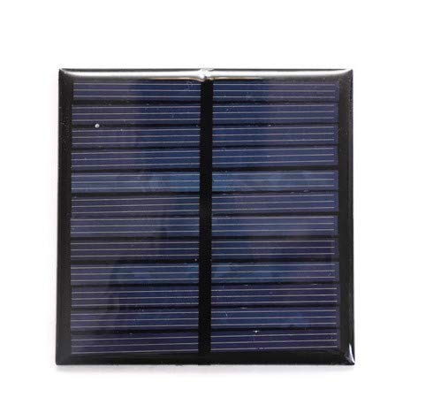



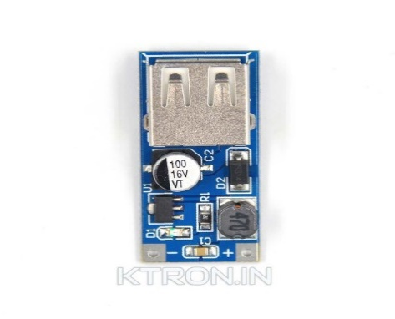



**Part-II**



**APPLICATIONS**

In today’s life people carry a lot of electronic devices with them and keeping them charged can be a headache sometimes. Hence this solar power bank which uses the simple concept of energy conversion and helps to keep our electronic devices charged on the go. This is a very efficient way of charging your devices at a very economic pricing. The best part of this design is that we can just carry the charged battery pack with us anywhere and it is smaller than most of the power banks available in the market.