Final Project Report
Kidicode

Version 1.0



Group Id: S25PROJECTEA754
Student Name VUID BC190402729
Supervisor Name: Abdullah Qamar


CERTIFICATE

This is to certify that (BC190402729) have worked on and completed their Software Project at Software & Research Projects Section, Department of Computer Sciences, Virtual University of Pakistan in partial fulfillment of the requirement for the degree of BS in Computer Sciences under my guidance and supervision.

In our opinion, it is satisfactory and up to the mark and therefore fulfills the requirements of BS in Computer Sciences.

Supervisor / Internal Examiner

Abdullah Qamar
Supervisor,
Software Projects & Research Section,
Department of Computer Sciences
Virtual University of Pakistan

___________________
(Signature)

External Examiner/Subject Specialist
<<External Supervisor Name>>

___________________
(Signature)

Accepted By:

_____________
(For office use)

EXORDIUM

In the name of Allah, the Compassionate, the Merciful.

Praise be to Allah, Lord of Creation,
The Compassionate, the Merciful,
King of Judgment-day!

You alone we worship, and to You alone we pray for help,
Guide us to the straight path

The path of those who You have favored,

Not of those who have incurred Your wrath,
Nor of those who have gone astray.

DEDICATION

I dedicate this project to God Almighty my creator, my strong pillar, my source of inspiration, wisdom, knowledge and understanding. He has been the source of my strength throughout this program and on His wings only have I soared. I also dedicate this work to my Parents who has encouraged me all the way and whose encouragement has made sure that I give it all it takes to finish that which I have started. Thank you.
I also want to thanks to my teachers who guide me and my supervisor Abdullah Qamar who was very nice Teacher.

ACKNOWLEDGEMENT

Foremost, I would like to express my sincere gratitude to my advisor << Abdullah Qamar >> for the continuous support for my project development for his patience, motivation, enthusiasm, and immense knowledge. His guidance helped me in all the time of Development and writing of this document. I could not have imagined having a better advisor and mentor for my Project development.

PREFACE

The successful completion of this project was a unique experience for me because interacting various teachers I achieved a better knowledge about Kidicode The experience which I gained by doing this project was essential at this turning point of my career this project is being submitted which content detailed analysis of the project undertaken by me. The project provides an opportunity for a student to devote her skills knowledge and competence required during the technical session.

TABLE OF CONTENTS
CHAPTER NO .1 8
1 Introduction 8
1.1 Use Case Diagram 9
1.2 Usage Scenarios 9
1.3 Adopted Methodology 9
1.4 Work Plan 9
2 Scope of Project: 10
2.1 Definitions, Acronyms, and Abbreviations 10
3 Functional and non-Functional Requirements: 11
3.1 Functional Requirements: 11
3.2 Non-Functional Requirements 13
4 Use Case Diagram(s): 13
5 Usage Scenarios: 14
6 Adopted Methodology 37
6.1 The waterfall models 37
6.2 The spiral model 37
6.3 VU Process Model 38
6.4 Reasons for choosing the Methodology 39
7 Work Plan (Use MS Project to create Schedule/Work Plan) 39
7.1 Work Plan 39
7.2 Team structure: 40
7.3 Detailed Project Schedule: 40
7.4 Time Line Chart 41
CHAPTER NO. 2 41
1 Introduction of Design Document 42
Entity Relationship Diagram: 42
Sequence Diagram 42
Architecture Design Diagram: 42
Class Diagram: 42
Database Design: 42
Interface Design: 43
Test cases: 43
2 Entity Relationship Diagram (ERD) 44
3. Sequence Diagrams 45
Login 45
Registration 46
Dashboard: 47
Open Course Creation: 48
Parent Dashboard: 48
Quiz: 49
Admin Publishes Approved Research Paper 50
Admin Publishes Approved Research Paper Student Submits Research Paper 51
4. Architecture Design Diagram 52
5 Class Diagram 53
6 Database Design 54
7. Interface Design: - 55
Create account 55
Login 56
Student Dashboard: 57
Course 58
Instructor Panel: 58
Submit Assignment: 59
Quiz: 59
Admin Dashboard: 60
8. Test Cases 61
Test Case —1 Login 61
Test Case — 3 Create New Account 61
Test Case — 3 Student Dashboard 62
Test Case — 4 Course Detail Page 62
Test Case — 5 Instructor Dashboard 63
Test Case — 6 Assignment Submission Page 63
Test Case — 7 Quiz Attempt Page 64
Test Case — 8 Admin Dashboard 64
1. 64
CHAPTER NO. 3 65
1. Architecture Design Diagram 66
2. REFERENCES 67
3. APPENDIX 68

CHAPTER NO .1

Gathering & Analyzing Info

Introduction
The Software Requirement Specification (SRS) is a critical document that defines the functionalities, constraints, and expectations of a software system. It serves as a reference point for all stakeholders, including developers, clients, testers, and project managers, ensuring that the software meets the intended goals and functions as desired. This document outlines both functional and non-functional requirements and provides a clear understanding of how the system will operate.

1.1 Use Case Diagram
The Use Case Diagram illustrates the interactions between the users (actors) and the system. It visually represents the functional requirements by showing how users will engage with various features of the software. This helps in identifying the primary system functionalities and the role of each actor.

1.2 Usage Scenarios
Usage Scenarios describe practical examples of how users will interact with the system in real-world situations. These scenarios provide detailed steps to demonstrate the user experience, the system’s behavior, and how it responds to specific inputs. This section helps validate the requirements from a user’s perspective.

1.3 Adopted Methodology
The development of this system follows the [Waterfall/Spiral/Vu Process Modal] methodology. This approach was selected due to its suitability for managing the complexity and scale of the project. The methodology ensures regular feedback, continuous improvement, and alignment with user requirements throughout the development life cycle.

1.4 Work Plan
The Work Plan defines the timeline, major phases, and tasks required to complete the project. It includes:
- Requirement gathering
- System design
- Implementation
- Testing and validation
- Deployment and maintenance

Scope of Project:
The scope of the Kidicode project involves the design and development of a comprehensive Learning Management System (LMS) and web application tailored for a company offering STEM and AI coding courses to children in Pakistan. This platform will provide a seamless and interactive learning environment that supports online (via Zoom and Microsoft Teams), in-person, and hybrid education models. It will cater to multiple user roles including administrators, instructors, students, and parents, each with specific dashboards and permissions. Core features of the system will include user registration and authentication, course creation and management, interactive assessments such as quizzes and coding challenges, and gamification elements like points, badges, and leaderboards to enhance engagement. The LMS will also include SCORM/xAPI integration for learning activity tracking, progress monitoring tools for students and parents, and a secure payment gateway for handling subscriptions and course purchases. Additionally, the platform will feature a company portfolio and blog section to showcase training programs, achievements, and success stories. The project will be built using modern web technologies such as Laravel for the backend, React/Vue/Angular for the frontend, and MySQL or PostgreSQL for database management, with deployment on cloud platforms like AWS or Firebase. This project aims to deliver a robust, scalable, and user-friendly system to promote coding education among young learners in Pakistan..

Definitions, Acronyms, and Abbreviations

FAQ | Frequently Asked Questions
SRS | Software Requirement Specifications
VU | Virtual University

Functional and non-Functional Requirements:

Functional Requirements:
Functional Requirements refer to the specific behaviors, features, and functions a system must perform. These define what the system should do, such as tasks, data handling, and interactions between users and the system. For example, in a vaccination portal, functional requirements include user registration, child profile creation, updating vaccination status, and generating reports.

User Registration and Login
Users should be able to create an account using email, phone number, or social media. After registration, they must log in securely to access their respective dashboards.
Role-Based Dashboards
Admin Dashboard: Allows the admin to manage users, view analytics, add or remove courses, and update website content.
Instructor Dashboard: Instructors can upload course materials, create quizzes, view student performance, and communicate with students.
Student Dashboard: Students can view enrolled courses, access learning materials, take quizzes, submit assignments, and track their progress.
Parent Portal: Parents can view their child’s course progress, quiz results, and receive performance updates.
Course Management
Admins and instructors should be able to create new courses, assign difficulty levels (Beginner, Intermediate, Advanced), upload videos, notes, and add deadlines. Courses can be edited or deleted anytime.
Quizzes and Assignments
Instructors can create multiple types of assessments including MCQs, coding problems, and written assignments. Students must be able to attempt and submit them, and view results after grading.
Gamification System
To keep students motivated, the system should award points for completing tasks, give badges for achievements, and display a leaderboard showing top-performing students.
Progress Tracking
Each student’s progress should be tracked and displayed using graphs or percentage bars. Instructors and parents should also have access to this information.
SCORM/xAPI Support
The platform should support SCORM or xAPI packages to allow standard tracking and reporting of learning activities.
Payment and Subscription
Students should be able to view free and paid courses.
For paid courses, the platform should offer monthly or yearly subscription plans.
Secure payment integration (e.g., PayPal, JazzCash) must be available for fee processing.
Blog and Portfolio Section
The website should include a section where the admin can post blogs, share company news, student achievements, and highlight success stories.
Responsive Design and Accessibility
The application should work smoothly on all devices including desktops, tablets, and smartphones. It should be easy to navigate for both kids and parents.

Non-Functional Requirements
Non-functional requirements define the quality attributes, performance standards, and operational constraints of a system. Unlike functional requirements (which describe what the system should do), non-functional requirements describe how the system should behave and the conditions under which it must operate. They focus on aspects like system performance, security, usability, reliability, scalability, and maintainability.
Security: Robust authentication, data encryption, and compliance with industry security protocols.
Performance: Efficient handling of multiple concurrent users without latency or downtime.
Scalability: Capable of scaling to accommodate additional users, trainers, and fitness centers.
Usability: Clean and intuitive user interface, ensuring ease of navigation for all roles.
Availability: High system uptime with minimal service interruptions.
Compatibility: Cross-browser and multi-device support for optimal accessibility.
Maintainability: Modular and maintainable architecture, allowing updates without major service disruptions.
Backup & Recovery: Regular system backups and reliable recovery options to protect against data loss.

Use Case Diagram(s):
A use case diagram is a simple visual tool used in software development to show how different users interact with a system. It displays the main functions of the system, called use cases, and the actors (such as users or other systems) that perform these actions. For example, in a vaccination portal, parents might register their children or view schedules, while healthcare workers update vaccination records. The diagram helps everyone understand what the system should do and who will use each part of it.

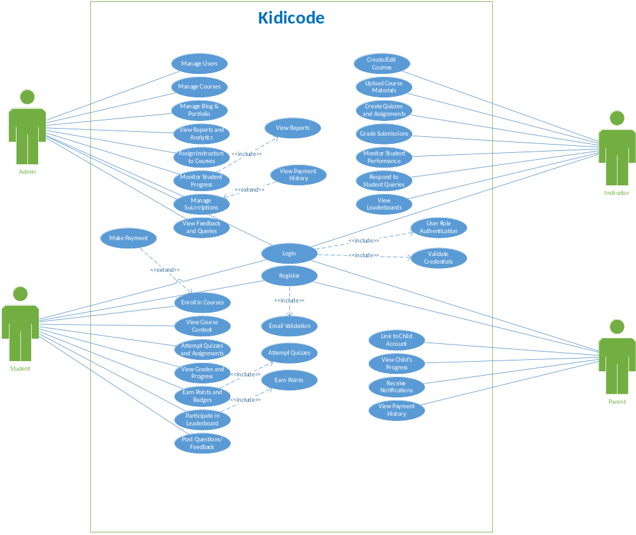

Usage Scenarios:
UC01 - Manage Users
Use Case ID | UC01
Use Case Name | Manage Users
Description | Admin manages platform users by creating, updating, or deleting user accounts.
Primary Actors | Admin
Secondary Actors | None
Preconditions | Admin is logged in and has access to the dashboard.
Main Flow | 1. Admin opens the 'Manage Users' section.  2. Views list of users.  3. Selects add/edit/delete operation.  4. System updates the database accordingly.
Postconditions | User information is updated or removed from the system.
Alternative Flows | 1. Invalid input – system shows error.  2. Deletion fails due to dependencies.
Author | BC190402729

UC02 - Manage Courses
Use Case ID | UC02
Use Case Name | Manage Courses
Description | Admin manages the course list, including creating, editing, or deleting courses.
Primary Actors | Admin
Secondary Actors | None
Preconditions | Admin is authenticated and has access to course management.
Main Flow | 1. Admin selects 'Manage Courses'.  2. Creates or updates course info.  3. Submits changes.  4. System reflects updated course list.
Postconditions | Courses are available for users to view or enroll.
Alternative Flows | 1. Duplicate course name – system blocks submission.  2. Missing required fields – show alert.
Author | BC190402729

UC03 - Manage Blog & Portfolio
Use Case ID | UC03
Use Case Name | Manage Blog & Portfolio
Description | Admin updates the blog and portfolio section of the website.
Primary Actors | Admin
Secondary Actors | None
Preconditions | Admin is logged in and on content management screen.
Main Flow | 1. Admin opens blog section.  2. Adds or edits blog entries and portfolio items.  3. Saves changes.  4. System updates public-facing content.
Postconditions | Content is visible on the website to all users.
Alternative Flows | 1. Image upload error – show retry option.  2. Content validation fails – prevent publish.
Author | BC190402729

UC04 - View Reports and Analytics
Use Case ID | UC04
Use Case Name | View Reports and Analytics
Description | Admin views system-wide reports such as user activity, enrollments, and performance.
Primary Actors | Admin
Secondary Actors | None
Preconditions | Data is available in the system.
Main Flow | 1. Admin opens the 'Analytics' page.  2. Selects report type.  3. Views statistics or downloads report.
Postconditions | Reports are displayed or exported.
Alternative Flows | 1. Data not available – show 'no data' message.
Author | BC190402729

UC05 - Assign Instructors to Courses
Use Case ID | UC05
Use Case Name | Assign Instructors to Courses
Description | Admin assigns available instructors to specific courses.
Primary Actors | Admin
Secondary Actors | None
Preconditions | Instructor and course data exist in the system.
Main Flow | 1. Admin selects a course.  2. Chooses an instructor from the list.  3. Assigns instructor.  4. System updates the assignment.
Postconditions | Instructor is linked with the selected course.
Alternative Flows | 1. Instructor already assigned – alert Admin.  2. Course not found – show error.
Author | BC190402729

UC06 - Monitor Student Progress
Use Case ID | UC06
Use Case Name | Monitor Student Progress
Description | Admin monitors the progress of all students across courses.
Primary Actors | Admin
Secondary Actors | None
Preconditions | Student performance data is available.
Main Flow | 1. Admin selects 'Student Progress'.  2. Views detailed progress data per student or course.  3. May download or share report.
Postconditions | Admin is informed of student activity and completion rates.
Alternative Flows | 1. No activity from student – system shows 0%.
Author | BC190402729

UC07 - Manage Subscriptions
Use Case ID | UC07
Use Case Name | Manage Subscriptions
Description | Admin adds or updates subscription plans available to students.
Primary Actors | Admin
Secondary Actors | None
Preconditions | Admin has access to the subscription panel.
Main Flow | 1. Admin navigates to 'Subscriptions'.  2. Creates or modifies plan details.  3. Submits changes.  4. System saves and applies plans.
Postconditions | New subscription plans are active.
Alternative Flows | 1. Plan name conflict – notify admin.  2. Save failure – prompt retry.
Author | BC190402729

UC08 - View Feedback and Queries
Use Case ID | UC08
Use Case Name | View Feedback and Queries
Description | Admin views feedback and questions submitted by students and parents.
Primary Actors | Admin
Secondary Actors | None
Preconditions | Feedback must be submitted.
Main Flow | 1. Admin opens 'Feedback'.  2. Reviews entries.  3. Responds if needed.
Postconditions | Admin is aware of user concerns.
Alternative Flows | 1. No feedback – show empty state.
Author | BC190402729

UC09 - Create/Edit Courses
Use Case ID | UC09
Use Case Name | Create/Edit Courses
Description | Instructor creates or edits course materials and structure.
Primary Actors | Instructor
Secondary Actors | None
Preconditions | Instructor is assigned to a course.
Main Flow | 1. Instructor accesses course panel.  2. Edits title, description, or modules.  3. Saves changes.
Postconditions | Course structure is updated.
Alternative Flows | 1. Unauthorized access – system denies.  2. Missing fields – system prompts input.
Author | BC190402729

UC10 - Upload Course Materials
Use Case ID | UC10
Use Case Name | Upload Course Materials
Description | Instructor uploads PDFs, videos, and supporting materials.
Primary Actors | Instructor
Secondary Actors | None
Preconditions | Instructor must have a course assigned.
Main Flow | 1. Instructor selects a module.  2. Clicks upload and selects files.  3. System stores materials.
Postconditions | Materials are available to students.
Alternative Flows | 1. File too large – system warns.  2. Format unsupported – prompt change.
Author | BC190402729

UC11 - Create Quizzes and Assignments
Use Case ID | UC11
Use Case Name | Create Quizzes and Assignments
Description | Instructor creates quizzes and tasks for evaluation.
Primary Actors | Instructor
Secondary Actors | None
Preconditions | Instructor is logged in and has course rights.
Main Flow | 1. Instructor selects 'Create Quiz'.  2. Adds questions and answers.  3. Sets duration and publishes.
Postconditions | Students can now access the quiz.
Alternative Flows | 1. Invalid structure – system does not save.
Author | BC190402729

UC12 - Grade Submissions
Use Case ID | UC12
Use Case Name | Grade Submissions
Description | Instructor reviews and grades student submissions.
Primary Actors | Instructor
Secondary Actors | None
Preconditions | Submissions must be available.
Main Flow | 1. Instructor opens grading panel.  2. Reviews answers.  3. Assigns marks and feedback.
Postconditions | Grades are visible to students.
Alternative Flows | 1. Error saving grade – retry needed.
Author | BC190402729

UC13 - Monitor Student Performance
Use Case ID | UC13
Use Case Name | Monitor Student Performance
Description | Instructor checks class-wide progress and individual stats.
Primary Actors | Instructor
Secondary Actors | None
Preconditions | Student data is present in system.
Main Flow | 1. Instructor accesses analytics tab.  2. Selects a course and timeframe.  3. Views detailed performance charts.
Postconditions | Instructor is informed of learner success/failures.
Alternative Flows | 1. Data unavailable – show 'no activity'.
Author | BC190402729

UC14 - Respond to Student Queries
Use Case ID | UC14
Use Case Name | Respond to Student Queries
Description | Instructor answers course-related questions.
Primary Actors | Instructor
Secondary Actors | None
Preconditions | Students must post a query.
Main Flow | 1. Instructor reviews question inbox.  2. Opens a question.  3. Sends reply.
Postconditions | Student receives the response.
Alternative Flows | 1. Response fails – instructor is notified.
Author | BC190402729

UC15 - View Leaderboards
Use Case ID | UC15
Use Case Name | View Leaderboards
Description | Instructor views class leaderboard for gamified progress.
Primary Actors | Instructor
Secondary Actors | None
Preconditions | Gamification must be active.
Main Flow | 1. Instructor opens leaderboard tab.  2. System shows rankings by points and badges.
Postconditions | Instructor sees top-performing students.
Alternative Flows | 1. No activity – leaderboard is empty.
Author | BC190402729

UC16 - Login
Use Case ID | UC16
Use Case Name | Login
Description | User logs into the system with valid credentials.
Primary Actors | Student, Parent, Instructor, Admin
Secondary Actors | None
Preconditions | User must be registered.
Main Flow | 1. User opens login page.  2. Enters credentials.  3. System authenticates.  4. User is redirected to dashboard.
Postconditions | User is logged into their role-based panel.
Alternative Flows | 1. Invalid credentials – show error.  2. Forgotten password – prompt recovery.
Author | BC190402729

UC17 - Register
Use Case ID | UC17
Use Case Name | Register
Description | Allows new users to register into the system.
Primary Actors | Student, Parent
Secondary Actors | None
Preconditions | Registration page must be available.
Main Flow | 1. User opens registration form.  2. Enters personal info.  3. System validates and creates account.
Postconditions | New user account is created.
Alternative Flows | 1. Email already exists – show error.  2. Missing info – system alerts.
Author | BC190402729

UC18 - Enroll in Courses
Use Case ID | UC18
Use Case Name | Enroll in Courses
Description | Student enrolls into available courses.
Primary Actors | Student
Secondary Actors | Payment Gateway
Preconditions | Student must be logged in.
Main Flow | 1. Student selects a course.  2. If paid, redirected to payment.  3. On success, student is enrolled.
Postconditions | Student gains access to course content.
Alternative Flows | 1. Payment fails – enrollment not completed.
Author | BC190402729

UC19 - Make Payment
Use Case ID | UC19
Use Case Name | Make Payment
Description | Handles payment transaction for paid courses.
Primary Actors | Student
Secondary Actors | Payment Gateway
Preconditions | Student selects a paid course.
Main Flow | 1. Student is redirected to payment.  2. Enters payment info.  3. System verifies and confirms payment.
Postconditions | Enrollment proceeds after successful payment.
Alternative Flows | 1. Payment gateway error – notify student.
Author | BC190402729

UC20 - Email Validation
Use Case ID | UC20
Use Case Name | Email Validation
Description | System validates email during registration.
Primary Actors | System
Secondary Actors | None
Preconditions | User must enter email.
Main Flow | 1. User submits registration form.  2. System sends validation link.  3. User confirms email.
Postconditions | Email is verified.
Alternative Flows | 1. Email not delivered – resend option.
Author | BC190402729

UC21 - Validate Credentials
Use Case ID | UC21
Use Case Name | Validate Credentials
Description | System validates login credentials.
Primary Actors | System
Secondary Actors | None
Preconditions | User submits login form.
Main Flow | 1. System checks email and password.  2. If correct, login succeeds.  3. If incorrect, reject login.
Postconditions | User is either logged in or denied access.
Alternative Flows | 1. Multiple failures – temporarily lock account.
Author | BC190402729

UC22 - User Role Authentication
Use Case ID | UC22
Use Case Name | User Role Authentication
Description | System determines user role after login.
Primary Actors | System
Secondary Actors | None
Preconditions | User login is successful.
Main Flow | 1. System retrieves user role.  2. Redirects to the appropriate dashboard.
Postconditions | User is taken to their respective dashboard.
Alternative Flows | 1. Role missing – default to general view.
Author | BC190402729

Adopted Methodology

It is a method to use development of project. We have adopted the VU Process Model which is the combination of Waterfall methodology and Spiral methodology. VU Process Model will combine the benefits of Waterfall and Spiral methodologies.

The waterfall models
The Waterfall model is one of the most common and classic of life cycle models, also referred to as a linear-sequential life cycle model. It is based on the factory assembly-line process. It follows a structured sequential path from Requirements to Maintenance, setting out milestones at each stage which must be accomplished before the next stage can begin.
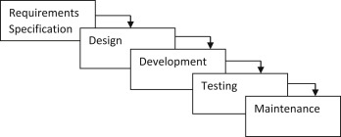

The spiral model

The spiral model, also known as the spiral lifecycle model, is a systems development method (SDM) used in information technology (IT). This model of development combines the features of the prototyping model and the systems development life cycle (SDLC).

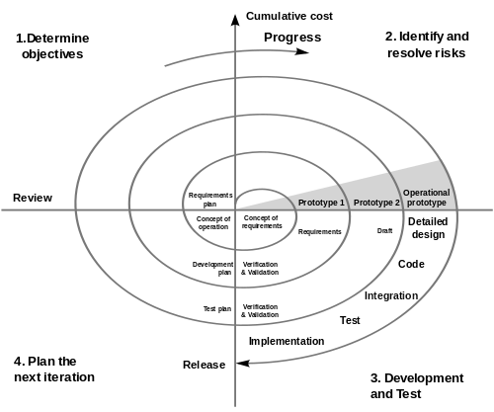

VU Process Model

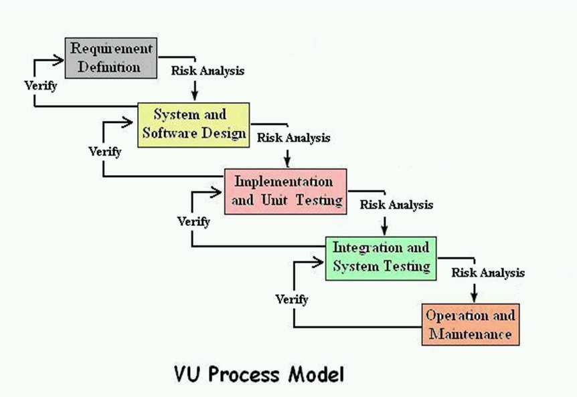

Reasons for choosing the Methodology
- The main idea to choose is to get the benefits of both these models.
- It is sequential model with backward repetition.
- We want to achieve the linear nature of waterfall and iterative plus risk reduction nature of spiral model.
- In vu process model we will be work in phases to complete the given project.
- All the activities are performed in a sequence in VU Process Model.

If we want to do correction or betterment at any stage and repetition whenever necessary then we can choose VU process mode

Work Plan (Use MS Project to create Schedule/Work Plan)

Work Plan

The Work plan is backbone of any project if our plan is suitable for project then project will be completed within time and budget. Project plan shows the tasks and responsibilities distribution. We plan the software development progress mainly. It describes the team management, standards, processes and constraints of project resources.
Plan consists of following stages.
- Team structure
- Detailed project schedule

Team structure:

Our team will consist of three members one supervisor two developer, managers, tester and quality assurer. Depending on experience one will be manager and other will be tester.
Diagram

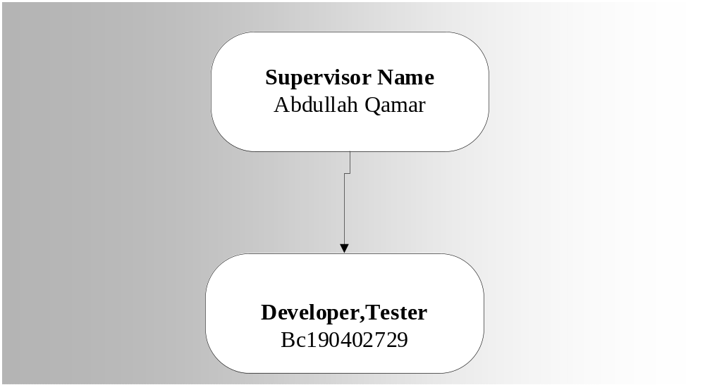

Detailed Project Schedule:

The task assign in the above plan are the base of all work plan the day wise allocation to each phase is represented bellow.
Working Plan

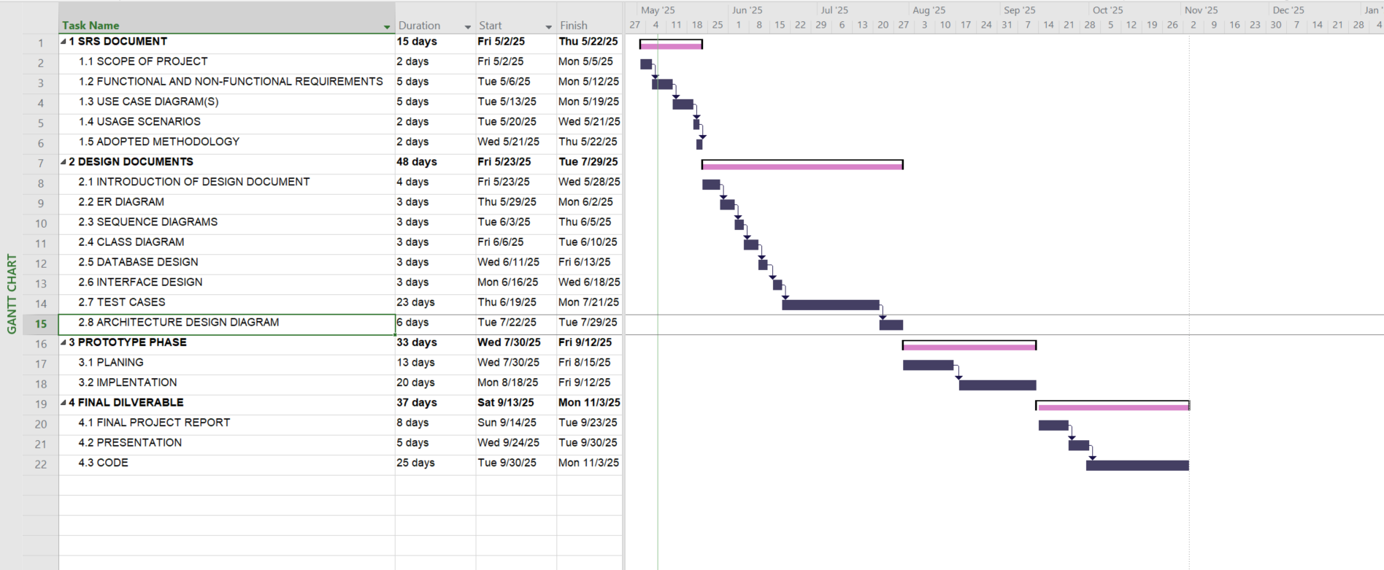

Time Line Chart

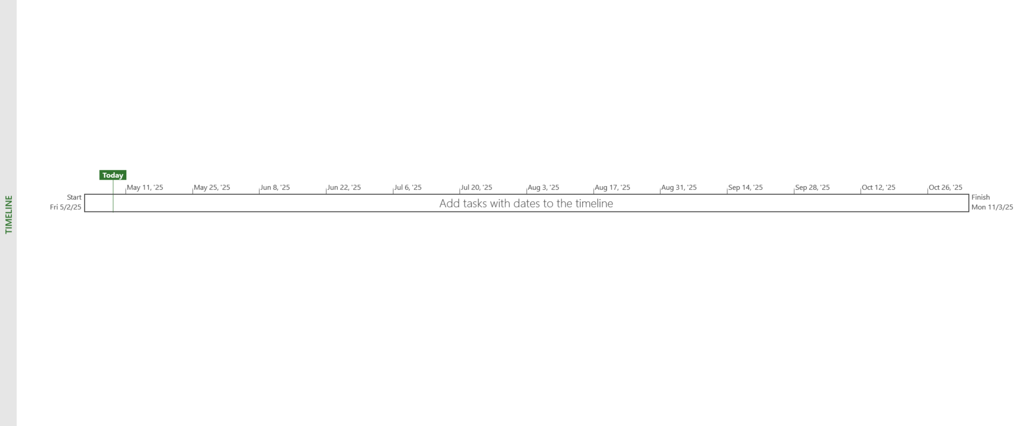

CHAPTER NO. 2
Designing the Project

1 Introduction of Design Document

This document is designed to see what is to be built at its origin levels in order to give a software expansion team an overall guidance of the architecture of the software project. This phase surrounds
- Entity Relationship Diagram (ERD)
- Sequence Diagrams
- Architecture Design Diagram
- Class Diagram
- Database Design
- Interface Design
- Test Cases

Entity Relationship Diagram:
Entity Relationship Diagram is a data model for describing a database in an abstract model. It contains entities and their relationships. An entity may be defined as a thing which is recognized as being capable of an independent existence and which can be uniquely identified.

Sequence Diagram
Sequence Diagram is an interaction diagram that shows how processes operate with each other.

Architecture Design Diagram:
Architecture Design Diagram used to represent data in the form of layers. It contains three layers’ data link layer, application layer and business layer.

Class Diagram:
In Class diagram we will describe the structure of KIDICODE by showing the system's classes, show their attributes, operations or methods and relationships between classes or objects. In a class diagram classes represent both the main objects and interactions.

Database Design:
Database Design is a process of producing a detailed data model of a database. It can be taken as the logical design of the base data structures to store the data

Interface Design:
Interface Designs a GUI view of main software. It shows how our Software Application will look like and how we interference with the System.

Test cases:
In the test cases for the KIDICODE are also given. A test case in software engineering is a set of conditions or variables under which a tester will determine whether an application or software system is working correctly or not.

2 Entity Relationship Diagram (ERD)
An Entity-Relationship Diagram (ERD) is a visual representation of the relationships among entities in a system. It uses rectangles to represent entities, ovals for attributes, and diamonds to depict relationships

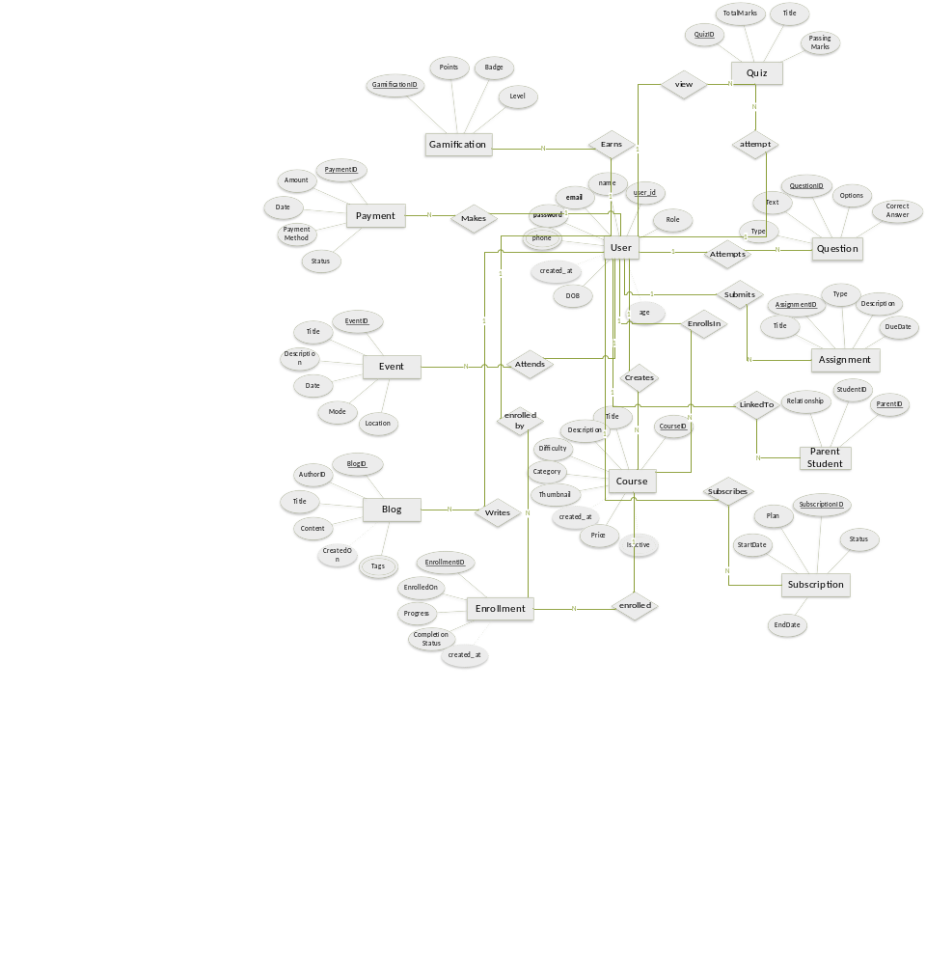

3. Sequence Diagrams
Sequence diagrams in UML visually depict the order of messages and interactions between objects or components in a system over time. They illustrate the dynamic behavior of a system, showcasing the sequence of events in a specific scenario or use case.

Login
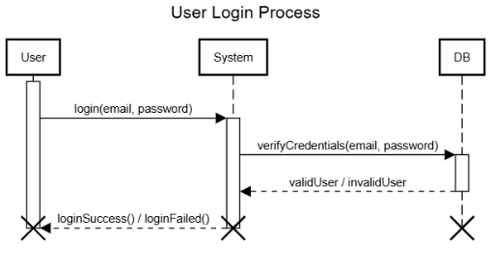

Registration

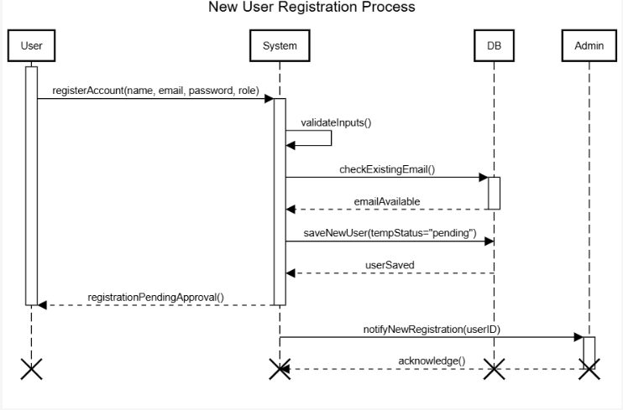

Dashboard:

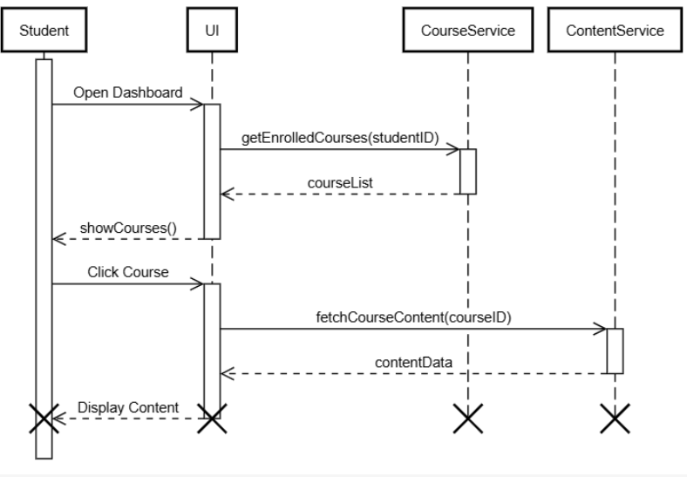

Open Course Creation:

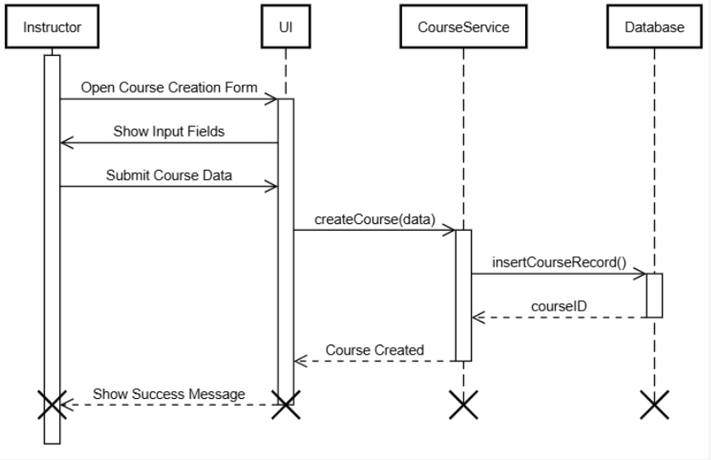

Parent Dashboard:
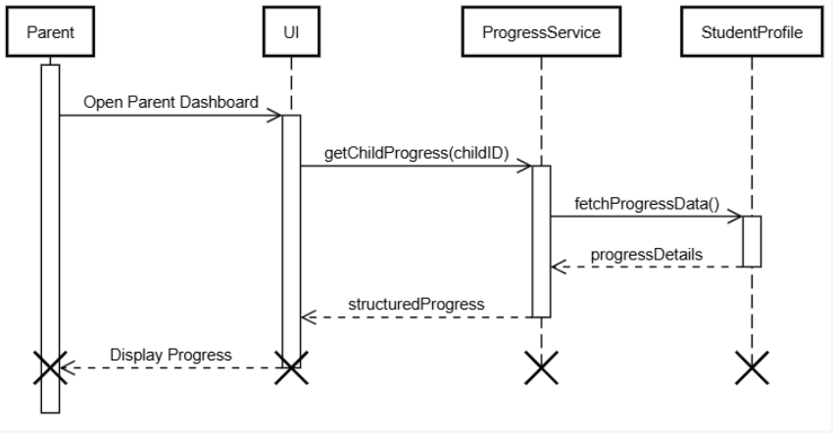

Quiz:

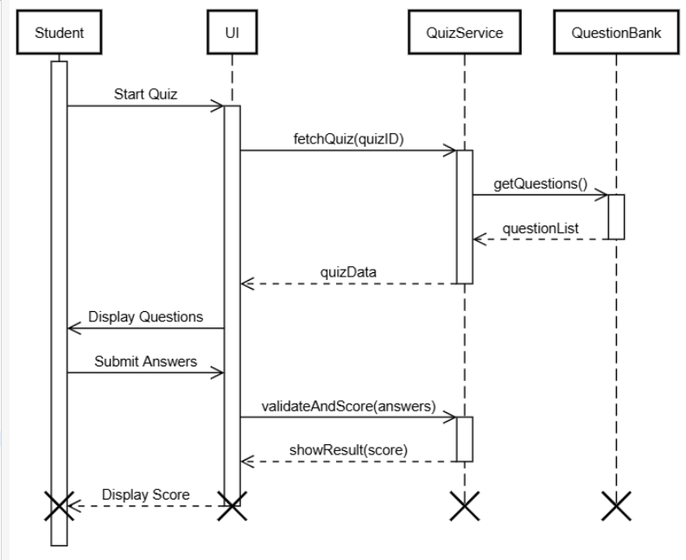

Admin Publishes Approved Research Paper

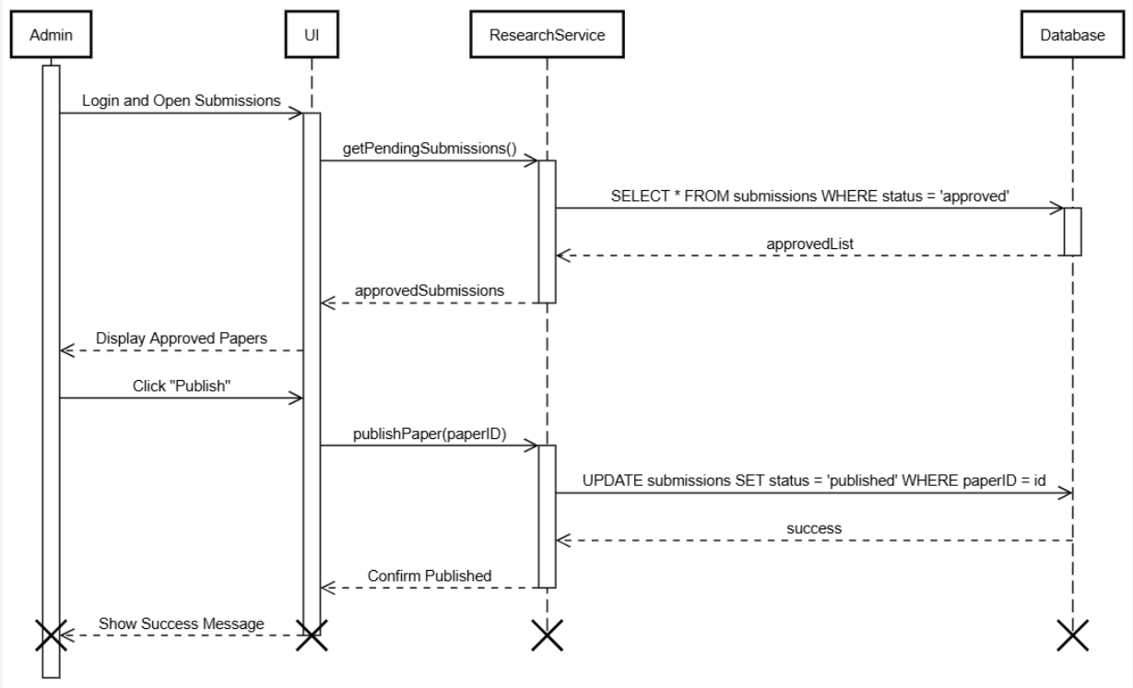

Admin Publishes Approved Research Paper Student Submits Research Paper

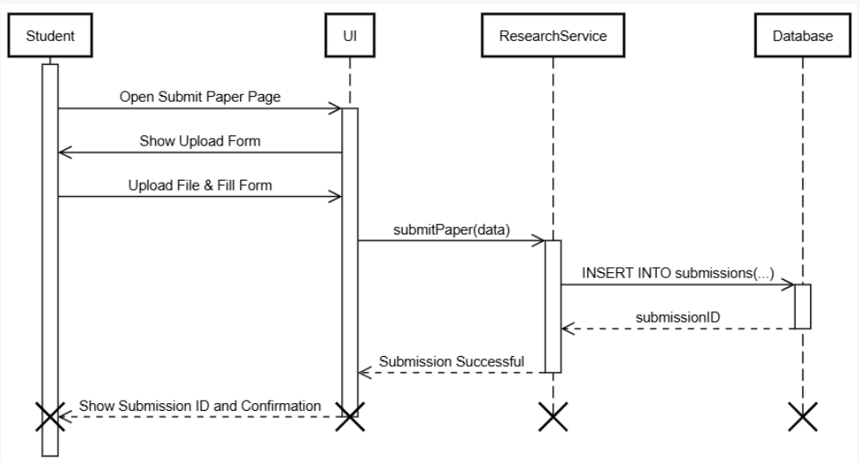

4. Architecture Design Diagram
An architectural diagram is a visual representation that maps out the physical implementation for components of a software system. It typically includes key elements such as modules, components, layers, and their interactions. This diagram provides a conceptual overview of the system’s architecture.

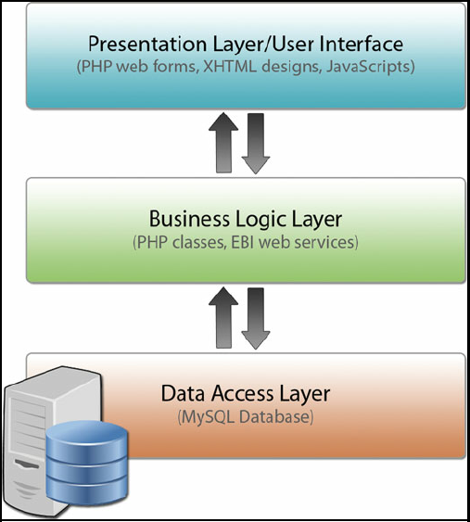

5 Class Diagram
A Class Diagram is a visual representation in UML that depicts the structure of a system by showing classes, their attributes, methods, and relationships. The diagram uses rectangles to represent classes, lines to indicate relationships, and additional notations for attributes and methods within each class.

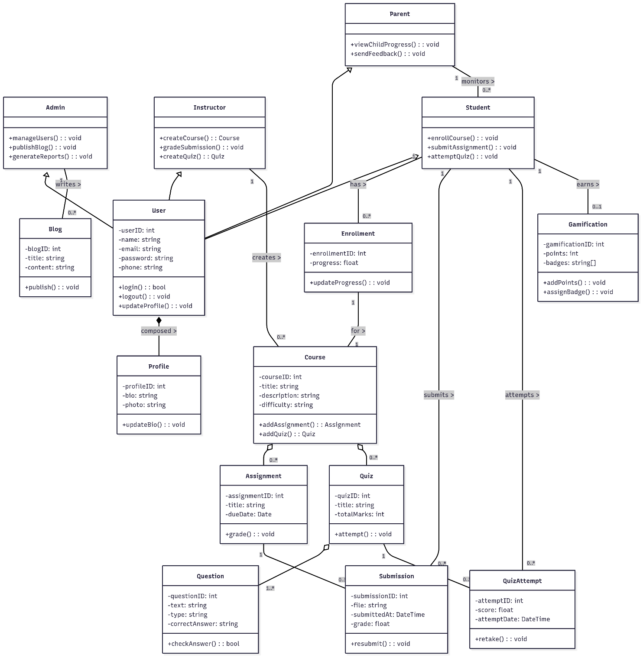

6 Database Design
Database design is the process of defining the structure that will organize and store data efficiently in a database system. It involves specifying tables, relationships, constraints, and data types to ensure accurate and secure data storage. The goal is to create a well-organized and normalized database schema that supports the requirements of an application. Effective database design improves data integrity, reduces redundancy, and enhances overall system performance.

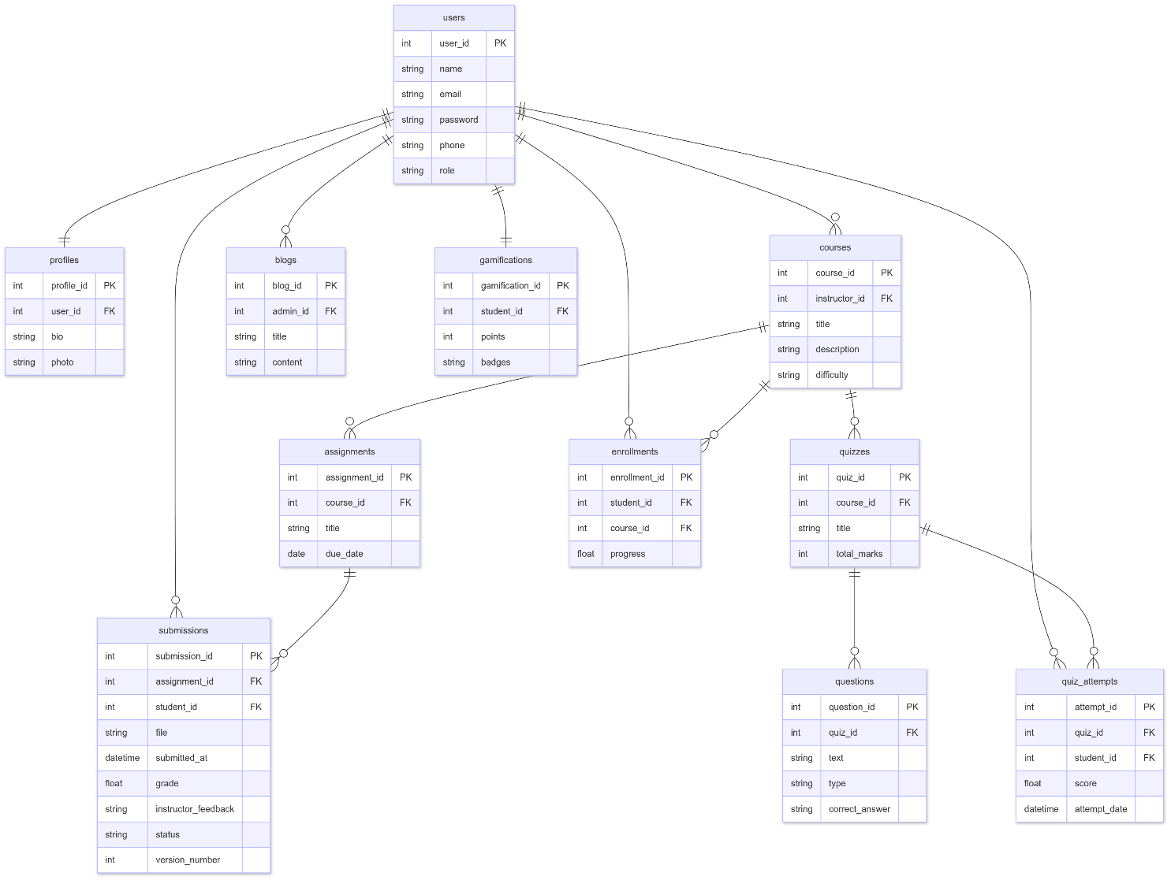

7. Interface Design: -
Interface design involves creating the visual and interactive elements of software or applications. It focuses on optimizing user experience through careful consideration of layout, navigation, aesthetics, and usability. Designers aim to craft an intuitive, visually appealing interface that enhances user satisfaction and efficiency in interacting with digital systems.

Create account
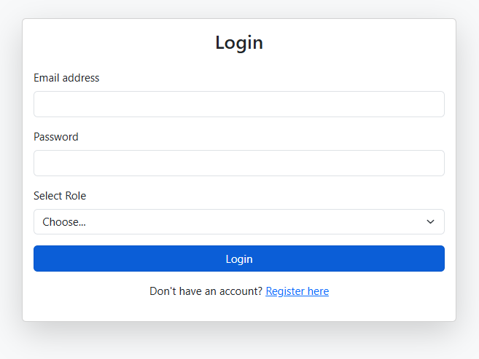

Login
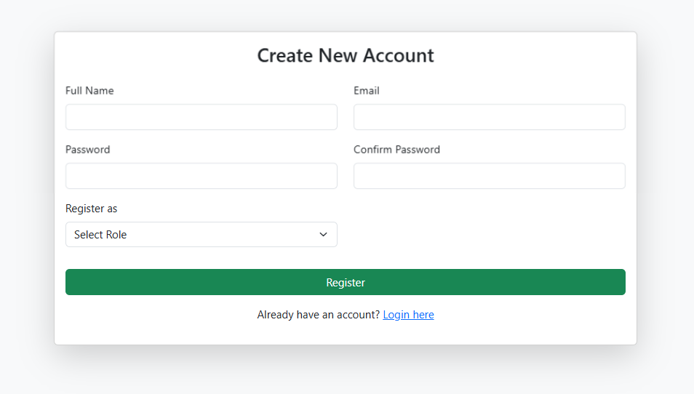

Student Dashboard:
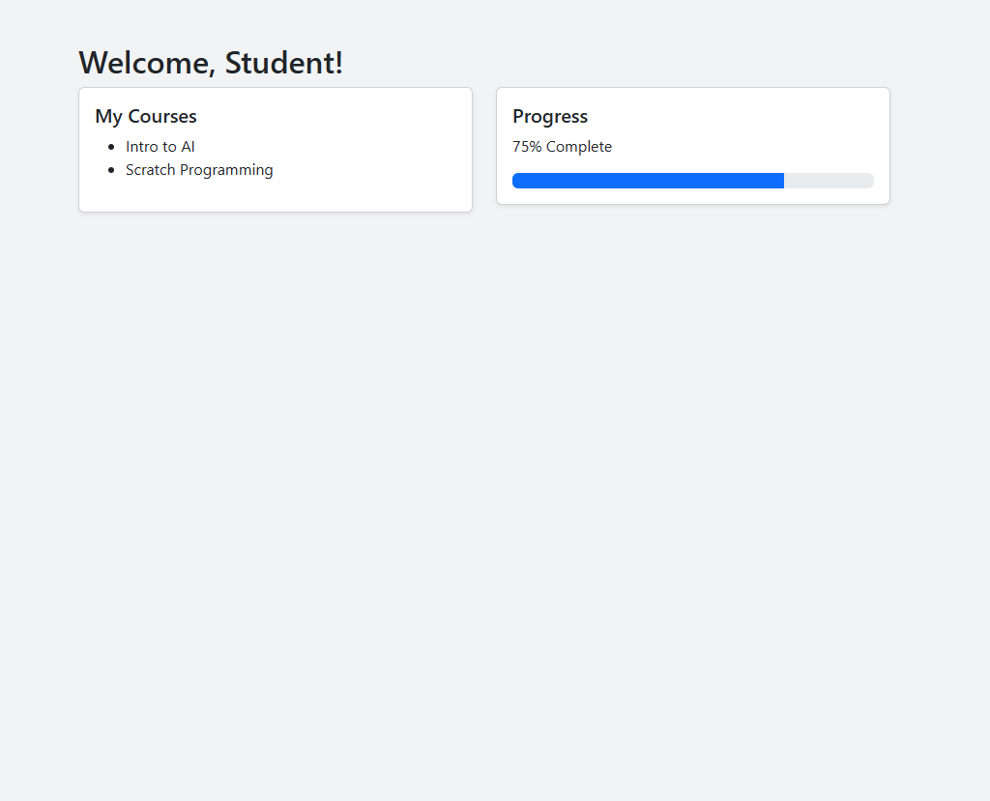

Course



Instructor Panel:

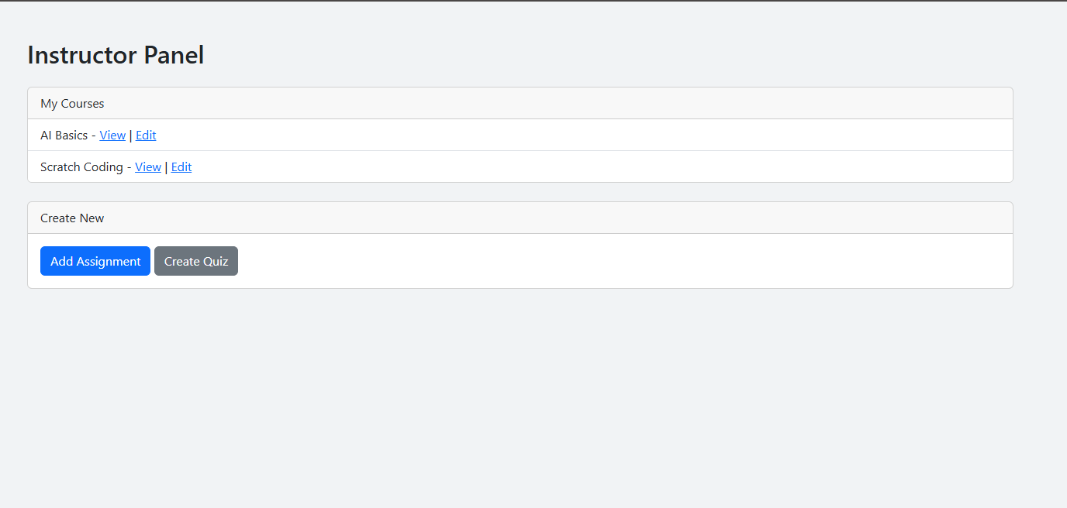

Submit Assignment:
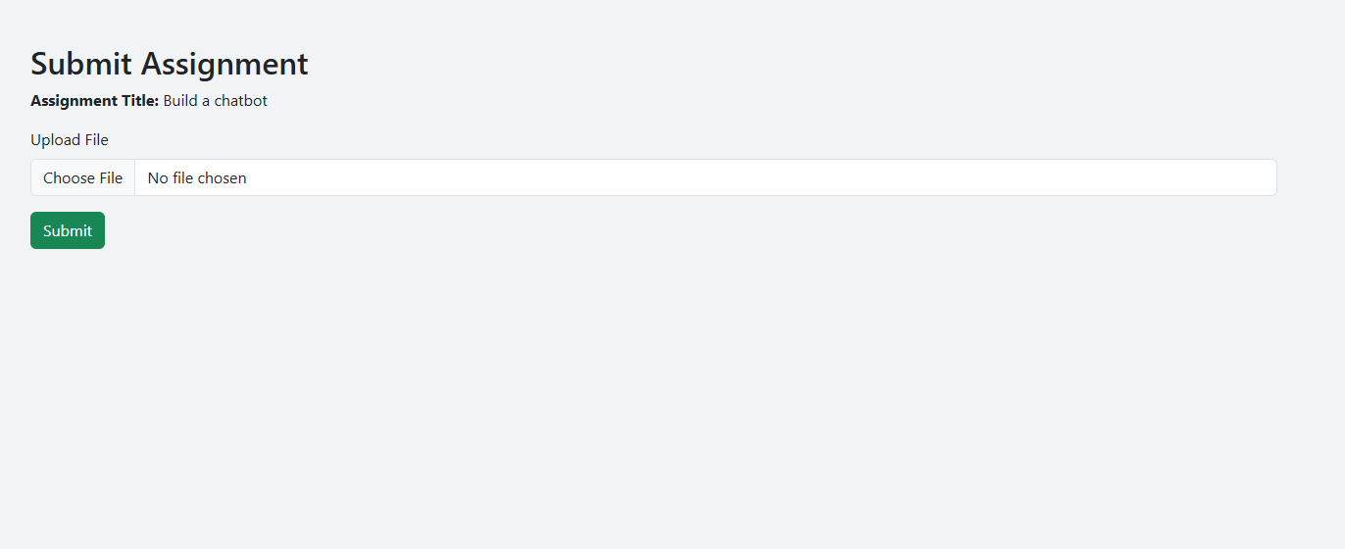

Quiz:



Admin Dashboard:

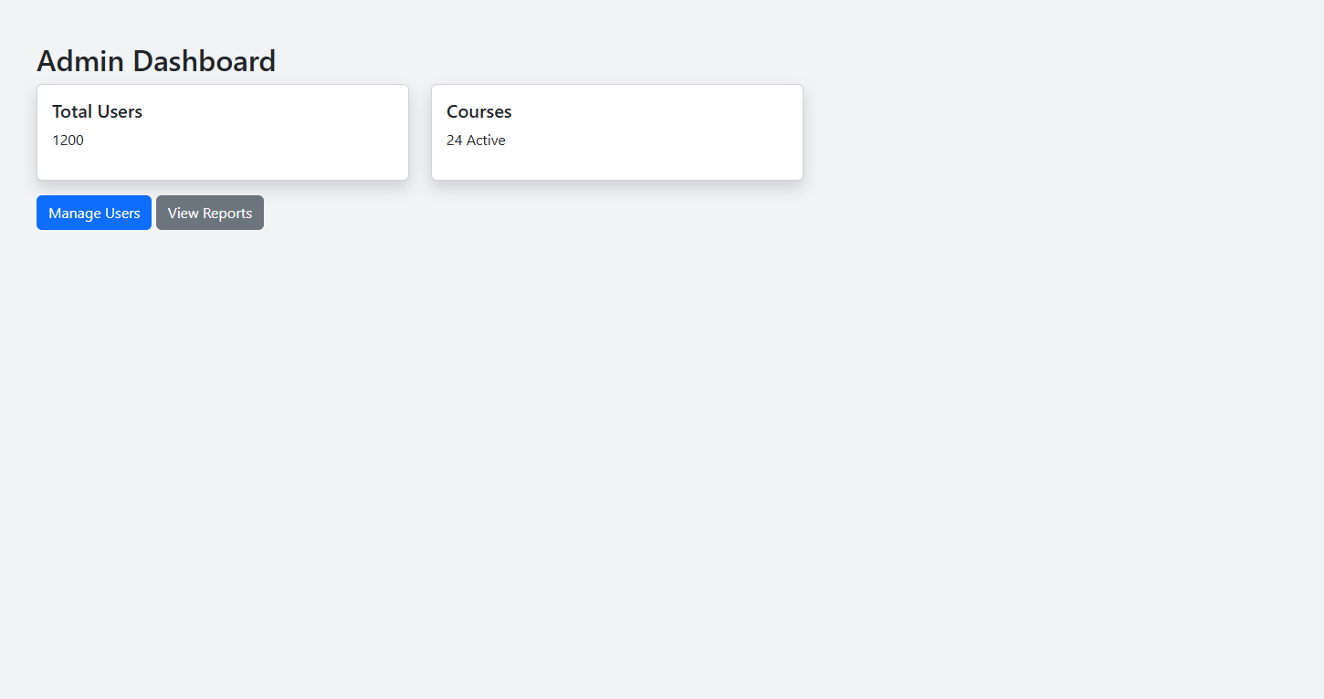

Test Cases

Test cases are specific scenarios or conditions designed to validate whether a software application or system functions as intended. Test cases serve as a blueprint for testing procedures, allowing testers to identify and correct defects or issues before software is released. They contribute to the overall quality assurance process by ensuring that software meets the specified requirements and performs reliably under various conditions.

Test Case —1 Login
Field | Description
Test Case ID | TC01
Title | Verify login functionality with valid credentials
Pre-conditions | • User account must exist and be approved
Actions | 1. Launch application  2. Click on Login  3. Enter valid email and password  4. Click Login button
Expected Results | • User is redirected to their respective dashboard
Tested By | BC190402729
Result | Pass

Test Case — 3 Create New Account
Field | Description
Test Case ID | TC02
Title | Check response for account creation
Pre-conditions | • Application running  • User must not be already registered
Actions | 1. Click on Register  2. Choose user type  3. Fill registration form  4. Submit the form
Expected Results | • Registration request submitted  • Awaiting admin approval
Tested By | BC190402729
Result | Pass

Test Case — 3 Student Dashboard
Field | Description
Test Case ID | TC03
Title | Verify student dashboard displays enrolled courses and progress
Pre-conditions | • User must be logged in as a student  • Student must be enrolled in at least one course
Actions | 1. Login as a student  2. Navigate to Dashboard  3. View course list and progress bar
Expected Results | • Dashboard shows list of enrolled courses  • Progress bar reflects completion status
Tested By | BC190402729
Result | Pass

Test Case — 4 Course Detail Page
Field | Description
Test Case ID | TC04
Title | Verify course detail page shows assignments and quizzes
Pre-conditions | • User must be enrolled in the course  • Course must have assignments and quizzes
Actions | 1. Login as student/instructor  2. Click on a course from dashboard  3. View assignments and quizzes list
Expected Results | • Course title, description, and instructor details are shown  • Assignments and quizzes are listed
Tested By | BC190402729
Result | Pass

Test Case — 5 Instructor Dashboard
Field | Description
Test Case ID | TC05
Title | Verify instructor dashboard lists managed courses and allows quiz/assignment creation
Pre-conditions | • User must be logged in as an instructor  • Instructor must be assigned at least one course
Actions | 1. Login as instructor  2. Open dashboard  3. View course list  4. Click "Create Assignment"/"Create Quiz"
Expected Results | • Courses are displayed with action links  • Instructor is redirected to appropriate creation forms
Tested By | BC190402729
Result | Pass

Test Case — 6 Assignment Submission Page
Field | Description
Test Case ID | TC06
Title | Verify assignment submission with file upload
Pre-conditions | • User must be logged in as student  • Assignment must be available and open for submission
Actions | 1. Navigate to Assignment Page  2. Upload a file  3. Click Submit
Expected Results | • File is uploaded successfully  • Submission confirmation message appears
Tested By | BC190402729
Result | Pass

Test Case — 7 Quiz Attempt Page
Field | Description
Test Case ID | TC07
Title | Verify quiz attempt with multiple-choice questions
Pre-conditions | • User must be logged in as student  • Quiz must be published and active
Actions | 1. Open quiz from course page  2. Answer questions  3. Submit quiz
Expected Results | • Answers are recorded  • Submission confirmation or result shown (if immediate)
Tested By | BC190402729
Result | Pass

Test Case — 8 Admin Dashboard
Field | Description
Test Case ID | TC08
Title | Verify admin dashboard shows system metrics and navigation to admin tools
Pre-conditions | • User must be logged in as admin
Actions | 1. Login as admin  2. Open Admin Dashboard  3. View user/course stats  4. Click “Manage Users” or “View Reports”
Expected Results | • System summary cards are displayed  • Navigation buttons work correctly
Tested By | BC190402729
Result | Pass

CHAPTER NO. 3
Development plan (Architecture Diagram)

Architecture Design Diagram
Architecture diagram is the basically pictorial diagram which show the components of the system and the relation between the components. Its looks like the planning of the house that where should the rooms and where the windows and the door of the house and rooms should.
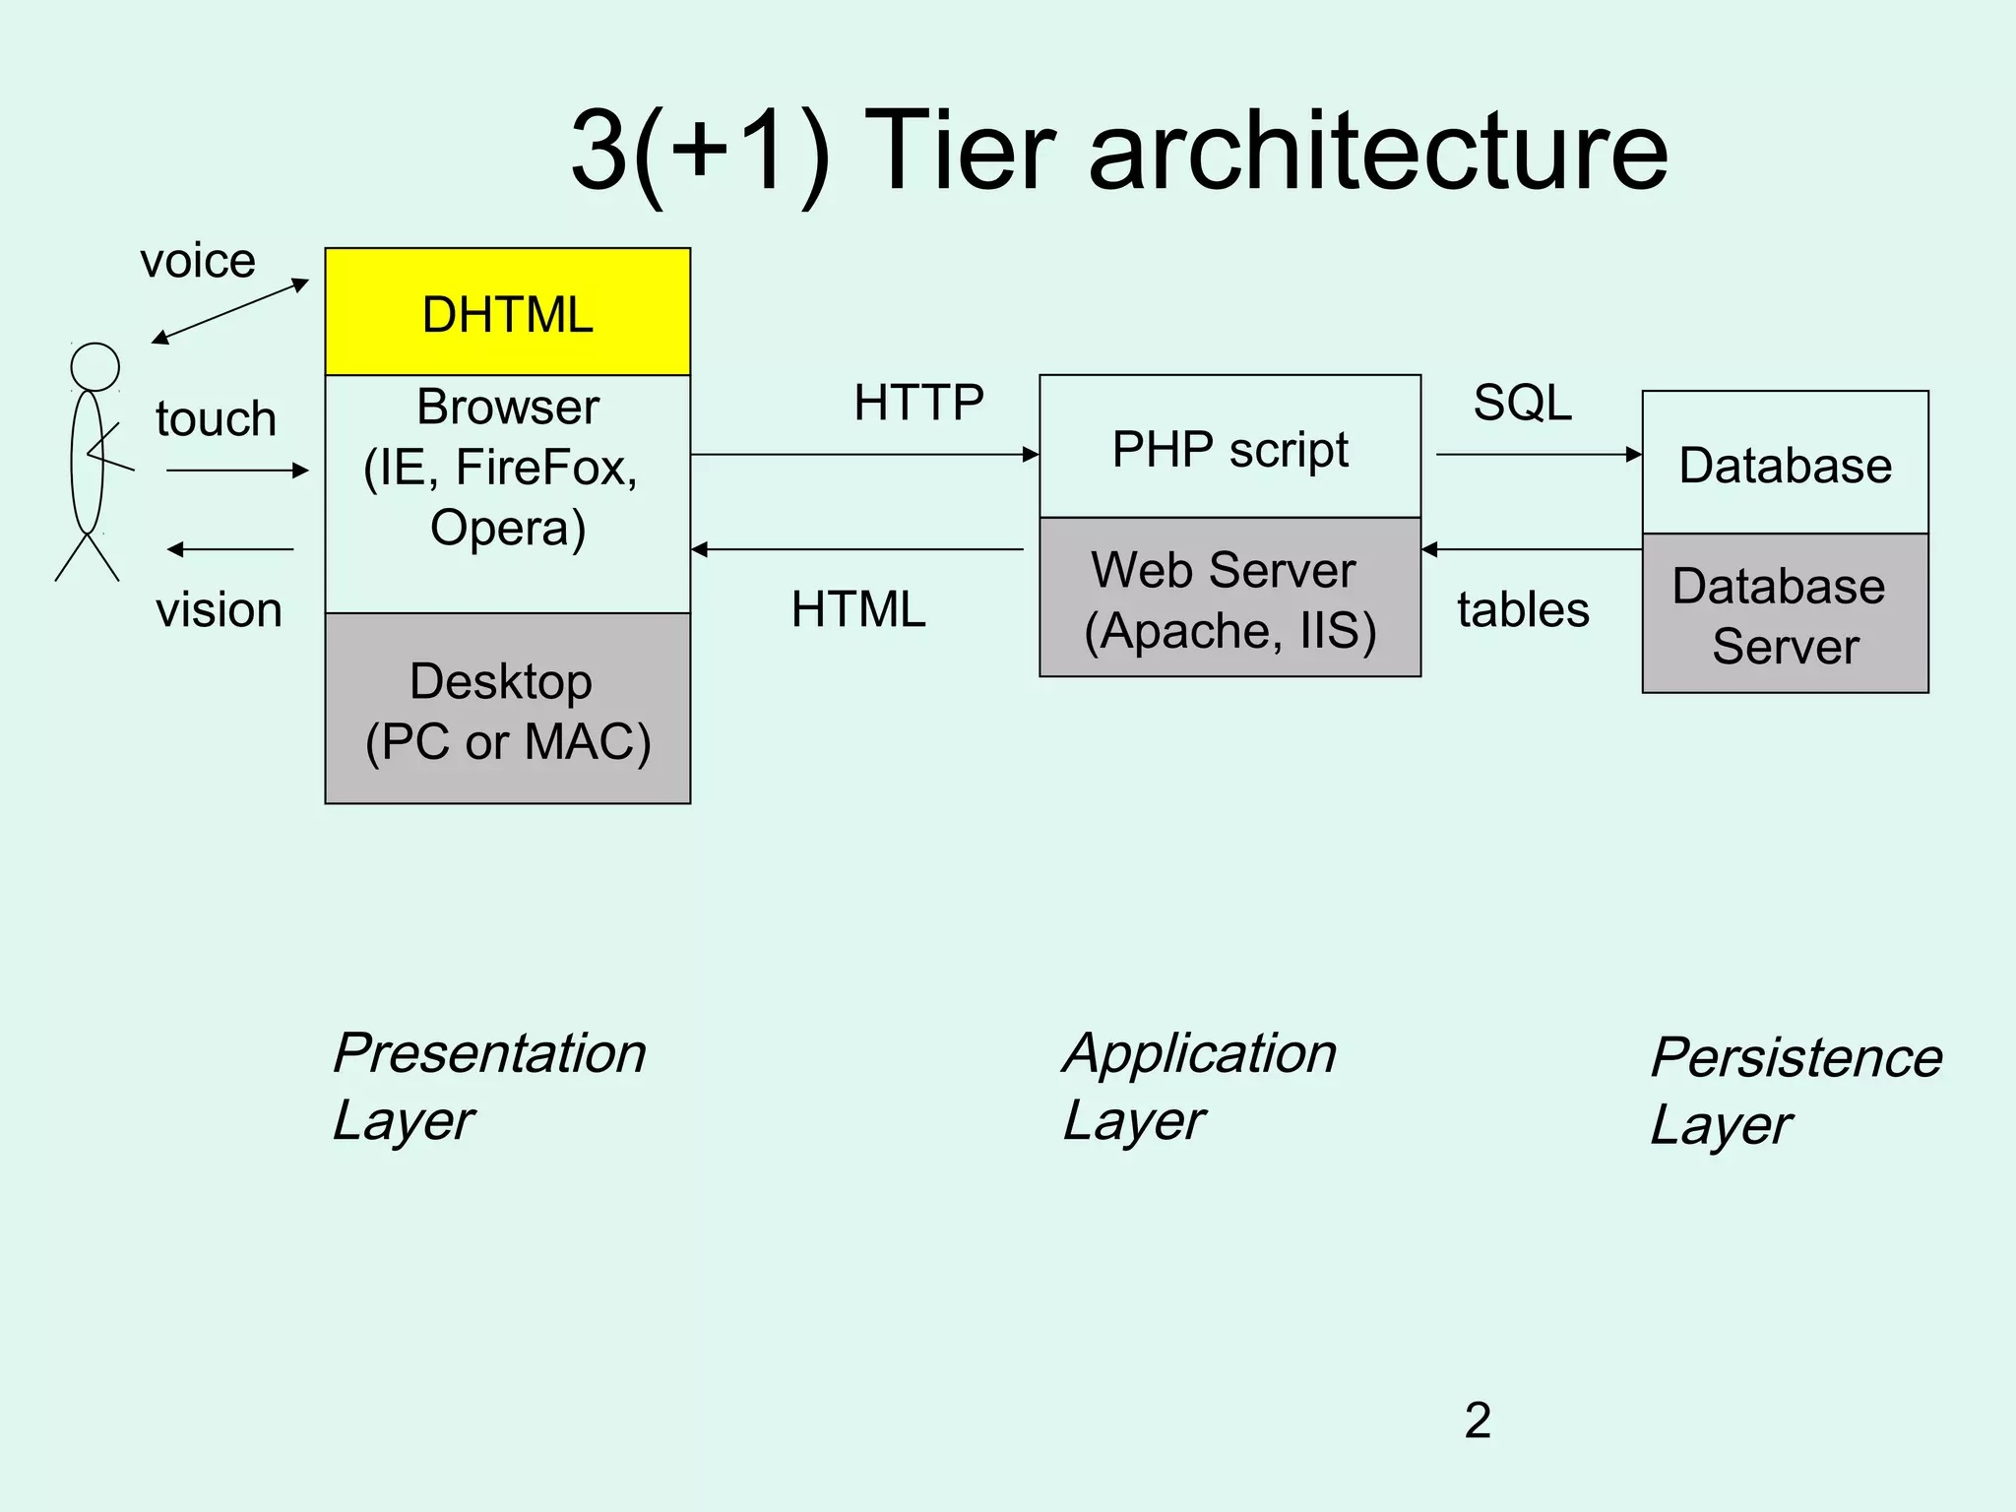

REFERENCES

Software Engineering, I, Handouts, Virtual University of Pakistan.
Software Engineering II, Handouts, Virtual University of Pakistan.
Object Oriented Programming Handouts, Virtual University of Pakistan.
Data Ware House, Handouts, Virtual University of Pakistan.
Database Management System, Handouts, Virtual University of Pakistan.
https://www.google.com.pk/
https://www.w3schools.com

APPENDIX
PHP is a scripting language designed to fill the gap between SSI (Server Side Includes) and Perl, intended for the Web environment. Its principal application is the implementation of Web pages having dynamic content. PHP has gained quite a following in recent times, and it is one of the frontrunners in the Open Source software movement. Its popularity derives from its C-like syntax, and its simplicity

