ECE 2564
Fall 2025
Homework 12

Please sign

“I have neither given nor received unauthorized assistance on this assignment. I have not copied any part of this submission from unauthorized resources”.

For this assignment, you will complete parts of project 3. You can work on any part of project 3 you wish but to get credit for this assignment, you need to complete the steps below.

Fill the below table with what you expect to get for each part:
Item | Full points | Expected points
The game wakes up from sleep mode on a button interrupt.  Note: Since the program is set to always be in sleep mode unless awakened by an interrupt, if you can see anything on your board change because of a button tap based on your code written within the main loop or within an ISR, your board has “woken” up from sleep mode. | 20
The program boots to a title screen that shows your name. Upon any interrupt, go to the menu screen.  (Please note this is different from the final project requirement and acts as a stepping stone for your final implementation) | 10
Set up a timer to wake the board often enough to process the joystick being tapped up or down | 20
In the Menu, tapping JSB up will move the cursor up, and tapping JSB will move the cursor down. | 10
Tapping JSB while selecting instructions or play will show the instructions or game screen, respectively. These screens only need to print “Instructions” or “Game” for HW9. | 10
Set up the buzzer to play note C4 for 1 second on loading the game by doing the TODOs in Buzzer.h | 30

When you are ready to submit your HW12, commit your work to GitHub with a meaningful message such as "My HW12 submission". Take a screenshot of your GitHub submission on the GitHub website highlighting your GitHub ID and your submission message. See the below example. Replace the below image with your own screenshot from the GitHub site.
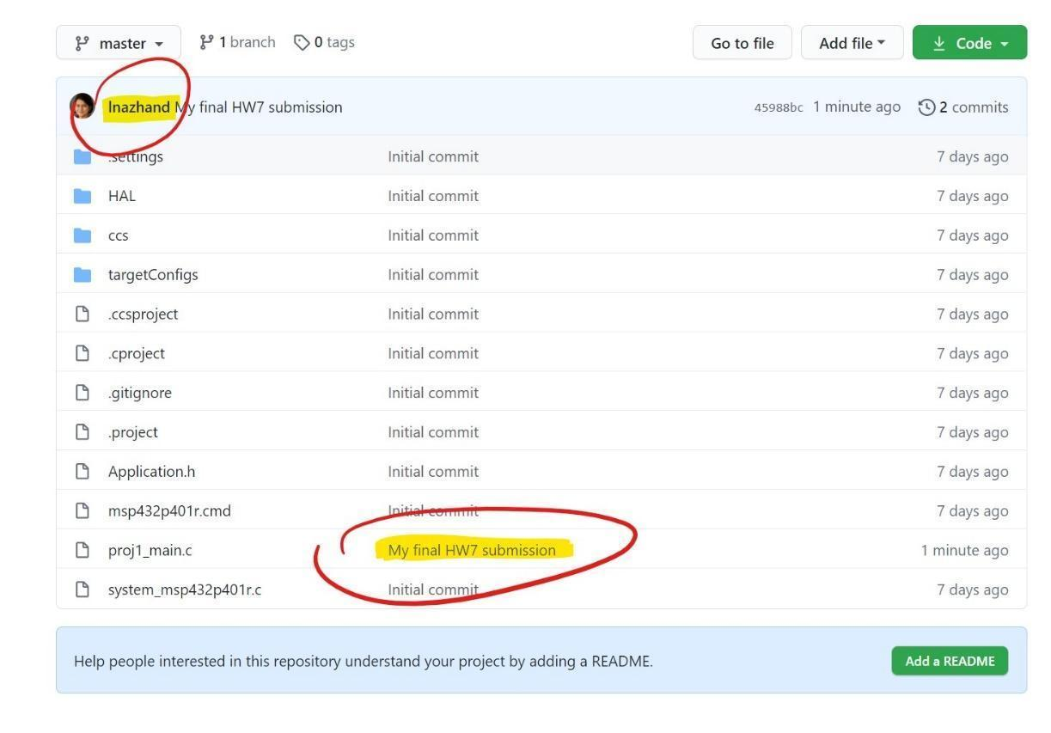
Submit the updated version of this document to Canvas by the deadline for HW12.

