1
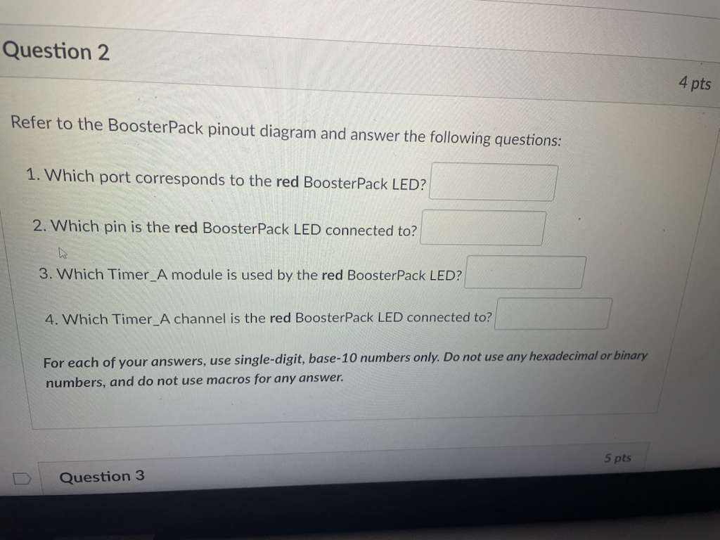
2, 6, 0, 3

2
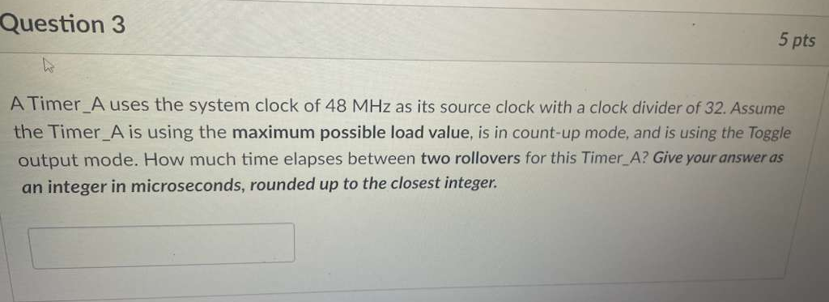
87381

3
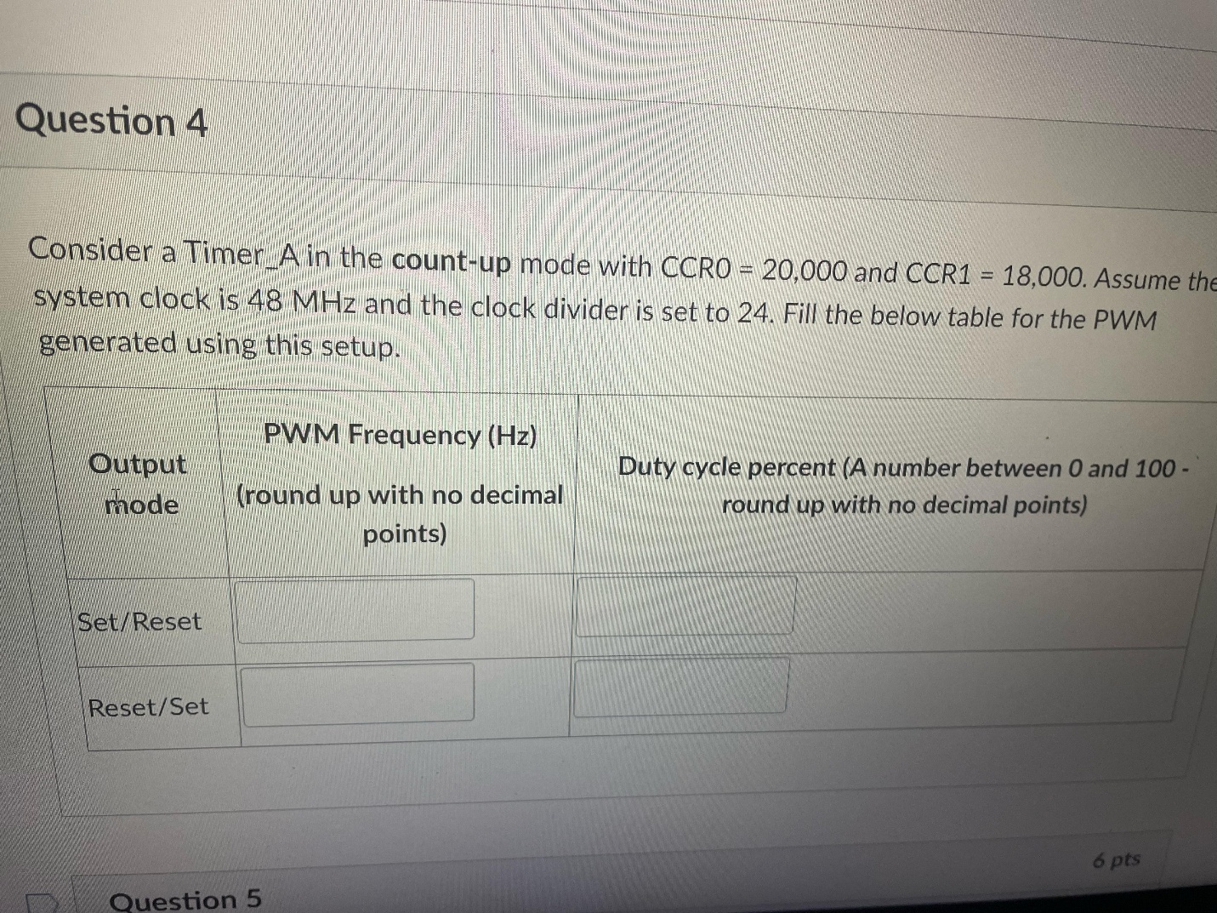
100, 10
100, 90

4
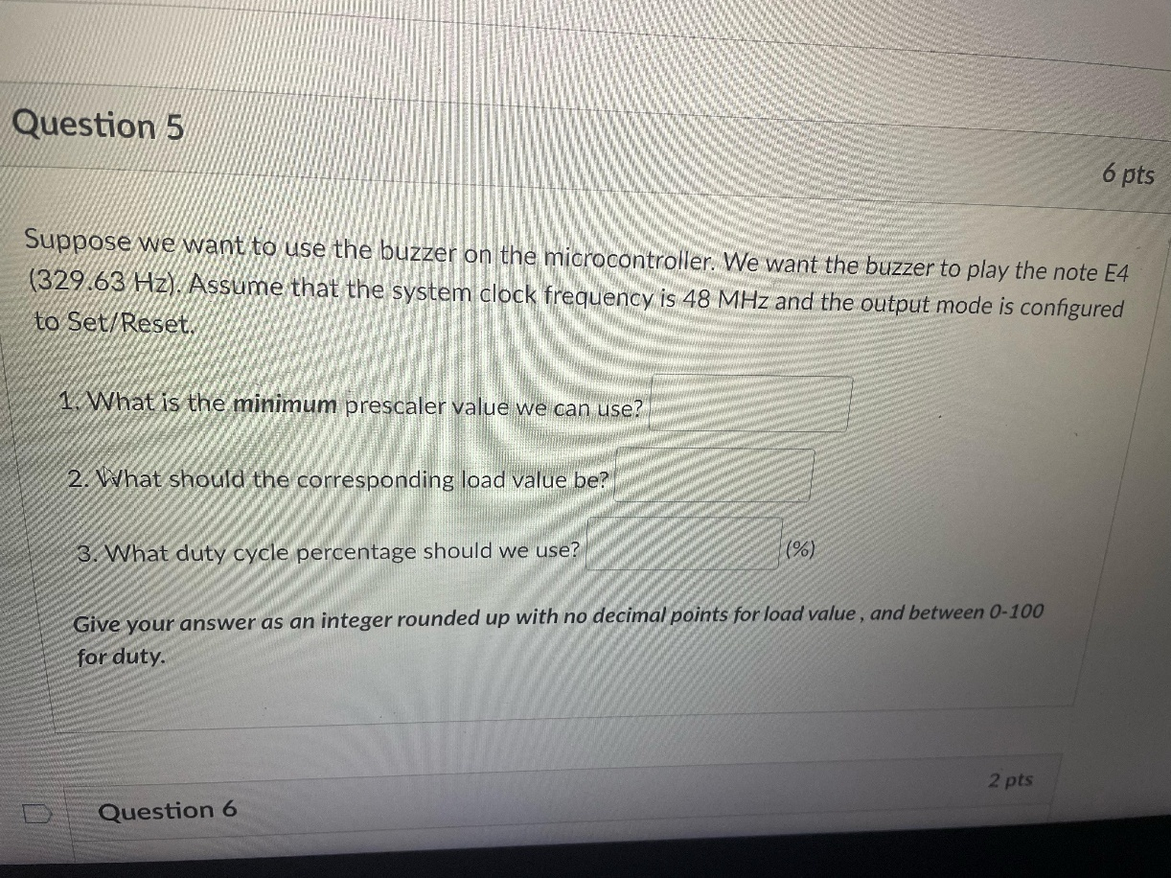
3, 48539, 50

5
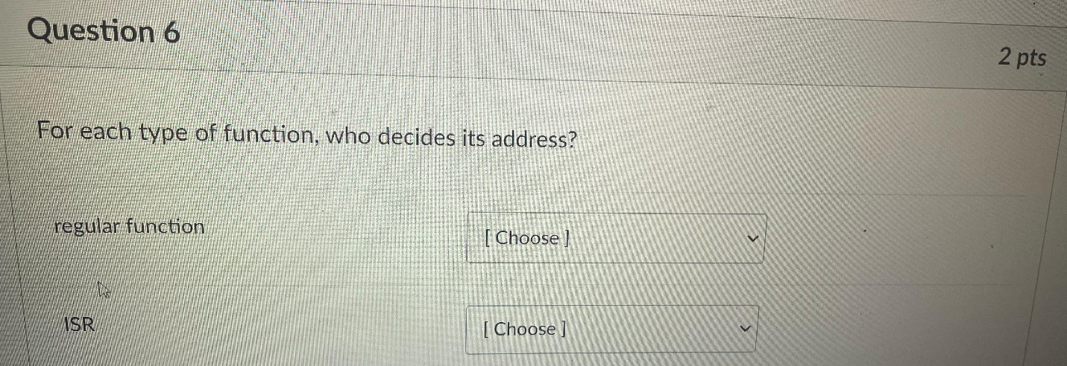
Software, vector table

6
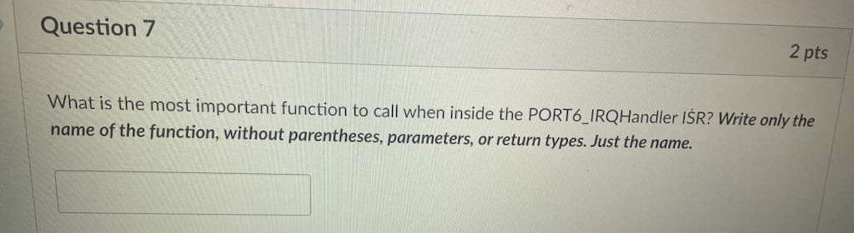
GPIO_clearInterruptFlag – NOT SURE

7
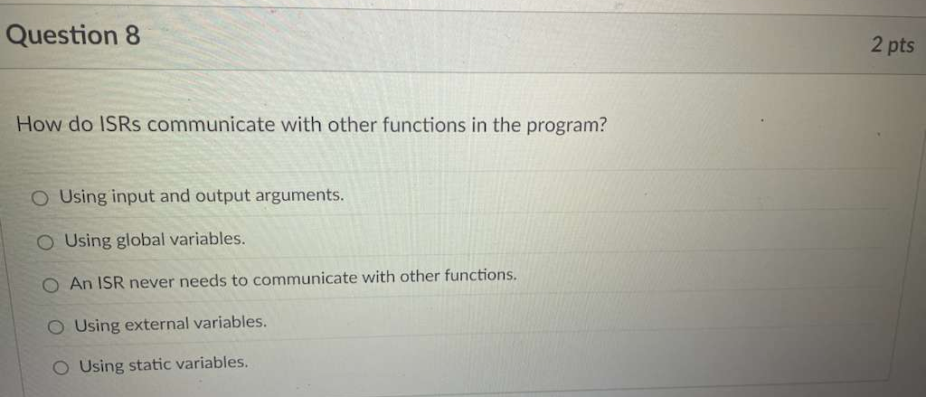
2nd

8
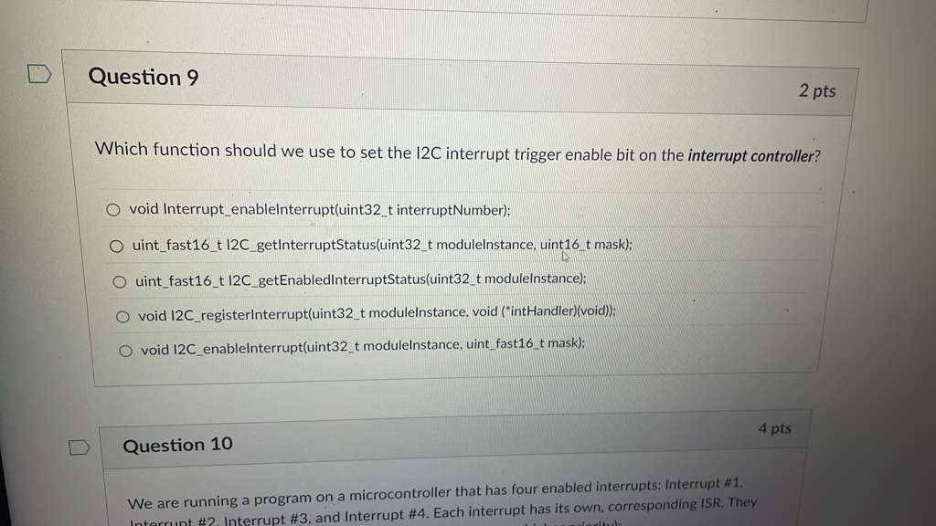
1st

9
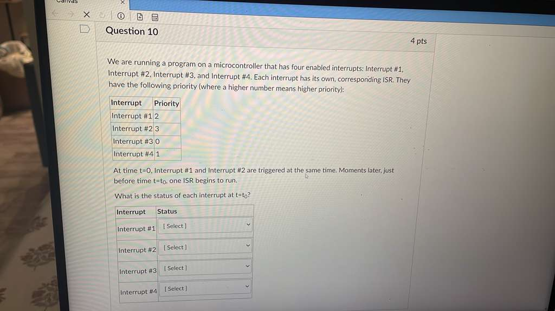
Pending, Active, Inactive * 2

10
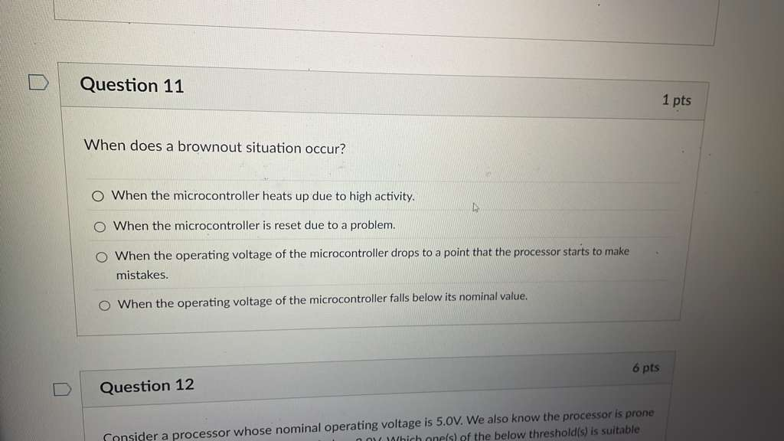
3rd

11
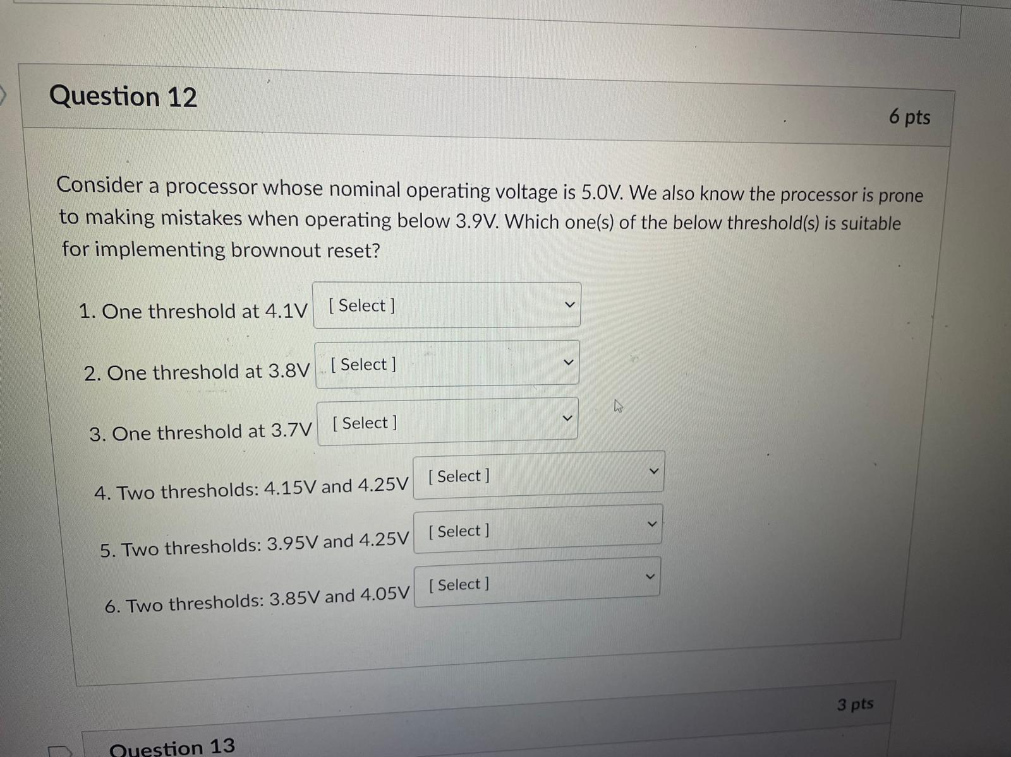
Unsuit * 3, Suit * 2, Unsuit

12
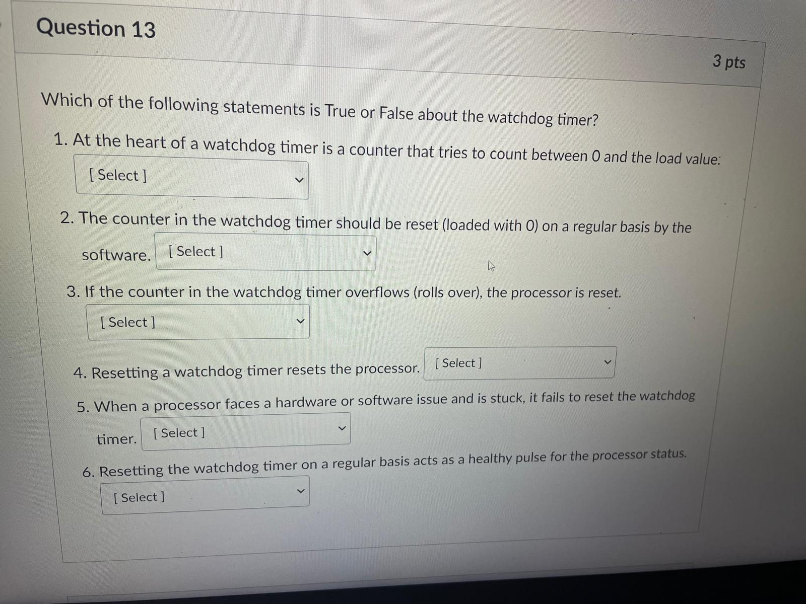
T * 3, F, T, T

13
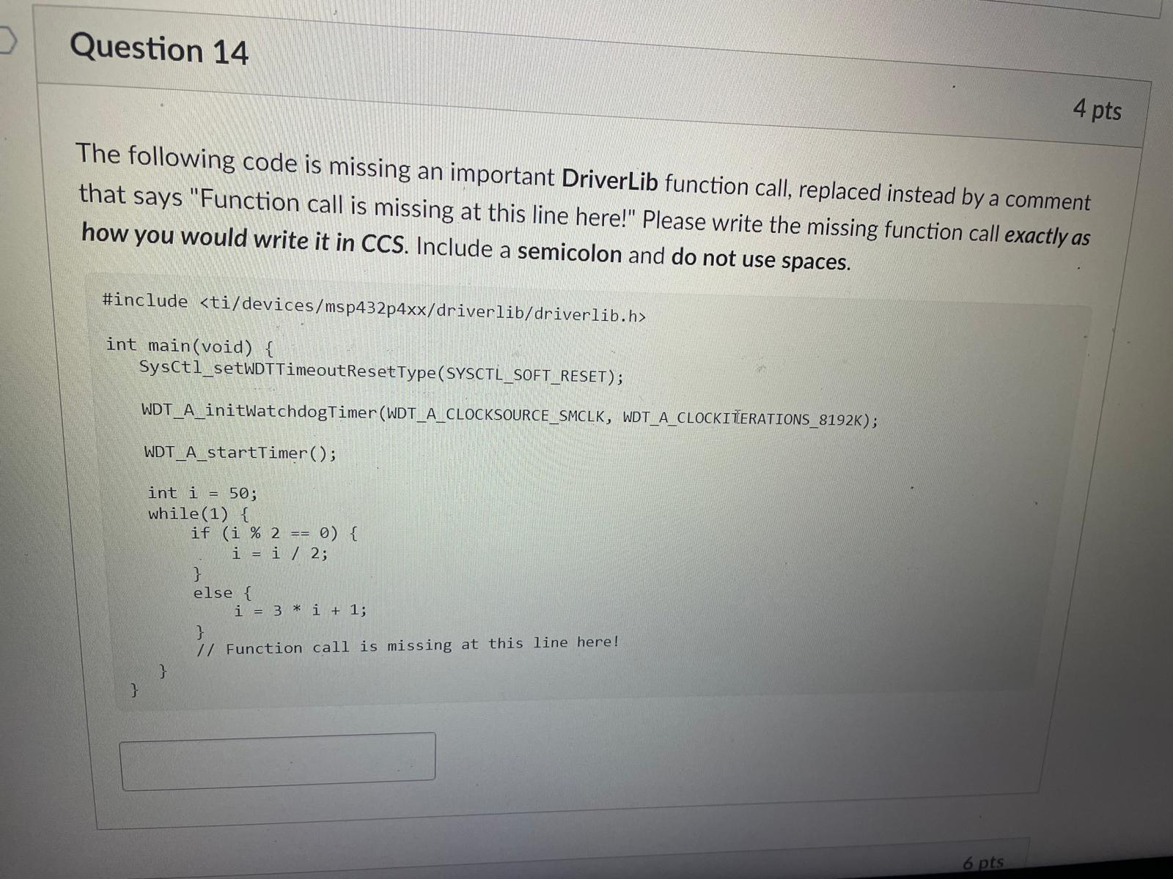
WDT_A_clearTimer();

14
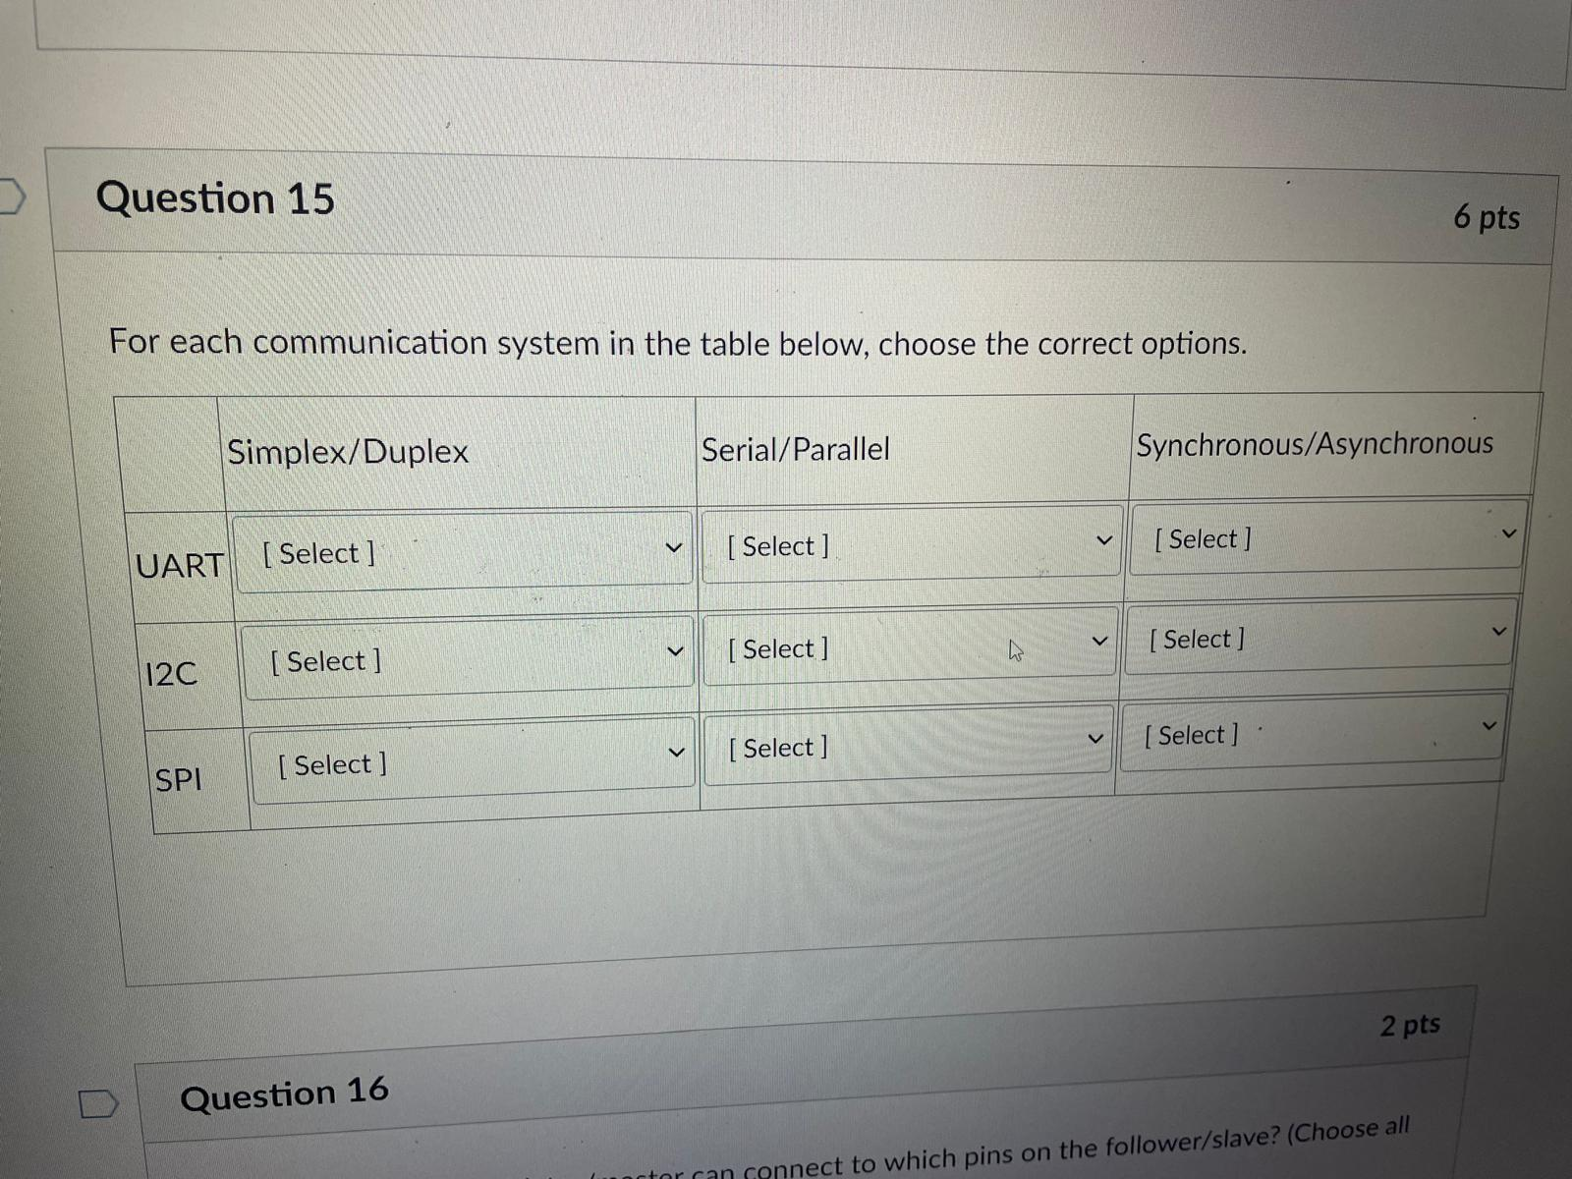
Full, Serial, Asyn
Half, Serial, Syn
Full. Serial, Syn

15
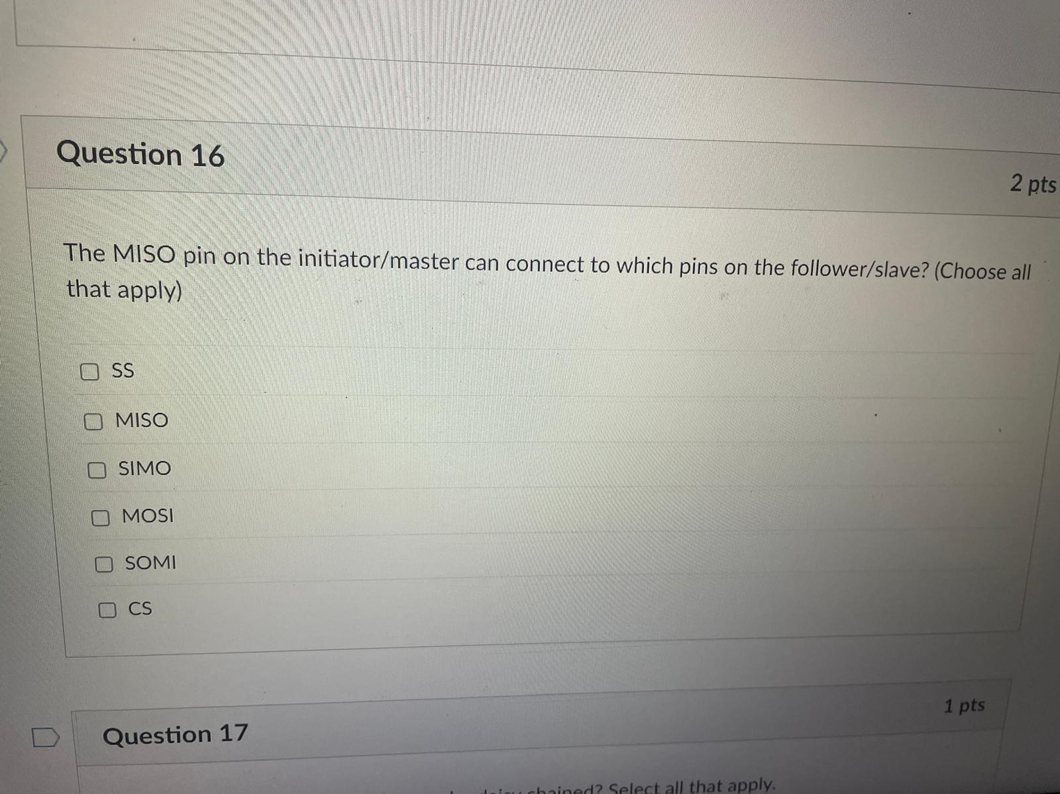
SIMO, MOSI

16
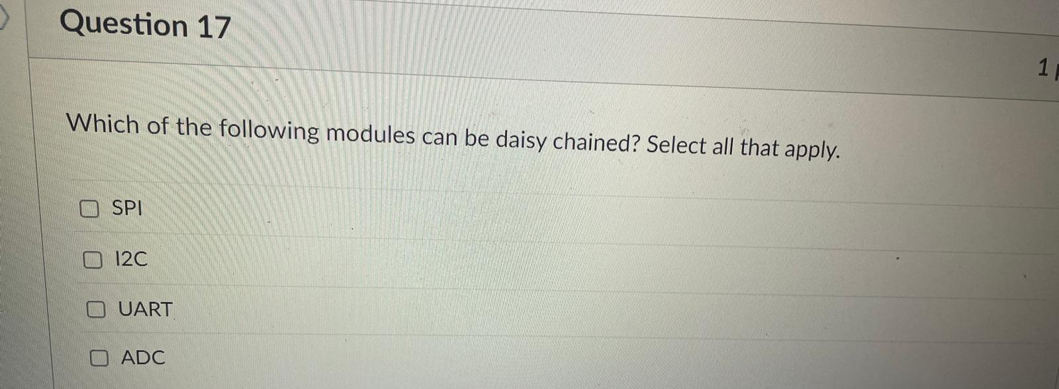
SPI

17
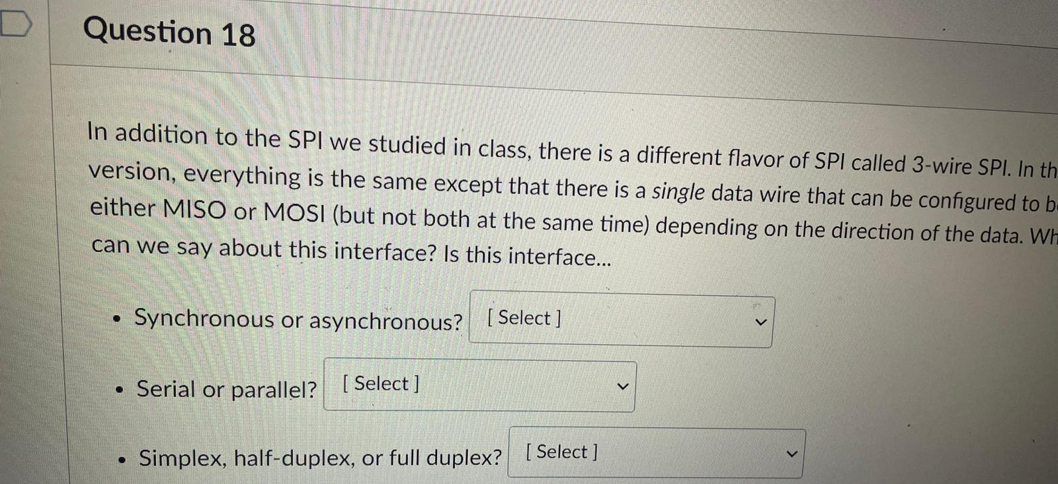
Syn, Ser, Half

18
Low

19
1

20
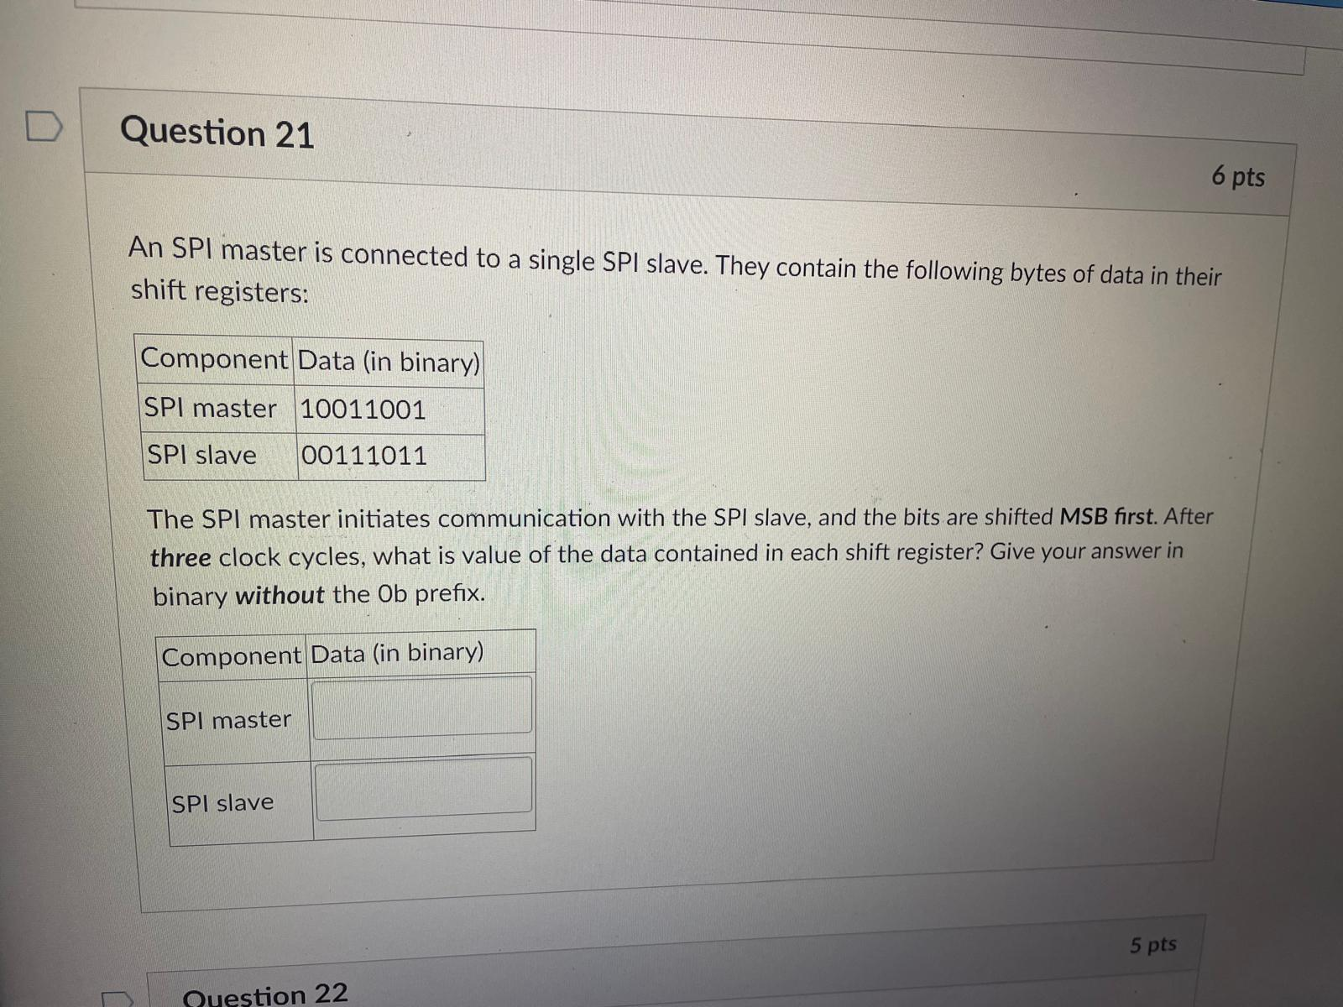
11001001
11011100

21
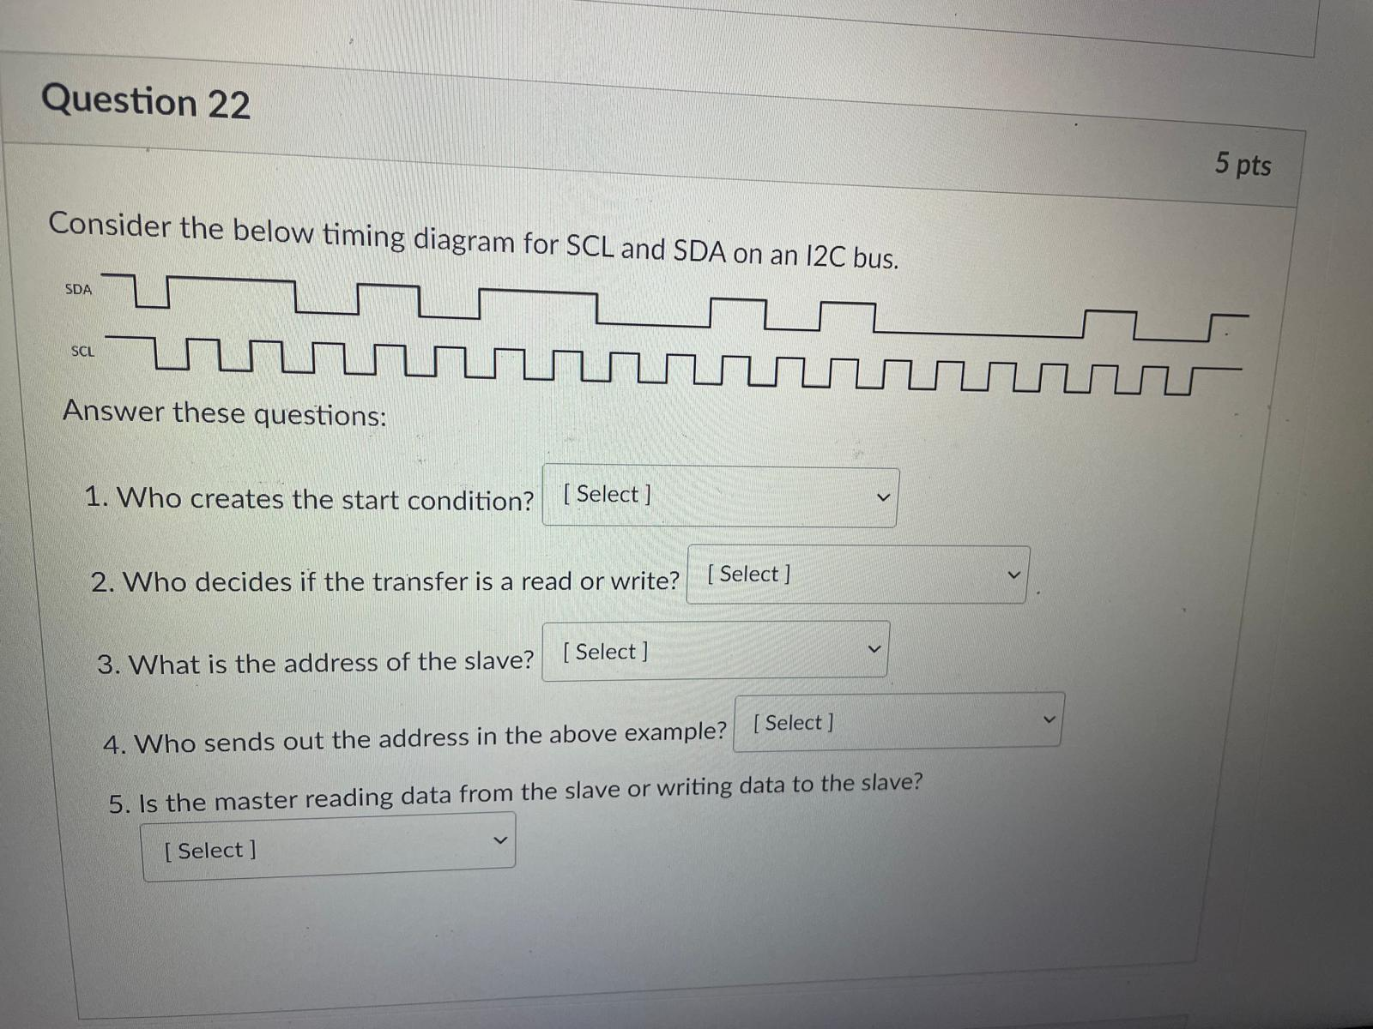
Master * 2, 0b1101011 = 0x6B, Master, Write

22
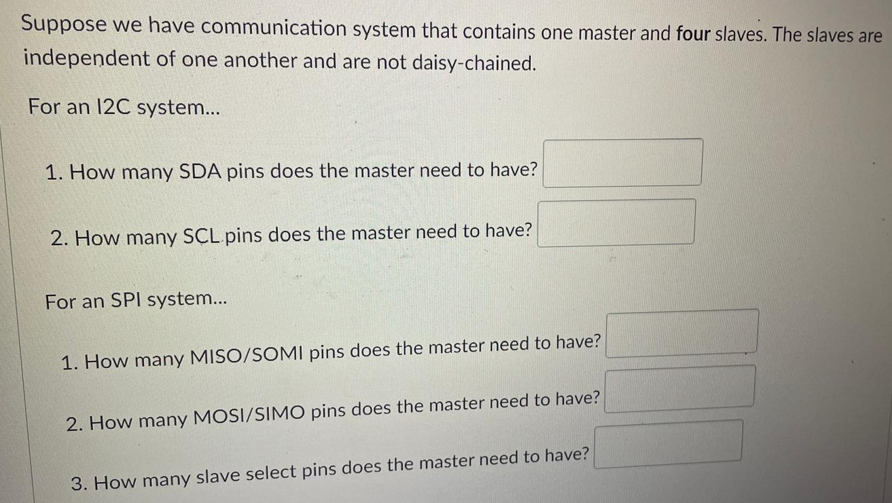
1, 1, 1, 1, 4

23
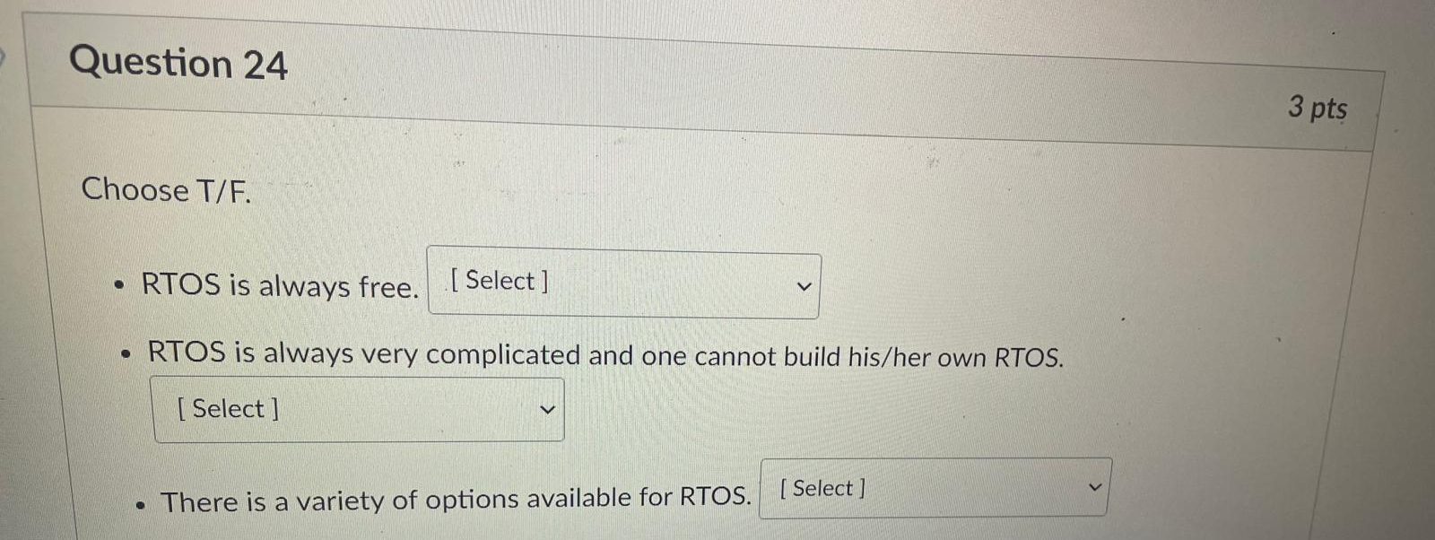
F, F, T

24
RAM – volatile
ROM, Flash - non

25
Non-blocking

26
2nd


