ECE 2564
Fall 2025
Homework 3

Please sign (You can type your name in place of signature.)
“I have neither given nor received unauthorized assistance on this assignment.”
Samin Rahman
To complete this homework, you need to complete the following steps:

- Sign the Honors Code statement.

- Accept the following GitHub classroom assignment:
https://classroom.github.com/a/r3wzhCvY

- Import your homework repository to CCS.

- There are two projects for this homework. Follow the instructions below to complete each problem. As you follow the instructions, you are developing code in CCS and creating an answer/solution document. The solution document could be this Word document where you have entered your answers, screenshots, etc. Alternatively, you can create a document from scratch.

- Once you have finished each problem, submit your code to GitHub.

- Turn your solution document (perhaps a modified version of this document) to Canvas.

- You will be graded based on the code you submit on GitHub and the document you submit to Canvas.
- All the C header files required for this homework are already included in the starter kit. You are not allowed to add/include any additional header files to your source code.

Problem 0. Enter your GitHub repository link here.

Problem 1. (25 points)
In this problem, you will experiment with setting, resetting and toggling bits of a given integer. You are required to use predefined macros, BIT0, BIT1, BIT2, … or define your own bitmasks to achieve this. Open the project related to problem 1 and read the whole code including comments. There are to-do items in the code that you have to complete. After finishing each to-do, you are welcome to compile and debug the code to make sure your code works as you expect it.

Tip: You can view variables in binary by right clicking on variable row > Number Format > Binary:
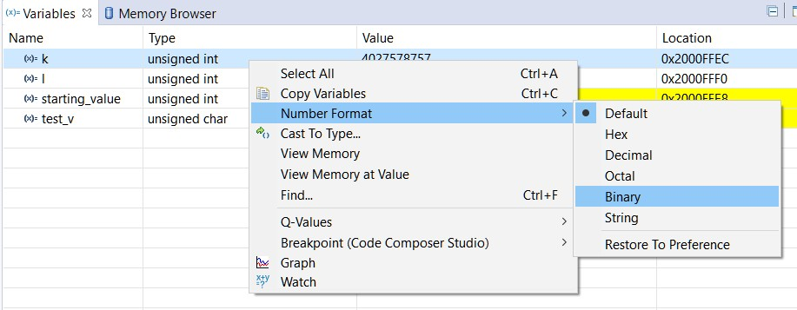

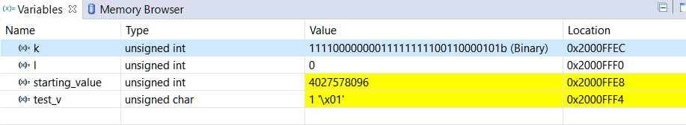

- (20 points) Copy-paste your whole code from hw3_p1_main.c to your solution document.
/*
* This project is related to the problem 1 of HW3, ECE2564 Fall 2025.
* It is important that you read the PDF homework description to understand what you need to do.
* The comments and TODO items in this document may not be self-sufficient to tell you how to complete this project.
*/

// This is so that we can use printf
#include <stdio.h>

// This is so that we can use BIT0, BIT1, ... macros as well as types bool, keywords true, false
#include <ti/devices/msp432p4xx/driverlib/driverlib.h>

void main()
{
// You should change starting_value to different values and test the code you write below to check if it works for all cases.
unsigned int starting_value = 0xF0000000;
bool test_v;

unsigned k = starting_value;

/* Example: In the below example we clear all the bits in k except for the LSB, or Bit 0 and store the result in a new variable l.
* For this purpose, we use BIT0 mask.
* To see where this macro is defined and what it means, hold the Ctrl key on your keyboard and click on BIT0 word below.
* The first 16 bitmasks, BIT0 to BITF are defined simply as BIT* where * is the bit index in hex.
* For all other single-bit masks the macro is defined as BIT(x) where x is any unsigned number and is the index of the single 1 in the bitmask.
* Optional: Debug the code without changing anything and see the values for k and l.
*/

unsigned int l = k & BIT0;

/*
* TODO #1: Write a snippet of code that will cause the bits 2, 7 and 10 of k to be set to 1,
* without affecting any other bits of k. Store the result back into k. 5 points
*/

k |= (BIT2 | BIT7 | BITA);

/*
* TODO #2: Write a snippet of code that will cause the third least-significant nibble (4-bit chunk) of k to contain
* the bit pattern 1011 without affecting any other bits of k. Store the result back into k. 5 points
* Hint: The least-significant nibble are bits 0, 1, 2, and 3. Your goal is to make bits 8, 9, 10 and 11 be 1, 0, 1, and 1, respectively.
*/

k |= (BIT8 | BITA | BITB);
k &= ~BIT9;

/*
* TODO #3: Write a snippet of code that toggles bit 1 and 2, sets bit 4 and 6 to 1, and resets bit 8 and 11 to 0. Store the result back into k. 5 points
*/

k ^= (BIT1 | BIT2);
k |= (BIT4 | BIT6);
k &= ~(BIT8 | BITB);

/*
* TODO #4: Write the expression that computes variable test_v, the Boolean value that is True if the third MSB of k equal to the fourth LSB of k.
* You need to remove the word "true" that is assigned to test_v and replace it with some other expression that evaluates based on the aforementioned condition.
*/

// Implement the evaluation for test_v here
int thirdMSB = (k >> 29) & BIT0;
int fourthLSB = (k >> 3) & BIT0;
test_v = (thirdMSB == fourthLSB);

if (test_v)
printf("The test variable is true.\n");
else
printf("The test variable is false.\n");
}

- (5 points) Show a screenshot of the debugger window at the end of your debugging session. Make sure the Variables view is open. The starting_value should be something you have chosen. Also, since you have written code for updating k, k should be different from starting_value and your test_value could be true or false depending on your k.

Test case for false 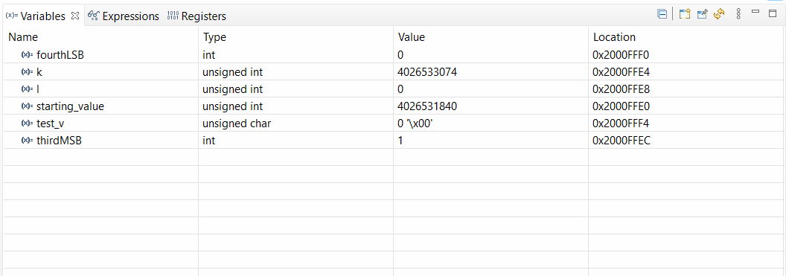
Test case for true 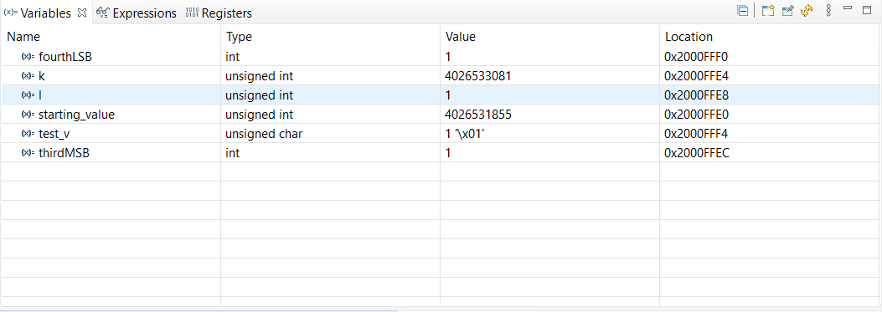

Problem 2. (75 points)
In this problem, you will experiment with structures, pointers, macros, enum, typedef and bit manipulation. Consider a stage lighting system. Each light in the system has an x and y coordinate that reflects its location on the stage which can be between 0 and 100. Each light also has a register that determines its status, called Light Status Register or LSR. For each LSR, the bits control the light based on the below specification.

- Bit 0: controls whether the light flickers: 0 no flicker, 1 flicker.
- Bit 2-1: control the light intensity: 00 off, 01 low, 10 medium, 11 high.
- Bit 4-3: control the color: 00 white, 01 blue, 10 red, 11 green.
- Bit 7-5: unused.

Examples:
- If we write 0x00 to an LSR, it means that the corresponding light should be off.
- If we write 0xFF to an LSR, it means that the corresponding light should be green, high intensity, and flickering.

Our goal is to develop a project that can control this lighting system with an easy-to-read and easy-to-debug code.

- (3 points) Write the value of an LSR that programs a light with red color, low intensity and no flicker. Show the value both in binary and hex.
Binary: 00010010, Hex: 0x12

- (3 points) Translate what it means if the value of an LSR is 0x9A.
In binary it’s 10011010, so the light is green, low intensity, no flicker

- (14 points) Open the project associated with problem 2 in CCS and study the whole code, especially the comments! Complete TODOs #1 through #5. These to-do items only set the stage for developing code. Copy-paste your code for to-do items 1 through 5. Once you finish this step, your code should compile without errors.

// TODO #1: complete the below bitmasks. Intensity mask is given to you as an example.
// You need to change the rest from 0 to the appropriate value.
// The position in this context means the lowest index in the bitmask that contains a 1
#define INTENSITY_MASK (BIT1 | BIT2)
#define COLOR_MASK (BIT3 | BIT4)
#define FLICKER_MASK BIT0

//-----------------------------------
// TODO #2: complete the below bitmask positions. Intensity bit position is given to you as an example.
// You need to change the rest from 0 to the appropriate value.
// The position of the mask is the index of the lowest bit of the mask.
#define INTENSITY_BIT_POS 1
#define COLOR_BIT_POS 3
#define FLICKER_BIT_POS 0

//-----------------------------------
// TODO #3: Use typedef and enum keywords to define three new types called color_t, intensity_t, and flickering_t.
// These new types enumerate different color, intensity, and flickering possibilities.
// For intensity_t, use the format INT_* where * is OFF, LOW, MED, or HIGH
// For flickering_t, use format FLICK_* where * is OFF or ON
// color_t is done for you as an example.
typedef enum {WHITE, BLUE, RED, GREEN} color_t;
typedef enum {INT_OFF, INT_LOW, INT_MED, INT_HIGH} intensity_t;
typedef enum {FLICK_OFF, FLICK_ON} flickering_t;

//-----------------------------------
// TODO #4: There is no action item here for you except for reading the below line.
// In here we are defining a new type LSR_t just to add readability to our code.
typedef unsigned char LSR_t;

//-----------------------------------
// TODO #5: Create a structure that hold the data needed for each light.
// Most of the work is done for you. All you need is to study this and add one element that is missing.
typedef struct {
LSR_t lightSetting; // the setting of the light
unsigned int x; // the x coordinate of the light
unsigned int y; // the y coordinate of the light
} light_t;

- (8 points) Complete to-do item #6, which is developing three functions and debugging them. (The first function is given to you as a guide.) Copy-paste the solution to your three functions below. (The placeholder for these functions is below the main function.)
/*
* input:
* LSR_t
* output:
* color_t
* effect:
* This function isolates the color setting of LSR and returns it
* Example: If the input is 0xFF, the output is RED
*/

color_t getColorSetting(LSR_t inLSR)
{
// The below line creates a warning because the right side of the assignment is not of type color_t.
// If you like you can typecast the right side to color_t
// The typecasted version is like this:
// color_t colorSetting = (color_t) ((inLSR & COLOR_MASK) >> COLOR_BIT_POS);
color_t colorSetting = ((inLSR & COLOR_MASK) >> COLOR_BIT_POS);
return colorSetting;
}

/*
* input:
* LSR_t
* output:
* intensity_t
* effect:
* This function isolates the intensity setting of LSR and returns it
*
* Example: If the input is 0xFF, the output is INT_HIGH
*/
intensity_t getIntensitySetting(LSR_t inLSR)
{
intensity_t intensitySetting = ((inLSR & INTENSITY_MASK) >> INTENSITY_BIT_POS);
return intensitySetting;
}

/*
* input:
* LSR_t
* output:
* flickering_t
* effect:
* This function isolates the flickering setting of LSR and returns it
*
* Example: If the input is 0xFF, the output is FLICK_ON
*/
flickering_t getFlickeringSetting(LSR_t inLSR)
{
flickering_t flickerSetting = ((inLSR & FLICKER_MASK) >> FLICKER_BIT_POS);
return flickerSetting;
}

- (2 points) Debug your code for item #6 and take a screenshot and put it here. Change tempLSR to 0x9A before you debug. You can check your code against the answer you provided to part B. They should match! Notice how in the variable view the enum variables are shown with their enum instance. For example, the variable flickering will be either FLICK_ON or FLICK_OFF in the debugger after you are done debugging this section.

The color, flickering, and intensity variable values match the answer to part B 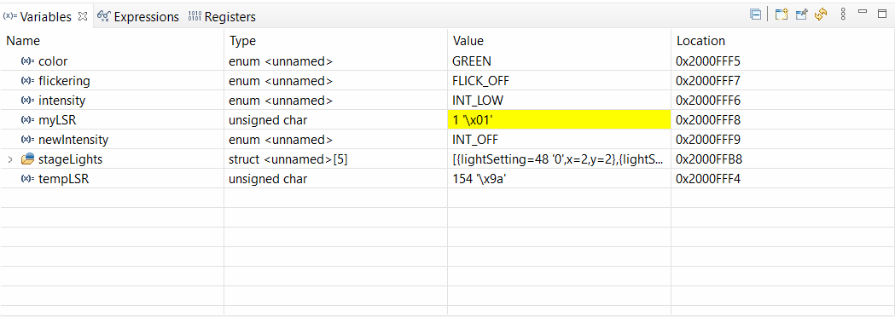

- (18 points) Complete to-do item #7 by developing another three functions. Copy-paste the solution to your three functions below. (The placeholder for these functions is below the main function.)

/*
* input:
* LSR_t * (the pointer to the LSR that needs to be updated) and intensity_t (the new intensity)
* output:
* nothing
* effect:
* This function updates the intensity of the LSR pointed by LSR_p to the new intensity
*/
void updateIntensity(LSR_t* LSR_p, intensity_t newIntensity)
{
*LSR_p &= ~INTENSITY_MASK;
*LSR_p |= (newIntensity << INTENSITY_BIT_POS);
}

/*
* input:
* LSR_t * (the pointer to the LSR that needs to be updated) and color_t (the new color)
* output:
* nothing
* effect:
* This function updates the color of the LSR pointed by LSR_p to the new color
*
*/
void updateColor(LSR_t* LSR_p, color_t newColor)
{
*LSR_p &= ~COLOR_MASK;
*LSR_p |= (newColor << COLOR_BIT_POS);
}

/*
* input:
* LSR_t * (the pointer to the LSR that needs to be updated) and flickering_t (the new flickering)
* output:
* nothing
* effect:
* This function updates the flickering of the LSR pointed by LSR_p to the new flickering
*/
void updateFlicker(LSR_t* LSR_p, flickering_t newFlicker)
{
*LSR_p &= ~FLICKER_MASK;
*LSR_p |= (newFlicker << FLICKER_BIT_POS);
}

- (2 points) Debug the lines of code related to item #7 after updating them to produce your answer in part A. Take a screenshot of your debugger output. What is the value of tempLSR? Check it against your answer to part A; they should match!

0x92 = 10010010 in binary, which matches the answer to part A (ignoring the unused bits)
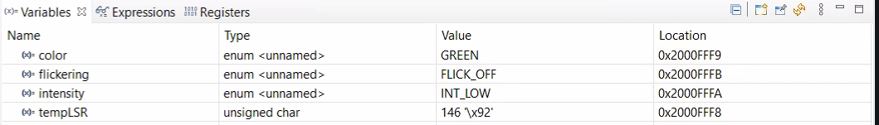

- (8 points) Complete item #8 and copy-paste the solution for the code you have written for makeLSR. (The placeholder for this function is below the main function.)
/*
* input:
* intensity_t, color_t and flickering_t of the to-be-constructed LSR
* output:
* LSR_t
* effect:
* This function receives three integers representing lamp flickering status, color, and intensity and returns the LSR value
* that will create that light combination. Use 0s for unused bits in the LSR.
* For example, makeLSR with high intensity, red color and flickering returns 0x17
*/
LSR_t makeLSR(intensity_t newIntensity, color_t newColor, flickering_t newFlickering)
{
LSR_t lsr = 0;
updateColor(&lsr, newColor);
updateIntensity(&lsr, newIntensity);
updateFlicker(&lsr, newFlickering);
return lsr;
}

- (2 points) Debug the lines that test makeLSR. Take a screenshot of the debugger window and paste it here.

myLSR = 0x13 = 00010011 in binary, which means red, low intensity, flickering – exactly as intended
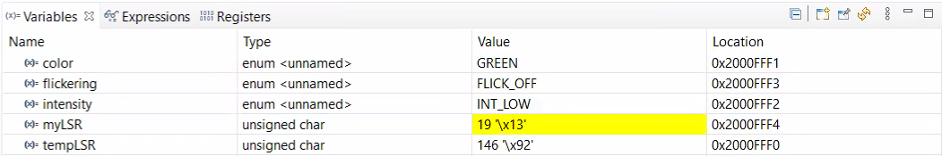

- (18 points) Write this function increaseLight for item #9. To receive full points, you need to call these functions within this function:
  - getIntensitySetting
  - updateIntensity
Copy-paste your answer to increaseLight function here. (The placeholder for this function is below the main function.)
/*
* input:
* LSR_t * (the pointer to the LSR that its light intensity should be increased
* output:
* none
* effect:
* The intensity setting of the light that the pointer is pointing to is increased by one level. If it is HIGH, it stays HIGH.
*/
void increaseLight(LSR_t *LSR_p)
{
intensity_t tempIntensity = getIntensitySetting(*LSR_p);
if (tempIntensity != INT_HIGH)
{
tempIntensity++;
updateIntensity(LSR_p, tempIntensity);
}
}

- (2 points) Debug item #9, can you confirm that the light intensity of myLSR has increased?

Yes, newIntensity is now INT_MED when originally myLSR had an intensity of INT_LOW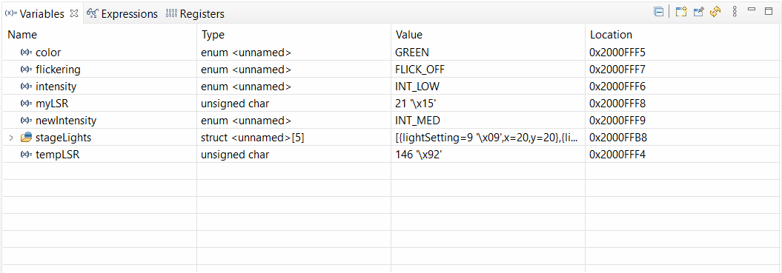

- (18 points) Complete to-do item #10. This is the first time you are writing any code inside the main function. You need to call the functions you developed in the earlier steps to achieve your goal. Copy-paste your snippet of code here.

/* TODO #10: Write a snippet of code that if the x coordinate of a light is greater than 50, then intensity is increased.
* If the x coordinate and the y coordinate of a light are more than 50, the color should be blue. Otherwise, the light should flicker.
* You have to use the functions you developed earlier to achieve this.
*/
unsigned int i;

for (i = 0; i < 5; ++i) {
if (stageLights[i].x > 50) {
increaseLight(&stageLights[i].lightSetting);
}

if (stageLights[i].x > 50 && stageLights[i].y > 50) {
updateColor(&stageLights[i].lightSetting, BLUE);
} else {
updateFlicker(&stageLights[i].lightSetting, FLICK_ON);
}
}
}

- (2 points) Debug this last part. Make sure the lights with the x and y coordinates that fall under the conditions described in the to-do item are updated correctly. Take a screenshot of the debugger window and attach it here.

All light settings are updated correctly according to the given conditions


