Problem 1

A.
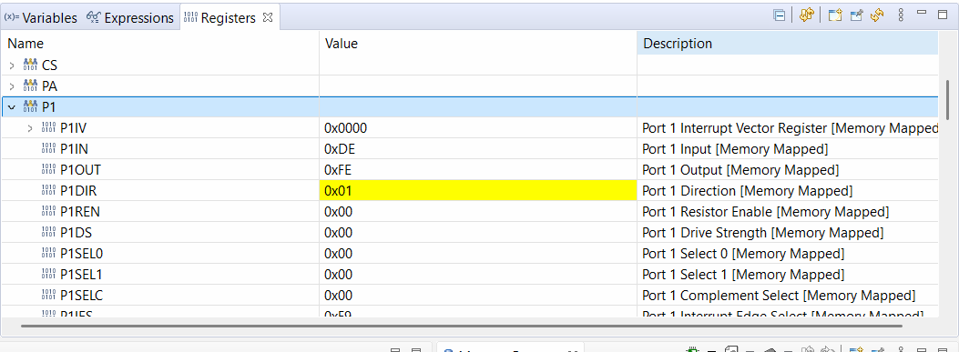

B.
Before pressing LB2: P1IN = 0xDE = b11011110
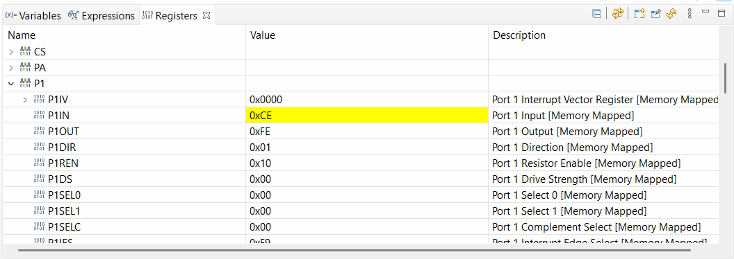
After pressing LB2: P1IN = 0xCE = b11001110
Page 37 of Lauchpad User Guide (User Buttons diagram) shows that LB2 is Pin 4 of Port 1, so its input bit is the 5th LSB of P1IN. Since input is active-low, we see that this bit transitions from 1 to 0 upon pressing LB2.

C.
Before: P1OUT = 0xFE = b11111110
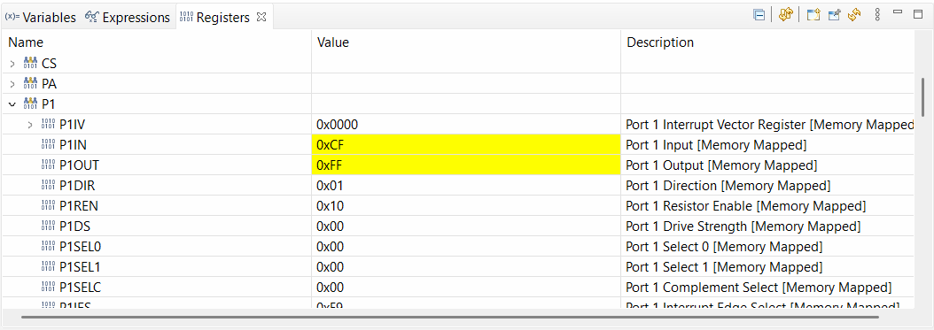
After: P1OUT = 0xFF = b11111111
Page 37 of Lauchpad User Guide (User LEDs diagram) shows that LL1 is Pin 0 of Port 1, so its output bit is the LSB of P1OUT. Since output is active-high, we see that this bit transitions from 0 to 1, and the LED lights up.

D.
BoosterPack User Guide
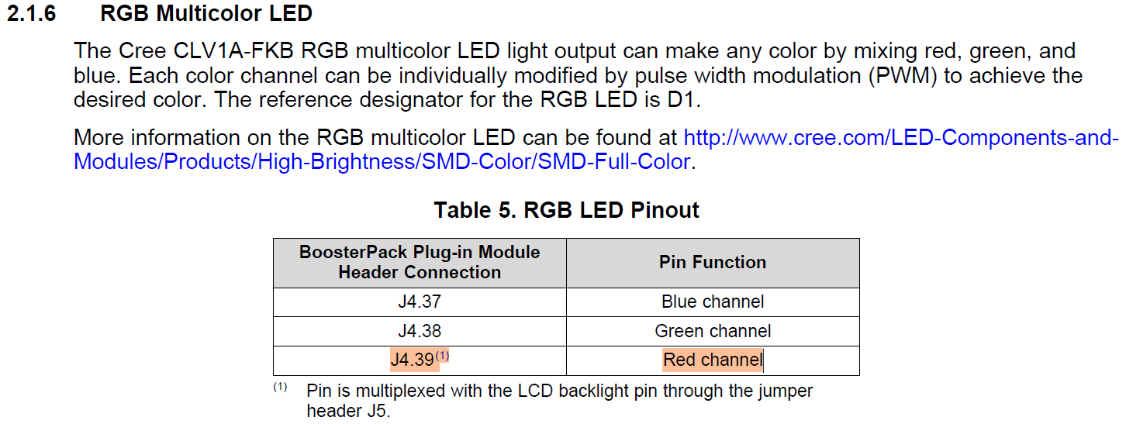
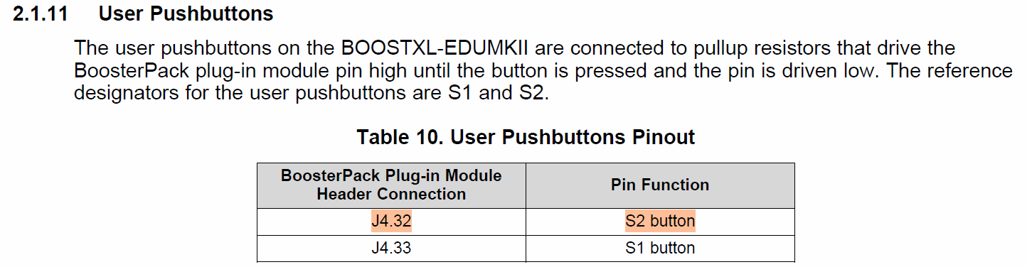

LaunchPad User Guide
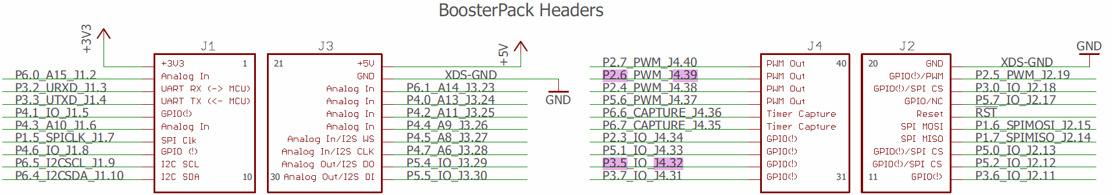

MCU Datasheet
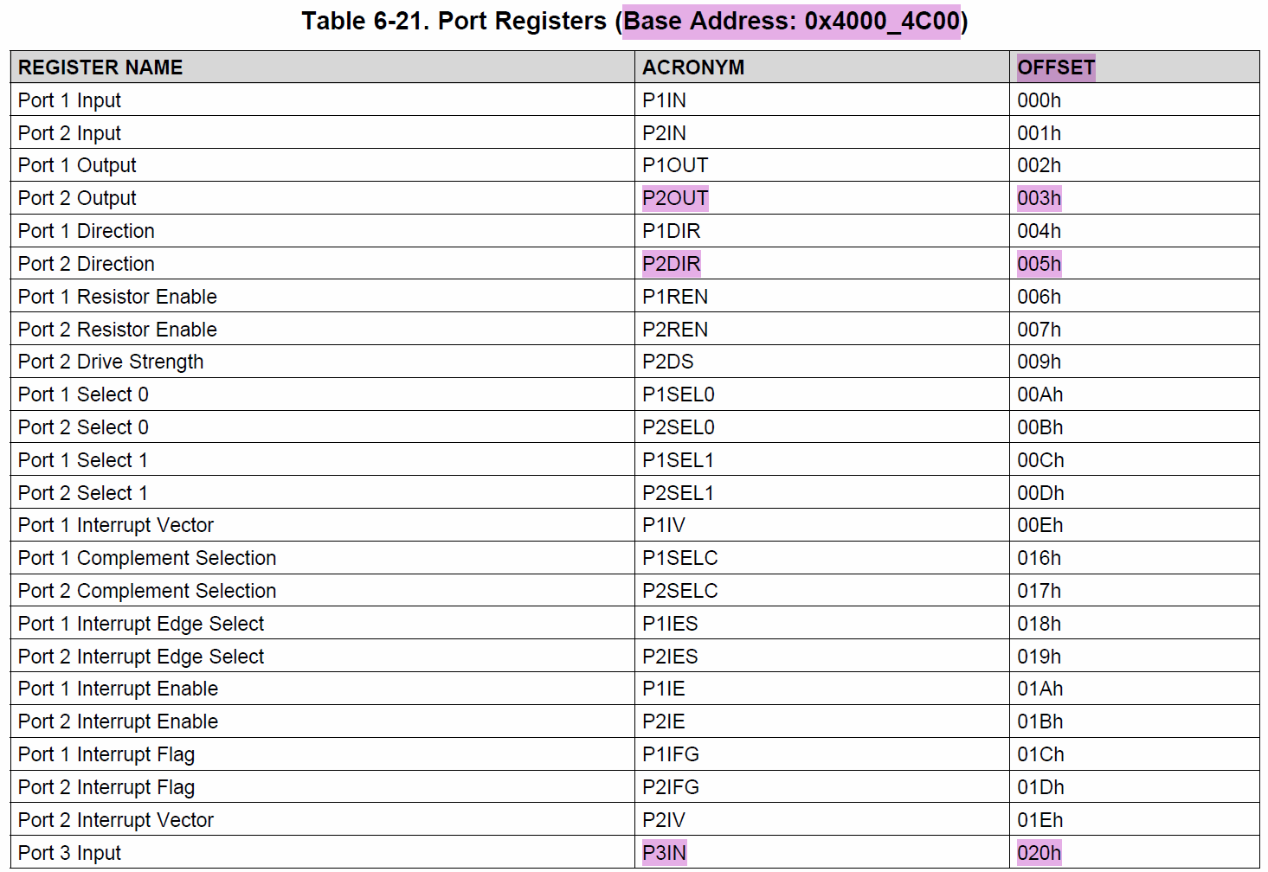
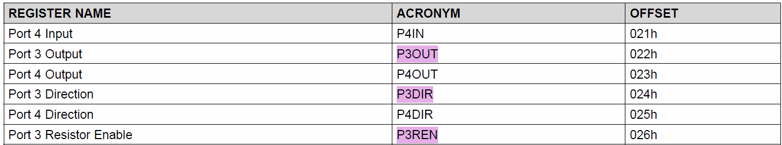

Debugger:
When BB2 pressed:
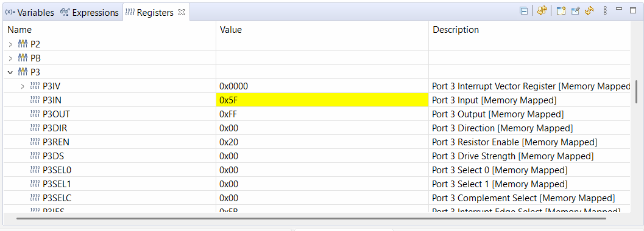
When LED glows red:


