ECE 2564
Fall 2025
Homework 5

Please sign

“I have neither given nor received unauthorized assistance on this assignment. I have not copied any part of this submission from unauthorized resources”.

To complete this homework, you need to complete the following steps:
- Follow the instructions here to create your homework repository. For the homework link, use the below link:
https://classroom.github.com/a/mgGRutnm

- Follow the instructions here to import your homework repository to CCS.

- There is one project for this homework. Follow the instructions in this document to complete the problem.

- Once you have finished the problem, follow the instructions here to submit your work to GitHub. This assignment does not ask you to send the screenshots of your code. Your code will be solely graded based on your GitHub submission. Please allow enough time before the deadline for GitHub submission and double-checking your code. If you have any issue with GitHub and the deadline is close, zip-up your HW5 folder and submit it to a help ticket before the deadline. No late assignment is accepted due to technical difficulties with GitHub.

- Turn your solution document (perhaps a modified version of this document) to Canvas. Your grade will depend on both these submissions.

- For this assignment, you need to use graphics functions to implement an FSM.

To learn more about graphics library and the display on the BoosterPack refer to this page:
https://sites.google.com/vt.edu/introduction-to-embeddedsystem/graphics?authuser=0
To learn more about programming an FSM refer to this page:
https://sites.google.com/vt.edu/introduction-to-embeddedsystem/finite-state-machines/fsm-recipe?authuser=0
- A golden solution is provided with this homework. Use the instructions here to flash the golden solution to observe its behavior.

- Sign the Honor Code statement
Problem 0. Enter your GitHub Repository link here.

(100 points) Problem 1.

The goal of this assignment is for you to learn to work with the display and practice implementing FSM using programming.

Block diagram:
The below graph shows the block diagram of the FSM we wish to implement in this homework. The FSM has two inputs and two outputs. In the code the pair of inputs are organized in one struct. The pair of outputs are also organized in another struct.

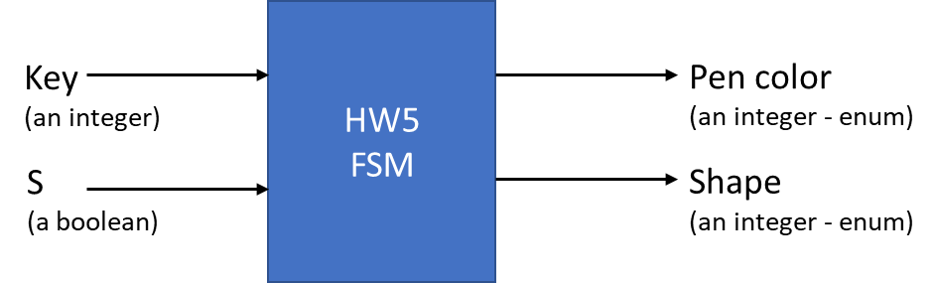

FSM diagram:
The graph in the next page shows the FSM diagram we wish to implement. It shows the states as well as transitions. The initial state is S0. Each transition shows the inputs that invoke it and the output it results in. The detailed description of the format of transition rules is presented in the figure below.

Transition (edge) format:
The below figure shows how inputs and outputs are organized on the transition arrow on the FSM graph that is shown in the next page.

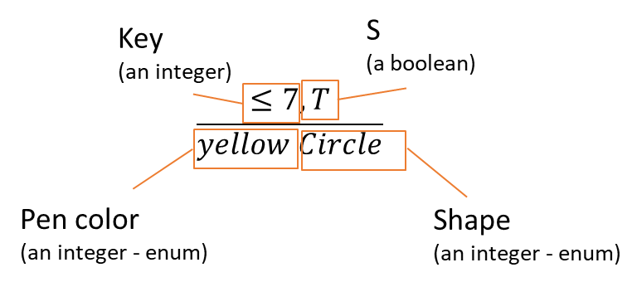
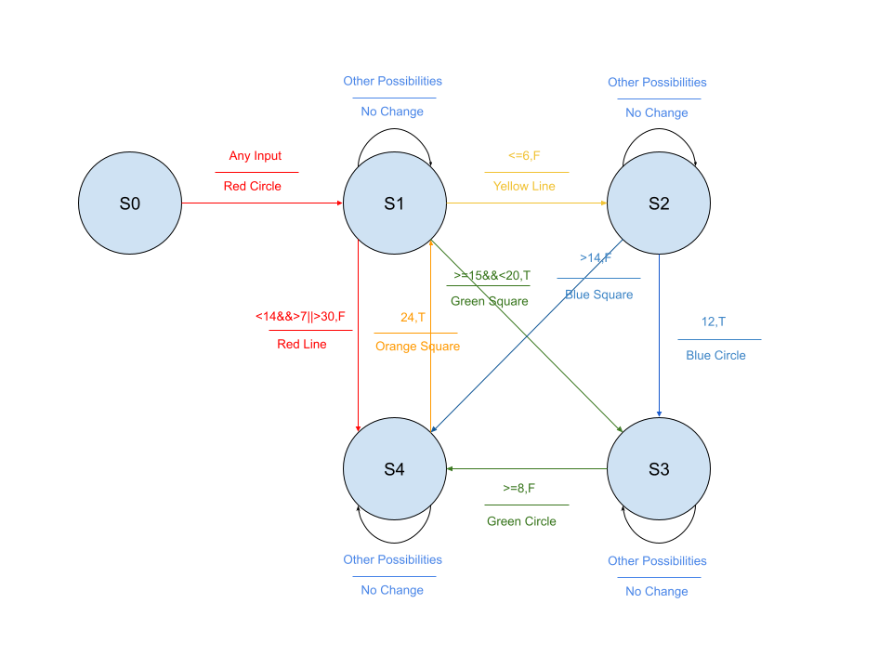
S0->S1->S4->S1->S2->S3->S4->S1->S3
S0->S1->S3->S4->S1->S2->S4->S4->S1

Starter code
In the provided starter code, we have implemented several of the states and edges. We have also defined many of the enum macros needed. You need to carefully read the entire starter code including comments to see what is done and what needs to be added to implement the FSM in the figure.

Providing input to the FSM
To test your FSM, you have to feed it input. There are two ways to feed the input of the FSM:

- Manually from the user using this function:
(Please use debugger while using this function)
in = refresh_input_manual();

- Automatically simulating from pre-determined numbers using this function:
in = refresh_input_simulate();

You should comment out one of them and keep one. If you choose the manual, you will have to use debug mode and enter the input for each transition on the console.

- (65 points) Complete all the TODOs and make sure your FSM is working as intended. Submit your work to GitHub.
(For the line draw any line you wish)

- (10 points) The simulated input function uses an array with the following format. The first number in each tuple is key and the second one is S (0 for false and 1 for true).

input_t in_array[12] = {{3, 1}, {6, 1}, {5, 1}, {4, 0}, {10, 1}, {6,0}, {6, 1}, {3, 0}, {10, 0}, {19, 1}, {6, 1}, {4, 0}};

    - Create an array that results in the following transition. Increase the size of the array if you need to. Put your answer in your code with comment part B.i (you can comment out this array if you wish in your submission.)
S0->S1->S4->S1->S2->S3->S4->S1->S3

    - Create an array that results in the following transition. Increase the size of the array if you need to. Put your answer in your code with comment part B.ii (you can comment out this array if you wish in your submission.)
S0->S1->S3->S4->S1->S2->S4->S4->S1

- (5 points) Fill the circles and squares with color instead of just drawing the perimeter. (This is similar to the golden solution.)

- (5 points) Make the line thicker similar to the golden solution.

- (5 points) Make sure the texts that appear on screen throughout the program are all white (similar to the golden solution).

- (10 points) Move the texts that show state transitions such as “S0 to S1” to the bottom of the screen and show the rounds on top of the screen. Refer to the golden solution for reference. The first transition is called “Round 1”, the second transition is “Round 2”, etc.

