ECE 2564
Fall 2025
Homework 7

Please sign

“I have neither given nor received unauthorized assistance on this assignment. I have not copied any part of this submission from unauthorized resources”.

For this assignment, you will complete parts of Project 1. You can work on any part of Project 1 you wish but to get credit for this assignment, you need to complete the steps below.

Fill the table below with what you expect to get for each part:
(Please note some of these are different from the final project requirement and act as a stepping-stone for your final implementation.)
Item | Full points | Expected points
Finish the TODO items in UART.h file | 5
Finish the TODO items in HAL.c file | 5
Finish the TODO items in UART.c file | 25
Finish the TODO items in proj1_main.c | 10
Set up a UART connection at 9600 BPS in your serial terminal and test your program. You should see ‘L’ on the terminal for letters, ‘N’ for numbers, and ‘O’ for other characters.  (Note: The Golden Solution echoes back the typed character instead of ‘L’/‘N’/‘O’ to the terminal.) | 5
Set up a UART connection at 19200 BPS in your serial terminal, tap on BB2 (for graders LB2 is also correct) and test your program again. You should see the same results as the test with 9600 BPS. | 5
Repeat the above tests for 38400 BPS and 57600 BPS. | 5
Typing characters into MobaXterm will also type them on the board  For a final submission, it should something like this  Displaying p, 5, or ? on the LCD and L, N, O on the terminal is fine | 20
Typing either “u”, “l” (lowercase L, not i), “d”, or “r” will turn on the BLB.  (Please note this is different from the final project requirement and acts as a stepping stone for your final implementation.) | 20
Total | 100

When you are ready to submit your HW7, commit your work to GitHub with a meaningful message such as "My HW7 submission". Take a screenshot of your GitHub submission on the GitHub website highlighting your GitHub ID and your submission message. See the below example. Replace the below image with your own screenshot from GitHub site.
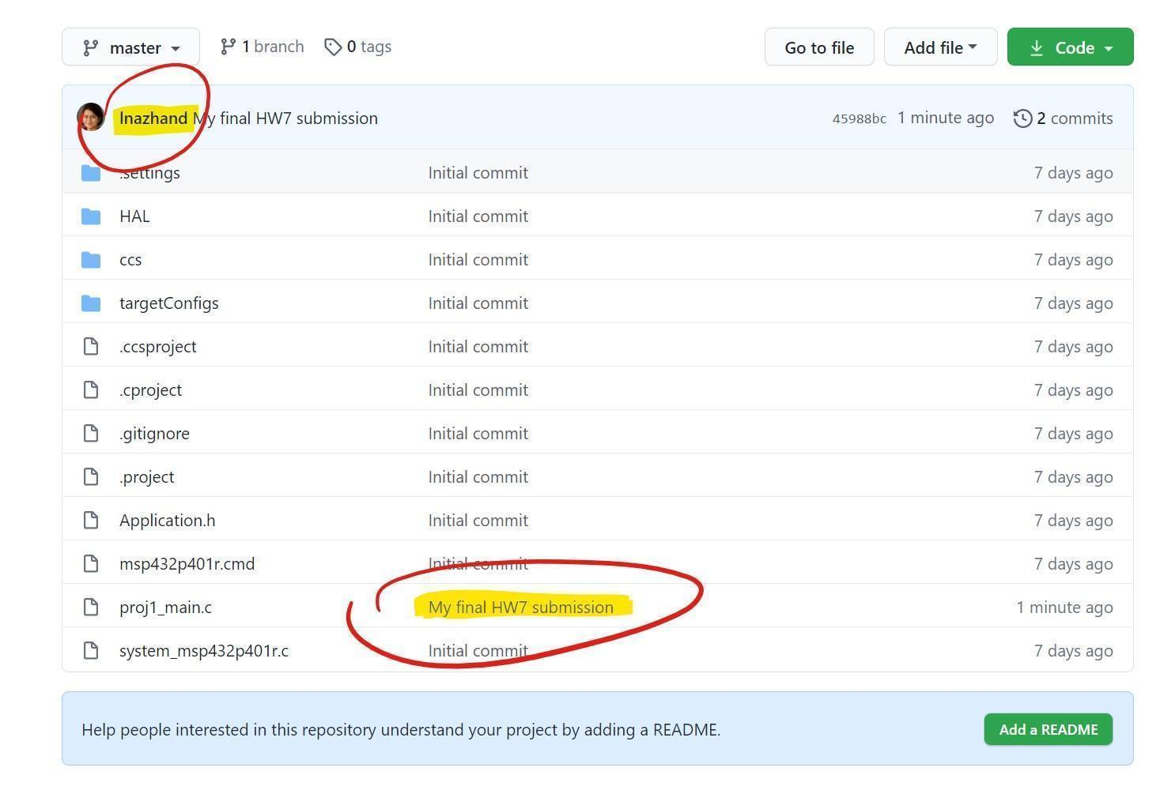
Submit the updated version of this document to Canvas by the deadline for HW7.

