ECE 2564
Fall 2025
Homework 8

Please sign

“I have neither given nor received unauthorized assistance on this assignment. I have not copied any part of this submission from unauthorized resources”.

For this assignment, you will complete parts of project 1. You can work on any part of project 1 you wish but to get credit for this assignment, you need to complete the steps below.
Fill the table below with what you expect to get for each part:
(Please note some of these are different from the final project requirement and act as a stepping-stone for your final implementation.)
Item | Full points | Expected points
Tapping LB2 toggles the Baud Rate. It cycles through the values of 9600, 19200, 38400, and 57600. | 5
The menu screen has at least the default three options: Play Game, High Scores, and Instructions.  For this and the following requirements regarding the different screens, you only need something on the LCD to differentiate the different screens. | 5
A new screen that follows the format of the Game Screen is shown. The squares do not have to be randomized and the values don’t have to be correct.  (Please note this is different from the final project requirement and acts as a stepping stone for your final implementation.) | 10
Prompt over UART, one of the four different scenarios that can occur. It can be deterministic right now but should be randomized in the future.  (Please note this is different from the final project requirement and acts as a stepping stone for your final implementation.) | 20
Valid letters and numbers are echoed over the serial terminal. (”SP”, “SP4”, “IG”, etc.) | 10
Entering inputs that don’t make sense do not affect the serial input or game state, such as “y” will ignore the y, “AG” will ignore that. It only accepts up to 3 character inputs per prompt.  EDIT: Telling the user they input an invalid character is also fine for this section (you’re just getting a bit ahead!).  (Please note this is different from the final project requirement and acts as a stepping stone for your final implementation.) | 20
After entering a valid input, the player is prompted with another event, TR and PE should have some change, but don’t have to be correct. After a raid event, the year should increment by 1.  (Please note this is different from the final project requirement and acts as a stepping stone for your final implementation.) | 20
Upon pressing BB1, the game ends and allows the player to return to the title screen and play again.  (Please note this is different from the final project requirement and acts as a stepping stone for your final implementation.) | 10
Total | 100
When you are ready to submit your HW8, commit your work to GitHub with a meaningful message such as "My HW8 submission". Take a screenshot of your GitHub submission on the GitHub website highlighting your GitHub ID and your submission message. See the below example. Replace the below image with your own screenshot from GitHub site.
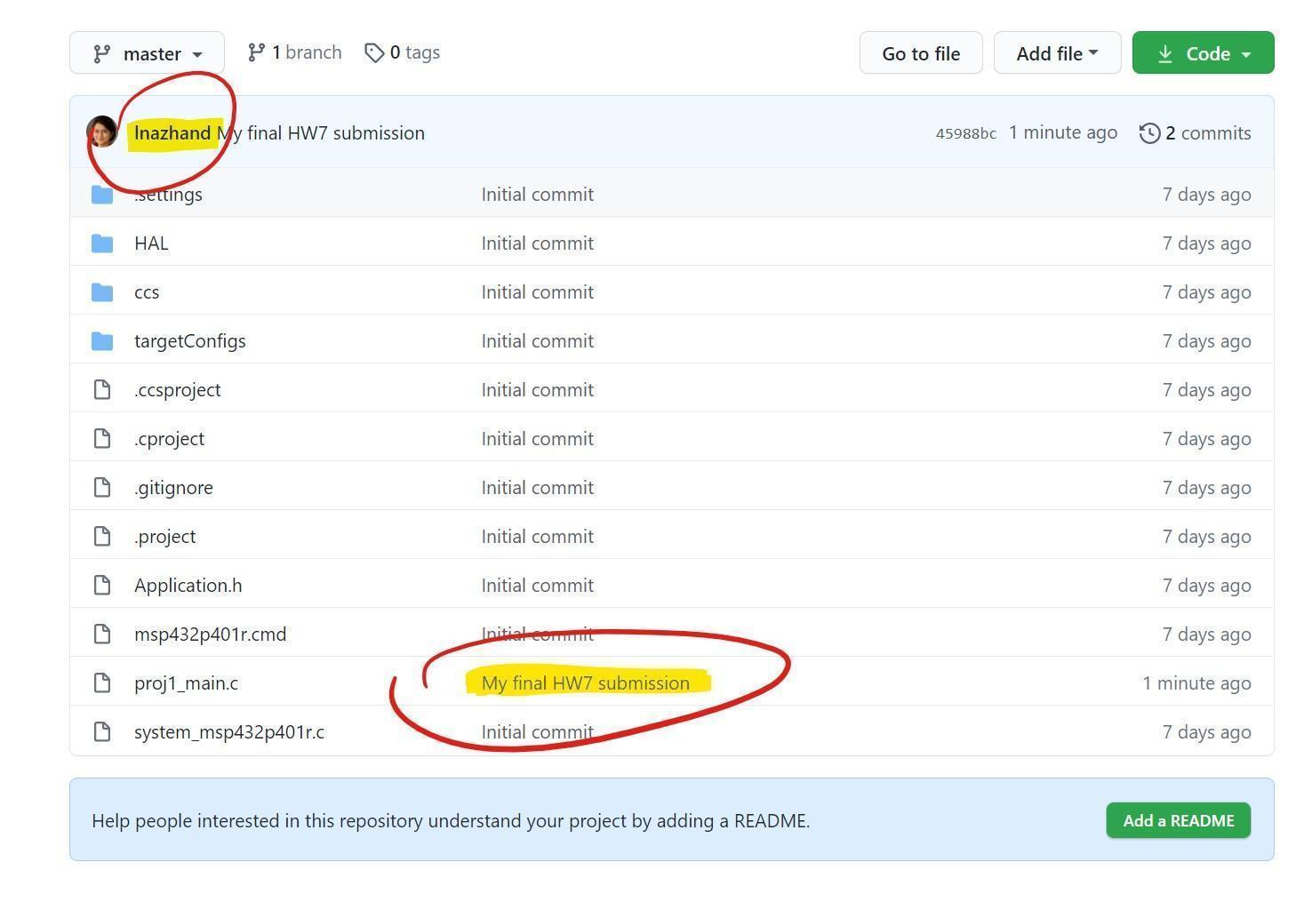
Submit the updated version of this document to Canvas by the deadline for HW8.

