Documentation of Final Project

# Name : Subhan Hagverdiyev

# Neptun Code : NHL9KN

**Title of the project : Restaurant Management System**

1. Problem statement and the task description
   1. Program definition

Program should represent simple online restaurant system, where user can order food from chosen menu and there is also panel for admin. There are 5types of foods on menu. Each of them has data which shows order, name , quantity and price. Also, all data should be stored in text file.

* 1. Tasks
     + In the beginning welcome page appears.
     + During the execution of the program, admin can add foods to menu and this data should be stored on dynamic array
     + Program should include simple menu, so user can access various operations
     + In Menu there are choices if user enter character instead of number the program restarts
     + Admin have 2 choices either can see total cash or can update food

1. Solution Design

I tried to demonstrate design of my program by simple flow-chart Flow-Chart in the next page →



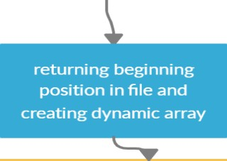

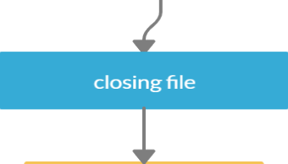

|  |  |
| --- | --- |
| Food menu | **Simple selecting 1** |
| Admin panel | **Selecting 2 then can either select 1 for seeing total cash or selecting 2 for updating food** |
| Quit | Exit(1) |

menu



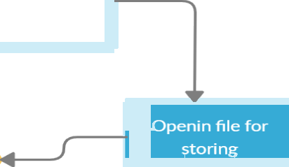

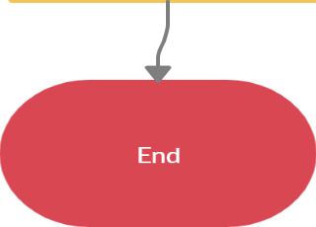

1. Solution
   1. Partition and structure of program “Main.cpp” – Main program and solution

“Design.h” – Welcome page of program

“Foods.h” – Foods menu

Foods.cpp” – Implementations of Foods class

“Design.cpp” –Implementation of Design class

* 1. Tricky algorithms, techniques

I have used switch case for the menu which is useful for returning to the main menu if user wants. For this I have created switch case in infinite loop which ends only in one case when user wants to exit : exit(1) function is called.

Another trick I have used is cin function when I check if user entered desired input(integer not character). I have used while(!cin()) – When input fails, the std::ios_base::failbit is set on the stream and the stream won't convert to true (or the not operator ! applied to a stream returns true). Once the std::ios_base::failbit is set, the stream will refuse to make any progress until the bit is cleared again. Using clear()  I reset the error bits. Once the bits are reset the offending character is still in the input, however. To get rid of the next character I just used ignore().

1. (optional) External Solutions

I have only used Standard c++ classes & libraries and I wrote whole project on my own using knowledge & experience obtained from lectures, lab sessions and online tutorial

5.Testing

I have tested program by executing it several times. It executes without errors, there are only safe warnings that can be neglected. I have tested its features one by one and everything seems to be working as planned.

1)The case when user enters character:

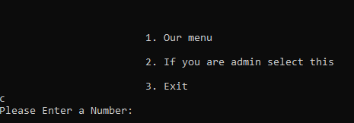

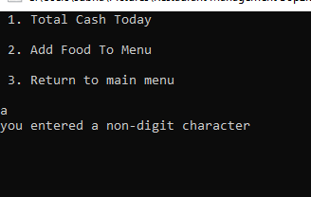

2)The case when user wants to return to menu

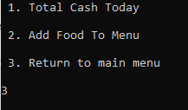

3) When user enters the order after that the total cash is saved to file. By returning to menu and then admin panel to check total cash for one day.

