Lab 3: Requirements and Verification
Model Based Design of Embedded Software
Subhang Vempati

Problem 1

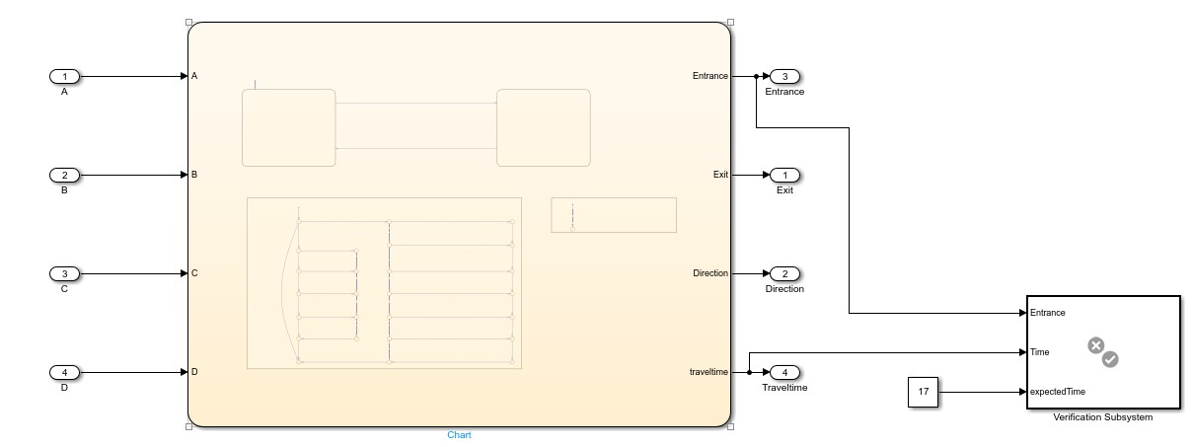
In my model I used direction as true or false in the initial state and the conditions are given as crossing and entrance and exit. These entrance and exit are the arrays which has the members in the buffer. Every member crossing the and staying exit are calculated in these buffers.
In entrance from exit path 2 people go to direction false state and while coming back to exit to entrance 1 person comes back with the torch.

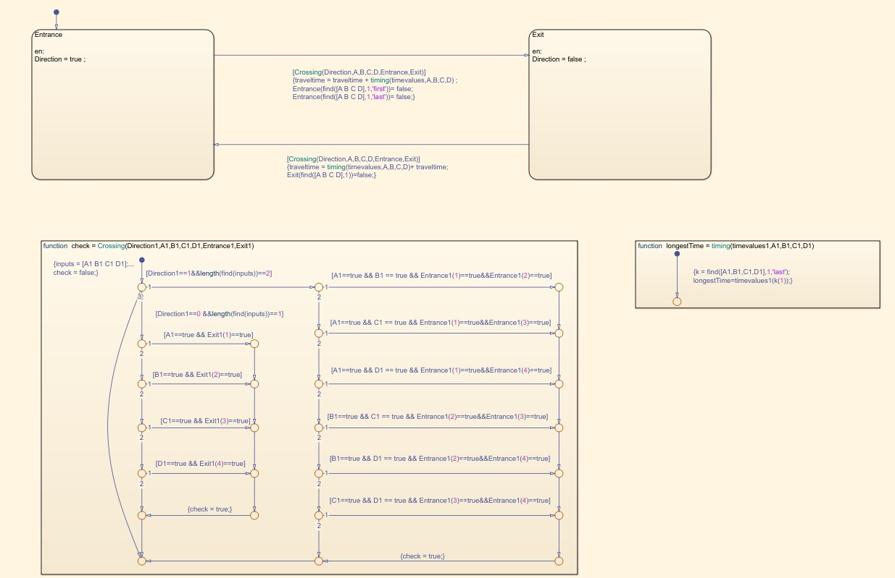
First initialised both entrance and exit buffers as [1 2 5 10] and then exit as [false false false false]
Every time a person crosses the bridge an element in exit buffer is changed to true and entrance buffer is changed to 0.

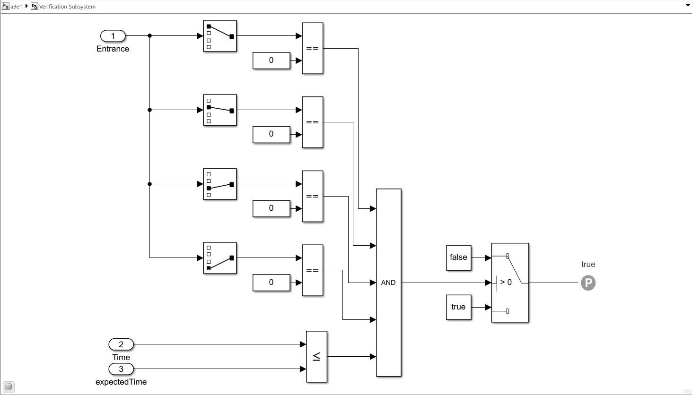

The models stop working when all elements in entrance are replaced with 0 and all elements in exit are changed to true
The lowest possible time taken by the model is 17 minutes.

Step 1 | Step 2 | Step 3 | Step 4 | Step 5 | Step 6 | Step 7
[7 3] | [1 2] | [1 1] | [8 2] | [10 5] | [2 1] | [1 2]

Problem 3
There were 2 unsatisfied cases in my previous model in assignment 2. Have run SLDV for 3 hours for decision, Conditional decision and MCDC. There were unsatisfied with decision at door done and direction of the elevator. When you press a floor which is in opposite direction of the elevator then it will continue to go in the same direction stop at the floor and then changes its direction.
Changes were made in the state flow by adding a buffer and the elevator will follow the buffer and compares the floor button pressed and the direction it is in and chooses the optimal direction it must go in.

Problem 4

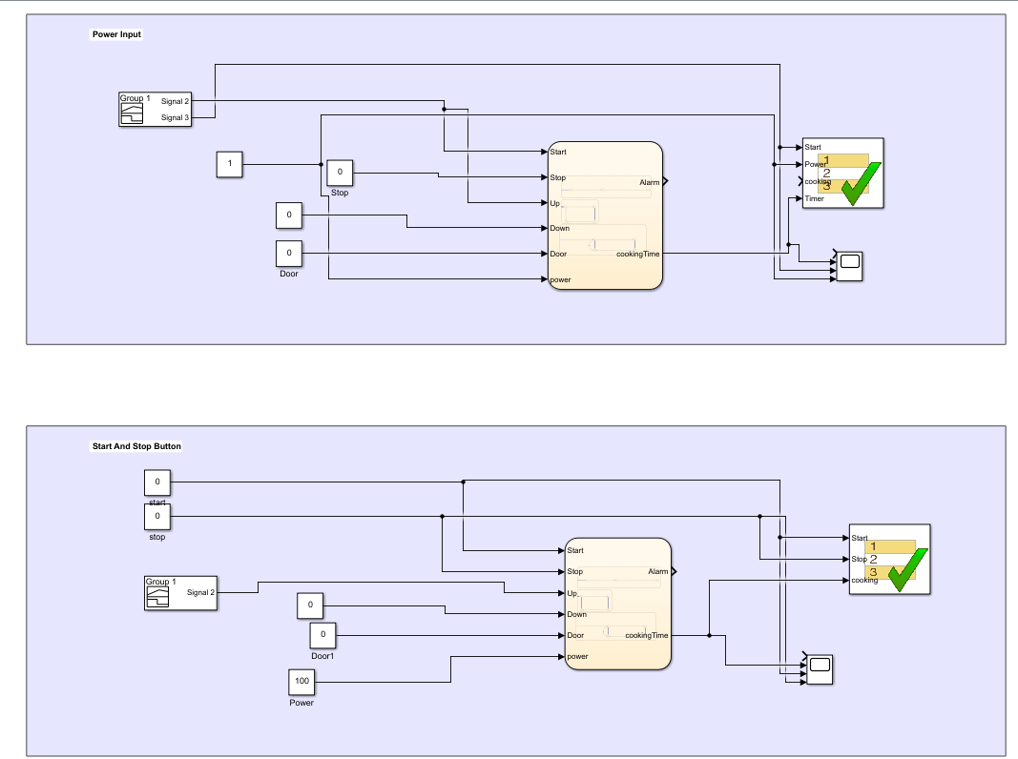

I used a signal builder just to give signals to the previously made microwave circuit in
Assignment 2 and then used a test assessment and then made an output from the scope.

