**AML Assignment-3**

- SUBHANI SHAIK[MT18117]

**Dataset: ExtendedYaleB dataset**

* For Dictionary learning and Transform learning, our dataset has 10 classes yaleB11-yaleB21 where each class has 585 images of 3x480x640 resolution.
* As this image is large, it is converted to grayscale image and then resized to 28x28 and 60x60 for our processing convenience (resized due to high computational duration).
* So our dataset has total of 5850 samples.

**1.** **Dictionary learning**:

* For Dictionary learning, optimization function is

argmin ∑ ||Y-DX||22 + ⋋||X||0

* To update X (representation), I used OMP (orthogonal matching pursuit) algorithm.
* It initializes our representation approximation to our data by taking sparsity parameter.
* For this I used K-SVD algorithm for optimizing. It is used to update atoms of our D (dictionary).
* In this K-SVD algorithm, it will first fix the D and try to best fit our representation(X) iteratively.
* And next fix the X including rank-1 approximation of residual matrix that in previous step and updates the D.
* Trained the dictionary by choosing parameters sparsity, epochs and dimensions of our D and X.
* Tried Random initialization and Glorot initialization and reported the training errors.

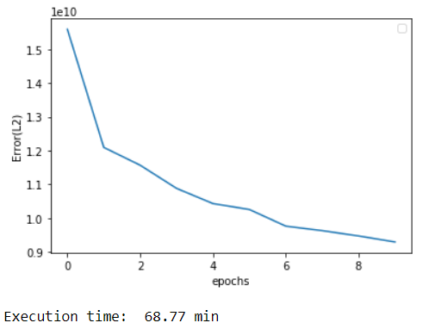

For more epochs-

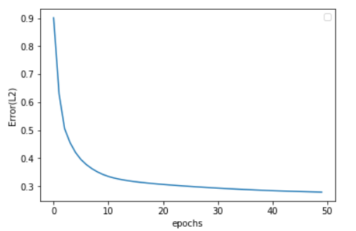

**3. Transfer learning framework:**

* Transfer learning is a technique used to improve the learning of the target predictive function. It depends on the source and target domains and tasks.
* In this our domain of source DS and target DT are similar i.e., the images are taken under different illuminations.
* And task is classification by forming the synthetic and analysis parts from dictionary learning and transform learning.
* We can design a convolutional transform learning (analysis framework) and include a classifier to it to recognize the class.
* We can design a network using CNN along with TL like in following papers [paper1](https://hal.archives-ouvertes.fr/hal-01862201/document) (Convolutional TL), Inductive Transfer learning technique- [paper2](http://proceedings.mlr.press/v28/maurer13.pdf) (sparse multi-task and transfer learning).
* In Inductive transfer learning we will have source domain and target domain as same, and task is different (here classification) but related.
* Thus we can train our network using transfer learning (dictionary as weights) and classify our new dataset.

**5. Analysis:**

* For Dictionary learning, I trained for Random initialization and Glorot initialization for 28x28, 32x32, 60x60 image sizes for our computation convenience and analysed the performances of each.
* All the execution is under without GPU.
* Set the parameters of sparsity=4.
* For 60x60 image patches: trained for 8 epochs and convergence is observed as number of epochs are increased.
* As our dictionary size is more it is taking so much of time (it is taken >1hour for just 8epochs).
* By increasing epoch, the error is decreasing.
* For 28x28 image dataset: trained for 50 epochs and observed convergence is smooth and faster.
* As epochs are more giving better performance.

|  |  |  |
| --- | --- | --- |
|  | Training error | Dictionary Visualization |
| 60x60 image patches | C:\Users\Subhani\Desktop\AML Assignment_3\1.PNG | C:\Users\Subhani\Desktop\AML Assignment_3\2.PNG |
| 28x28 image patches | C:\Users\Subhani\Desktop\AML Assignment_3\3.PNG | C:\Users\Subhani\Desktop\AML Assignment_3\4.PNG |