**AI Programming Assignment-3**

**1. Travelling saleman problem(TSP) using Ant Colony System Optimization(ACO):**

TSP is the problem of finding a shortest closed tour which visits all the cities in a given set of cities. In a symmetric TSP the distance between two cities is same regardless of the direction of travel(i.e., Undirected graph) whereas in asymmetric TSP the distance between same cities is different regardless of direction of travel.

Here I followed the symmetric TSP.

**Program flow:**

**Step1**: Initialize cities with distances and pheromone level between each cities.

**Step2**: Assign cities randomly to ants.

**Step3**: select next city according to probability of cities with respect to pheromone levels and distance between them. The probability can be calculated using the following formula:

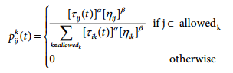

where

p(t)= probability of edge between cities for selection for ant K.

T(t)= pheromone level

n(t)= (1/Lk) distance between edge.

Alpha, Beta= parameters for tuning

if alpha=0 then it will select the cities which are closest to it.

If beta=0 then it leads to only pheromone amplification is at work, i.e., it will lead to system to a stagnation situation(in which all the ants generates a sub-optimal tour).

**Step4**: compute the total tour length by each ant respectively and update the shorter tour in each iteration.

**Step5**: For every edge udpate the pheromone level using the formula:

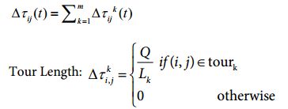

where

rho=rate of evaporation.

Q=amount of pheromone that is deposited on edge by ant k.

Lk= total tour length by ant k.

T(t+1)= change in pheromone level on edge i,j between cities

**Step6**: Repeat the process till converge or till maximum iterations.

Input for all the cases are same respectively for comparison purpose.(which is randomly generated)

**Results and Analysis:**

|  |  |  |  |  |  |  |  |
| --- | --- | --- | --- | --- | --- | --- | --- |
|  |  | Cities=10, Ants=10 | | | Cities=30,Ants=60 | | |
|  |  | Iteration=5 | Iterations=10 | Iterations=50 | Iteration=5 | Iterations=10 | Iterations=50 |
| Alpha=0.7  Beta=0.7  rho=0.5 | Shortest Tour length | In1  165 | In2  164 | In3  164 | In4  171 | In5  171 | In6  170 |
| Time | <0:00:00 sec | <0:00:00 sec | 0:00:02sec | <0:00:00 sec | 0:00:4 sec | 0:00:23 sec |
| Alpha=0.15  Beta=0.3  rho=0.4 | Shortest Tour length | In7  168 | In8  165 | In9  164 | In10  171 | In11  171 | In12  171 |
| Time | <0:00:00 sec | <0:00:00 sec | 0:00:03 sec | 0:00:1 sec | 0:00:05 sec | 0:00:24 sec |

Note: Inx=InputX.txt

**Graphs:**

**Input1:**

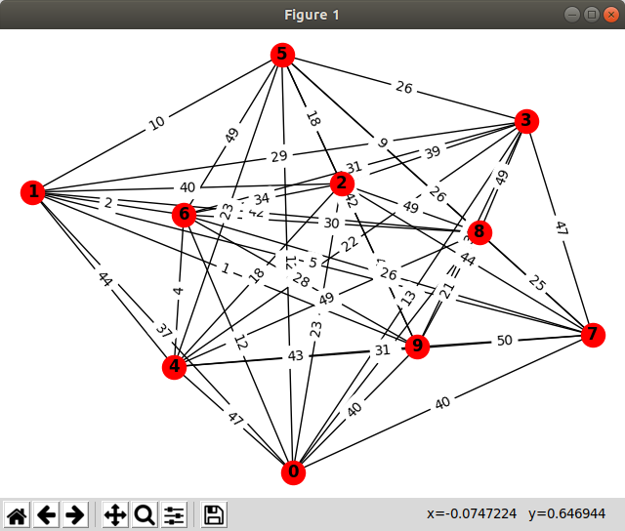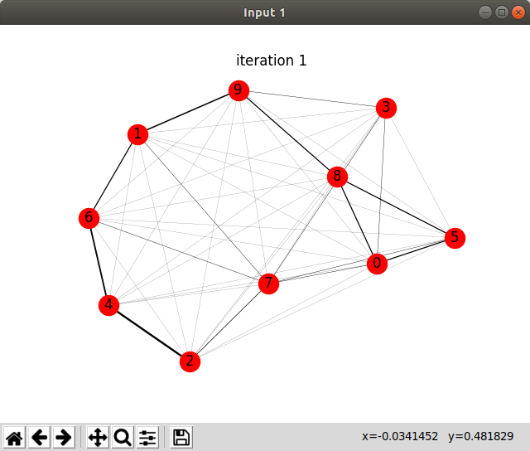

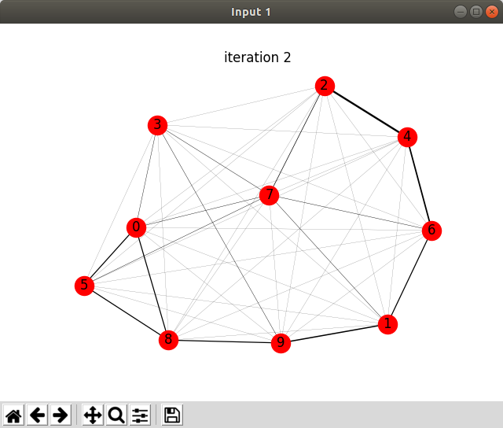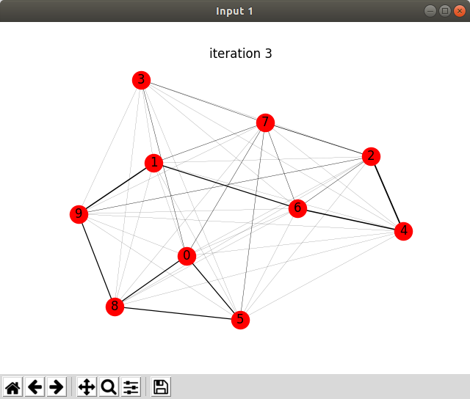

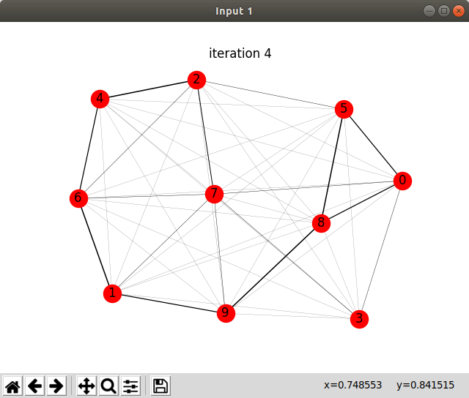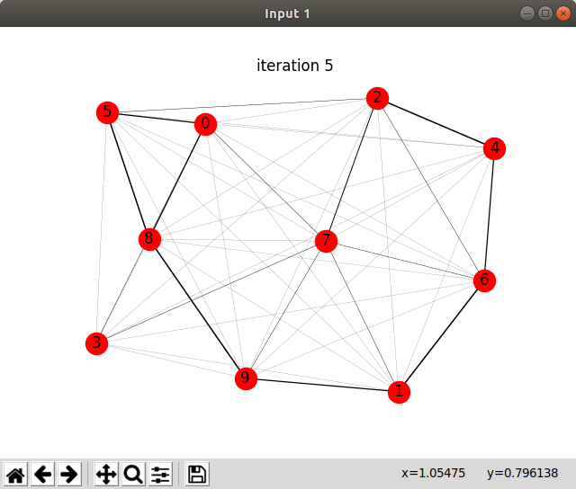

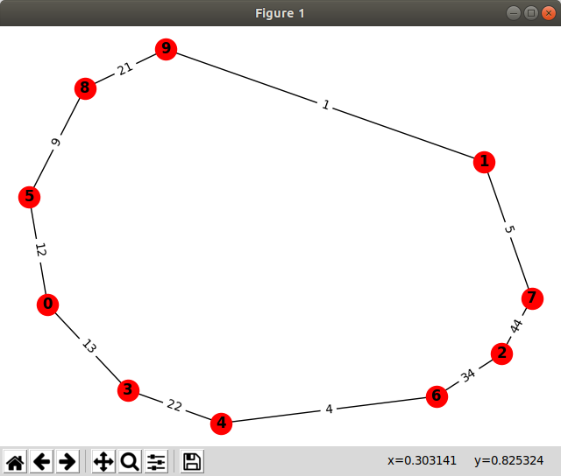

**Input4:**

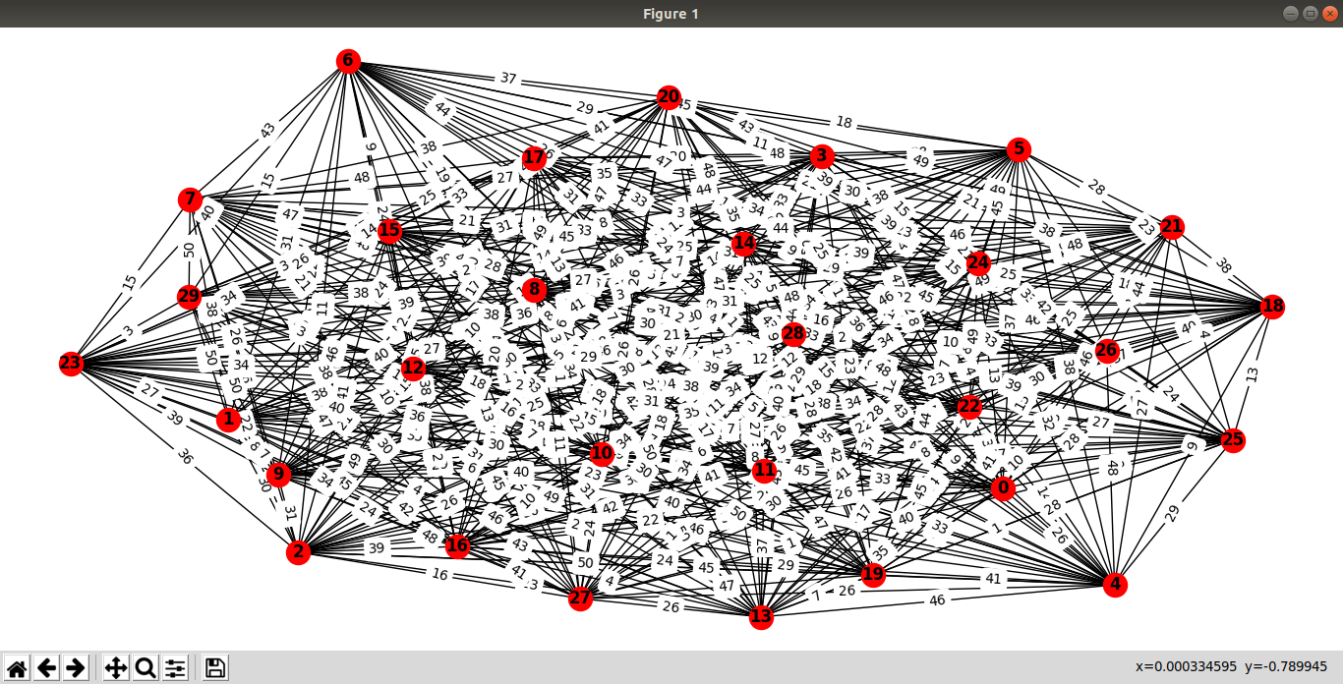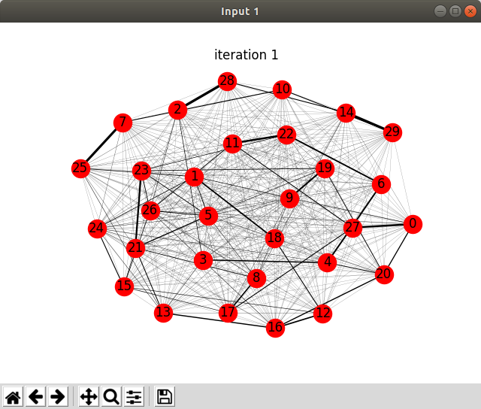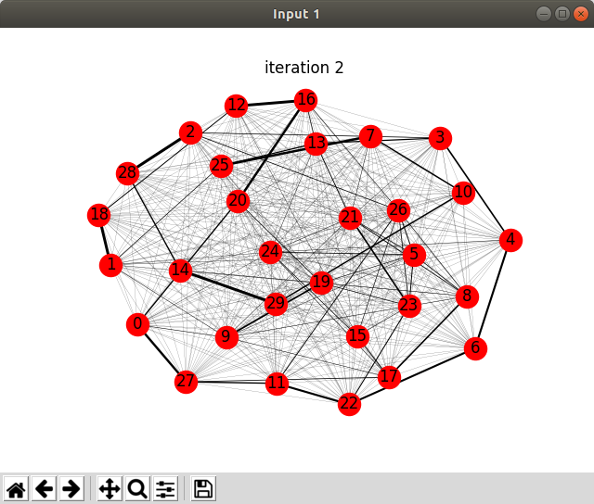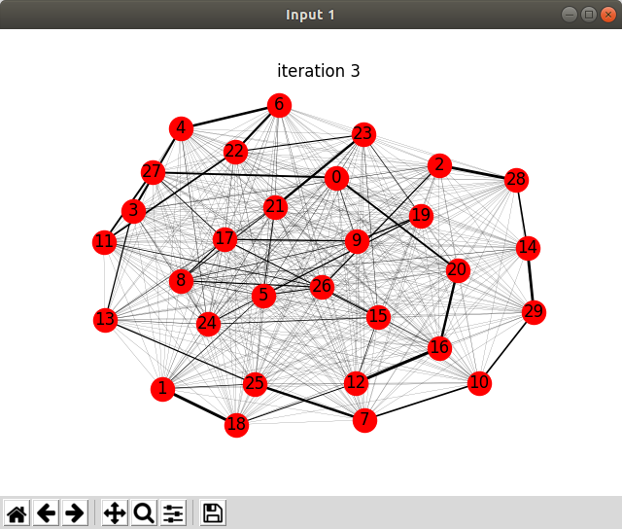

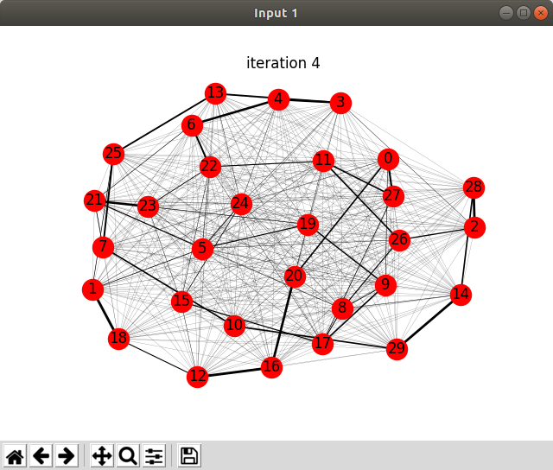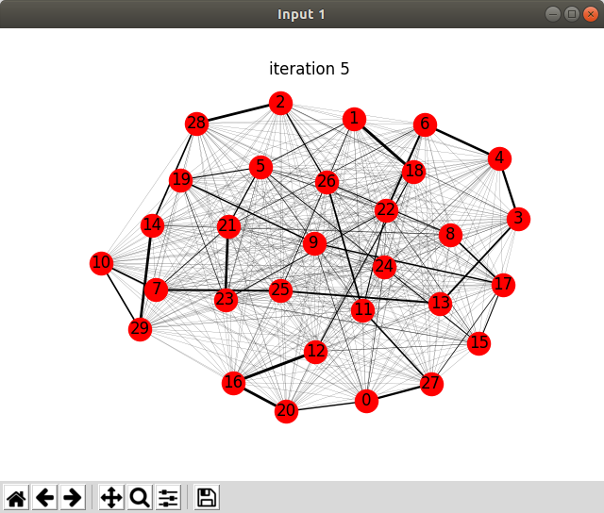

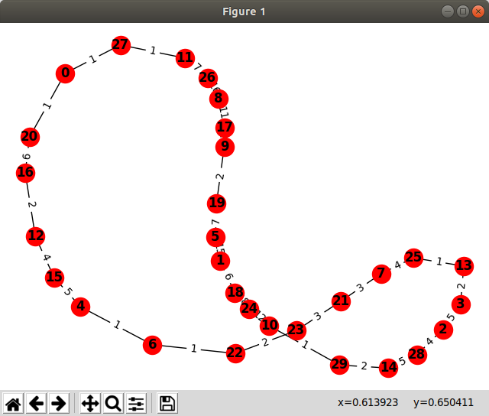

**Assumptions to implementation:**

* Initially assigned cities to ants randomly(not each city is assigned to an ant).
* Initially pheromone levels between each city(edge) is assigned to 1.(symmetrically)
* Symmetric TSP is used.

**Conclusion:**

By changing the parameters the convergence rate is not much effected(due to implications of mathematics) but changing the iterations will effect the convergence of ants choosing path i.e., ant following other ants.