**Algorithm:**

According to David Hughes et.al the detection of leaf disease depends on type of image we are working on. Types: colour, grayscale, segmented.

The initial paper about plant disease detection and classification using deep learning – they experimented on above types of images and trained using Transfer learning and from scratch.

For Transfer learning they have taken pre-trained models of AlexNet and GoogLeNet and done training on above images and reported the results.

For Training from Scratch they trained on AlexNet and GoogLeNet architecture on above images and reported the results.

Observation: the training and validation accuracies of above images are varies with respect to what type of image we are using.

Order of Accuracies : Colour images > Segmented images > GrayScale images

Current results:

Gray Scale images, resized images because of computational convenience.

Experimented on SVM with RBF kernel and got

Train accuracy:

Test Accuracy: 0.83

Implemented basic 5 layer CNN with dropout rate=0.2, epochs=50, lr=0.1

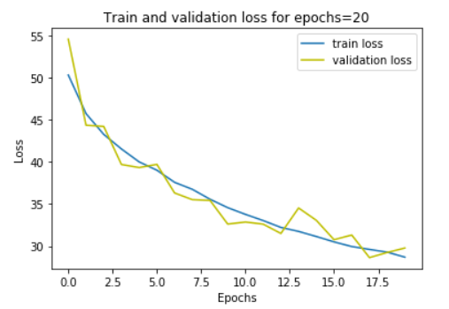

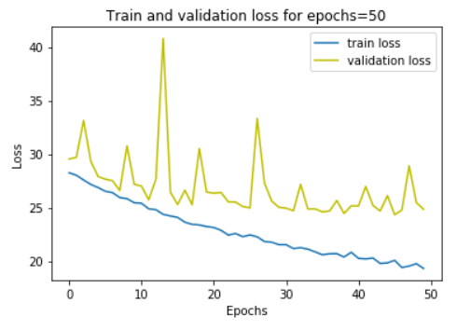

By increasing epochs, the train and validation loss are converging.

Above results are basic results without any specific feature selection.

We will implement our model based on advanced literature review.