**Report**

**1.**

**i. Dataset Analysis and plotting:**

**data_1**:

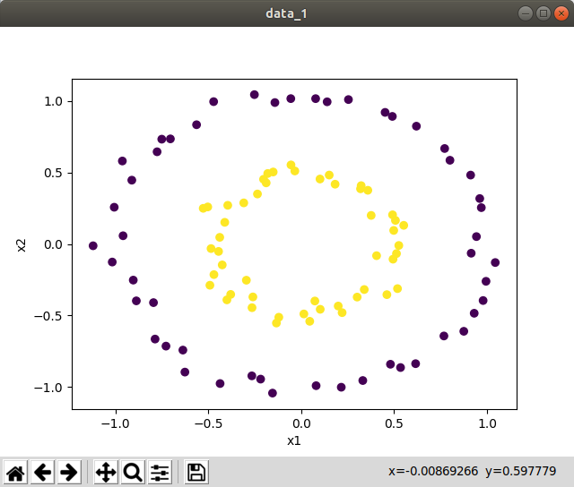

Balance: Yes

Number of samples: 100

Dimension: 2 dimensions

Separability: Non-Linear

Noise: No

Classes: {0,1}

**data_2**:

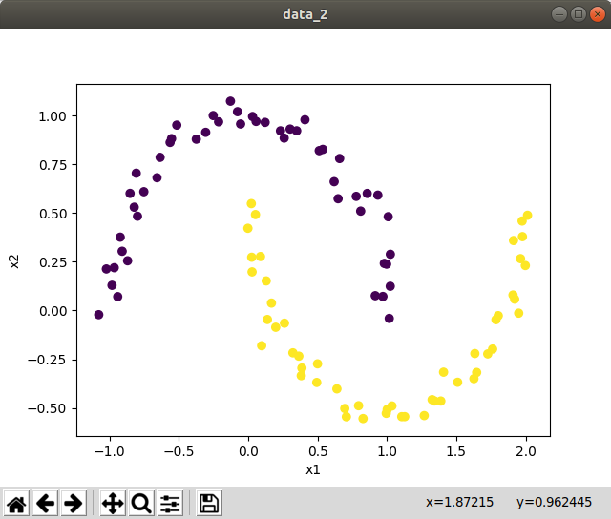

Balance:Yes

Number of samples:100

Dimension: 2 dimensions

Separability: Non Linear

Noise: No

Classes: {0,1}

**data_3**:

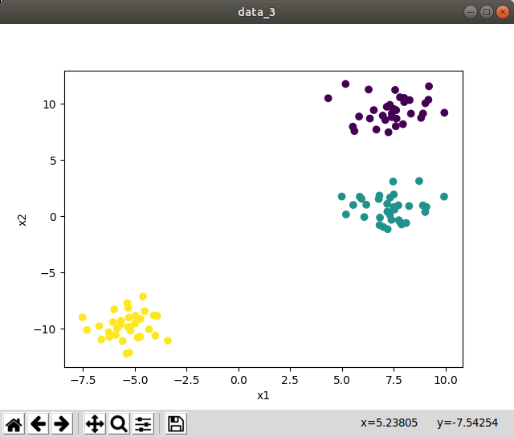

Balance:No

Number of samples:100

Dimension: 2 dimensions

Separability: Linear

Noise: No

Classes: {0,1,2}

**data_4**:

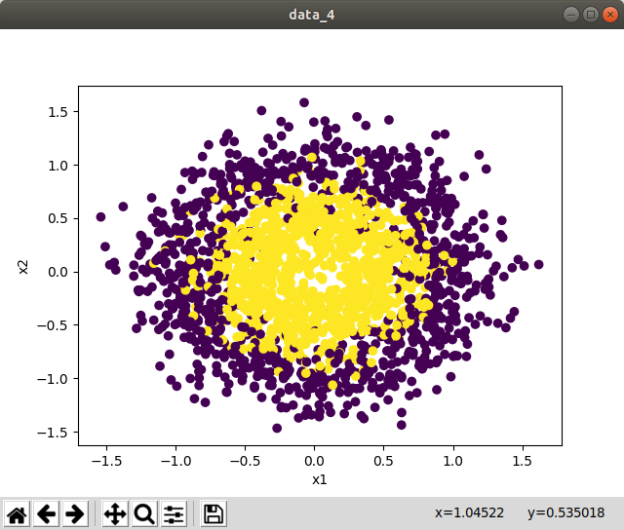

Balance:Yes

Number of samples:2000

Dimension: 2 dimensions

Separability: Non Linear

Noise: Yes

Classes: {0,1}

**ii. SVM Decision boundaries for Datasets:**

By observing the dataset, I chose following kernel and implemented by taking appropriate parameters(constant , degree)

|  |  |  |
| --- | --- | --- |
| Dataset | Custom Kernel | Decision Boundary |
| Data_1 | Polynomial  (c=1,degree=2) |  |
| data_2 | Polynomial  (c=1,degree=3) |  |
| data_3 | Linear |  |
| data_4 | Polynomial  (c=1,  degree=2) |  |

Used Custom Polynomial kernel: np.power((c+np.dot(x,y.T)),d)

**iii. SVM with Linear Kernel:**

**data_1:**

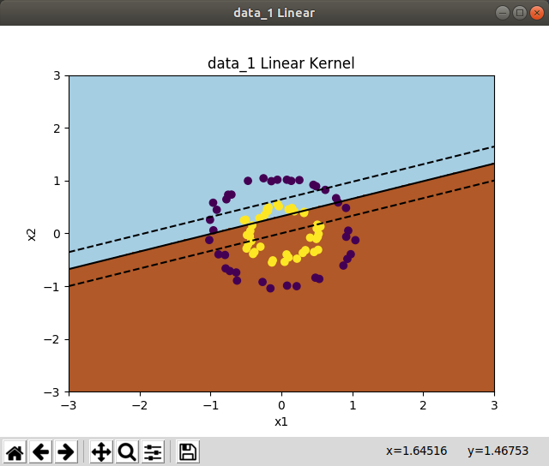

F1-Score: 0.56

Accuracy:0.45

bias(b) : 0.38793275

Confusion matrix:

TP: 2 FP: 9

TN:2 TN: 7

**data_2:**

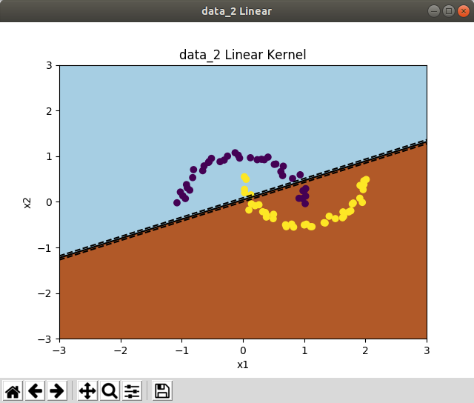

F1-Score: 0.8750000000000001

Accuracy:0.9

bias(b) : 0.08580343

Confusion matrix:

TP: 11 FP: 0

TN:2 TN: 7

**data_3 OVR:**

Accuracy for all individual plotting are 1.0

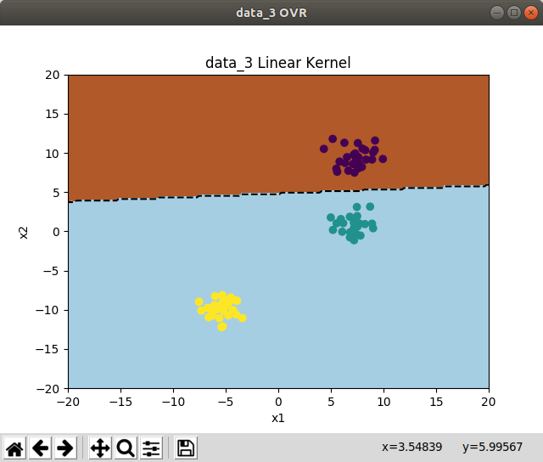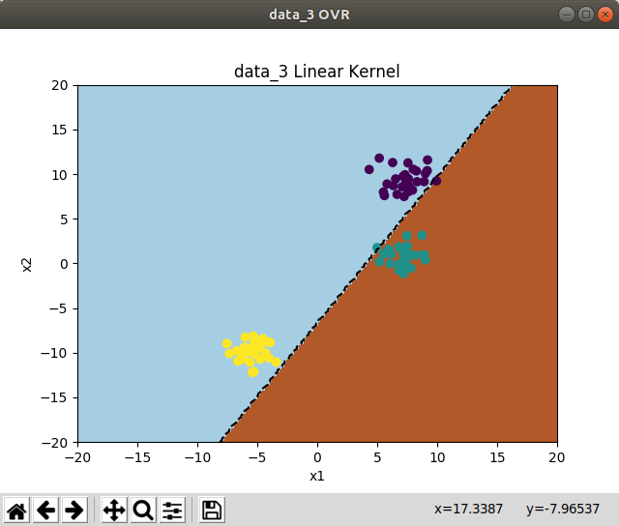

class 0 vs rest: class 1 vs Rest:

bias: -2.23721209 bias: -5.01318078

Confusion3: confusion3:

[[15 0] [[11 0]

[ 0 5]] [ 0 9]]

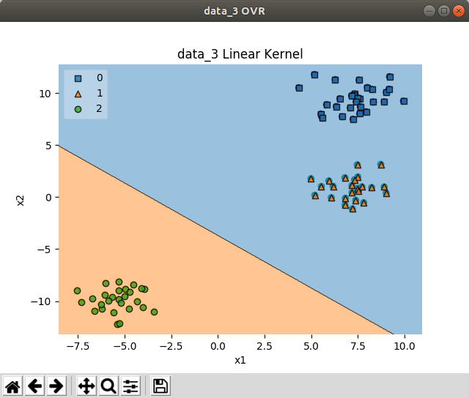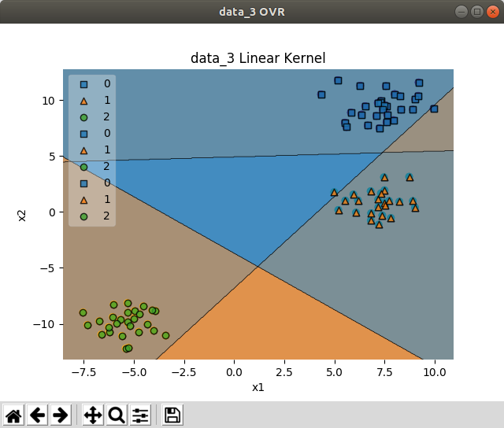

bias : -0.40477513

confusion3:

[[14 0]

[ 0 6]]

**data_3 OVO:**

Accuracy for all individual plotting are 1.0

**class 0 vs 1 Train and Test**

bias : 2.23721216

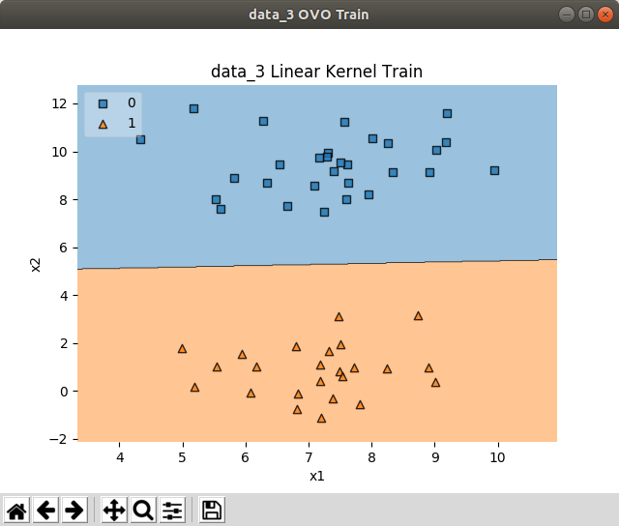

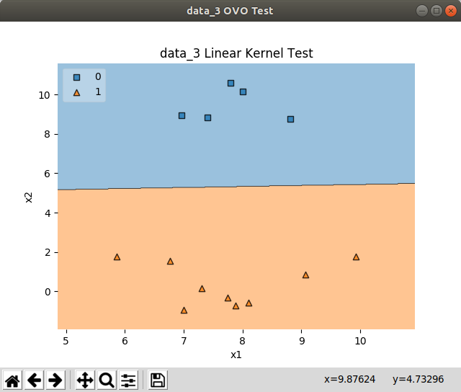

**class 0 vs 2 Train and Test:**

bias : -0.00693931

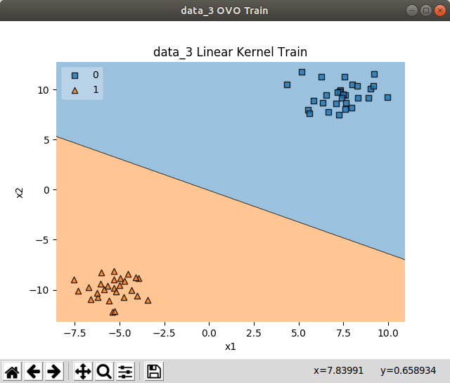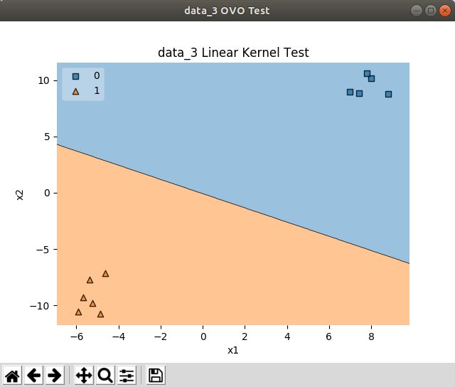

**class 1 vs 2 Train and Test:**

bias : -0.40477513

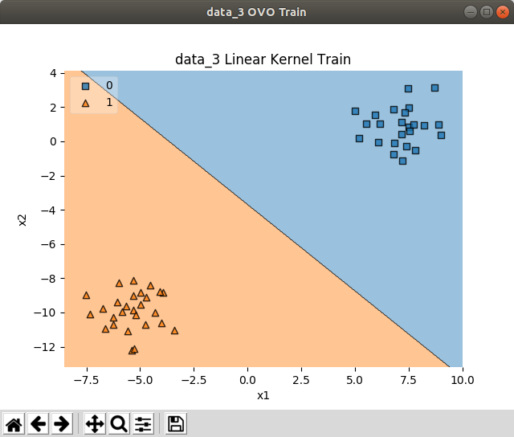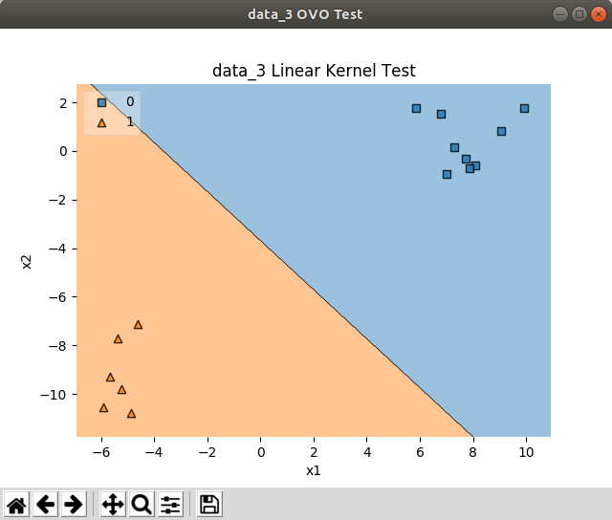

**data_4:**

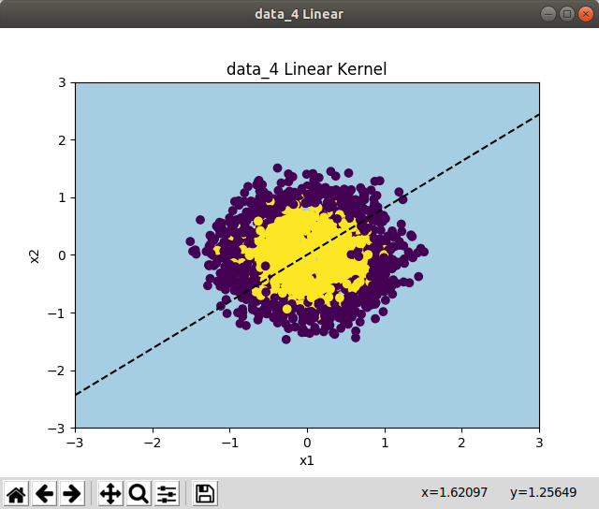

Accuracy for test: 0.4625

confusion4:

[[ 0 11]

[ 0 9]]

bias4: [0.99993001]

**iv. SVM with RBF Kernel:**

**data_1:**

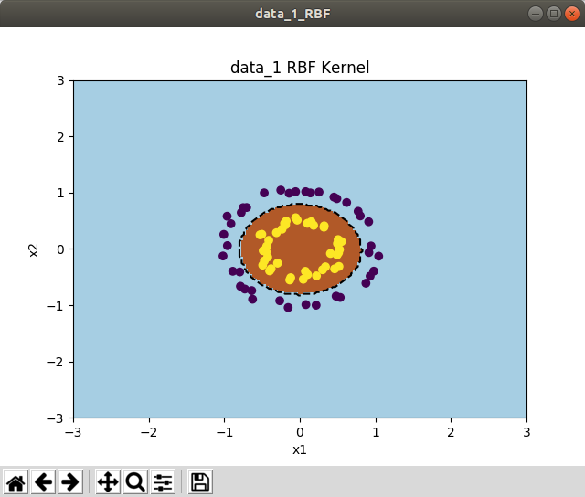

Accuracy for test: 1.0

confusion1:

[[11 0]

[ 0 9]]

bias1: [-2.6212776]

**data_2:**

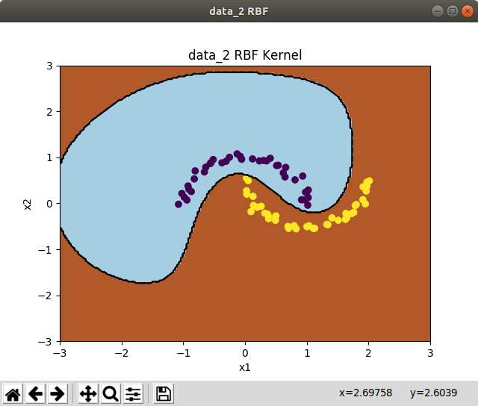

f1 Score: 0.9411764705882353

Accuracy for test: 1.0

confusion2:

[[11 0]

[ 0 9]]

bias2: [0.11650227]

**data_3 OVR:**

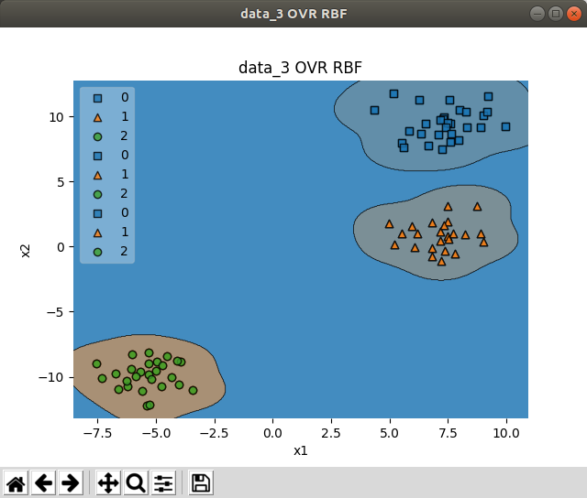

class 0 vs Rest:

F1 : 1.0

bias3: [-0.22586886]

class 1 vs Rest:

F1: 1.0

intercept 3: [-0.38168894]

class 2 vs Rest:

F1: 1.0

bias3: [-0.40387025]

**data_3 OVO:**

**class 0 vs 1:**

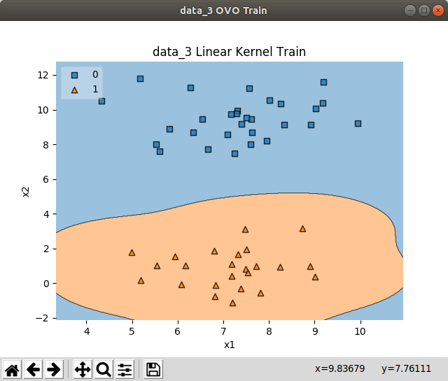

**class 0 vs 2:**

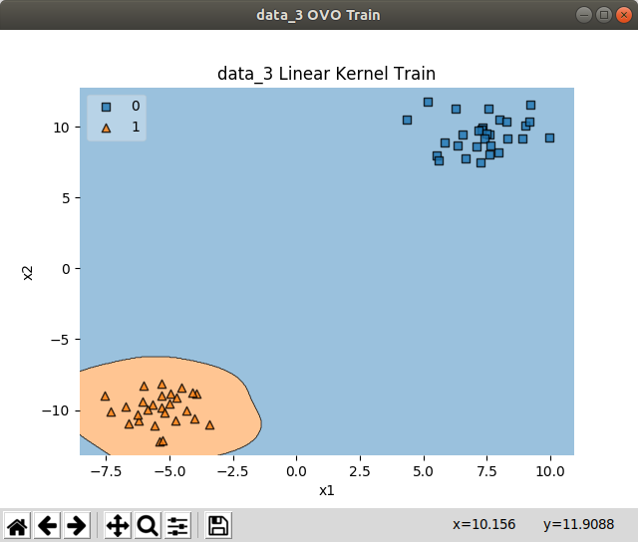

**class 1 vs 2:**

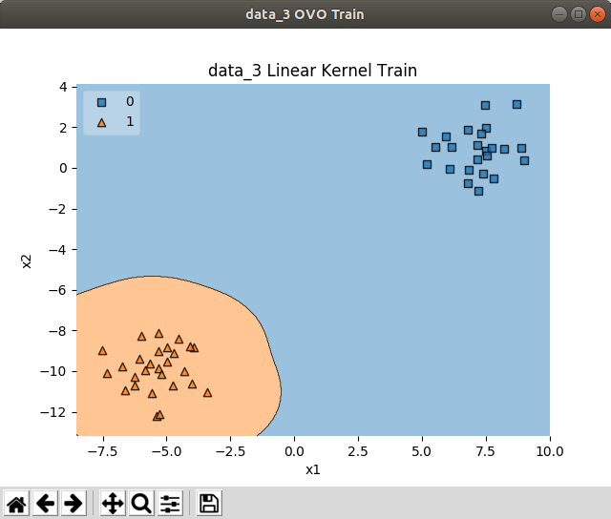

class 0 vs 1:

F1 : 1.0

intercept 3: [-0.11057571]

class 0 vs 2:

F1 1.0

intercept 3: [-0.12318428]

class 1 vs 2:

F1: 1.0

intercept 3: [-0.012874]

**data_4:**

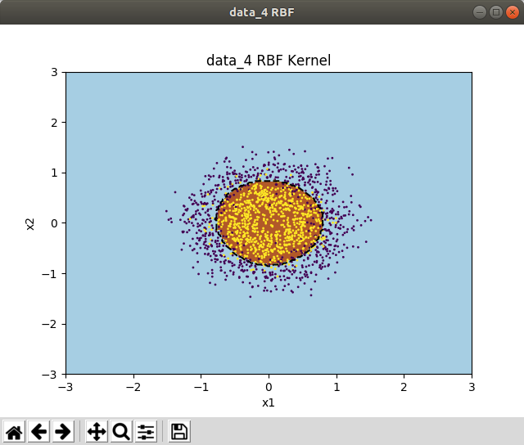

F1 score: 0.8475452196382429

Accuracy for test: 0.8525

confusion matrix:

[[9 2]

[0 9]]

bias: [-4.18883444]

**v. Hindi Handwritten Characters using RBF:**

In this, there are 5 hindi characters. So, I labelled them as classes from 0 to 4.

Initially loaded the data images and vectorized them and then trained on SVM using RBF Kernel.

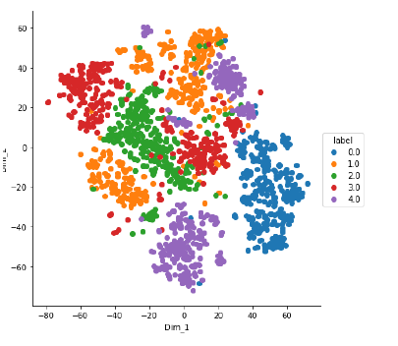**T-SNE:**

here I used cross validation=2

Validation error in fold:1: 0.85

Validation error in fold2:0.86