While building the project, I ran into a few issues and made the following changes to resolve them:
1.
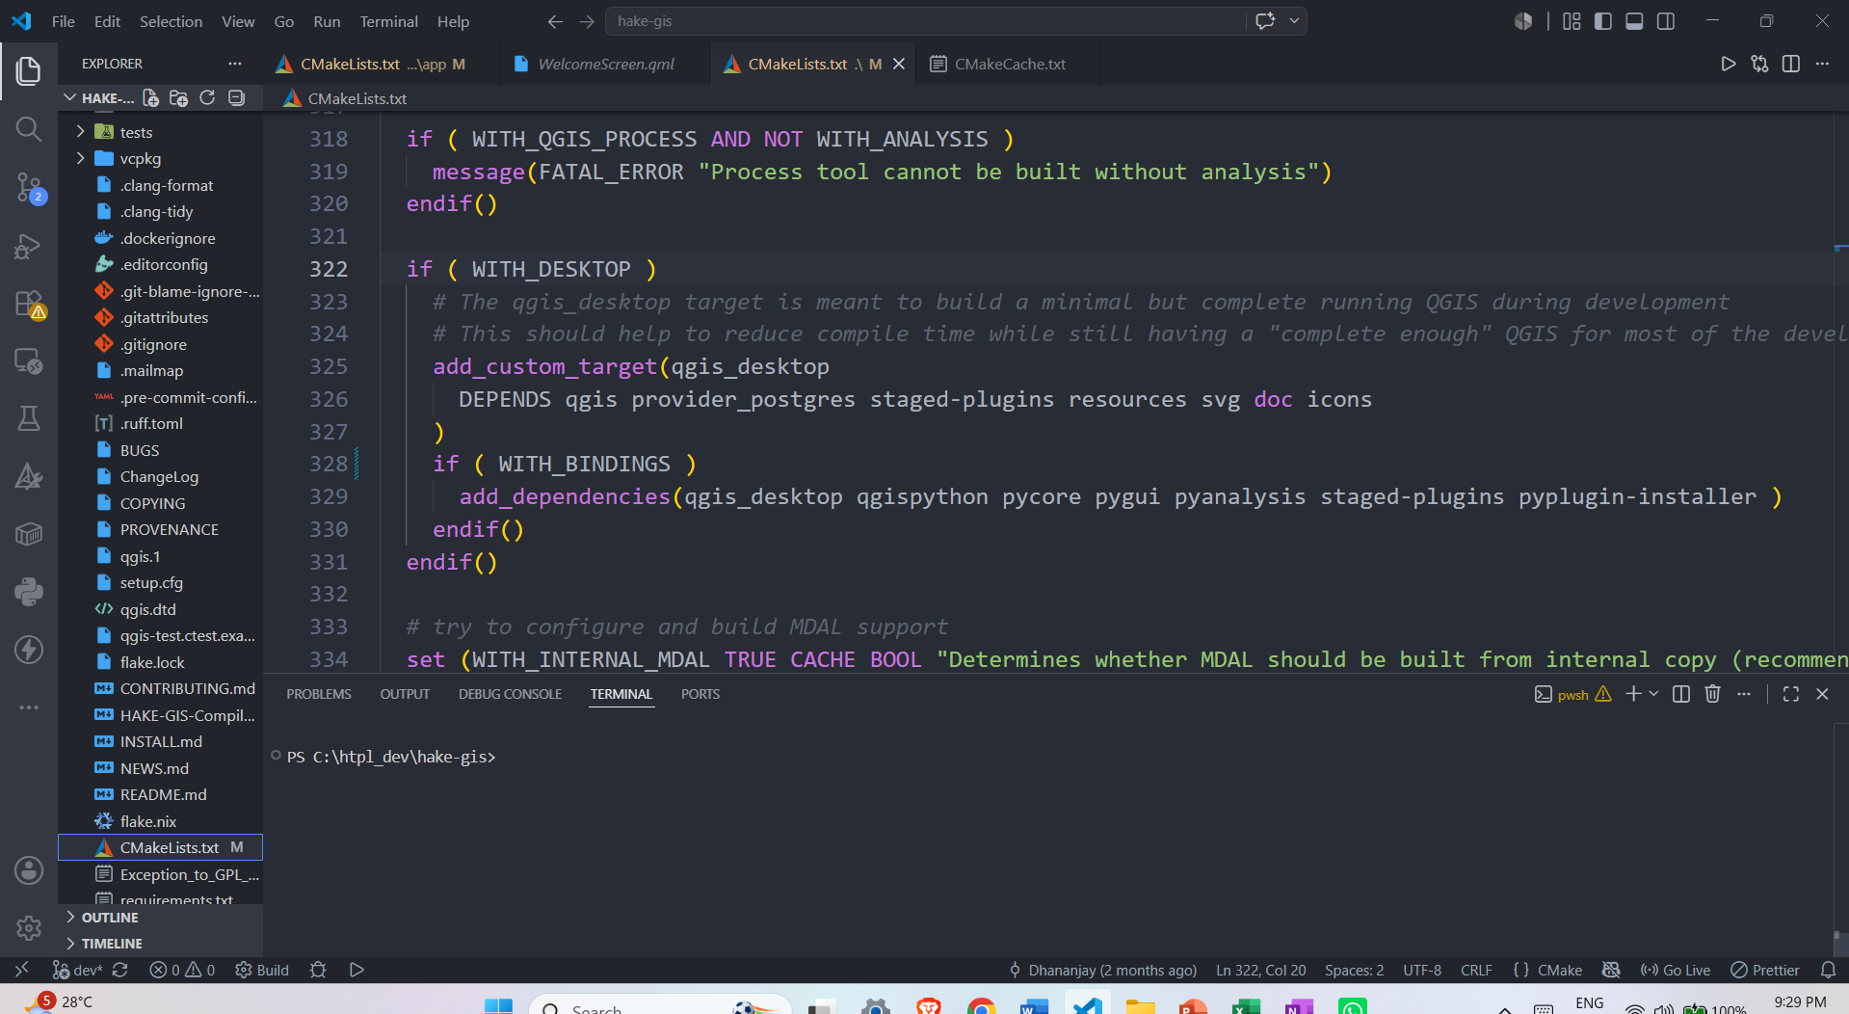
WITH_DESKTOP WITH_BINDINGS (change)

2.
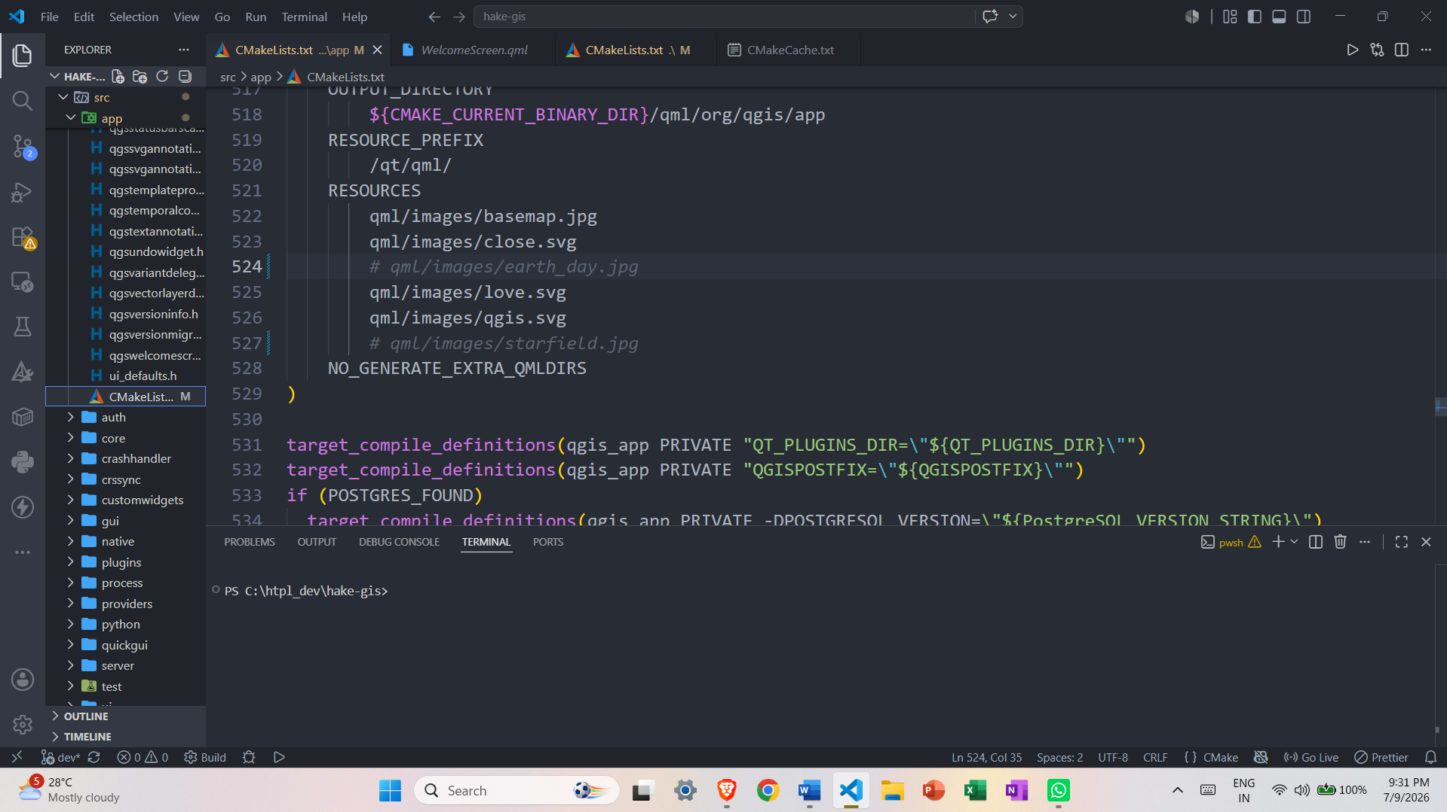
qml/images/earth_day.jpg
qml/images/starfield.jpg
[ these files were not found so I commented out the related code so the build would proceed.]

3.
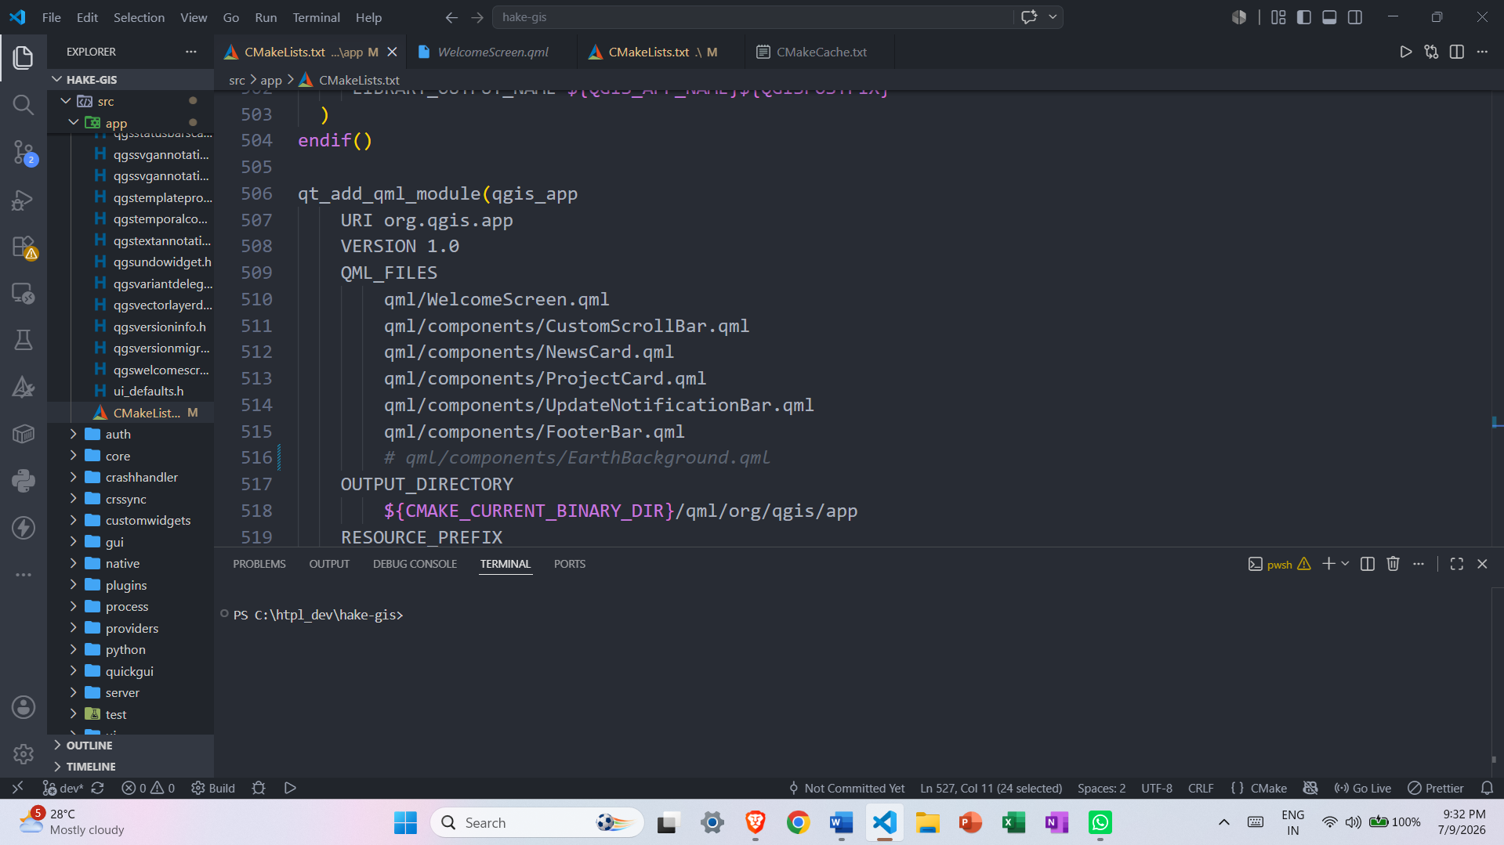

qml/components/EarthBackground.qml
[This file was also missing so I commented out the code that referenced it for the same reason.]

After these changes, the build completed successfully

